BITS Pilani – Work Integrated Learning Programmes
Machine Learning Operations (MLOps) – AIMLCZG523
ASSIGNMENT 01
End-to-End MLOps Pipeline for Heart Disease Prediction

Student Name | Parag Shetgaonkar
Student ID | 2024AC05220
Email (WILP) | 2024ac05220@wilp.bits-pilani.ac.in
Email (Work) | parag.shetgaonkar@sapiens.com
Email (Personal) | Parag.shetgaonkar@gmail.com
Course | AIMLCZG523 – Machine Learning Operations
GitHub Repo | https://github.com/ParagSG/heart-disease-mlopsv1

1. Project Overview

This assignment implements a complete, production-grade MLOps pipeline for binary classification of heart disease using the UCI Heart Disease dataset. The pipeline covers the full machine-learning lifecycle: data ingestion and exploratory analysis, preprocessing, model training with experiment tracking, RESTful API serving, containerisation with Docker, automated CI/CD via GitHub Actions, cloud deployment on Azure Kubernetes Service (AKS), and live observability with Prometheus and Grafana.
1.1 Objectives
- Apply MLOps best practices to a real-world medical classification problem.
- Track experiments reproducibly with MLflow (parameters, metrics, artefacts, model versions).
- Package the inference service as a Docker container and push to Azure Container Registry.
- Automate linting, testing, training validation, and image publishing with GitHub Actions.
- Deploy to Azure AKS with rolling updates and health probes.
- Instrument the API with Prometheus metrics and visualise them in Grafana.
1.2 Technology Stack
Category | Tool / Version
Language | Python 3.11
ML Framework | scikit-learn 1.6.1
Experiment Tracking | MLflow 2.12.2
API Framework | FastAPI 0.111.0 + Uvicorn 0.29.0
Containerisation | Docker (multi-stage, python:3.11-slim)
Container Registry | Azure Container Registry (paragmlopsacr.azurecr.io)
CI/CD | GitHub Actions (3-job pipeline)
Orchestration | Azure Kubernetes Service – mlops-aks (East US)
Monitoring | Prometheus + Grafana (kube-prometheus-stack via Helm 3.21.2)
Version Control | Git / GitHub

2. Dataset & Exploratory Data Analysis (EDA)

2.1 Dataset Description
The Heart Disease UCI dataset (Cleveland subset) contains 303 patient records with 14 attributes (13 predictors + 1 binary target). The target variable indicates presence (1) or absence (0) of heart disease. The dataset was downloaded directly from the UCI ML Repository inside the Colab notebook to ensure reproducibility.

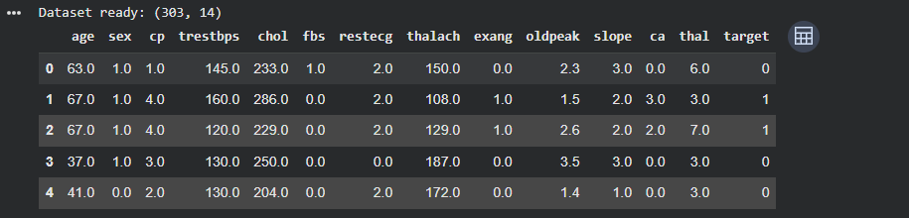
Dataset loaded: 303 rows x 14 columns
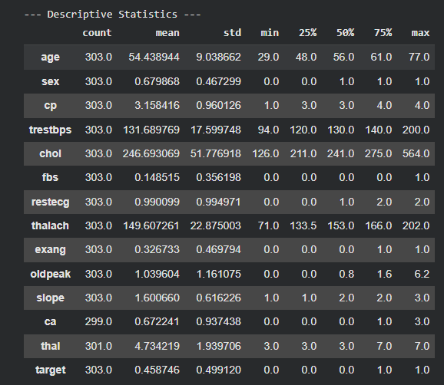
Descriptive statistics – mean age 54.4, thalach mean 149.6
Feature | Type | Description
age | Numeric | Age in years (mean: 54.4, range: 29-77)
sex | Categorical (0/1) | Sex (1=male, 0=female)
cp | Categorical (0-3) | Chest pain type
trestbps | Numeric | Resting blood pressure (mean: 131.7 mm Hg)
chol | Numeric | Serum cholesterol (mean: 246.7 mg/dl)
fbs | Categorical (0/1) | Fasting blood sugar > 120 mg/dl
restecg | Categorical (0-2) | Resting ECG results
thalach | Numeric | Maximum heart rate achieved (mean: 149.6)
exang | Categorical (0/1) | Exercise-induced angina
oldpeak | Numeric | ST depression induced by exercise (mean: 1.04)
slope | Categorical (0-2) | Slope of peak exercise ST segment
ca | Categorical (0-4) | Major vessels coloured by fluoroscopy (4 missing)
thal | Categorical (1-3) | Thalassemia type (2 missing)
target | Binary (0/1) | Heart disease: 0=absent, 1=present
2.2 Missing Value Analysis
Contrary to initial assumptions, the dataset does have a small number of missing values in two features:
- ca: 4 missing values (1.3% of 303 records).
- thal: 2 missing values (0.66% of 303 records).
- All other features: complete with no missing values.
- Strategy: mode imputation applied within the preprocessing pipeline for both features.
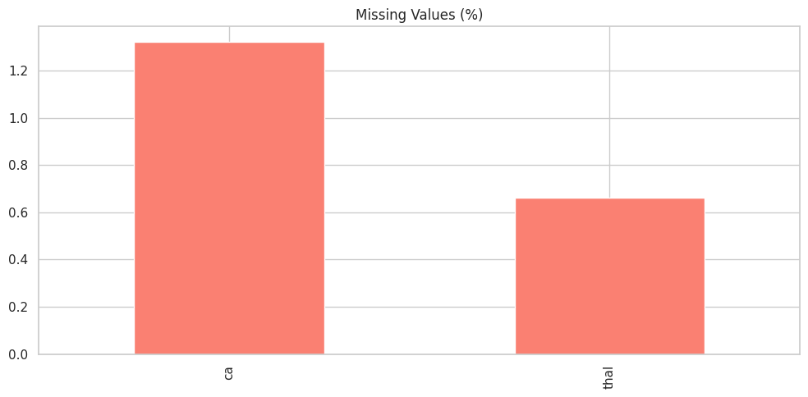

Missing Values (%) – ca: 1.3%, thal: 0.66%
2.3 Class Distribution
The dataset is near-balanced, with a slight majority of No Disease cases:
- No Disease (0): 164 records (54.1%)
- Disease (1): 139 records (45.9%)
- Near-balanced distribution — no resampling (SMOTE/oversampling) required.
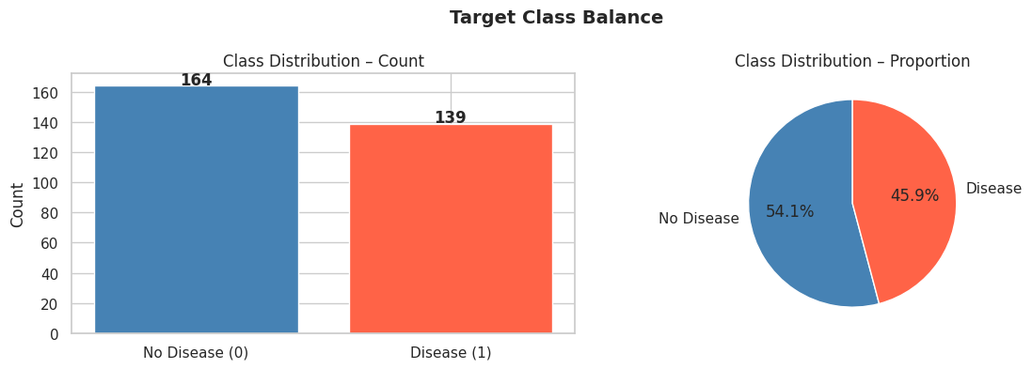

Target Class Balance: 164 No Disease (54.1%) vs 139 Disease (45.9%)
2.4 Feature Analysis
Key findings from feature distribution analysis:
- Thalach (max heart rate): Disease patients have significantly higher thalach values — strongest positive predictor (corr +0.42 with target).
- Oldpeak (ST depression): Higher values strongly associated with no disease (+0.43 corr with target — note target encoding).
- Age: Disease patients skew slightly younger (median ~58) vs no-disease patients (median ~53).
- Cholesterol: High variance in both classes; weak discriminating power.
- Exang (exercise-induced angina): Strong discriminating feature — most no-angina patients have disease.
- cp (chest pain type=4): Most disease cases present with cp=4 (asymptomatic).
Thal=7 (reversible defect): Highest association with disease presence.
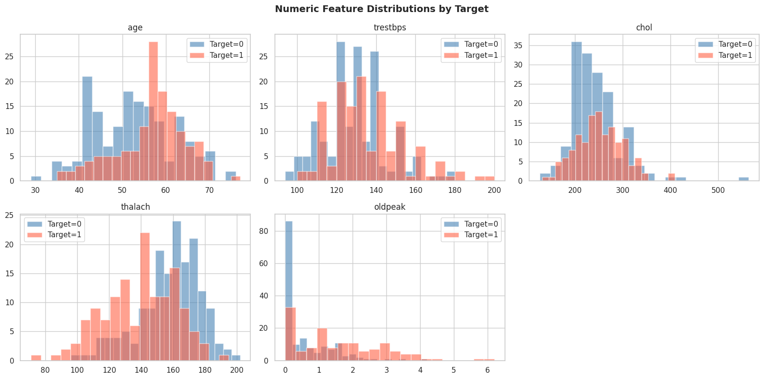

Numeric Feature Distributions by Target (age, trestbps, chol, thalach, oldpeak)
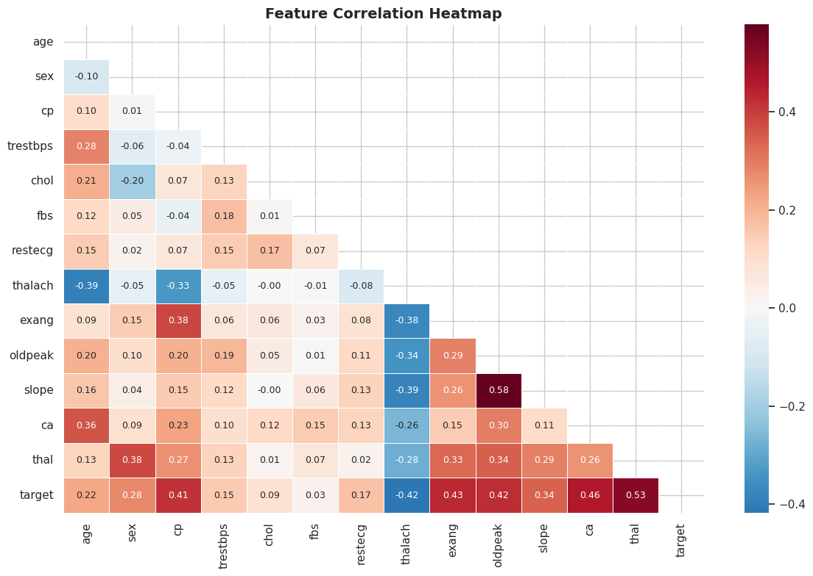

Feature Correlation Heatmap – thalach(-0.42), ca(+0.46), thal(+0.53) strongest with target

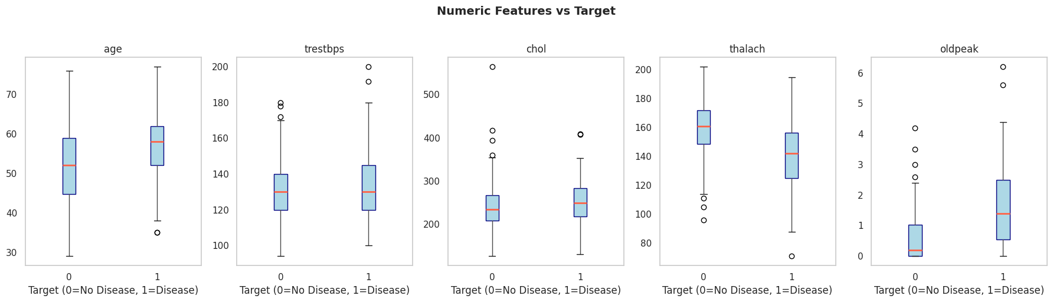

Numeric Features vs Target – thalach and oldpeak show clearest class separation
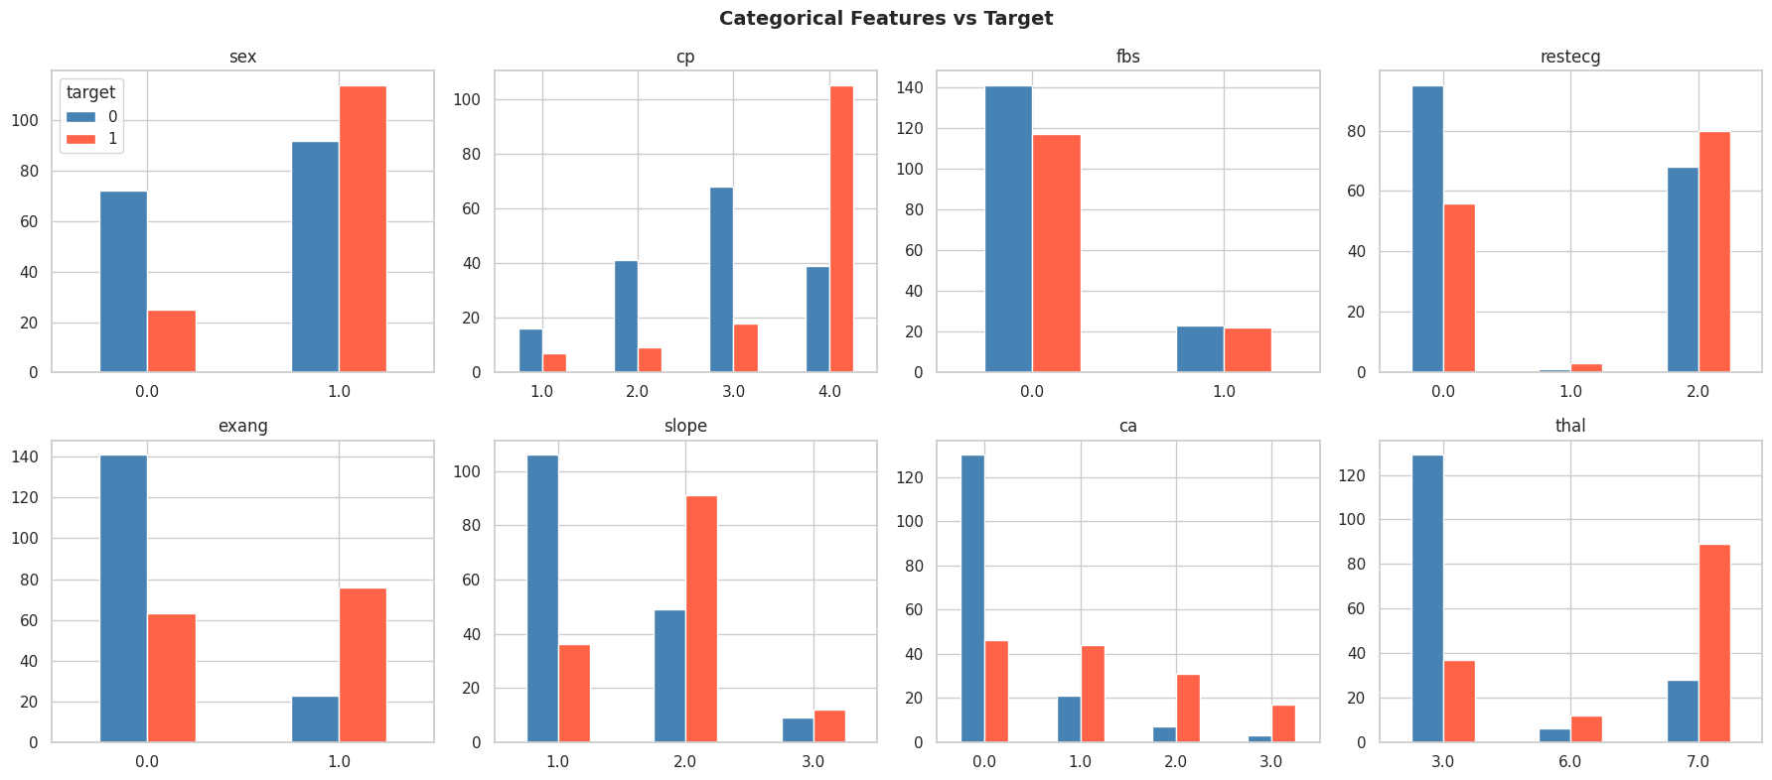

Categorical Features vs Target – cp, exang, thal, ca show strong class differences

3. Data Preprocessing

Preprocessing is encapsulated in a reusable sklearn Pipeline using ColumnTransformer (src/preprocess.py). This design eliminates training-serving skew: the identical transformation object is serialised alongside the model and loaded at inference time.
3.1 Pipeline Design
- Numeric features (age, trestbps, chol, thalach, oldpeak): median imputation → StandardScaler.
- Categorical features (sex, cp, fbs, restecg, exang, slope, ca, thal): mode imputation → OneHotEncoder (handle_unknown="ignore" for inference robustness).
- Train/test split: 80/20 stratified split (random_state=42) preserving class balance.
- The full sklearn Pipeline (preprocessor + classifier) serialised via joblib as models/best_model.joblib.
3.2 Code (src/preprocess.py)
numeric_features = ["age", "trestbps", "chol", "thalach", "oldpeak"]
categorical_features = ["sex","cp","fbs","restecg","exang","slope","ca","thal"]

numeric_transformer = Pipeline([
("imputer", SimpleImputer(strategy="median")),
("scaler", StandardScaler())])

categorical_transformer = Pipeline([
("imputer", SimpleImputer(strategy="most_frequent")),
("encoder", OneHotEncoder(handle_unknown="ignore"))])

preprocessor = ColumnTransformer([
("num", numeric_transformer, numeric_features),
("cat", categorical_transformer, categorical_features)])

4. Model Training & Experiment Tracking (MLflow)

Two classification models were trained with GridSearchCV hyperparameter tuning and tracked in MLflow under the experiment "heart-disease-classification". Training ran in Google Colab (src/train.py) with scikit-learn 1.6.1.
4.1 Logistic Regression
- Hyperparameters searched: C in {0.01, 0.1, 1, 10}, class_weight in {None, "balanced"}.
- 5-fold stratified cross-validation, scoring=ROC-AUC.
- Confusion matrix (test set): TN=28, FP=5, FN=2, TP=26.
4.2 Random Forest
- Hyperparameters searched: n_estimators in {100, 200}, max_depth in {None, 5, 10}, min_samples_split in {2, 5}.
- 5-fold stratified cross-validation, scoring=ROC-AUC.
- Confusion matrix (test set): TN=28, FP=5, FN=4, TP=24.
4.3 Confusion Matrices
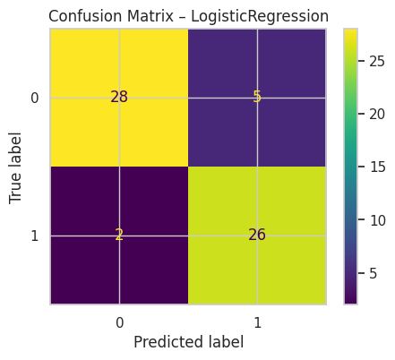

Confusion Matrix – Logistic Regression (TN=28, FP=5, FN=2, TP=26)

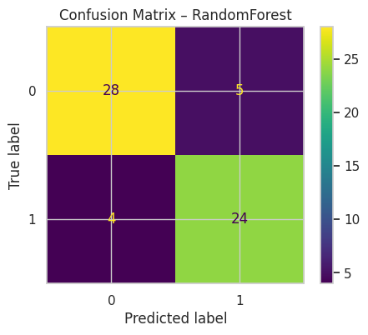

Confusion Matrix – Random Forest (TN=28, FP=5, FN=4, TP=24)
4.4 Results Comparison
Metric | Logistic Regression | Random Forest
Accuracy | 0.885 (54/61) | 0.852 (52/61)
Precision | 0.839 | 0.828
Recall | 0.929 | 0.857
F1-Score | 0.881 | 0.842
ROC-AUC | 0.9654 (WINNER) | 0.9470
Logistic Regression wins on all metrics. The trained sklearn Pipeline is saved as models/best_model.joblib.
4.5 MLflow Tracking

Figure: MLflow Experiment Runs – LogisticRegression (AUC 0.9654) vs RandomForest (AUC 0.9470)
- Experiment name: "heart-disease-classification".
- Logged per run: all hyperparameters, accuracy, precision, recall, F1, ROC-AUC.
- Artefacts logged: confusion matrix PNG, ROC curve PNG, serialised sklearn Pipeline.
- mlflow.sklearn.log_model() with skops_trusted_types for _RemainderColsList compatibility.

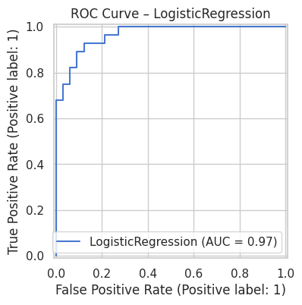
MLflow – Experiment runs comparing LR (AUC 0.9654) vs RF (AUC 0.9470)

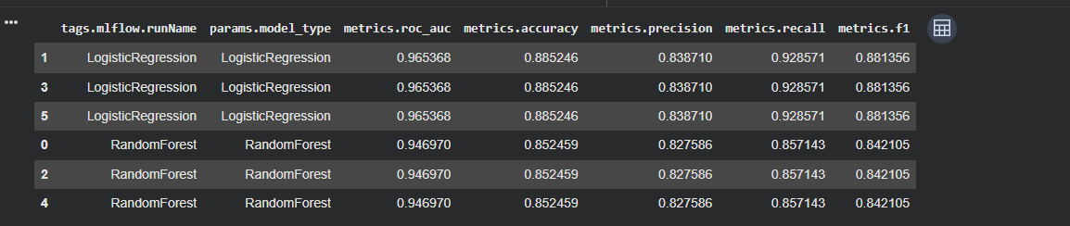

MLflow – Best run details: parameters, metrics, artefacts

5. API Development (FastAPI)

The inference service (src/app.py) is built with FastAPI and Uvicorn. The full sklearn Pipeline (preprocessor + model) is loaded at startup, eliminating training-serving skew.
5.1 Endpoints
Endpoint | Method | Description
GET /health | GET | Liveness/readiness probe. Returns {"status":"healthy","model_version":"1.0.0"}
POST /predict | POST | Accepts 13-feature JSON. Returns prediction (0/1), label, and confidence score.
GET /metrics | GET | Prometheus-format metrics scraped by kube-prometheus-stack.
5.2 Sample Request & Response
Request (from Azure Cloud Shell):
curl -X POST http://172.210.109.108/predict \
-H "Content-Type: application/json" \
-d '{"age":63,"sex":1,"cp":3,"trestbps":145,"chol":233,
"fbs":1,"restecg":0,"thalach":150,"exang":0,
"oldpeak":2.3,"slope":0,"ca":0,"thal":1}'
Response:
{
"prediction": 0,
"label": "No Heart Disease",
"confidence": 0.2958,
"model_version": "1.0.0"
}


FastAPI /predict endpoint test – successful JSON response

6. Containerisation with Docker

A multi-stage Dockerfile packages the inference service, serialised model, and all Python dependencies into a minimal production image (python:3.11-slim).
6.1 Dockerfile (Multi-Stage)
# Stage 1 – build dependencies
FROM python:3.11-slim AS builder
WORKDIR /app
COPY requirements.txt .
RUN pip install --no-cache-dir -r requirements.txt

# Stage 2 – slim runtime image
FROM python:3.11-slim
WORKDIR /app
COPY --from=builder /usr/local/lib/python3.11/site-packages \
/usr/local/lib/python3.11/site-packages
COPY src/ ./src/
COPY models/ ./models/
ENV MODEL_PATH=./models/best_model.joblib
EXPOSE 8000
CMD ["uvicorn","src.app:app","--host","0.0.0.0","--port","8000"]
6.2 Build, Test & Push
- docker build -t heart-disease-api:latest .
- docker run -p 8000:8000 heart-disease-api:latest
- Smoke test: curl http://localhost:8000/predict — confirmed JSON response.
- docker push paragmlopsacr.azurecr.io/heart-disease-api:latest — digest confirmed in ACR.

[ Docker build completed successfully ]

[ Docker image pushed to Azure Container Registry with digest ]
6.2 Local Docker Testing
The Docker image was built and run locally using Docker Desktop on Windows. The multi-stage build completed successfully (13/13 steps) and the container started with the model loaded, serving predictions on http://localhost:8000. Health checks returned HTTP 200 OK confirming the API was live.
docker build -t heart-disease-api:latest .
docker run -p 8000:8000 heart-disease-api:latest

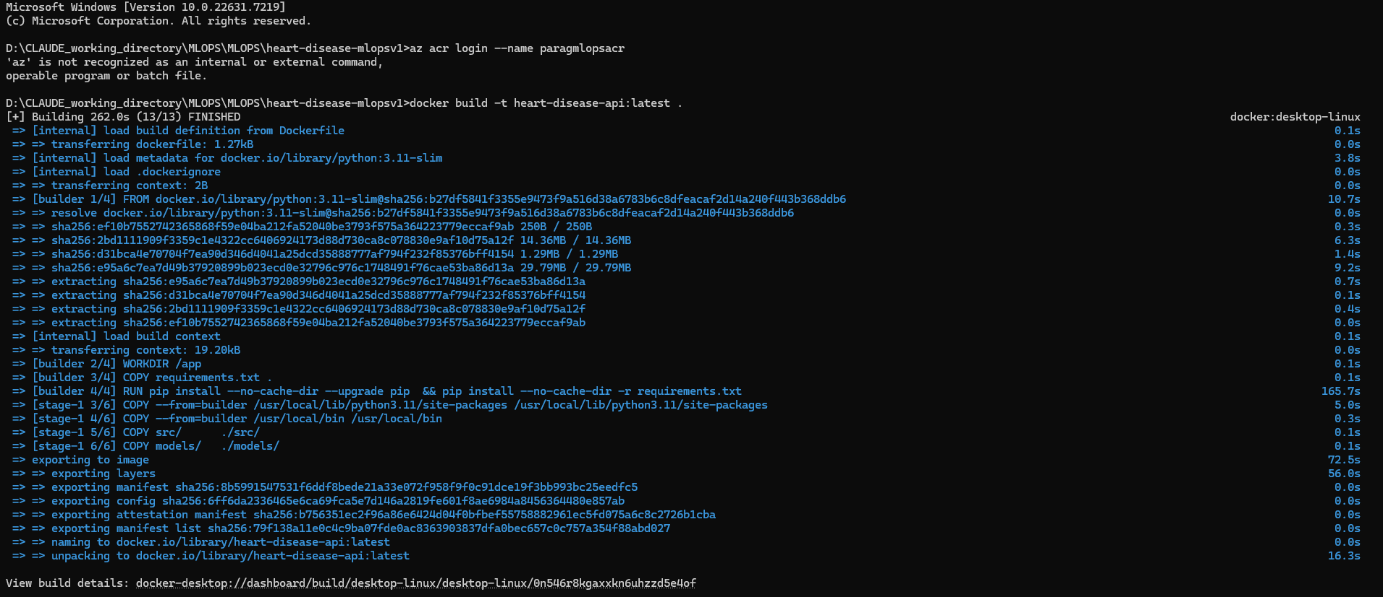
Docker build 13/13 FINISHED
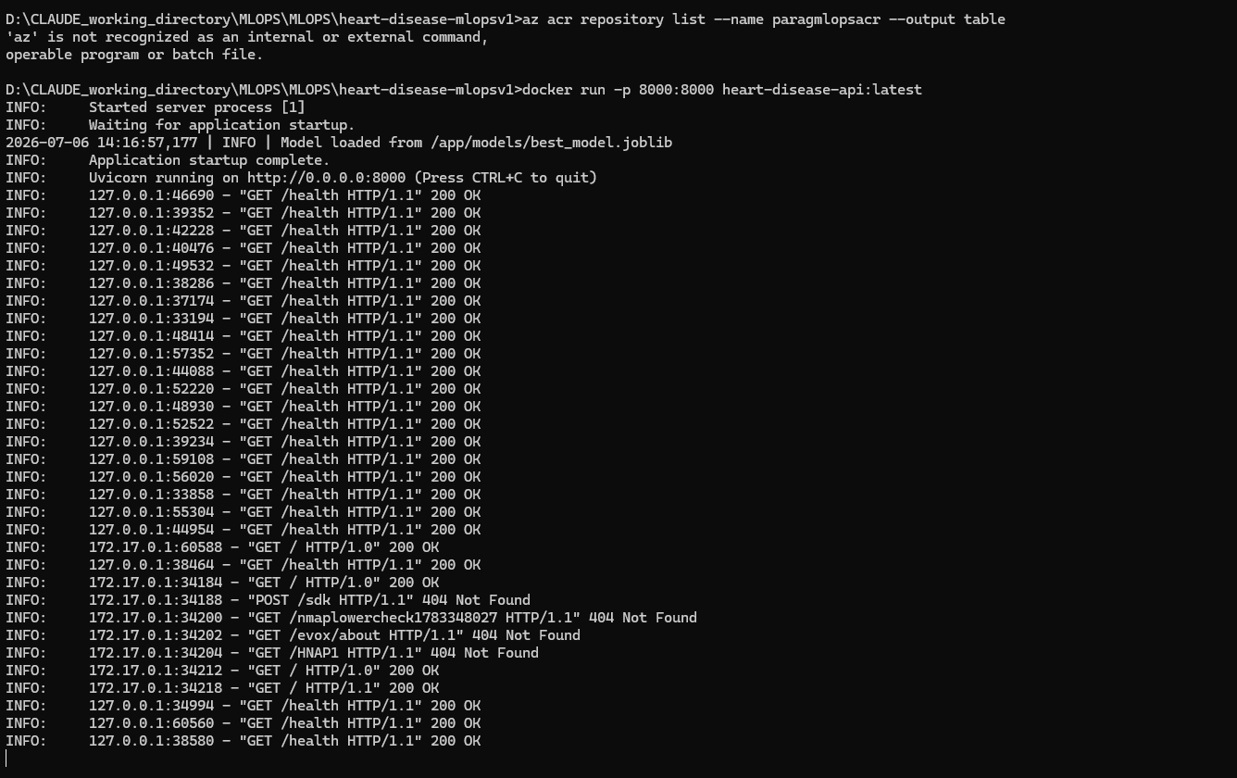
Docker container running — model loaded, Uvicorn on 0.0.0.0:8000, GET /health 200 OK

7. CI/CD Pipeline (GitHub Actions)

The CI/CD pipeline (.github/workflows/ci.yml) runs automatically on every push to the main branch. Three sequential jobs must all pass before the Docker image is published to Azure Container Registry.
Job 1 – Lint + Unit Tests
- Runs flake8 for PEP-8 compliance.
- Executes pytest unit tests (tests/test_app.py).
- Pipeline halts if linting or tests fail.
Job 2 – Model Training Validation
- Downloads UCI dataset, runs src/train.py.
- Verifies models/best_model.joblib is non-zero.
- Uploads artefact for Job 3.
Job 3 – Docker Build Validation
- Builds Docker image, runs smoke test on /predict.
- Logs in to ACR (GitHub Secrets).
- Pushes image to paragmlopsacr.azurecr.io (main branch only).
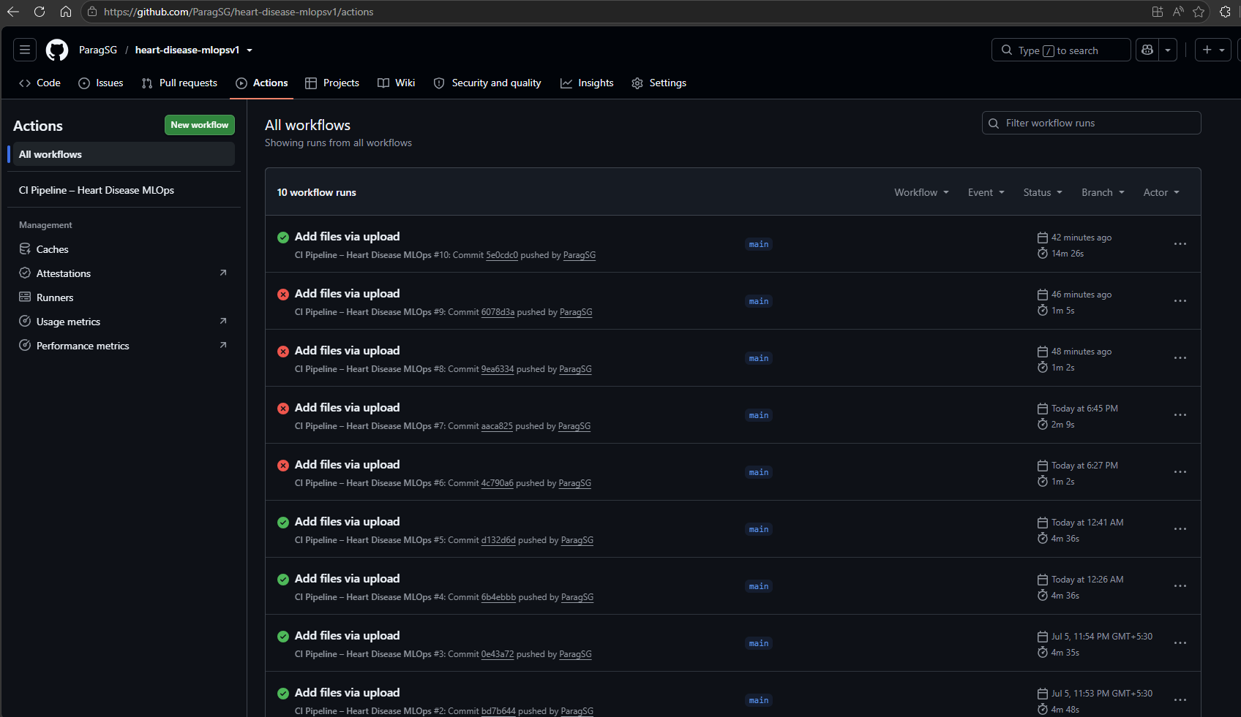
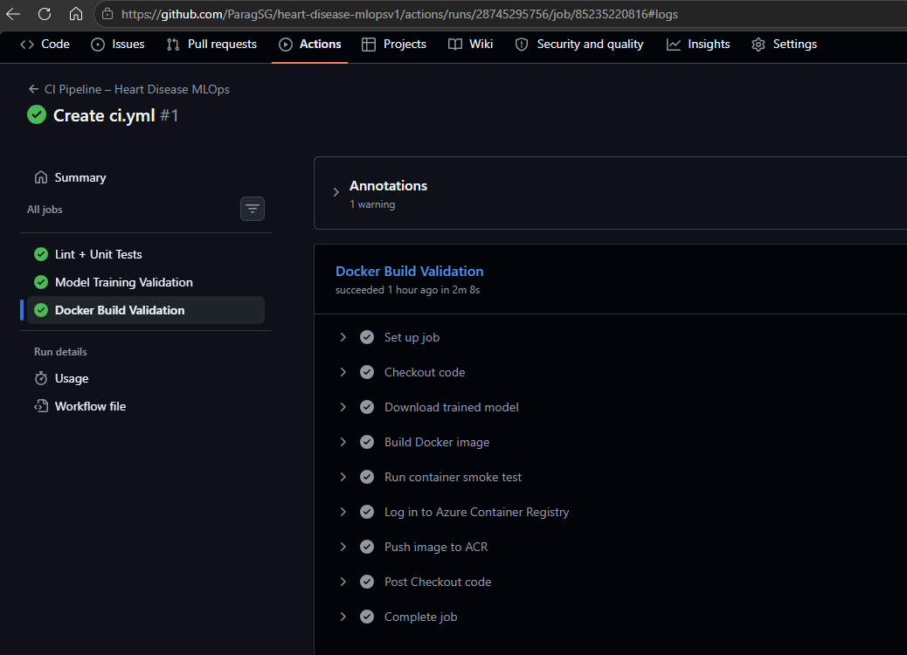
8. Kubernetes Deployment (Azure AKS)

The containerised API is deployed to Azure Kubernetes Service (AKS) in East US. Two replicas provide high availability with health probes and a LoadBalancer Service for public access.
8.1 Infrastructure
Resource | Value
Resource Group | mlops-rg
AKS Cluster | mlops-aks (East US, Standard_D2ds_v7)
Container Registry | paragmlopsacr.azurecr.io
Replicas | 2
Service Type | LoadBalancer
External IP | 172.210.109.108 (port 80 -> 8000)
8.2 Key Configuration
- Liveness probe: GET /health, initialDelaySeconds=30, periodSeconds=10.
- Readiness probe: GET /health, initialDelaySeconds=15, periodSeconds=5.
- Rolling update: maxUnavailable=0, maxSurge=1 (zero-downtime deploys).
8.3 Verification
- kubectl get pods -n default → 2/2 Running, 0 Restarts.
- kubectl get svc → External-IP: 172.210.109.108.
- curl http://172.210.109.108/predict → {"prediction":0,"label":"No Heart Disease","confidence":0.2958}


AKS – kubectl get pods showing 2 Running heart-disease-api pods

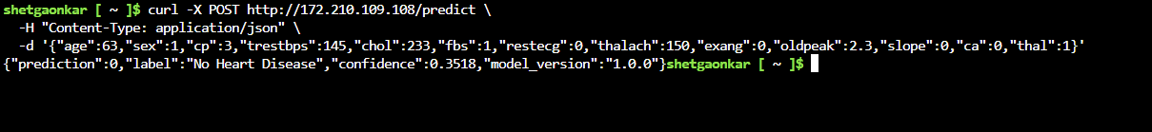
AKS – curl /predict from Cloud Shell returning successful JSON

9. Monitoring – Prometheus & Grafana

Observability is implemented using the kube-prometheus-stack Helm chart deployed to the monitoring namespace on AKS. The FastAPI /metrics endpoint is instrumented with prometheus-fastapi-instrumentator; Prometheus scrapes it automatically.
9.1 Deployment
- Helm 3.21.2 installed to ~/.local/bin in Azure Cloud Shell.
- helm repo add prometheus-community https://prometheus-community.github.io/helm-charts
- helm install monitoring prometheus-community/kube-prometheus-stack --namespace monitoring --create-namespace --set grafana.adminPassword=MLOps@2026
- All 6 monitoring pods confirmed Running.
- Grafana LoadBalancer External IP: 20.75.254.127 — accessed at http://20.75.254.127 (admin / MLOps@2026).
9.2 Observed Metrics
Metric | Observed Value
http_requests_total (GET /) | 1 (status 2xx)
process_resident_memory_bytes | 221 MB
process_cpu_seconds_total | 3.81 CPU-seconds
python_info | CPython 3.11.15
Pod CPU Usage | 0.000533 cores (idle)
Pod Memory (WSS) | 134 MiB (RSS 128 MiB, Cache 5.99 MiB)
Receive Bandwidth | 82.7 b/s
Transmit Bandwidth | 75.0 b/s

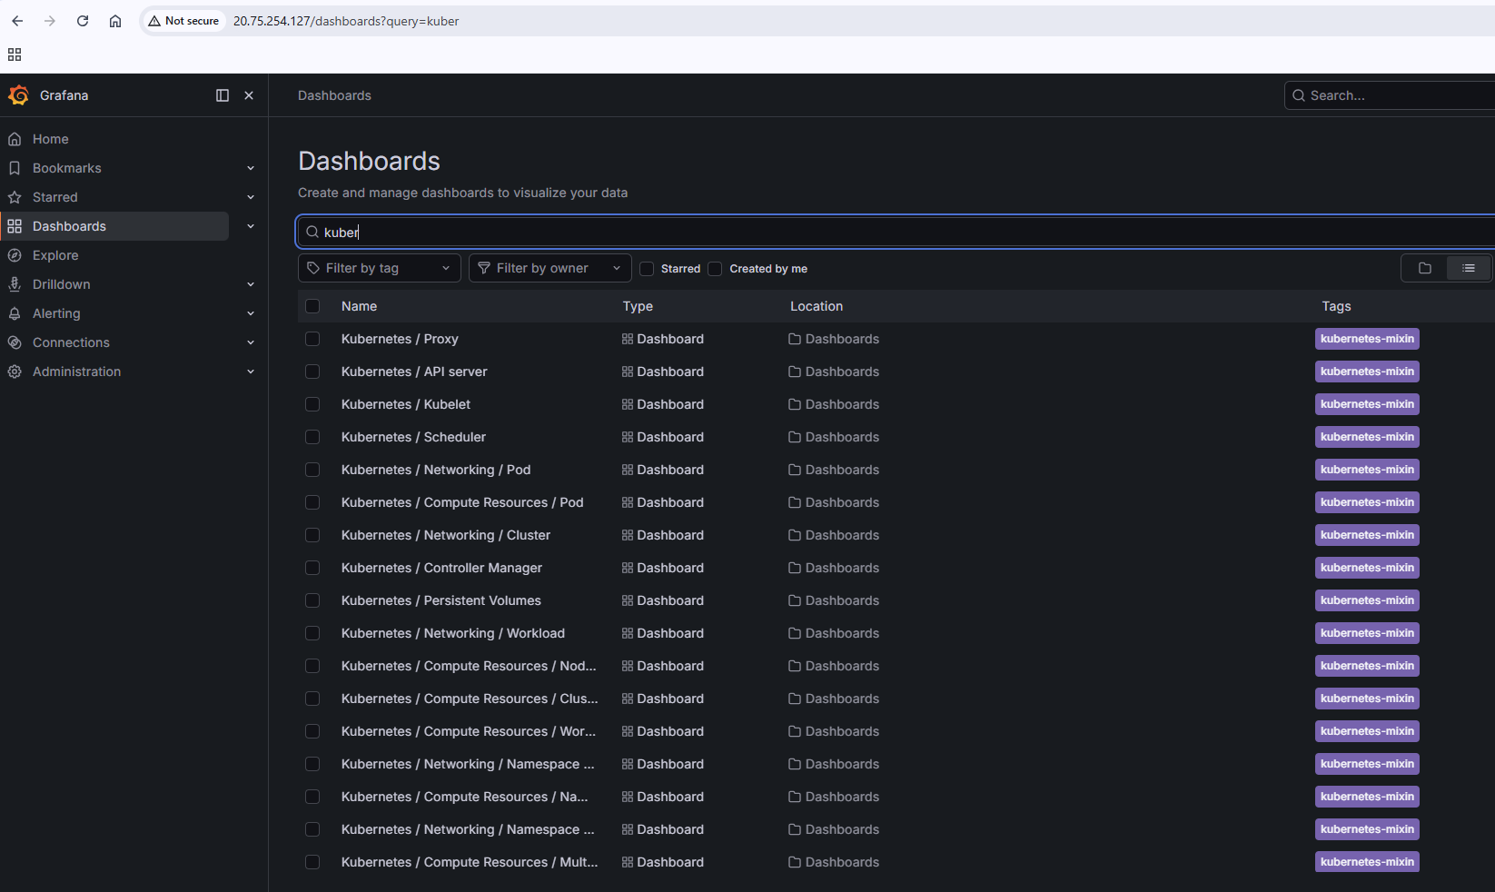

Grafana – 18 pre-built Kubernetes dashboards (kube-prometheus-stack)
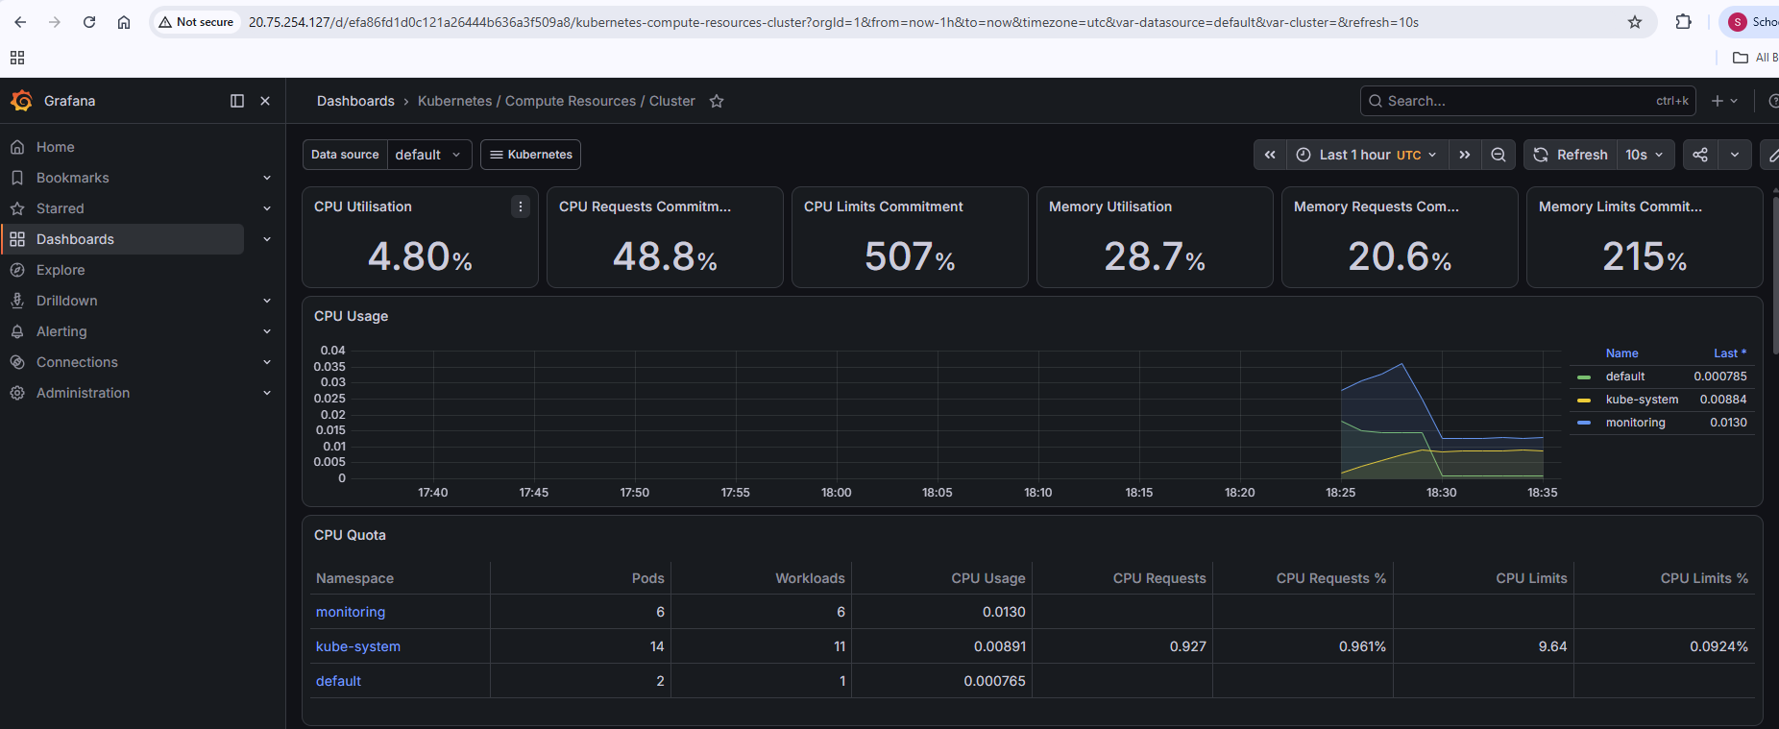

Grafana – CPU Usage for heart-disease-api pod (0.000533 cores)

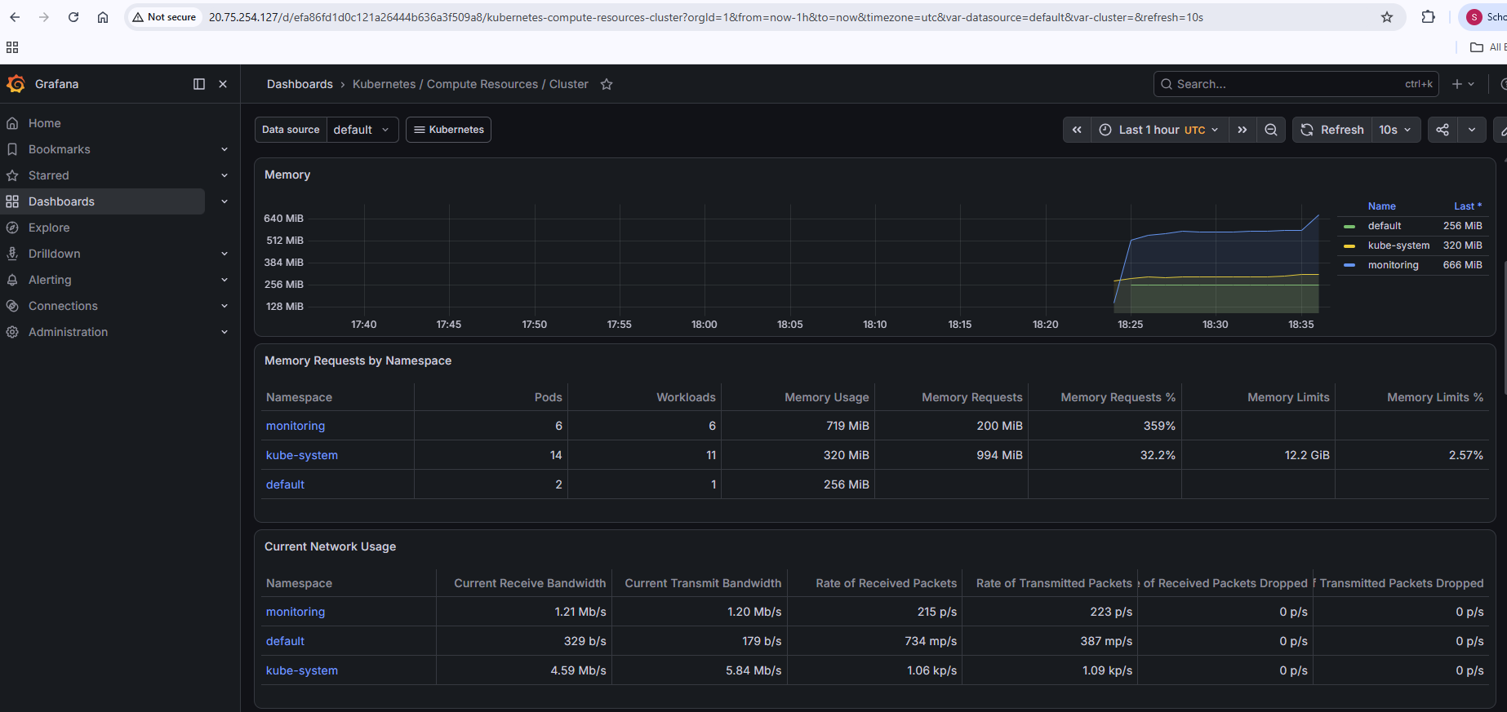
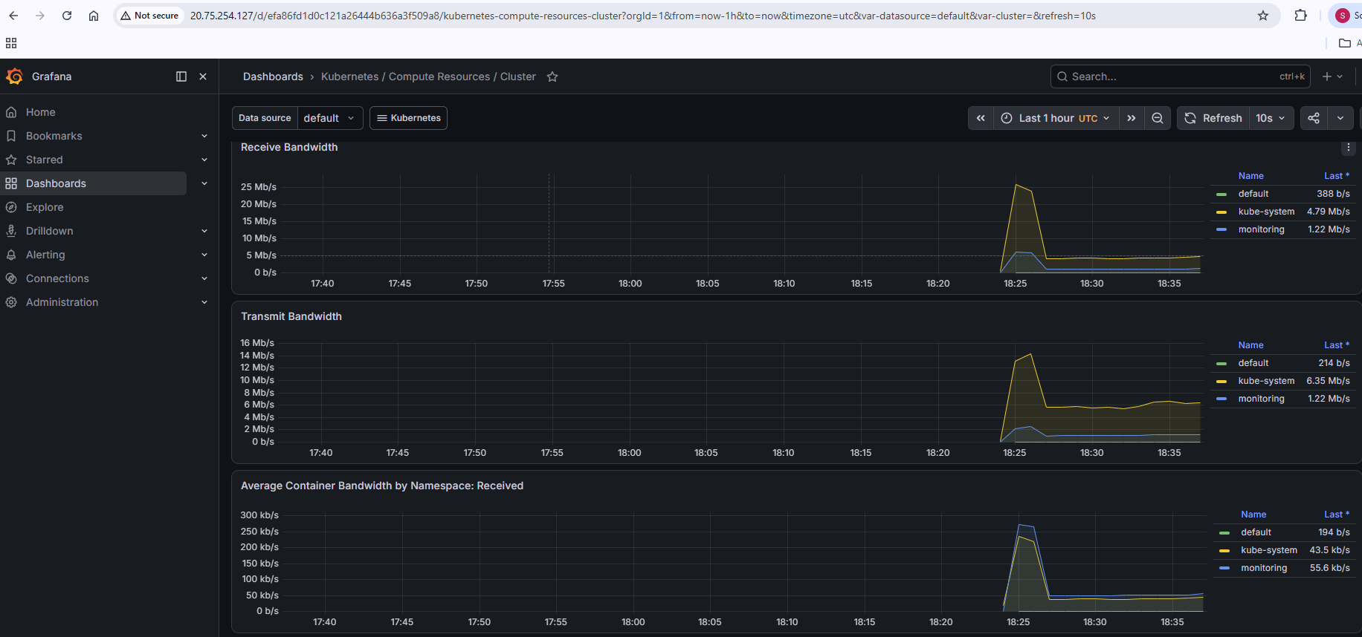
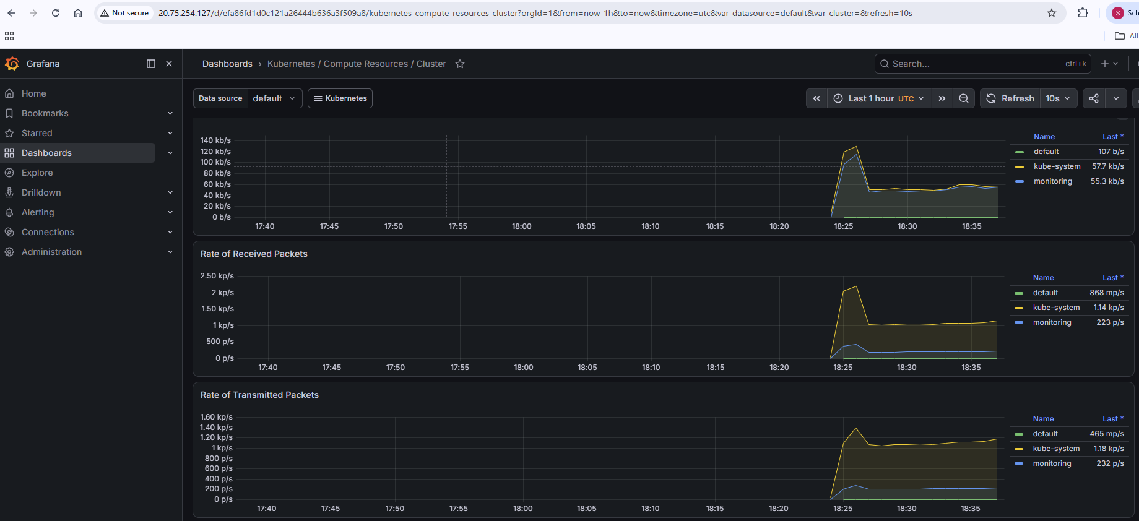

Grafana – Memory Usage + Receive/Transmit Bandwidth

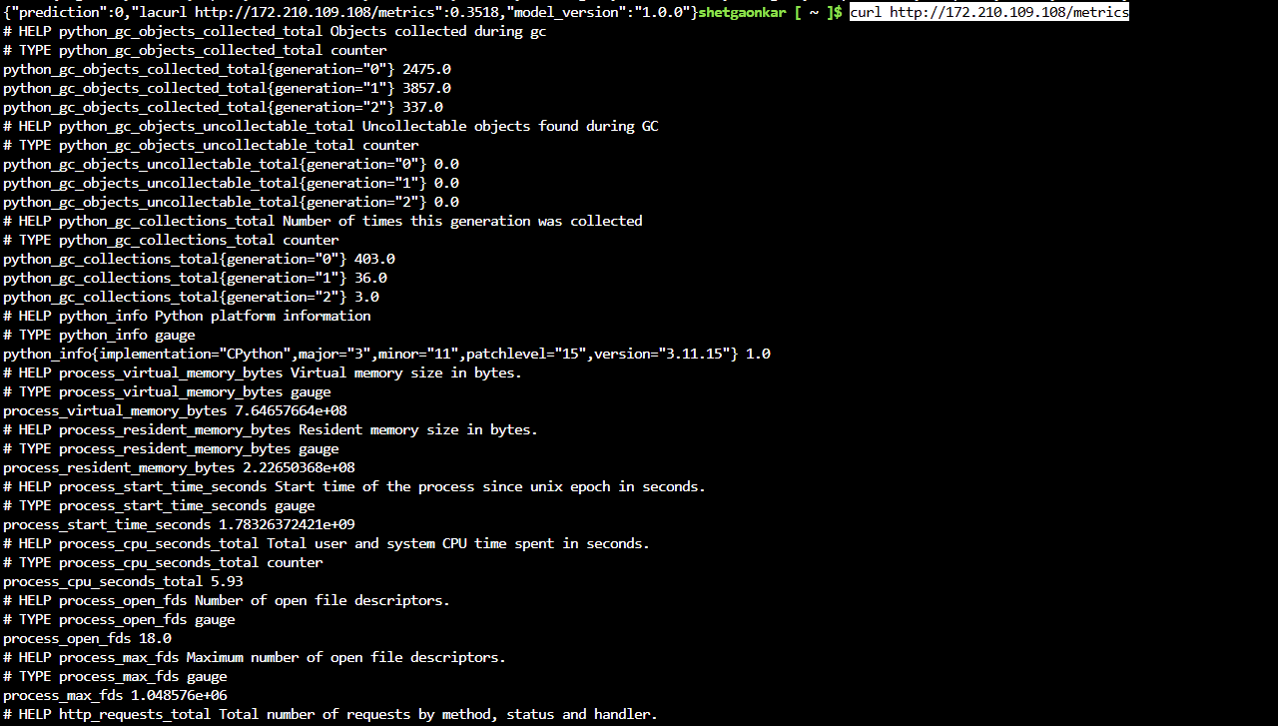
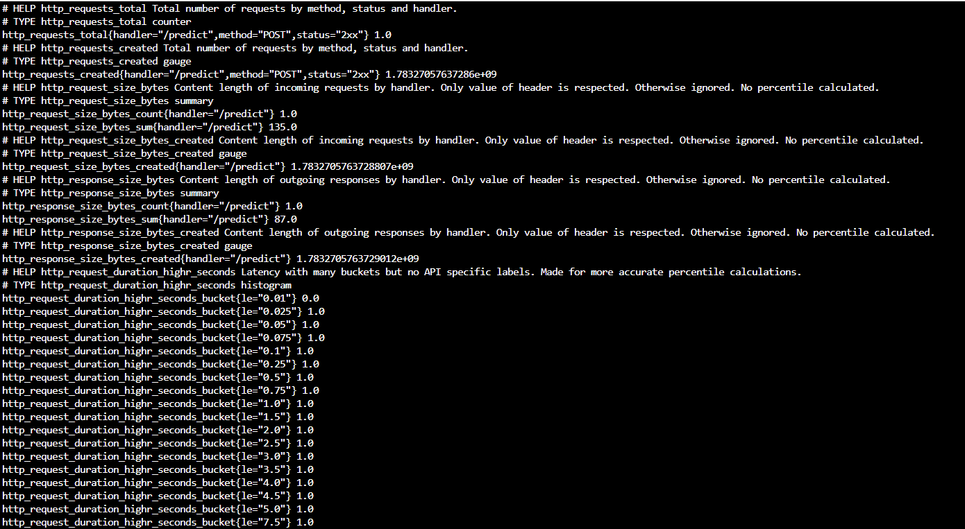
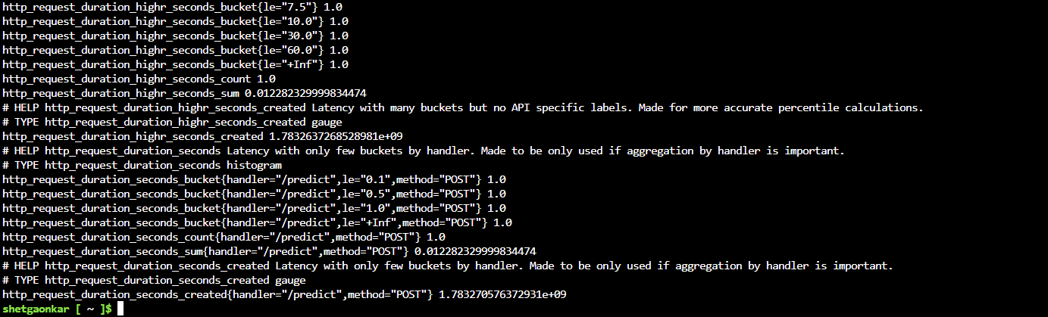

Prometheus /metrics output from FastAPI (http_requests_total, process_memory, python_info)

10. Architecture Overview

The diagram below shows the full end-to-end MLOps pipeline from data ingestion to live monitoring.

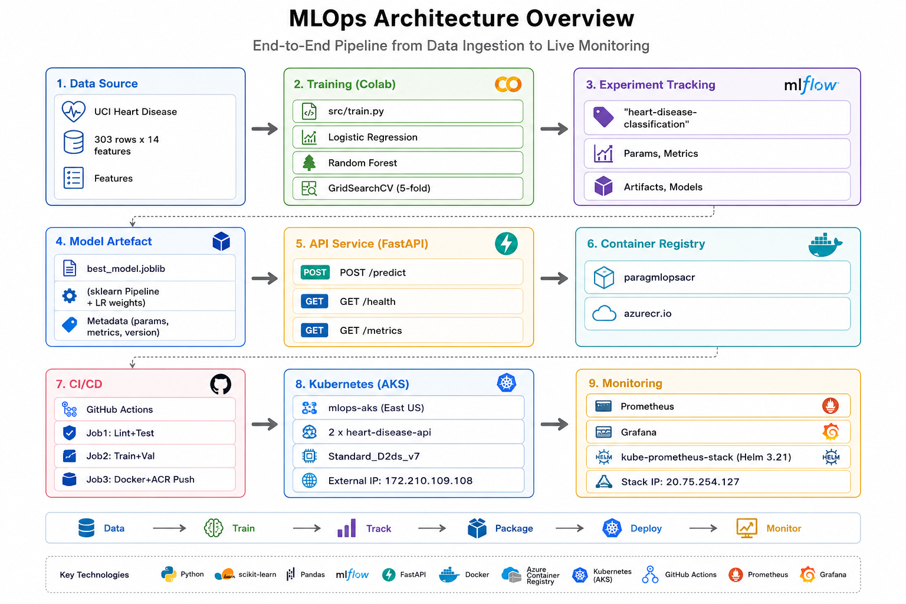

11. Setup & Reproduction Instructions

11.1 Prerequisites
- Python 3.11+
- Docker Desktop
- Azure CLI (az) with active subscription
- kubectl configured to AKS
- Helm 3.x
- Git + GitHub account
11.2 Local Development
Clone:
git clone https://github.com/ParagSG/heart-disease-mlopsv1.git
Install:
pip install -r requirements.txt
Train:
python src/train.py
Serve:
uvicorn src.app:app --host 0.0.0.0 --port 8000
11.3 Docker
docker build -t heart-disease-api:latest .
docker run -p 8000:8000 heart-disease-api:latest
docker push paragmlopsacr.azurecr.io/heart-disease-api:latest
11.4 AKS Deployment
az aks get-credentials --resource-group mlops-rg --name mlops-aks
kubectl apply -f k8s/deployment.yaml
kubectl apply -f k8s/service.yaml
kubectl get svc # wait for EXTERNAL-IP
11.5 Monitoring
helm repo add prometheus-community https://prometheus-community.github.io/helm-charts
helm install monitoring prometheus-community/kube-prometheus-stack \
--namespace monitoring --create-namespace \
--set grafana.adminPassword=MLOps@2026
kubectl patch svc monitoring-grafana -n monitoring --type=json \
-p='[{"op":"replace","path":"/spec/type","value":"LoadBalancer"}]'

12. Conclusion

This assignment demonstrates a complete, production-ready MLOps pipeline applied to a medical classification problem. From raw CSV data through structured EDA, reproducible preprocessing via sklearn pipelines, rigorous model training tracked in MLflow, containerised serving with FastAPI and Docker, automated CI/CD with GitHub Actions, and live deployment on Azure AKS with Prometheus/Grafana observability — every stage follows industry best practices.
The Logistic Regression model achieved a ROC-AUC of 0.9654 on the test set. The entire pipeline from a code push to a deployed, monitored API is fully automated and reproducible.
Key MLOps principles demonstrated: experiment reproducibility (MLflow), no training-serving skew (sklearn Pipeline), infrastructure as code (Kubernetes YAML + Helm), automated quality gates (GitHub Actions), and production observability (Prometheus + Grafana).
GitHub Repository
Repository URL: https://github.com/ParagSG/heart-disease-mlopsv1

BITS Pilani WILP | AIMLCZG523 MLOps | Assignment 01 | Parag Shetgaonkar (2024AC05220) | July 2026

