MH-29-TC-428

IMRAN SOHIL

05/10/2022 12:37:03

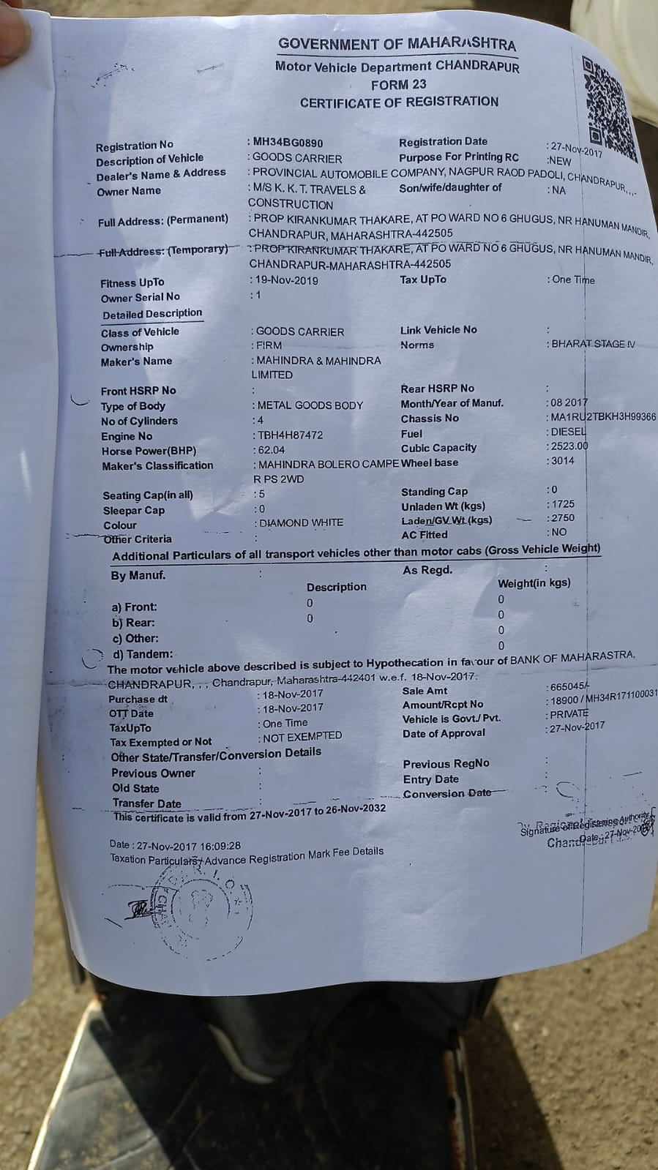

05/10/2022 12:37:03

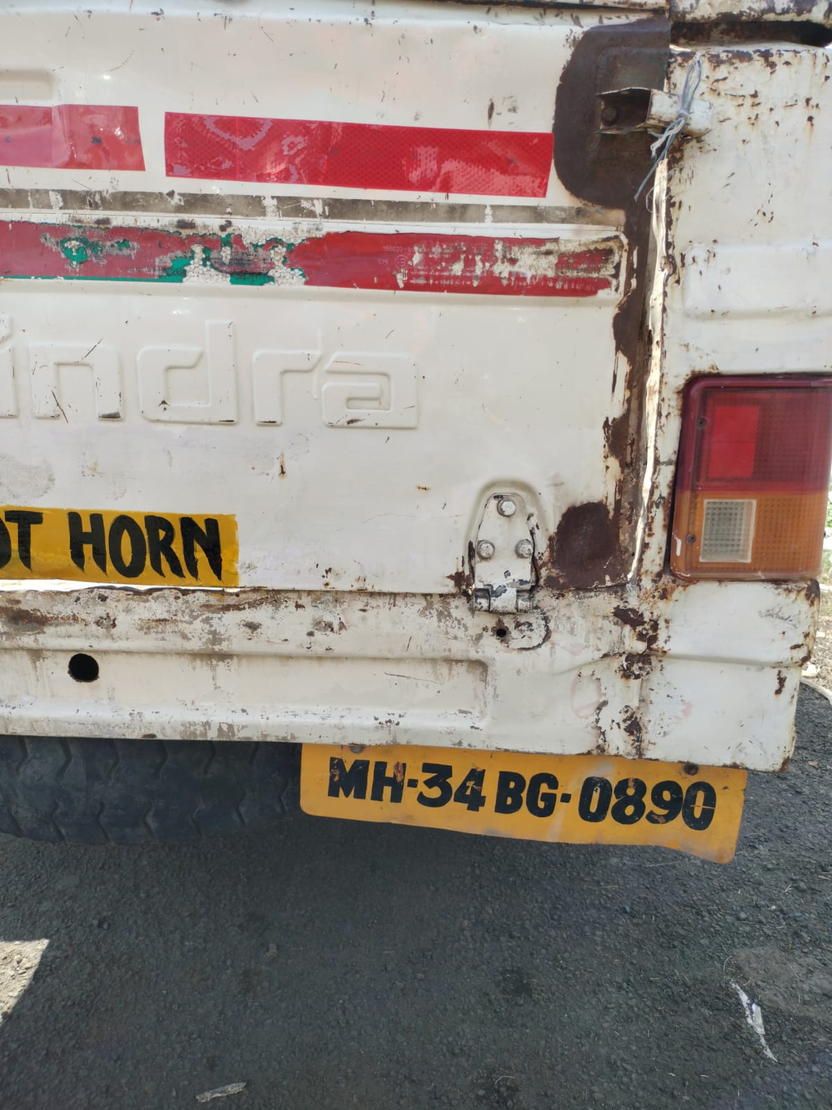

05/10/2022 12:37:03

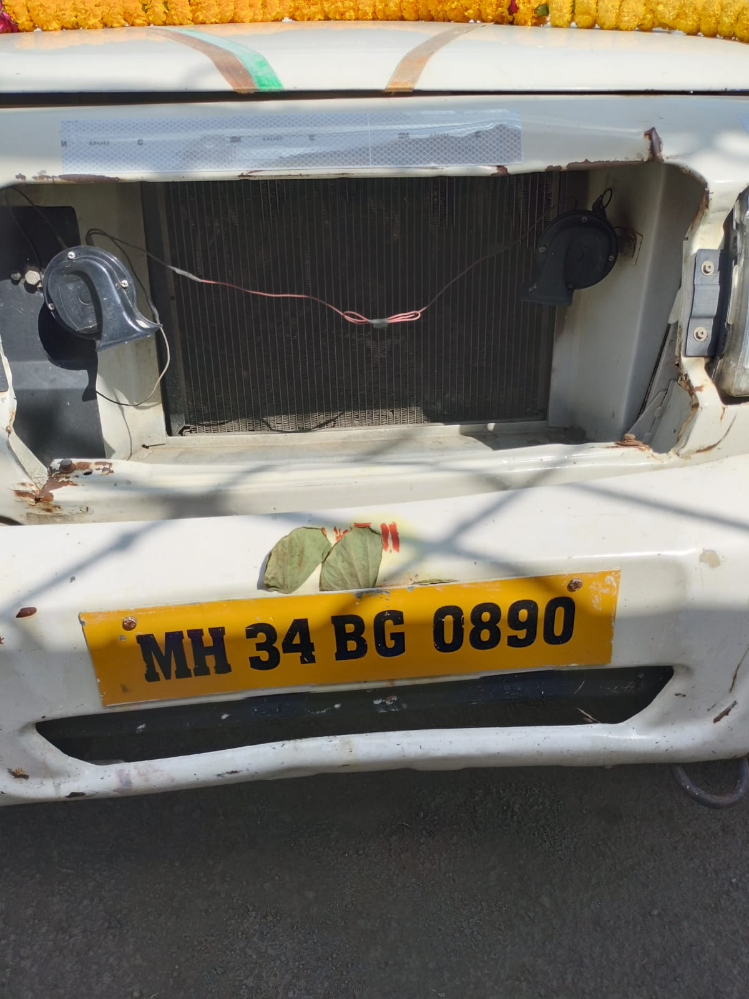



**06/10/2022**

**MH343M366CT7VK10D421OXT8W6**

**SHL/16/2021-2022/2624114044/COP/3716**



**Installation Certificate**

COP:

COP Valid Till:

**30-09-2022**

Certificate No:

**MH34-BG-0890**

Creation Date:

Valid From:

Valid Till:

**06/10/2022**

**05/10/2023**

Application Details

Product Name

Quantity

**CT**

**1**

**Reflectors**

**4**

Vehicle Details

Owner Name

Vehicle Make

Vehicle Model

**K. K. T. TRAVELS CONSTRUCTION**

**MAHINDRA MAHINDRA LTD**

**LCV**

Chassis Number

Mobile Number

Year of Manufacturing

**9366**

**9999999999**

**2017**

Images

FRONT LEFT IMAGE

BACK RIGHT IMAGE

DOCUMENT IMAGE

Dealer Details

Dealer Name:

Trade Lic. No.:

RTO Location

**MH40**

Declaration

We hereby certify that we have supplied/installed the ARAI approved RRT as per the CMVR rule no 104/104D specified under CMVR GSR

784 (

E) 291 (E

).