**MH27BX6928**

MH-16-TC-218

IMRAN SOHIL

04/10/2022 12:37:03

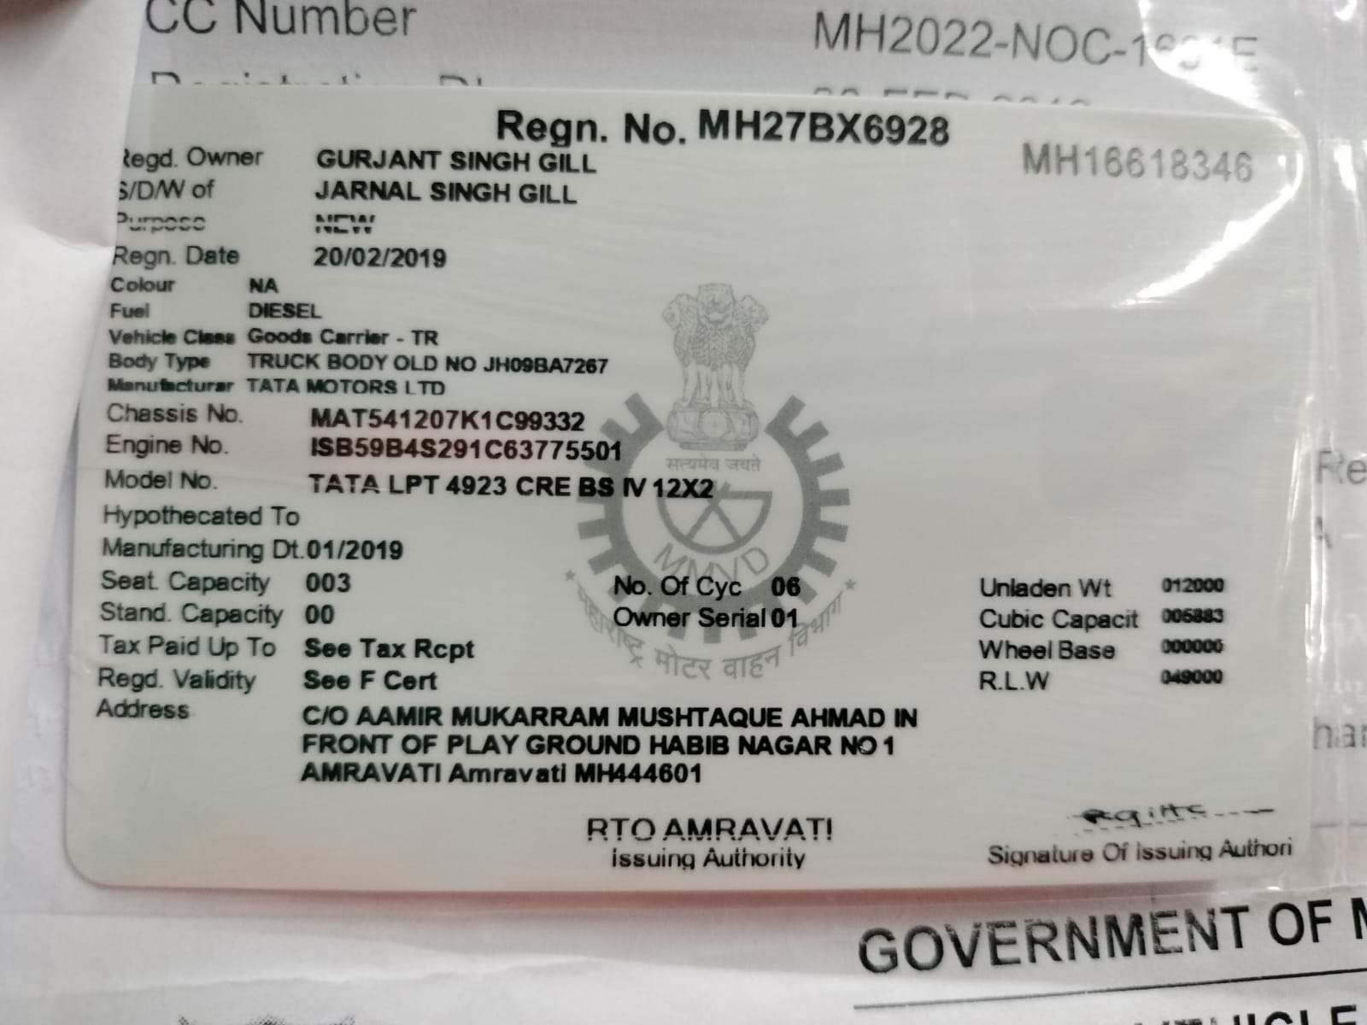

04/10/2022 12:37:03

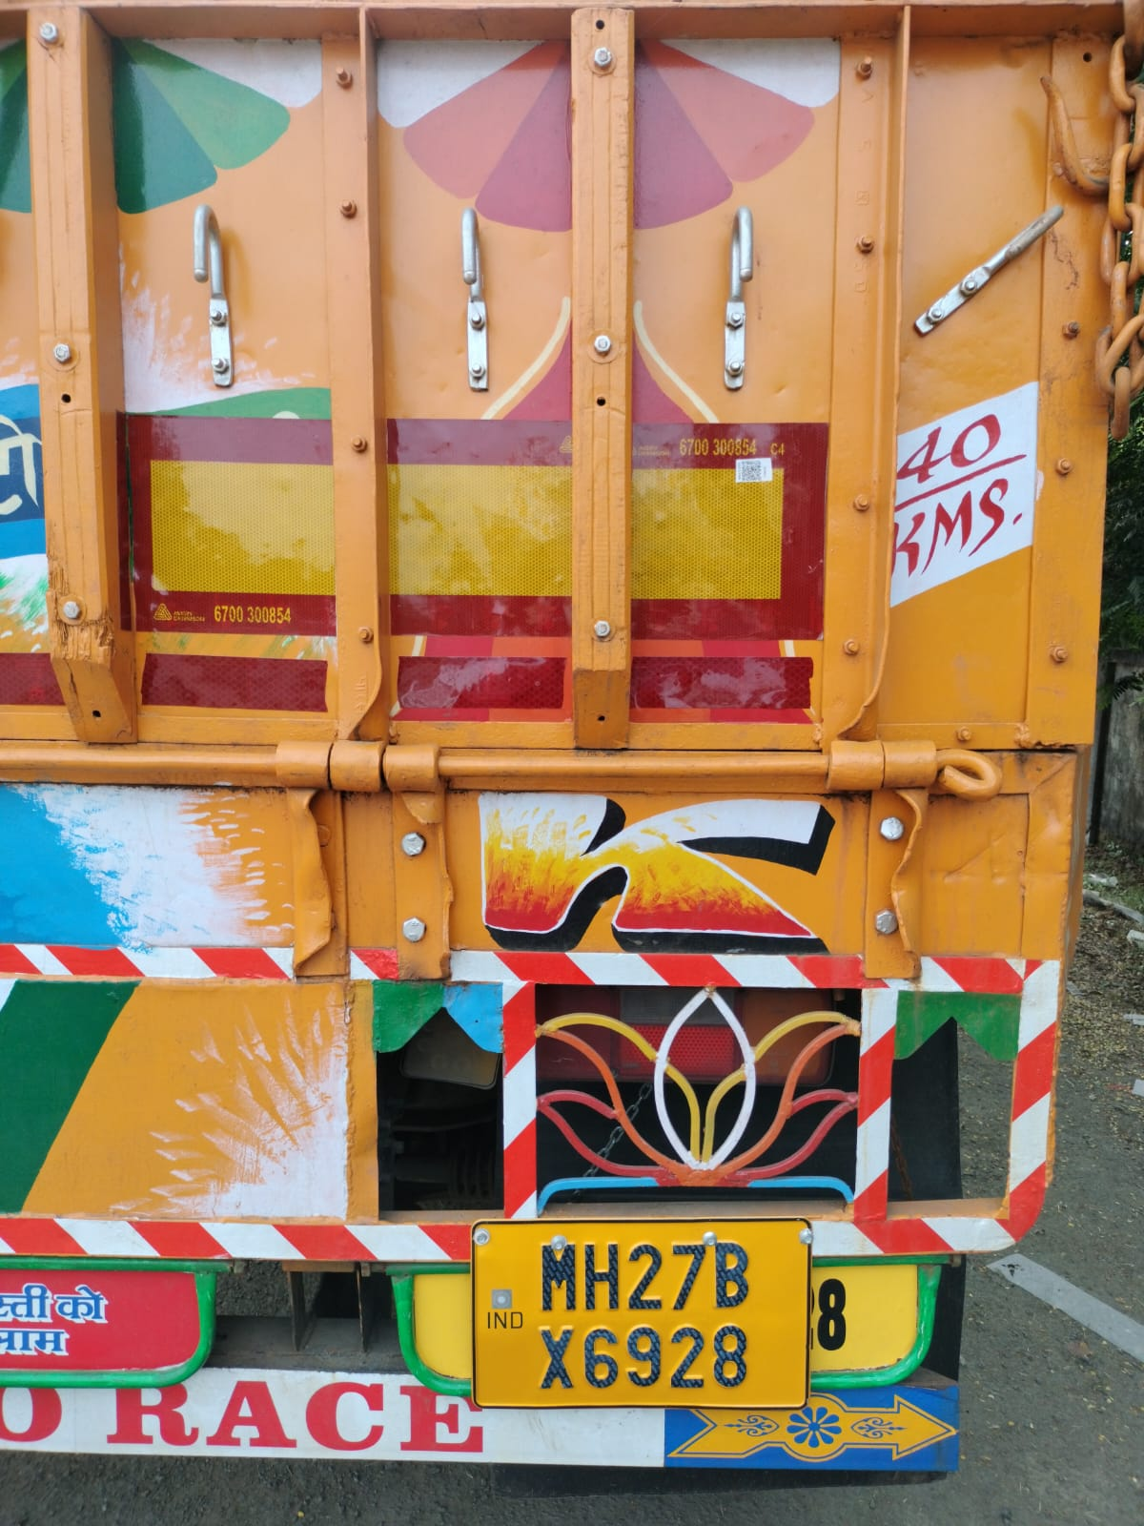

04/10/2022 12:37:03



**HCV**





**Installation Certificate**

COP:

**SHL/16/2021-2022/3659174597/COP/4583**

COP Valid Till:

**30-09-2023**

Certificate No:

**MH27AVERY779C4P90HG8XGN1PBPTN**

Creation Date:

Valid From:

Valid Till:

**04/10/2022**

**04/10/2022**

**03/10/2023**

Application Details

Product Name

Quantity

**C4**

**1**

**Reflectors**

**4**

Vehicle Details

Owner Name

Vehicle Make

Vehicle Model

**GURJANT GILL**

**TATA MOTORS LTD**

Chassis Number

Mobile Number

Year of Manufacturing

**9332**

**9999999999**

**2019**

Images

FRONT LEFT IMAGE

BACK RIGHT IMAGE

DOCUMENT IMAGE

Dealer Details

Dealer Name:

Trade Lic. No.:

RTO Location

**MH40**

Declaration

We hereby certify that we have supplied/installed the ARAI approved RRT as per the CMVR rule no 104/104D specified under CMVR GSR

784 (

E) 291 (E

).