MH-16-TC-218

IMRAN SOHIL

07/10/2022 12:37:03

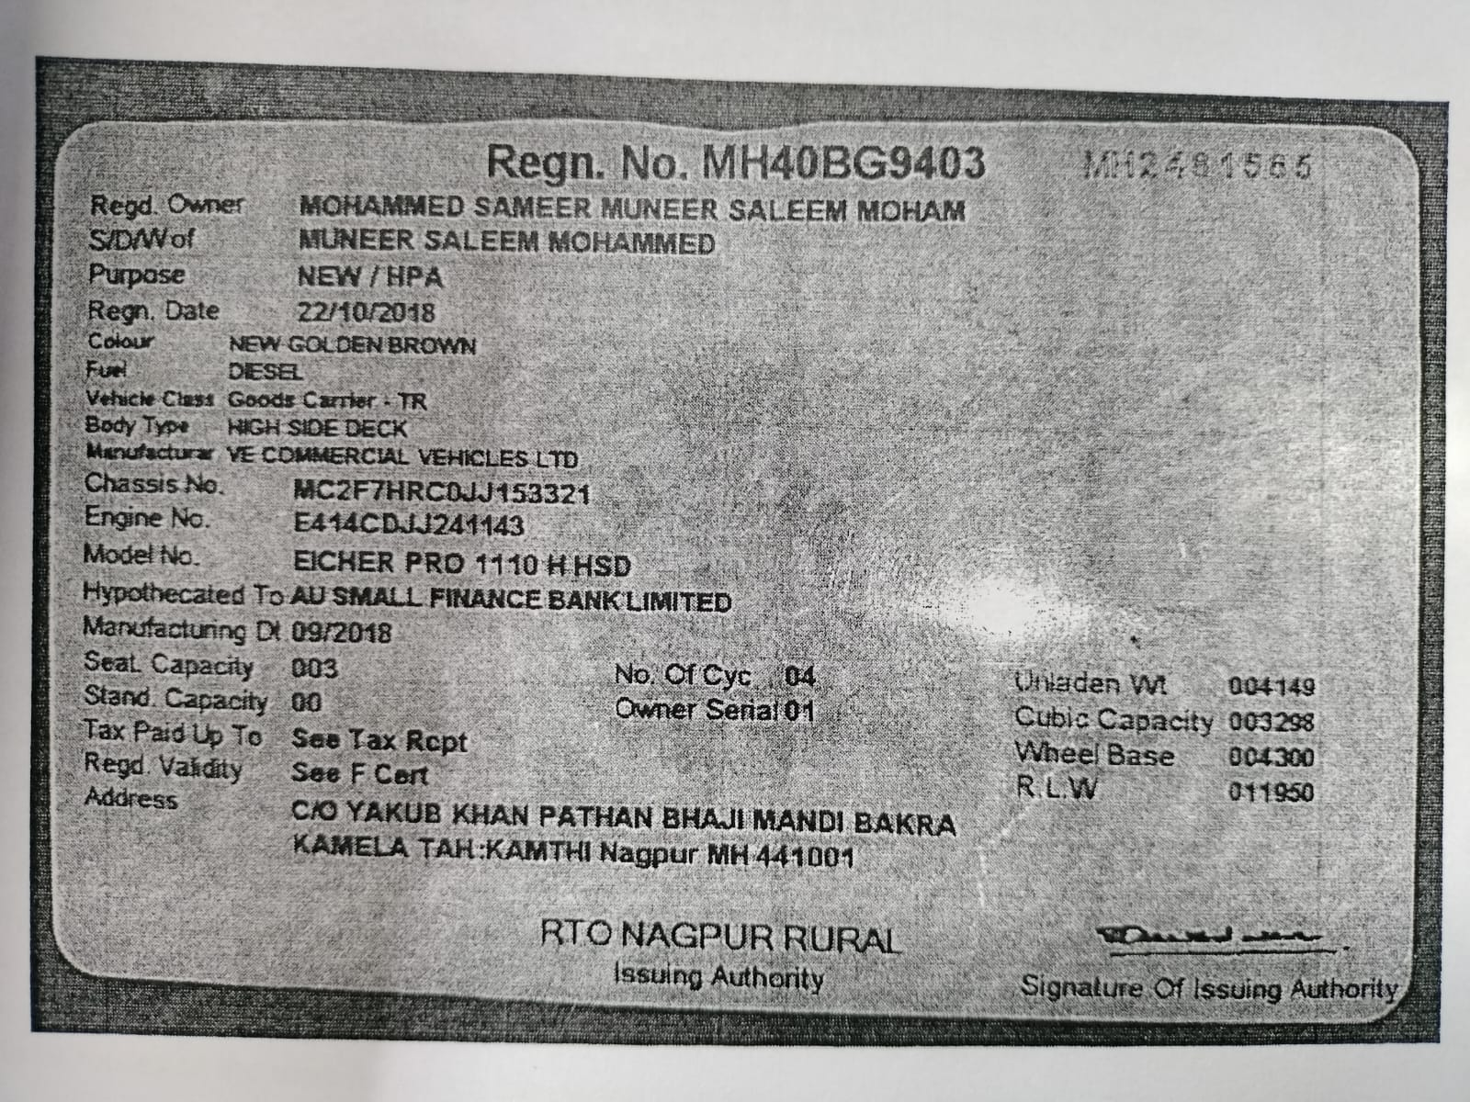

07/10/2022 12:37:03

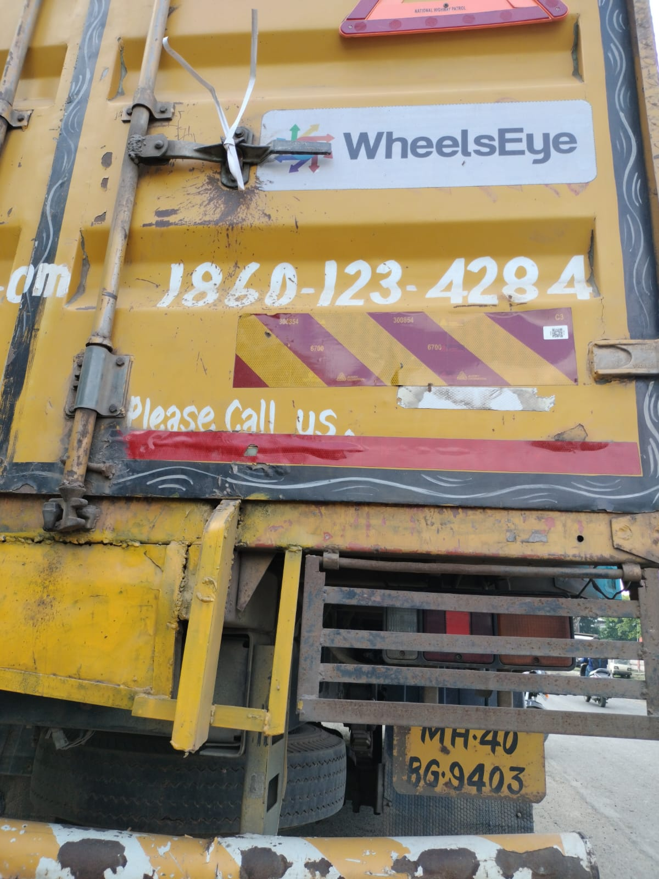

07/10/2022 12:37:03

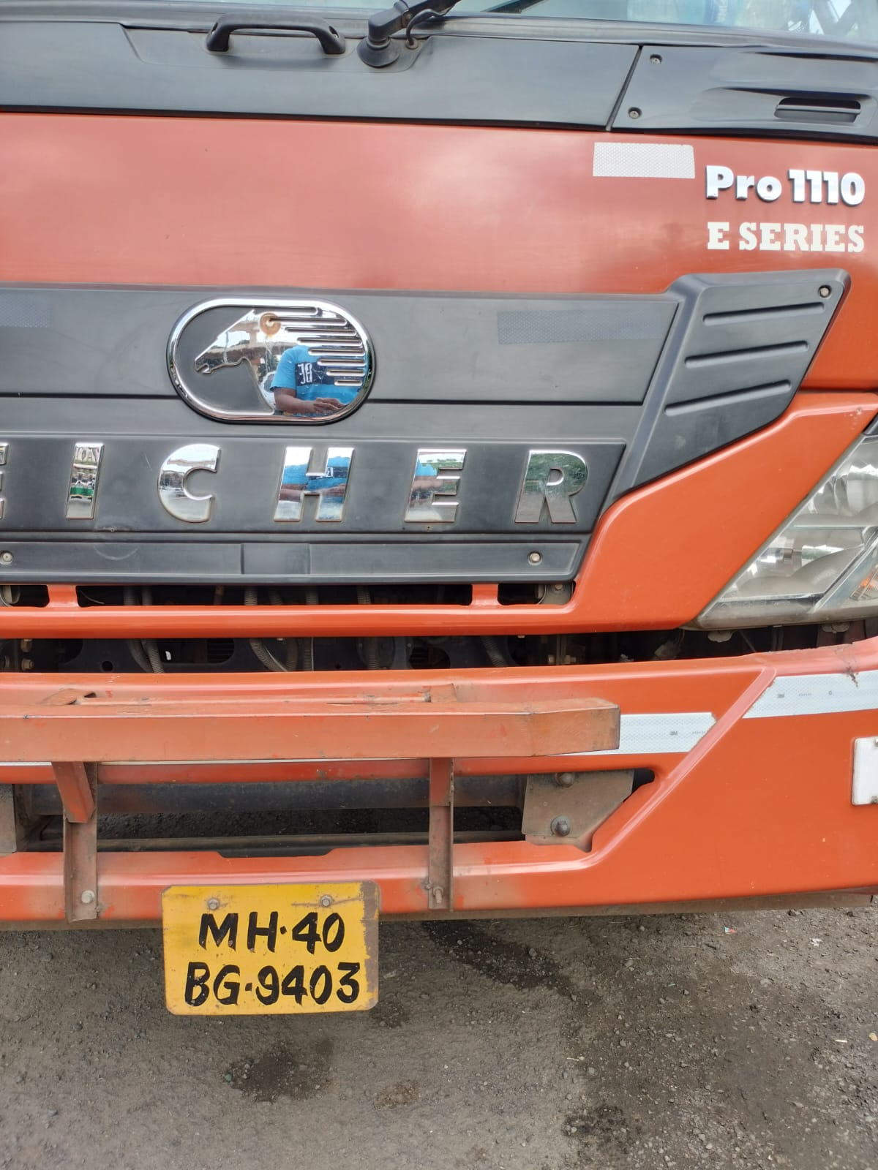

**2018**

**3321**

**MGV**

**VE COMMERCIAL VEHICLES LTD**

**MOHAMMED SAMEER MUNEER SALEEM MOHAM**

**06/10/2023**

**07/10/2022**

**07/10/2022**

**MH40-BG-9403**



**MH40AVERY906C3XYEXK11RDTL862V**

**SHL/16/2021-2022/9040477575/COP/0210**



**Installation Certificate**

COP:

COP Valid Till:

**30-09-2023**

Certificate No:

Creation Date:

Valid From:

Valid Till:

Application Details

Product Name

Quantity

**C3**

**1**

**Reflectors**

**4**

Vehicle Details

Owner Name

Vehicle Make

Vehicle Model

Chassis Number

Mobile Number

Year of Manufacturing

**9999999999**

Images

FRONT LEFT IMAGE

BACK RIGHT IMAGE

DOCUMENT IMAGE

Dealer Details

Dealer Name:

Trade Lic. No.:

RTO Location

**MH40**

Declaration

We hereby certify that we have supplied/installed the ARAI approved RRT as per the CMVR rule no 104/104D specified under CMVR GSR

784 (

E) 291 (E

).