MusicPlayer

Open MusicPlayer App. When you go into the app, you will in local tap(Fig1). Click music in tableView below to play music(Fig2).

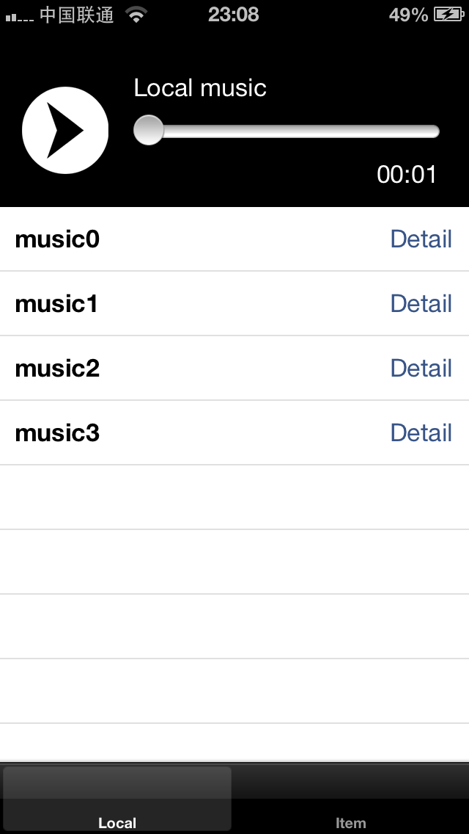 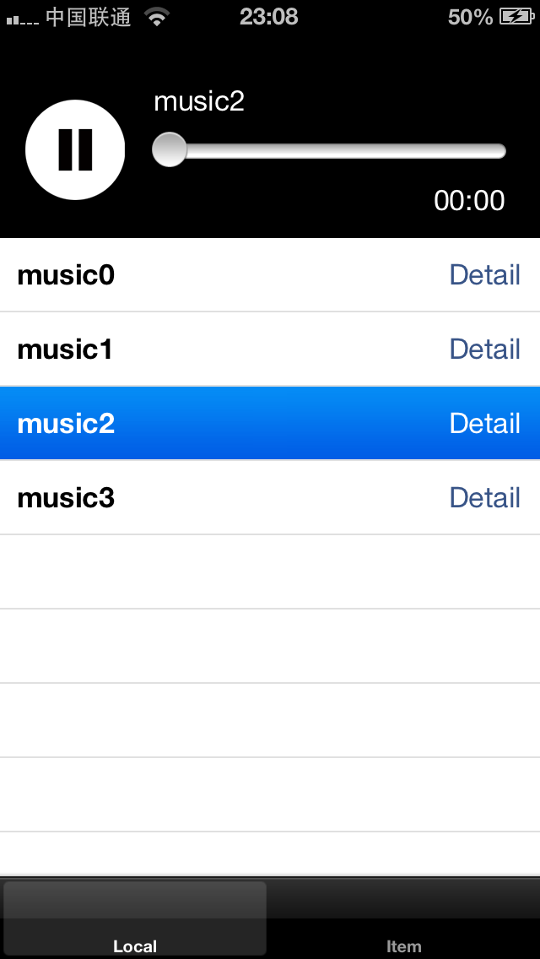

Fig1 Fig2

Tap remote turn to play music from remote server. You can click the music listed in tableView to play it(Fig3). Click the ‘add’ button on top-right to add one music with its URL to the list. After fill up two textField with music name and music URL, click ‘add’ button to save these information(Fig4).

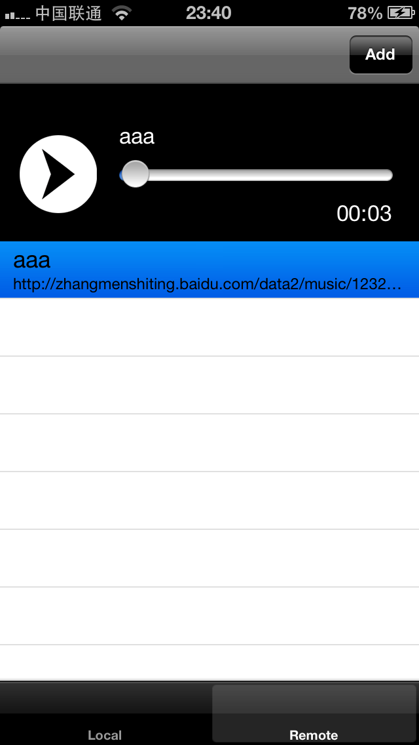 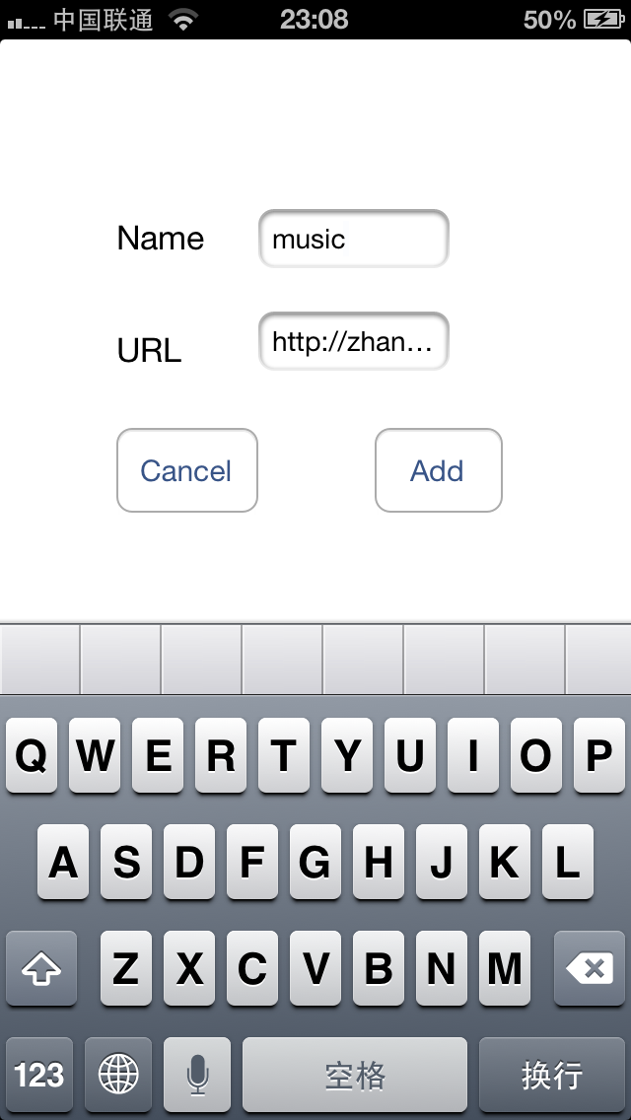

Fig3 Fig4

After added the music, click the specific row in list to play music(Fig5). Due to network connection status, this function may not work if network is off or poor.

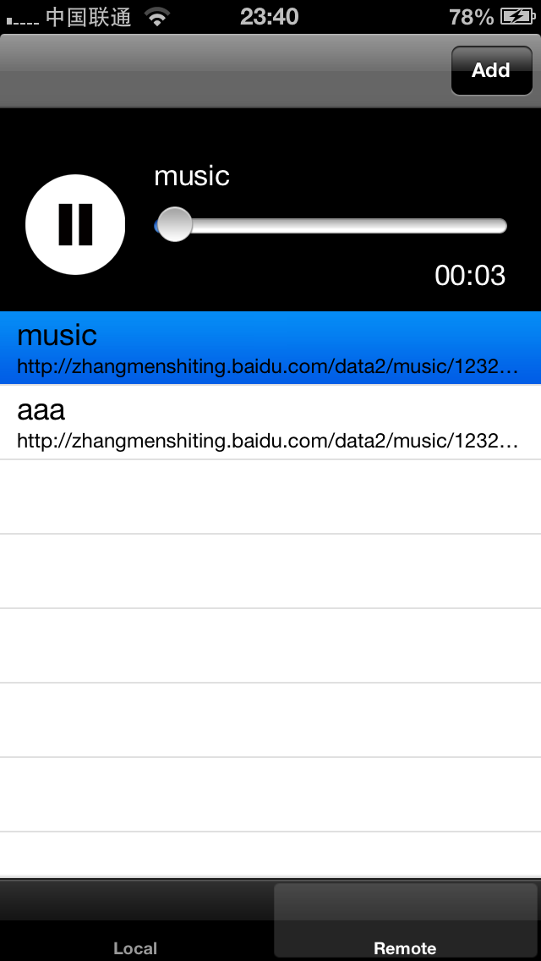

Fig5