Open VideoPlayer app, you can see a list of movies in local tap. You can click one of the movies to watch it(Fig1). Click remote tap to change into remote section(Fig2). Click the ‘+’ button at the top-right in Fig2 to add a movie with URL.

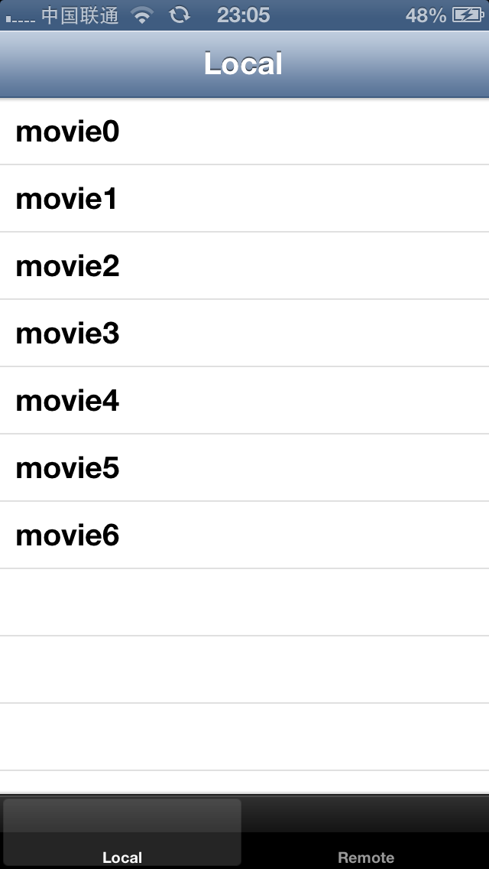 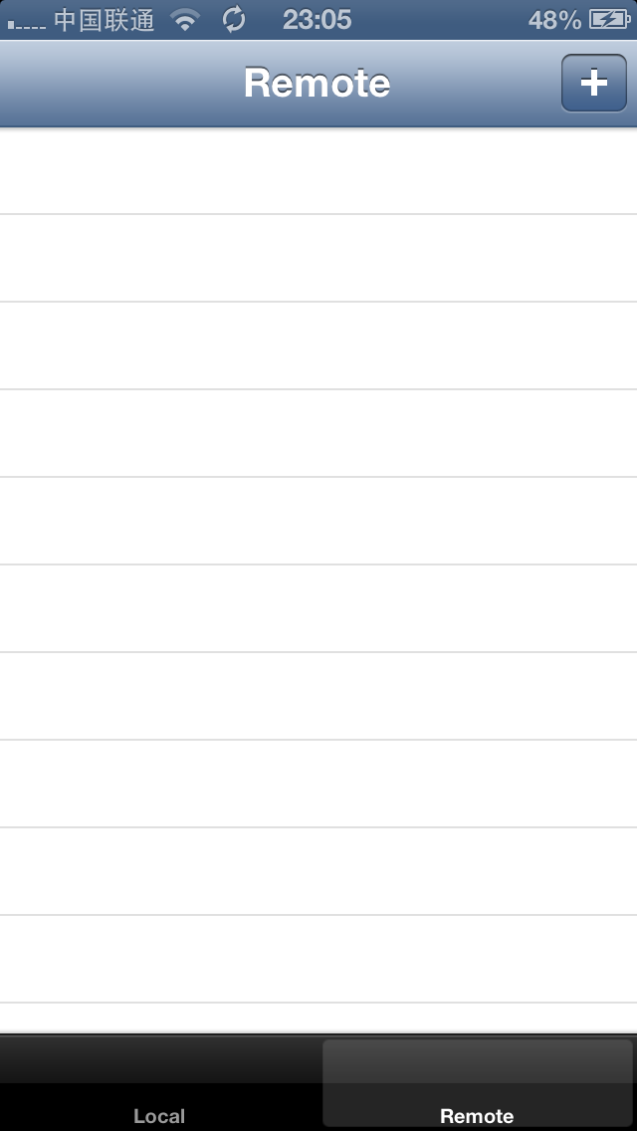

Fig1 Fig2

Fill up movie’s name field and URL field, then click add button to save your input(Fig3). After that, you will see the movie in the list(Fig4). You can play the movie by clicking the row.

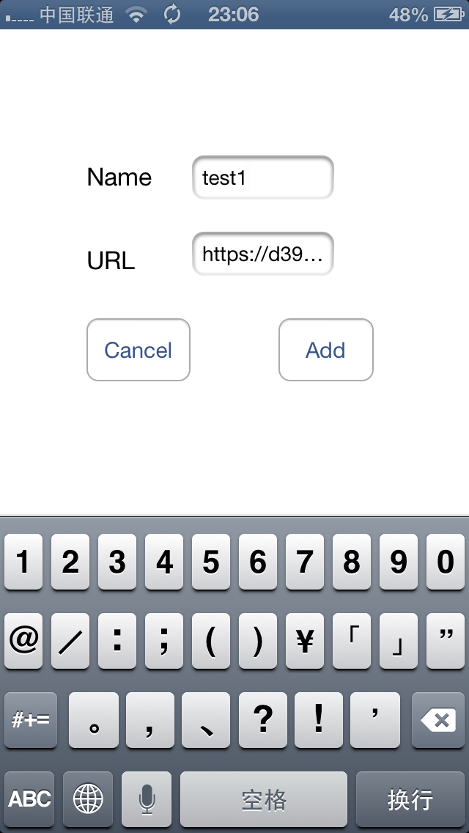 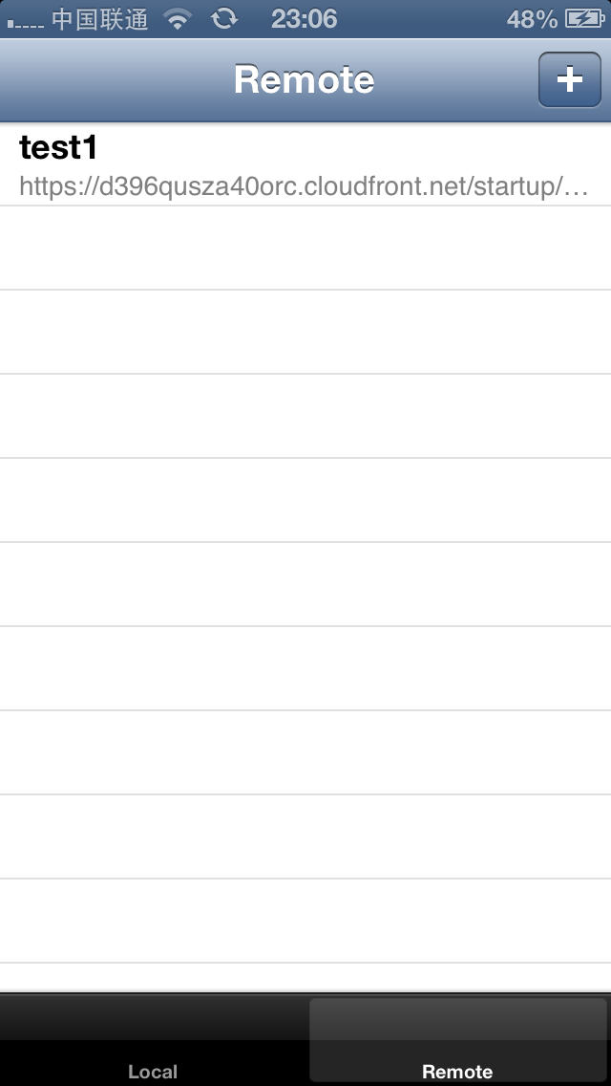

Fig3 Fig4

The screenshot of movie playing status is shown as below(Fig5).

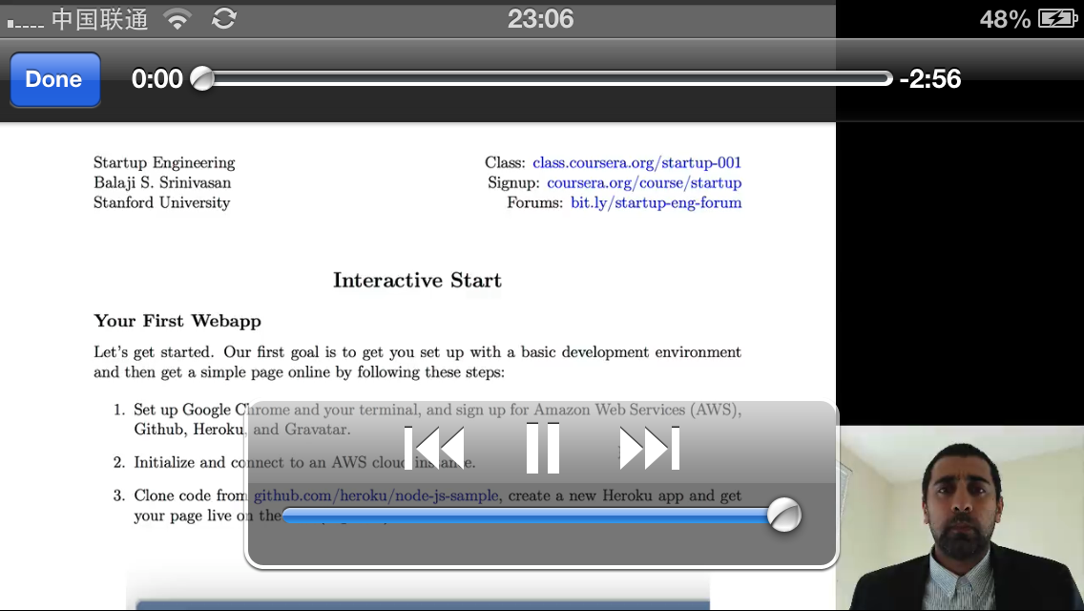

Fig5