SECURITY VALIDATION REPORT
TEST-001 — Network Reconnaissance Detection
AI-Augmented SOC Triage Platform | Controlled VMware Laboratory
Field | Recorded value
Report date | 25 August 2026 (IST)
Prepared by | Parakh Shinde
Classification | Internal lab evidence
Frameworks | ISO/IEC 27001:2022 aligned; NIST CSF 2.0; NIST SP 800-61; MITRE ATT&CK
Test status | PARTIALLY PASSED — telemetry observed; alert detection not proven

1. Executive conclusion
The test confirmed that Splunk received near-real-time Suricata telemetry associated with an SSH connection path. Four events were returned for source IP 10.0.10.40 and destination 10.0.10.10 on TCP port 22. The evidence proves collection, indexing, field extraction, and cross-host visibility.
AUDIT RESULT Partially Passed. No Suricata alert signature was present, so the supplied evidence does not prove that a network reconnaissance detection fired.
This distinction is intentional: a mature SOC report separates observed network activity from a confirmed detection. TEST-001 must be retested using the authorized Kali source and intended target, with an alert-producing rule or correlation search.

2. Scope and authorization
Item | Scope
Environment | Private VMware cybersecurity laboratory only
Authorized systems | SOC server 10.0.10.10; web server 10.0.10.20; Windows endpoint; authorized Kali host
Test method | Bounded Nmap SYN/service scan; no destructive exploitation
Excluded | Public systems, uncontrolled DoS/DDoS, destructive malware, credential theft and persistence
Primary objective | Validate telemetry, detection, triage, investigation and reporting workflow

3. Expected versus observed
Validation point | Expected | Observed | Result
Source identity | Authorized Kali IP recorded | 10.0.10.40 | Verify
Target identity | Web server 10.0.10.20 | 10.0.10.10 | Mismatch
Network telemetry | Events indexed in Suricata | 4 SSH/flow events | Pass
Detection signature | Recon/scan signature populated | Blank signature field | Fail
AI triage | Incident with severity and rationale | Not supplied | Not tested
MITRE mapping | T1046 after detection validation | Insufficient evidence | Not assigned

4. Evidence and timeline
Evidence source: Splunk Enterprise search over index=suricata, earliest=-15m. Screenshot captured 25 August 2026. The query filtered for 10.0.10.40 and displayed time, host, source/destination IP, destination port, event type and signature.
Time (IST) | Reporting host | Event | Source → destination
01:12:39.758 | web-server | ssh | 10.0.10.40 → 10.0.10.10:22
01:12:44.237 | windows-endpoint | flow | 10.0.10.40 → 10.0.10.10:22
01:12:54.238 | windows-endpoint | flow | 10.0.10.40 → 10.0.10.10:22
01:13:57.431 | web-server | flow | 10.0.10.40 → 10.0.10.10:22
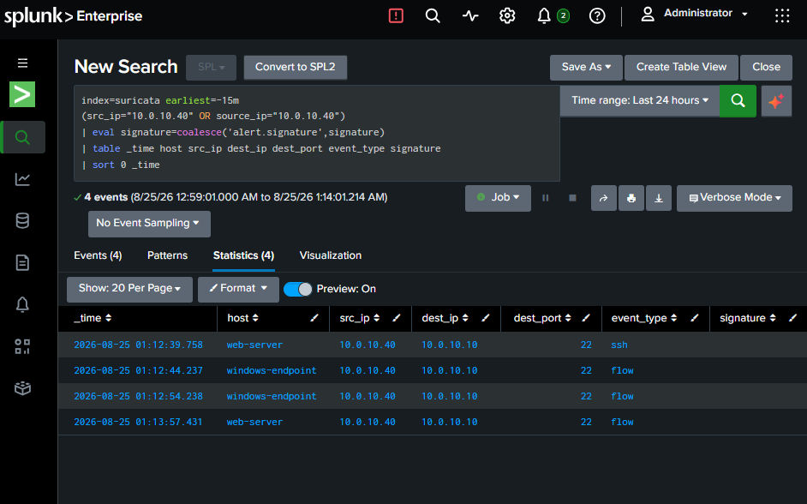
Figure 1. Splunk evidence showing four Suricata SSH/flow events; signature field is blank.

5. Detection analysis
The search demonstrates data visibility but not a triggered IDS analytic. Suricata event_type values of ssh and flow are protocol/connection records. A populated alert.signature or a separate Splunk correlation result is required before claiming a scan detection.

Analyst assessment
- True-positive status: Undetermined; the activity may be authorized administration or test traffic.
- Severity: Informational until scan behavior or an IDS/correlation alert is established.
- MITRE ATT&CK: T1046 Network Service Discovery is a candidate only after scan behavior is verified.
- Containment: Not recommended from this evidence alone.
- Data-quality issue: Test source and target differ from the documented Kali-to-web-server scenario.

6. Corrective actions and retest
Priority | Action | Acceptance criterion
P1 | Confirm current IPs with ip -br address / ipconfig and update the test plan. | Recorded source and target match executed command.
P1 | Run a bounded scan from the authorized Kali host to 10.0.10.20. | Command, start time and end time captured.
P1 | Search event_type=alert and inspect alert.signature. | Recon/scan signature or approved correlation alert present.
P2 | Run the AI pipeline and capture incident details. | failed=0 and new incident linked to the event.
P2 | Verify MITRE mapping and analyst decision. | T1046 supported by evidence; response documented.
P3 | Record detection latency and triage latency. | Measured timestamps included in final report.

Retest procedure
- On Kali, record date -Is and ip -br address.
- Run: sudo nmap -sS -sV -T3 --top-ports 20 10.0.10.20.
- In Splunk, search index=suricata earliest=-15m src_ip=<confirmed_Kali_IP> dest_ip=10.0.10.20 event_type=alert.
- Capture alert.signature, ports, timestamps, reporting host and raw event.
- Run ai-soc-pipeline.service and record the summary.
- Capture dashboard severity, verdict, evidence, MITRE mapping and recommended response.
- Close TEST-001 only when all acceptance criteria pass.

7. Framework alignment
Framework | Relevant function/control area | Project evidence
ISO/IEC 27001:2022 | A.8.15 Logging; A.8.16 Monitoring activities | Suricata events collected and searchable in Splunk.
ISO/IEC 27001:2022 | A.5.24–A.5.28 incident planning, assessment, response, learning and evidence | Structured test record, evidence handling and corrective actions.
NIST CSF 2.0 | DE.CM, DE.AE, RS.AN, RS.MI, RC.IM | Monitoring, event analysis, response decision and improvement workflow.
NIST SP 800-61 | Preparation; Detection and Analysis; Containment; Post-Incident Activity | Authorized test, evidence assessment, no unnecessary containment, retest plan.
MITRE ATT&CK | T1046 Network Service Discovery | Candidate mapping; not confirmed by current evidence.

8. Evidence-handling record
Original evidence should be retained read-only. For repeatable evidence handling, record filename, capture time, collector, source system and SHA-256 hash. Screenshots support the finding but do not replace raw Splunk exports or audit logs.
Evidence ID | Description | Status
EV-TEST001-01 | Splunk screenshot: four Suricata SSH/flow events | Included
EV-TEST001-02 | Kali command output and timestamps | Pending attachment
EV-TEST001-03 | Raw Splunk event export | Pending
EV-TEST001-04 | AI dashboard incident evidence | Pending
EV-TEST001-05 | Pipeline failed=0 log | Pending

9. Final disposition
STATUS OPEN FOR RETEST — telemetry pipeline passed; detection, AI triage and ATT&CK mapping require additional evidence.
Approval to close | Date | Retest result
________________________ | ________________________ | ________________________

