# Horror Game

Game development document

2024/07/07

Unique Games

Topic - This is a survival horror game

* Shooting and camera angle - First person
* Envirenment - Night time story mode
* Puzzles - We should puzzle using real wold intractable object.Some puzzles should not found easily.
* Enemies - Human type enemies and dogs and some bugs type enemies.Enemies can damage player and player should try to avoid enemies every time.Player can create traps using objects.

Map

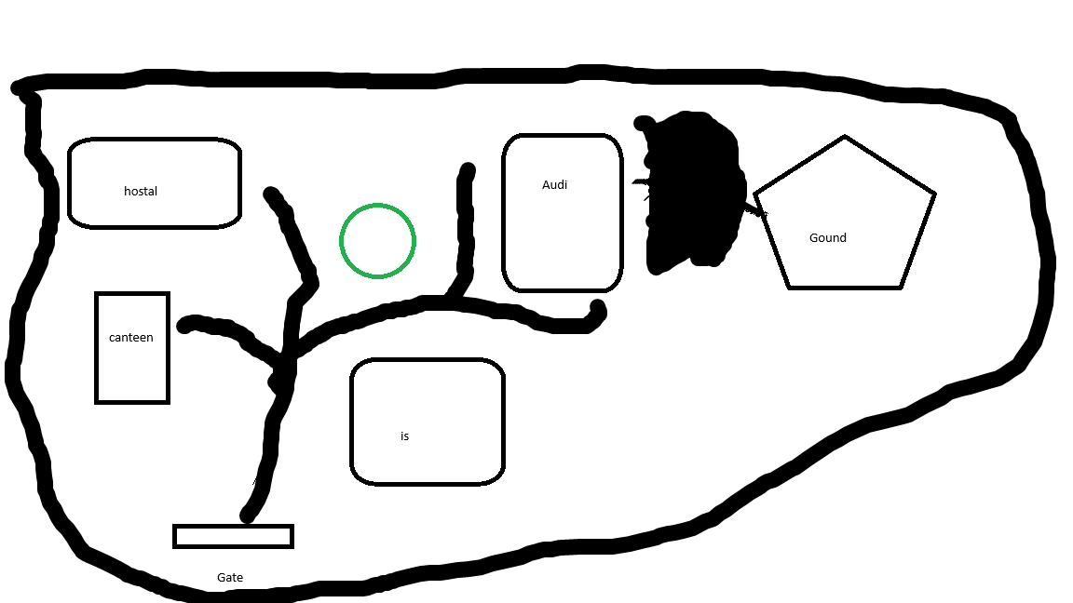

Figure 1 - The map

This is a ground map in game. This is like a university.In map we can see hostel , canteen , admin department , auditorium and Ground area . In game time situation ground is a graveyard.

Story

Background story - Sarah is the Greek’s girl friend. Greek is the main character.At 2002 Sarah was suicide some abnormal situation.But it is unbelievable reason for Greek. Therefore Greek think some unrecognized case exists behind the university.At current time is 2010.

On other hand this is not only suicide case in this area. Therefore that university closed at 2005.After closing this university this is a prohibited area for unauthorized people.But Greek is a brave boyfriend and he think some justice to be found exist this area.

01- start point - Main gate

Player has some items . New paper, touch , water bottle.GPS tracker, mobile Phone and recorder.

* Player has limited bag space

Player come to main gate area. But he see main gate has some keypad locker.(First puzzle)

Now player enter the university.But he hasn't any university ground map. He should found main area map.It’s broken now. But he found that map exploration will be easy.

02 - Hostel

He think some valuable data may be excites in her hostel room.Therefore he think go to hostel building.Her hostel room number is 219.player should find (2nd puzzle) that room and after that that room has a cupboard.

Puzzles

01.



02 chemical creation - some time we should destroy key and locks. That time player should create some damageable chemicals and then player can use