DATA INPUT FOR THE PROGRAM MULTALL_OPEN USING “NEW_READIN”

UPDATED FOR VERSION MULTALL-OPEN-19.2 . January 2019.

IMPORTANT NOTE.

MULTALL_OPEN can use either of two different input files.

One is closely the same as used in previous versions of MULTALL and is read by subroutine OLD_READIN. The data for this is mainly formatted, which means all data values must be in the correct columns and any value not present will be taken as zero. The data requirements for this are described in the manual “old-readin-input-data.doc”.

The other is thought to be a more rational layout of the data and is read by subroutine NEW_READIN. The data input for this is all free format, that means that a value must be present for every number being input, if a value is not present the next value will be taken, even if it is on a different line, and this will almost certainly cause an error. The details of this input type are described in this manual.

The program decides which form of input to use by reading a file named “intype” which contains the single character “N” or “O” for “new” and “old” READIN respectively. The file “intype” must be in the same directory as that from which the program is being run.

All data for NEW_READIN is in Free Format which means that there must be at least one space between adjacent numbers and that all numbers in a list must be present. If any value in a list is missing then the next value will be taken, even if it is on the next line of data, and this will almost certainly lead to an error. However, many lines of data can be set by default and this option is chosen replacing the appropriate line of numeric data by any alphabetic character, e.g. by “D” .

Each line of data is referred to as a “CARD” which is a legacy from the time when the data was input on punched cards, as it was at the start of development of this program in the mid ‘70’s .

Many lines of data are be preceded by a comment line describing the data to be input in the next line. These are included to help in identifying each line of data. These comment lines can contain any alphanumeric characters but must not be more than 72 characters long. Such comment lines are referred to as CARD XXdescription in the following description of the data input, so whenever CARD XXdescription and CARD XX are called for, two lines of data are required with the first line a comment line and the second line containing the required data.

More details of the input data options are given in the section entitled NOTES, which follows the end of the input data description.

CARD LIST

***************************************************************************

CARD 1

TITLE

TITLE Is a title for the run, up to 72 alphanumeric characters in length.

There are no defaults for this line of data.
***************************************************************************

CARD 2description and 2

CP, GA

CP Gas specific heat capacity in J/Kg K. e.g. CP = 1005 for air . Set any negative value to use real gas properties.

GA Gas specific heat ratio , e.g. = 1.4 for air.

The above values are chosen as defaults if this card is a single alphabetic character, e.g. “D”.
**************************************************************************

CARD 3 This is only required if CP in the previous card was negative.

CP1, CP2, CP3, TREF, RGAS

CP1 The value of CP at TREF in J/kg K

CP2 The rate of change of CP with temperature at TREF

CP3 The second derivative of the variation of CP with temperature at TREF.

TREF The reference temperature in degrees K .

RGAS The constant value of gas constant in J/kg k.

The specific heat is taken to vary as:

For combustion products typical values are TREF = 1400, CP1 = 1272.5, CP2 = 0.2125, CP3 = 0.000015625, RGAS = 287.5.

The above values are chosen as defaults if this card is a single alphabetic character, e.g. “D”.
**************************************************************************

CARD 4description and 4.

ITIMST

ITIMST defines the type of timestep to be used.

= 3-> Non-uniform time steps updated as a function of Mach number using the basic “scree” scheme. This is the standard option.

= 5-> Low speed flow using an artificial speed of sound. Use this if the maximum Mach number is less than about 0.25. Extra data is then needed in CARD 6.

= 6-> Fully incompressible flow with constant density. Extra data is then needed in CARD 7.

= 4 or -4 ->The SSS scheme is used with the values of F1, F2 and F3 input as data in card 5 .

If the values of ITIMST are negative, -3, -5 or -6 , then the options are as with the same positive values described above, but the SSS scheme with standard coefficients is used. This should allow larger CFL numbers, up to 0.75 or more, but is sometimes less robust.

ITIMST = 3 is the usual option but = -3 may allow larger CFL numbers and so give faster convergence. See Note 3 for more details.

There are no defaults for this data.
**************************************************************************

CARD 5 Only needed if ITIMST in Card 4 was = 4 or -4 .

F1, F2EFF, F3, RSMTH, NRSMTH

F1, F2EFF, F3 Coefficients of the SSS scheme. Standard values are F1= 2.0, F2EFF = -1.0, F3 = -0.65 .

RSMTH Residual smoothing factor, Standard value = 0.4

NRSMTH Number of residual smoothing passes. Standard value= 1.

See Note 3 for more details of the SSS scheme.

There are no defaults for this data.
**************************************************************************
CARD 6 Only needed if ITIMST in Card 4 was = 5 or -5 .

VSOUND, RF_PTRU, RF_VSOUND, VS_VMAX

VSOUND An initial guess of the artificial speed of sound. It should be about twice the expected maximum relative velocity. It is only an initial guess and is automatically changed by the VS_VMAX ratio during the calculation.
Default = 150 m/s .

RF_PTRU A relaxation factor on the changes in the calculated pressure. Typical value = 0.01 .

RF_VSOUND A relaxation factor on the changes in the calculated artificial speed of sound. Typical value = 0.002 .

VS_VMAX The ratio of the calculated sound speed to the calculated maximum flow speed. Typical value = 2.0 .

Defaults are as given above.
See Note 18 for more details of the low Mach number scheme.
**************************************************************************

CARD 7 Only needed if ITIMST in CARD 4 was = 6 or -6 .

VSOUND, RF_VTRU, RF_VSOUND, VS_VMAX , DENSTY

VSOUND An initial guess of the artificial speed of sound. It should be about twice the expected maximum relative velocity. It is only an initial guess and is automatically changed by the VS_VMAX ratio. Default = 150 m/s .

RF_VTRU A relaxation factor on the changes in the calculated pressure. Typical value = 0.01 .

RF_VSOUND A relaxation factor on the changes in the calculated artificial speed of sound. Typical value = 0.002 .

VS_VMAX The ratio of the calculated sound speed to the calculated maximum flow speed. Typical value = 2.0 .

DENSTY The fixed value of density for the incompressible flow. The default value is 1.2 kg/m³ , a typical value for air.

The defaults are as given above .
See Note 18 for more details of the low Mach number scheme.
***************************************************************************
CARD 8description and 8

CFL, DAMPIN, MACHLIM, F_PDOWN

CFL The CFL number which determines the length of time step. Standard vale = 0.4 for the Scree scheme but higher values up to 0.75 may be possible with the SSS scheme.

DAMPIN The damping factor which limits the ratio of maximum change to the average change per time step. Standard value = 10.0 . Higher values, e.g. 25.0, may give faster convergence but are less stable.

MACHLIM The maximum relative Mach number is limited to this value. Typical value = 2.0 . The calculation should not fail but may not converge fully if the maximum Mach number exceeds this value.

F_PDOWN The pressure may be downwinded to prevent overshoots and undershoots at strong shock waves. Standard value = 0.0 but set = 0.1 if more shock smearing is required.

Defaults are as given above.

See Notes 3 and 5 for more details .
***************************************************************************

CARD 9description and 9

IF_RESTART

IF_RESTART If = 0 then start the calculation from an initial guess of the flow field

IF_RESTART If = 1 then start the calculation from a previous solution which has been saved in a file named “flow_out” .

Default is IF_RESTART = 0.

Starting from a restart file should give faster convergence.

Note that the file “flow_out” is always written when convergence or maximum iterations are reached and is also used as the plotting file.
***************************************************************************

CARD 10description and 10

NSTEPS_MAX, CONLIM

NSTEPS_MAX The maximum number of time steps before the calculation will be stopped. The value depends on the case but 3000 is usually enough for a single blade row, 5000 for a single stage and up to 10000 for a multistage calculation. More than 10000 time steps should never be needed.

CONLIM The convergence level defined as the average percentage change in velocity per time step divided by the RMS velocity of all grid points. Typical value = 0.005 .
Note that CONLIM is the percentage change so the usual convergence limit is very tight.

Defaults are NSTEPS_MAX = 5000, CONLIM = 0.005
***************************************************************************

CARD 11description and 11

SFXIN, SFTIN, FAC_4TH, NCHANGE

SFXIN The smoothing factor in the streamwise (J) direction. Standard value =0.005 .

SFTIN The smoothing factor in the pitchwise (I) and spanwise (K) directions. Standard value =0.005 .

FAC_4TH The proportion of fourth order smoothing. The second order smoothing used is (1-FAC_4th) x SFXIN and the fourth order smoothing used is FAC_4th*SFXIN . The same for SFTIN. Typical value = 0.8 .

NCHANGE The smoothing factors and damping are increased at the start of the calculation and are gradually decreased to the values set above over NCHANGE steps. Typical value = NSTEPS_MAX/4 .

Defaults values are as given above.
***************************************************************************

CARD 12description and 12

NROWS

NROWS The number of blade rows to be calculated. The limit is only imposed by the dimensioning of the program.
The current limit is 26. Edit “commall-open“ if this needs to be increased.

There is no default value for this data since NROWS will vary from case to case.
***************************************************************************

CARD 13description and 13

IM , KM

IM The number of grid points in the pitchwise direction. This is the same for all blade rows. A typical value = 46. Fewer points, e.g. 28, will give faster run times, more points e.g. 64, will give greater accuracy. The current limit as set by the dimensions of “commall-open” is 83.

KM The number of grid points in the spanwise direction. This is the same for all blade rows. A typical value = 46. Fewer points, e.g. 28, will give faster run times , more points e.g. 64, will give greater accuracy. The current limit as set by the dimensions of “commall-open” is 83.

There are no default values for these two numbers since they will vary from case to case.
***************************************************************************

CARD 14description and 14

FP(I), for I = 1,IM-1

FP(I), I=1 to IM-1 FP(I) are the relative grid spacings in the pitchwise direction. IM-1 values must be input. If FP(3) is set to zero then the spacings are generated automatically as a geometric progression with expansion ratio FP(1) and maximum spacing ratio = FP(2) . These are applied away from both blade surfaces. Typical values are FP(1) = 1.25, FP(2) = 10.0 , FP(3) = 0.0. All the remaining IM-4 values must still be input but they are not used.

Note that these are the relative spacings so that only their ratios matter, their absolute values do not matter. A higher expansion ratio and a larger ratio of maximum to minimum spacing will give more grid points in the boundary layers. However, it is recommended that the expansion ratio should not be greater than 1.3 as large values will generate numerical errors.

It is usually more convenient to use the option to generate the spacings automatically but data must still be input for the IM-4 points that will not be used.

There are no defaults for this data.
***************************************************************************
CARD 15description and 15

FR(K), for K = 1,KM-1

FR(K), K=1 to KM-1 FR(K) are the relative grid spacings in the spanwise direction. KM-1 values must be input. If FR(3) is set to zero then the spacings are generated automatically as a geometric progression with expansion ratio FR(1) and maximum spacing ratio = FR(2) . These are applied away from both endwalls. Typical values are FR(1) = 1.25, FR(2) = 10.0 , FR(3) = 0.0 . All the remaining KM-4 values must still be input but they are not used.

Note that these are the relative spacings so that only their ratios matter, their absolute values do not matter. A higher expansion ratio and a larger ratio of maximum to minimum spacing will give more grid points in the boundary layers. However, it is recommended that the expansion ratio should not be greater than 1.3 as large values will generate numerical errors.

It is usually more convenient to use the option to generate the spacings automatically but data must still be input for the KM-4 points that will not be used.

The spacings are automatically adjusted to accommodate the specified tip gaps.

There are no defaults for this data.
***************************************************************************

CARD 16description and 16

IR, JR, KR, IRBB, JRBB, KRBB

IR The block size of the smallest multigrid blocks in the I direction. Typically IR = 3 . Set IR = 1 if performing a throughflow calculation.

JR The block size of the smallest multigrid blocks in the J direction. Typically JR = 3.

KR The block size of the smallest multigrid blocks in the K direction. Typically KR = 3. Set KR = 1 if performing a quasi-3D blade –to-blade calculation.

IRBB The block size of the second level of multigrid blocks in the J direction. Typically IRBB = 9. Set = 1 if IR = 1.

JRBB The block size of the second level of multigrid blocks in the J direction. Typically JRBB = 9.

KRBB The block size of the second level of multigrid blocks in the K direction. Typically KRBB = 9. Set = 1 if KR = 1.

The default values are the typical ones given above. However, there is no need to use these exact values. Larger block sizes may give faster convergence but are more likely to need lower safety factors, see card 17.

It is desirable, but not essential, that there are a whole number of blocks across the pitch and span. So, if IR = 3 and IRBB = 9, good values for IM would be 19, 28, 37, 46, 55, and 65 . Similarly for KM.

If IM was = 2 to specify a throughflow calculation, then IR and IRBB must = 1.

If KM was = 2 to specify a Q3D blade-to-blade calculation, then KR and KRBB must = 1.

In addition to these two block sizes there is a third level of multigrid for which the blocks cover the whole span and whole pitch with one block upstream of the leading edge, 2 blocks within the blade passage, and one block downstream of the trailing edge. i.e. only 4 blocks per blade row. These “superblocks” are generated automatically with no user input.

The default values are as given above.
***************************************************************************

CARD 17description and 17

FBLK1, FBLK2, FBLK3

FBLK1 The safety factor on the time step length for the first level of multigrid blocks. Typical value = 0.4 .

FBLK2 The safety factor on the time step length for the second level of multigrid blocks. Typical value = 0.2 .

FBLK3 The safety factor on the time step length for the third level of multigrid blocks, Typical value = 0.1.

These safety factors are the ratio of the CFL number used for the block to the theoretical limiting value. The defaults are the values suggested above. Larger values will give faster convergence but may lead to instability.
***************************************************************************

CARD 18description and 18

IFMIX

IFMIX Set IFMIX= 1 if a mixing plane is to be used. Set = 0 if there is no mixing plane.

The default is IFMIX = 1. It is very unlikely that a mixing plane will not be used when there is more than one blade row.
**************************************************************************

CARD 19description and 19 . Only needed if IFMIX (card 18) is not 0 .

RFMIX, FEXTRAP, FSMTHB, FANGLE

RFMIX The relaxation factor on the isentropic forcing downstream of the mixing plane. Typical value = 0.025 , reduce this if there is any sign of instability at the mixing plane.

FEXTRAP The factor by which the flux is extrapolated from upstream of the mixing plane to the mixing plane.
Typical value = 0.8 but use a larger value for close grid spacings.

FSMTHB The factor scaling the special smoothing upstream and downstream of the mixing plane. Typical value 1.0 .

FANGLE The factor by which the flow direction is extrapolated from downstream to the mixing plane. Typical value = 0.8 but use a larger value for closer grid spacings.

See Note 17 for more details of the mixing plane treatment. Use larger values of FEXTRAP and FANGLE, e.g. 0.95, if the streamwise grid spacing is very small at the mixing plane. The value of FSMTHB does not seem to be very important.

The default values are those given above.
**************************************************************************

CARD 20description and 20

IFCOOL, IFBLEED, IF_ROUGH

IF COOL Set = 1 or 2 if any cooling flows are to be included on any blade row. IFCOOL = 1 gives a uniform coolant flow over the patch with the velocity determined by the input value of Mach number. The input value of stagnation pressure is not used except to calculate the efficiency. IFCOOL = 2 allows the coolant velocity to vary over the patch as determined by the local static pressure and the input stagnation pressure. The input value of Mach number is not used. Set IFCOOL = 0 if there are no cooling flows. Default = 0 .

IF BLEED Set = 1 if there are bleed flows from the hub or casing of any blade row. Set = 0 if there are no bleed flows. Default = 0 .

IF_ROUGH Set = 1 if any surface of any blade row is to be treated as rough. Set = 0 if all surfaces of all blade rows are smooth. Default = 0.

Defaults are as given above. Further input is needed later in Cards 86 and in the sections entitled COOLING FLOWS and BLEED FLOWS at the end of the input data if any of these are non-zero.
***************************************************************************
CARD 21description and 21

NSECS_IN

NSECS_IN The number of quasi stream surfaces on to which the input blade geometry will be interpolated. This is the same for all blade rows. The interpolation is done before generating the final grid. NSECS_IN is usually the same as the number of input stream surfaces, (NSECS_ROW, Card 51) but they need not be the same.

If the number of input stream surfaces is not the same for all blade rows then set NSECS_IN equal to the largest number of input surfaces. It is usually more convenient to have NSECS_IN = NSECS_ROW and with the same value for all blade rows.

Note that there is no default value for this data.
***************************************************************************

CARD 22description and 22

IN_PRESS, IN_VTAN, IN_VR, IN_FLOW, IF_REPEAT, RFIN

IN_PRESS Determines how the pressure is extrapolated to the inlet boundary. Usual value = 0 so the pressure is calculated from the density which is solved for by the continuity equation. If =1 the inlet pressure is extrapolated from the interior flow field. If = 3 the pitchwise averaged pressure is extrapolated. If = 4 the passage average pressure is extrapolated. See Note 1 for more details.

IN_VTAN Determines the boundary condition on the inlet tangential velocity or flow angle. Set = 0 if the absolute flow angle is fixed, set = 2 if the relative flow angle is fixed, set = 1 if the absolute tangential velocity is fixed. See Note 1 for more details.

IN_VR Determines the boundary condition on the inlet radial velocity. Set = 0 if it is extrapolated from the downstream flow field. Set = 1 if the radial velocity is determined by a fixed meridional pitch angle which is input in Card 81. If IN_VR = 1 the pitch angle specified must be compatible with the slopes of the hub and casing at inlet.

IN_FLOW Determines whether to try to force a specified mass flow rate. Set = 0 if no mass flow forcing. Set = 2 to force the local flow towards the current average flow. Set = 3 to force the flow towards an input value which is input in Card 26. See Note 11 .
This option is seldom used so the usual value = 0.

IF_REPEAT Determines whether to force a repeating stage condition at the inlet boundary. Set = 0 for no repeat condition, which is most usual. Set = 1 to use the repeating flow condition in which case extra data will be read in Card 27 .

RFIN The relaxation factor on changes in the inlet pressure. The value depends on the choice of IN_PRESS. If IN_PRESS = 0 then set = 0.5. For other choices of IN_PRESS set = 0.1. Reduce if there are any signs of instability at the inlet boundary. See note 1 for more details.

The defaults values are: IN_PRESS = 0, IN_VTAN = 0, IN_VR = 1, IN_FLOW = 0, IF_REPEAT = 0, RFIN = 0.5 .
***************************************************************************

CARD 23description and 23

IPOUT, SFEXIT, NSFEXIT, FP_EXTRAP, FRACWAVE

FRACWAVE and FP_XTRAP are new to version MULTALL_OPEN_19.2.F

IPOUT Determines the boundary condition on the exit static pressure. IPOUT = 0 means that the pressure is fixed as PDHUB on the hub and simple radial equilibrium is imposed. IPOUT = -1 means the pressure is fixed as PDTIP on the casing and simple radial equilibrium is imposed. IPOUT = +1 means the exit pressure is fixed at all spanwise positions with a linear variation between the input values PDHUB and PDTIP. IPOUT = +3 means that the spanwise exit pressure variation is read in as data in Card 76 .

SFEXIT A factor for smoothing the exit flow field. If SFEXIT is not zero this is smoothed in both the pitchwise and spanwise directions. It is usually only used when there is instability due to the flow trying to reverse at the exit boundary in which case set SFEXIT = 0.1 and NSFEXIT = 5 -> 10. Increase these to apply a more powerful smoothing. Most usually SFEXIT = 0.0 .

NSFEXIT The smoothing is applied over NSFEXIT points upstream of the exit boundary. Typically = 5 but increase it to apply a more powerful smoothing over more mesh points.

FP_EXTRAP The fraction by which the pressure is extrapolated to the downstream boundary. Typical value = 0.9 . This is also used when FRACWAVE = 0 so the original boundary condition is used. Reduce the value if there is instability at the downstream boundary.

FRACWAVE The fraction of the required change in pitchwise average exit pressure that is added on each time step. The pressure is added as a one-dimensional wave which changes the density, velocity and energy as well as the pressure. Typical value = 0.25 but reduce if there are any signs of instability at the downstream boundary.
The new boundary condition is used if FRACWAVE is greater than zero. If it = zero or if it is not included in the data set then the original exit boundary condition is used.
The options IPOUT = -1, 0 ,+1 or +3 can still be used with the new exit boundary condition.

Defaults are IPOUT = 1, SFEXIT = 0.0, NSFEXIT = 0 , FP_EXTRAP = 0.9,
FRACWAVE = 0.0 See Note 2 for more details of how IPOUT is used.
**************************************************************************
CARD 24description and 24

PLATE_LOSS, THROTTLE_EXIT

PLATE_LOSS The loss coefficient of a simulated perforated plate or wire mesh screen at the exit boundary. This may be used to make the exit flow more uniform if there is a tendency for it to reverse at exit. It works by increasing the static pressure upstream of the simulated plate by PLATE_LOSS x ( ρ V_{m}²- (ρ V_{m}² )_{mid} ) . A value = 2.0 should make a non-uniform flow closely uniform. The use of SFEXIT is usually a better way of preventing reverse flows and so this option is not usually needed, hence PLATE_LOSS usually = 0.0 .

THROTTLE_EXIT Simulates a throttle downstream of the calculated region. The exit pressure is made to vary with exit mass flow rate so it lies on a parabolic curve passing through THROTTLE_PRES and THROTTLE_MAS both of which are input in the next card. This is useful for calculations on compressors near their stall point. The solution found should lie at the intersection of the compressor’s static pressure to mass flow characteristic and the parabolic curve through these points. Set THROTTLE_EXIT = 1.0 to use this option. Set = 0.0 if this option is not used as is most usual unless near the stall point.

Defaults are PLATE_LOSS = 0, THROTTLE_EXIT = 0 so the option is not used .
***************************************************************************

CARD 25 .
This card is only needed if THROTTLE_EXIT in Card 24 is not zero.

THROTTLE_PRES, THROTTLE_MAS, RF_THROTL

THROTTLE_PRES The exit pressure is made to vary with exit mass flow rate along a parabolic curve passing through the point THROTTLE_PRESS and THROTTLE_MAS . In N/m² .

THROTTLE_MAS The mass flow at the point where the exit pressure is THROTTLE_PRES . In Kg/s .

RF_THROTL A relaxation factor on changes in exit pressure when using this option. Typical value = 0.1 .

See Card 24 for details of this option. There are no defaults for this card.
***************************************************************************
CARD 26description and 26 .

This card is only needed in IN_FLOW in card 22 is not zero .

FLOWIN, RFLOW

FLOWIN The required mass flow rate in Kg/s . This is only used when IN_FLOW = 3.

RFLOW A relaxation factor on the mass flow forcing. Typical value = 0.1 .

There are no defaults for this card. It is very seldom used because IN_FLOW is usually set to zero.
***************************************************************************

CARD 27description and 27.

Only needed if IF_REPEAT in card 23 is not zero.

NINMOD, RFINBC

NINMOD The inlet boundary conditions are moved towards the repeating stage condition every NINMOD steps. Typically NINMOD = 10.

RFINBC A relaxation factor on the changes in inlet boundary conditions. Typical value = 0.025 . Reduce this if there are any signs of instability at the inlet boundary.

Default values are as given above.
***************************************************************************

CARD 28description and 28 .

ILOS, NLOS, IBOUND

ILOS Determines which viscous model will be used.
Set = 0 for an inviscid calculation.
Set = 10 to use the original mixing length model, subroutine LOSS.
Set = 100 to use the newer mixing length model, subroutine NEW_LOSS .
Set = 200 to use the Spalart-Almaras turbulence model, subroutine SPAL_LOSS .
Generally ILOS = 100 is preferred.

NLOS The loss subroutine is called every NLOS time steps. Usually NLOS = 5 , lower values may be more stable but will run more slowly, higher values may be less stable but faster. It is seldom necessary to change the value from 5 .

IBOUND Determines whether the endwalls will be treated as viscous or inviscid. If IBOUND = 0, both walls are viscous. IBOUND = 1 makes the hub inviscid, IBOUND = 2 makes the casing inviscid, IBOUND = 3 makes both endwalls inviscid.
Usually set IBOUND = 0 .

Defaults are ILOS = 100, NLOS = 5, IBOUND = 0 .
***************************************************************************

CARD 29description and 29.

Only needed if ILOS in card 28 is not zero.

REYNO, RF_VIS, FTRANS, TURBVIS_LIM, PRANDTL,YPLUSWALL

REYNO If REYNO is greater than 100 it is the Reynolds number of the flow based on the axial chord and the exit relative velocity of the first blade row. This is used to calculate the dynamic viscosity.
If REYNO is positive but less than 100 then REYNO = (dynamic viscosity x 10⁵).
If REYNO is negative then Abs(REYNO) x 10 ⁻⁵ is the dynamic viscosity at a temperature of T = 288K and it varies as (T/288)^{0.62} which is a good approximation for air.

RF_VIS A relaxation factor on the changes in viscous forces. Usual value = 0.5 and it is seldom necessary to change this.

FTRANS A very simple boundary layer transition criterion. The flow is taken to be fully turbulent if the ratio of the maximum calculated turbulent viscosity to laminar viscosity is greater than FTRANS. Set FTRANS = 14 to use this model. However it is not considered very reliable and usually set FTRANS = 0.0 to obtain fully turbulent flow or set FTRANS = 10000. to obtain fully laminar flow.

TURBVIS_LIM The maximum allowed value of turbulent viscosity is TURBVIS_LIM x the laminar viscosity. Usually set TURBVIS_LIM = 1000 but higher values, up to 3000, may be necessary in multistage machines

PRANDTL The Prandtl number of the fluid. Usually set = 1.0.

YPLUSWALL If this is greater than 5 then the wall shear stresses are obtained by assuming that the first grid point is at the given value of YPLUS and the original wall functions are not used. If this is done a typical value of YPLUSWALL = 11 . However, this option is not preferred and usually set YPLUSWALL = 0.0 to obtain the wall shear stresses from the wall functions.
In Version 10.5 YPLUSWALL can be used to choose the Shih et al wall functions. If its value is between -10.0 and zero then only the velocity term in these functions is used. This gives results very similar to the original wall function. If its value is less than -10.0 then both the velocity and pressure terms in the Shih et al wall functions are used. The author is dubious of the value of this.

Defaults are: REYNO = 500,000 , RF_VIS = 0.5, FTRANS = 0.0, PRANDTL = 1.0 , YPLUSWALL = 0.0, TURBVIS_LIM = 3000.
***************************************************************************

CARD 30description and 30

This card is only needed if ILOS = 200, i.e. if the Spalart-Allmaras (S-A) turbulence model is being used.

FAC_STMIX, FAC_ST0, FAC_ST1, FAC_ST2, FAC_ST3, FAC_SFVIS, FAC_VORT, FAC_PGRAD

FAC_STMIX A factor which moves the turbulent viscosity calculated by the S-A model towards the mixing length value obtained from NEW_LOSS. Set = 1.0 to use this but usually set = 0.0 .

FAC_ST0 A scaling factor on the first source term in the S-A model. Standard value = 1.0 but 1.5 is sometimes found to give better results.

FAC_ST1 A scaling factor on the second source term in the S-A model. Standard value = 1.0 .

FAC_ST2 A scaling factor on the second source term in the S-A model. Standard value = 1.0 .

FAC_ST3 A scaling factor on the third source term in the S-A model. Standard value = 1.0 .

FAC_SFVIS A factor which may be used to increase the smoothing of the turbulent viscosity calculated by the S-A model. Usual value = 2.0 . Higher values are seldom necessary.

FAC_VORT This is new to version 17.5. It allows the main source term for turbulent viscosity to be increased by streamwise vorticity as suggested by Lee et al in ASME GT2017-63245 . The increase is limited to (1 + FAC_VORT) x the original source term. Lee et al suggest a value = 0.9191 for FAC_VORT. The default value = 1.0 . So far there is little experience of using this option.

FAC_PGRAD This is also new to version 17.5. The main source term for turbulent viscosity is increased by adverse pressure gradients, again as suggested by Lee et al. The increase is limit to (1 + FAC_PGRAD) x the original term. Lee et al suggest a value of 0.6565 for FAC_PGRAD. The default value = 1.0 . So far there is little experience of using this option. Both FAC_VORT and FAC_PGRAD can be used together to increase the source term by their product.
The defaults are as given above.
***************************************************************************
CARD 31description and 31.

YPLAM, YPTURB

YPLAM Is the value of YPLUS below which the
boundary layer is taken to be fully laminar. The usual value = 5.0 .

YPTURB Is the value of YPLUS above which the flow is taken to be fully turbulent. Usual value = 25.0 .

Defaults are as given above. Between these values the viscosity is blended between the laminar and the calculated turbulent value. These values are only used when there are grid points within the laminar sub layer, YPLUS < 25 , otherwise the flow is taken to be fully turbulent or fully laminar as determined by FTRANS .
***************************************************************************
CARD32description and 32

Only needed if IM = 2 to specify a throughflow calculation.

Q3DFORCE, SFPBLD, NSFPBLD

Q3DFORCE A factor scaling the force applied via the blade surface pressure distribution to keep the flow on the stream surface. Usually set = 1.0 but often higher values, sometimes up to 5, can be used and give faster convergence.

SFPBLD The blade surface pressures are smoothed by SFPBLD. Typical value = 0.1. This high smoothing greatly helps to obtain realistic pressure distributions and improves convergence.

NSFPBLD The smoothing is applied NSFPBLD times. Typical value = 2. But increase to apply more powerful smoothing.
Defaults are as given above.
See Note 20 for details of the throughflow method.
***************************************************************************
CARD 33description and 33

ISHIFT, NEXTRAP_LE, NEXTRAP_TE

ISHIFT Determines the type of grid matching between adjacent blade rows.
If ISHIFT = 0, the grids input are not changed.
If ISHIFT = 1 the blade rows are moved axially so that the grids coincide at the mixing plane on the hub.
If ISHIFT = 2 the grids are moved so that they coincide at the mixing plane over the whole span and maintain the input stream surfaces.
ISHIFT = 3 is the same as 2 but makes the grid surfaces conical in the blade to blade gap.
ISHIFT = 4 is the same as 3 but do not change the hub and casing grid surfaces.
ISHIFT = 2 is usual and is strongly preferred.

NEXTRAP_LE If the grid direction upstream and downstream of a blade row is obtained by extrapolating the blade centre line then NEXTRAP_LE is the number of the grid points downstream of the leading edge of the point that is used for the extrapolation. Typical value = 10 .

NEXTRAP_TE If the grid direction upstream and downstream of a blade row is obtained by extrapolating the blade centre line then NEXTRAP_TE is the number of the grid points upstream of the trailing edge of the point that is used for the extrapolation. Typical value = 10 .

The defaults are ISHIFT = 2 (which is strongly preferred), NEXTRAP_LE = NEXTRAP_TE = 10 .

NEXTAP_LE and NEXTRAP_TE are not used if IF_ANGLES(NR) =1 but values must still be input.

See note 12 for more details of the grid matching at the mixing plane.
***************************************************************************

CARD 34description and 34

NSTAGE(N), N=1, NROWS

NSTAGE(N) Is the stage number of the Nth blade row.

There are no defaults for this card as there is no general method of deciding which blade row belongs to which stage. If there is an IGV in front of a compressor stage, or an OGV at exit from a turbine stage, then that stage should have 3 blade rows.
***************************************************************************

CARD 35description and 35 .

NOUT(N) , N = 1 to 5

NOUT(N) Five values of time step number (NSTEP) at which an output file “flow_out” will be written.

This is mainly used when debugging a failed solution when several values of NOUT(N) would be set to give outputs just before failure.

If NOUT(1) is set to zero (0) then the initial guess of the flow field is sent to the plotting file “flow_out”. This is very helpful in finding errors in the data which cause the program to fail on the first iteration.

Setting all NOUT by one large number, e.g. 9999999999999999999999999999, may cause errors on some compilers and so should be avoided.

An output file is always written at N = NMAX or when the convergence limit is reached.

The default is that all NOUT(N) > NMAX so it is not used.
***************************************************************************

CARD 36description and 36.

IOUT(I) , I = 1, 13

IOUT(I) The value of IOUT determines which variables are to be written to the output file “results.out”.
If IOUT(I) = 0, do not write out the Nth variable.
If IOUT(I) = 1 write out the variable on the pitchwise grid lines determined by KOUT(K) which is input in the next card.
If IOUT(I) = 2 write out a pitchwise mass averaged value of the variable on the grid lines determined by KOUT(K).
The variables are numbered as shown below.

The variables are numbered as follows :

1 = Percentage change in meridional velocity.
2 = Axial velocity
3 = Absolute swirl velocity
4 = Radial velocity
5 = Static pressure
6 = Relative Mach number
7 = Absolute stagnation temperature
8 = Meridional velocity
9 = Swirl angle tan-1(Wq/Vm).
10 = Meridional pitch angle tan-1(Vr/Vm)
11 = Density
12 = Ratio of P/ T**(γ/(γ-1)) to the inlet value at mid span and mid pitch. This should =1.0 for isentropic flow and can be thought of as the ratio of the local stagnation pressure to that that would be obtained in an insentropic process.
13 = Pressure coefficient (P-PIN)/(P01-PIN)

This option is mainly used for debugging as the files are likely to be too large for visual inspection. The usual choice is to set all IOUT(I) = 0 so no output to “results.out” is obtained. This option can be used in conjunction with KOUT in the next card to limit the amount of output.

The default is that all IOUT(I) = 0 so there is no output to “results.out” .
***************************************************************************

CARD 37description and 37.

KOUT(K), K = 1,KM

KOUT(K) KOUT is used to decide on which spanwise (K) grid lines to write output to the file “results.out”.
Write output for this K value if KOUT(K) = 1.
Do not write if KOUT(K) = 0 .

The default is that all KOUT(K) = 0 so that there is no output to “results.out”.

***************************************************************************
***************************************************************************
End of the data which does not depend on the blade row. The following data must be input separately for every row.
***************************************************************************
***************************************************************************
***************************************************************************
***************************************************************************
START OF THE DATA INPUT FOR EACH BLADE ROW.
RETURN TO THIS POINT AFTER COMPLETING THE DATA FOR ALL BUT THE LAST BLADE ROW.
***************************************************************************
***************************************************************************
CARD 38

BLANK CARD This is just used to space out the data.
***************************************************************************
CARD 39 .

BLANK CARD This is just used to space out the data.
***************************************************************************
CARD 40 .

ROWTYP

ROWTYP An alphabetic description of the next blade row. e.g. “ROTOR 1 “ .

***************************************************************************

CARD 41description and 41 .

NBLADES_IN_ROW

NBLADES_IN_ROW The number of blades in the blade row.

There is no default value for this card.
***************************************************************************

CARD 42description and 42 .

JMROW, JLEROW, JTEROW

JMROW The number of streamwise (J index) grid points at which the geometry of the row will be input. The value is the same for all stream surfaces used for input.

JLEROW The number of the leading edge grid point.

JTEROW The number of the trailing edge grid point.

Note that JLEROW and JTEROW are measured relative to the start of this row, not the start of the whole machine.

There are no default values for this data.
***************************************************************************
CARD 43description and 43 .

KTIPS, KTIPE

KTIPS The value of the spanwise grid point (K index) at the start of any tip leakage gap. For a hub gap set KTIPS = 1, for a tip gap set KTIPS equal to the last grid point on the solid blade. Set = 0 if no hub or tip leakage.
Set KTIPS to a negative number to model a shrouded tip
seal in which case extra data input is needed in CARDS SHRD1 to SHRD3.

KTIPE The value of the spanwise grid point at which any tip leakage ends. For a hub gap set KTIPE = the first grid point on the solid blade. For a tip gap set KTIPE = KM . Not used for the shrouded blade model but a value must still be input.

There are no defaults for these values.
***************************************************************************

CARD 44description and 44 .

These cards are only needed if KTIPS is greater than zero.

FRACTIP1, FRACTIP2

FRACTIP1 Is the tip clearance as a fraction of the span at the blade leading edge

FRACTIP2 Is the tip clearance as a fraction of the span at the blade trailing edge.

The tip gap is assumed to vary linearly between FRACTIP1 and FRACTIP2 .

There are no defaults for these values. ***************************************************************************

CARD 45description and 45 .

This card is only needed if both KTIPS and KTIPE are greater than zero. for the current blade row number.

FTHICK(K), K=1,KM, i.e. KM values.

FTHICK FTHICK is a factor multiplying the blade thickness so that it can be set to zero in the tip gap. The thickness should be zero at the last point on the blade and all points beyond that. It is usually set = 1.0 for points well away from the tip and gradually reduced to zero over the last few points on the blade.
For example, if KT is the value of KTIPS then FTHICK(KT-3) = 1.0, FTHICK(KT-2) = 0.9, FTHICK(KT-1) = 0.5, FTHICK(KT) = 0.0 and FTHICK = 0.0 for all K > KT would be typical.

There are no defaults for these values.
***************************************************************************

CARD 46description and 46 .

JTRAN_I1, JTRAN_IM, JTRAN_K1, JTRAN_KM

JTRAN_I1 The boundary layer is treated as laminar on the I=1 blade surface up to this point beyond which the transition criterion based on FTRANS is applied.

JTRAN_IM The boundary layer is treated as laminar on the I=IM blade surface up to this point beyond which the transition criterion based on FTRANS is applied.

JTRAN_K1 The boundary layer is treated as laminar on the K=1 hub surface up to this point beyond which the transition criterion based on FTRANS is applied.

JTRAN_KM The boundary layer is treated as laminar on the K=KM casing surface up to this point beyond which the transition criterion based on FTRANS is applied.

The J values are measured relative to the start of the current row, not the start of the whole machine. They are automatically changed later to the J values for the whole machine. Set them all = 0 and FTRANS to zero for fully turbulent boundary layers.

There are no defaults for these values .
***************************************************************************
CARD 47description and 47 .

NEW_GRID

NEW_GRID NEW_GRID is used to decide whether or not to generate a new grid, with different streamwise (J index) points, for this blade row. Set NEW_GRID = 1 to generate a new grid, in which case extra data will be input in the section headed NEW GRID DATA . Set NEW_GRID = 0 to use the grid points read in as data as the grid for the calculation.

NEW_GRID is a very useful way of refining the grid when greater accuracy is required. The number of streamwise (J) points can be increased or they can be clustered in places of interest.

There is no default for this data .
***************************************************************************

CARD 48description and 48 .

RPMROW, RPMHUB

RPMROW The rotational speed of this blade row, in RPM. It is positive if the rotation is in the positive tangential direction.

RPMHUB The rotational speed of the hub of this blade row, in RPM. Positive if the rotation is in the positive tangential direction.

Warning the RPM may often be negative. The hub rotation need not be the same as the blade rotation, e,g. a cantilevered compressor stator with a rotating hub. The casing is taken to be rotating at the same speed as the blade row between the limits JROTTS and JROTTE, input in the next card, elsewhere the casing rotation is zero.

There are no defaults for these values.
***************************************************************************

CARD 49description and 49 .

JROTHS, JROTHE, JROTTS, JROTTE

JROTHS The J value at which the hub starts rotating at RPMHUB.

JROTHE The J value at which the hub stops rotating at RPMHUB .

JROTTS The J value at which the casing starts rotating at RPMROW .

JROTTE The J value at which the casing stops rotating at RPMROW .

Beyond these values the rotations are taken to be zero. The J values are relative to the start of this blade row not those for the whole machine. Set both values = JMROW if a stationary hub or casing is required. Note that the J values are those for the grid used in the input data, they are automatically reset if NEW_GRID is used.

There are no defaults for these values.
***************************************************************************

CARD 50description and 50 .

PUPROW, PLEROW, PTEROW, PDNROW

PUPROW An initial guess of the static pressure at inlet to this blade row. In N/m² .

PLEROW An initial guess of the static pressure at the leading edge of this blade row. In N/m² .

PTEROW An initial guess of the static pressure at the trailing edge of this blade row. In N/m² .

PDNROW An initial guess of the static pressure at the exit to this blade row. In N/m² .

These are only used for the initial guess of the flow field, they should not affect the final solution but the more accurate they are the faster will be the convergence.

There are no defaults for these values .
***************************************************************************

CARD 51description and 51 .

NSECS_ROW, INSURF

NSECS_ROW The number of quasi-stream surfaces on which the blade sections of this row will be input. This is usually the same as NSECS_IN but if it is different then interpolation in the NSECS_ROW input sections will be used to obtain data on NSECS_IN uniformly spaced sections.

INSURF Determines whether the first and last sections of the NSECS_ROW input sections will be on the hub and casing.
Usually set INSURF = 0, so the first section is the hub and the last section the casing.
If INSURF = 1 the coordinates of the hub stream surface will be read in later under “Annulus Geometry”.
If INSURF = 2 then the coordinates of the casing stream surface will be read in later under “Annulus Geometry”.
If INSURF > 2 then the coordinates of both the hub and casing will be read in later under “Annulus Geometry”.

If a new hub surface geometry is input then the first stream surface used to define the blade geometry should be at a lower radius than the new hub. If a new casing surface geometry is input then the last stream surface used to define the blade geometry should be outside of the new casing. Otherwise extrapolation is necessary, which may be very inaccurate.

The defaults are NSECS_ROW = NSECS_IN and INSURF = 0 ***************************************************************************

CARD 52description and 52 .

IF_CUSP, IF_ANGLES

IF_CUSP Determines whether a cusp will automatically be generated for this blade row. If IF_CUSP = 0 no cusp will be generated. If IF_CUSP = 1 a cusp will be generated and extra data will be needed in card 53 . IF_CUSP = 2 the body force model will be used to force trailing edge separation and extra data will be needed in Card 54 .

IF_ANGLES Determines whether the grid angles upstream and downstream of the blade row are generated by extrapolation from the blade centre line or are read in as data in Cards 66-70. IF_ANGLES = 0 means use extrapolation, IF_ANGLES = 1 means read in the angles in Cards 66-70 .

Defaults are IF_CUSP =0 , IF_ANGLES = 0
***************************************************************************

CARD 53.

This card is only needed if IF_CUSP in card 52 was = 1 .

ICUSP, LCUSP, LCUSPUP

ICUSP The cusp is centred on the blade centre line if ICUSP = 0 . It is flush with the I=1 blade surface if ICUSP = 1 and with the I=IM blade surface if ICUSP = -1. Usually ICUSP = 0 .

LCUSP The number of grid cells on the cusp. Typically LCUSP = 3 .

LCUSPUP The cusp is started LCUSPUP grid points upstream of the trailing edge point. Usually LCUSPUP = 0 .

A trailing edge cusp is usually used for blades with a thick trailing edge as it gives a better representation of the real flow. If one is not used then negative loading is likely to occur near the trailing edge and this is not found in practice.

The use of a cusp at the trailing edge is described in Note 15.

There are no defaults for this data.
***************************************************************************

CARD 54 .

This card only needed if IF_CUSP = 2 so a body force is being used to force separation at the trailing edge.

NUP_I1, NUP_IM, NWAKE, SEP_THIK, SEP_DRAG

NUP_I1 The body force starts NUP_I1 points upstream of the trailing edge on the I=1 blade surface.

NUP_IM The body force starts NUP_IM points upstream of the trailing edge on the I=IM blade surface.

N_WAKE The body force extends N_WAKE grid points downstream of the trailing edge. N_WAKE may be negative.

SEP_THICK The body force is applied to all grid points which are greater than a distance (SEP_THICK x blade thickness at the separation point) from the extrapolated blade surface. Typical value = 0.01. The value can be made negative to increase the pitchwise extent of the body force field.

SEP_DRAG The magnitude of the body force is proportional to (1-SEP_DRAG). Typical value = 0.99. Reducing this value increases the body force .

The body force model to force separation at a trailing edge is described in Note 16.

This option is seldom used. A cusp is generally preferred.

There are no defaults for this data.
**************************************************************************

****************************************************************************************************************************************************
NEXT START TO INPUT THE DATA ON EACH OF THE “NSECS_ROW” QUASI STREAM SURFACES WHICH ARE USED TO SPECIFY THE BLADE SHAPE.

NOTE THAT IF KM = 2 THEN ONLY A SINGLE STREAM SURFACE MUST BE USED FOR BLADE GEOMETRY INPUT.

RETURN TO THIS POINT AFTER DATA ON ALL BUT THE LAST STREAM SURFACE HAS BEEN INPUT.
***************************************************************************
**************************************************************************

CARD 55 .

BLANK CARD This is just used to space out the data set.
***************************************************************************

CARD 56 .

BLANK CARD This is just used to space out the data set.
***************************************************************************

CARD 57 .

IF_DESIGN, IF_RESTAGGER, IF_LEAN

IF_DESIGN = 0 If there are no changes to this blade section.
= 1 If this section is to be redesigned using data from the cards entitled “Blade Redesign Data” at the end of the main data description in which case the usual data input on the stream surface, Cards 58 to 65, are not used.

IF_RESTAGGER = 0 If this blade section is not rotated. = 1 to rotate this section using the data in Card 65A .

IF_LEAN = 0 If this section is not leaned. = 1 to lean this section using the data in Card 65B .

Defaults are: IF_DESIGN = 0 , IF_RESTAGGER = 0, IF_LEAN = 0.

***************************************************************************
Jump to the section entitled “Blade Design Data” if IF_DESIGN is not zero. Cards 58 to 65 are then not needed for this stream surface.
***************************************************************************
CARD 58 .

FAC1, XSHIFT

FAC1 The axial coordinates input in the next card are scaled by FAC1. Usually = 1.0 but may use 0.001 if the coordinates are input in millimeters, since the final coordinates must be in metres.

XSHIFT The axial coordinates input in the next card are shifted a distance XSHIFT in the axial direction. XSHIFT is applied before scaling by FAC1 and so should be in the same units as XSURF .

There are no defaults for this data.
***************************************************************************
CARD 59 .

XSURF(J,K), J = 1, JMROW

XSURF XSURF are the axial coordinates of the points on the stream surface used to define the blade shape. The values are scaled by FAC1 so that the final coordinates are in metres. Note that this must include points upstream and downstream of the blade as well as on it.

There are no defaults for this data.
***************************************************************************

CARD 60 .

FAC2, TSHIFT

FAC2 The r-theta coordinates input in the next card are scaled by FAC2. Usually = 1.0 but may use 0.001 if the coordinates are input in millimeters, since the final coordinates must be in metres.

TSHIFT The r-theta coordinates input in the next card are shifted a distance TSHIFT in the circumferential direction. TSHIFT is applied before scaling by FAC2 and so should be in the same units as RT_UPP .

There are no defaults for this data.
***************************************************************************

CARD 61 .

RT_UPP(J,K), J = 1,JMROW

RT_UPP RT_UPP are the r-theta coordinates of the points on the upper surface of the blade on the stream surface used to define the blade shape. The upper surface is the one with the largest r-theta coordinate and for which the “I” index is 1. The values are scaled by FAC2 so that the final coordinates are in metres. Note that this must include points upstream and downstream of the blade as well as on it. The points upstream and downstream of the blade should be roughly aligned with the relative flow.

There are no defaults for this data.
***************************************************************************

CARD 62

FAC3

FAC3 The blade tangential thickness , delta(r-theta) , input in the next card is scaled by FAC3. Usually = 1.0 but may use 0.001 if the coordinates are input in millimeters, since the final coordinates must be in metres.

There are no defaults for this data.
***************************************************************************

CARD 63 .

RT_THICK(J,K), J = 1,JMROW

RT_THICK RT_THICK is the blade tangential thickness, delta(r-theta) at the points on the stream surface used to define the blade shape. The values are scaled by FAC3 so that the final coordinates are in metres. Note that this must include points upstream and downstream of the blade, where the tangential thickness will be zero, as well as on the blade.

There are no defaults for this data.
***************************************************************************

CARD 64 .

FAC4, RSHIFT

FAC4 The radial coordinates input in the next card are scaled by FAC4. Usually = 1.0 but may use 0.001 if the coordinates are input in millimeters, since the final coordinates must be in metres.

RSHIFT The radial coordinates input in the next card are shifted by RSHIFT before being used. . RSHIFT is applied before scaling by FAC4 and so should be in the same units as RSURF .

There are no defaults for this data.
***************************************************************************

CARD 65 .

RSURF(J,K), J = 1,JMROW

RSURF RSURF is the radius, of the points on the stream surface used to define the blade shape. The values are scaled by FAC4 so that the final coordinates are in metres. Note that this must include points upstream and downstream of the blade. The points upstream and downstream of the blade should be roughly aligned with the flow, i.e. with the meridional streamlines.

There are no defaults for this data.
***************************************************************************

***************************************************************************
***************************************************************************
If IF_DESIGN is not = zero then insert here the cards from the section entitled “BLADE REDESIGN DATA” which is at the end of the main input data. If IF_DESIGN is equal to zero continue with Card 65A .
***************************************************************************
***************************************************************************
If IF_RESTAGGER in Card 57 was not zero then insert the following card to restagger the blade section

CARD 65Adescription and 65A

ROTATE. FRACX_ROT

ROTATE The angle of clockwise rotation of the blade section, in degrees.

FRACX_ROT The centre of rotation as a fraction of the axial chord. Usually = 0.5

Note that this option changes all the local blade angles on the stream surface by ROTATE degrees whilst keeping the stream surface geometry unchanged. It can be used for both axial and radial flow machines

Defaults are ROTATE = 0.0 and FRACX_ROT = 0.5.
***************************************************************************

If IF_LEAN in Card 57 was not zero then insert the following card to lean the blade.

CARD 65Bdescription and 65B

ANGLEAN

ANGLEAN The angle by which this blade section is leaned relative to the first section. In degrees. Positive if the lean is in the positive circumferential (i.e. theta) direction.

Default is ANGLEAN = 0.0
***************************************************************************

***************************************************************************
***************************************************************************
If KM = 2 so that a quasi-three dimensional blade-to-blade calculation is being performed then insert here the cards from the section at the end of the main data input entitled “QUASI-3D DATA” .

If KM is greater than 2 continue with the main data set, CARD 66 .
***************************************************************************
***************************************************************************

***************************************************************************
***************************************************************************
END OF BLADE GEOMETRY INPUT ON ONE QUASI STREAM SURFACE.
RETURN TO CARD 55 FOR THE NEXT QUASI STREAM SURFACE UNLESS THIS WAS THE LAST ONE.
***************************************************************************
***************************************************************************

***************************************************************************
***************************************************************************
If INSURF is not = zero then insert here the cards which define the hub and casing geometry which are described at the end of the main input data under the heading “ANNULUS GEOMETRY DATA”.

If INSURF is equal to zero continue with Card 66 .
***************************************************************************
***************************************************************************

CARDS 66 to 70 are only needed if IF_ANGLES(NR) for this blade row was greater than zero.

CARD 66description and 66

N_ANGLES

N_ANGLES The number of spanwise positions at which the grid angles upstream and downstream of the blade row will be specified. Usually 3 to 5 points are sufficient.
CARD 67

FRACN_SPAN(N), N=1,N_ANGLES

FRACN_SPAN The fraction of blade span at which the grid angles will be specified.

CARD 68

ANGL_UP(N), N=1,N_ANGLES

ANGL_UP the grid angles upstream of the blade row at the above fractions of span. In degrees. Positive if flow along the grid angle would have a positive tangential velocity.
CARD 69

ANGL_DWN1(N), N=1,N_ANGLES

ANGL_DNW1 the grid angles downstream of the blade row at the blade trailing edge at the above fractions of span. In degrees. Positive if flow along the grid angle would have a positive tangential velocity.
CARD 70

ANGL_DWN2(N), N=1,N_ANGLES

ANGL_DWN2 the grid angles downstream of the blade row at the last grid point in the row, usually the mixing plane or downstream boundary, at the above fractions of span. In degrees. Positive if flow along the grid angle would have a positive tangential velocity.

There are no defaults for this data
***************************************************************************
CARDS TF1 to TF3 are only needed if IM = 2 so that a throughflow calculation is being performed.

CARD TF1description and TF1

ANGL_TYP, NANGLES

ANGL_TYP If ANGL_TYPE = “A” The blade exit flow angle is specified directly in CARD TF3.
If ANGL_TYP = “D” it is specified as a deviation angle from the blade centre line.

NANGLES The exit flow angles are specified at NANGLES spanwise positions.

There are no defaults for this data.
***************************************************************************

CARD TF2

FRAC_SPAN(N), N= 1,NANGLES

FRAC_SPAN The fraction of span at which the angles will be given. NANGLE values must be input.

There are no defaults for this data.
***************************************************************************

CARD TF3

EXIT_ANGL(N), N=1,NANGLES

EXIT_ANGL The blade exit flow angle or deviation angle depending on ANGL_TYP . In degrees.
Flow angles are positive if flow along that angle would have a positive tangential velocity. Deviation angles are measured from the blade centre line angle and are positive if the flow departs from that angle in a clockwise direction.

There are no defaults for this data.
***************************************************************************

***************************************************************************
***************************************************************************
If NEW_GRID is not = zero then insert here the cards which define the new number and new positions of the streamwise (J) grid points as described at the end of the main input data under the heading “NEW GRID DATA” . If NEW_GRID is equal to zero continue with Card 71 .
***************************************************************************
***************************************************************************

******************************************************************************************************************************************************
END OF ALL DATA INPUT ON ONE BLADE ROW.
RETURN TO CARD 38 TO START ON THE NEXT BLADE ROW UNLESS THIS WAS THE LAST ROW.
***************************************************************************
***************************************************************************

***************************************************************************
AFTER INPUTTING THE BLADE GEOMTRY ON ALL STREAMWISE SURFACES START TO INPUT DATA FOR THE INLET AND EXIT BOUNDARY CONDITIONS.
***************************************************************************

CARD 71 .

BLANK CARD

This is only used to space out the data. It must be input.
***************************************************************************

CARD 72 .

BLANK CARD

This is only used to space out the data. It must be input.
***************************************************************************

CARD 73 .

KIN
KIN KIN is the number of points at which the inlet boundary conditions and the exit static pressure profile will be input in the next set of cards.

There is no default for this data.
***************************************************************************

CARD 74description and 74 .

FR_IN(K), K = 1, KIN-1

FR_IN(K) FR_IN is a table of the relative spanwise grid spacings of the points where the boundary conditions are given. Only the relative spacing are needed the absolute values do not matter.
If FR_IN(3) is set to zero then the spacings are generated automatically as a geometric progression with expansion ratio FR_IN(1) and maximum spacing ratio = FR_IN(2) . These are applied away from both endwalls . Typical values are FR_IN(1) = 1.25, FR_IN(2) = 10.0, FR_IN(3) = 0.0 . All the remaining KIN-4 values must still be input but they are not used.

Note there are KIN-1 spacings for the KIN points.

There are no defaults for this data.
***************************************************************************

CARD 75description and 75.

PO1(K), K = 1, KIN

PO1(K) PO1 is the inlet stagnation pressure at points on the inlet boundary spaced by FR_IN . In N/m² . The first point must be on the hub and the last point on the casing .

There are no defaults for this data.
***************************************************************************

CARD 76description and 76 .

This card is only needed if IPOUT = 3

PD(K), K = 1,KIN

PD(K) PD is the exit static pressure at points on the outlet boundary spaced by FR_IN . In N/m² . The first point must be on the hub and the last point on the casing .

This data is only needed if IPOUT = 3, otherwise the exit pressure is fixed by other methods.
See note 2 for more details on the use of IPOUT.

There are no defaults for this data.
***************************************************************************

CARD 77description and 77 .

TO1(K), K = 1,KIN

TO1(K) TO1 is the inlet absolute stagnation temperature at points on the inlet boundary spaced by FR_IN . In degrees K . The first point must be on the hub and the last point on the casing .

There are no defaults for this data.
***************************************************************************

CARD 78description and 78 .

VTIN(K), K = 1,KIN

VTIN(K) VTIN is the inlet absolute tangential velocity at points on the inlet boundary spaced by FR_IN . In m/sec . The first point must be on the hub and the last point on the casing .

Note that the value of VTIN is only used as an initial guess if IN_VTAN = 0 or = 2. It is the fixed value of inlet absolute tangential velocity if IN_VTAN = 1 .

There are no defaults for this data.
***************************************************************************

CARD 79description and 79 .

VM1(K), K = 1,KIN

VM1(K) VM1 is an initial guess of the inlet meridional velocity at points on the inlet boundary spaced by FR_IN . In m/sec . The first point must be on the hub and the last point on the casing .

This is only an initial guess but it determines the initial mass flow rate and so should be as accurate as possible.

There are no defaults for this data.
***************************************************************************

CARD 80description and 80 .

BS(K), K = 1,KIN

BS(K) BS is the inlet yaw angle based on the meridional velocity, i.e. tan⁻¹(V_{θ}/V_{m}) at points on the inlet boundary spaced by FR_IN . In degrees. It is positive if the tangential velocity is positive. The first point must be on the hub and the last point on the casing .

Note that this is the absolute angle if IN_VTAN = 0 and the relative angle if IN_VTAN = 2. It is not used if IN_VTAN = 1 but must still be input.

There are no defaults for this data.
***************************************************************************

CARD 81description and 81 .

BR(K), K = 1,KIN

BR (K) BR is the inlet pitch angle i.e. tan⁻¹(V_{r}/V_{x}) at points on the inlet boundary spaced by FR_IN . In degrees. The first point must be on the hub and the last point on the casing .

BR is the fixed meridional pitch angle at inlet if IN_VR = 1 . It is not used for the other options of IN_VR but values must still be input.

There are no defaults for this data.
***************************************************************************

CARD 82description and 82 .

PDOWN_HUB, PDOWN_TIP

PDOWN_HUB The exit static pressure on the hub. In N/m² . This is always used for the initial guess but is only used during the calculation if IPOUT = 0 or 1 .

PDOWN_TIP The exit static pressure on the casing. In N/m² . This is always used for the initial guess but it is only used during the calculation if IPOUT = 1 or -1.

This is the main exit boundary condition. Accurate values should be input even when they are only used for the initial guess. See Note 2 for details of how IPOUT is used.

There is no default for this data.
***************************************************************************

CARD 83description and 83 .

Only needed if ILOS = 10, to use the original mixing length model.

For each of NROWS blade rows input,

XLLIM_I1, XLLIM_IM, XLLIM_K1,XLLIM_KM, XLLIM_DWN, XLLIM_UP

XLLIM_I1 The mixing length limit on the blade lower (I=1) surface as a fraction of the blade pitch. Typical value = 0.03 .

XLLIM_IM The mixing length limit on the blade upper (I=IM) surface as a fraction of the blade pitch. Typical value = 0.03 .

XLLIM_K1 The mixing length limit on the hub (K=1) as a fraction of the mid-span blade pitch. Typical value = 0.03 .

XLLIM_KM The mixing length limit on the casing, K=KM, as a fraction of the mid-span blade pitch. Typical value = 0.03 .

XLLIM_DWN The mixing length limit on streamwise (K=constant) surfaces downstream of the trailing edge of the blade row as a fraction of the blade pitch. Typical value = 0.04 .

XLLIM_UP The mixing length limit on the streamwise (K=constant) surfaces upstream of the leading edge of the blade row as a fraction of the blade pitch. Typical value = 0.02 .

There are NROWS lines of data needed here. Increase the mixing length limits if the flow is known to be highly turbulent or in regions where separations occur.

The defaults are that all mixing length limits = 0.03, except XLLIM_UP = 0.02.
***************************************************************************

CARD 84description and 84 .

Only needed if ILOS = 100 or = 200 so that the loss routines NEWLOSS or SPAL_LOSS are being used.

XLLIM_IN, XLLIM_LE, XLLIM_TE, XLLIM_DN, FSTURB, TURBVIS_DAMP

For each of NROWS blade rows input

XLLIM_IN The mixing length limit at the upstream boundary to the blade row. Typical value = 0.02 .

XLLIM_LE The mixing length limit at the leading edge of the blade row. Typical value = 0.03 .

XLLIM_TE The mixing length limit at the trailing edge of the blade row. Typical value = 0.04 .

XLLIM_DN The mixing length limit at the exit boundary of the blade row. Typical value = 0.05 .

FSTURB The free stream turbulent viscosity as a multiple of the laminar viscosity. Usually = 0.0 but increase in regions of high turbulence.

TURBVIS_DAMP On passing through a mixing plane the turbulent viscosity downstream of the plane is this multiple of the pitchwise averaged turbulent viscosity upstream of the mixing plane. Typical value = 0.5, but this is very much a guess.

There are NROWS lines of data needed here. Increase the mixing length limits and FSTURB if the flow is known to be highly turbulent or in regions where separations occur.

The defaults are XLLIM_IN = 0.02, XLLIM_LE = 0.03, XLLIM_TE = 0.04, XLLIM_DN = 0.05, FSTURB = 1.0, TURBVIS_DAMP = 0.5 .
***************************************************************************

CARD 85description and 85 .

FACMIXUP, NMIXUP

FACMIXUP The mixing length limits input above are increased by this factor for the first NMIXUP time steps. This helps to overcome initial transients. Typical value = 2.0 .

NMIXUP The mixing length limits are decreased from (FACMIXUP x the input values) to the input values over the first NMIXUP time steps. Typical value NMIXUP = 1000 .

This applies to all turbulence models. It is not usually necessary to increase the turbulent viscosity and may slow convergence slightly so set FACMIXUP to zero if not required.
The increase in mixing lengths is not used if starting from a restart file.

The defaults are FACMIXUP = 2.0, NMIXUP = 1000.
***************************************************************************

CARD 86description and 86 .

This card only needed if IF_ROUGH in Card 20 is greater than zero .

For each of NROWS blade rows input

ROUGH_H, ROUGH_T, ROUGH_L, ROUGH_U

ROUGH_H Is the surface roughness on the hub, in microns.

ROUGH_T Is the surface roughness on the casing, in microns.

ROUGH_L Is the surface roughness on the passage lower, I = 1, surface, in microns.

ROUGH_U Is the surface roughness on the passage upper. I= IM, surface, in microns.

There are NROWS of values needed. Note that the passage lower surface is the blade upper surface, I = 1, and vice versa.

The defaults are that all surfaces are hydraulically smooth, with zero roughness.
***************************************************************************

***************************************************************************
***************************************************************************
If IFCOOL is not zero then input here the cards used to define the cooling flows. These are described near the end of the data input.
***************************************************************************
***************************************************************************

***************************************************************************
***************************************************************************
If IFBLEED is not zero then input here the cards used to define the bleed flows. These are described near the end of the data input.
***************************************************************************
***************************************************************************

***************************************************************************
***************************************************************************
If there is shroud leakage on any blade row, as defined by KTIPS being set to less than zero, then input here the cards used to define the shroud leakage flows. These are described near the end of the data input.
***************************************************************************
***************************************************************************

***************************************************************************
***************************************************************************
END OF ALL DATA INPUT
***************************************************************************
***************************************************************************

BLADE REDESIGN DATA
***************************************************************************
****************************************************************
The following cards number IFDES1 to IFDES4 are input if using the blade section redesign option. These are needed for every blade section for which IF_DESIGN was non-zero.
***************************************************************************
***************************************************************************

CARD IFDES1description and IFDES1

N_SS, N_LE, N_TE

N_SS The number of points used to define the new stream surface. Typically about 8 points are sufficient.

N_LE The number of the leading edge point in the N_SS input points.

N_TE The number of the trailing edge point in the N_SS input points.

Note that there must be an input point at the leading edge and one at the trailing edge.
***************************************************************************

CARD IFDES2description and IFDES2

For N = 1, N_SS , i.e. N_SS lines of data in total . Input
XSS(N), RSS(N), RELSPACE(N)

XSS The axial coordinate of the point on the stream surface. In metres.

RSS The radius of the point on the stream surface. In metres.

RELSPACE The relative grid spacing of the final grid points at the point on the stream surface. Only the relative values are needed the absolute values are not used.

Note. Interpolation between the points is used so that the input points must define a smooth surface and the spacing of the points should note change suddenly.

The stream surface shape is set by this redesign procedure, not by the usual stream surface data input.

**************************************************************************
CARD IFDES3description and IFDES3 .

NNEW, NSMOOTH

NNEW The number of points at which new blade geometry will be input in the next card. Typically 5 to 10 points are sufficient.

NSMOOTH The number of times that the new blade data will be smoothed. Typical value = 2 .

There are no defaults for this data .
**************************************************************************

CARD IFDES4description and IFDES4 .

For N = 1 to NNEW input the following data, i.e. NNEW cards in total.
FRACNEW(N) ,BETANEW(N), THICKUP(N), THICKLOW(N)

FRACNEW The fraction of meridional chord at which the blade details are given. The first value must be 0.0 and the last value = 1.0

BETANEW The blade camber line angle at FRACNEW. In degrees. It is positive if a vector in the direction of the angle would have a positive tangential component.

THICKUP The blade tangential thickness above the camber line as a fraction of the axial chord.

THICKLOW The blade tangential thickness below the camber line as a fraction of the axial chord.

If THICKUP is not equal to THICKLOW then the camber line is not a true centre line of the blade.

There are no defaults for this data.
**************************************************************************
CARD IFDES5description and IFDES5

FRAC_CHORD_UP, FRAC_CHORD_DWN, RTHETA_MID

FRAC_CHORD_UP The grid extension upstream of the leading edge as a fraction of the meridional chord.

FRAC_CHORD_DWN The grid extension downstream of the trailing edge as a fraction of the meridional chord.

RTHETA_MID The tangential coordinate of the mid grid point, i.e. the point with the mid J value.. This may be used to change the blade stacking but is usually set it = 0.0

There are no defaults for this data
**************************************************************************

**************************************************************************
**************************************************************************
End of data input for the redesign option. Return to the main input data, Card 66.
**************************************************************************
**************************************************************************

DATA FOR A QUASI-3D BLADE-TO-BLADE CALCULATION

This data is only input when KM=2.

CARD Q3D1description and Q3D1

Q3DFORCE

Q3DFORCE A factor scaling the force which is applied to keep the flow on the specified stream surface. Typical value = 1.0 but larger values are often stable and will give faster convergence.

CARD Q3D2

NSS

NSS The number of points used to define the stream surface, usually about 5 points should be sufficient

CARD Q3D3

FRACSS(N), N=1,NSS NSS values of the fraction of distance along the stream surface at which its thickness will be given. The distance is measured from the first point on the input stream surface and its length is the meridional distance from the first to last points on the input stream surface. Hence FRACSS(1) = 0.0 and FRACSS(NSS) = 1.0 .

CARD Q3D4

TKSS(N), N=1,NSS The relative stream surface thickness at points FRACSS. The relative thickness is the local value divided by the value at the first point.

There are no defaults for this data.

Note that only a single stream surface must be used to define the geometry if KM = 2 .

See Note 19 for more details of the Q3D model.

End of Q3D data return to main data input, Card 66
********************************************************
ANNULUS GEOMETRY DATA
**************************************************************************
****************************************************************
Cards to define a new annulus geometry which are needed for any blade row for which INSURF is greater than zero.
**************************************************************************
**************************************************************************

CARD INSRF1 .

This card only needed if INSURF = 1 or INSURF > 2 .

NHUB

NHUB NHUB is the number of points which will be used to define the hub stream surface if INSURF = 1 or INSURF > 2 . Typically use about 5 points per blade row.
There are no defaults for this data.
**************************************************************************

CARD INSRF2 .

This card only needed if INSURF = 1 or INSURF > 2 .

XHUB(N), N=1 to NHUB. i.e. NHUB values in total .

XHUB Axial coordinates of points on the hub stream surface. They are scaled by FAC1 so that the final coordinates are in metres.

There should be several points per blade row so that the hub stream surface is well defined.
There are no defaults for this data.
**************************************************************************

CARD INSRF3 RHUB(N) , N=1,NHUB

This card only needed if INSURF = 1 or INSURF > 2 .

RHUB(N), N=1 to NHUB. i.e. NHUB values in total .

RHUB Radial coordinates of points on the hub stream surface. They are scaled by FAC4 so that the final coordinates are in metres.
There should be several points per blade row so that the hub stream surface is well defined.
There are no defaults for this data.
**************************************************************************
CARD INSURF4 .

This card only needed if INSURF = 2 or INSURF > 2 .

NTIP

NTIP NTIP is the number of points which will be used to define the casing stream surface if INSURF = 2 or INSURF > 2 .
Typically use about 5 points per blade row.

There are no defaults for this data.
**************************************************************************

CARD INSRF5 .

This card only needed if INSURF = 2 or INSURF > 2 .

XTIP(N), N = 1 to NTIP. i.e. NTIP values in total.

XTIP Axial coordinates of points on the casing stream surface.
They are scaled by FAC1 so that the final coordinates are in metres.

There should be several points per blade row so that the casing stream surface is well defined.

There are no defaults for this data.
**************************************************************************

CARD INSRF6 .

This card only needed if INSURF = 2 or INSURF > 2 .

RTIP(N), N=1 to NTIP . i.e. NTIP values in total.

RTIIP Radial coordinates of points on the casing stream surface.
They are scaled by FAC4 so that the final coordinates are in metres.

There should be several points per blade row so that the casing stream surface is well defined.

There are no defaults for this data.

**************************************************************************
**************************************************************************
End of data input to define new hub and casing geometry. Return to the main data input CARD 66.
**************************************************************************
NEWGRID DATA
****************************************************************
****************************************************************
The following Cards NG_1 to NG_12 are only needed if subroutine NEWGRID is used to generate a new grid with a different number of streamwise (J index) grid points This is done for any blade row for which NEW_GRID is greater than zero.
********************************************************************************************************************************

CARD NG_1 .

BLANK CARD This is just used to space out the data.
***************************************************************************

CARD NG_2 .

NUP, NON, NDOWN

NUP NUP is the number of grid points upstream of the leading edge to be generated by subroutine NEWGRID.

NON NON is the number of grid points on the blade surface to be generated by subroutine NEWGRID .

NDOWN NDOWN is the number of grid points downstream of the trailing edge to be generated by subroutine NEWGRID .

Subroutine NEWGRID will generate a new grid with this number of points. If any of NUP, NON or NDOWN are zero the grid point spacing are generated from a table of a few relative grid point spacings as in Card NG_4. If NUP, NON or NDOWN are greater than zero then the relevant grid spacings, i.e. upstream, on or downstream of the blade, are read in from a table of spacing as in Card NG_5. The second option is the most usual .

There are no defaults for this data.
***************************************************************************
CARD NG_3 .

This is only needed if NUP from the last card, NG_2, was zero.

NUP

NUP NUP is the number of grid points upstream of the leading edge to be input in the next card. This new value of NUP overwrites the value of zero set in CARD NG_2.

***************************************************************************
CARD NG_4 .

This is only needed if NUP in card NG_2 was zero .

XFRACUP(N) , RELSPUP(N) , N=1,NUP

XFRACUP(N) A table of fractional distances upstream of the blade leading edge at which the grid spacing will be given. The first value must be 0.0 and the last value must be 1.0 .

RELSPUP(N) The relative grid spacing at XFRACUP(N) .

Note only the relative spacings are needed, the absolute value do not matter. The advantage of the type of input compared to that in Card NG_5 is that far fewer points need to be given, typically 4 or 5 points will suffice.

There is no default for this data.
***************************************************************************

CARD NG_5 .

This is only needed if NUP in card NG_2 was greater than zero .

UPF(J) J = 1,NUP

UPF(J) NUP values of the relative grid spacing upstream of the leading edge of the blade row. Only the relative spacing are needed, the absolute values do not matter.

There is no default for this data.
***************************************************************************

CARD NG_6 .

This is only needed if NON in card NG_2 was zero.

NON

NON NON is the number of grid points on the blade surface to input in the next card. This new value of NON overwrites the value of zero set in Card NG_2 .

There is no default for this data.

***************************************************************************

CARD NG_7 .

This is only needed if NON in card NG_2 was zero .

XFRACON(N) , RELSPON(N) , N = 1,NON

XFRACON(N) A table of fractional distances ON the blade surface at which the grid spacing will be given. The first value must be 0.0 and the last value must be 1.0 .

RELSPON(N) The relative grid spacing at XFRACON(N) .

Note only the relative spacings are needed the absolute value do not matter. The advantage of the type of input compared to that in Card NG_8 is that far fewer points need to be given, typically 4 or 5 points will suffice.

There is no default for this data.
***************************************************************************

CARD NG_8 .

This is only needed if NON in card NG_2 was greater than zero .

ONF(J) J = 1,NON

ONF(J) NON values of the relative grid spacing on the blade surface. Only the relative spacing are needed the absolute values do not matter.

There is no default for this data.
***************************************************************************
CARD NG_9 .

This is only needed if NDOWN from card NG_2 was zero.

NDOWN

NDOWN NDOWN is the number of grid points downstream of the trailing edge to be input in the next card. This new value of NDOWN overwrites the value of zero set in Card NG_2 .

There is no default for this data.

CARD NG_10 .

This is only needed if NDOWN in card NG2 was zero .

XFRACDWN(N) , RELSPDWN(N), N=1,NDOWN

XFRACDWNP(N) A table of fractional distances downstream of the blade trailing edge at which the grid spacing will be given. The first value must be 0.0 and the last value must be 1.0 .

RELSPDWN(N) The relative grid spacing at XFRACDWN(N) .

Note only the relative spacings are needed the absolute value do not matter. The advantage of the type of input compared to that in Card NG_11 is that far fewer points need to be given, typically 4 or 5 points will suffice.

There is no default for this data.
***************************************************************************

CARD NG_11 .

This is only needed if NDOWN in card NG2 was greater than zero .

DOWNF(J) J = 1,NDOWN

DOWNF(J) NDOWN values of the relative grid spacing downstream of the blade trailing edge. Only the relative spacing are needed the absolute values do not matter.

There is no default for this data.
***************************************************************************

CARD NG_12 .

UPEXT, DWNEXT

UPEXT The upstream extent of the original grid upstream of the leading edge is multiplied by UPEXT. The leading edge position is unchanged.

DWNEXT The downstream extent of the original grid downstream of the trailing edge is multiplied by DWNEXT. The trailing edge point is unchanged.

Note that if there is another blade row upstream/downstream of the current one and the option to generate the grid between rows automatically using ISHIFT = 2, 3 or 4 , is used, then these numbers will not have any effect. Set UPEXT and DWNEXT both = 1.0 to keep the original grid extensions.

There are no defaults for this data.
***************************************************************************

***************************************************************************
***************************************************************************

End of NEWGRID data for the current blade row. Return to the main data input, CARD 71.

***************************************************************************
***************************************************************************
COOLING FLOW DATA
***************************************************************************
***************************************************************************
If IFCOOL is not zero insert here the cards which define the cooling flows for each blade row. The data is the same for IFCOOL = 1 or IFCOOL = 2. Note that the option IFCOOL= 2 is only included in version 18.3 and above.

***************************************************************************
***************************************************************************
***************************************************************************
***************************************************************************
For N = 1 to NROWS insert the following cards.
***************************************************************************
***************************************************************************

CARD CWL1description and CWL1 .

NCWLBLADE, NCWLWALL

NCWLBLADE The number of cooling flow patches on the blade surfaces.

NCWLWALL The number of cooling flow patches on the hub and casing.

Set these to zero if there is no cooling on this blade row.
**************************************************************************

FOR N =1, NCWLBLADE input CARDS CWL2 and CWL3

CARD CWL2description and CWL2 .

IC, JCBS, JCBE, KCBS, KCBE

IC The “I” value of the blade surface through which coolant is being ejected. Must = 1 or IM .

JCBS The “J” value at the start of the cooling patch.

JCBE The “J” value at the end of the cooling patch.

KCBS The “K” value at the start of the cooling patch.

KCBE The “K” value at the end of the cooling patch.
**************************************************************************
CARD CWL3 .

CFLOWB, TOCOOLB, POCOOLB, MACHCOOL, SANGLEB, XANGLEB,
RVTIN_B, RPM_COOL

CFLOWB = the mass flow rate of coolant through the current patch for the whole blade row. In Kg/sec.

TOCOOLB = the absolute stagnation temperature at which the coolant is supplied to the blade row. In K.

POCOOLB = the absolute stagnation pressure at which the coolant is supplied to the blade row. In N/m².
It is only used to estimate the efficiency if IFCOOL = 1.
It is used together with the local static pressure to determine the coolant ejection velocity if IFCOOL = 2.

MACHCOOL = the relative Mach number at which the coolant leaves the blade surface. It is used to obtain the coolant ejection velocity if IFCOOL =1.
It is not used if IFCOOL = 2.

SANGLEB = the angle between the coolant jet and the plane which is locally tangent to the blade surface. In degrees. See Note 14.

XANGLEB = the angle between the projection of the cooling jet onto the blade surface and a line which is the intersection of the blade surface with a surface of constant radius, i.e. with a cylindrical surface. In degrees. See Note 14 .

RVT_IN Is the angular momentum (radius x tangential velocity) with which the coolant flow is supplied to the blade row by any pre-swirl system. Set = zero if no pre- swirl system.

RPM_COOL Is the rotational speed , in RPM, of the disc through which the coolant flow is supplied to the blade row. RVT_IN and RPM_COOL are used to find the pumping work on the coolant between its supply condition to the disc and the point where it enters the mainstream. Set = zero except for coolant which is supplied to a rotating blade row or disc.

Note. All this data must be input for each of NCWLBLADE cooling patches on the current blade row. Omit this data if NCWLBLADE = zero.

Note that the option IFCOOL = 2 is only available in version 18.3 and above.

Return to Card CWL2 to insert data for the next blade surface coolant patch on this row.

***************************************************************************

FOR N =1, NCWLWALL input CARDS CWL4 and CWL5

CARD CWL4description and CWL4 .

KC, JCWS, JCWE, ICWS, ICWE

KC The “K” value of the endwall surface through which coolant is being ejected. Must = 1 or KM .

JCWS The “J” value at the start of the cooling patch.

JCWE The “J” value at the end of the cooling patch.

ICWS The “I” value at the start of the cooling patch.

ICWE The “I” value at the end of the cooling patch.

***************************************************************************

CARD CWL5 .

CFLOWW, TOCOOLW, POCOOLW, MACHCOOL, SANGLEW, TANGLEW,
RVTIN_W, RPM_COOL

CFLOWW = the mass flow rate of coolant through the current patch for the whole blade row. In Kg/sec.

TOCOOLW = the absolute stagnation temperature at which the coolant is supplied to the blade row. In K.

POCOOLW = the absolute stagnation pressure at which the coolant is supplied to the blade row. In N/m².
It is only used to estimate the efficiency if IFCOOL = 1.
It is used together with the local static pressure to determine the coolant ejection velocity if IFCOOL = 2.

MACHCOOL = the relative Mach number at which the coolant leaves the blade surface. It is used to obtain the coolant ejection velocity if IFCOOL =1.
It is not used if IFCOOL = 2.

SANGLEW = the angle between the coolant jet and the plane which is locally tangent to the endwall surface. In degrees. See Note 14.

XANGLEW = the angle between the projection of the cooling jet onto the endwall surface and a line which is the intersection of the blade surface with a surface of constant circumferential coordinate, i.e. with the axial-radial plane θ = constant. In degrees. See Note 14.

RVTIN_W Is the angular momentum (radius x tangential velocity) with which the coolant flow is supplied to the blade row by any pre-swirl system. Set = zero if no pre- swirl system.

RPM_COOL Is the rotational speed , in RPM, of the disc through which the coolant flow is supplied to the blade row. RVT_IN and RPM_COOL are used to find the pumping work on the coolant between its supply condition to the disc and the point where it enters the mainstream. Set = zero except for coolant which is supplied to a rotating blade row or disc.

Note. All this data must be input for each of NCWLWALL cooling patches. Omit this data if NCWLWALL = zero.

Note that the option IFCOOL = 2 is only available in version 18.3 and above.

******************************************************************************************************************************************************
Return to Card CWL4 to insert data for the next endwall surface coolant patch on this row.
***************************************************************************
***************************************************************************
***************************************************************************
***************************************************************************

Return to Card CWL1 to insert cooling flow data for the next blade row.

***************************************************************************
***************************************************************************

***************************************************************************
***************************************************************************
End of all data input for cooling flows. Return to the main data input.
***************************************************************************
***************************************************************************
BLEED FLOW DATA
***************************************************************************
***************************************************************************
If IFBLEED is not zero insert here the cards which define the bleed flows for each blade row.
***************************************************************************
***************************************************************************

FOR N = 1, NROWS insert the following cards.

CARD BL1description and BLD1 .

NBLEED

NBLEED The number of bleed patches in this blade row, including both blade surfaces and endwalls.
*********************************************************************

For N = 1 to NBLEED insert cards BLD2

CARD BLD2

IBLDS, IBLDE, JBLDS, JBLDE, KBLDS, KBLDE, MASSBLED

IBLDS = the I value where the bleed starts.
IBLDE = the I value where the bleed ends.
JBLDS = the J value where the bleed starts, defined relative to the start of the current blade row.
JBLDE = the J value where the bleed ends, defined relative to the start of the current blade row.
KBLDS = the K value where the bleed starts.
KBLDE = the K value where the bleed ends.
MASSBLED = the mass flow bled off in Kg/s.

Note that there can be bleed flows through either the endwall surfaces or the blade surfaces, or both.
***************************************************************************
Return to card BLD2 for the next bleed patch on the current blade row.
***************************************************************************

***************************************************************************
Return to cards BLD1 to input bleed data on the next blade row.
***************************************************************************

End of all bleed flow data return to the main data input.

***************************************************************************
SHROUD LEAKAGE DATA
***************************************************************************
***************************************************************************
Insert here the cards which define the shroud leakage for each blade row for which KTIPS is less than zero.
***************************************************************************
***************************************************************************

FOR N = 1 to NROWS insert cards SHRD1 to SHRD3 .

Cards SHRD1 to SHRD3 are only needed if KTIPS is less than zero for this row.

CARD SHRD1 .

KSHROUD, JLEAKS, JLEAKE, JLKINS, JLKINE

KSHROUD The K value where leakage takes place, set = 1 for hub leakage, = KM for tip leakage.

JLEAKS The J value where the leakage starts, this is relative to the J value at the start of the current blade row.

JLEAKE The J value where the leakage ends, this is relative to the J value at the start of the current blade row.

JLKINS The J value where the leakage flow starts to re-enter the main flow. this is relative to the J value at the start of the current blade row.

JLKINE The J value where the leakage flow finishes re-entering the main flow. this is relative to the J value at the start of the current blade row.

Note the leakage is extracted uniformly over the area of extraction between JLEAKS and JLEAKE and re-injected uniformly over the area of injection between JLKINS and JLKINE.

Note that shroud leakage flow from downstream of the blade to upstream, as in compressors, can be handled. In this case JLEAKS and JLEAKE should be greater than JTE, and JLEAKINS and JLEAKINE should be less than JLE.

***************************************************************************

CARD SHRD2 .

SEALGAP, NSEAL, CFSHROUD, CFCASING

SEALGAP The seal clearance in metres.

NSEAL The number of shroud seals (fins).

CFSHROUD The skin friction coefficient on the shroud outer surface, this is rotating at the same speed as the blade row. Typical value = 0.005.

CFCASING The skin friction coefficient on the endwall surface adjacent to the shroud. This could be the hub or casing, typical value = 0.005.

***************************************************************************

CARD SHRD3 .

WCASE, PITCHIN

WCASE The rotational speed of the hub or casing adjacent to the shroud in RPM. This will always be zero for the casing but could be the machine rotational speed for the hub.

PITCHIN The angle in the meridional plane at which the leakage flow re-enters the mainstream. The angle is measured from a tangent to the hub or casing and is always treated as positive. In degrees. Guess it = 45deg if the angle is not known.

***************************************************************************
Return to Card SHRD1 for shroud leakage on the next blade row for which KTIPS is negative.
***************************************************************************

***************************************************************************
***************************************************************************
End of shroud leakage data. Return to the main data input.
***************************************************************************
***************************************************************************
NOTES ON THE INPUT DATA

Note 1 INLET BOUNDARY CONDITIONS

IN_PRESS is used to specify the boundary condition on the static pressure at inlet.

If IN_PRESS = 0 , the inlet pressure is calculated from the inlet density, which is calculated directly by the solver, and an assumption of locally isentropic flow from the inlet stagnation conditions. In this case higher values of RFIN, typically = 0.5, can usually be used.

If IN_PRESS = 1, the inlet pressure is linearly extrapolated along the grid lines from the interior flow field assuming d2P/dm2 = 0.

If IN_PRESS = 3 the upstream boundary condition is as with IN_PRESS = 1 but the pressures are circumferentially averaged before extrapolation. This may be used to cure an instability which sometimes occurs at the inlet boundary. This instability takes the form of a saw tooth wave along the inlet boundary and usually seems to occur when the grid is highly distorted (i.e. skewed) at inlet.

If IN_PRESS = 4 then the boundary condition is as with IN_PRESS = 1 but the inlet static pressure is taken to be uniform over the whole inlet boundary and is taken from the pressure extrapolated at the mid-span and mid-pitch point. This option may be useful for calculating flows with a strong velocity gradient in the inlet as it prevents failure if the inlet velocity reverses locally.

Boundary conditions which use d2P/dm2 =0, i.e. IN_PRESS = 1 , 3 or 4 require a lower value of the inlet pressure relaxation factor, RFIN. Typically RFIN = 0.1 in such cases.

IN_PRESS = 0 is generally preferred for axial flow machines.

The inlet pressure and the specified inlet stagnation pressure and temperature are used, together with the assumption of isentropic flow, to compute the absolute velocity at inlet. This is then resolved into the velocity components according to IN_VTAN and IN_VR.

IN_VTAN is used to specify the type of boundary condition on the inlet flow direction on the blade-blade stream surface (i.e. on tan-1 (Vθ/Vm)).

If IN_VTAN = 0, the absolute flow angle is held fixed at the value given by BS(K) . In degrees, card 77.

If IN_VTAN = 2, then the relative flow angle is held
fixed and = BS(K). In degrees, card 77 .

If IN_VTAN = 1, then the absolute swirl velocity is held fixed and equal to VTIN(K) , card 75, in m/sec. and the value of BS(K) is ignored.

IN_VTAN = 0 is usually the best condition for both fixed and rotating blade rows.

IN_VTAN = 1 should be used if the relative inlet flow is supersonic since the unique incidence condition then applies and a fixed flow direction may then be unstable.

IN_VR is used to specify the inlet boundary condition on the radial velocity at inlet.

If INVR = 0 then the radial velocity at inlet will be obtained by extrapolation from the interior flow field V_{r}(1) = V_{r}(2) , and the value of BR(K) will be ignored although it must still be input.

If IN_VR = 1 then the radial velocity at inlet is obtained from the meridional velocity and the input value of meridional pitch angle, BR(K), card 78.

If the radial velocity is expected to change with meridional distance, as in radial flow machines. Then IN_VR = 1 must be used as V_{r}(1) = V_{r}(2) is not physically realistic and so is likely to be unstable.

It is important that the specified pitch angle on the endwalls is compatible with the endwall slope, as determined by the annulus geometry. If this is not the case local instability may occur.

NOTE 2 EXIT BOUNDARY CONDITIONS

The usual exit boundary condition is a specified static pressure. This spanwise variation in static pressure is determined by IPOUT.

If IPOUT = 1 then the exit pressure is input a both hub and tip and a linear variation with span is assumed.

If IPOUT = 0 then the pressure is fixed at the hub and the spanwise variation is obtained from radial equilibrium, assuming no streamline curvature.

If IPOUT = -1 the pressure is fixed on the casing and the spanwise variation is obtained from radial equilibrium assuming no streamline curvature.

If IPOUT = 3 the spanwise variation of exit pressure is input as data in card 73.

These options fix the spanwise variation in pitchwise area averaged pressure at exit. The pitchwise variation in the exit pressure is obtained by extrapolating from the next upstream grid point. The proportion of the upstream pressure variation that is imposed on the exit boundary is FEXTRAP which is input in card 19. This extrapolation allows pressure waves to interact with the exit boundary with little reflection. A typical value of FEXTRAP is 0.8 or 0.9 .

In some cases the flow tries to reverse at the exit boundary, i.e. to try to enter through it. This is always unstable as there are no boundary conditions to give the properties of the entering fluid. There are several possible ways of overcoming this. The simplest method is to apply high smoothing near the boundary so as to make the flow more uniform. This is done by SFEXIT and NSFEXIT in card 23. Typical values are SFEXIT = 0.1, NSFEXIT = 5 but either may be increased to give a more powerful smoothing.

An alternative method is to model a perforated plate or wire mesh at exit. The resistance of the mesh will cause the flow through it to be more uniform and should remove any tendency to reverse flow. This option is chosen by setting PLATE_LOSS in card 24 as the pressure loss coefficient of the plate, which the pressure drop through it divided by the upstream dynamic head. A value 0f 2,0 should make a non-uniform flow closely uniform.

A further option is to model a throttle at exit. This is mainly used to obtain solutions for compressors near their stall point. At the stall point the mass flow varies very rapidly with exit pressure, inevitably leading to instability at conditions very close to the stall point. To overcome this the exit pressure may be made to vary with the exit mass flow along a parabolic curve passing through a prescribed point with mass flow = THROTTLE_MAS and static pressure = THROTTLE_PRES. This simulates the presence of a throttle downstream of the calculation domain. A simple choked throttle would have a mass flow directly proportional to the exit stagnation pressure but it was found that a steeper curve gave better results and so the parabolic variation of pressure with mass flow was chosen. The final solution should lie at the intersection of the machine characteristic and the throttle line so the steeper the line the closer should be the mass flow to the required mass flow. If this option is chosen then THROTTLE_EXIT must be set = 1 in card 24 and then THROTTLE_PRESS, THROTTLE_MAS and RF_THROTL must be input in card 25 .

A new exit boundary condition is included in Version 19.2. The changes in pitchwise average static pressure at the downstream boundary are brought about by a series of one-dimensinal pressure waves. These are based on the method of characteristics so they change the density, velocity and energy as well as the pressure. The pitchwise variation in exit static pressure is extrapolated from upstream by fraction FP_XTRAP, typical value = 0.9. The fraction of the required change in pitchwise average pressure that is added on each time step = FRACWAVE whose typical value = 0.25 . FP_XTRAP and FRACWAVE are input as extra data in CARD 23.

The new exit boundary condition is only available if using “NEW_READIN” data input format.

The new boundary condition is used if FRACWAVE is greater than zero. If FRACWAVE = zero or its value is not included in CARD 23 then the original boundary condition is used. Old data sets which do not include FP_XTRAP and FRACWAVE will still run and will use the old boundary condition. The options IPOUT = -1, 0, +1 or +3 can still be used to fix the pitchwise average exit pressure with the new condition.

It is thought that the new boundary condition is better than the original one in that it causes less interference between the pitchwise variation in exit pressure and the upstream flow, this is particularly desirable when pressure waves are intersecting the downstream boundary. It should therefore be regarded as the preferred exit boundary condition. Three new test cases which include this effect are added to the selection of test cases. These are all named ***-19.2.dat
NOTE 3 TIME STEP OPTIONS

CFL is the timestep multiplying factor and is the main parameter controlling stability of the program. The length of timestep taken is given by Δt = CFL.Δs/a0 where Δs is the minimum length scale of a cell and a0 is the local speed of sound at inlet.

Local time stepping is always used based on the length scale of each cell and the local average relative Mach number in the cell. The time steps are updated every 5 steps using the current Mach number.

For the “scree” scheme values of CFL = 0.4 -> 0.5 are typical. To give a margin of safety it is usual to start with CFL = 0.4 and only to increase it if this is stable.

For the SSS scheme values of CFL = 0.7 are typical. Larger values are often stable but may give oscillatory residuals without causing failure. In such cases the solution is usually perfectly acceptable.

Values of CFL less than 0.2 should never be needed.

If problems with stability occur then the first remedy tried should be a reduction in CFL.

ITIMST determines the type of time step to be used. The standard option is ITIMST = 3 which means that the timestep is evaluated for each individual cell, using the cell dimensions and Mach number, and the standard “scree” scheme is used.

If ITIMST = -3 then the time step is evaluated as above but the SSS scheme is used.

If ITIMST = 4 or -4 then SSS scheme is used and the coefficients are read in as data.

If ITIMST = 5 then the low Mach number option is used with the standard “scree” scheme. This uses artificial compressibility to calculate the pressure from an artificially low speed of sound, which is input as data. This speed of sound should be about twice the maximum relative velocity expected in the flow.

If ITIMST = -5 then the low Mach number option is used with the SSS scheme.

If ITIMST = 6 then artificial compressibility is used with fully incompressible flow. The required density is read in as data.

If ITIMST = -6 then the incompressible option is used with the SSS scheme.
NOTE 4 ARTIFICIAL VISCOSITY OR SMOOTHING FACTORS

The smoothing factor SFT controls the smoothing in the pitchwise and spanwise directions and SFX controls that in the streamwise (meridional) direction. The smoothing applied is always combined second and fourth order smoothing with the proportion of 4th order being input as FAC_4TH . Hence the smoothing applied to the primary variables is

SFX*(1- FAC_4TH) *(second order value) + SFX*FAC_4TH * (fourth order value)

Typical values of FAC_4TH are 0.8 with higher values giving less artificial viscosity.

Low values of SFT and SFX which are approximately equal to 0.01 x CFL will usually provide stability with negligible 'viscous' effect from the smoothing. Hence with CFL = 0.4 the smoothing factors would typically be 0.004 . Lower values are usually stable and give even less influence of the artificial viscosity.

The input values of SFT and SFX are scaled by CFL/0.5 before they are used.

An increase of smoothing should be the second resort (after reducing CFL) if signs of instability occur.

The values of SFT and SFX may be automatically increased during the first NCHANGE steps to help overcome initial transients. The increase is 0.02 on starting and decreases to zero after NCHANGE steps. Typically NCHANGE = NMAX/4 .

NOTE 5 NEGATIVE FEEDBACK TO LOCALISE ANY INSTABILITY

DAMP controls the amount of negative feedback.

The maximum change of the variables in any cell on every iteration is limited if its magnitude is comparable to or greater than [ DAMP x (the average change of the variable concerned)]. This prevents local instabilities, such as might occur during the initial transient, growing and causing failure of the whole calculation. It should have no effect at all on the steady solution.

A value of DAMP = 10 is usually acceptable and should be regarded as standard. Low values (= 5 ) give greater stability but sometimes produce incorrect results, e.g. premature convergence, and so should be used with caution. Higher values of DAMP will produce faster convergence and DAMP > 25 means that damping has very little effect and may be used with caution if the initial transients are weak.

If the value of DAMP is set to be greater than 100 then the damping is not used. This is usually possible with the “scree” scheme. However, use of DAMP will give usually faster convergence with no loss of accuracy.

The value of DAMP is be automatically increased during the first NCHANGE steps in the same way as SFT and SFX.

NOTE 6 PITCHWISE AND SPANWISE GRID SPACING

FR(K) and FP(I) control the relative spacing of the grid lines in the spanwise and pitchwise directions respectively. Only the relative spacings are needed and the values input are then divided by their sum to give the fraction of the height and gap occupied by each element.

The change in relative spacing between adjacent grid points should not be greater than about 30% , i.e. F(I+1)/F(I) < 1.3 , because the smoothing routines assume uniform spacing and will produce numerical errors for highly non-uniform spacing. Lower values than this, say 1.20, are really preferable, especially when fine grids, i.e. a large number of pitchwise or spanwise grid points, are used.

The streamwise grid spacing (J direction) should also not vary by a factor of more than about 1.3 between adjacent points. Again an expansion ratio of about 1.20 is preferred.

Overall very large variations (~ 50:1) in grid spacing may be used as long as the spacing is changed gradually as described above.

Highly non-uniform grid spacing with the ratio of maximum to minimum spacing = about 20 are usual for viscous calculations. The larger this ratio and the larger the expansion ratio the more closely the grid points will be clustered in the boundary layers.

The grid spacing is generated automatically within the program if FP(3) or FR(3) is set equal to zero. In this case the spacing is varied as a geometrical progression away from both walls with a ratio FR(1) or FP(1) between adjacent points up to a maximum spacing = FR(2) or FP(2) times the spacing at the wall. The same expansion ratio and same maximum are used away from the other wall. The other values of FP and FR must still be input but are not used and so can be set equal to zero. For example when using this option the values of FR(K) might be:

FR(1) = 1.2
FR(2) = 25.0
FR(3) = 0.0
All other values of FR(K) = 0.0

This will give a grid expansion ratio of 1.2 up to a maximum value of 25. All other values of FR(K) from K = 4 to K = KM-1 (or FP(I) from I = 4 to IM-1) must be input but are not used and so can be set equal to zero.

Use of too high a grid expansion ratio is one of the most frequent mistakes made by users of the program.
NOTE 7 OUTPUT FILES

IOUT(I) where I = 1 to 13, determines which flow variables are to be sent to the file “results.out” on convergence or when output is requested via NOUT. This is a formatted file and so may be inspected on the screen or printed out .

IOUT(I) = 1 or 3 gives a full printout of the I'th variable,

IOUT(I) = 0 gives no printout.

OUT(I) = 2 gives a printout of the circumferentially mass averaged value of the variable.

The variables are only written to the file at spanwise grid point (K) where KOUT(K) = 1. If KOUT(K) = 0 they are not output.

The variables are numbered as follows :

1 = Percentage change in Vm
2 = Axial velocity
3 = Absolute swirl velocity
4 = Radial velocity
5 = Static pressure
6 = Relative Mach number
7 = Absolute stagnation temperature
8 = Meridional velocity
9 = Swirl angle tan-1(Wq/Vm).
10 = Meridional pitch angle tan-1(Vr/Vm)
11 = Density
12 = Ratio of P/ T**(γ/(γ-1)) to the inlet value at mid-span and mid-pitch. This should =1.0 for isentropic flow and can be thought of as the ratio of the local stagnation pressure to that that would be obtained in an insentropic process to the same temperature.
13 = Pressure coefficient (P-PIN)/(P01-PIN)

The above output is sent to the file “results.out” on fortran unit 3 but a printed output file is very long and is not usually very useful. Graphical inspection of the output is much more efficient. The program can easily be edited to write out other properties if required.

A separate output file called “flow.out” is automatically sent to Fortran unit 7 on completion of a run. This file contains the primary flow quantities, which can be used to compute any other flow quantity. The file is unformatted and may be read and plotted by a plotting program, it should be straightforward to interface it to different plotting routines, it is also used as a restart file. An unformatted file called “grid.out” is automatically written to Fortran unit 21 and is also used for plotting but not for the restart.

A formatted file called "global.plt" used for plotting some one-dimensional mass averaged flow quantities against meridional distance is sent to Fortran unit 11.

A formatted file named “stage.log” is sent to Fortran unit 4 and may be used for plotting the convergence of the calculation against time step number.

A formatted file called “loss-co.plt” contains the loss of isentropic efficiency at every “J’ station, based on the local mass averaged flow, is written to Fortran unit 23 at the end of any run and is used to plot lost efficiency against meridional distance.

A formatted file called “mixbconds” is written to Fortran unit 12. This contains the mixed out values of the flow properties at each mixing plane at every spanwise (K) grid point. It may be used to provide the inlet boundary conditions to a subsequent calculation on an individual blade row or smaller group of blade rows.

The plotting programs that use some of these files are based on the Hgraph plotting package and so are not publicly available.

NOTE 8 MULTIGRID LEVELS

Three levels of multigrid are available in the standard program. Unlike most multigrid methods the block sizes used do not need to be increased in multiples of 2, in fact any block sizes can be used but multiples of 3 seem to be about optimum.

IR, JR, KR are the number of individual elements along the I,J,K sides of the smaller multigrid blocks.

IRBB, JRBB, KRBB are the numbers of individual elements along the I,J,K sides of the larger blocks.

If IR, JR, KR are all = 1, then the multigrid is not used .

It is preferable but by no means essential to use an integral number of blocks in each coordinate direction i.e. (IM-1)/IR, (IM-1)/(IRBB), (JM-1)/JR, (JM-1) /(JRBB), (KM-1)/KR, and (KM-1) /(KRBB) should all be integers.

The optimum block size depends on the problem, but IR, JR, KR, all = 3 seems good, as does IRBB, JRBB, KRBB all = 9 . With these values suitable values of IM and KM would be 19, 28, 37, 46, 55, 64, 73 or 82 . The value of JM is not so critical.

A third level of multigrid is formed from one-dimensional blocks which fill the whole pitch and whole span. This is highly beneficial in speeding up convergence as it allows information to be transmitted from outlet to inlet (and vice-versa) in a few time steps. The block sizes for this are generated automatically without any user input. Four of these “superblocks” are generated, one upstream of the leading edge, two within the blade row and one downstream of the trailing edge. If this third level of multigrid is used then the second level blocks should not also fill the whole pitch and span and so it may be desirable to use rather smaller blocks for the first two levels of multigrid.

The time steps used for the multigrid blocks are estimated within the program but the theoretical values need to be reduced to ensure stability. The scaling factors on the changes produced by the multigrid are input as data in card 17. The greater these are the faster will be convergence but the greater the tendency to instability. Hence the values should be significantly less than unity. Typical safe values are FBLK1=0.4, FBLK2=0.2 and FBLK3=0.10 , although larger values can often be used and if a calculation is going to be repeated many times it might be worth experimenting with higher values. The third level of multigrid is sometimes prone to instability and should not be used with too high a scaling factor. A factor 0f 0.1 is usual.

NOTE 9 STREAMWISE SURFACES FOR BLADE GEOMETRY INPUT.

The streamwise or cylindrical surfaces on which blade section data is input are not necessarily true stream surface and are usually not the same as the surfaces which are used for the computational mesh. The blade geometry is input on NSECS_ROW surfaces and is then interpolated onto NSECS_IN evenly spaced stream surfaces. In most cases NSECS_ROW and NSECS_IN will be the same. The program will then interpolate in the NSECS_IN surfaces to set up the calculation mesh with KM streamwise grid lines spaced as determined by FR(K). The interpolation will be less accurate if the spacing of the input stream surfaces does not vary smoothly and so the spacing between input stream surfaces should change monotonically so that a graph of spanwise distance against input surface number is a smooth curve.

IF INSURF = 0 then the first and last of the input surface will be the hub and casing respectively. This is strongly preferred. If INSURF = 1 then the hub stream surface may be input as a separate table of coordinates and the intersection of this with the quasi-orthogonal lines of the other stream surfaces is found. If INSURF = 2 then the casing stream surface is input as a separate table. If INSURF = 3 then both hub and casing stream surfaces are input in this way.

It is strongly preferred that the first input section should be on the hub and the last section on the casing of the machine. However, the hub and casing shapes can be input separately using INSURF = 1, 2 or 3. In which case the program will find the intersection of the quasi-orthogonal lines with the hub and casing but this procedure is of limited accuracy and should be avoided if possible.

The number of sections required depends on how much the blade geometry changes along the span. At least two sections are needed and that is sufficient for a blade with linear variations in section. More than 5 sections are seldom required even for highly twisted blades.

For a quasi-3D calculation, with KM = 2, then only one stream surface is input and the other surface is generated from a table of stream surface thickness against fraction of meridional distance.

The points at which the blade coordinates are input on each streamwise surface determine the intersection of the quasi-orthogonal surfaces (J = constant) with that section, and so the number of input points (JM) must always equal the number of quasi-orthogonal surfaces (JM). Similarly, the leading edge point (JLE) and trailing edge point (JTE) must be the same on all surfaces. The relative spacing of the J points along each surface should also be similar on all surfaces since the quasi-orthogonal surfaces need to intersect the meridional plane in a smooth curve to allow good interpolation.

NOTE 10 DIMENSIONS OF DATA AND VARIABLES

The program works with dimensional quantities. Physical dimensions of input coordinates and fluid properties should always be consistent. If the dimensions are in metres then all fluid properties must be in SI units. However, for a single stationary blade row the dimensions of the blade do not affect the magnitude of the velocities and so any convenient units may be used for the blade coordinates. The input geometrical data can be scaled by FAC1, FAC2 and FAC3 and this allows the data to be converted from any other units to metres if necessary.

If it is desired to use British units then they must be consistent, if lengths are in ft then pressures must be in poundals/sq ft and temperatures in degrees R and the gas specific heat in ft poundals/ deg R.

NOTE 11 SPECIFICATION OF THE MASS FLOW RATE

IN_FLOW in Card 22 may be used to obtain a specified mass flow as input in card 26. This option is not generally used as the mass flow forcing introduces artificial changes of stagnation pressure.

If IN_FLOW = 3, Then the required mass flow rate for the whole annulus or machine, in kg/sec, is read in Card 26.

If IN_FLOW = 2, Then the local mass flow is forced towards the current average mass flow . This may give faster convergence whilst the final mass flow should still be fixed by the pressure ratio.

If IN_FLOW = 0 Then the mass flow is determined by the input pressure ratio as is usual for Euler and Navier-Stokes solvers and is not forced in any way.

The mass forcing function is damped by a factor RFLOW, input in Card 26, for which a typical value is 0.1 . However, when using IN_FLOW = 2, lower values of RFLOW, say = 0.01, should be used as high values can cause spurious entropy changes even when the mass flow is only forced towards the average value..

When this option is used then the stagnation pressure change will be adjusted to make the mass flow and specified pressure ratio compatible and conservation of stagnation pressure (or entropy) cannot be expected. Hence the calculated efficiency will not be correct when IN_FLOW = 3 is used.

IN_FLOW =0 should be regarded as standard. However, IN_FLOW =2 may give faster convergence, especially for centrifugal compressors. IN_FLOW=3 should not be used unless the mass flow expected is known reasonably accurately, however, in difficult cases it may be used to provide a good initial guess as a restart file.

NOTE 12 USE OF ISHIFT TO MATCH THE GRIDS AT MIXING PLANES

This is a special option for shifting the coordinates of the input data for multi-blade row calculations so that the grids become contiguous at the mixing planes.

IF ISHIFT = 0 then the grid coordinates are used as read in with no changes. Note this option must be not be used unless the mixing plane and next downstream plane were made coincident in the raw data.

If ISHIFT =1 then the axial coordinates of all but the first blade row are automatically shifted from their input values to make the blade rows line up on the hub stream surface so that the first grid point on one row is coincident with the last grid point on the upstream row. Note that only the axial coordinates on the hub are shifted so that the radial coordinates must already be compatible, hence the option must be used with great care especially on radial flow machines.

If ISHIFT = 2 then the blades not shifted but the grid spacing is made to vary geometrically between the trailing edge of one blade row and the downstream mixing plane and between the leading edge of the next row and the upstream mixing plane. The mixing plane and the next downstream plane are automatically made to be coincident as is necessary. This option gives a good grid between the blade rows. If it is required to shift the blades before forming the grid this can be done using XSHIFT and RSHIFT in Cards 58 and 64.

If ISHIFT = 3 the grid spacing is again made to vary geometrically between the trailing edge of one blade row and the downstream mixing plane and between the leading edge of the next row and the upstream mixing plane, exactly as with ISHIFT = 2. However, in the meridional view, the grid will be formed by straight lines (conical stream surfaces) joining the trailing edge of one blade row and the leading edge of the next row. This is also applied to the hub and casing and so can cause small changes of annulus geometry. This option is necessary when the surfaces on which the blade geometry is input are not continuous at the interface plane. i.e. different surfaces are used in different blade rows. This is often the case if the data input is on cylindrical surfaces.

If ISHIFT = 4 is the same as ISHIFT = 3 but the hub and casing shapes are not changed, i.e. they are not made conical surfaces. This is better than ISHIFT = 3 unless the hub or casing shapes are discontinuous.

The use of ISHIFT = 2 or = 4 is strongly recommended.

NOTE 13 GRID EXTRAPOLATION UPSTREAM AND DOWNSTREAM OF A BLADE ROW WHEN ISHIFT IS NOT = 0 .

When a new grid is generated between blade rows by using ISHIFT = 2, 3 or 4 then the slope of the periodic boundary (I=1 and I=IM) upstream and downstream of the blade can be obtained either by extrapolating the blade centre line or by inputting the grid angles as data. The choice between the two methods is determined by IF_ANGLES in CARD 52.

If the option to extrapolate the blade centerline is chosen, i.e. IF_ANGLES = 0, then the extrapolation is from a point NEXTRAP_LE grid points downstream from the leading edge to the leading edge and from a point NEXTRAP_TE points upstream of the trailing edge to the trailing edge. NEXTRAP_LE and NEXTRAP_TE are input in CARD 34 and are usually taken to be 10 , but this may need to be increased for a highly cambered leading or trailing edge. This is the usual option.

In some cases the blade centre line is highly curved at the leading or trailing edges and the above extrapolation may give an incorrectly aligned grid. In such cases the angle of the grid to the meridional direction (i.e. to a line of constant theta coordinate) can be read in as data in CARD 66. BETAUP is the grid angle upstream of the leading edge. Downstream of the trailing edge the grid angle varies from BETADWN1 at the trailing edge to BETADWN2 at the downstream mixing plane or downstream boundary. In most cases BETADWN2 and BETDWN1 will be closely equal. This option is chosen if IF_ANGLES in Card 52 was greater than zero.

The grid angles are positive if a vector in the direction of the angle has a positive component in the circumferential (theta) direction.

NOTE 14 DEFINITION OF COOLING FLOWS AND OF DIRECTION OF EJECTION

The cooling flows may be ejected through "patches" on the blade and endwall surfaces. The I, J and K grid points covered by the patch are input as data. The coolant stagnation temperature, stagnation pressure and direction of ejection are taken to be constant over each patch. The stagnation temperature and pressure that are input are those at which the coolant is supplied to the blade, which will usually be at a lower radius than its point of ejection. The increase of stagnation temperature and pressure due to work done on the coolant by a rotating blade is calculated within the program using the input values of the coolant supply angular momentum (RVT_IN) and disc rotational speed (RPM_COOL).

In versions earlier than 18.3 only the option IFCOOL = 1 is available.

IF IFCOOL = 1 then the coolant velocities are determined by the input stagnation temperature and Mach number and do not change through the calculation. The velocity of ejection relative to the blade is then calculated from the specified relative Mach number of the flow leaving the cooling holes. The coolant velocity is uniform over the patch and the stagnation pressure, which is input, is not used except to calculate the efficiency. The subroutine COOLIN_1 is only called once in this case and so uses negligible CPU time.

In version 18.3 and above the option IFCOOL =2 is available.

IF IFCOOL = 2 then the coolant velocity is determined by the input stagnation pressure and temperature and the local static pressure on the coolant patch. It therefore varies over the patch and through the calculation. The change in stagnation pressure due to pumping work on the coolant as it flows through a rotating blade is estimated and used in the calculation of the ejection velocity and overall efficiency. The coolant ejection Mach number, which must still be input, is not used in this case. The subroutine COOLIN_2 is called every 5 time steps and so uses slightly more CPU time in this case.

The direction of the cooling jet leaving the blades and endwalls is specified by two angles. The first angle is that between the coolant jet and a plane tangent to the surface through which it is being ejected. This is more easily visualised as (90° - the angle between the coolant jet and the local normal to the surface). See Fig 20a. The second angle is that between the projection of the coolant jet onto the surface and a line in the surface. The definition of this line differs for blade surface or endwall ejection as described below.

For ejection through the blade suction or pressure surfaces the line is a line of constant radius in the surface, i.e. the intersection of the blade surface with a cylindrical surface. See Fig 20b. The angle is positive if the radial component of the jet velocity is positive.

For ejection through the hub or casing the line is a line of constant circumferential angle, θ, drawn on the hub or casing, i.e. the intersection of the hub or casing with a plane of constant circumferential angle θ passing through the machine axis. This angle is positive if the circumferential (theta) component of the jet velocity is positive.

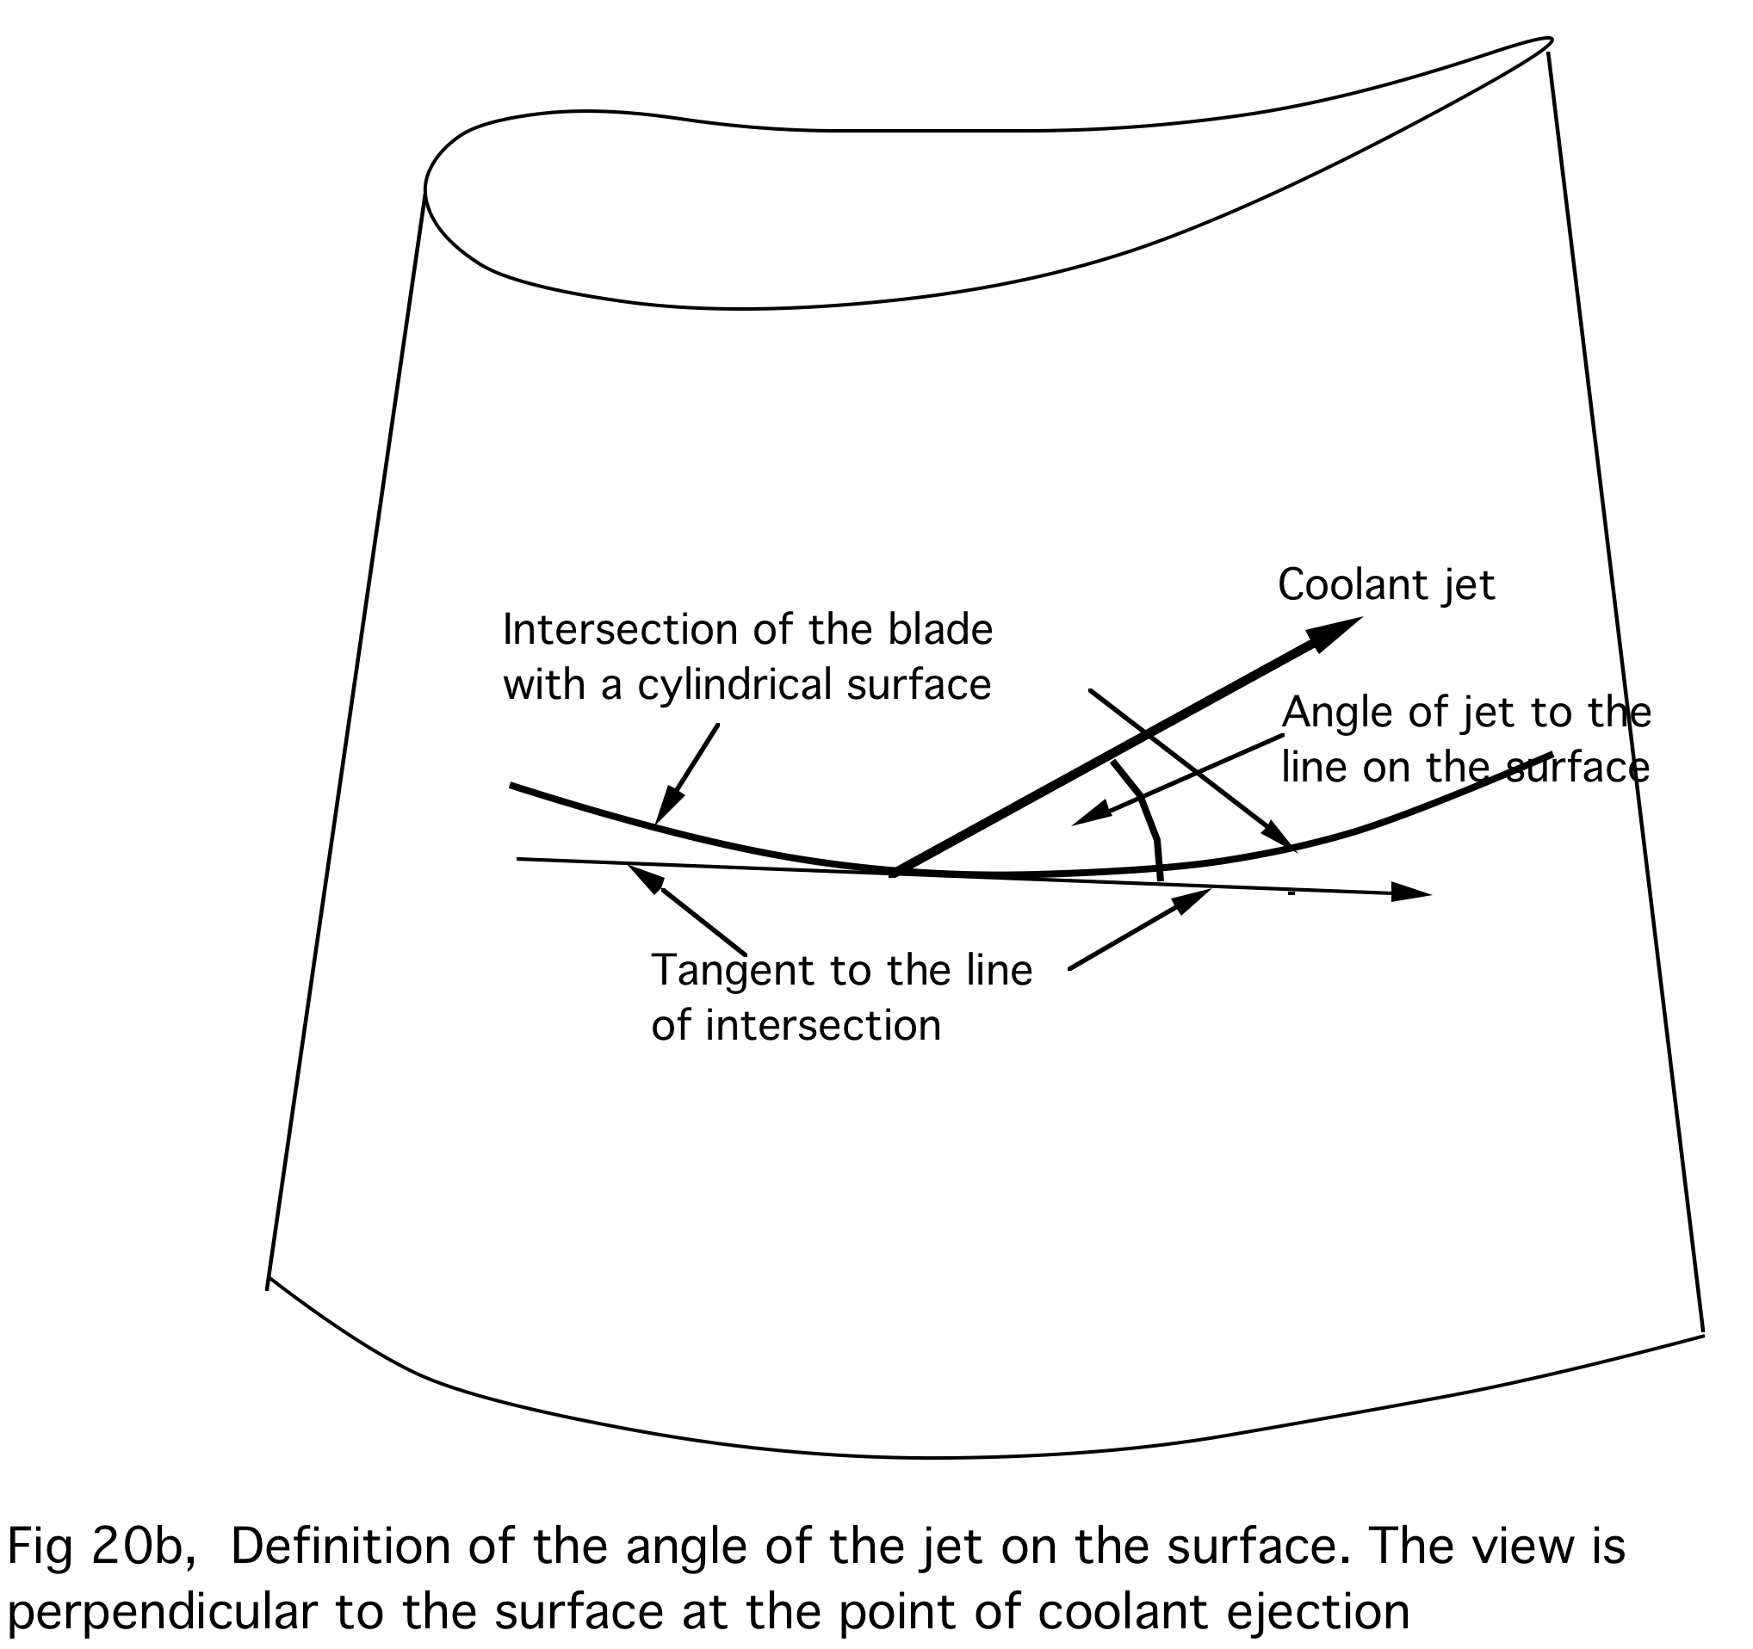

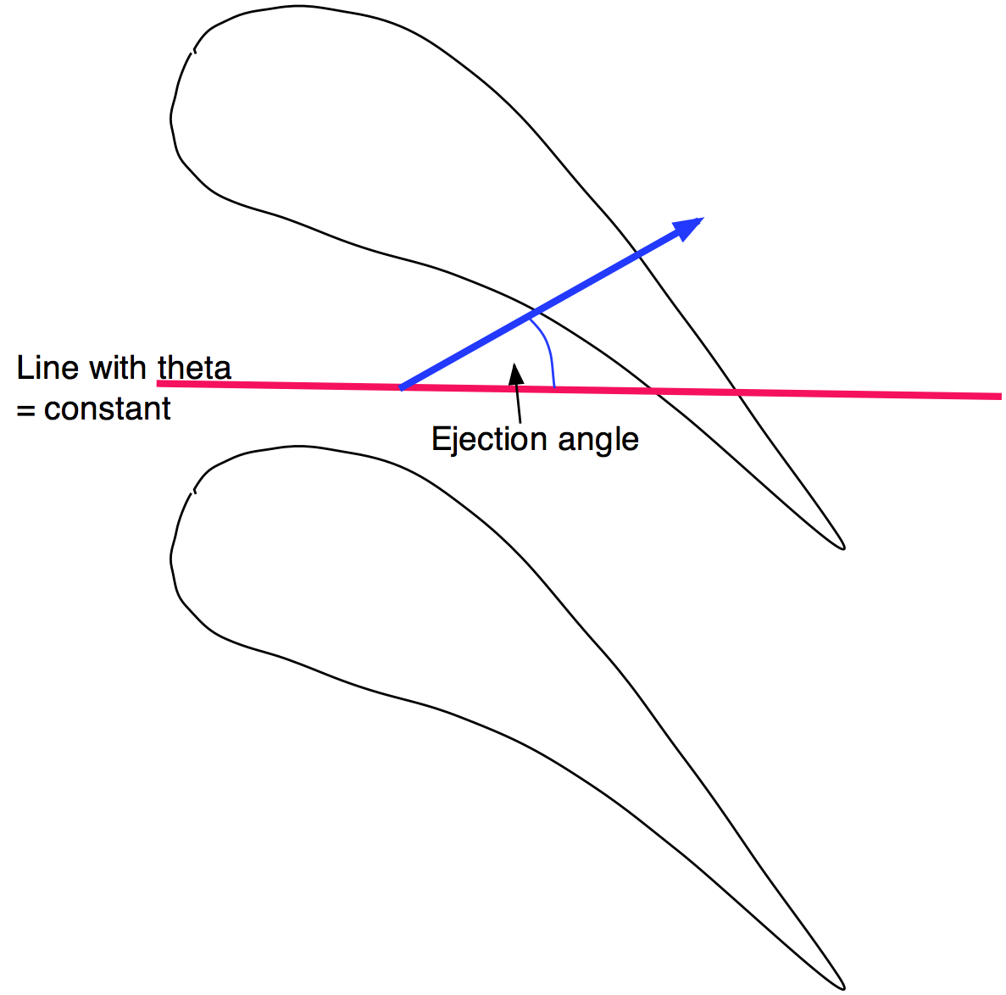
Fig 20c. Endwall Coolant ejection angle.

These definitions of cooling flow direction have been chosen because they can be easily applied to both axial and radial flow machines.

NOTE 15 USE OF A TRAILING EDGE CUSP.

If a fine grid is used around a blunt trailing edge (TE) it is usually found that the flow does not separate soon enough at the start of the trailing edge circle. This leads to a locally low pressure as the flow follows the highly curved surface and gives an unrealistic loading of the TE. Usually this produces a negative load at the TE due to too low a pressure on the pressure surface. In practice it is always found that, in subsonic flow, the loading falls to zero at the TE.

To overcome this problem it is recommended that a cusp is fitted to the TE. The cusp is a triangular region behind the TE , as shown in the figure below, which may be regarded as an extension of the blade surface, except that flow can pass through it. The cusp is made to carry no tangential force and so does not contribute to the lift on the blade or the work done by it. However, it does exert a meridional force on the blade, which is exactly balanced by the force it exerts on the flow. This force can be thought of as a base pressure x the tangential thickness of the TE.

The portion of the blade upstream of the trailing edge is modified so that any high curvature due to the trailing edge circle is removed and the smooth surfaces before the start of the curvature are extrapolated to the trailing edge point. The trailing edge point will then have a finite thickness and this forms the base of the cusp. The cusp can then be aligned with either the blade centre line (most usual) or with either blade surface and its length can be input in terms of the number of grid points on it. A cusp is chosen by setting IFCUSP = 1 in Card 52.

If IFCUSP = 1 then ICUSP, LCUSP and LCUSPUP are input in the next card, Card 53.
ICUSP = 1 The cusp is aligned with the I=1 blade surface
ICUSP = -1 The cusp is aligned with the I = IM blade surface
ICUSP = 0 The cusp is aligned with the blade centre line. This is the usual choice.
LCUSP Is the number of cells on the cusp.
LCUSPUP The cusp starts this number of grid points upstream of the trailing edge.
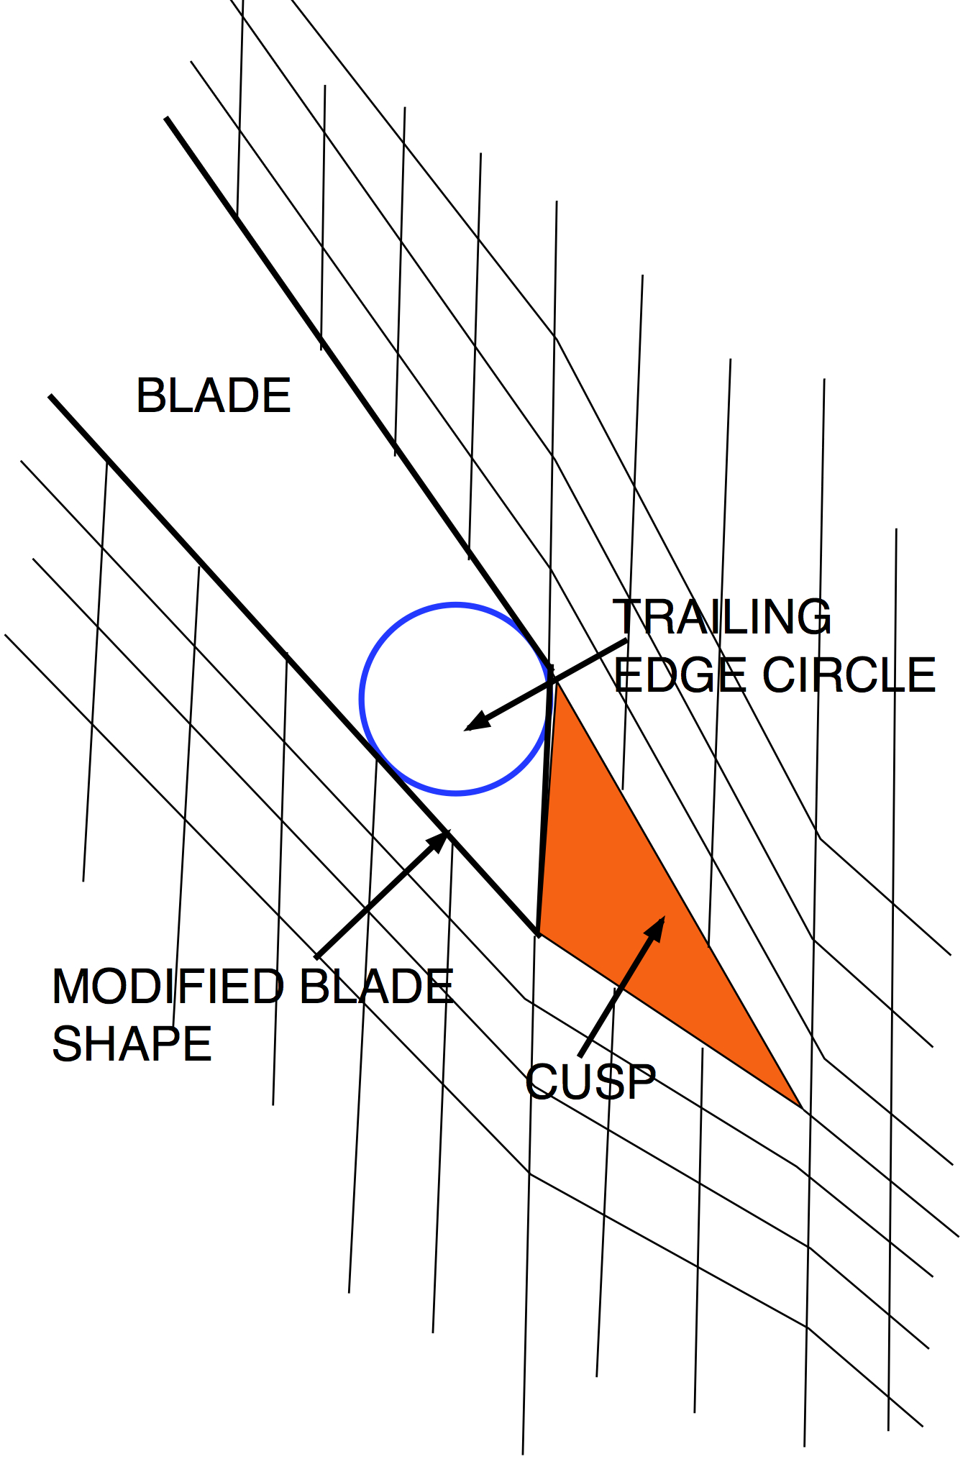
NOTE 16 USE OF A BODY FORCE TO MAKE THE FLOW SEPARATE AT A THICK TRAILING EDGE

It is difficult to use a cusp on a blade row with a very thick trailing edge but if the grid is refined around the trailing edge (TE) the flow will usually not separate soon enough, leading to a locally low pressure on the pressure surface and negative blade loading at the TE. This is not physically realistic and in practice the flow usually separates at the start of the trailing edge circle (blend point). To try to overcome this a TE separation can be forced by a body force field allowing a fine mesh to be used around the TE. This is invoked by setting IFCUSP = 2.

The body force is applied over a region defined by NSEP_I1, NSEP_IM, N_WAKE and SEP_THICK all of which are input in Card 54.

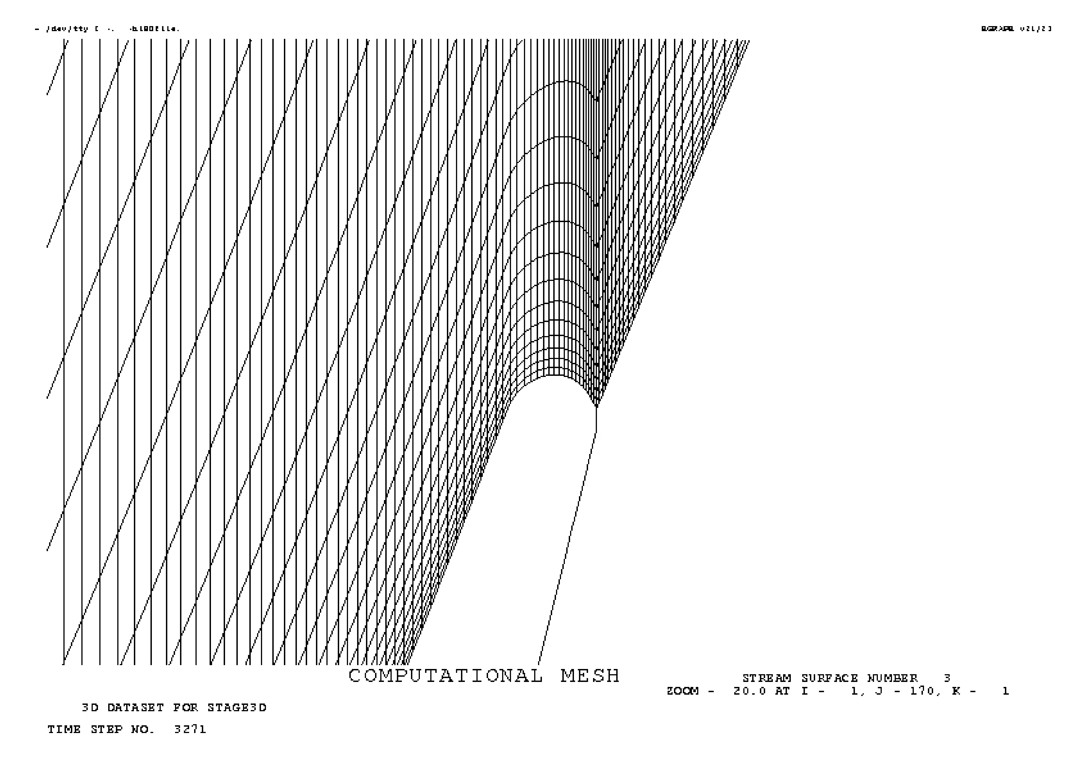
NSEP_I1 is the number of grid points upstream of the TE from which the blade I = 1 surface is extrapolated. NSEP_IM is the same for the I = IM surface . The force field extends N_WAKE grid points downstream of the trailing edge point , JTE , this value may be negative to stop the force field before the TE. The body force is applied over a region which is more than (SEP_THIK x local blade thickness) inside the extrapolated region. The magnitude of the body force is proportional to
(1 – SEP_DRAG) and it acts in the direction of the local velocity. Typically SEP_THIK = +0.01 (it may be positive or negative) and SEP_DRAG = 0.99 . Lower values of SEP_DRAG lead to virtually stagnant flow in the affected region.

Fig 15a. A fine grid around a thick trailing edge.

The body force is applied over the shaded region as illustrated below. The region may be made wider in the pitchwise direction by making SEP_THIK negative.

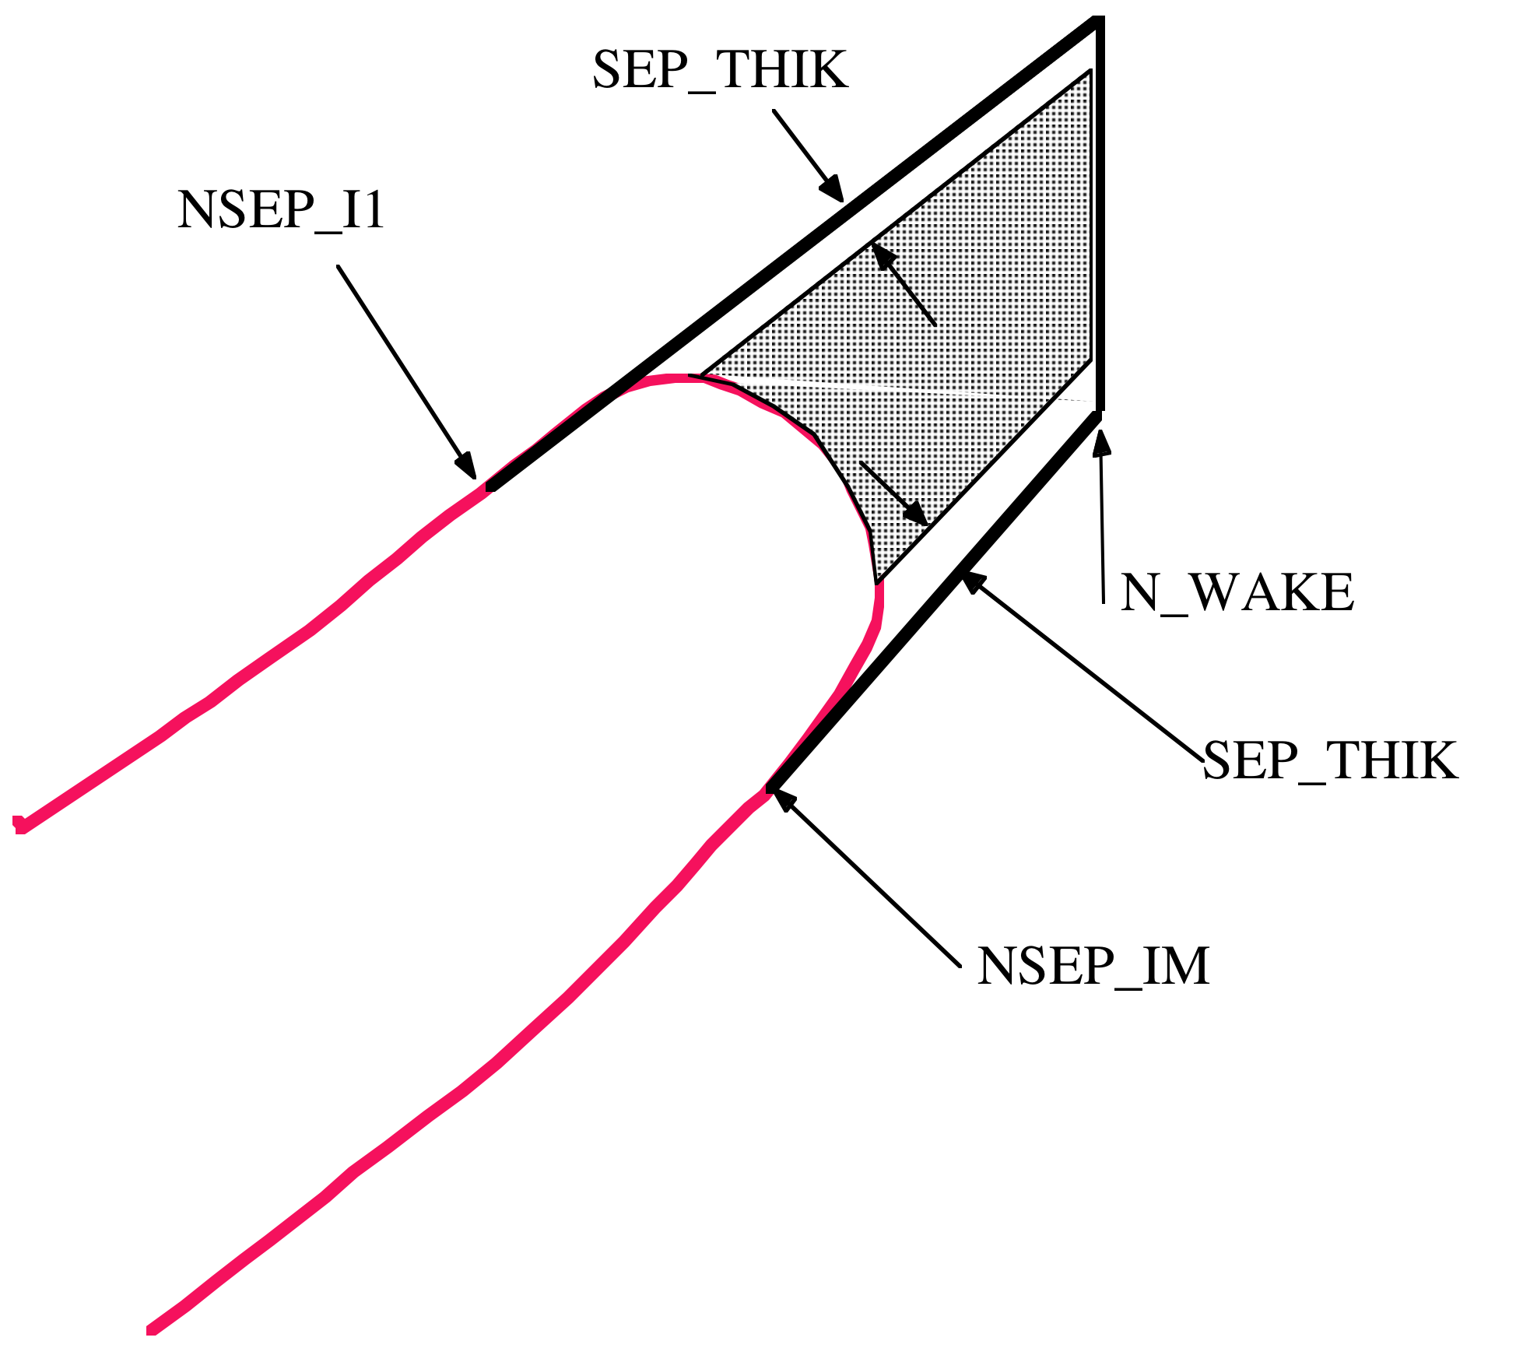
Fig 15b. Extent of the body force field.
Body force is applied over the shaded region

In practice this option is seldom used. It is easier to use a cusp with the option to extrapolate the blade surface from upstream of the TE, so that there is no large change of curvature of the blade surface and the TE itself has a finite thickness, then to form a cusp over several grid points downstream of the TE.
NOTE 17 THE MIXING PLANE MODEL

Development of a good mixing plane model is one of the most difficult problems in CFD. The mixing plane is an artificial concept designed to permit steady calculations of blade rows which are in relative motion due their rotation. It is generally assumed that the mixing plane should allow the flow from an upstream blade row to mix out as if it were doing so in a long duct with constant area and it should allow the flow to enter the downstream row as if it had originated from a pitchwise uniform flow far upstream. Hence the mixing plane must transmit the mixed out fluxes of mass momentum and energy from one blade row to the next whilst causing the minimum distortion to the pitchwise non-uniform flows leaving the upstream row and entering the downstream row. The mixing out of a non-uniform flow to a pitchwise uniform flow is generally an irreversible process and although the fluxes of mass, momentum and energy must be conserved in the mixing process the entropy will usually increase. This increase in entropy represents the mixing loss which occurs in the real flow. However, It should be emphasised that this is only a model of reality and it is not obvious that the mixing loss, which occurs in the unsteady flow in a real machine, is the same as that at the mixing plane.

Several different mixing plane model have been used during the development of MULTALL. The latest one in MULTALL-14.6, MULTALL-15.2 and MULTALL_OPEN is thought to be the best yet. It is a combination of the latest one used in TBLOCK, which is robust and permits reversed flows across the mixing plane, with the flux extrapolation method used in earlier versions of MULTALL. The same model is now used in both MULTALL and TBLOCK.

As in all previous versions there are two coincident “J’ grid surfaces at the mixing plane. These are numbered JMIX and JMIX+1. All flow properties are pitchwise uniform and equal on both of these faces, although they will vary in the spanwise (K) direction. The pitchwise uniform value is the mixed out value. The values are made equal on both surfaces by treating the flow from JMIX to JMIX+1 as if it were between two faces of a one-dimensional finite volume cell, which extends over the whole pitch, and time stepping the flow between them, exactly as for the cells in the rest of the grid. This ensures that when the solution is converged the fluxes on the two coincident surfaces become equal. Since the flows are pitchwise uniform this makes all the flow properties equal on the two faces.

The upstream and downstream faces of the mixing plane are decided by checking the flow direction on each spanwise (K) grid surface and the direction can change from one surface to the next. There is no presumption that the flow is in the positive J direction. Hence the model can allow any amount of reverse flow.

For the cells upstream of the mixing plane, i.e. , assuming that the flow is in the positive J direction, those between JMIX-1 and JMIX, the fluxes on their upstream face are calculated as usual but the fluxes on their downstream face, i.e. on the mixing plane, JMIX, are obtained by flux extrapolation. If the upstream face is JMIX-1, this involves adding a fraction of the difference between the local flux and the pitchwise averaged flux at JMIX -1 to the flux calculated from the uniform flow at JMIX. i.e.

FLUX_{jmix} = FLUX_{avg},_{jmix} + FEXTRAP x (FLUX_{jmix-1} – FLUX_{avg,jmix-1})

Hence the cells between JMIX-1 and JMIX “see” only a fraction (1-FEXTRAP) of the uniform flux at the mixing plane. FEXTRAP is input as data and a typical value is 0.8 - 0.9. The more closely the grid lines JMIX-1 and JMIX are spaced the larger should be FEXTRAP, values of 0.99 can be used for very close spacing. The value should be decreased for wide spacing of the grid points when there will be more decay of the non-uniformity between the grid points.

The pitchwise average flux at JMIX is not changed by this procedure and so the uniform flow at JMIX satisfies conservation of mass, momentum and energy between the non-uniform flow at JMIX-1 and the uniform flow at JMIX , hence it is the mixed out flow corresponding to the non-uniform flow at JMIX-1 .

A different model is used if FEXTRAP is set to zero. In this case there is no flux extrapolation and the changes in the primary variables in the cells immediately upstream of the mixing plane are then made pitchwise uniform. Note that it is the changes not the values that are made uniform. The treatment then becomes the same as in TBLOCK-13 where it was found to be exceptionally robust.

Flux extrapolation was found to be of little benefit and slightly destabilising on the downstream side of the mixing plane and so is not used there. Since, with flow in the positive J direction, JMIX+1 is on the mixing plane the next surface downstream of the mixing plane is JMIX+2. The cells between JMIX+1 and JMIX+2 are updated using the pitchwise uniform flux from the uniform flow at JMIX+1 and the pitchwise average flux at JMIX+2. Hence the changes that points at JMIX+2 receive from their upstream cells is pitchwise uniform. However, they also receive a pitchwise non-uniform change from the cells downstream of them so the flow on them is not pitchwise uniform. This ensures conservation of mass momentum and energy between the mixing plane and the downstream flow. This is the treatment used in TBLOCK-13, it is robust and permits reversed flow but it does tend to make the flow too uniform when applied close to a leading edge, in which case the entropy and enthalpy downstream of the mixing plane may not be pitchwise uniform. This is overcome by smoothing the flow at JMIX+2 towards an isentropic flow which is calculated using with the local static pressure at JMIX+2, the pitchwise uniform enthalpy and entropy from JMIX+1 and the flow direction from a weighted average of the pitchwise uniform value at the mixing plane and the average of the pitchwise varying values at JMIX+3 and JMIX+4 . The fraction of the average downstream angles used is FANGLE, which is input as data in card 19, and for which a typical value is 0.9 . Taking the average flow direction from JMIX+3 and JMIX+4 was found to be more stable and not significantly less accurate than extrapolating the flow direction from JMIX+3 and JMIX+4. On every time step the flow at JMIX+2 is smoothed towards this isentropic value by a factor RFMIX, a low value of 0.01 is usually sufficient for this, although higher values (say 0.05) are usually perfectly stable. If RFMIX = zero then there is no smoothing to isentropic flow and the treatment is the same as in TBLOCK-13.

This procedure works well in all cases except those when the flow relative to the downstream blade row is supersonic so that pressure waves, either expansions or shocks, run into the mixing plane from downstream. In this case the pitchwise variation in flow direction downstream of the mixing plane must be compatible with the Mach number variation, i.e. they must satisfy the Prandtl-Meyer relationship. Whenever the downstream flow is supersonic this relationship is used everywhere except at mid-pitch, where the angle is still set by the angle extrapolation. This allows pressure waves to intersect the mixing plane without reflection as illustrated in the Figure below.

The smoothing of points adjacent to the mixing plane has also been changed so that it does not include values of the variables on the mixing plane, this ensures that the pitchwise uniform values on the mixing plane do not influence the rest of the flow. This smoothing is scaled by FSMTHB which is input as data and for which a typical value is 1.0, however, the exact value does not seem to have much effect on the solution.

To use exactly the same mixing plane model as in TBLOCK-13 set both FEXTRAP and RFMIX = 0.0
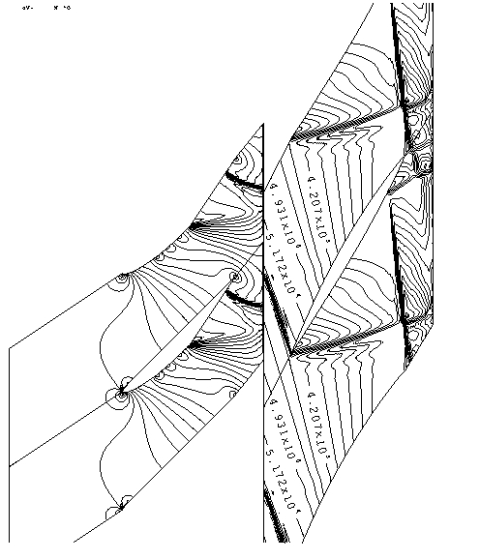
Intersection of pressure waves with the mixing plane.

The model described also works well with reverse flow across the mixing plane as illustrated by the Figure below. 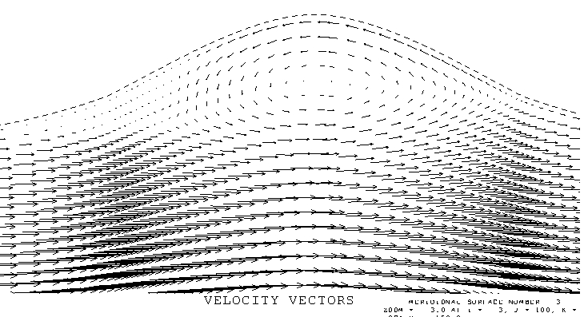
Reverse flow across the mixing plane, which is in the centre of the bulge.

NOTE 18. LOW MACH NUMBER SCHEMES

The “scree’ scheme works well at Mach numbers down to 0.25 but convergence becomes slower and the solutions become less smooth below this. To run at very low and incompressible Mach numbers a method based on artificial compressibility is used.

Instead of solving the continuity equation for the density it is effectively solved for the pressure using an artificial density, ρ_{s} , as a conserved variable. This is used to calculate the pressure using

P_{ref} is usually the inlet stagnation pressure, ρ_{s},_{ref} the inlet stagnation density. S is an artificial speed of sound, whose value is set in the data and is typically about twice the maximum relative velocity expected in the flow, much less than the true speed of sound. The time steps are based on this artificial speed and so can be larger than the conventional steps by a factor c/S. The changes in the artificial density are a factor (c/S)² greater than those of the true density and so are not so susceptible to rounding errors.

The energy and momentum equations are solved in the usual way to obtain ρE, ρVx, ρVr and ρ rV_{θ}.

The true density, ρ , undergoes only small changes and is only used to obtain the velocities
, V , from the mass fluxes, ρ V . Hence it can be calculated from the pressure and temperature, using the gas law, with relaxation of the changes by a factor RF_PTRU , for which a typical value is 0.01. The true density is then used to obtain the velocity components and the internal energy. If the flow is incompressible then the constant density is used.

The value of the artificial speed of sound is automatically updated every 5 time steps using

S_{new} = VMAX x VS_VMAX

S = (1-RF_{S})*S + RF_{S}* S_{new}

where VMAX is the current maximum relative velocity in the flow and VS_VMAX is input as data with a typical value = 2.0. RF_{S} has a typical value = 0.002 so that the speed is only updated over the order 1000 time steps.

The method works down to fully incompressible flow and can be used for multistage calculations. However, the calculated efficiencies are not reliable because they use the true density changes which are very small

NOTE 19 THE QUASI-3D BLADE-TO-BLADE MODEL

The code can be run with only two spanwise gridlines to predict the flow between two stream surfaces. With cell corner storage it is necessary to have two spanwise grid points, one on each stream surface, as illustrated in the Figure below. The coordinates of only one stream surface are input and the spacing of the stream surfaces, i.e. the stream surface thickness, is input as data. It is trivial to specify no flow through the stream surfaces but this is not sufficient to ensure that the velocity vectors follow the mean surface. It is usual to apply a body force acting perpendicular to the flow to ensure this. However, with two grid points it is possible to apply the force via a pressure difference between the two surfaces. The mid point of the two surfaces is regarded as a boundary between two half cells. Any flow crossing this boundary will cause an increase in pressure in one half cell and an equal decrease in the other half cell. This is in addition to the change in pressure calculated by the normal solution procedure which is the same on both surfaces.
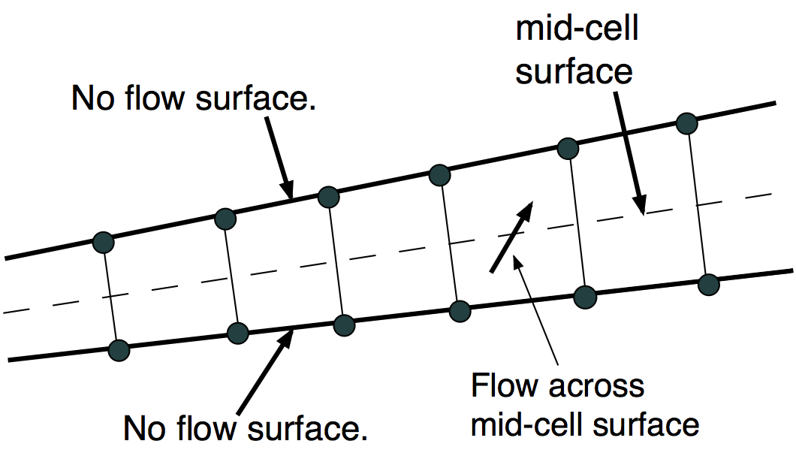
The change in pressure is calculated in a time marching fashion using

The mass flux is the flow crossing the mid-surface and c is an estimate of the local speed of sound. This gradually builds up a pressure difference that drives the flow crossing the mid-surface to zero. Since the change in pressure is equal and opposite on the two stream surfaces this does not affect the streamwise component of the pressure force applied on the flow by the surfaces.

The blade geometry is input in the usual way but only on a single stream surface. The stream surface thickness is input separately as a table of relative thickness against fraction of meridional distance. Only the relative thicknesses are needed, the absolute values are not used.

The pressure changes calculated by the equation above are factored by an input variable, Q3DFORCE. The value of this does not seem to be very important, very low values, e.g. 0.1, are stable but do not make the flow follow the stream surface very closely. A value of 1.0 is standard, larger values are usually stable but offer no advantage.

Viscous forces are retained on the blade surfaces but not on the stream surfaces so that the model gives a prediction of the blade profile loss. Run times for a single blade row are the order of 10 seconds on a single processor.
NOTE 20 THE THROUGHFLOW MODEL

The program can run as a type of throughflow calculation if IM is set equal to 2 so that there is only a single cell in the pitchwise direction. The full 3D blade geometry must be input in the usual way. However, the number of grid points in the streamwise, J, and spanwise, K, directions can be much less than for a 3D calculation. Typically 30 points streamwise and 15 points spanwise would be sufficient. This gives run times of only a few seconds per blade row.

As with the Q3D method (Note 19) a mean stream surface is defined at the mid point of the blade-to-blade gap as illustrated in the Figure below. Any flow crossing this surface causes an increase in pressure on one blade surface and an equal decrease on the adjacent surface. This builds up an approximate blade loading which is updated every time step until the flow follows the mean surface. The blade loading automatically acts perpendicular to the mean surface and so does not generate loss. The loading distribution is only a crude approximation to the true 3D loading but its overall magnitude will be compatible with the flow turning imposed by the blade. This, coupled with the use of the full 3D blade geometry makes the prediction of the effects of blade lean and sweep realistic.

As with the Q3D model the pressure changes are scaled by a factor, Q3DFORCE, which is input as data. The exact value of this is not very important, the standard value is 1.0 but larger values are usually stable and may give faster convergence. It is also found to be very beneficial to smooth the blade surface pressures as otherwise they tend not to be smooth. The smoothing also has the benefit of reducing the blade loading at the leading edge where it can become very high due to a sudden change in flow direction. The smoothing factor, SFPBLD, and number of smoothing passes, NSFPBLD, are input as data with standard values being 0.1 and 2 respectively. It should be emphasized that this smoothing only affects the blade loading and not the average pressures acting on the flow.

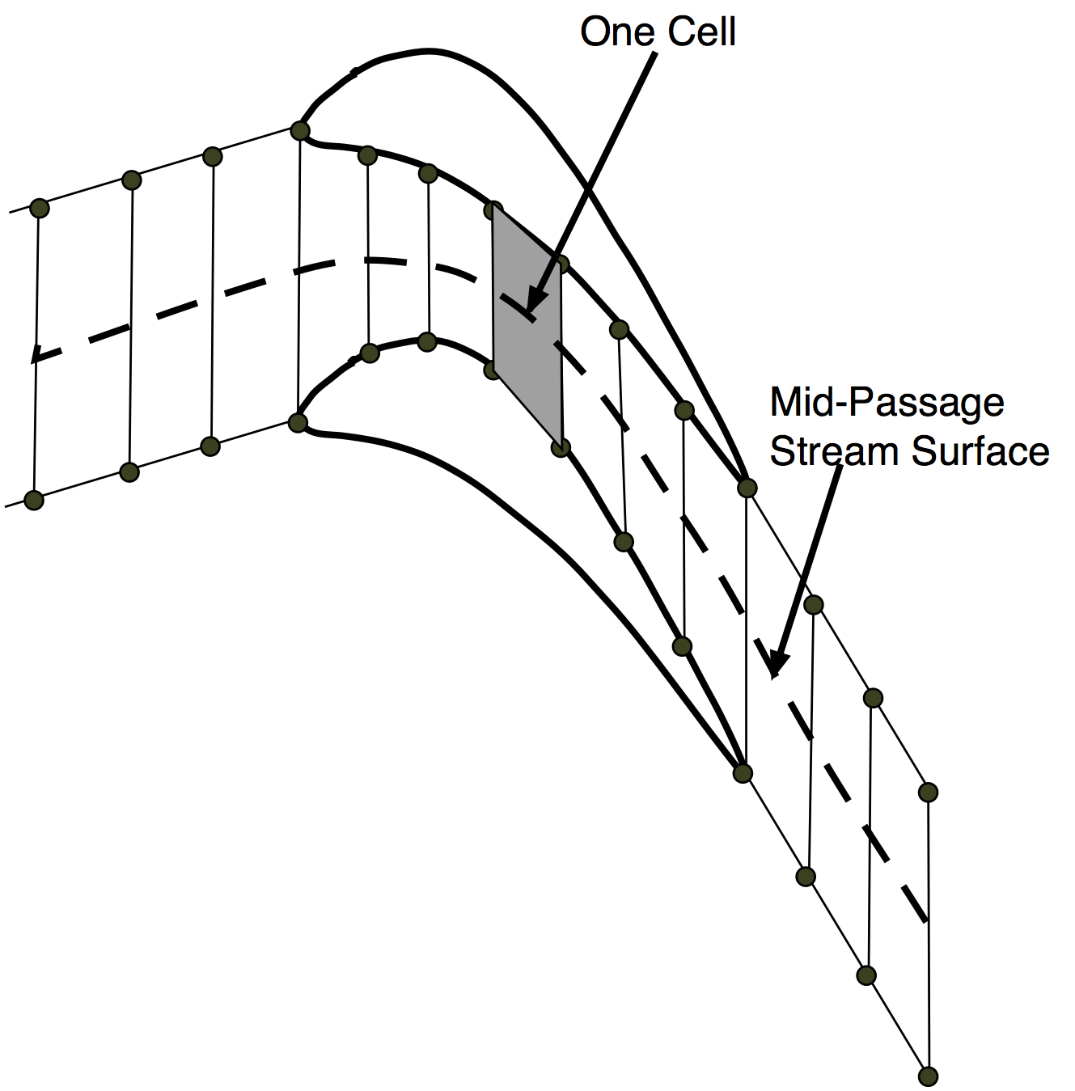

As with any throughflow method it is necessary to allow for any flow deviation empirically and this is done by inputting a table of either the deviation angle or the exit flow angle against fraction of span. The deviation between the flow angle and the blade centre line angle is increased from zero at the leading edge to the specified value at the trailing edge, varying linearly with the grid J index. The deviation causes the blade force to no longer act perpendicular to the flow and so, to prevent spurious loss generation, it is resolved perpendicular to the imposed flow.

Most throughflow programs also input the loss coefficients empirically, however, in the present code it is more convenient to maintain the shear stresses on the blade surfaces and so allow the loss to be generated automatically. Clearly the wall functions are not valid when there are only 2 grid points across the pitch but the wall function model which works by specifying the value of Yplus at the grid point on the wall generates a skin friction coefficient of C_{f} = 2/(Yplus)² . This method is used when YPLUSWALL is set to be greater than 5.0 . Inputting a value of YPLUSWALL = 20 gives a very typical value of C_{f} = .005, this acts on the relative velocity which is the same on both blade surfaces and so produces realistic losses.

Tip leakage can still be modeled in this method but there is no pressure difference driving the flow across the tip gap and so the leakage flow is not deflected by the blade and is only due to the difference between the inlet flow direction and the blade surface angle, hence its magnitude and loss generation is likely to be lower than in reality.

The flow along every stream tube is effectively one-dimensional with the local flow area being that measured normal to the mean stream surface. This means that choking occurs as in 1D nozzle, the flow will choke at the point of minimum area and only normal shock waves can be predicted in supersonic flow downstream of the throat. The method therefore cannot predict the oblique shock waves that are common in turbomachines. This limitation is common to all time-marching throughflow methods which specify the flow direction. When used on a blade row with supersonic flow within the blade to blade passage, such as a transonic fan, unrealistic shock waves and shock loss can be predicted.

