This is your basic whitepaper designed by a team of one.

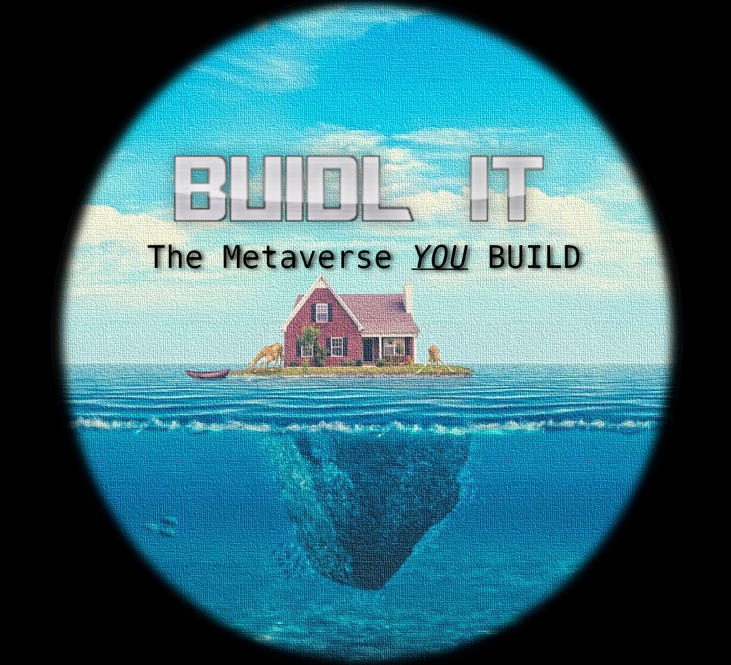
I don’t have time for fancy - just details - I am one DEV and one DEV alone.
They call me Macguyver for a reason and its the same reason they do not call me GANDALF.
I can perform wonders but not MAGIC.

For the Utility Token and NFT the launch will be on the ETHEREUM chain for longevity and security there will be a claimable "play only” NFT launched on the POLYGON NETWORK

There will be no fancy presales or convoluted and dramatic launch sequences.
WYSIWYG - in other words what you read here is it, the whole project and flow.

This project is a go as of 11 March 2022
launched - running - in development as we go please hold on!

If you want to contribute please do so by email or contact via github.

next steps:

- Launch erc721 token called BUIDL price 250 USDT - ETHEREUM -
estimated date - 14th march 2022

- Launch erc20 token called IT - price 1 USDT - ETHEREUM - estimated date - 20th march 2022

- token and NFT give aways TBA probably 2.5k of $IT and 20 NFTs - not convoluted. Ask and receive

- Launch locked staking contract - estimated date 01 april 2022
Publish staking page for 3, 6 and 9 months to reward 27.5%, 35.5% and 54.9% APY claimable every 21 days

- Publish token sale page - estimated time - < april 5th 2022

- Publish NFT Rewards Pool Claim Page - < april 5th 2022

- Start sales of token for stable coins to create liquidity. - estimated date april 5th 2022 (coins will be held in the contract and can only be released to liquidity pair 80%)

- Start sales of NFTs - < april 5th 2022

- Publish 3D jobs board for platform users.< may 5th 2022

- Development starts for additional features to the 3D instance - estimated date march 11th 2022

- NFT Holders start to play - estmated date may 2022

- 3D Model viewer & uploader revealed - estmated date may 2022

- 3D model marketplace revealed - estmated date may 2022

Success landmarks?

Economy created.
players playing.
HODLing stakers earning APY

modelers creating selling models - for game and as a launchpad for their work to clients
gamers buying models to include in their world
programmers offering skills and time
gamers paying programmers in utility token to advance their worlds
marketplace is operational
NFT Holders receive rewards
I get to eat decent food and care for my baby giving her and my wife the life they deserve.

