
Supply Chain MANAGEMENT System
Report


Executive Summary
This report outlines the design, implementation, and analysis of a supply chain management system inspired by Wayfair. The system is designed as a C#.NET console-based application that supports warehouses to manage furniture inventory in a Microsoft SQL Server database (SupplyChainDb). The Binary Search Tree (BST) is a custom-built runtime data structure that provides an average-case search time complexity of O(log n) based on ItemID. This system assists nine different operations located in search by identifier, search by category, create an exhaustive inventory report, add an item, delete an item, sell an item, restock an item, create a low-stock report, and leave the system. Any modification in inventory quantities is immediately saved to the database so that cumulative QuantitySold and QuantityRestocked values ensure they are up to date. A team of five people conducted the implementation over six Scrum sprints and without using external libraries. Eighteen MSTest unit tests were used to verify that all core data structure operations and boundary condition work correctly these tests were all successful.

Table of Contents
1. Introduction 3
2.1 Justification of Data Structure 3
2.2 Class Design 3
2.3 Algorithm Analysis with Pseudocode 4
2.4 Time Complexity Summary 6
3.Testing 6
3.1 Testing Approach 6
3.2 Test Cases 7
4. Conclusion 9
4.1 Summary of Work Done 9
4.2 Project Sprint Overview 9
4.3 Limitations and Reflection 9
4.4 Future Approach 10
5. References 11

Tables of Figures
Figure 1 Class Diagram showing FurnitureItem, BSTNode, and CustomBST relationships 3
Figure 2 BST structure showing sample data inserted by ItemID with search path 3
Figure 3 BST Delete: three cases handled by the DeleteRecursive algorithm 4
Figure 4 MST test cases 5
Figure 5 Sprint / Gantt Chart showing task distribution across 6 sprints 7

1. Introduction
This report presents the design, implementation, and evaluation of a Wayfair-inspired Supply Chain Management System that was designed as part of the CST2550 Algorithms and Data Structures module.
The system is a C# .NET Console application used to allow warehouse personnel to administer furniture inventory kept in a Microsoft SQL Server database (SupplyChainDb). It supports the operations like search, add/remove, sell, restock, report on the items of the inventory. The core functionality of the application is implemented using a custom-built Binary Search Tree (BST), which serves as the primary runtime data structure and was selected for its O(log n) average-case search performance.
The development effort was undertaken by a five-member team that worked using Scrum methodology. No third-party libraries or auto-generated code have been used, all data structures and algorithms have been implemented by hand, written in C# as specified in the coursework.
The outline for the report is as follows: Section 2 Data structure design, class diagram and algorithm pseudo code with time complexity analysis. Section 3 is a description of the testing approach and contains all 18 test cases. Section 4 contains a conclusion consisting of overview of the sprint, limitation, and reflection. All the references are listed in Section 5.
2. Design

2.1 Justification of Data Structure
A Binary Search Tree has been chosen because the most common function is the search for items by their unique numeric ItemID. The property of BST guarantees that all the nodes that lie in the left subtree have smaller ItemIDs than those of the current node, and those in the right subtree have greater ItemIDs. Such an ordering has the effect that each comparison is likely to eliminate half of the remaining nodes. As a result, the computational complexity of search, insertion, as well as deletion, is O(logn) on average(Goodrich et al., 2013; Sedgewick and Wayne, 2011). Alternative structures were considered and turned down. Arrays and linked lists would be O (n) linear search costs. A hash table would give O(1) search but does not support ordered traversal, which is required to display the inventory sorted by ItemID (Atieh et al, 2016). The BST therefore provides both the efficient search and the natural in-order sorted output in O(n).

Data Structure | Search | Insert | Delete | Sorted Output | Verdict
Array (unsorted) | O(n) | O(1) | O(n) | No | Rejected
Linked List | O(n) | O(1) | O(n) | No | Rejected
Hash Table | O(1) | O(1) | O(1) | No | Rejected
Binary Search Tree | O(log n)* | O(log n)* | O(log n)* | Yes O(n) | Selected

2.2 Class Design
The system comprises three classes; FurnitureItem stores all data fields for a single inventory record, including table ItemID, Name, Category, WarehouseZone, Price, StockLevel and two persistent tracking fields, QuantitySold and QuantityRestocked, both of which are stored and retrieved from the SQL database. BSTNode is a wrapper for the FurnitureItem, that holds the references to its left and the right children. CustomBST is a manual binary search tree class that has embedded a hidden root node and logically overrides an integrated set of recursive procedures - namely, Insert, Search, Delete (and all three standard deletion cases), InOrderTraversal to present data in an ordered set, SearchByCategory, DisplayLowStockItems and GetMaxID - accordingly, offering powerful data manipulation and retrieval capabilities (Goodrich et al., 2013).

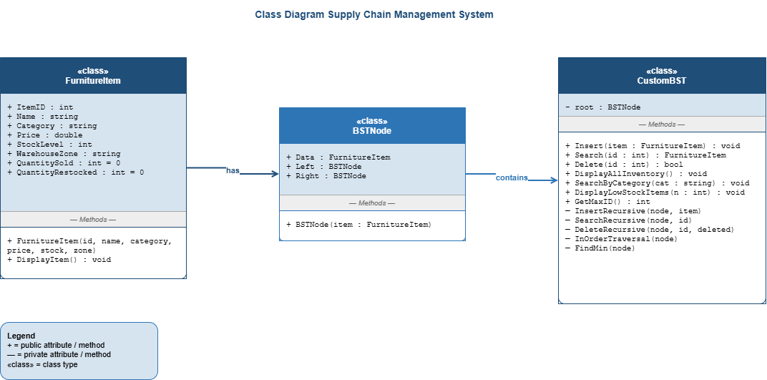

Figure 1 Class Diagram showing FurnitureItem, BSTNode, and CustomBST relationships

2.3 Algorithm Analysis with Pseudocode
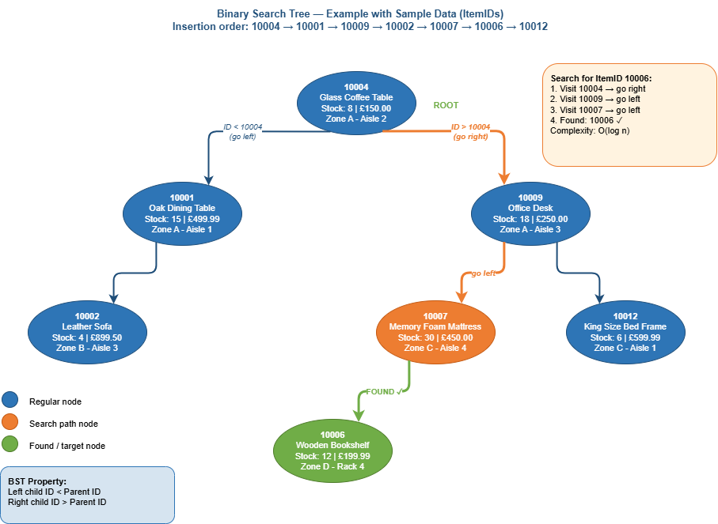
Figure 2 BST structure showing sample data inserted by ItemID with search path
INSERT O(log n) average / O(n) worst case
FUNCTION Insert(root, newItem)
IF root IS NULL THEN
RETURN new BSTNode(newItem)
END IF
IF newItem.ItemID < root.ItemID THEN
root.Left ← Insert(root.Left, newItem)
ELSE IF newItem.ItemID > root.ItemID THEN
root.Right ← Insert(root.Right, newItem)
ELSE
// Duplicate IDs ignored
RETURN root
END IF
RETURN root
END FUNCTION
SEARCH O(log n) average / O(n) worst case
FUNCTION Search(root, targetID)
IF root IS NULL THEN
RETURN NULL
END IF
IF root.ItemID = targetID THEN
RETURN root.Data
END IF
IF targetID < root.ItemID THEN
RETURN Search(root.Left, targetID)
ELSE
RETURN Search(root.Right, targetID)
END IF
END FUNCTION
DELETE O(log n) average / O(n) worst case
The Delete operation has three structurally different cases as shown in Figure 3. In case1 the leaf node has no children and its removal is by returning null. Case 2 is used when the node has one child, the node is just replaced by the child. Case 3, the most complex it occurs when the node has two children. In this case, the information stored in the node is swapped with in-order successor which is the minimest node in the right sub-tree. Then the successor is deleted recursively, thus maintaining the BST ordering property in the process.
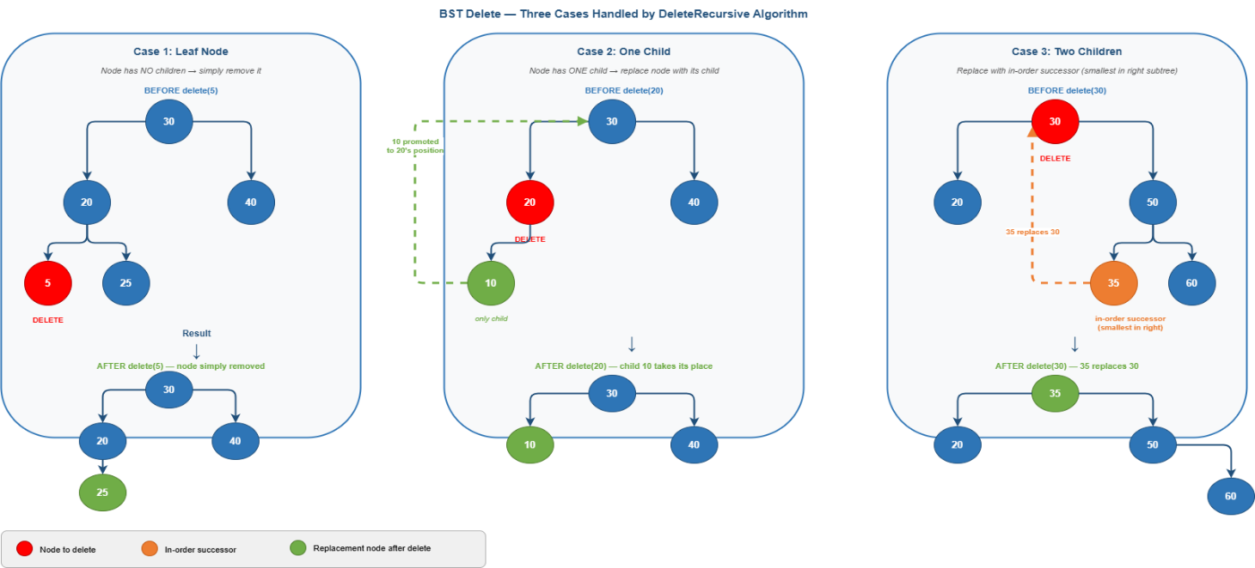
Figure 3 BST Delete: three cases handled by the DeleteRecursive algorithm
FUNCTION Delete(root, targetID)
IF root IS NULL THEN
RETURN NULL
END IF
IF targetID < root.ItemID THEN
root.Left ← Delete(root.Left, targetID)
ELSE IF targetID > root.ItemID THEN
root.Right ← Delete(root.Right, targetID)
ELSE
// Node found
IF root.Left IS NULL THEN
RETURN root.Right
END IF
IF root.Right IS NULL THEN
RETURN root.Left
END IF
// Case 3: Two children
successor ← FindMin(root.Right)
root.ItemID ← successor.ItemID
root.Data ← successor.Data
root.Right ← Delete(root.Right, successor.ItemID)
END IF
RETURN root
END FUNCTION
IN-ORDER TRAVERSAL (Display All) O(n)
FUNCTION InOrderTraversal(root)
IF root IS NOT NULL THEN
InOrderTraversal(root.Left)
PRINT root.Data
InOrderTraversal(root.Right)
END IF
END FUNCTION

2.4 Time Complexity Summary

Operation | Best Case | Average Case | Worst Case | Notes
Insert | O(1) | O(log n) | O(n) | Root insert / skewed tree
Search by ID | O(1) | O(log n) | O(n) | Root match / skewed tree
Delete | O(1) | O(log n) | O(n) | Root leaf / skewed tree
Display All | O(n) | O(n) | O(n) | Visits every node
Category Search | O(1) | O(n) | O(n) | No BST ordering on category
Low Stock Report | O(n) | O(n) | O(n) | Full traversal required
GetMaxID | O(1) | O(log n) | O(n) | Rightmost node

3.Testing

3.1 Testing Approach
Unit testing has been performed using the MSTest unit testing framework (Microsoft.VisualStudio.TestTools.UnitTesting) in a separate Visual Studio test project which has a reference to the main SupplyChain project. Each test method is independently structured, creating its own instances of the CustomBST or FurnitureItem, ensuring that no state is shared across tests. FurnitureItem tests are using IDs to match the database range (10001, 10004) while BST structural tests use small IDs (5, 10, 30, 150) in order to keep tree shapes simple and predictable, independent of the database sample data.
The tests are divided into 3 divisions (1) correctness of the FurnitureItem class (2) operations of CustomBST (insert, search, delete, GetMaxID) and (3) stock boundary conditions. Both positive tests as well as negative tests (edge cases: empty tree, non alternative IDs, duplicate inserts) are included. All 18 of the tests pass successfully.
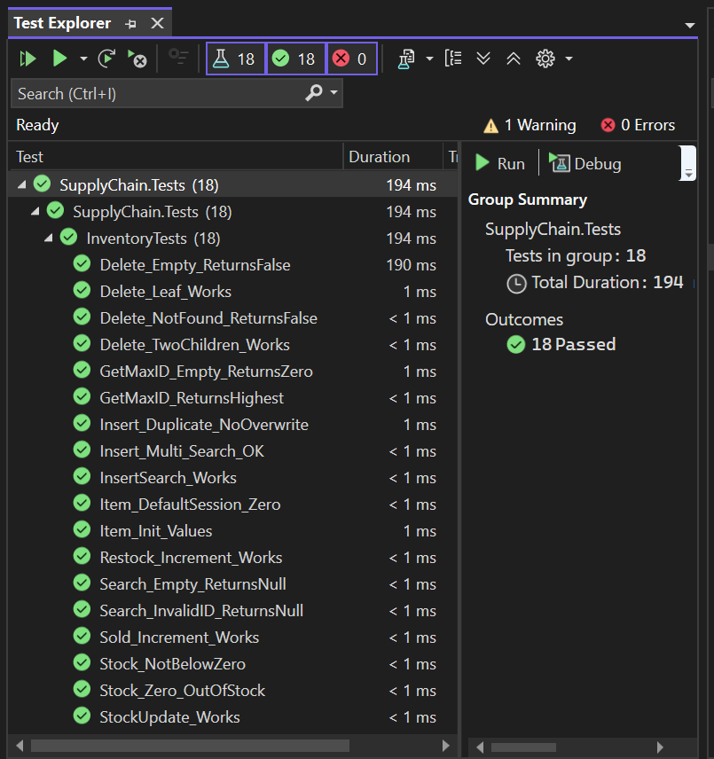
Figure 4 MST test cases

3.2 Test Cases

# | Test Method | Category | Input / Action | Expected Result | Pass/Fail
1 | InsertSearch_Works | BST | Insert ID 10001, search 10001 | Returns item, Name='Leather Sofa' | Pass
2 | Search_InvalidID_Returns Null | BST | Insert ID 10002, search 999 | Returns null | Pass
3 | StockUpdate_Works | Stock | Stock=20, sell 5, restock 10 | StockLevel = 25 | Pass
4 | Item_Init_Values | FurnitureItem | Create item ID 10004 all fields | All fields match constructor | Pass
5 | Item_DefaultSession_Zero | FurnitureItem | Create new item ID 10005 | QuantitySold=0, Restocked=0 | Pass
6 | Sold_Increment_Works | Stock | ID 10006: Stock=15, sell 4 | StockLevel=11, QuantitySold=4 | Pass
7 | Restock_Increment_Works | Stock | ID 10007: Stock=2,  restock 10 | StockLevel=12, Restocked=10 | Pass
8 | Insert_Multi_Search_OK | BST | Insert IDs 150,30,70; search each | Correct item for each ID | Pass
9 | Insert_Duplicate_NoOverwrite | BST | Insert ID 200 twice (diff names) | Original name preserved | Pass
10 | Search_Empty_ReturnsNul l | BST | Search empty tree | It returns null | Pass
11 | Delete_Leaf_Works | BST Delete | Insert 10,5,15 delete leaf | Returns true; search(5)=null | Pass
12 | Delete_TwoChildren_Works | BST Delete | Insert 10,5,15 and delete root 10 | Returns true; 5 and 15 intact | Pass
13 | Delete_NotFound_Returns False | BST Delete | Delete non-existing ID 999 | Returns false | Pass
14 | Delete_Empty_ReturnsFalse | BST Delete | Delete the ID 10001 from empty tree | Returns false, no exception | Pass
15 | GetMaxID_ReturnsHighest | BST | Insert 10,25,5 call GetMaxID | Returns 25 | Pass
16 | GetMaxID_Empty_Returns Zero | BST | Empty tree GetMaxID | Returns 0 | Pass
17 | Stock_NotBelowZero | Boundary | ID 10008 Stock=3, sell exactly 3 | StockLevel=0, QuantitySold=3 | Pass
18 | Stock_Zero_OutOfStock | Boundary | ID 10009 Create with StockLevel=0 | StockLevel == 0 | Pass

4. Conclusion

4.1 Summary of Work Done
The team managed to design and implement a fully functional furniture supply chain management system in C# .NET. A custom Binary Search Tree was built entirely from the scratch, and implementing all the core operations including insertion, search, deletion (covering all three structural cases) in-order traversal, category search and the low stock reporting. The system is coupled with a Microsoft SQL Server database (SupplyChainDb) all changes in inventory (add, remove, sell, restock, etc.) are immediately persisted, including QuantitySold and QuantityRestocked, which are now permanent database fields and survive application restarts (Zhang and Pan, 2022). Changes were made to the SQL schema setting the IDENTITY(10001,1) for auto incrementing the ItemID. A nine option menu driven console interface offers complete user interaction with full input validation. Eighteen MSTest unit tests those all operations of core data structures as well as stock management logic.

4.2 Project Sprint Overview
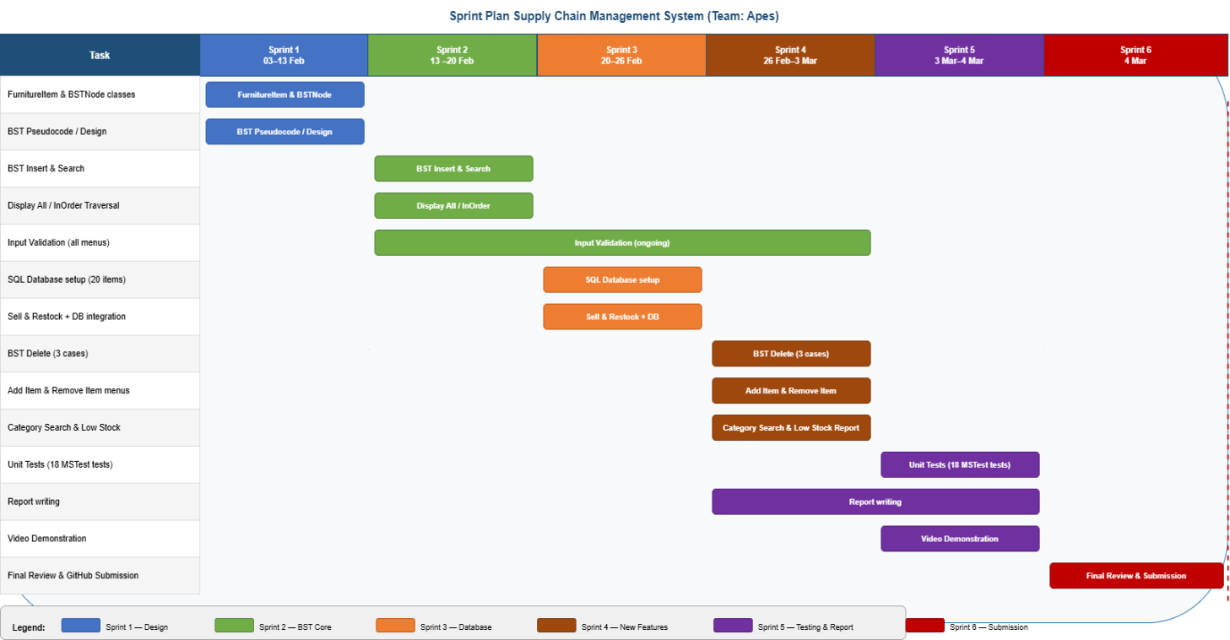
Figure 5 Sprint / Gantt Chart showing task distribution across 6 sprints

4.3 Limitations and Reflection
The main disadvantage of the current implementation of the BST lacks of self-balancing. If items are inserted in ascending or descending order, i.e. in order of Insertion of ItemID, a situation that can happen if the items are inserted in the sequence from a database, the tree degenerates into a linked list, meaning all operations will degrade from O(log n) to O(n). It would guarantee O(log n) in the worst case if a self balancing AVL tree or Red Black tree is implemented (Adelson - Velsky and Landis, 1962; Cormen et al., 2022).
Category search is the O(n) because of keying of the BST on the ItemID instead of the category.Introducing a secondary data structure, keyed on category, would make this better. The QuantitySold and QuantityRestocked columns are now added to the table and set to DEFAULT 0 along with the ItemID column having been configured as IDENTITY(10001, 1), so that there is no need for manual management of the IDs. All changes to stocks (sell and restock orders) are immediately persisted from the database, so cumulative totals persist through application restarts. However, the connection string is still hard coded using the name of a particular server, so this needs to be manually edited by team members working on different machines.

4.4 Future Approach
In a later version, the team would initialize a AVL tree with itself to ensure a O(log n) worst case time irrespective of insertion order (Goodrich et al. 2013). Externalisation of the connection string would be done in a configuration file. Adopting test driven development, that is writing tests before implementation, would provide a way to detect the presence of edge cases early on (Nagappan et al., 2008 Tosun et al., 2018). All these improvements will result in a more robust, maintainable and portable system.

5. References
- Atieh, A.M., Kaylani, H., Al-Abdallat, Y., Qaderi, A., Ghoul, L., Jaradat, L. and Hdairis, I. (2016) ‘Performance improvement of inventory management system processes by an automated warehouse management system’, Procedia CIRP, 41, pp. 568–572.
- Cormen, T.H., Leiserson, C.E., Rivest, R.L. and Stein, C. (2022) Introduction to algorithms. 4th edn. Cambridge, MA: MIT Press.
- Goodrich, M.T., Tamassia, R. and Goldwasser, M.H. (2013) Data structures and algorithms in Python. Hoboken, NJ: Wiley.
- GeeksforGeeks (2024a) Binary Search Tree — Search and Insertion.
- GeeksforGeeks (2024b) Deletion in Binary Search Tree.
- Nagappan, N., Maximilien, E.M., Bhat, T. and Williams, L. (2008) ‘Realizing quality improvement through test-driven development: results and experiences of four industrial teams’, Empirical Software Engineering, 13(3), pp. 289–302.
- Sedgewick, R. and Wayne, K. (2011) Algorithms. Boston, MA: Addison-Wesley Professional.
- Tosun, A., Ahmed, M., Turhan, B. and Juristo, N. (2018) ‘On the effectiveness of unit tests in test-driven development’, in Proceedings of the 2018 International Conference on Software and System Process. New York: ACM, pp. 113–122.
- Wayfair (2025) Wayfair — Online Home Store for Furniture, Decor, Outdoors and More.
- Zhang, Y. and Pan, F. (2022) ‘Design and implementation of a new intelligent warehouse management system based on MySQL database technology’, Informatica, 46(3).

