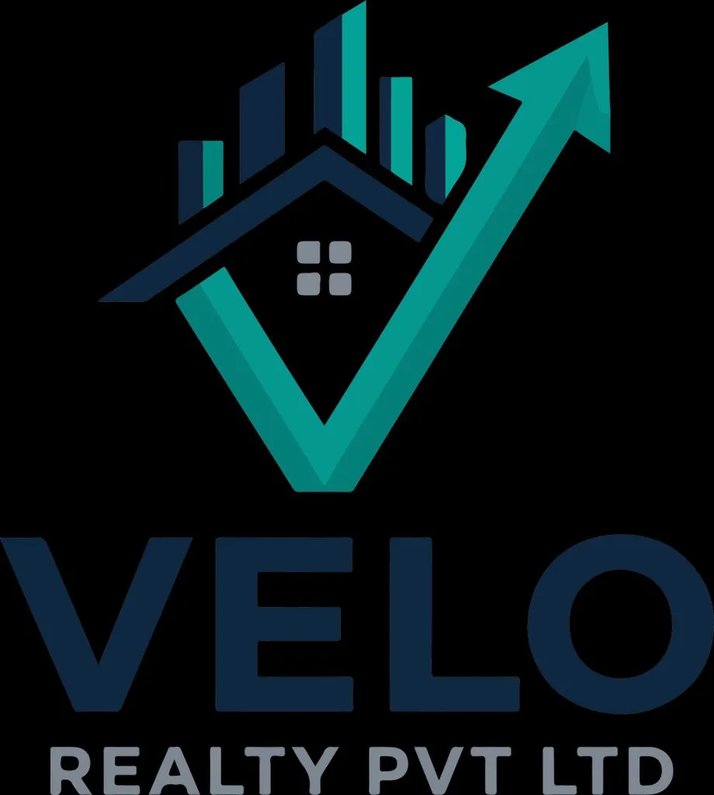
VELO REALTY PVT LTD
Dynamic Real Estate Website Documentation
React TypeScript + Express.js + PostgreSQL | Luxury, Fast, Backend-Driven Property Platform

Midnight Navy  #1A2B3C  Authority | Kinetic Teal  #00A896  Speed | Slate Silver  #8E8E93  Urbanity | Crisp White  #FFFFFF  Clarity
Prepared as a functional and technical blueprint for building a premium, dynamic, high-performance real-estate website inspired by modern UAE property portals, adapted for VELO Realty branding and multi-developer content management.

1. Executive Summary
VELO Realty should be built as a premium property discovery and lead-generation platform, not as a static brochure website. Every visible section — hero banners, properties, developers, communities, amenities, awards, blogs, FAQs, SEO metadata, lead forms, testimonials, and homepage blocks — must be editable from the backend without developer involvement.
- Primary goal: create a fast, elegant, conversion-focused real estate website for multiple developers and projects.
- Business model support: off-plan projects, ready properties, resale/rent listings, developer showcases, community pages, lead capture, WhatsApp enquiries, and admin-controlled campaigns.
- Technical foundation: React TypeScript frontend, Express.js backend, PostgreSQL database, CDN-backed 4K image pipeline, and SEO-friendly rendering strategy.
- Brand feel: Midnight Navy for trust, Kinetic Teal for movement/growth, Slate Silver for luxury detail, and Crisp White for readability.

2. Reference Website Observations
Reference | Useful Pattern to Adapt | VELO Recommendation
storeys.ae | Premium real-estate positioning, visual-led browsing, editorial/lifestyle feel. | Use cinematic hero sections, lifestyle imagery, curated property stories, and developer-led landing pages.
drehomes.com | Large navigation with Properties, Developers, Communities, Services, Guides, currency selection, and mortgage calculator style utilities. | Create a broad but clean information architecture with dedicated developer, community, property, service, guide, and calculator modules.
milestonehomesre.com | Direct property search, Buy/Sell/Rent filters, card-based listings, WhatsApp/email enquiry actions. | Use quick search above the fold, property cards with clear price/bed/area/status, and fast enquiry CTAs.

3. Website Vision and Positioning
- Position VELO as a trusted, modern, growth-focused real estate brand with an investment-first visual identity.
- Homepage must communicate three things in 5 seconds: premium properties, trusted developers, and easy enquiry.
- Design language should feel corporate-luxury: clean spacing, dark navy sections, teal motion accents, large imagery, minimal clutter.
- The site should support Dubai/UAE-style inventory today but remain reusable for any city, developer, or company later.

4. Brand Design System
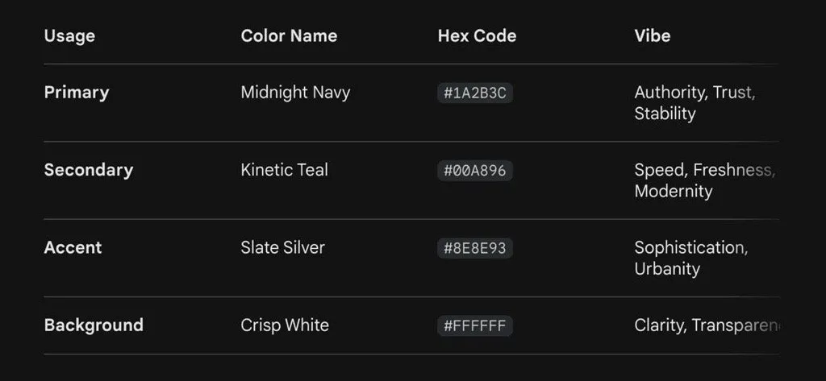
Token | Hex | Usage
Primary / Midnight Navy | #1A2B3C | Header, footer, premium section backgrounds, headings, trust blocks, overlays.
Secondary / Kinetic Teal | #00A896 | CTA buttons, hover states, price tags, active filters, progress/arrow motifs, highlights.
Accent / Slate Silver | #8E8E93 | Borders, metadata, icons, muted copy, separators, luxury card details.
Background / Crisp White | #FFFFFF | Main content background, form panels, property cards, blog pages.
Soft Tint | #E9F7F6 | Light teal card backgrounds, badges, calculator panels, success states.
Dark Overlay | rgba(26,43,60,.65) | Hero image overlays and text readability over 4K photography.

- Logo usage: keep the VELO mark prominent in navbar and footer; use the arrow/check motif as a subtle pattern in hero overlays and section dividers.
- Typography: use a modern sans-serif such as Inter, Manrope, or Plus Jakarta Sans; headings must be bold and spacious, body text readable.
- Icons: thin-line real estate icons with teal highlights: building, villa, location pin, handover, payment plan, developer, WhatsApp, map, calendar.
- Buttons: primary teal filled button, secondary navy outline button, tertiary text button with arrow animation.

5. Sitemap and Main Modules
Page / Module | Purpose | Backend Editable Content
Home | Brand introduction, search, featured projects, developers, communities, enquiry. | Hero sliders, banners, featured listings, counters, testimonials, SEO.
Properties | Searchable property inventory for buy/rent/off-plan/ready. | Listings, prices, images, amenities, floor plans, status, availability.
Property Details | High-conversion landing page for a single project/property. | Gallery, overview, price, floor plans, brochure, map, FAQs, enquiry form.
Developers | List and profile pages for every developer/company. | Developer logos, descriptions, projects, banners, stats.
Communities / Locations | Location-based discovery and SEO landing pages. | Area guides, images, nearby landmarks, projects, map pins.
Services | Investment consultancy, property management, mortgage advisory, valuation, relocation, etc. | Service sections, icons, FAQs, CTAs.
Blogs / Guides | SEO and authority-building content. | Articles, categories, authors, related projects, metadata.
About VELO | Company credibility and team introduction. | Company story, mission, leadership, awards, team, partners.
Contact | Lead capture and location details. | Forms, office address, map, WhatsApp numbers, departments.
Admin Portal | Full content and listing control. | RBAC, CRUD, uploads, SEO, leads, analytics, publishing.

6. Homepage Structure
- Premium sticky navbar with logo, property categories, developers, communities, services, guides, contact, WhatsApp, and currency/language selector if required.
- Full-screen hero with 4K background/video, dark navy overlay, headline, subheadline, primary CTA, secondary CTA, and search tabs: Buy, Rent, Off-plan, New Launch.
- Advanced search bar with location, developer, property type, price range, bedrooms, handover year, and project status.
- Featured projects carousel with high-quality cards and fast hover interactions.
- Top developers grid with logos and project counts.
- Popular communities section with image tiles and SEO links.
- Why VELO section: trust, verified listings, investment guidance, fast response, premium developer network.
- Latest launches / investment opportunities block controlled by backend priority order.
- Testimonials, awards, partner logos, blog previews, lead capture CTA, and rich footer.

7. Property Listing Experience
- Listings must load quickly, support pagination or infinite scroll, and preserve filters in URL parameters.
- Cards should display image, title, location, price/starting price, bedrooms, area, developer, handover, status badge, and quick CTA.
- Filters must be backend-driven: city, community, developer, property type, bedrooms, price, area, handover, amenities, furnishing, status, payment plan.
- Sorting options: newest, featured, price low-high, price high-low, handover soon, most viewed.
- Admin should control featured listings, ranking weight, visibility, and sold-out/archive status.
Card Element | Design Direction
Image | 4K source, served as responsive WebP/AVIF, lazy-loaded with blur placeholder.
Badge | Teal badge for New Launch / Featured; silver badge for Ready / Sold Out.
Price | Bold navy price with clear “Starting from” support.
CTA | View Details, WhatsApp, Enquire Now.
Micro-data | Beds, baths, sq.ft, developer, handover date.

8. Property Detail Page Requirements
- Hero gallery with image/video carousel, project title, developer, location, price, and enquiry CTA.
- Sticky enquiry panel on desktop and sticky bottom CTA on mobile.
- Overview, highlights, amenities, payment plan, floor plans, master plan, location map, developer profile, brochure download, FAQs, similar properties.
- Lead forms must capture name, phone, email, country code, preferred contact mode, message, source page, campaign UTM, and property ID.
- Every detail page must have editable SEO title, meta description, slug, OG image, structured schema fields, and canonical URL.

9. Backend-Driven CMS/Admin Requirements
Admin Feature | Required Capability
Dashboard | Total properties, active listings, leads, conversion rate, top projects, recent enquiries.
Property CRUD | Create/edit/delete/archive properties with draft/publish workflow.
Media Manager | Upload 4K images, videos, floor plans, brochures; auto-compress and generate variants.
Developer Management | Developer profiles, logos, description, contact, project mapping.
Community Management | Location guides, banners, map coordinates, related projects.
Homepage Builder | Reorder hero, featured projects, counters, testimonials, banners, developer blocks.
Lead Management | View leads, assign to agents, status pipeline, notes, export CSV/Excel.
SEO Manager | Slugs, titles, descriptions, OG images, schema fields, redirects.
User/RBAC | Super Admin, Content Admin, Sales Manager, Agent, Viewer.
Audit Logs | Track who changed what and when for listings, media, leads, and SEO.

10. Database Architecture - PostgreSQL
Core Table | Purpose / Key Fields
users | Admin and agent login users, role_id, status, last_login.
roles / permissions | RBAC permissions for modules and actions.
developers | Name, logo, description, slug, SEO, status.
communities | City, area, description, coordinates, SEO, hero image.
properties | Title, slug, type, status, developer_id, community_id, price, beds, baths, area, handover, visibility.
property_media | Image/video/floor plan/brochure URLs, alt text, sort order, image variants.
amenities | Amenity master list with icon and category.
property_amenities | Mapping table between properties and amenities.
payment_plans | Milestone, percentage, due timing, property_id.
floor_plans | Name, bedrooms, area, price, image/file, property_id.
leads | Contact details, property_id, source, UTM, assigned_to, status, notes.
blogs | Article content, category, author, SEO, publish status.
pages / sections | Dynamic content blocks for home/about/services.
settings | Global site settings: phone, WhatsApp, email, currency, social links.
audit_logs | Admin action history.

11. API Architecture - Express.js
- Use REST APIs with clear module separation: /api/properties, /api/developers, /api/communities, /api/leads, /api/media, /api/admin, /api/seo.
- Public APIs must be cached and optimized for fast browsing; admin APIs must require JWT authentication and RBAC checks.
- Use validation middleware such as Zod/Joi, centralized error handling, request logging, rate limits, and pagination on all list APIs.
- Use signed upload URLs or controlled upload endpoints for media; store original and generated image variant metadata.
- Provide OpenAPI/Swagger documentation for all modules before frontend integration.
Endpoint | Purpose
GET /api/properties | Public listing with filters, sort, pagination.
GET /api/properties/:slug | Property detail page data.
POST /api/admin/properties | Create property from admin.
PUT /api/admin/properties/:id | Update property.
POST /api/leads | Create enquiry lead from website.
GET /api/developers | Developer list.
GET /api/communities | Community/location list.
GET /api/home | All backend-controlled homepage sections.
POST /api/media/upload | Upload property images/files.
GET /api/admin/leads | Lead management list with filters.

12. Frontend Architecture - React TypeScript
- Use Vite/React TypeScript with modular feature folders: properties, developers, communities, leads, cms, admin, shared components.
- Use React Query/TanStack Query for API caching, background refresh, pagination, and mutation handling.
- Use React Router with SEO-friendly routes: /properties/:slug, /developers/:slug, /communities/:slug, /buy, /rent, /off-plan.
- Use typed API clients and shared interfaces for property, developer, lead, media, SEO, and admin modules.
- Use component-level skeleton loading, optimistic UI for admin forms, and strict error/empty states.

13. Performance Requirements for 4K Images
- Never serve raw 4K images directly to all users. Upload original 4K files, then generate optimized variants: thumbnail, card, detail, hero, and retina sizes.
- Serve WebP/AVIF where supported, fallback to JPEG/PNG, and use responsive srcset for device-based image loading.
- Use CDN caching, lazy loading, priority loading for hero image only, blur placeholders, and explicit width/height to prevent layout shift.
- Compress images during upload using a queue worker; do not make users wait for heavy processing in the request thread.
- Use Lighthouse targets: LCP under 2.5 seconds, CLS below 0.1, INP below 200 ms, compressed pages, minified JS, route-based code splitting.
Layer | Optimization
Frontend | Lazy loading, image placeholders, code splitting, prefetch important routes.
Backend | Cache headers, pagination, indexed queries, compressed JSON, CDN URLs.
Database | Indexes on slug, status, developer_id, community_id, price, type, created_at.
Media | WebP/AVIF variants, CDN, signed URLs, alt text, separate originals.
Deployment | Nginx/Brotli, HTTP/2 or HTTP/3, CDN, monitoring, uptime checks.

14. SEO and Marketing Requirements
- Every property, developer, community, service, and blog page must have editable SEO metadata.
- Generate XML sitemap dynamically and update it when pages are published/unpublished.
- Use structured data for RealEstateAgent, Residence/Apartment where applicable, BreadcrumbList, FAQPage, and Article.
- Create backend-controlled landing pages for high-intent keywords such as “Apartments for sale in [community]”, “Projects by [developer]”, and “New launch properties”.
- Add canonical URL support, redirects manager, Open Graph images, clean slugs, and internal linking.

15. Lead Generation and CRM Flow
1. Visitor lands from Google/ad/social/WhatsApp.
2. Visitor searches or opens property/developer/community page.
3. Visitor clicks WhatsApp, Enquire Now, Request Callback, Download Brochure, or Book Consultation.
4. Lead is stored with property/page context, source, UTM, and timestamp.
5. Admin/sales team assigns lead to an agent and updates status: New, Contacted, Qualified, Site Visit, Negotiation, Converted, Lost.
6. System sends email/WhatsApp notification to internal sales team if configured.

16. Security and Compliance
- JWT-based admin authentication, refresh token rotation, password hashing, optional 2FA for Super Admin.
- RBAC for each admin module and action: view, create, edit, delete, publish, export.
- Rate-limit public lead forms and protect with spam prevention.
- Validate all inputs, sanitize HTML content, and restrict file uploads by type and size.
- Use HTTPS, secure cookies, environment-based secrets, database backups, audit logs, and monitoring alerts.

17. Admin UX Requirements
- Admin should be simple enough for non-technical real estate staff to update website content daily.
- Property form should be split into logical tabs: Basic Info, Location, Pricing, Gallery, Amenities, Payment Plan, SEO, Publish.
- Media upload should support drag/drop, reorder, alt text, mark as cover image, and image variant generation status.
- Homepage builder should allow enable/disable, reorder, and select content without code deployment.
- Lead screen should show quick filters, assignment, notes, export, WhatsApp click, and follow-up reminders.

18. Design Direction by Section
Section | Visual Treatment
Navbar | White or transparent over hero; navy on scroll; teal hover underline; clear hierarchy.
Hero | Large 4K property image, navy gradient overlay, bold headline, search widget.
Property Cards | White cards, soft shadow, rounded corners, teal badges, navy titles.
Developer Logos | Clean grid with grayscale/silver hover to full color if available.
Community Tiles | Image tiles with navy overlay and teal arrow icon.
Forms | White panels, navy labels, teal submit button, clear validation.
Footer | Midnight Navy background, silver text, teal CTA/social highlights.

19. Recommended Folder Structure
- frontend/src/features/properties
- frontend/src/features/developers
- frontend/src/features/communities
- frontend/src/features/admin
- frontend/src/features/leads
- frontend/src/components/ui
- frontend/src/services/api
- frontend/src/types
- backend/src/modules/property
- backend/src/modules/developer
- backend/src/modules/community
- backend/src/modules/lead
- backend/src/modules/media
- backend/src/modules/auth
- backend/src/middleware
- backend/src/db/migrations

20. Development Phases
Phase | Scope | Output
Phase 1 - Discovery & UI System | Finalize sitemap, content model, wireframes, color system, component library. | Approved UI/UX blueprint and reusable design system.
Phase 2 - Database & APIs | PostgreSQL schema, migrations, Express modules, Swagger docs. | Stable backend API foundation.
Phase 3 - Public Website | Home, listings, details, developers, communities, contact, blogs. | Responsive public website.
Phase 4 - Admin CMS | Property CRUD, media manager, homepage builder, leads, SEO. | Dynamic backend-controlled website.
Phase 5 - Performance & SEO | Image pipeline, caching, sitemap, schema, Lighthouse improvements. | Fast, SEO-ready production build.
Phase 6 - QA & Launch | Cross-browser testing, mobile testing, security, backups, deployment. | Production launch with monitoring.

21. Acceptance Criteria
- Admin can add/edit/publish/unpublish properties without code changes.
- Admin can change homepage hero, featured projects, developers, communities, testimonials, banners, and SEO content.
- Website loads fast even with 4K image uploads because optimized variants are served to visitors.
- All property listing filters work correctly and are reflected in URL state.
- Property detail pages are mobile-first, conversion-focused, and SEO-ready.
- Lead data is stored accurately with property/source context and visible in admin dashboard.
- Database queries are indexed and paginated; no large unbounded API responses.
- Website passes responsive QA, accessibility basics, and performance benchmarks before launch.

22. Final Recommendation
Build VELO Realty as a headless, backend-driven real estate CMS with a premium React frontend. The strongest competitive advantage will come from combining luxury design, dynamic content control, advanced property filtering, SEO landing pages, and a high-performance image pipeline. The brand colors already support a strong visual identity: navy for trust, teal for growth and action, silver for refinement, and white for clarity.

