FOLIUM: BEHAVIOURAL DECISION INTELLIGENCE THROUGH CALIBRATED BIAS DETECTION, CAUSAL ANALYSIS AND PAIRED LONG-HORIZON PORTFOLIO SIMULATION
Project Report
submitted in partial fulfilment of the requirement for the award of the Degree of
Bachelor of Technology
in
Computer Engineering
by
Jesil Shah ([Roll / UID No.])
Param Shah ([Roll / UID No.])
Het Shah ([Roll / UID No.])
under the guidance of
Dr. Nataash Raul

Department of Computer Engineering
Bharatiya Vidya Bhavan’s
Sardar Patel Institute of Technology
(Autonomous Institute Affiliated to University of Mumbai)
Munshi Nagar, Andheri (West), Mumbai – 400058
University of Mumbai
[Month, Year of Submission]

Certificate
This is to certify that the Project entitled “Folium: Behavioural Decision Intelligence through Calibrated Bias Detection, Causal Analysis and Paired Long-Horizon Portfolio Simulation” has been completed to our satisfaction by Mr. Jesil Shah, Mr. Param Shah and Mr. Het Shah under the guidance of Dr. Nataash Raul for the award of the Degree of Bachelor of Technology in Computer Engineering from the University of Mumbai.
Certified by

Dr. Nataash Raul [Name of Head of Department]
Project Guide Head of Department

[Name of Principal]
Principal

Department of Computer Engineering
Bharatiya Vidya Bhavan’s Sardar Patel Institute of Technology
(Autonomous Institute Affiliated to University of Mumbai)
Munshi Nagar, Andheri (West), Mumbai – 400058
[Month, Year of Submission]

Project Approval Certificate
This is to certify that the Project entitled “Folium: Behavioural Decision Intelligence through Calibrated Bias Detection, Causal Analysis and Paired Long-Horizon Portfolio Simulation” by Mr. Jesil Shah, Mr. Param Shah and Mr. Het Shah is found to be satisfactory and is approved for the award of the Degree of Bachelor of Technology in Computer Engineering from the University of Mumbai.

External Examiner Internal Examiner

(Signature) (Signature)

Name: Name:

Date: Date:

Seal of the Institute

Statement by the Candidates
We wish to state that the work embodied in this report titled “Folium: Behavioural Decision Intelligence through Calibrated Bias Detection, Causal Analysis and Paired Long-Horizon Portfolio Simulation” forms our own contribution to the work carried out under the guidance of Dr. Nataash Raul at the Sardar Patel Institute of Technology. We declare that this written submission represents our ideas in our own words and, where others’ ideas or words have been included, we have adequately cited and referenced the original sources. We also declare that we have adhered to all principles of academic honesty and integrity and have not misrepresented, fabricated or falsified any idea, data, fact or source in our submission.

Name and Signature:

1. Jesil Shah ______________________

2. Param Shah ______________________

3. Het Shah ______________________

Date: ______________
Acknowledgements
It is a pleasure to acknowledge the help and support that went into this project. We express our sincere gratitude to our guide, Dr. Nataash Raul, for his guidance throughout the work. His insistence that every number shown to an investor should be traceable to evidence shaped many of the design decisions described in this report.
We thank [Name of Examiner / Reviewer] for advice during the project reviews, and the Head of Department and the staff of the Department of Computer Engineering, Sardar Patel Institute of Technology, for the facilities required to carry out this work.
Finally, we thank our families and friends for their constant encouragement.

Jesil Shah
Param Shah
Het Shah

Abstract
Retail investors in India often decide to sell, hold or add to a share under the influence of recent price movements, social signals and the pain of a paper loss, rather than in the light of their own finances and time horizon. Most investing tools describe the stock; very few examine the decision that the investor is about to take. This project presents Folium, a full-stack decision-support web application that evaluates one intended action on one holding against the investor’s whole financial picture.
For every analysis, Folium (i) reads the free-text reason given by the investor for stated cash needs and feelings, (ii) classifies the most likely behavioural pattern behind the decision—loss aversion, herd behaviour, the disposition effect or a rational motive—using an XGBoost classifier with 22 features, an isotonic calibration curve and exact TreeSHAP explanations, (iii) projects the HOLD and SELL alternatives over the investor’s own horizon on the same 1,000 block-bootstrapped market paths built from real NIFTY 50 and gold history, after Indian capital-gains tax and charges, (iv) estimates what pushes such decisions using DoWhy backdoor adjustment and g-computation, (v) renders a six-part explanation from hand-written English and Hindi templates, (vi) issues a HOLD, SELL or BUY MORE verdict from explicit evidence rules rather than a language model, and (vii) seals the analysis into a per-investor SHA-256 hash chain that can be verified later. The system is built with FastAPI, PostgreSQL with row-level security, Redis and a React/TypeScript front end.
On a held-out test set of 4,000 synthetic decisions placed on real market days and re-weighted to real regime frequencies, the classifier reaches 87.9% accuracy, a macro-F1 score of 0.840 and an expected calibration error of 0.014; readings shown with High confidence are correct 98.7% of the time. It significantly outperforms a rules-only baseline and logistic regression (McNemar $p<{10}^{−4}$) and performs on par with a random forest. Trained only on 2008–2019 and tested on 2020–2026, it scores 86.5%. Among six market-path generators, the 12-month block bootstrap is the only one that reproduces both the spread of real one-year returns and volatility clustering. The simulator’s one-year return quantiles lie within 1.4 percentage points of the real index, and the causal estimates recover the known generator effects with a mean absolute error of about 0.5 percentage points. Because the behavioural labels are synthetic, these figures are development-stage results; they do not establish psychological diagnosis, real-market causality or improved investor returns.
Keywords: behavioural finance, decision support, XGBoost, probability calibration, SHAP, causal inference, block bootstrap, Monte Carlo simulation, explainable AI, row-level security.

Executive Summary
What was built. Folium is a working web application with sign-up, two-step verification, a portfolio of Indian assets with live prices, a five-step analysis pipeline with live progress, bilingual explanations and downloadable reports, a tamper-evident audit chain, and data-export and account-deletion tools. The machine-learning research code (in src/) is called by the product back end through a single bridge module, so the figures reported in this book are produced by the same code that serves users.
What was measured. Every numerical result in this report comes from evaluation files committed in the repository: results/reports/bias_v4_evaluation.json, results/reports/simulator_v2_evaluation.json, results/causal_v4.json and results/reports/paper_evaluation.json. The charts in Chapters 8 and 9 were plotted directly from these files by blackbook/make_figures.py.
Headline results (development stage, synthetic labels). Bias model v4.1: 87.9% accuracy, macro-F1 0.840, ECE 0.014, 21 of 21 behavioural sense checks passed, against 53.4% accuracy for the previous v3 model on the same cases. Over five data splits it averages 87.2% ± 0.6, significantly above the rules-only baseline (84.4%) and logistic regression (84.9%) and statistically tied with a random forest (87.0%). Simulator v2: bad-year, typical-year and good-year returns of −6.9%, +11.6% and +34.7% against −7.5%, +11.3% and +33.3% for the real NIFTY 50. Causal module: 45 effects recovered with a mean absolute error of 0.48 percentage points and the correct sign in 97% of cases. Over 1,000 investors, the paired simulation recommends holding for 58%, finds a toss-up for 41% and favours selling for 1%; equity funds favour holding far more clearly than single stocks. Explanations on the current pipeline: 100% completeness and zero jargon leaks across 332 explanations (166 English, 166 Hindi); English Flesch reading ease 76.4.
Release scope and roadmap. This release delivers the complete investor journey—sign-up by e-mail or Google, the financial profile and portfolio, live analysis, bilingual explanation, reports and record verification—running against PostgreSQL and Redis. Three engineering milestones are planned for the next release, and the groundwork for each already exists in the repository: an administrator console, built on the existing statistics view (which holds no personal data) and audited two-step reset endpoints; continuous integration, for which all three test suites (635 tests) already run with one command each; and HTTPS deployment, for which container definitions are ready. Optional Gemini assistance is fully implemented behind consent and number-checking guards and needs only a production API key to go live. On the research side, the behavioural labels are synthetic by design; validating the readings against real, consented investor decisions is the planned next study, so this report makes no claim about improved investment outcomes.
Table of Contents
Chapter 1: Introduction 1
1.1 Project Background 1
1.2 Domain Overview 1
1.3 Problem Context 2
1.4 Problem Statement 2
1.5 Motivation 3
1.6 Objectives 3
1.7 Scope of the Project 4
1.8 Intended Users and Stakeholders 4
1.9 Expected Contributions 5
1.10 Organisation of the Report 5
Chapter 2: Literature Review and Existing Systems 6
2.1 Behavioural Foundations 6
2.2 Machine Learning for Tabular Financial Classification 7
2.3 Explainable Machine Learning 8
2.4 Causal Modelling 9
2.5 Long-Horizon Simulation and Resampling 9
2.6 Security Foundations for a Financial Web Application 10
2.7 Comparison of Existing Approaches 10
2.8 Research and Implementation Gaps 11
2.9 How the Proposed System Addresses the Gaps 11
Chapter 3: Requirements Analysis and Feasibility Study 12
3.1 Functional Requirements 12
3.2 Non-Functional Requirements 14
3.3 Hardware Requirements 16
3.4 Software Requirements 16
3.5 Development Environment 17
3.6 Feasibility Study 17
3.7 Use Cases and User Roles 18
3.8 Assumptions and Constraints 19
Chapter 4: System Analysis and Methodology 20
4.1 Proposed System 20
4.2 Overall Workflow 20
4.3 Input and Output Specification 21
4.4 Data Sources 21
4.5 Dataset Description: Dataset v4.1 22
4.6 Data Preprocessing and Module Methodology 26
4.7 Design Methodology 27
4.8 Module Decomposition 28
4.9 Methodological Justification 28
4.10 Ethical Considerations and Data Privacy 29
Chapter 5: System Architecture and Design 30
5.1 High-Level Architecture 30
5.2 Component Architecture of the Analysis Pipeline 31
5.3 Data-Flow Diagrams 32
5.4 Use-Case Diagram 34
5.5 Activity Diagram 35
5.6 Sequence Diagram 36
5.7 Entity–Relationship Design 37
5.8 Deployment Diagram 38
5.9 User-Interface Design 38
Chapter 6: Detailed Implementation 40
6.1 Repository Organisation 40
6.2 Dataset Generator (src/dataset_v4.py) 41
6.3 Bias Model v4.1 (src/bias_model_v4.py) 42
6.4 Bias Step in the Product (backend/core/bias_detector.py, comment_reader.py) 45
6.5 Simulator v2 (src/simulator_v2.py) and Its Bridge (backend/core/simulator.py) 46
6.6 Cause-and-Effect Module (src/causal_v4.py) 49
6.7 Recommendation (backend/core/recommendation.py) 51
6.8 Pipeline Orchestrator (backend/core/pipeline.py) 52
6.9 Explanation Engine (src/explainer.py, explanation_templates.py, explanation_report.py, llm_polish.py) 53
6.10 Data Layer and Row-Level Security (backend/db/) 54
6.11 Tamper-Evident Audit Chain (backend/core/audit.py) 55
6.12 Authentication and Session Security (backend/auth/, backend/middleware/) 56
6.13 Portfolio, Prices and Market Context (backend/services/) 58
6.14 Account Deletion and Data Export (backend/services/account_deletion.py) 58
6.15 Front End (frontend/src/) 58
6.16 Error Handling and Edge Cases 59
Chapter 7: Algorithms and Technical Foundations 61
7.1 Motive Competition in the Data Generator 61
7.2 Gradient-Boosted Multi-Class Classification 61
7.3 Definitional Guard 62
7.4 Isotonic Calibration of the Top Label 63
7.5 Exact TreeSHAP Attribution 63
7.6 Block-Bootstrap Market Paths 64
7.7 The Holding and the Two Wealth Paths 64
7.8 Tax Rules (FY 2025-26, New Regime) 65
7.9 Causal Estimands and Estimators 66
7.10 Evidence Rules for the Verdict 67
7.11 Hash-Chained Audit Log 67
7.12 End-to-End Pseudocode of One Analysis 68
7.13 Computational Considerations 68
Chapter 8: Experimental Setup and Evaluation 69
8.1 Evidence Base and Scope 69
8.2 Experimental Environment 69
8.3 Bias Model: Data Split and Protocol 69
8.4 Evaluation Metrics 70
8.5 Bias Model Results 71
8.6 Baselines and Ablations 74
8.7 Forced Sales 77
8.8 Comparison with the Previous Model (v3) 77
8.9 Sense Checks 77
8.10 Simulator Evaluation Protocol 78
8.11 Causal Evaluation Protocol 79
8.12 Explanation Evaluation Protocol 80
8.13 Reproducibility Considerations 80
Chapter 9: Results and Discussion 81
9.1 Simulator Realism 81
9.2 Why a 12-Month Block Bootstrap 82
9.3 The Horizon Matters, and How Stable the Numbers Are 83
9.4 Results Across 1,000 Investors and Sensitivity to Assumptions 85
9.5 Each Stock Is Different 87
9.6 Paired Gap Against Real History 88
9.7 Monthly Investing and Portfolio Context 88
9.8 Cause and Effect 89
9.9 Explanation Quality 91
9.10 Application Outputs 92
9.11 Discussion 94
Chapter 10: Testing and Validation 96
10.1 Testing Objectives 96
10.2 Test Suites and Execution Status 96
10.3 Unit Testing 96
10.4 Integration Testing 98
10.5 Functional and System Testing 100
10.6 Input Validation and Edge-Case Testing 101
10.7 Performance Testing 101
10.8 Defects, Inconsistencies and Open Issues 102
Chapter 11: Applications, Advantages and Limitations 104
11.1 Real-World Applications 104
11.2 Advantages 104
11.3 Limitations 105
11.4 Security and Privacy Considerations 106
11.5 Scalability 106
11.6 Maintenance Requirements 107
11.7 Risks and Responsible Use 107
Chapter 12: Conclusion and Future Scope 108
12.1 Summary of the Problem 108
12.2 Summary of the Implemented Solution 108
12.3 Key Outcomes and Verified Findings 108
12.4 Boundaries of the Present Work 109
12.5 Roadmap and Future Scope 109
12.6 Potential for Further Research and Deployment 111
References 112
Appendix A: Installation and Execution Guide 117
Appendix B: API Reference 118
Appendix C: Dataset and Database Schema 121
Appendix D: Reproducibility and Test Commands 123
Appendix E: Configuration Reference 124
Appendix F: User Manual 125
Appendix G: Screenshots and Evidence to Be Supplied 126
Appendix H: Glossary 128
Appendix I: Repository Reference 129
List of Figures
Figure 4.1: How each case in dataset v4.1 is generated (generated diagram based on src/dataset_v4.py::build_dataset) 23
Figure 4.2: (a) Label distribution in dataset v4.1; (b) share of market regimes among real trading days and among sampled cases (plotted from data/v4/decisions_v4.csv and bias_v4_evaluation.json) 25
Figure 5.1: Three-tier architecture of Folium (generated diagram) 30
Figure 5.2: Components involved in one analysis (generated diagram) 31
Figure 5.3: Context-level (level-0) data-flow diagram (generated diagram) 32
Figure 5.4: Level-1 data-flow diagram of the analysis process (generated diagram) 33
Figure 5.5: Use-case diagram (generated diagram) 34
Figure 5.6: Activity diagram of a decision analysis (generated diagram) 35
Figure 5.7: Sequence diagram of an analysis with live progress (generated diagram) 36
Figure 5.8: Entity–relationship diagram of the main tables (generated from Alembic migrations 0001–0012) 37
Figure 5.9: Deployment diagram of the development and demonstration set-up (generated diagram) 38
Figure 8.1: Confusion matrix of bias model v4.1 on the test set, rows normalised, real-frequency weighting (plotted from bias_v4_evaluation.json) 72
Figure 8.2: Per-class precision, recall and F1, real-frequency weighting (plotted from bias_v4_evaluation.json) 72
Figure 8.3: Reliability diagram after calibration; each point is a confidence bin with its case count (plotted from bias_v4_evaluation.json) 73
Figure 8.4: Accuracy of v4.1 against baselines and an upper bound on the same test set (plotted from bias_v4_evaluation.json) 74
Figure 8.5: (a) Accuracy with 95% bootstrap confidence intervals on the seed-7 test set; (b) mean ± SD over five split seeds (plotted from paper_evaluation.json) 76
Figure 9.1: One-year NIFTY 50 return percentiles: real index (rolling windows) against simulator v2 and the earlier v1 (plotted from simulator_v2_evaluation.json) 81
Figure 9.2: (a) Kolmogorov–Smirnov distance between each generator’s one-year returns and the real NIFTY 50; (b) autocorrelation of squared monthly returns, a measure of volatility clustering (plotted from paper_evaluation.json) 82
Figure 9.3: (a) Share of futures in which holding beats selling and (b) median paired gap, by horizon, for the base case (plotted from simulator_v2_evaluation.json) 83
Figure 9.4: Monte Carlo convergence for the base case, 20 repeats per size: (a) probability that holding wins, mean ± SD; (b) run-to-run variation of the median rupee gap (plotted from paper_evaluation.json) 84
Figure 9.5: Share of 1,000 simulated investors whose analysis lands in each verdict band, overall, by horizon, by asset type, and with history replayed exactly (plotted from paper_evaluation.json) 85
Figure 9.6: Share of verdicts that change across 300 investors when one assumption is changed at a time (plotted from paper_evaluation.json) 86
Figure 9.7: Measured company-specific volatility against the share of 20-year futures in which holding wins, for 24 NIFTY 50 stocks; colour shows measured beta (plotted from simulator_v2_evaluation.json) 87
Figure 9.8: Effect of each factor on the chance of selling: true effect from the generator against the g-computation estimate (plotted from results/causal_v4.json) 89
Figure 9.9: Explanation quality across 166 English and 166 Hindi explanations on the current pipeline (plotted from paper_evaluation.json) 91
Figure 9.10: [PLACEHOLDER — screenshot to be inserted] Result page: recommendation with reasons, both futures chart and pattern found 92
Figure 9.11: [PLACEHOLDER — screenshot to be inserted] Live five-step progress during an analysis 92
Figure 9.12: [PLACEHOLDER — screenshot to be inserted] Six-part explanation in Hindi with the language switch 93
Figure 9.13: [PLACEHOLDER — screenshot to be inserted] Portfolio page with net worth, allocation and holdings 93
Figure 9.14: [PLACEHOLDER — screenshot to be inserted] “Verify this record” result and “How this was worked out” 93
Figure 9.15: [PLACEHOLDER — screenshot to be inserted] Google sign-in return and the Welcome profile step for a new Google account 94
List of Tables
Table 1.1: Stakeholders of the Folium system 4
Table 2.1: Comparison of existing approaches with Folium 10
Table 3.1: Functional requirements — accounts and security 12
Table 3.2: Functional requirements — profile and portfolio 13
Table 3.3: Functional requirements — analysis 13
Table 3.4: Functional requirements — data rights and administration 14
Table 3.5: Non-functional requirements 14
Table 3.6: Hardware requirements 16
Table 3.7: Software requirements 16
Table 3.8: User roles 18
Table 4.1: Inputs to one analysis 21
Table 4.2: Outputs of one analysis 21
Table 4.3: Label definitions used by the generator (LABEL_RULES in src/dataset_v4.py) 24
Table 4.4: Summary statistics of dataset v4.1 (from DATASET_CARD.md) 25
Table 4.5: Module decomposition 28
Table 6.1: Repository organisation 40
Table 6.2: Authentication and session-security controls 56
Table 6.3: Derived portfolio figures (backend/services/portfolio.py) 58
Table 6.4: Edge cases and their handling (from FOLIUM_MASTER.md §5, cross-checked against the code) 59
Table 7.1: Tax rules used by the simulator 65
Table 7.2: Recommendation rules (backend/core/recommendation.py::decide) 67
Table 8.1: Evaluation artefacts used in this report 69
Table 8.2: Hyper-parameters of bias model v4.1 (scripts/train_bias_v4.py) 70
Table 8.3: Overall test performance of bias model v4.1 71
Table 8.4: Per-class metrics (real frequency) 72
Table 8.5: Confidence bands and how often each is right (test set, real frequency) 73
Table 8.6: Accuracy by market regime 74
Table 8.7: Accuracy by action 74
Table 8.8: Baselines, ablation and ceiling (real-frequency test set) 75
Table 8.9: Learners compared over five split seeds, mean ± standard deviation (paper_evaluation.json) 75
Table 8.10: Seed-7 test set with bootstrap confidence intervals and McNemar tests 76
Table 8.11: Forced sales read as rational 77
Table 8.12: Selected sense checks (full list in results/reports/BIAS_MODEL_V4.md) 77
Table 9.1: Realism of simulated one-year returns 81
Table 9.2: Six market-path generators against the real index (10,000 ten-year paths each, same historical mean) 82
Table 9.3: Effect of horizon (₹1 lakh position; investor on ₹18 lakh a year with ₹11 lakh liquid) 83
Table 9.4: Monte Carlo convergence (base case: stock down 17%, 20 years) 84
Table 9.5: Paired simulation over 1,000 investors drawn from dataset v4.1 85
Table 9.6: Sensitivity analysis, one assumption at a time 86
Table 9.7: Walk-forward replay of a fund up 30% through every real window 88
Table 9.8: Base-case investor, stock down 17%, 14 years: difference of medians against the median paired gap 88
Table 9.9: Average effects in percentage points, true value with the g-computation estimate in brackets (selected rows of CAUSAL_V4.md) 89
Table 9.10: Accuracy of the causal estimates against the known truth 90
Table 9.11: Effect of the most helpful habit in each situation (habit modelled as halving the tendency) 90
Table 9.12: Explanation quality on bias model v4.1, simulator v2 and the template explainer (332 explanations, AI wording off) 91
Table 10.1: Test suites in the repository 96
Table 10.2: Representative unit tests 97
Table 10.3: Integration test scenarios 98
Table 10.4: System test cases (expected results from the specification; observed results to be recorded) 100
Table 10.5: Defects and inconsistencies 102
Table 12.1: Achievement of objectives 108
Table 12.2: Roadmap by phase 109
Table B.1: API endpoints (backend/api/v1/, backend/auth/routes.py) 118
Table C.1: Columns of dataset v4.1 (grouped) 121
Table C.2: Database tables (migrations 0001–0012) 121
Table D.1: Commands to reproduce results and run tests 123
Table E.1: Environment variables (.env.example; values are secrets and are not reproduced here) 124
Table G.1: Evidence required from the team 126
Table H.1: Glossary 128
List of Abbreviations and Symbols
Abbreviation | Meaning
API | Application Programming Interface
ATE | Average Treatment Effect
CI | Confidence Interval (also Continuous Integration in Chapter 12)
CSRF | Cross-Site Request Forgery
DAG | Directed Acyclic Graph
DFD | Data-Flow Diagram
ECE | Expected Calibration Error
EMI | Equated Monthly Instalment
ER | Entity–Relationship
FD | Fixed Deposit
GBM | Geometric Brownian Motion (lognormal return model)
GUC | Grand Unified Configuration (PostgreSQL run-time setting)
JSONB | Binary JSON column type in PostgreSQL
JWT | JSON Web Token
KS | Kolmogorov–Smirnov (distance between two distributions)
LTCG / STCG | Long-Term / Short-Term Capital Gains
MFA | Multi-Factor Authentication
NIFTY 50 | National Stock Exchange of India’s 50-stock benchmark index
OIDC | OpenID Connect (identity layer used for Google sign-in)
ORM | Object-Relational Mapping
RLS | Row-Level Security
RS256 | RSA signature with SHA-256
SHAP | SHapley Additive exPlanations
SIP | Systematic Investment Plan
SPA | Single-Page Application
SSE | Server-Sent Events
TOTP | Time-based One-Time Password
UI | User Interface
VIX | Volatility Index (here, India VIX)
XGBoost | eXtreme Gradient Boosting

Symbol | Meaning
$$x∈R^{d}$$ | Feature vector of one decision ($d=22$)
$$K$$ | Number of behavioural classes ($K=4$)
$$F_{k}\left(x\right)$$ | Raw boosted-tree score (margin) for class $k$
$${\hat{p}}_{k}\left(x\right)$$ | Predicted probability of class $k$
$$ϕ_{j,k}$$ | SHAP contribution of feature $j$ to class $k$
$$m_{k}\left(x\right)$$ | Rule mask: 1 if the label definitions allow class $k$
$$g\left(⋅\right)$$ | Isotonic calibration map
$$W_{s,T}^{\left(H\right)},W_{s,T}^{\left(S\right)}$$ | After-tax wealth of HOLD / SELL on path $s$ at year $T$
$$Δ_{s,T}$$ | Paired difference $W_{s,T}^{\left(H\right)}−W_{s,T}^{\left(S\right)}$
$$p$$ | Share of simulated paths in which holding beats selling
$$β$$ | Sensitivity of a stock to the NIFTY 50
$$σ_{\text{own}}$$ | Company-specific yearly volatility
$$do\left(A=a\right)$$ | Intervention that sets treatment $A$ to $a$
$$h_{i}$$ | Chain hash of the $i$-th audit entry

Chapter 1: Introduction

1.1 Project Background
Participation of individual investors in Indian equity markets has grown sharply over the last decade. Discount brokers, mobile trading applications and the systematic investment plan (SIP) route into mutual funds have made it possible for a salaried person to own shares with a few taps. Access, however, is not the same as judgement. A first-time investor watching a holding fall 15% while friends discuss a market crash on a messaging group faces a decision that is as much emotional as financial.
Behavioural finance has studied such decisions for more than forty years. Kahneman and Tversky showed that people evaluate outcomes relative to a reference point and feel losses more strongly than equal gains [1]. Shefrin and Statman described the “disposition to sell winners too early and ride losers too long” [4], and Odean found clear evidence of it in brokerage records [2]. Bikhchandani, Hirshleifer and Welch explained how people can rationally follow the crowd and still end up in an informational cascade [3]. These patterns are not rare quirks: they are systematic and they cost money [14].
At the same time, the same action can be perfectly sensible for a different person. Selling a losing share is a mistake if it is driven by panic, but it is the right thing to do if the investor’s college fees are due next month and there is no emergency fund. Any tool that labels a decision “biased” without looking at the investor’s own finances will be wrong exactly when it matters most.
Folium was built to address this gap. The project began as a research effort on behavioural bias detection with a Streamlit prototype and synthetic data (versions v1 to v3 of the models, kept in the repository as rollback options). Over successive iterations it grew into a complete product: a FastAPI back end, a React front end, a PostgreSQL database with row-level security, a dataset built on real NIFTY 50 and India VIX history, a calibrated classifier, a tax-aware simulator, a causal-analysis module, a bilingual explanation engine and a tamper-evident audit trail.

1.2 Domain Overview
The project sits at the intersection of three areas.
Behavioural finance supplies the vocabulary of the problem: loss aversion, herd behaviour and the disposition effect are the three patterns Folium looks for, alongside a “rational” class that covers legitimate motives such as rebalancing, a near goal, cutting a loss or needing cash.
Machine learning and causal inference supply the tools to read a decision from data. A gradient-boosted tree classifier estimates which pattern best explains the situation and the action; isotonic calibration makes its confidence honest; SHAP attributions explain which inputs pushed the reading; and backdoor adjustment and g-computation estimate which factors change the chance of each action.
Secure web engineering supplies the means to deliver all of this to a real person. Financial data is sensitive, so authentication, session management, data isolation, auditability and data-subject rights (export and deletion) are part of the problem, not an afterthought.

1.3 Problem Context
Existing investing tools fall broadly into three groups. Brokerage and portfolio-tracking apps show prices, profit and loss, and charts; they describe the asset, not the decision. Robo-advisers construct a portfolio from a risk questionnaire but do not examine an individual trade at the moment it is being considered. Financial news and social media, which strongly influence retail behaviour, offer opinion without any link to the investor’s circumstances.
None of these answers the question an investor is really asking at the moment of decision: “Given my income, loans, emergency fund, the rest of my portfolio and how long I can wait, is what I am about to do sensible, or am I reacting to the moment?” Answering it requires combining four separate pieces of evidence—the behavioural reading, the financial consequences of each choice, the factors that drive such choices, and a clear explanation—and doing so in a way that never hides an assumption or invents a number.

1.4 Problem Statement
To design and implement a secure, explainable decision-support system that, for a single intended action (sell, hold or buy more) on a single holding of an Indian retail investor:
- identifies the behavioural pattern most likely behind the decision, with a calibrated confidence and a faithful explanation of the inputs that drove the reading;
- compares the after-tax wealth outcome of holding and of selling over the investor’s own horizon, under the same simulated market conditions;
- estimates which situational and personal factors push investors towards that action, and which single habit would help most;
- explains all of the above in plain English or Hindi without allowing wording to alter any number;
- issues a recommendation from transparent evidence rules; and
- records each analysis in a form that the investor can later verify has not been altered.

1.5 Motivation
Three observations motivated the project.
First, the cost of behavioural mistakes is real but invisible at the moment of decision. An investor who panic-sells during a correction rarely sees the counterfactual: what the money would have become had it stayed invested. Folium makes that counterfactual concrete by projecting both paths on identical market scenarios.
Second, existing “AI” financial assistants often produce fluent text whose numbers cannot be traced. For a decision about real money, a single invented rupee figure is unacceptable. We wanted a system in which every figure on screen comes from a deterministic computation and every assumption is disclosed.
Third, the Indian context matters. Taxes (short- and long-term capital gains under the FY 2025-26 regime), the importance of gold and fixed deposits in household portfolios, EMIs and education fees as fixed obligations, and the need for explanations in Hindi are rarely handled by tools designed elsewhere.

1.6 Objectives
The objectives of the project, as reflected in the repository, are:
- O1 – Behavioural reading. Build an action-aware, portfolio-aware classifier that distinguishes loss aversion, herd behaviour, the disposition effect and rational decisions, with calibrated confidence and per-decision explanations.
- O2 – Consequence projection. Build a simulator that compares HOLD and SELL over the investor’s horizon (1–30 years) on shared market paths, after Indian tax and transaction costs.
- O3 – Cause and effect. Quantify what pushes each action and estimate the benefit of simple debiasing habits, validated against a known ground truth.
- O4 – Explanation. Produce structurally complete, jargon-free explanations in English and Hindi from templates, with an optional language-model rewording that is rejected if it changes any number.
- O5 – Recommendation. Derive HOLD, SELL or BUY MORE from written rules over the simulation and the behavioural reading, never from a language model.
- O6 – Trust and security. Deliver the above through a secure web application with strong authentication, per-user data isolation, a verifiable audit chain, and data export and deletion.

1.7 Scope of the Project
In scope. Listed Indian shares (NSE/BSE) and equity mutual funds as the subject of a decision; gold, fixed deposits, savings, property, loans, rent received and SIPs as context; three actions (sell, hold, buy more); four behavioural classes; horizons of 1–30 years; English and Hindi output; a web interface usable on desktops and phones.
Out of scope. Execution of trades or any broker integration; real-time trading signals; whole-portfolio optimisation (each analysis concerns one position); derivatives, cryptocurrency, credit-card balances and insurance; inflation-adjusted (real) projections; and any claim of personalised investment advice. The application states clearly that it is for information and education.

1.8 Intended Users and Stakeholders
Table 1.1: Stakeholders of the Folium system
Stakeholder | Interest in the system
Retail investor (primary user) | A second opinion on a pending decision, grounded in their own finances, in a language they are comfortable with
Administrator | Resetting a user’s two-step verification after a verified recovery request
Financial educators and researchers | A transparent example of how behavioural patterns, simulation and causal estimates can be combined
Project guide and examiners | Evidence that the system is correct, secure and honestly evaluated

1.9 Expected Contributions
The project does not claim to invent a new classifier, causal estimator or resampling method. Its contribution is the integration of established methods into one decision-time pipeline governed by explicit numerical safeguards:
- an action-aware classifier whose inputs include which patterns the label definitions permit, guarded so that it can never output a pattern the definitions rule out, with confidence calibrated to real market-regime frequencies;
- a paired hold-versus-sell simulator that uses common random numbers, real NIFTY and gold history, measured stock beta and idiosyncratic risk, and Indian tax rules;
- a causal module validated against an exactly reproducible data generator, including a negative control;
- an explanation layer where templates are authoritative and any AI wording is subject to a number-preservation guard;
- a per-investor hash-chained audit log with verification that detects alteration, deletion, forgery and forks.

1.10 Organisation of the Report
Chapter 2 reviews the literature and existing systems. Chapter 3 states the requirements and feasibility. Chapter 4 describes the methodology, including the dataset. Chapter 5 presents the architecture and design diagrams. Chapter 6 explains the implementation module by module with code excerpts. Chapter 7 develops the algorithms and their mathematics. Chapter 8 documents the experimental setup and evaluation, and Chapter 9 presents and discusses the results. Chapter 10 covers testing, Chapter 11 applications and limitations, and Chapter 12 concludes with future scope. References and appendices follow.

Chapter 2: Literature Review and Existing Systems
This chapter reviews the theory and prior work on which Folium is built. For each strand we state what the work establishes, what it does not, and how it is used in the project. The review follows the one carried out for our research paper on Folium, extended with the engineering sources relevant to the implementation.

2.1 Behavioural Foundations

2.1.1 Prospect theory and reference dependence
Kahneman and Tversky’s prospect theory explains departures from expected-utility predictions under risk [1]. Its central features are reference-dependent valuation (outcomes are judged as gains or losses relative to a reference point such as the purchase price), loss aversion (losses loom larger than equal gains) and non-linear weighting of probabilities. Cumulative prospect theory later extended the framework to rank-dependent probability weighting [17]. Prospect theory is descriptive: it explains why a person may behave as if a paper loss matters, but it gives no procedure for classifying a particular live decision. In Folium it justifies treating the unrealised gain or loss and the market’s fear level as candidate signals, without treating every loss-making sale as irrational.

2.1.2 The disposition effect
Shefrin and Statman linked the tendency to sell winners and hold losers to mental accounting, regret aversion and self-control [4]. Odean confirmed the effect empirically in the trading records of a discount brokerage, showing that investors realised gains at a higher rate than losses [2]. Thaler’s work on mental accounting supports the idea that people place gains and losses in separate mental “accounts” [18]. A single decision observed at one moment can only suggest the disposition effect; it cannot prove it. Folium therefore uses the gain or loss and the market regime as features and reports the reading as a tendency to watch for, not a diagnosis.

2.1.3 Herding and informational cascades
Bikhchandani, Hirshleifer and Welch showed that sequential decision-makers can rationally ignore their own information and follow others, producing fragile cascades [3]. De Long et al. showed that noise traders can move prices even in the presence of rational arbitrageurs [19]. Together these imply that following the crowd is not automatically irrational and that crowd signals carry information. Folium uses market fear (India VIX) and strong monthly index moves as proxies for crowd pressure, and the comment reader looks for explicit mentions of friends, colleagues or messaging groups; neither is treated as conclusive evidence of herding.

2.1.4 Empirical investor behaviour
Barber and Odean found that individual investors who trade more earn lower net returns [14], and that overconfidence shows up in trading intensity [15]. Grinblatt and Keloharju showed that investor traits, past returns and the trading context jointly affect trading decisions [16]. These studies caution against drawing individual conclusions from group-level patterns and suggest that a single questionnaire and one market snapshot cannot capture everything. Folium accordingly avoids demographic shortcuts: years of investing, for instance, was deliberately excluded as an input because the app does not collect it.

2.1.5 Market efficiency as a counterweight
Fama’s review of efficient markets [20] reminds us that trading in response to new information can be entirely rational. This is why Folium always includes a rational class with several legitimate motives and why the classifier’s “allows” logic ensures that a bias is only considered when the situation makes it possible.

2.2 Machine Learning for Tabular Financial Classification

2.2.1 Gradient boosting and XGBoost
Friedman formulated gradient boosting as stage-wise functional optimisation [26]. Chen and Guestrin’s XGBoost added second-order optimisation, regularisation, sparsity-aware split finding and efficient histogram-based training [5]. Gradient-boosted trees are widely regarded as a strong default for medium-sized tabular data because they capture non-linear interactions—such as the joint effect of a loss, a falling market and high fear—without a hand-specified functional form. Breiman’s random forests [25] are the natural alternative tree ensemble. Folium uses XGBoost for its multi-class classifier and compares it with logistic regression and a 500-tree random forest on identical splits (Section 8.6). The comparison finds the two tree ensembles statistically tied, which is consistent with this literature: on tabular data of this size, the choice between well-tuned tree ensembles matters less than the features and the labels.

2.2.2 Probability calibration
A classifier can be accurate yet badly calibrated: its stated probabilities may not match how often it is right. Zadrozny and Elkan showed how to transform classifier scores into calibrated multi-class probabilities, including through isotonic regression [6]. Niculescu-Mizil and Caruana compared calibration across learners and showed that boosted trees in particular tend to push probabilities away from 0 and 1 [27]. Guo et al. demonstrated that high accuracy does not imply good calibration, introducing expected calibration error (ECE) as a standard summary [28]. Folium calibrates the top-class probability with an isotonic curve fitted on out-of-fold predictions and reports ECE and reliability bins.

2.2.3 Evaluation under imbalance and time
Saito and Rehmsmeier showed that precision–recall analysis is more informative than ROC analysis under class imbalance [29]; Folium reports per-class precision, recall and F1 and uses macro-F1 because loss aversion is the smallest class (10%). López de Prado warns that random splits of financial data overstate generalisation because of temporal dependence and leakage [24]. Folium therefore adds an out-of-time evaluation: trained only on 2008–2019 decisions and tested on 2020–2026.

2.3 Explainable Machine Learning

2.3.1 SHAP feature attribution
Lundberg and Lee unified several attribution methods under Shapley values from cooperative game theory [7], and later gave an exact polynomial-time algorithm for tree ensembles, TreeSHAP [35]. SHAP values are additive: the contributions of all features plus a base value equal the model’s raw output. Folium uses XGBoost’s built-in exact TreeSHAP and groups the 22 feature contributions into 18 plain-language “drivers”. An important limitation is that SHAP explains the prediction function, not the causal mechanism: a large SHAP value means a feature moved the score, not that changing it in the real world would change behaviour [31].

2.3.2 Local surrogates and counterfactual explanations
LIME fits a simple surrogate model around an instance [8]; its explanations depend on how perturbations are sampled. Counterfactual explanations describe the smallest change to the input that would change the prediction [9], and DiCE generates diverse counterfactuals [30]. These ideas are related to Folium’s hold-versus-sell comparison but are not the same thing: Folium’s comparison is a scenario simulation of two actions on shared market paths, not a perturbation of classifier inputs.

2.3.3 Explainable AI in finance
Weber, Carl and Hinz’s systematic review of explainable AI in finance stresses that explanation methods must be evaluated in their financial context [34]. Folium contributes a specific design rule for this context: explanations are rendered from templates fed by computed facts, so wording cannot introduce numbers.

2.4 Causal Modelling
Pearl’s structural causal models formalise interventions with the $do\left(⋅\right)$ operator and graphical criteria for identifying effects from observational data [10]. Robins introduced g-computation (the parametric g-formula) [36], and Hernán and Robins give a modern treatment of identification assumptions—consistency, positivity and conditional exchangeability [37]. Sharma and Kiciman’s DoWhy library organises causal analysis into four steps: model the graph, identify the estimand, estimate, and refute [11]. Chernozhukov et al.’s double machine learning offers another route with flexible nuisance models [32].
A recurring caution in this literature is that refutation tests passing does not rule out unobserved confounding. Folium’s causal work uses a synthetic dataset whose generator is known exactly, which allows the estimates to be checked against the true effects—an option real-world studies do not have. The results are therefore validation of the method on a known mechanism, not evidence about how Indian investors behave.

2.5 Long-Horizon Simulation and Resampling
Simulating future wealth requires plausible market paths. Drawing independent monthly returns destroys volatility clustering and the link between crashes and recoveries. Künsch’s block bootstrap resamples contiguous blocks of a dependent series [12]; Politis and Romano’s stationary bootstrap uses random block lengths and a circular wrap [33]. Efron and Tibshirani’s bootstrap framework motivates reporting quantiles rather than a single forecast [13]. Hamilton’s regime-switching model [23] reminds us that the past may not contain future regimes. Markowitz’s portfolio selection [21] and Merton’s lifetime portfolio choice [22] establish that a decision should be judged at the level of the whole portfolio and over the investor’s horizon.
Folium uses a circular 12-month block bootstrap over 2007–2026 NIFTY 50 and gold-in-rupee history, recentres the average growth to stated long-run rates, and reports the 10th, 50th and 90th percentiles of both paths.

2.6 Security Foundations for a Financial Web Application
Several standards underpin the application layer. JSON Web Tokens are defined in RFC 7519 [38]; Folium signs them with RS256. Time-based one-time passwords for two-step verification follow RFC 6238 [39]. Passwords are hashed with bcrypt [40] and their strength is checked with zxcvbn [41]. Cross-site request forgery is mitigated with the double-submit cookie pattern described by OWASP [42]. Per-user data isolation uses PostgreSQL row-level security policies [43]. The tamper-evident audit log follows the hash-chaining idea of Haber and Stornetta [44] using SHA-256 as specified in FIPS 180-4 [45]. Live progress is delivered with server-sent events as defined in the HTML standard [46].

2.7 Comparison of Existing Approaches
Table 2.1: Comparison of existing approaches with Folium
Approach | Looks at the decision? | Uses investor’s finances? | Explains numbers? | Weakness relevant to this problem
Brokerage / portfolio trackers | No | Holdings only | Charts only | Describe the asset, not whether the action is sensible
Robo-advisers | At onboarding | Risk questionnaire | Allocation rationale | Do not evaluate an individual pending trade
Behavioural questionnaires | No | Self-reported | Score only | Measure a trait, not the present situation
Generic LLM chat assistants | Yes | Only if typed in | Fluent text | Numbers may be invented; no calibration or audit
Academic bias studies [2], [14] | Retrospectively | Account data | In papers | Population-level; not a decision-time tool
Folium (this work) | Yes, at decision time | Income, outflows, fund, portfolio, horizon | Every figure traced to computation | Synthetic behavioural labels (Section 11.3)

2.8 Research and Implementation Gaps
From the review, five gaps emerge that the project tries to address in a measurable way:
- Context-blind bias labelling. Studies and tools tend to treat a loss-making sale or a winner sold early as a bias. A decision-time tool must recognise forced sales, rebalancing and near goals as rational.
- Uncalibrated confidence. Classifiers presented to end users rarely report whether “90%” means right nine times in ten.
- Prediction confused with causation. Feature attributions are often presented as reasons that, if changed, would change outcomes. Causal claims need a graph, an estimand and validation.
- Unpaired, untaxed simulations. Simple “what if” calculators compare actions on different random scenarios or ignore tax, inflating noise and overstating the case for holding.
- Untraceable explanations. Generated text may misstate figures. A guard that rejects any wording containing a number not in the source facts is rarely implemented.

2.9 How the Proposed System Addresses the Gaps
Folium’s response is to keep each question separate and answer it with the appropriate tool: the classifier reads the pattern (gap 1 and 2: action-aware features, a definitional guard, cash-need input and isotonic calibration), the causal module answers “what pushes this action” against a known truth (gap 3), the simulator compares both actions on the same after-tax paths (gap 4), and the explanation engine turns verified facts into words under a numeric guard (gap 5). The recommendation is a small, readable rule set over these outputs, and the audit chain lets the investor confirm later that nothing was changed.

Chapter 3: Requirements Analysis and Feasibility Study
The requirements below were reconstructed from the implemented code, the API routes, the database migrations and the project’s master reference document (FOLIUM_MASTER.md). Each requirement is marked with its status as found in the repository: Built (implemented and covered by tests), Partial (implemented in part) or Pending (designed but not implemented).

3.1 Functional Requirements

3.1.1 Accounts and security
Table 3.1: Functional requirements — accounts and security
ID | Requirement | Status
FR-1 | Register with e-mail and password; verify the e-mail address before first login | Built
FR-2 | Log in with an optional “Keep me signed in”; refresh sessions silently; log out | Built
FR-3 | Reset a forgotten password by e-mailed link | Built
FR-4 | Enable two-step verification with an authenticator app (TOTP), with 8 single-use backup codes | Built
FR-5 | Request two-step recovery; an administrator who proves their own TOTP may reset it | Built (endpoint only, no admin UI)
FR-6 | Sign in with Google end to end: return to the app, two-step verification, “keep me signed in”, keep an account in its grace period | Built (Google replaced by a stand-in in automated tests; the local callback address is registered with Google)
FR-6a | After a first Google sign-in, collect the Tier-1 profile before any other page; let a Google-only account set a password | Built (/app/welcome, “Set a password” in Settings)
FR-7 | Re-verify (password, and TOTP if enabled) before changing sensitive profile fields; log every change | Built

3.1.2 Profile and portfolio
Table 3.2: Functional requirements — profile and portfolio
ID | Requirement | Status
FR-8 | Record age, after-tax income, EMIs, rent, education fees (and end year), emergency fund, risk tolerance (five-question quiz) and horizon | Built
FR-9 | Add, edit and remove shares (NSE/BSE, live prices) and mutual funds (searched and priced via MFAPI.in) | Built
FR-10 | Record gold (grams), fixed deposits, savings, property, loans, rent received and monthly SIP | Built
FR-11 | Compute net worth, liquid assets, monthly surplus and allocation; fall back to average cost when a price is unavailable | Built

3.1.3 Analysis
Table 3.3: Functional requirements — analysis
ID | Requirement | Status
FR-12 | Submit an analysis for one holding with an action (sell / hold / buy more), optional months held and a free-text reason | Built
FR-13 | Capture and store the market context (NIFTY 1-month return, 30-day volatility, India VIX), the portfolio snapshot and the stock’s beta and own volatility at submission | Built
FR-14 | Run the five-step pipeline in the background and stream live progress; replay progress after a page reload | Built
FR-15 | Read the comment for stated cash needs (English, Hinglish, Hindi) and for feelings; quote them back verbatim | Built
FR-16 | Classify the behavioural pattern with calibrated High / Medium / Low confidence and show what weighed most | Built
FR-17 | Project HOLD and SELL over the investor’s horizon, after tax, with median, bad-case and good-case values by year | Built
FR-18 | Show cause-and-effect factors and the single most helpful habit | Built
FR-19 | Produce a six-part explanation in English and Hindi; download HTML (both languages) and PDF (English) reports | Built
FR-20 | Issue a HOLD / SELL / BUY MORE verdict with reasons and the numbers used; show “both sides” | Built
FR-21 | Record the analysis in a tamper-evident chain and let the investor verify it | Built
FR-22 | List past analyses with filtering by pattern and search by holding | Built

3.1.4 Data rights and administration
Table 3.4: Functional requirements — data rights and administration
ID | Requirement | Status
FR-23 | Download all personal data as JSON | Built
FR-24 | Delete the account with a 30-day grace period, after which personal data is anonymised | Built
FR-25 | Opt in or out of optional AI help (Gemini) for comment reading and wording | Built (live API not exercised)
FR-26 | Administrative console with usage statistics, user management and an MFA-recovery queue | Planned for the next release (milestone C2); the aggregate statistics view and audited MFA-reset endpoints are in place

3.2 Non-Functional Requirements
Table 3.5: Non-functional requirements
ID | Category | Requirement and how it is met
NFR-1 | Correctness | Numbers shown must come from computation. Templates are authoritative; AI wording is rejected if it adds a number.
NFR-2 | Transparency | Missing inputs are filled with disclosed defaults listed under “How this was worked out”.
NFR-3 | Security | bcrypt (cost 12), RS256 JWT (15-minute access, 7-day refresh with rotation), CSRF double-submit, TOTP, Fernet-encrypted MFA secrets, security headers.
NFR-4 | Privacy and isolation | PostgreSQL row-level security on all user-owned tables; the app connects as a non-superuser role.
NFR-5 | Integrity | Append-only audit table (UPDATE and DELETE rules do nothing) with per-investor hash chain.
NFR-6 | Availability under failure | A price or market-data outage never breaks a page; defaults are used and disclosed; explanation failures fall back to templates.
NFR-7 | Performance | One simulation of 1,000 paths × 30 years takes about 0.1 s (measured 103.4 ms in the evaluation file); analysis runs in the background so the request returns immediately (HTTP 202).
NFR-8 | Abuse resistance | Rate limits: login 5/minute, registration 3/hour, password reset 3/hour, analysis 10/minute.
NFR-9 | Usability | Plain titles, no model names or accuracy figures in the UI, confidence in words, light and dark themes, responsive layout.
NFR-10 | Localisation | Every explanation template exists in English and Hindi with identical structure, enforced by tests.
NFR-11 | Reproducibility | Market and portfolio snapshots stored with each decision; fixed random seeds for dataset, training and simulation.
NFR-12 | Maintainability | Single bridge between product and research code; versioned models with rollback switches (BIAS_MODEL_VERSION, SIMULATOR_VERSION).

3.3 Hardware Requirements
The project was developed and demonstrated on a Windows laptop running every service natively (SETUP.md). The figures below are the minimum we consider practical for the development set-up; they are based on the documented memory use of the ML libraries (~400 MB on import) and the size of the ML dependency set (~900 MB), not on a formal benchmark.
Table 3.6: Hardware requirements
Component | Development / demo | Notes
Processor | 4-core x86-64 | Model training (scripts/train_bias_v4.py) took 81.4 s on the development machine
Memory | 8 GB RAM (16 GB recommended) | PostgreSQL, Redis/Memurai, Uvicorn, Vite and the ML stack run together
Storage | ~3 GB free | Python environment, Node modules, dataset and models
Network | Internet access | Live prices (Yahoo Finance, MFAPI.in); optional e-mail and Gemini

3.4 Software Requirements
Table 3.7: Software requirements
Layer | Software (versions as pinned in the repository)
Language runtimes | Python 3.13; Node.js with npm
Back end | FastAPI 0.115, Pydantic 2.10, asyncpg, Alembic, structlog, slowapi, Uvicorn
Authentication | PyJWT (RS256), bcrypt, zxcvbn, pyotp, Authlib, cryptography (Fernet)
Data stores | PostgreSQL 18; Redis-compatible store (Memurai on Windows)
Machine learning | numpy 2.4.2, pandas 3.0.1, scipy 1.17.1, scikit-learn 1.8.0, xgboost 3.2.0, shap 0.51.0, dowhy 0.14, networkx 3.6.1, pgmpy 1.0.0, yfinance 0.2.66
Explanations and reports | jinja2 3.1.6, textstat 0.7.13, reportlab 5.0.1; optional google-genai
Front end | React 19, Vite 8, TypeScript, Tailwind 4, Radix-based components, TanStack Query 5, React Hook Form with Zod, Recharts 3, Vitest
Tooling | Git, pytest, Jupyter (research notebooks)
Why Python 3.13 is mandatory. The comments in backend/requirements-ml.txt record that dowhy 0.14 restricts scipy to ≤ 1.15.3 on Python versions below 3.13. On 3.11 or 3.12, pip would therefore downgrade scipy away from the 1.17.1 under which the model artefacts were built. Pinning Python 3.13 avoids this silent change.

3.5 Development Environment
Development used a Python virtual environment with the pinned ML stack, a helper (scripts/with_env.py) that loads .env into any command, Alembic migrations run as the owner role finai, the API served by Uvicorn on port 8000, and the Vite development server on port 3000 proxying /v1/* to the API so that cookies and CSRF operate on a single origin. A Dockerfile.backend and docker-compose.yml exist for later deployment but were not used locally.

3.6 Feasibility Study

3.6.1 Technical feasibility
Every component relies on mature open-source libraries. XGBoost, scikit-learn and SHAP are standard for tabular modelling; DoWhy provides causal identification and refutation; FastAPI and asyncpg support asynchronous I/O for long-running analyses; PostgreSQL provides row-level security natively. The heaviest computation—training the classifier and running the causal study—happens offline (81.4 s and 54.2 s respectively, per the evaluation files). At request time, one prediction and one 1,000-path simulation are fast enough to run inside a background task. The approach is therefore technically feasible on commodity hardware.

3.6.2 Operational feasibility
The user supplies information they already know (income, loans, holdings) once, and each analysis then needs only a holding, an action and an optional sentence. Gaps are filled with disclosed defaults instead of blocking the user. Explanations avoid jargon and are available in Hindi. A non-technical investor can therefore operate the system without training.

3.6.3 Economic feasibility
All software used is free and open source. Market data comes from free sources (Yahoo Finance via yfinance and MFAPI.in). The optional services—transactional e-mail and Gemini—have free tiers and are disabled by default. The development cost was therefore limited to the team’s time and existing hardware. Hosting costs for a deployment have not been estimated because the system has not been deployed (Section 12.5).

3.6.4 Legal and ethical feasibility
The application handles personal financial data, so it implements data minimisation (no crypto, credit-card or insurance data collected), consent for any third-party AI processing, a privacy page that describes only what is true today, export and deletion of personal data, and a clear statement that the output is not investment advice. Formal regulatory review was outside the project’s scope.

3.7 Use Cases and User Roles
Table 3.8: User roles
Role | Description | Main use cases
Visitor | Not signed in | View landing and privacy pages; register; log in; reset password
Investor (role = user) | Verified account holder | Maintain profile and portfolio; request and read analyses; download reports; verify records; export data; delete account; manage two-step and AI consent
Administrator (role = admin) | Operator with own TOTP | Inspect a user’s two-step status; reset two-step after a recovery request
The principal use case, “Request decision analysis”, proceeds as follows. Pre-condition: the investor is signed in and has at least one holding. Main flow: (1) the investor opens “New analysis”, picks a holding and an action, and optionally enters months held and a reason; (2) the system validates the input, captures the market and portfolio snapshots, creates the decision and returns its identifier; (3) the browser opens the live progress stream; (4) the five steps run and publish progress; (5) the result page shows the verdict, projections, explanation and verification. Alternative flows: market data unavailable → a calm median market is assumed and disclosed; a step fails → the decision is marked failed and the page says so. Post-condition: the decision row is complete and an audit entry exists.

3.8 Assumptions and Constraints
Confirmed constraints (from the code). One position per analysis; horizons capped at 30 years with a default of 20 when none is given; tax rules fixed to FY 2025-26 (new regime); mutual funds treated as equity funds; gold valued at the international price before Indian duty and GST; nominal (not inflation-adjusted) rupees; Hindi PDF reports refused because ReportLab cannot shape Devanagari (HTML offered instead).
Income is collected after tax. The profile asks for monthly take-home pay because that is the figure people know. Where the simulator needs income before tax (for the slab rate on interest), it inverts the income-tax formula (Section 7.8).
Assumptions made by the models (stated in the app). Long-run growth rates of 11% for shares, 9% for gold, 6.75% for FDs and 3% for savings; sale charges of 0.15%; a habit modelled as halving the tendency it acts on; the ₹1.25 lakh long-term gains exemption available for the sale.
Assumptions made for this report. Hardware figures in Table 3.6 are practical estimates. Institutional details marked in square brackets (roll numbers, names of the Head of Department and Principal, submission date) must be supplied by the team.

Chapter 4: System Analysis and Methodology

4.1 Proposed System
Folium treats an investment decision as the unit of analysis. The investor states what they intend to do with one holding; the system then answers four separate questions and only afterwards combines them:
- What pattern is most likely behind this decision? — the bias model (Section 4.6.2).
- What would each choice lead to, in rupees, after tax, over my horizon? — the simulator (Section 4.6.3).
- What generally pushes people towards this action, and what habit would help? — the causal module (Section 4.6.4).
- What should I do, and why? — the evidence rules and the explanation engine (Sections 4.6.5–4.6.6).
Keeping these questions apart is the main methodological choice of the project. A high classifier probability is not a psychological diagnosis; a SHAP attribution is not a causal effect; and a simulated wealth advantage is not a promise. Each module reports what it can support, and the recommendation rules read only the outputs they are designed to read.

4.2 Overall Workflow
The workflow has an offline part and an online part.
Offline (research, run by developers). Build dataset v4.1 from real market history (python -m src.dataset_v4); train and evaluate the bias model (scripts/train_bias_v4.py); evaluate the simulator (scripts/evaluate_simulator_v2.py); run the causal study (python -m src.causal_v4); evaluate explanation quality (scripts/evaluate_explanations.py). The outputs are model artefacts in models/ and result files in results/.
Online (per analysis, in the product). Capture the request and its context, run the five pipeline steps (comment reading and bias detection, simulation, explanation, recommendation, audit), stream progress, and present the result. The online path loads the offline artefacts; it never retrains anything.

4.3 Input and Output Specification
Table 4.1: Inputs to one analysis
Input | Source | Used by
Holding (symbol, exchange, quantity, average price, current price) | Portfolio + live quote | All steps
Action (sell / hold / buy more) | Investor | Bias model, recommendation
Months held | Investor (optional) | Bias model, tax in simulator
Reason in own words | Investor (optional) | Comment reader → cash_need_stated
Age, income, EMIs, rent, education fees, emergency fund, risk tolerance, horizon | Profile | Bias model, simulator
Gold, FDs, savings, property, loans, rent received, SIP | Financial profile | Bias model (shares/ratios), simulator (destination of sale, SIP)
NIFTY 1-month return, 30-day volatility, India VIX | Captured at submission | Bias model, explanation
Stock beta and own volatility | Measured from 10 years of monthly prices at submission | Simulator

Table 4.2: Outputs of one analysis
Output | Stored in (decisions column)
Comment facts and cues with verbatim quotes | comment_facts
Pattern, calibrated confidence, probabilities, top drivers | bias_detected, bias_confidence, explainer_output.bias
Hold/sell percentiles by year, probability holding wins, typical gap, sale breakdown | simulation_curves, opportunity_cost_inr, hold_*, sell_*
Causal effect and habit; six-part explanation in English and Hindi | causal_effect, explainer_output
Verdict, reasons, inputs used, both sides | recommendation, debate_transcript
Audit entry (fingerprints and chain hash) | audit_logs table

4.4 Data Sources
Three kinds of data are used.
- Real market history. Daily NIFTY 50 closes and India VIX values [54] downloaded through yfinance [52] and cached in data/v4/market_history.csv (10 June 2008 to 5 October 2026, 4,475 trading days). Monthly NIFTY 50 returns (plus a 1.25% dividend yield) and gold-in-rupee returns (COMEX gold × USD/INR) from October 2007 to September 2026 (228 months) are cached in data/sim_v2/monthly_history.csv for the simulator.
- Synthetic investor decisions. Dataset v4.1 (data/v4/decisions_v4.csv): 20,000 decisions generated by src/dataset_v4.py on real trading days.
- Live data at run time. Share prices and history (Yahoo Finance), mutual-fund NAVs (MFAPI.in [53]) and the gold price, cached for 15 minutes.
No real investor’s trading records are used. This is a deliberate and important limitation, discussed in Section 11.3.

4.5 Dataset Description: Dataset v4.1

4.5.1 Why synthetic labels
There is no public dataset that pairs Indian retail investors’ individual decisions with their full finances and a ground-truth behavioural label. Building one would require a large, consented user study. The project therefore constructs decisions synthetically while anchoring the market side to reality. The design principle, recorded in data/v4/DATASET_CARD.md, is that labels are motives, not rules: each simulated investor has hidden tendencies, the situation decides which biased motives are possible, these compete with a rational motive, and the winning motive sets both the action and the label. The same sale can therefore be rational for one investor and biased for another, and the model must infer which from what the app can observe.
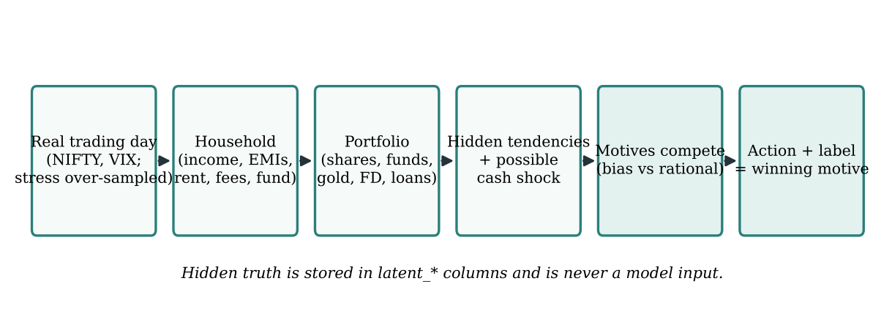
Figure 4.1: How each case in dataset v4.1 is generated (generated diagram based on src/dataset_v4.py::build_dataset)

4.5.2 Generation steps
Figure 4.1 shows the steps; each corresponds to a function in src/dataset_v4.py.
- A real day (_situation). A trading day is sampled with stress over-weighted (regime weights normal 1, bull 1, correction 2, euphoria 3, crash 6) so that every motive has enough examples. The day’s real 1-month return, 30-day volatility, VIX and 52-week drawdown are attached. A holding period is drawn from a log-normal distribution (median 14 months, clipped to 1–84), and the position’s gain or loss is the real NIFTY move over that period raised to a stock beta (drawn around 1.0) plus stock-specific noise.
- A household (_investor). Age, income (rounded to ₹1,000), years investing, risk tolerance, horizon, home ownership, rent (12–40% of income), EMIs, education fees with an end year, and an emergency fund that is likelier when more money is left each month. Fourteen per cent of borrowers carry extra debt worth 25–65% of income.
- A portfolio (_portfolio). Liquid assets scale with income and experience; equity share follows risk tolerance; gold is 4–38% of liquid assets; property, loans and rent received apply to home-owners.
- Hidden tendencies and cash shocks. Loss-aversion, herd and disposition tendencies are drawn, partly explained by observable traits. A cash shock (job loss, medical bill, fees due) occurs with probability $0.04+0.06⋅\left[\text{no fund}\right)+0.12⋅clip\left({\left(0.30−s\right)}/{0.30},0,1\right)$, where $s$ is the surplus ratio. An emergency fund absorbs 70% of shocks. The money is needed when a shock is not absorbed, or when fixed payments exceed income and there is no fund.
- A stated cash need. Investors who need the money say so with probability 0.65; those who do not mention it spuriously with probability 0.03. This is the observable cash_need_stated input.
- Motive competition (_choose). The candidate motives compete with weights described in Section 7.1, and one is sampled.

4.5.3 Label definitions
Table 4.3: Label definitions used by the generator (LABEL_RULES in src/dataset_v4.py)
Label | Motive | Action | Applies when
Loss aversion | panic | sell | at a loss, NIFTY down 2%+ over the month, and VIX ≥ 20 or a correction/crash
Loss aversion | refusal | hold | position down 25% or more
Disposition effect | sell winner | sell | up 8%+ in a normal or rising market
Disposition effect | hold loser | hold | down 5–25% in a normal or rising market
Herd behaviour | sell into fear | sell | VIX ≥ 22 or NIFTY down 5%+ over the month
Herd behaviour | buy into a rally | buy more | NIFTY up 4%+ over the month
Rational | stay the course, add regularly, buy value, average down, cut a loss, rebalance, goal near, needs cash | any | the investor’s own situation explains the action
A consequence of these definitions, noted in the dataset card, is that in a calm market herd behaviour and panic-driven loss aversion cannot occur; a calm-market analysis can only read the disposition effect, loss-aversion “refusal” or rational.

4.5.4 Contents
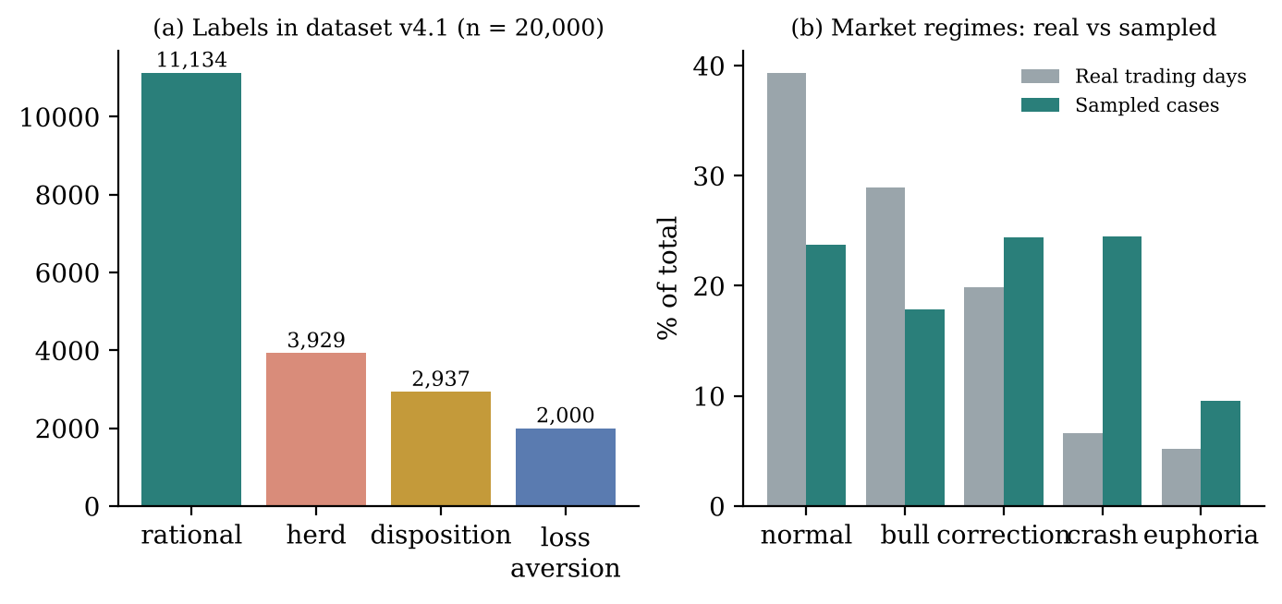
Figure 4.2: (a) Label distribution in dataset v4.1; (b) share of market regimes among real trading days and among sampled cases (plotted from data/v4/decisions_v4.csv and bias_v4_evaluation.json)
Figure 4.2(a) shows that rational decisions form the majority (11,134 cases, 55.7%), followed by herd behaviour (3,929; 19.6%), the disposition effect (2,937; 14.7%) and loss aversion (2,000; 10.0%). Actions are split into hold 8,251, sell 7,995 and buy more 3,754. Figure 4.2(b) shows the deliberate over-sampling of stress: crashes make up 24.5% of cases against 6.6% of real days. Because of this, every evaluation figure quoted in this report is re-weighted back to real regime frequencies.
Table 4.4: Summary statistics of dataset v4.1 (from DATASET_CARD.md)
Feature | 5th percentile | Median | 95th percentile
Age | 28 | 38 | 56
Monthly income | ₹26,000 | ₹75,000 | ₹2,19,000
Fixed monthly payments | ₹0 | ₹16,500 | ₹79,500
Money left each month (share of income) | 35% | 75% | 100%
Liquid assets | ₹1.6 L | ₹9.7 L | ₹62.7 L
Position share of liquid assets | 2% | 12% | 32%
Gain or loss on position | −42% | +5% | +106%
Money pressure is represented explicitly: 0.7% of households pay out more than they earn, 8.2% of borrowers have EMIs above 60% of income, 44% have no emergency fund, cash shocks hit 6.8% of decisions, and the money is needed in 1,165 cases, 889 of which end in a forced sale.

4.6 Data Preprocessing and Module Methodology

4.6.1 Feature engineering
The same function, build_features in src/bias_model_v4.py, converts raw inputs into the 22 model features for both training and live requests, so the two cannot drift apart. The derived features are:
$$\text{surplus_ratio}=clip\left(\frac{\text{income}+\text{rent received}−\text{committed outflow}}{\text{income}},−2,2\right)$$
$$\text{debt_ratio}=clip\left(\frac{\text{loans}}{\text{liquid assets}+\text{property}},0,5\right)$$
together with three one-hot action flags, position, equity and gold shares clipped to [0, 1], an owns_property flag, and three allows_* flags that state which biased labels the definitions permit for this situation and action. The function raises an error if any raw input is missing: filling gaps is the caller’s job, so that the caller can disclose what it filled.
Handling missing values in the product. backend/core/bias_detector.py::build_v4_inputs fills missing profile fields with training-set medians and records them in assumed_defaults; missing portfolio values are recorded in fixed_inputs. Missing market data is replaced by the median real trading day (NIFTY +1.0% over a month, VIX 16.9). All of these appear on the result page under “How this was worked out”.

4.6.2 Behavioural classification
An XGBoost multi-class model scores the four classes. Its probabilities are passed through a guard that zeroes any class the definitions rule out, then the top probability is calibrated with an isotonic curve fitted on out-of-fold predictions weighted to real regime frequencies. The chosen class is explained by exact TreeSHAP values summed into 18 drivers. Confidence is shown as High (≥ 0.85), Medium (≥ 0.65) or Low.

4.6.3 Paired simulation
For the chosen horizon, 1,000 market paths are formed from 12-month blocks of real monthly history. Both HOLD and SELL are evaluated on the same paths. HOLD keeps the position, which moves with the market by its measured beta plus its own volatility; SELL pays charges and capital-gains tax today and moves the proceeds into the investor’s existing mix of FDs, savings and gold. Each year, both are valued as cash in hand after tax.

4.6.4 Causal estimation
Because dataset v4.1 is generated by written rules, the generator’s action probabilities can be recomputed exactly under any change of input, giving the true causal effect. The estimates the app shows, however, come from the data alone, as a real study would produce them: DoWhy backdoor adjustment with refutation tests, and g-computation with a gradient-boosted model. Gold share is a built-in negative control.

4.6.5 Evidence-based recommendation
A small rule set maps the action, the behavioural reading and the probability $p$ that holding beats selling to a verdict (Table 7.2). The rules are a pure function and every verdict stores the reasons and numbers used.

4.6.6 Explanation
All model outputs are gathered into one facts dictionary by build_facts. Hand-written Jinja2 templates, identical in structure in English and Hindi, turn the facts into six sections. An optional Gemini rewording is accepted only if it introduces no new number or rupee amount and its length stays within 0.6–1.8 times the original.

4.7 Design Methodology
The repository’s history shows an iterative, version-driven methodology. Each model has been replaced by a better-evaluated successor while the previous version is retained for rollback and comparison: bias detector v1 → v2 → v3 (pickled XGBoost models in models/) → v4.0 → v4.1; simulator v1 (synthetic paths, fixed 20 years) → v2; causal analysis (older src/causal_inference.py) → v4. Each new version is accompanied by an evaluation script that writes every reported number to a JSON file and a Markdown report that compares it with its predecessor on the same cases. The web application was built in milestones (M1 database and authentication core, M2 MFA and OAuth, M3 the analysis pipeline, then phases B1–B3 for the audit chain, data rights and comment reading), visible in the commit messages.

4.8 Module Decomposition
Table 4.5: Module decomposition
Module | Location | Responsibility
Authentication | backend/auth/ | Passwords, JWT, cookies, CSRF tokens, TOTP, OAuth, encryption
API | backend/api/v1/ | HTTP routes for auth, users, portfolio, decisions, market, meta, admin
Middleware | backend/middleware/ | CSRF enforcement, rate limiting, security headers, request logging
Services | backend/services/ | Portfolio valuation, prices, market context, e-mail, account deletion
Pipeline | backend/core/ | Orchestrator, step registry, SSE events, the five steps, bridge to src/
Data layer | backend/db/ | asyncpg pool, RLS transactions, Redis client, Alembic migrations 0001–0012
Research models | src/ | Dataset, bias model, simulator, causal module, explainer, templates, reports
Front end | frontend/src/ | Pages, components, API client, query hooks, providers

4.9 Methodological Justification
Why a tree ensemble and not a neural network? The inputs are 22 heterogeneous tabular features; tree ensembles handle such data well with modest compute, provide exact and fast SHAP values, and store compactly as native JSON rather than a pickle.
Why give the model the label rules as inputs? The definitions determine which labels are possible; the hard part is deciding between the permitted ones. Supplying the allows_* flags lets the model focus on that judgement, and the guard guarantees definitional consistency. The evaluation (Section 8.6) shows that a rules-only baseline already reaches 85.2%, so the model’s value lies in the remaining judgement and in calibrated confidence.
Why paired paths? If HOLD and SELL were simulated on different random markets, part of the difference would be noise. Common random numbers isolate the effect of the decision.
Why validate causal estimates on synthetic data? Real observational data never reveals the true effect. A known generator is the only setting in which an estimator’s accuracy can be measured directly; the price is that results describe the generator, not people.
Why rules for the verdict? A verdict about money should be checkable by hand. A rule set with stated thresholds meets this need; a language model does not.

4.10 Ethical Considerations and Data Privacy
The pattern found is presented as “a tendency to watch for, not an accusation”. No model name or accuracy figure is shown to the user, and confidence appears in words. Feelings detected in the comment are quoted back but never change the reading or the verdict; only a stated fact—a need for the money—can change the model input. Optional AI processing requires the investor’s explicit consent and sends only the comment and analysis numbers, never the name or e-mail. Each investor’s data is isolated by row-level security, and the investor can export or delete it. On deletion, personal data is erased after a 30-day grace period, while the audit chain is kept but unlinked from any person because the audit table is append-only.

Chapter 5: System Architecture and Design
All diagrams in this chapter are generated diagrams drawn from the structure of the code (blackbook/make_figures.py); none is a screenshot. Equivalent Mermaid definitions are supplied separately in blackbook/diagram_sources/.

5.1 High-Level Architecture
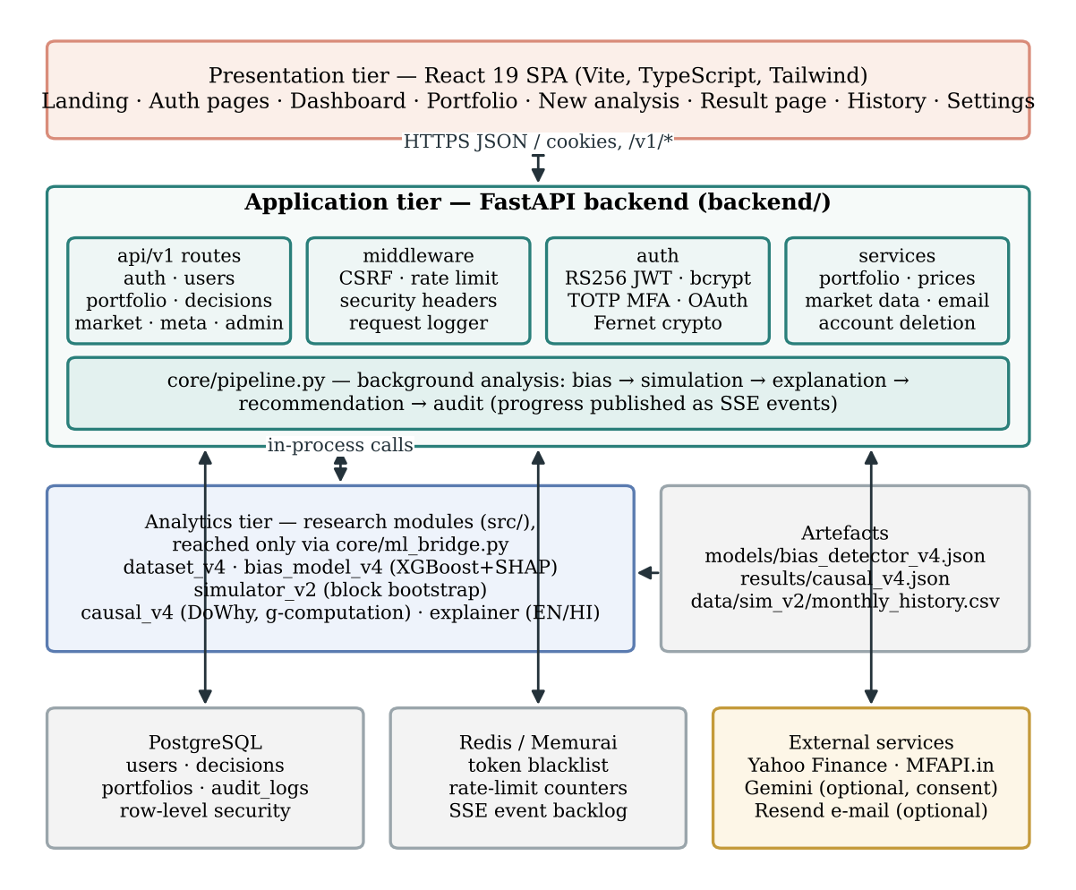
Figure 5.1: Three-tier architecture of Folium (generated diagram)
Figure 5.1 shows the three tiers. The presentation tier is a React single-page application [51]. During development the Vite server proxies every /v1/* request to the API, so the browser sees one origin; this keeps the httpOnly session cookies and the CSRF double-submit check simple.
The application tier is a FastAPI [50] service (backend/main.py). Its routers live in backend/api/v1/, its cross-cutting concerns in backend/middleware/, its authentication primitives in backend/auth/ and its domain services in backend/services/. The analysis itself runs as a background task orchestrated by backend/core/pipeline.py.
The analytics tier is the research code in src/. A deliberate design decision is that the back end never re-implements the models: backend/core/ml_bridge.py is the only place where backend/ reaches into src/. It adds the repository root to the import path, imports the heavy ML libraries lazily (about 2 seconds and 400 MB), runs blocking work in a thread so the event loop is not stalled, and maps vocabulary between the two worlds (for example disposition ↔ disposition_effect). The rationale, recorded in the master reference, is that the research modules produced the reported numbers, and re-implementing them would risk silently changing those numbers.
The data tier consists of PostgreSQL, which stores users, portfolios, decisions and the audit chain under row-level security, and a Redis-compatible store, which holds the token blacklist, rate-limit counters and the event backlog for live progress. External services are called only for prices and market data, and—optionally—for e-mail and Gemini.

5.2 Component Architecture of the Analysis Pipeline
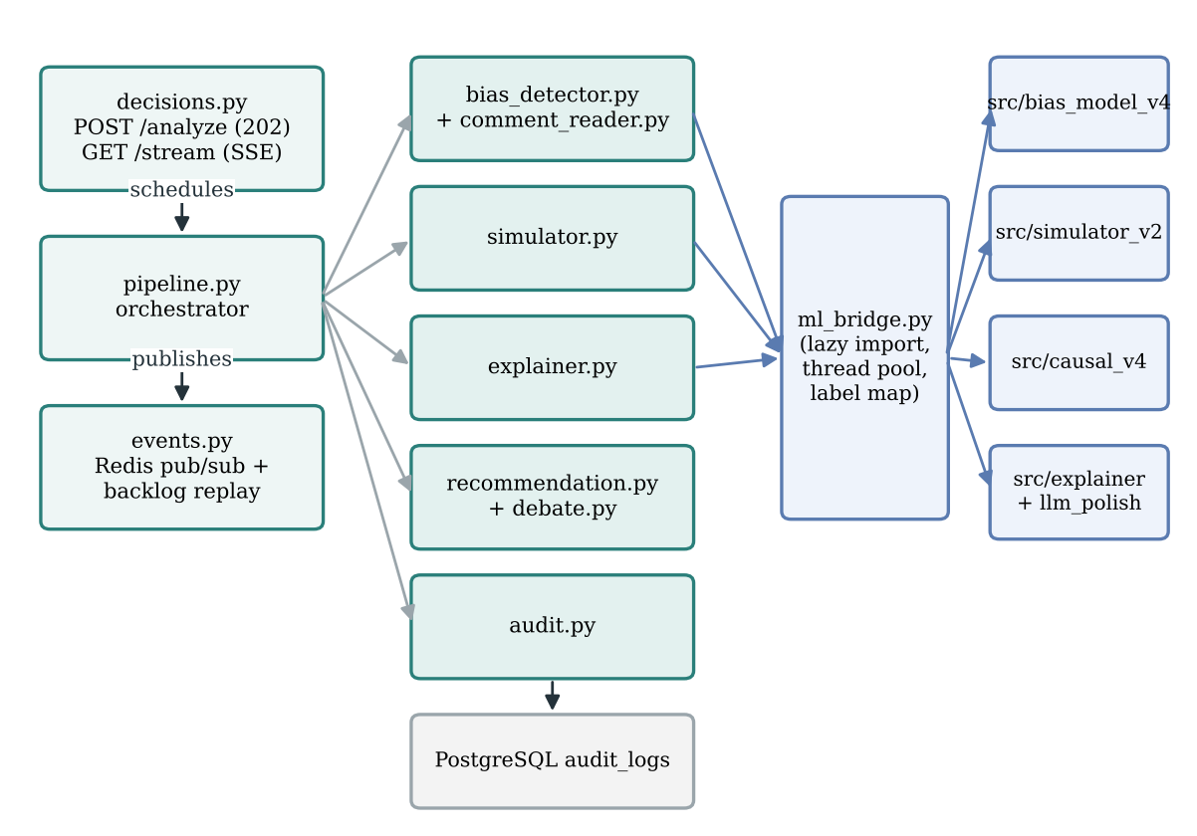
Figure 5.2: Components involved in one analysis (generated diagram)
Figure 5.2 zooms into the pipeline. decisions.py handles POST /v1/decisions/analyze, schedules run_analysis_pipeline as a FastAPI BackgroundTask and returns immediately. The orchestrator calls five step functions in a fixed order defined in events.STEP_ORDER: bias detection, simulation, explanation, debate (recommendation) and audit. Each step is registered through steps.register_step; the step registry also holds placeholder implementations (stub_steps.py) so that the orchestration could be built and tested before the models existed. The first four steps call into src/ through the bridge. The audit step writes to the audit_logs table directly.
A step returns a StepResult holding the columns to update and the fields to attach to its progress event; it does not write status or publish events itself. The orchestrator owns those responsibilities and refuses any step that tries to write the columns it reserves (status, pipeline_step, error_message, and so on). This separation is visible in Listing 6.11.

5.3 Data-Flow Diagrams
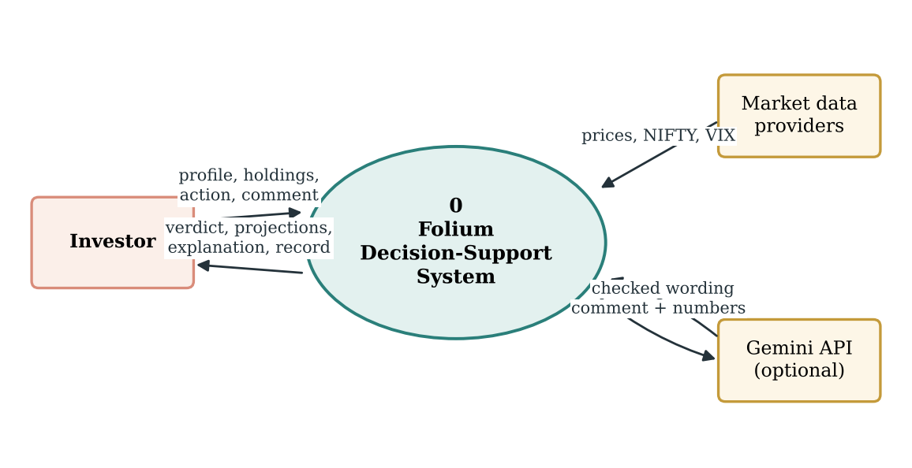
Figure 5.3: Context-level (level-0) data-flow diagram (generated diagram)
At the context level (Figure 5.3) the system exchanges data with three external entities. The investor supplies their profile, holdings, the intended action and an optional comment, and receives a verdict, projections, an explanation and a verifiable record. Market data providers supply prices, NIFTY and VIX. The Gemini API is an optional entity: it receives a comment and analysis numbers only for investors who have consented and only when the server enables it, and its output is accepted only after checks.
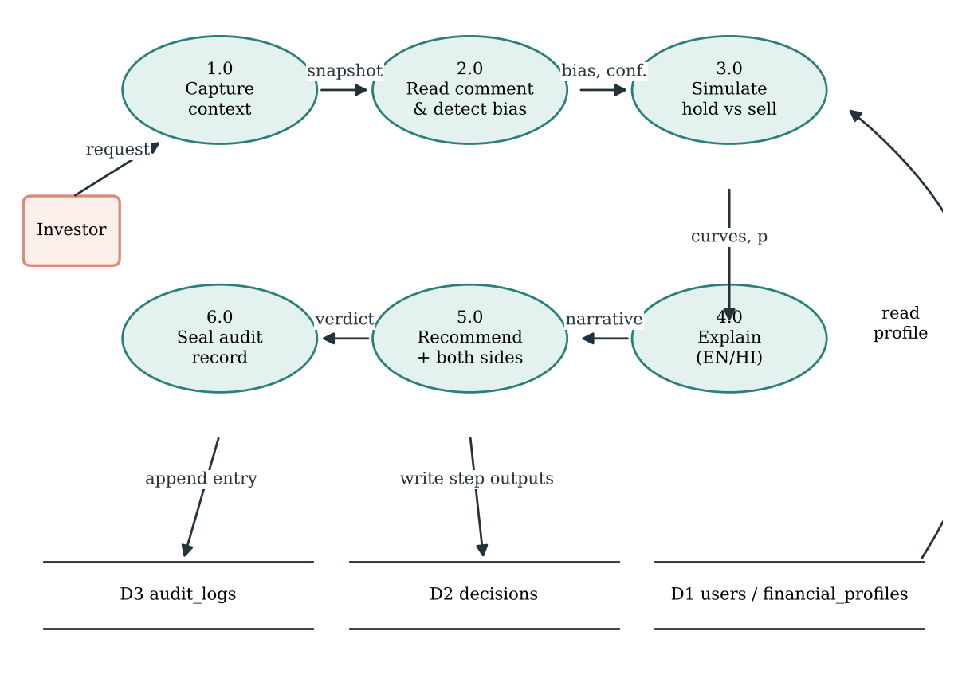
Figure 5.4: Level-1 data-flow diagram of the analysis process (generated diagram)
Figure 5.4 decomposes the analysis into six processes. Process 1.0 corresponds to the analyze endpoint (context capture); processes 2.0–6.0 correspond to the five pipeline steps. Every process writes its outputs into the decisions store (D2) and the next process reads the refreshed row, which is why the orchestrator reloads the decision before each step. The simulation reads the investor’s profile and financial profile (D1) for income, SIP and the destination of sale proceeds; the final process appends an entry to the audit store (D3).

5.4 Use-Case Diagram
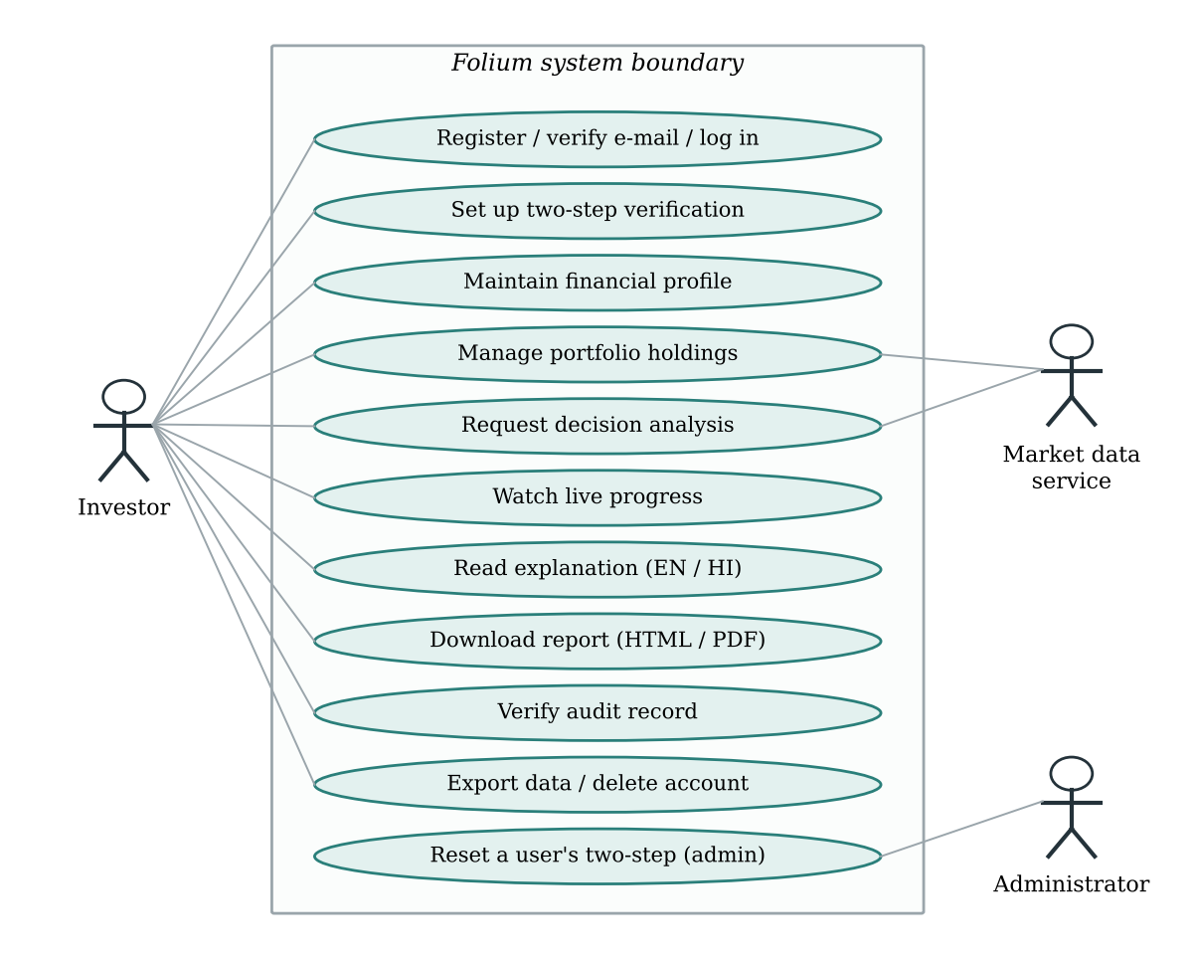
Figure 5.5: Use-case diagram (generated diagram)
Figure 5.5 shows the two human actors and one external system actor. The investor’s use cases correspond to the routes listed in Appendix B; registration and login are available both by e-mail and through Google. The administrator’s implemented use case is resetting a user’s two-step verification (backend/api/v1/admin.py); the wider administrator console is the next planned milestone (Section 12.5). The market data service participates in portfolio management (live prices) and in analysis requests (market context and stock risk).

5.5 Activity Diagram
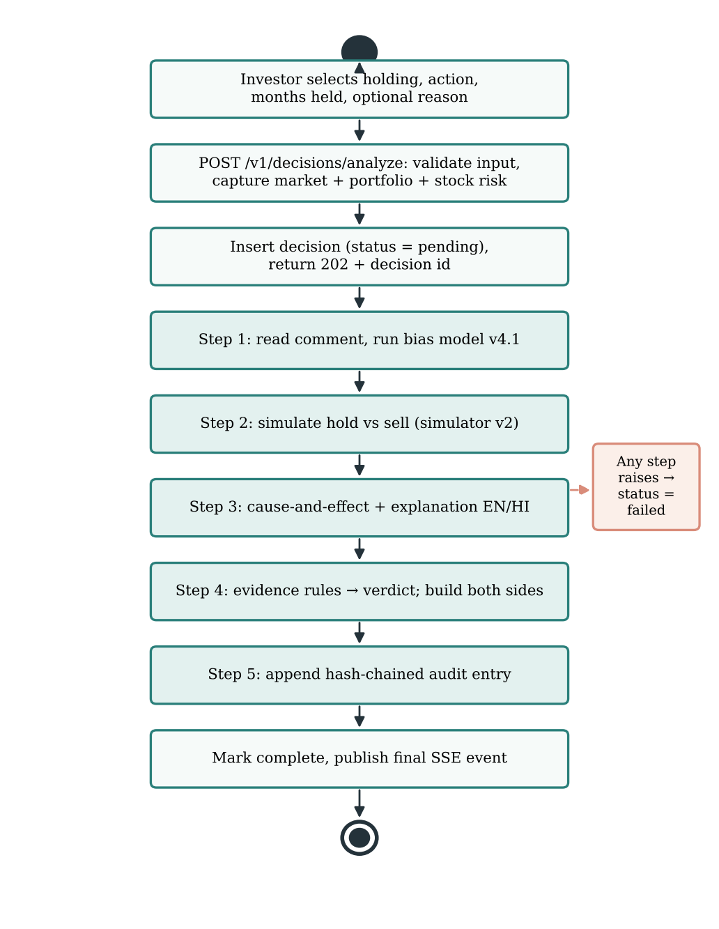
Figure 5.6: Activity diagram of a decision analysis (generated diagram)
Figure 5.6 traces one analysis from the investor’s input to completion. The synchronous part (the first three activities) ends with an HTTP 202 response so that the browser is never kept waiting for the models. The five shaded activities run in the background. If any step raises an exception, control leaves the main flow: the decision is marked failed, the error is stored, a failed event is published so that connected browsers stop waiting, and the error is reported to Sentry if configured. Wording problems never fail an analysis, because the explanation step falls back to template text.

5.6 Sequence Diagram
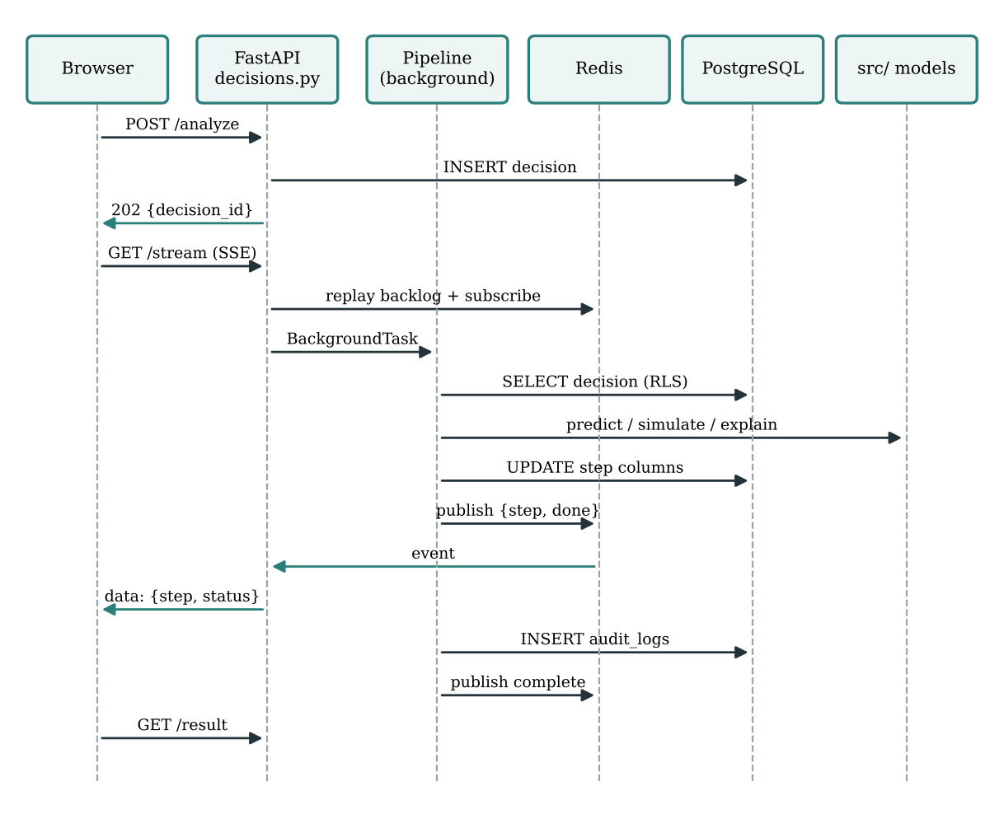
Figure 5.7: Sequence diagram of an analysis with live progress (generated diagram)
Figure 5.7 shows the message order. A subtle detail is the backlog replay. If the browser opened the stream only by subscribing to Redis pub/sub, any event published before the subscription (for example a fast first step) would be lost, and a reload during an analysis would show an empty history. backend/core/events.py therefore appends every event to a Redis list with a time-to-live as well as publishing it. The stream endpoint first replays the list and then follows live messages, de-duplicating by a per-decision sequence number. If the stream cannot be opened at all, the result page falls back to polling.

5.7 Entity–Relationship Design
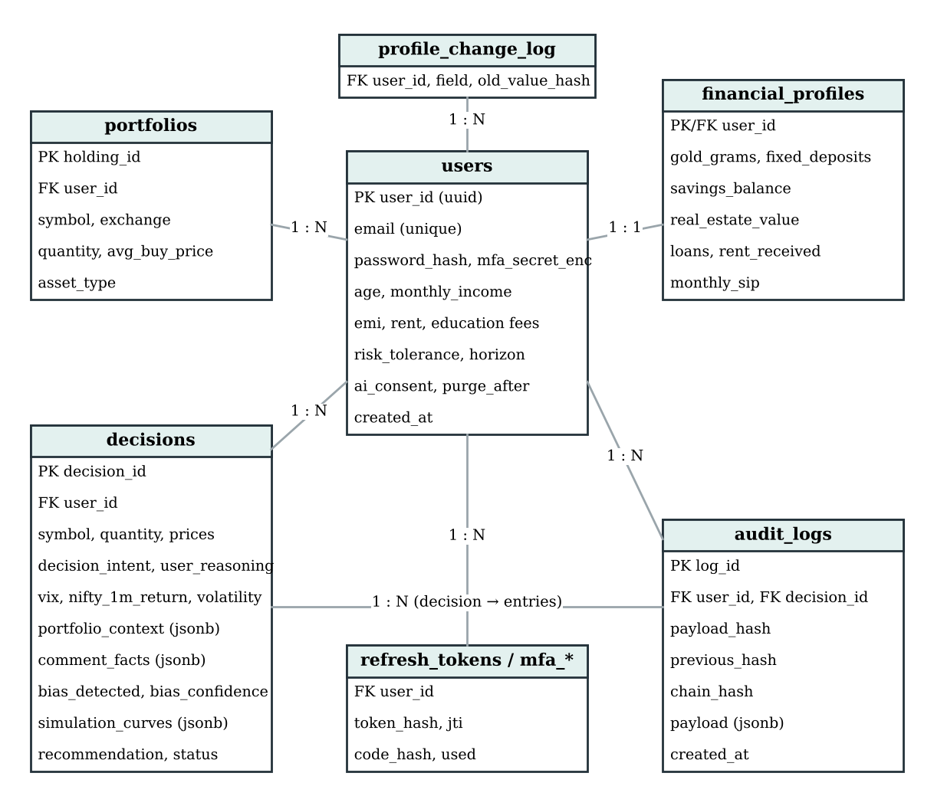
Figure 5.8: Entity–relationship diagram of the main tables (generated from Alembic migrations 0001–0012)
Figure 5.8 shows the principal entities. users is the root: it holds the account, the Tier-1 financial profile, the deletion schedule (purge_after, anonymised_at) and the AI consent flag. financial_profiles has a one-to-one relationship with users and stores gold, deposits, savings, property, loans, rent received and monthly SIP. portfolios holds shares and mutual funds. Each analysis is a row of decisions, which stores both the inputs (including JSONB snapshots of the portfolio and the comment reading) and every model output. audit_logs holds the hash-chained entries; its foreign keys use ON DELETE SET NULL so that the chain survives anonymisation. Authentication support tables (refresh_tokens, mfa_backup_codes, mfa_recovery_requests) and profile_change_log complete the schema. Tables bias_profiles, market_cache, sip_registrations and kite_tokens exist from earlier plans but are reserved and not used by the current product.
Row-level security is enabled and forced on decisions, audit_logs, portfolios, sip_registrations and profile_change_log (migration 0007), with financial_profiles added later. Each policy compares the row’s user_id with a per-transaction setting, as explained in Section 6.10.

5.8 Deployment Diagram
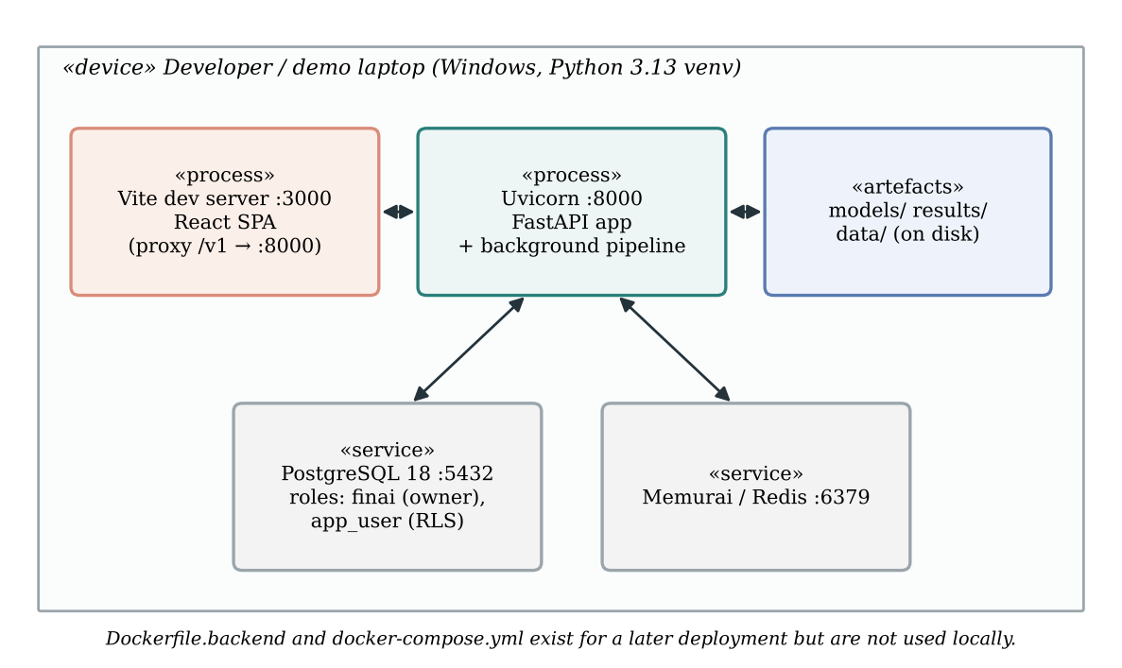
Figure 5.9: Deployment diagram of the development and demonstration set-up (generated diagram)
Figure 5.9 shows the configuration actually used: all processes on one Windows laptop with native PostgreSQL 18 and Memurai. PostgreSQL has two roles: finai, the owner used for migrations, and app_user, a non-superuser used by the application so that RLS policies bind. Model artefacts and result files are read from disk. A container set-up exists in the repository but has not been used, and no production deployment with HTTPS exists yet.

5.9 User-Interface Design
The front end (frontend/src/pages) has public pages (landing, privacy, authentication, and /auth/google, where Google sign-in returns) and application pages under /app. A first Google sign-in lands on /app/welcome, which collects the Tier-1 profile; until it is filled, every other signed-in page except Settings redirects there. The remaining application pages are an overview dashboard, the portfolio, a new-analysis form with a live market card, the result page, history and settings. The result page is the centre of the design. In order, it shows the live five-step progress (with plain titles such as “Reading your decision” and “Projecting the future”), the recommendation with its reasons, the position against the whole portfolio, a chart of both futures, the pattern found with probability bars, the six-part explanation with an English/हिंदी switch, report downloads, “What weighed most”, cause and effect, both sides in numbers, “In your own words”, “Verify this record” and “How this was worked out”. Product rules applied throughout are: no model names or accuracy figures, confidence as High/Medium/Low, and a light or dark theme with serif headings.
Screenshots of these pages are not included in the repository, and we have not reproduced them for this report. Appendix G lists the screenshots to capture and how to capture them; placeholders are reserved in Chapter 9.

Chapter 6: Detailed Implementation
This chapter walks through the implementation module by module. Code listings are excerpts copied from the repository; where lines have been omitted for space this is shown with .... Identifiers and logic are unchanged. Proposed improvements are kept out of the listings and discussed in Chapter 12.

6.1 Repository Organisation
Table 6.1: Repository organisation
Path | Contents
backend/ | Product API: api/v1/ routes, auth/, core/ (pipeline and steps), services/, db/ (pool, Redis client, Alembic migrations 0001–0012), schemas/, middleware/, tests/
frontend/ | React application (src/pages, src/components, src/lib, src/providers, src/test)
src/ | Models and engines. Current: dataset_v4.py, bias_model_v4.py, simulator_v2.py, causal_v4.py, explainer.py, explanation_templates.py, explanation_report.py, llm_polish.py, market_data.py. Earlier versions kept for rollback or reference: bias_detector.py (v3), simulator.py (v1), causal_inference.py, and the old Streamlit prototype (api.py, dashboard.py)
models/ | bias_detector_v4.json and .meta.json (current); v4.0 and pickled v1–v3 models (rollback)
data/ | v4/decisions_v4.csv, v4/market_history.csv, v4/DATASET_CARD.md, sim_v2/monthly_history.csv
results/ | causal_v4.json, evaluation JSONs and reports/ (three model reports)
scripts/ | Training, evaluation, seeding, purging, key generation, environment checks
tests/ | Tests for the models and engines (no database needed)
notebooks/, archive/ | Research notebooks (01–09) and archived scripts and results from earlier versions

6.2 Dataset Generator (src/dataset_v4.py)
Purpose. Produce the 20,000 labelled decisions used to train the bias model and to validate the causal module.
Inputs and outputs. Input: cached market history and a seed (2026). Output: data/v4/decisions_v4.csv with situation, household, portfolio, action, label and hidden latent_* columns.
Processing logic. The key function for the rest of the system is applicable_bias_motives, which encodes the label table, and its action-specific wrapper allowed_labels, which the bias model uses both as an input and as a guard. Keeping the table in exactly one place means the generator, the model and the tests cannot disagree about what a label means.
Listing 6.1: The label rules in code form — applicable_bias_motives and allowed_labels (src/dataset_v4.py)
def applicable_bias_motives(s: dict) -> list[Motive]:
"""The bias motives the situation allows — LABEL_RULES in code form."""
gl, r1m, vix, regime = s["unrealized_gl"], s["nifty_1m_return"], s["vix"], s["regime"]
falling_fear = gl < -0.03 and r1m <= FALLING_1M and (vix >= FEAR_VIX or regime in ("crash", "correction"))
calm = regime in ("normal", "bull")
out: list[Motive] = []
if falling_fear:
out.append(Motive("loss_aversion_panic", "loss_aversion", "sell"))
if gl <= DEEP_LOSS:
out.append(Motive("loss_aversion_refusal", "loss_aversion", "hold"))
if calm and gl >= EARLY_WIN:
out.append(Motive("disposition_sell_winner", "disposition", "sell"))
if calm and DEEP_LOSS < gl <= MODERATE_LOSS:
out.append(Motive("disposition_hold_loser", "disposition", "hold"))
if vix >= HERD_FEAR_VIX or r1m <= HERD_FEAR_1M:
out.append(Motive("herd_sell_fear", "herd", "sell"))
if r1m >= FRENZY_1M:
out.append(Motive("herd_buy_frenzy", "herd", "buy_more"))
return out
def allowed_labels(unrealized_gl, nifty_1m_return, vix, action) -> set[str]:
s = {"unrealized_gl": unrealized_gl, "nifty_1m_return": nifty_1m_return,
"vix": vix, "regime": _regime(nifty_1m_return, vix, 0.0)}
return {"rational"} | {m.label for m in applicable_bias_motives(s) if m.action == action}
The thresholds (DEEP_LOSS = -0.25, MODERATE_LOSS = -0.05, EARLY_WIN = 0.08, FEAR_VIX = 20, HERD_FEAR_VIX = 22) are module constants, so the dataset card, the tests and the code all refer to the same values. The regime function classifies a day as crash, correction, euphoria, bull or normal from its 1-month return, VIX and 52-week drawdown; inside allowed_labels the drawdown is passed as 0 because every rule treats crash and correction alike.
The motive competition (_choose) builds a list of candidates—one rational motive chosen by rational_action, plus every applicable bias motive—and samples one with probability proportional to its weight (Section 7.1). rational_action encodes the legitimate reasons in priority order: needs cash, rebalance an oversized position (above 35% of liquid assets), goal near with a gain, buy value in a fall with spare cash and a long horizon, add regularly, cut a loss, average down, and otherwise stay the course.
Reproducibility. The generator uses numpy.random.default_rng(2026) and the cached market file, so rebuilding gives identical output (verified by tests/test_dataset_v4.py).

6.3 Bias Model v4.1 (src/bias_model_v4.py)
Purpose. Read the behavioural pattern most likely behind a decision, with calibrated confidence and an explanation.
Inputs. The 20 raw inputs in INPUTS (action, gain or loss, months held, market values, age, horizon, risk tolerance, income, rent received, outflow, emergency fund, position/equity/gold shares, liquid assets, property, loans and cash_need_stated).
Outputs. A dictionary with bias_type, calibrated confidence, all four calibrated probabilities, the raw model_probabilities, the allowed labels, whether the guard changed the answer, the top drivers, the computed features and the inference time.
Listing 6.2: Feature construction shared by training and live requests — excerpt of build_features (src/bias_model_v4.py)
def build_features(raw: pd.DataFrame) -> pd.DataFrame:
missing = [c for c in INPUTS if c not in raw.columns]
if missing:
raise KeyError(f"bias model v4 inputs missing: {missing}")
...
allowed = [allowed_labels(g, r, v, a)
for g, r, v, a in zip(gl, r1m, vix, raw["action"])]
income = raw["monthly_income"].astype(float)
surplus = income + raw["rent_received"].astype(float) - raw["monthly_outflow"].astype(float)
X = pd.DataFrame({
"action_sell": (raw["action"] == "sell").astype(int),
...
"allows_disposition": [int("disposition" in a) for a in allowed],
"allows_herd": [int("herd" in a) for a in allowed],
"allows_loss_aversion": [int("loss_aversion" in a) for a in allowed],
...
"surplus_ratio": _ratio(surplus, income).clip(-2.0, 2.0),
"debt_ratio": _ratio(raw["loans_outstanding"],
raw["liquid_assets"].astype(float) + raw["real_estate_value"].astype(float),
).clip(0.0, 5.0),
"cash_need_stated": raw["cash_need_stated"].astype(int),
}, index=raw.index)
return X[list(FEATURES)]
The function refuses to run with missing inputs, rejects unknown actions, and guards divisions with _ratio, which returns 0 when the denominator is not positive. Returning columns in the fixed FEATURES order matters because the booster expects features by position.
Listing 6.3: The definitional guard and top-label calibration — apply_guard and calibrate_top_label (src/bias_model_v4.py)
def apply_guard(p: np.ndarray, mask: np.ndarray) -> np.ndarray:
"""Zero the patterns the definitions rule out, then renormalise."""
q = p * mask
return q / q.sum(axis=1, keepdims=True)
def calibrate_top_label(p, curve_x, curve_y):
p = np.asarray(p, dtype=float)
k = p.argmax(axis=1)
rows = np.arange(len(p))
top = p[rows, k]
rest = 1.0 - top
second = np.sort(p, axis=1)[:, -2]
c = np.interp(top, curve_x, curve_y)
floor = np.where(rest > 0, second / np.maximum(rest + second, 1e-12) + 1e-6, top)
c = np.clip(np.maximum(c, floor), 0.0, 1.0)
scale = np.where(rest > 1e-12, (1.0 - c) / np.maximum(rest, 1e-12), 0.0)
q = p * scale[:, None]
q[rows, k] = c
return q
Because “rational” is always allowed, the mask never zeroes every class, so the renormalisation in apply_guard is safe. calibrate_top_label replaces only the chosen class’s probability with its calibrated value and rescales the others to fill the remainder, preserving their ratios. The floor term is a careful detail: it ensures calibration can lower the stated confidence but can never demote the chosen class below the runner-up. In the words of the docstring, calibration “changes how sure the model says it is, never what it says”.
Listing 6.4: One prediction with exact TreeSHAP drivers — excerpt of predict (src/bias_model_v4.py)
def predict(inputs: Mapping[str, Any], top_n: int = 5) -> dict[str, Any]:
bundle = load()
meta = bundle["meta"]
raw = pd.DataFrame([{k: inputs[k] for k in INPUTS}])
X = build_features(raw)
margins, contribs = _margins_and_contribs(bundle["booster"], X)
p_model = softmax(margins)
mask = allowed_mask(raw)
p_guarded = apply_guard(p_model, mask)
curve = meta["calibration"]
p = calibrate_top_label(p_guarded, np.array(curve["x"]), np.array(curve["y"]))[0]
k = int(p.argmax())
label = LABELS[k]
return {
"bias_type": label,
"confidence": round(float(p[k]), 4),
...
"drivers": _drivers(contribs[0, k, :-1], X.iloc[0], top_n),
...
}
_margins_and_contribs asks XGBoost for both the raw margins and pred_contribs=True, which returns exact TreeSHAP values per class. Only the chosen class’s contributions (contribs[0, k, :-1], dropping the bias column) are passed to _drivers, which sums them by the DRIVER_OF mapping into plain drivers such as “gain or loss”, “market fear” or “position size”, ranks them by magnitude and records whether each pushes towards or against the reading. This fixed a defect of the earlier v3 model, whose explanation ranked factors for whichever class had the largest total attribution—in 98.6% of test cases not the class it displayed (per bias_v4_evaluation.json).
Artefacts and loading. The model is stored as native XGBoost JSON (models/bias_detector_v4.json), not a pickle, with a metadata file holding the feature list, the calibration curve and the training medians. load caches the booster behind a lock and refuses to run if the metadata’s feature list differs from the code’s.
Training (scripts/train_bias_v4.py). The 20,000 cases are split 80/20 into development and test sets, stratified by label × regime (seed 7). Five-fold stratified cross-validation with early stopping (up to 3,000 trees, patience 80) determines the tree count: the mean best iteration × 1.1 = 402 trees. The same folds produce out-of-fold predictions for fitting the isotonic curve. Sample weights re-weight each regime to its real frequency. Hyper-parameters are listed in Table 8.2.

6.4 Bias Step in the Product (backend/core/bias_detector.py, comment_reader.py)
Purpose. Assemble model inputs from the database, run the comment reader and the model, and store the results.
build_v4_inputs reads the decision row, the user’s profile and the portfolio snapshot captured at submission. It computes the position, equity and gold shares from the snapshot and fills any missing profile field with the training median from the model’s metadata, appending its name to assumed_defaults. Missing market values use the median real trading day. The bridge then runs predict in a worker thread, maps the label to the product vocabulary and writes bias_detected, bias_confidence and the bias block of explainer_output.
Comment reading runs first so that cash_need_stated is available to the model. The rule-based reader scans the comment with regular expressions in English, Hinglish and Hindi.
Listing 6.5: Excerpt of the phrase rules for facts and feelings (backend/core/comment_reader.py)
_FACT_RULES: dict[str, tuple[str, ...]] = {
"cash_need": (
r"\bneed (the |some |that |this )?(money|cash|funds?)\b",
r"\b(school|college|tuition|education|exam) fees?\b",
r"\b(medical|hospital|surgery|treatment|operation)\b",
r"\b(lost my job|job loss|laid off|layoffs?|unemployed|no salary)\b",
r"\b(paisa|paise|paison) (chahiye|ki zarurat|ki zaroorat|chahiye the)\b",
...
),
...
}
_CUE_RULES: dict[str, tuple[str, tuple[str, ...]]] = {
"fear": ("loss_aversion", (
r"\b(scared|afraid|frightened|panic\w*|nervous|worried|anxious)\b",
r"\bbefore it (gets worse|falls more|drops more)\b",
...)),
"crowd": ("herd_behavior", (
r"\b(everyone|everybody)\b",
r"\b(whatsapp|telegram) group\b",
...)),
...
}
Each match is returned with the whole sentence that contains it, quoted verbatim, so the investor sees exactly which words were read. The design separates facts (statements about the investor’s situation) from cues (feelings). Only the cash_need fact changes anything—it sets the model input. Feelings are quoted back in “In your own words” with a note on whether they agree with the reading, but they never change the reading or the verdict. When the investor has consented and the server has a key, Gemini may read the comment as well; its answer is accepted only if every item has an allowed kind and a quote that appears word for word in the comment. Otherwise the rule-based reading stands.

6.5 Simulator v2 (src/simulator_v2.py) and Its Bridge (backend/core/simulator.py)
Purpose. Compare holding and selling one position over the investor’s horizon.
Inputs. A SimInputs dataclass: position value and cost basis, months held, asset type (stock or equity fund), horizon (clamped to 1–30), annual income, the rest of the liquid portfolio, beta and own volatility, monthly SIP and education fees with their end year, number of paths (1,000) and seed.
Outputs. Year-by-year 10th/50th/90th percentiles for both paths, end-of-horizon summaries, the sale breakdown (tax, charges, proceeds, destination split), the comparison (median paired gap, probability holding wins), portfolio context and every assumption used.
Listing 6.6: Circular 12-month block bootstrap — _bootstrap (src/simulator_v2.py)
def _bootstrap(rng: np.random.Generator, n_paths: int, months: int, n_hist: int) -> np.ndarray:
"""(n_paths, months) indices into history: 12-month blocks, joined end to end.
Circular (Politis & Romano): a block may wrap from the last month to the
first, so every month is equally likely. Without it the first and last
months of history are under-sampled — and October 2007 starts with the
2008 crash.
"""
b = int(ASSUMPTIONS["block_months"])
n_blocks = -(-months // b)
starts = rng.integers(0, n_hist, size=(n_paths, n_blocks))
return ((starts[:, :, None] + np.arange(b)) % n_hist).reshape(n_paths, -1)[:, :months]
The function is fully vectorised: it draws all block starts at once, expands each into 12 consecutive month indices with broadcasting, wraps them with the modulo operator and trims to the required length. The same index matrix is then used for equity and gold, which preserves their real month-by-month relationship.
Listing 6.7: The paired HOLD and SELL valuation, after tax — excerpt of simulate (src/simulator_v2.py)
growth = a["fd_rate"] + beta * (market_growth - a["fd_rate"])
eq_shock = eq_log[idx] - eq_log.mean()
own = rng.normal(-own_vol ** 2 / 2, own_vol, size=(n, m))
pos_cum = np.exp(np.cumsum(math.log1p(growth) / 12 + beta * eq_shock + own, axis=1))
...
# ── HOLD: the position stays; in hand = value - costs - tax on the gain ──
hold_value = inp.position_value * pos_cum
hold_gain = hold_value - inp.cost_basis
hold_in_hand = hold_value * (1 - a["sale_cost"]) - equity_gains_tax(hold_gain, inp.months_held + months_ahead)
# ── SELL: tax and costs now; proceeds into the safer money ──────────────
sale = sale_today(inp)
split = destination(inp)
p = float(sale["proceeds"])
gold_part = p * split["gold"] * gd_cum
gold_in_hand = gold_part - gold_gains_tax(gold_part - p * split["gold"], months_ahead, slab)
sell_in_hand = (gold_in_hand + p * split["fixed_deposits"] * fd_after_tax
+ p * split["savings"] * sav_after_tax)
...
diff = hold_end - sell_end
opp = float(np.median(diff))
prob_hold = float((diff > 0).mean())
Three design points are visible here. First, the holding’s typical growth is set with the capital-asset-pricing relation (FD rate plus beta times the equity premium), so that a volatile stock is not projected to grow faster merely because it is volatile. Second, the own-volatility shock has mean $−{σ^{2}}/2$ in log space, so that its expected multiplicative effect is one. Third, HOLD is valued as if cashed in each year (charges and capital-gains tax deducted), while SELL paid its tax on day one and is taxed on interest each year; the two are therefore compared like for like. The headline gap is the median of the paired differences, because single-stock outcomes are right-skewed and the mean would overstate the usual result.
Listing 6.8: Indian tax helpers — marginal_slab_rate and equity_gains_tax (src/simulator_v2.py)
def marginal_slab_rate(annual_income: float) -> float:
taxable = max(0.0, float(annual_income) - TAX["standard_deduction"])
if taxable <= TAX["rebate_up_to"]:
return 0.0
for upper, rate in TAX["slabs"]:
if taxable <= upper:
return rate * (1 + TAX["cess"])
return TAX["slabs"][-1][1] * (1 + TAX["cess"])
def equity_gains_tax(gain, months_held, exemption: float | None = None):
gain = np.maximum(np.asarray(gain, dtype=float), 0.0)
months = np.asarray(months_held, dtype=float)
exempt = TAX["ltcg_exemption"] if exemption is None else exemption
short = months <= TAX["equity_ltcg_after_months"]
stcg = gain * TAX["equity_stcg"]
ltcg = np.maximum(gain - exempt, 0.0) * TAX["equity_ltcg"]
return np.where(short, stcg, ltcg) * (1 + TAX["cess"])
The helpers work on whole arrays, so tax is computed for all 1,000 paths and every month in one call. Losses pay nothing; set-off against other gains is not modelled (a stated limitation).
The bridge (backend/core/simulator.py::build_sim_inputs) builds SimInputs from the decision, the profile and the portfolio snapshot. It uses the beta and own volatility measured at submission by backend/services/prices.py::stock_risk (from 10 years of monthly prices), falling back to the median NIFTY 50 stock (beta 1.0, own volatility 21%) and recording that in fixed_inputs. Because the profile records take-home pay, the bridge first converts it to gross income before the slab rate is looked up: annual_income = gross_from_take_home(12 × monthly income) + 12 × 0.7 × rent received, where rent counts at 70% because of the 30% standard deduction on house property (Section 7.8). It also writes legacy columns (hold_median_20y and similar) that keep their historical names even though the horizon is now the investor’s own; this naming inconsistency is cosmetic and noted in Section 10.8.

6.6 Cause-and-Effect Module (src/causal_v4.py)
Purpose. Estimate what pushes each action and which habit helps most, and verify the estimates against the truth.
Processing logic. action_probabilities re-implements the generator’s motive weights so that, for any case, it returns the exact probability of sell, hold and buy more; consistency_with_stored_data confirms that it matches the stored motive share of all 20,000 cases (maximum absolute error 0.0, per results/causal_v4.json). A do(...) helper applies an intervention to a data frame. The true effect of an intervention is then the mean change in these exact probabilities. The estimated effect comes from two estimators trained on the observed data only.
Listing 6.9: G-computation estimator — GComputation (src/causal_v4.py)
class GComputation:
"""S-learner: P(action | everything observed), queried under interventions."""
def __init__(self, df: pd.DataFrame, seed: int = 0):
from sklearn.ensemble import HistGradientBoostingClassifier
self.model = HistGradientBoostingClassifier(max_iter=400, learning_rate=0.06, max_leaf_nodes=31,
l2_regularization=1.0, random_state=seed)
self.model.fit(df[OBSERVED], df.action.map({a: i for i, a in enumerate(ACTIONS)}))
def probabilities(self, df: pd.DataFrame) -> np.ndarray:
p = self.model.predict_proba(_refresh_derived(df)[OBSERVED])
out = np.zeros((len(df), 3))
out[:, self.model.classes_] = p
return out
The g-computation estimate of an intervention is the average predicted probability after the intervention minus the average before it (_delta). Note that _refresh_derived recomputes the surplus ratio after an intervention on income or outflow, so derived features stay consistent.
The DoWhy estimator (dowhy_effect) builds a GML graph in which every observed variable points to the outcome and profile variables point to the latent tendencies, identifies the effect with the maximal adjustment set, estimates it with backdoor.linear_regression, and runs three refuters—placebo treatment, random common cause and a data subset—each with 10 simulations. An effect passes when the placebo effect is below 25% of the estimate, adding a random common cause changes it by less than 10%, and the subset estimate is within 25%.
Habits. Each habit is modelled as halving the tendency it targets (for example “reframing the loss” halves loss aversion); “not watching the crowd” caps the market fear reaching the investor at VIX 15. The results file stores, for each (pattern, action) situation, the share who take the action and the change the best habit would make. backend/core/explainer.py reads results/causal_v4.json and caches it.

6.7 Recommendation (backend/core/recommendation.py)
Listing 6.10: The evidence rules for the sell intent — excerpt of decide (backend/core/recommendation.py)
_STRONG, _WEAK = 0.60, 0.40
_BIAS_CONFIDENT = 0.60
def decide(intent, bias, confidence, p_hold, horizon_years=20):
"""Return (verdict, reasons). Pure function — unit-testable without a DB."""
p = 0.5 if p_hold is None else p_hold
biased = bias != "rational"
...
if intent == "sell":
if p >= _STRONG:
reasons.append(f"Holding beat selling in {pct} of {horizon_years}-year simulations.")
if biased:
reasons.append(f"The urge to sell shows signs of {bias_name}.")
return "HOLD", reasons
if p <= _WEAK:
reasons.append(f"Holding beat selling in only {pct} of simulations.")
return "SELL", reasons
reasons.append(f"The simulations are close to even ({pct} favour holding).")
if biased:
reasons.append(f"With {bias_name} detected, the cautious choice is to wait.")
return "HOLD", reasons
...
return "SELL", reasons
decide is a pure function: it takes values, returns a verdict and a list of reasons, and touches neither the database nor the network, which makes it directly unit-testable. If no simulation result is available, the odds are treated as even and that fact is stated. When a reason mentions the confidence of a bias reading, confidence_band writes it in words (high ≥ 0.85, medium ≥ 0.65, otherwise low), never as a percentage, matching the product rule that no raw probability is shown to the investor. The step wrapper recommend stores a debate_transcript with engine = "evidence_rules_v1", the reasons, the exact inputs used and the “both sides” cases built afterwards by backend/core/debate.py. The cases are never read by the verdict.

6.8 Pipeline Orchestrator (backend/core/pipeline.py)
Listing 6.11: The step loop and failure handling — excerpt of run_analysis_pipeline (backend/core/pipeline.py)
try:
for step_name in STEP_ORDER:
await _set_status(db, decision_id, user_id, "processing", step_name)
await publish_event(redis, decision_id, {"step": step_name, "status": "running"})
# Reload before each step so it sees the previous steps' writes
decision = await _load_decision(db, decision_id, user_id)
if decision is None:
raise LookupError(f"decision {decision_id} not found for user {user_id}")
ctx = PipelineContext(decision_id=decision_id, user_id=user_id,
decision=decision, db=db, redis=redis)
result = await resolve_step(step_name)(ctx)
await _apply_updates(db, decision_id, user_id, result.updates)
await publish_event(redis, decision_id,
{"step": step_name, "status": "done", **result.event})
await _set_status(db, decision_id, user_id, "complete", None, completed=True)
await publish_event(redis, decision_id, {"step": "complete", "status": "done"})
except Exception as exc: # noqa: BLE001 — any step failure fails the decision
sentry_sdk.capture_exception(exc)
try:
await _set_status(db, decision_id, user_id, "failed", None,
error_message=str(exc)[:500])
finally:
await publish_event(redis, decision_id,
{"step": "failed", "status": "error", "error": str(exc)[:500]})
The loop guarantees two properties. Each step sees what earlier steps wrote, because the row is reloaded every time. And a connected browser always learns that the run ended: the success path publishes complete, and the failure path publishes failed inside a finally block, so even a failure while writing the status still notifies the stream. _apply_updates builds a parameterised UPDATE (column names come from the step’s own code, values are bound as parameters), casts JSONB columns explicitly and converts floats to Decimal through their string form to avoid binary-float noise in NUMERIC columns.

6.9 Explanation Engine (src/explainer.py, explanation_templates.py, explanation_report.py, llm_polish.py)
Purpose. Turn every model output into a six-section story—In short; What’s going on right now; Your two possible futures; The story of your money; Why we’re telling you this; What to do now—in English and Hindi, plus HTML and PDF reports.
Processing logic. build_facts gathers all numbers into one dictionary. Templates are rendered by Jinja2 [57] with StrictUndefined, so a missing fact raises an error during tests rather than printing a blank. A translation layer replaces internal terms (“p10”, “opportunity cost”, causal variable names) with plain phrases, and a 30-term jargon blocklist is enforced by tests. Money is formatted the Indian way (₹1.2 lakh in prose; ₹1,32,451 in tables). The narrative quotes the typical (median) outcome rather than the mean, because wealth distributions are right-skewed. English and Hindi template banks are hand-written and structurally identical (34 templates each, enforced by tests), so Hindi works offline.
Listing 6.12: The number-preservation guard for optional AI wording — guard_ok (src/llm_polish.py)
def guard_ok(original: str, polished: str) -> bool:
"""
The whole safety argument for this module.
Rejects the polished text if it contains any number or rupee amount that
is not present in the original, or if its length has drifted far enough
to suggest content was invented or dropped.
"""
if not polished or not polished.strip():
return False
invented_numbers = _numbers(polished) - _numbers(original)
if invented_numbers:
return False
invented_money = _money(polished) - _money(original)
if invented_money:
return False
ratio = len(polished) / max(len(original), 1)
if not 0.6 <= ratio <= 1.8:
return False
return True
_numbers normalises numeric tokens (so “1,20,000” and “120000” compare equal) and _money extracts rupee amounts including “lakh” and “crore”. Tables are replaced with placeholder tokens before the text is sent and restored afterwards, so the model never sees them. Any failure—no key, bad key, quota, timeout, malformed reply—returns the template text, and two consecutive failures open a five-minute circuit breaker. As written, the guard rejects added numbers; a dropped number is caught only indirectly through the length bound. Section 10.8 records this as a gap between the code and the stronger wording in the master document.
Reports. explanation_report.py produces a self-contained, print-ready HTML report in both languages and a PDF in English using ReportLab. A Hindi PDF is refused with an explanation because ReportLab cannot shape Devanagari; the HTML version prints correctly from a browser.

6.10 Data Layer and Row-Level Security (backend/db/)
Listing 6.13: Setting the per-transaction user for RLS — Database.rls_transaction (backend/db/pool.py) and the policy from migration 0007
async def rls_transaction(self, user_id):
async with self._pool.acquire() as conn:
async with conn.transaction():
await conn.execute(
"SELECT set_config('app.current_user_id', $1::text, true)",
str(user_id) if user_id is not None else "",
)
yield conn
ALTER TABLE decisions ENABLE ROW LEVEL SECURITY;
ALTER TABLE decisions FORCE ROW LEVEL SECURITY;
CREATE POLICY decisions_isolation ON decisions
FOR ALL
USING (user_id = NULLIF(current_setting('app.current_user_id', true), '')::uuid)
WITH CHECK (user_id = NULLIF(current_setting('app.current_user_id', true), '')::uuid);
The third argument true to set_config makes the setting local to the transaction, so it cannot leak to the next request that reuses the pooled connection. NULLIF(..., '') turns an unset setting into NULL, so a query that forgot to set the user sees zero rows instead of failing. The migration’s docstring records an important lesson: PostgreSQL superusers bypass RLS unconditionally, so the application must connect as the non-superuser app_user; the commit history shows this was fixed explicitly (fix(M1): enforce RLS by connecting the app as non-superuser app_user). A consequence for the API is that another user’s decision is simply invisible, so requesting it returns 404 rather than 403, revealing nothing about its existence.

6.11 Tamper-Evident Audit Chain (backend/core/audit.py)
Listing 6.14: Appending an entry under a per-investor lock — append_entry (backend/core/audit.py)
def genesis_hash(user_id: str, created_at: datetime) -> str:
return sha256(f"GENESIS:{user_id}:{created_at.isoformat()}")
async def append_entry(conn, user_id, decision_id, row, recorded_at=None):
"""Append one entry under a per-investor lock. ``conn`` must be inside a transaction."""
await conn.execute("SELECT pg_advisory_xact_lock(hashtextextended($1::text, 0))", str(user_id))
entries, genesis = await load_chain(conn, user_id)
previous = chain_head(entries, genesis)
payload = build_payload(row, recorded_at or datetime.now(timezone.utc))
payload_hash = sha256(canonical(payload))
chain_hash = sha256(previous + payload_hash)
await conn.execute(
"""INSERT INTO audit_logs (decision_id, user_id, event_type, payload_hash,
previous_hash, chain_hash, payload)
VALUES ($1, $2, $3, $4, $5, $6, $7::jsonb)""",
decision_id, user_id, payload["event"], payload_hash, previous, chain_hash, canonical(payload),
)
The payload contains two fingerprints: inputs_hash over 21 input fields (holding, prices, action, reason, market snapshot, portfolio snapshot and comment reading) and analysis_hash over 14 output fields (pattern, confidence, projections, explanation, transcript and verdict). canonical serialises with sorted keys and no spaces, and _normalise makes values identical however they arrive from the database (for example Decimal('1600.00') and 1600 both become "1600"). The advisory lock serialises appends per investor, so two analyses finishing together cannot both claim the same predecessor. Each payload also lists the fields its fingerprints cover, so the set can grow later without old entries failing verification.
Verification. verify_chain walks the entries by following links from the genesis rather than sorting by timestamp, which lets it detect an altered entry (its hashes no longer recompute), a removed entry (the next link points at nothing), a forged entry (it does not link in) and a fork (two entries claim the same predecessor). verify_decision recomputes both fingerprints from the current decision row and names which part changed, if any. At the database level, migration 0004 adds DO INSTEAD NOTHING rules for UPDATE and DELETE on audit_logs, making the table append-only.

6.12 Authentication and Session Security (backend/auth/, backend/middleware/)
Table 6.2: Authentication and session-security controls
Concern | Implementation
Passwords | bcrypt with cost 12; zxcvbn score ≥ 3 required (auth/password.py)
Tokens | RS256 JWT; access 15 minutes, refresh 7 days with rotation (auth/jwt_handler.py); both in httpOnly cookies, SameSite=Lax, Secure outside development (auth/cookies.py)
Revocation | Dual-jti blacklist in Redis invalidates both tokens on logout and refresh
CSRF | Double-submit: the csrf_token cookie must equal the X-CSRF-Token header on every mutating request (middleware/csrf.py)
Two-step | pyotp TOTP with valid_window=1; secret encrypted with Fernet; 8 bcrypt-hashed backup codes; recovery requests limited to one per e-mail per 24 hours (auth/mfa_handler.py)
Rate limits | slowapi with a Redis store: login 5/min, register 3/h, forgot-password 3/h, analyze 10/min, admin 20/min (middleware/rate_limiter.py)
Headers | Security headers on every response; CORS restricted to the configured origin
Google sign-in | OpenID Connect via Authlib; single-use state in Redis (10 minutes); only Google-verified addresses accepted; outcome returned in the URL fragment (Section 6.12.1)
Errors | One shape for all errors: {"error", "message", "request_id"} (backend/errors.py)

6.12.1 Google sign-in (backend/auth/routes.py, frontend/src/pages/auth/GoogleReturn.tsx, Welcome.tsx)
Google sign-in uses OpenID Connect through Authlib. GET /v1/auth/google/login?remember=&next= creates a random, single-use state value, stores it in Redis for ten minutes together with the “keep me signed in” choice and the in-app page to return to (only in-app paths are accepted, so the parameter cannot be abused as an open redirect), and redirects the browser to Google. When Google sends the browser back to GET /v1/auth/google/callback, the server consumes the state, exchanges the code for the user’s profile and accepts it only if Google reports the e-mail address as verified. Without that check, someone could link an unverified address to another person’s account. A verified address either opens a new account or links to the existing account with the same e-mail.
The callback always answers with a redirect to /auth/google#… in the web app, with the outcome in the URL fragment. Browsers never send a fragment to any server, so the single-use tokens it may carry stay out of server logs and Referer headers, and GoogleReturn.tsx removes the fragment from the address bar as soon as it has read it. The page then completes one of several outcomes: a normal sign-in; a two-step code prompt when the account has TOTP enabled; “Keep my account” for an account in its deletion grace period (POST /v1/auth/google/keep-account, protected by a single-use token instead of a session, and therefore exempt from CSRF like the other pre-session endpoints); or a plain explanation when the user cancelled, the request expired or Google refused.
A new account created through Google has no financial profile yet. The user object therefore carries needs_profile (true while any required Tier-1 field—age, income, risk tolerance, horizon—is empty) and has_password. The front end’s route guard sends such a user to /app/welcome until the profile is complete. Because sensitive changes, turning off two-step verification and deleting an account all require the password, a Google-only account is offered “Set a password” in Settings, which uses the existing reset-link e-mail. The locally registered callback address is http://localhost:3000/v1/auth/google/callback, reached through the Vite proxy; a deployment must add its own address to the OAuth client.

6.13 Portfolio, Prices and Market Context (backend/services/)
portfolio.py computes the derived figures listed in Table 6.3. prices.py fetches quotes (NSE symbols with suffix .NS, BSE .BO) and mutual-fund NAVs, caching them for 15 minutes; a failed lookup returns no price rather than an error, and the holding is valued at average cost with a “price unavailable” flag. market_data.py captures the NIFTY 1-month return, 30-day volatility and India VIX with a timeout; when unavailable, a calm median market is assumed and disclosed.
Table 6.3: Derived portfolio figures (backend/services/portfolio.py)
Figure | Formula
Committed outflow | EMIs + rent paid + education fees
Monthly surplus | income + rent received − committed outflow
Liquid assets | stocks + mutual funds + gold + fixed deposits + savings
Net worth | liquid + property − home loan − other loans
Equity share | (stocks + mutual funds) / liquid
Position share | value of the holding / liquid
Gold price per gram | GC=F (USD/troy oz) × INR=X / 31.1034768

6.14 Account Deletion and Data Export (backend/services/account_deletion.py)
Deleting an account requires the password (and a TOTP code if two-step is on) and signs the user out everywhere. For 30 days, logging in offers “Keep my account”. After that, a periodic task in the API process (every 6 hours by default) or scripts/purge_deleted_accounts.py anonymises the account: name, e-mail, phone, credentials, two-step secret, profile and financial data, holdings, sessions, backup codes and profile history are erased, and each analysis loses its comment, portfolio snapshot, explanation and projections. The user identifier and creation time—the chain’s genesis anchor—remain, together with the audit entries, unlinked to any person. Outright deletion is impossible by design because audit_logs is append-only. “Download my data” (GET /v1/users/me/export) returns everything held about the investor as JSON, excluding the password hash, the two-step secret and tokens.

6.15 Front End (frontend/src/)
The front end is a React 19 single-page application written in TypeScript and built with Vite. lib/api.ts configures an axios client that echoes the csrf_token cookie in the X-CSRF-Token header on mutating requests and, on an expired session, calls /v1/auth/refresh once (shared by concurrent requests) and retries. lib/queries.ts defines TanStack Query hooks for every resource. Forms use React Hook Form with Zod schemas. pages/app/DecisionPage.tsx (865 lines, the largest page) uses a stream hook from components/decision.tsx that opens an EventSource on the stream endpoint; the page renders the five steps as they progress, falls back to polling if the stream fails, and then lays out the result sections listed in Section 5.9. Charts use Recharts. lib/domain.ts holds shared constants such as the confidence bands (High ≥ 0.85, Medium ≥ 0.65), which the training script mirrors. Route guards send signed-out visitors to the login page while remembering where they were going, and send a signed-in user whose profile is incomplete to the Welcome page. The front end has 25 Vitest tests, including a dedicated suite for the Google return page.

6.16 Error Handling and Edge Cases
Table 6.4: Edge cases and their handling (from FOLIUM_MASTER.md §5, cross-checked against the code)
Situation | Behaviour (as implemented)
No live price | Valued at average cost, flagged “price unavailable”; for a new analysis the investor enters today’s price
Market data unavailable or slow | Calm median market assumed (NIFTY +1.0%/month, VIX 16.9) and disclosed; capture bounded by a timeout
Profile or portfolio gaps | Training medians used and listed under “How this was worked out”
Stock with too little history | Median NIFTY 50 stock (beta 1.0, own swings 21%) used and disclosed
No horizon | 20 years, stated; horizons above 30 are capped
Payments exceed income | surplus_ratio clipped at −2; a stated cash need reads a sale as rational
Very large position (> ~35% of liquid) | A sale can be read as rational rebalancing
Goal within 3 years with a gain | A sale can be read as rational
Reload during analysis | Event backlog replayed; polling fallback
Two analyses finishing together | Per-investor advisory lock keeps the audit chain linear
Unverified account registers again | Unverified record replaced; verified e-mail returns “already registered”
First sign-in with Google | Account created; Tier-1 profile requested on the Welcome page before any other page (Settings stays reachable)
Google sign-in cancelled, expired or refused | The app explains what happened and offers to try again; an address Google has not verified cannot sign in or be linked
Account made with Google has no password | “Set a password” offered, since sensitive changes, disabling two-step and deletion need one
Account in its deletion grace period signs in with Google | Google’s confirmation stands in for the password; “Keep my account” offered
AI help fails or misquotes | Rule-based reading / template text used
Hindi PDF requested | Refused with explanation; HTML offered

Chapter 7: Algorithms and Technical Foundations
This chapter states the algorithms used in Folium formally. Notation follows the List of Symbols. Each section ends with the parameter choices made in the repository and the reason for them.

7.1 Motive Competition in the Data Generator
For a case with situation $s$ and investor $i$, let $M\left(s\right)$ be the set of applicable bias motives (Listing 6.1) and $r$ the rational motive chosen by rational_action. The rational weight is
$$w_{r}=0.7+0.025y_{i}+0.25e_{i}+3.0c_{i},$$
where $y_{i}$ is years of investing, $e_{i}∈\{0,1\}$ indicates an emergency fund and $c_{i}∈\{0,1\}$ indicates that the money is genuinely needed. For a bias motive $m$ with label $ℓ\left(m\right)$,
$$w_{m}=S_{ℓ\left(m\right)}τ_{i,ℓ\left(m\right)}^{1.5}I_{m}\left(s\right),$$
where $τ_{i,ℓ}∈\left[0,1\right)$ is the investor’s hidden tendency, $S_{\text{loss aversion}}=3.4$, $S_{\text{herd}}=2.0$, $S_{\text{disposition}}=2.8$, and $I_{m}\left(s\right)≥1$ is the intensity of the situation (for example $I=1+min\left(3\left|g\right),1.5\right)$ for a panic sale with loss $g$, and $I=1+\text{crowd ratio}$ for selling into fear, where the crowd ratio is $clip\left({\left(V−10\right)}/{40},0.05,1\right)$ for India VIX value $V$). One motive is sampled with probability
$$P\left(\text{motive}=k\right)=\frac{w_{k}}{w_{r}+\sum_{m∈M\left(s\right)}{w_{m}}},$$
and it fixes both the action and the label. The exponent 1.5 makes strong tendencies matter disproportionately, and the large weight for a genuine cash need encodes the idea that necessity is a constraint, not a preference.

7.2 Gradient-Boosted Multi-Class Classification

7.2.1 Model
Let $x∈R^{22}$ be the feature vector and $y∈\{1,…,K\}$ with $K=4$. XGBoost learns, for each class, an additive model of $M$ regression trees:
$$F_{k}\left(x\right)=\sum_{m=1}^{M}{f_{m,k}}\left(x\right),{\hat{p}}_{k}\left(x\right)=\frac{e^{F_{k}\left(x\right)}}{\sum_{j=1}^{K}{e^{F_{j}\left(x\right)}}}.$$
The training objective combines the weighted multi-class log-loss with a complexity penalty for each tree [5]:
$$L=\sum_{i=1}^{n}{w_{i}}ℓ\left(y_{i},\hat{p}\left(x_{i}\right)\right)+\sum_{m,k}{Ω}\left(f_{m,k}\right),Ω\left(f\right)=γT+1/2λ∥ω∥^{2},$$
where $T$ is the number of leaves, $ω$ the leaf weights, and $w_{i}$ the regime re-weighting factor $w_{i}=\frac{π_{r\left(i\right)}^{\text{real}}}{π_{r\left(i\right)}^{\text{sample}}}$ for the regime $r\left(i\right)$ of case $i$. Each boosting round fits a tree to the first and second derivatives of the loss (Newton boosting), with the leaf weight $ω_{j}=−\frac{G_{j}}{H_{j}+λ}$ for gradient sum $G_{j}$ and Hessian sum $H_{j}$ in leaf $j$.

7.2.2 Parameter choices
max_depth = 5, learning_rate = 0.03, subsample = 0.85, colsample_bytree = 0.85, min_child_weight = 3, reg_lambda = 2.0, tree_method = "hist", 402 trees. A small learning rate with early stopping trades training time (still only about 81 seconds end to end) for smoother fits; depth 5 allows interactions of up to five inputs, enough for “a loss, in a falling market, with high fear, with a sell action”; row and column subsampling reduce variance.

7.2.3 Alternatives considered
Logistic regression would need hand-built interaction terms; a neural network would need more data and lose exact SHAP values; a random forest is a reasonable alternative but tends to give less sharp probabilities. The repository’s earlier versions (v1–v3) were also XGBoost but without the action, the portfolio or real markets; the step change from 53.4% to 87.9% accuracy came from better data and features rather than from a different algorithm.

7.3 Definitional Guard
Let $m_{k}\left(x\right)=1$ if label $k$ is allowed by the definitions for this situation and action (Listing 6.1), with $m_{\text{rational}}≡1$. The guarded probabilities are
$${\tilde{p}}_{k}=\frac{m_{k}{\hat{p}}_{k}}{\sum_{j}{m_{j}}{\hat{p}}_{j}}.$$
Because the model also receives the $m_{k}$ as inputs (allows_*), on the test set the guard never had to change an answer (guard_changed_answer = 0.0); it remains as a hard guarantee.

7.4 Isotonic Calibration of the Top Label
Let $c=\max_{k}{\tilde{p}}_{k}$ be the confidence of the chosen class and $z∈\{0,1\}$ whether that choice is correct. Isotonic regression finds the non-decreasing function $g$ minimising $\sum_{i}{w_{i}}{\left(z_{i}−g\left(c_{i}\right)\right)}^{2}$. Plain isotonic regression is a step function, so the repository uses centred isotonic regression [47]: the weighted centre of each constant block becomes a knot, and the knots are joined by straight lines, giving a strictly increasing curve. The curve is fitted on out-of-fold predictions, capped at 0.99, and applied by linear interpolation. The calibrated confidence is $g\left(c\right)$, floored so that the chosen class cannot fall below the runner-up (Listing 6.3); the remaining probability mass is shared among the other classes in their original ratios.
Expected calibration error. With confidence bins $B_{1},…,B_{10}$ of width 0.1,
$$ECE=\sum_{b=1}^{10}{\frac{W\left(B_{b}\right)}{W}}∨acc\left(B_{b}\right)−conf\left(B_{b}\right)∨,$$
where $W\left(B_{b}\right)$ is the total sample weight in bin $b$ and accuracy and confidence are weighted averages within the bin (function ece in scripts/train_bias_v4.py).

7.5 Exact TreeSHAP Attribution
For the chosen class $k$, SHAP decomposes the margin additively [7]:
$$F_{k}\left(x\right)=ϕ_{0,k}+\sum_{j=1}^{22}{ϕ_{j,k}}\left(x\right),$$
where $ϕ_{j,k}$ is the Shapley value of feature $j$—its average marginal contribution over all orderings of features—computed exactly in polynomial time for trees by TreeSHAP [35]. Folium groups features into drivers $D$ and reports $Φ_{D,k}=\sum_{j∈D}{ϕ_{j,k}}$, which is valid because Shapley values are additive. The repository checks additivity numerically: the largest deviation between $ϕ_{0,k}+\sum_{j}{ϕ_{j,k}}$ and the margin over the test checks is $8.1×{10}^{−6}$. A driver’s share is ${\left|Φ_{D,k}\right)}/{\sum_{D′}{\left|Φ_{D′,k}\right)}}$ and its direction is the sign of $Φ_{D,k}$.

7.6 Block-Bootstrap Market Paths
Let $\{r_{t}^{E},r_{t}^{G}\}_{t=1}^{N}$ be monthly log-returns of NIFTY 50 (including a 1.25% annual dividend yield) and gold in rupees, with $N=228$. To keep the swings of history but set typical growth to stated long-run rates $μ_{E}=11\text{\%}$ and $μ_{G}=9\text{\%}$, each series is recentred:
$${\tilde{r}}_{t}^{E}=r_{t}^{E}−{\overset{´}{r}}^{E}+\frac{ln\left(1+μ_{E}\right)}{12},{\tilde{r}}_{t}^{G}=r_{t}^{G}−{\overset{´}{r}}^{G}+\frac{ln\left(1+μ_{G}\right)}{12}.$$
A path of $12H$ months is built by drawing $⌈12H/{12}⌉$ block starts uniformly from $\{0,…,N−1\}$ and taking 12 consecutive months from each, indices taken modulo $N$ (circular block bootstrap [12], [33]). The cumulative index level is $E_{s,t}=exp\left(\sum_{u≤t}{{\tilde{r}}_{s,u}^{E}}\right)$, and similarly for gold.
Why 12-month blocks? A one-year block keeps intra-year volatility clustering and the immediate recovery after a crash month, while still giving many distinct combinations over a 20-year horizon. Why recentre? Gold compounded at about 14.8% a year in 2007–2026 (history.gold_growth_a_year = 0.1476 in the evaluation file); replaying that as the future would build an unusually strong gold boom into every path. The sensitivity analysis (Section 9.4) shows the effect of replaying history exactly. The choice of 12-month blocks was also tested against five alternative generators—a lognormal (GBM) model, independent months, and 3-, 6- and 24-month blocks—in Section 9.2: only 12- and 24-month blocks reproduce both the spread of real one-year returns and volatility clustering, and 24 months adds nothing measurable.

7.7 The Holding and the Two Wealth Paths
For a stock with beta $β$ and own monthly volatility $σ={σ_{\text{own}}}/{\sqrt{12}}$, the typical annual growth follows the capital-asset-pricing relation with the FD rate $r_{f}=6.75\text{\%}$:
$$μ_{\text{pos}}=r_{f}+β\left(μ_{E}−r_{f}\right),$$
and the position’s monthly log-return on path $s$ is
$$ρ_{s,t}=\frac{ln\left(1+μ_{\text{pos}}\right)}{12}+β\left({\tilde{r}}_{s,t}^{E}−{\overset{´}{\tilde{r}}}^{E}\right)+ε_{s,t},ε_{s,t}∼N\left(−{σ^{2}}/2,σ^{2}\right).$$
With $V_{0}$ the value today and $C$ the cost basis, the HOLD value in hand after $t$ months is
$$W_{s,t}^{\left(H\right)}=V_{0}e^{\sum_{u≤t}{ρ_{s,u}}}\left(1−κ\right)−{Tax}_{E}\left(V_{0}e^{\sum_{u≤t}{ρ_{s,u}}}−C,m_{0}+t\right),$$
where $κ=0.15\text{\%}$ are sale charges, $m_{0}$ the months already held and ${Tax}_{E}$ the equity gains tax. SELL realises today’s proceeds $P=V_{0}−{Tax}_{E}\left(V_{0}−C,m_{0}\right)−κV_{0}$ and splits them by the investor’s current shares $\left(α_{G},α_{F},α_{S}\right)$ of gold, FDs and savings:
$$W_{s,t}^{\left(S\right)}=α_{G}PG_{s,t}−{Tax}_{G}\left(⋅\right)+α_{F}P(1+r_{f}\left(1−τ\right))^{t/{12}}+α_{S}P(1+r_{sv}\left(1−τ\right))^{t/{12}},$$
where $τ$ is the investor’s marginal slab rate on interest and $r_{sv}=3\text{\%}$. Because both are computed on the same path $s$, the paired difference $Δ_{s,T}=W_{s,T}^{\left(H\right)}−W_{s,T}^{\left(S\right)}$ isolates the decision. The outputs are
$${\tilde{Δ}}_{T}={median}_{s}Δ_{s,T},p=\frac{1}{n}\sum_{s=1}^{n}{1}\left[Δ_{s,T}>0\right),$$
and the 10th, 50th and 90th percentiles of $W^{\left(H\right)}$ and $W^{\left(S\right)}$ for each year.

7.8 Tax Rules (FY 2025-26, New Regime)
Table 7.1: Tax rules used by the simulator
Item | Rule implemented in TAX
Listed equity held ≤ 12 months | 20% short-term gains tax
Listed equity held > 12 months | 12.5% on gains above ₹1,25,000
Gold | 12.5% after 24 months; otherwise slab rate
FD and savings interest | Investor’s marginal slab rate, every year
Cess | 4% on top of each tax
Slab rate | taxable = gross − ₹75,000; zero up to ₹12 lakh taxable (Section 87A rebate); above that 0/5/10/15/20/25/30% slabs in steps of ₹4 lakh
From take-home to gross income. The slab rate depends on income before tax, but the app records take-home pay. Let $T\left(g\right)$ be the new-regime income tax with cess on gross annual income $g$, including the Section 87A rebate and its marginal relief, under which tax just above ₹12 lakh taxable income is capped at the excess over ₹12 lakh so that nobody takes home less for earning more. Take-home pay is $h\left(g\right)=g−T\left(g\right)$, and the simulator needs $\hat{g}$ such that $h\left(\hat{g}\right)=12×\text{monthly take-home}$. Because $h$ is increasing everywhere except a short stretch inside the marginal-relief band, $\hat{g}$ is found by bisection between $h$ and $2h$ with 60 iterations (gross_from_take_home). Rent received is then added at 70%. For example, a take-home of ₹1.6 lakh a month corresponds to about ₹21.5 lakh gross, so interest is taxed at 26% rather than the 20.8% the take-home figure alone would imply.
These rules follow the capital-gains changes of the Finance (No. 2) Act, 2024 [55] and the new-regime slabs and rebate of the Finance Act, 2025 [56], as encoded by the project. They are a simplification: losses are not set off against other gains, and the full long-term exemption is assumed to be available for this sale.

7.9 Causal Estimands and Estimators
For a treatment $A$ and outcome $Y$ (the indicator that the investor takes a given action), the average treatment effect of moving $A$ from $a$ to $a′$ is
$$ATE=E\left[Y|do\left(A=a′\right)\right)−E\left[Y|do\left(A=a\right)\right).$$
Under consistency, positivity and conditional exchangeability given an adjustment set $Z$, the g-formula identifies it from observational data [10], [36], [37]:
$$E\left[Y|do\left(A=a\right)\right)=\sum_{z}{E}\left[Y|A=a,Z=z\right)P\left(Z=z\right).$$
G-computation estimates $E\left[Y|A,Z\right)$ with a flexible classifier (scikit-learn’s [48] histogram gradient-boosting model with 400 iterations, learning rate 0.06, 31 leaves) and averages its predictions over the sample with $A$ set to $a$ and to $a′$. DoWhy backdoor adjustment identifies the same estimand from a graph and estimates it with a linear probability model; it is then refuted three ways (placebo, random common cause, subset).
True effect. Because the generator is known, $E\left[Y|do\left(A=a\right)\right)$ can be computed exactly by re-evaluating the generator’s motive probabilities (Section 7.1) on every case with $A$ set to $a$. Estimator accuracy is then the mean absolute difference between estimated and true effects over 45 effect–action pairs, and sign agreement over effects of at least 0.5 percentage points.
Habits. A habit is an intervention on a hidden tendency, $do\left(τ←τ/2\right)$, evaluated within the situation where the pattern can occur.

7.10 Evidence Rules for the Verdict
Table 7.2: Recommendation rules (backend/core/recommendation.py::decide)
Intent | Rule
Sell | $p≥0.60$ → HOLD; $p≤0.40$ → SELL; otherwise HOLD if the sale reads as biased, else SELL
Hold | $p≤0.40$ → SELL; otherwise HOLD
Buy more | Herd behaviour, or any bias with confidence $≥0.60$ → HOLD; otherwise BUY MORE if $p≥0.50$, else HOLD
The band between 0.40 and 0.60 is treated as a toss-up, in which the behavioural reading acts as the tie-breaker. The rules are asymmetric by design: for a buy-more intent, a herd reading always counsels waiting because buying into a rally is the herd pattern by definition.

7.11 Hash-Chained Audit Log
Let $canon\left(⋅\right)$ be the canonical JSON serialisation (sorted keys, no spaces) and $H$ SHA-256 [45]. For the $i$-th entry of an investor with payload $P_{i}$:
$$h_{0}=H\left(GENESIS:‖\text{user_id}‖:‖\text{created_at}\right),π_{i}=H\left(canon\left(P_{i}\right)\right),h_{i}=H\left(h_{i−1}‖π_{i}\right).$$
Changing any byte of $P_{i}$ changes $π_{i}$ and therefore $h_{i},h_{i+1},…$; removing entry $i$ leaves entry $i+1$ pointing at a hash no entry produces. This is the linked time-stamping idea of Haber and Stornetta [44]. Verification is linear in the number of entries.
Algorithm 7.1 verify_chain(entries, genesis)
for each entry e:
if H(canon(e.payload)) ≠ e.payload_hash → report "altered"
else if H(e.previous_hash ‖ e.payload_hash) ≠ e.chain_hash → report "altered"
index entries by previous_hash
cur ← genesis (or the legacy zero genesis if only that is present)
while some entry has previous_hash = cur:
if more than one entry has previous_hash = cur → report "fork"
append that entry to order; cur ← its chain_hash
every entry not in order and not a reported fork → report "unlinked"
return valid = (no problems), order

7.12 End-to-End Pseudocode of One Analysis
Algorithm 7.2 analyse(decision)
facts ← read_comment(decision.user_reasoning) # rules (+ Gemini if consented)
x ← build_v4_inputs(decision, profile, snapshot, facts.cash_need)
bias ← predict(x) # guard → calibrate → TreeSHAP
sim ← simulate(build_sim_inputs(decision, profile, snapshot))
causal ← situation_effects(bias, decision.action) # from results/causal_v4.json
text_en, text_hi ← render_templates(build_facts(bias, sim, causal))
verdict, reasons ← decide(decision.action, bias.type, bias.confidence, sim.p, sim.horizon)
sides ← build_cases(decision, sim, bias, facts) # never read by decide
append_entry(user, decision) # hash chain

7.13 Computational Considerations
Inference is light: one XGBoost prediction with SHAP for a single row takes milliseconds (the result records inference_ms). The simulator is vectorised with NumPy over a $1000×12H$ matrix; for $H=30$ it runs in about 103 ms. A convergence study (Section 9.3) shows that at the app’s 1,000 paths the probability that holding wins is stable to about ±1.7 percentage points between runs, close to the binomial standard error of ±1.5 points, while the median rupee gap varies by about ±14%. The heavy ML imports are deferred until the first analysis and executed in a worker thread so the asynchronous server stays responsive. Training the classifier (five-fold cross-validation plus the final fit) and the causal study run offline in roughly 81 s and 54 s respectively. Audit verification and appends read one investor’s chain, which grows by one entry per analysis.

Chapter 8: Experimental Setup and Evaluation

8.1 Evidence Base and Scope
Every number in this chapter and the next is taken from an evaluation file committed in the repository. The files and the scripts that produce them are:
Table 8.1: Evaluation artefacts used in this report
Evaluation file | Produced by | Date in file | Runtime
results/reports/bias_v4_evaluation.json | scripts/train_bias_v4.py | 2026-10-08 | 81.4 s
results/reports/simulator_v2_evaluation.json | scripts/evaluate_simulator_v2.py | 2026-10-07 | 12.2 s
results/causal_v4.json | python -m src.causal_v4 | 2026-10-08 | 54.2 s
results/reports/paper_evaluation.json | scripts/evaluate_for_paper.py | 2026-10-27 | 224.9 s
These experiments were run by the team during development; they were not re-executed while preparing this report. Because every script uses fixed seeds and cached market data, they can be reproduced with the commands in Appendix D. The scope is development-stage evaluation on synthetic behavioural labels and real market history. No experiment with real investors has been performed.

8.2 Experimental Environment
Experiments ran in the project’s Python 3.13 virtual environment with the pinned library versions of Table 3.7 (XGBoost 3.2.0, scikit-learn 1.8.0, SHAP 0.51.0, DoWhy 0.14, NumPy 2.4.2, pandas 3.0.1). The hardware was the team’s development laptop (Section 3.3). scripts/verify_ml_env.py checks that the installed versions and artefacts match before results are regenerated.

8.3 Bias Model: Data Split and Protocol
- Data. 20,000 cases of dataset v4.1 with 22 features.
- Split. 16,000 development and 4,000 test cases, stratified by label × regime (seed 7). The test set is used once.
- Cross-validation. Five stratified folds on the development set with early stopping; the best iterations were 423, 330, 329, 381 and 364, giving $⌈1.1×\text{mean}⌉=402$ trees.
- Calibration. Centred isotonic curve fitted on the out-of-fold predictions.
- Weighting. Because stress regimes are over-sampled, every metric is reported both “as sampled” and re-weighted to the real frequency of each regime (normal 39.4%, bull 29.0%, correction 19.9%, crash 6.6%, euphoria 5.2%). The real-frequency figures are the ones quoted in the abstract.
- Additional protocols. Out-of-time (train 2008-06 to 2019-12, 13,601 rows; test 2020-01 to 2026-10, 6,399 rows, including the COVID crash); baselines (Section 8.6); comparison with v3 on the same test cases; forced-sale analysis; 21 scenario and relational sense checks.
Table 8.2: Hyper-parameters of bias model v4.1 (scripts/train_bias_v4.py)
Hyper-parameter | Value
Objective | multi:softprob (4 classes)
Number of trees | 402 (from cross-validation)
Maximum depth | 5
Learning rate | 0.03
Row / column subsample | 0.85 / 0.85
Minimum child weight | 3
L2 regularisation (λ) | 2.0
Tree method | hist
Random state / split seed | 42 / 7

8.4 Evaluation Metrics
For true labels $y_{i}$, predictions ${\hat{y}}_{i}$ and weights $w_{i}$:
$$\text{Accuracy}=\frac{\sum_{i}{w_{i}}1\left[{\hat{y}}_{i}=y_{i}\right)}{\sum_{i}{w_{i}}},{\text{Precision}}_{k}=\frac{TP_{k}}{TP_{k}+FP_{k}},{\text{Recall}}_{k}=\frac{TP_{k}}{TP_{k}+FN_{k}},$$
$$F1_{k}=\frac{2{\text{Precision}}_{k}{\text{Recall}}_{k}}{{\text{Precision}}_{k}+{\text{Recall}}_{k}},\text{Macro-F1}=\frac{1}{K}\sum_{k=1}^{K}{F}1_{k},$$
where the counts $TP_{k}$, $FP_{k}$, $FN_{k}$ are weighted sums. Macro-F1 gives each class equal importance, which matters because loss aversion is only 10% of cases. Log-loss is $−\frac{1}{W}\sum_{i}{w_{i}}ln{\hat{p}}_{y_{i}}\left(x_{i}\right)$, and ECE is defined in Section 7.4. For the simulator, the metrics are percentiles of simulated 1-year and 10-year returns compared with rolling windows of the real index. For the causal module, the metric is mean absolute error in percentage points between estimated and true effects, plus sign agreement. For explanations, the metrics are completeness (all six sections present), actionability (a concrete action stated), personalisation (the investor’s own figures used), jargon leaks, Flesch reading ease [49] for English and words per sentence for Hindi.

8.5 Bias Model Results

8.5.1 Overall performance
Table 8.3: Overall test performance of bias model v4.1
Metric | As sampled | Real frequency
Accuracy (test) | 86.0% | 87.9%
Macro-F1 (test) | 0.834 | 0.840
Log-loss (test, calibrated) | — | 0.246
ECE (test, calibrated) | — | 0.014
Cross-validation accuracy | 84.9% | 86.3%
Cross-validation macro-F1 | 0.824 | 0.829
Rule violations (pattern the definitions rule out) | — | 0%
The guard and the calibration step do not change any prediction on the test set: the model alone, the guarded model and the guarded-and-calibrated model all score 87.92% accuracy. Calibration lowered log-loss from 0.2482 to 0.2463 but did not lower ECE further on this test set (0.012 after the guard, 0.014 after calibration); the repository’s report notes that both are small and that the calibrated curve keeps the confidence bands honest where the raw model was over-confident in the middle range.

8.5.2 Per-class results
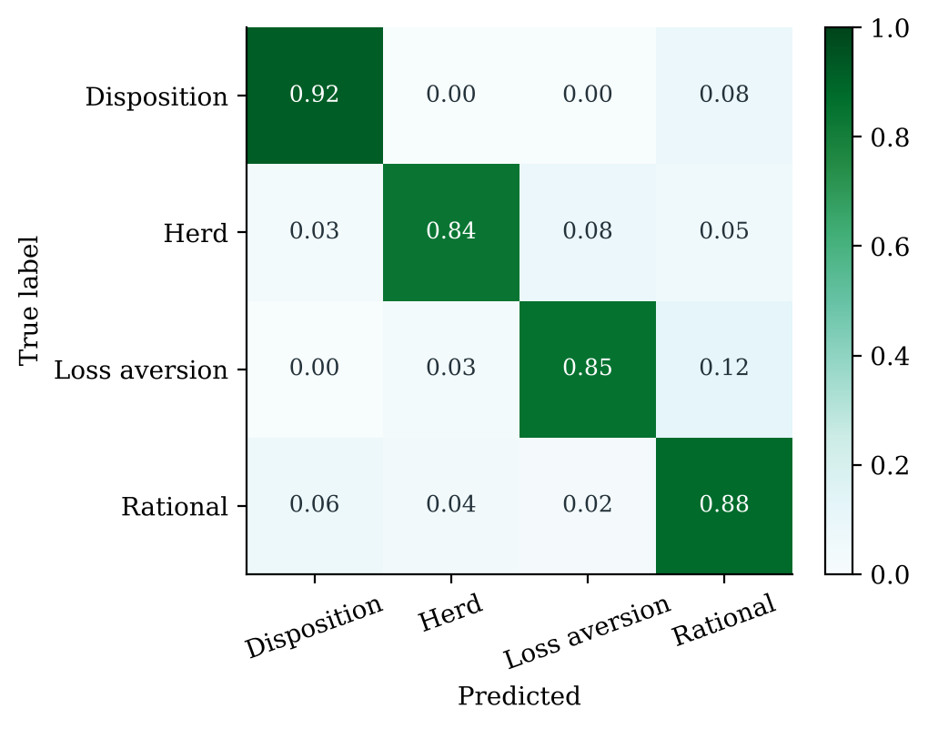
Figure 8.1: Confusion matrix of bias model v4.1 on the test set, rows normalised, real-frequency weighting (plotted from bias_v4_evaluation.json)
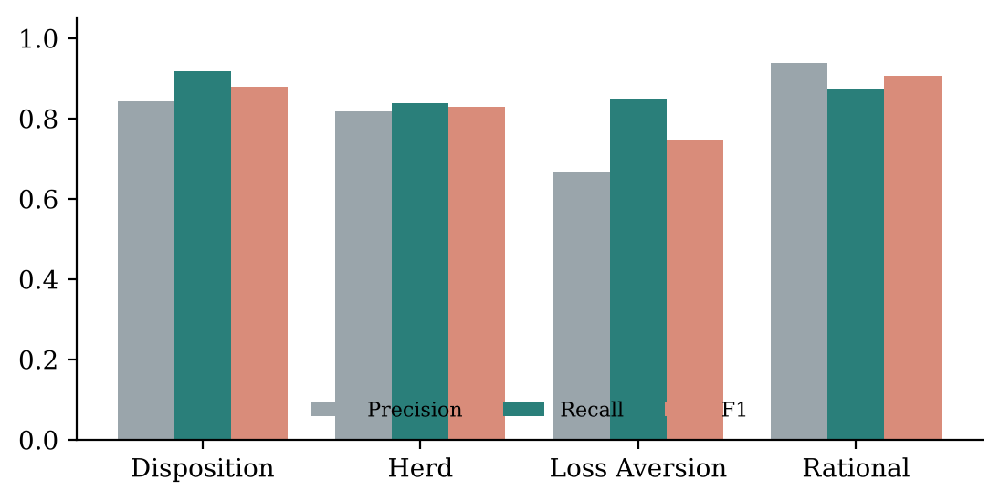
Figure 8.2: Per-class precision, recall and F1, real-frequency weighting (plotted from bias_v4_evaluation.json)
Table 8.4: Per-class metrics (real frequency)
Pattern | Precision | Recall | F1
Disposition effect | 0.844 | 0.918 | 0.879
Herd behaviour | 0.819 | 0.838 | 0.828
Loss aversion | 0.667 | 0.849 | 0.747
Rational | 0.939 | 0.875 | 0.906
Figure 8.1 and Table 8.4 show that loss aversion is the weakest class, with the lowest precision. The confusion matrix explains why: 8.0% of true herd cases are predicted as loss aversion, and 12.2% of true loss-aversion cases are predicted as rational. In a falling, fearful market a loss-making sale is permitted under both loss aversion (panic) and herd behaviour (selling into fear), and the data cannot always tell which motive won. Rational decisions are recognised with the highest precision (0.939), which matters because wrongly labelling a sensible decision as biased is the more harmful error for a user.

8.5.3 Calibration and confidence bands
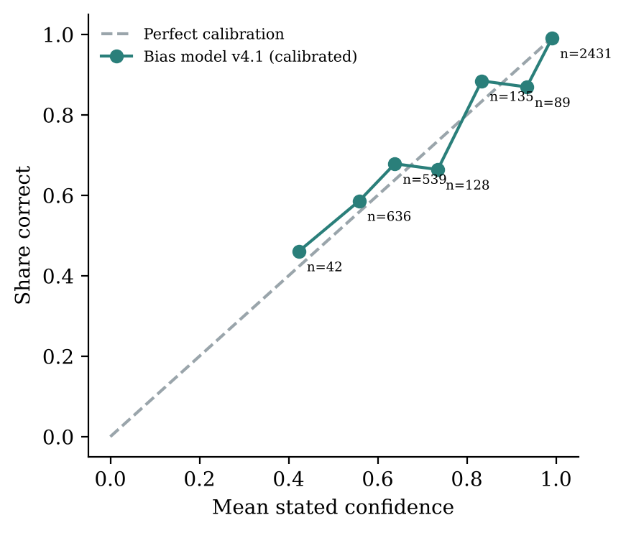
Figure 8.3: Reliability diagram after calibration; each point is a confidence bin with its case count (plotted from bias_v4_evaluation.json)
Table 8.5: Confidence bands and how often each is right (test set, real frequency)
Band shown to user | Threshold | Share of analyses | Share correct
High | ≥ 0.85 | 68.4% | 98.7%
Medium | 0.65–0.85 | 7.1% | 74.4%
Low | < 0.65 | 24.5% | 61.7%
Figure 8.3 shows the calibrated points lying close to the diagonal. Most cases (66% by weight) fall in the 0.95–1.00 bin, where the model is right 99.1% of the time against a mean stated confidence of 99.1%. The bands in Table 8.5 are what the user sees: a High reading is right about 99 times in 100, while a Low reading usually means that two patterns are close to even.
Single-reading cases. In 44.3% of real-frequency test cases the definitions allow only one label (for example, holding a winner in a calm market can only be rational), which flatters the overall figures. On the remaining 55.7%—the cases that need judgement—accuracy is 78.3% and macro-F1 0.747.

8.5.4 Results by regime and action
Table 8.6: Accuracy by market regime
Regime | Test cases | Accuracy | Macro-F1
Normal | 950 | 89.5% | 0.793
Bull | 713 | 87.8% | 0.834
Correction | 975 | 87.8% | 0.839
Crash | 979 | 77.6% | 0.771
Euphoria | 383 | 90.3% | 0.895

Table 8.7: Accuracy by action
Action | Test cases | Accuracy (real frequency)
Sell | 1,582 | 84.9%
Hold | 1,641 | 90.0%
Buy more | 777 | 89.4%
Crashes are the hardest regime (77.6%) because they are where loss aversion and herd behaviour overlap most.

8.5.5 Out-of-time generalisation
Trained only on decisions dated 2008–2019 and tested on 2020–2026, the model reaches 86.5% accuracy and 0.826 macro-F1 at real frequency—close to the random-split result. This suggests the model is not merely memorising particular market days. It does not test robustness to genuinely new market regimes or to real investors.

8.6 Baselines and Ablations
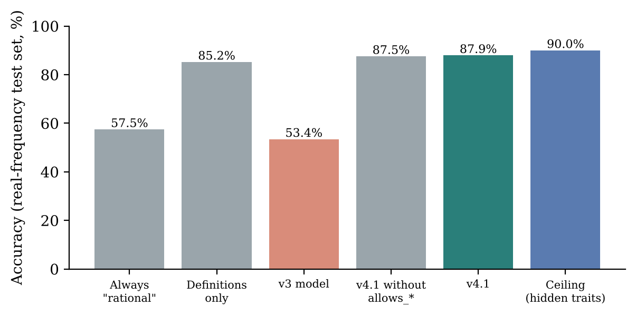
Figure 8.4: Accuracy of v4.1 against baselines and an upper bound on the same test set (plotted from bias_v4_evaluation.json)
Table 8.8: Baselines, ablation and ceiling (real-frequency test set)
Model | Accuracy | Macro-F1
Always “rational” | 57.5% | —
Previous model v3 (same test cases) | 53.4% | 0.309
Definitions only (call a bias whenever one can apply; loss aversion > disposition > herd) | 85.2% | 0.825
v4.1 without the allows_* inputs | 87.6% | 0.832
v4.1 | 87.9% | 0.840
Ceiling: v4.1 also given the hidden tendencies | 90.0% | 0.866
Table 8.8 is the most important table for interpreting the model honestly. Because labels are generated from written definitions, a rules-only baseline already reaches 85.2%. The model’s gain over that baseline is 2.7 percentage points of accuracy. Its value lies in two places: it disagrees with the rules in 9.6% of cases and, when it does, it is right 64% of the time against 36% for the rules—it recognises rebalancing, a near goal, cutting a loss and a stated cash need; and it provides calibrated confidence, which the rules cannot. Removing the allows_* inputs costs only 0.3 points but introduces rule violations (0.08% of cases), which the guard would then have to correct. The ceiling of 90.0% shows that about one case in ten cannot be resolved from what the app observes, because it depends on hidden tendencies. Where two biases could both apply (5.3% of cases), neither the model (58.2%) nor the rules (56.8%) do much better than chance.

8.6.1 Comparison with other learners
To test whether XGBoost is the right learner, scripts/evaluate_for_paper.py trains logistic regression and a 500-tree random forest on the same 22 features, with the same definitional guard and real-frequency weighting, over five different split seeds (7, 11, 23, 42 and 101). On the original split (seed 7), it adds 2,000 bootstrap resamples of the test set for confidence intervals and McNemar’s test for paired differences in correctness.
Table 8.9: Learners compared over five split seeds, mean ± standard deviation (paper_evaluation.json)
Model | Accuracy | Macro-F1 | ECE | Log-loss
Always “rational” | 57.4% ± 0.0 | 0.182 | 0.426 | —
Rules only (label definitions) | 84.4% ± 0.6 | 0.818 ± 0.006 | 0.156 | —
Logistic regression | 84.9% ± 0.4 | 0.816 ± 0.003 | 0.018 ± 0.003 | 0.321 ± 0.022
Random forest (500 trees) | 87.0% ± 0.5 | 0.833 ± 0.005 | 0.014 ± 0.003 | 0.282 ± 0.021
XGBoost (deployed settings) | 87.2% ± 0.6 | 0.831 ± 0.009 | 0.015 ± 0.004 | 0.267 ± 0.014

Table 8.10: Seed-7 test set with bootstrap confidence intervals and McNemar tests
Model | Accuracy [95% CI] | XGBoost minus model [95% CI] | McNemar p
Rules only | 85.2% [83.9, 86.4] | +2.7 pp [+1.6, +3.8] | $$2.4×{10}^{−7}$$
Logistic regression | 85.5% [84.2, 86.6] | +2.4 pp [+1.4, +3.4] | $$1.0×{10}^{−5}$$
Random forest | 87.6% [86.5, 88.7] | +0.2 pp [−0.4, +0.9] | 0.096
XGBoost | 87.8% [86.7, 89.0] | — | —
XGBoost as shipped (with calibration curve) | 87.9% [86.8, 89.1] | −0.1 pp [−0.5, +0.3] | 1.0
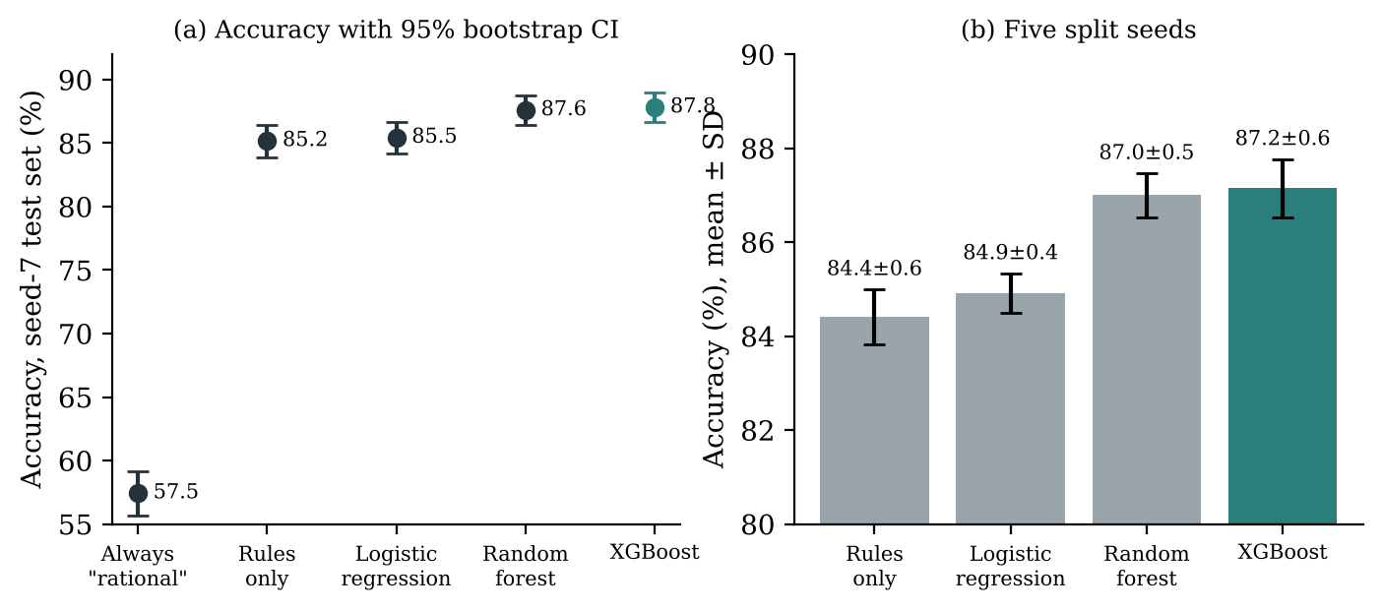
Figure 8.5: (a) Accuracy with 95% bootstrap confidence intervals on the seed-7 test set; (b) mean ± SD over five split seeds (plotted from paper_evaluation.json)
Figure 8.5 and Tables 8.9–8.10 lead to three conclusions. First, XGBoost’s advantage over the label definitions (+2.7 points) and over logistic regression (+2.4 points) is statistically significant; the non-linear interactions in the data matter. Second, XGBoost is statistically tied with a random forest (difference +0.2 points, confidence interval spanning zero, $p=0.096$). We therefore do not claim that XGBoost is the better learner. It was kept because it has the lowest log-loss, exact and fast TreeSHAP explanations, and a portable native JSON model format. Third, the calibration curve does not change accuracy, and on this split it moved ECE only from 0.012 to 0.014, so its measurable benefit here is in keeping the displayed bands honest (Table 8.5) rather than in any headline metric.

8.7 Forced Sales
Of the test cases, 167 are sales forced by money (an uncovered shock, or payments above income with no emergency fund).
Table 8.11: Forced sales read as rational
Model and condition | Read as rational
v4.1, need stated in the comment | 90.6%
v4.1, need not stated | 39.3%
v4.1, all forced sales | 71.9%
v4.0 (trained without money pressure) | 37.7%
The gap between stated and unstated needs is exactly what the comment reader is designed to close: when the investor writes “fees are due in March”, the cash_need_stated input is set and the sale is read as the forced sale it is.

8.8 Comparison with the Previous Model (v3)
v3 was evaluated on the same test cases with the same label mapping and was even given each case’s true years of investing, which the app never has. It scored 53.4% accuracy, 0.309 macro-F1 and an ECE of 0.254, and it output a pattern the definitions rule out in 13.5% of cases. Two structural defects explain this. First, v3 did not see the action: across 600 test cases, changing only the action changed v4.1’s answer in 83.7% of them and v3’s in none. Second, v3’s “what weighed most” explained a different pattern from the one it displayed in 98.6% of cases. Of the 13 scenario checks, v3 passed 5.

8.9 Sense Checks
The training script also runs 13 scenarios and 8 relational checks against a typical investor (dataset medians: age 38, ₹75,000 income, 12% position, emergency fund). v4.1 passes 21 of 21. Selected examples:
Table 8.12: Selected sense checks (full list in results/reports/BIAS_MODEL_V4.md)
ID | Scenario or check | Expected | v4.1
S1 | Calm market: selling a winner up 35% | Disposition | Disposition (0.98)
S3 | Calm market: holding a deep loser down 40% | Loss aversion | Loss aversion (0.65)
S4 | Calm market: selling at a 20% loss | Rational | Rational (1.00)
S6 | Crash: selling a winner up 25% into the fear | Herd | Herd (0.98)
S7 | Euphoric rally: buying more with little to spare | Herd | Herd (0.98)
S12 | Calm market: selling a winner, paying out more than earned, no fund | Rational | Rational (0.64)
S13 | Calm market: selling a winner, says the money is needed | Rational | Rational (0.64)
C1 | Same holding up 35%: the action changes the reading | sell → disposition; hold, buy → rational | Passed
C2 | Oversized holding (45%) reads less like disposition than a small one (8%) | lower | 0.56 vs 0.96
C5 | Selling a winner reads more rational with the goal 2 years away than 20 | higher | 0.49 vs 0.05
C6 | Gold share alone (5% vs 35%) barely moves the reading | small change | largest change 0.05
C7 | Fearful market, selling at a 15% loss: stated cash need raises “rational” | higher | 0.09 → 0.49
C6 doubles as a sanity check on spurious features: gold share has no role in the label definitions, and the model correctly gives it almost no influence.

8.10 Simulator Evaluation Protocol
The simulator was evaluated on four questions using scripts/evaluate_simulator_v2.py:
- Realism. Do simulated 1-year and 10-year NIFTY returns match rolling windows of the real index (217 one-year and 109 ten-year windows)?
- Horizon effect. For a base case—a ₹1 lakh position, an investor earning ₹18 lakh a year with ₹11 lakh liquid—how do $p$ and the typical gap change from 1 to 30 years, for a stock down 17% and a fund up 30%?
- Sensitivity. How do the results change with each assumption?
- Stock-specific risk. For 24 NIFTY 50 stocks, measured beta and own volatility from 10 years of monthly prices, how often does holding win over 20 years?
scripts/evaluate_for_paper.py extends this with five further experiments, using the deployed simulator through two evaluation-only hooks (paths= to supply given market paths and return_gaps= to return every paired gap) that the app never uses:
- Generator comparison. 10,000 ten-year paths from each of six generators—a lognormal (GBM) model, independent months, and 3-, 6-, 12- and 24-month blocks, all with the same historical mean—compared with the real index on one-year quantiles, the Kolmogorov–Smirnov (KS) distance and the autocorrelation of squared returns.
- Monte Carlo convergence. The base case repeated 20 times at 250 to 10,000 paths.
- Population study. 1,000 investors and positions drawn from dataset v4.1, each with their own horizon (median 23 years), asset type (40% funds) and the measured risk of one of the 24 stocks, with 1,000 paths each, under both the long-run assumptions and history replayed exactly.
- Walk-forward replay. A fund up 30% run through every real 5-year and 10-year window of history with the same tax and cost accounting, and each real outcome placed in the simulated distribution for the same case.
Except where stated, runs use 1,000 paths. Results are presented in Chapter 9.

8.11 Causal Evaluation Protocol
Dataset v4.1 is used with src/causal_v4.py. The mechanism check confirms that the re-implemented generator reproduces all 20,000 stored motive shares exactly (maximum absolute error 0.0). Thirteen factors (including the gold-share negative control) are intervened on, and their effects on the probabilities of sell, hold and buy more are computed exactly and estimated by g-computation; DoWhy estimates and refutes the effects on selling. Six (pattern, action) situations and four habits are evaluated in the same way.

8.12 Explanation Evaluation Protocol
Explanation quality is measured by scripts/evaluate_for_paper.py on the current pipeline—bias model v4.1, simulator v2 and the template explainer, with AI wording switched off—for 166 sell and hold decisions drawn from the population study (78 rational, 38 disposition, 27 herd and 23 loss aversion). Each case is explained in English and in Hindi, giving 332 explanations. This replaces the project’s earlier explanation check, which had been run on the previous model generation.

8.13 Reproducibility Considerations
- Fixed seeds: dataset 2026, split 7, model 42, cross-validation folds 1, simulator 2026, explanation evaluation 42.
- Cached market data (data/v4/market_history.csv, data/sim_v2/monthly_history.csv) makes the dataset and simulations reproducible offline.
- Pinned library versions and a verification script guard against silent changes in numerical libraries.
- Every analysis stores its market and portfolio snapshot and the stock’s measured risk, so a re-run of a stored decision reproduces its inputs.
- The journal-paper evaluations regenerate in about four minutes with python scripts/evaluate_for_paper.py; learner comparisons use five fixed split seeds.
- The bias model is stored as native XGBoost JSON with a metadata file, avoiding pickle compatibility issues between library versions.

Chapter 9: Results and Discussion
Chapter 8 reported the bias model in detail. This chapter presents the results of the simulator, the causal module and the explanation engine, discusses what all the results together demonstrate, and reserves space for screenshots of the running application.

9.1 Simulator Realism
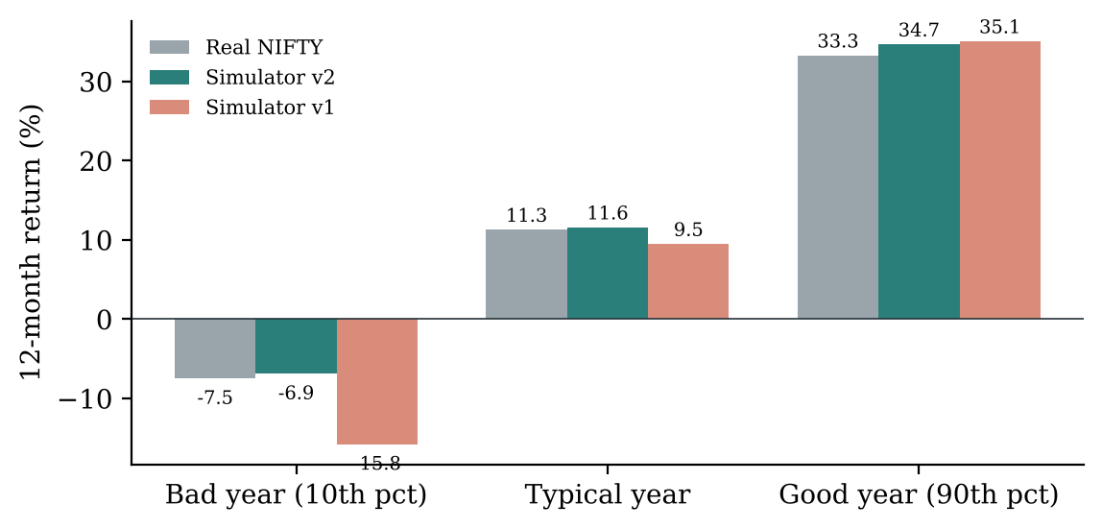
Figure 9.1: One-year NIFTY 50 return percentiles: real index (rolling windows) against simulator v2 and the earlier v1 (plotted from simulator_v2_evaluation.json)
Table 9.1: Realism of simulated one-year returns
Statistic | Real NIFTY (217 windows) | Simulator v2 | v2 replaying history | v1 synthetic paths
Bad year (10th percentile) | −7.5% | −6.9% | −8.1% | −15.8%
Typical year (median) | +11.3% | +11.6% | +10.3% | +9.5%
Good year (90th percentile) | +33.3% | +34.7% | +33.0% | +35.1%
Years below −20% | 4.6% | 4.3% | 4.6% | 6.8%
Figure 9.1 and Table 9.1 show that simulator v2’s one-year distribution lies within 1.4 percentage points of the real index at all three quantiles, whereas the earlier v1 paths produced bad years roughly twice as bad as reality. Over ten years, v2 is deliberately wider than the real record: the real 10-year annualised growth ranged from 8.8% to 14.8% (10th to 90th percentile), while v2’s middle 80% spans 2.4% to 19.8%. The real record holds only about two independent decades, so the simulator allows for decades better and worse than 2008–2026. This is a matching of one-year marginal distributions, not evidence of forecasting ability.

9.2 Why a 12-Month Block Bootstrap
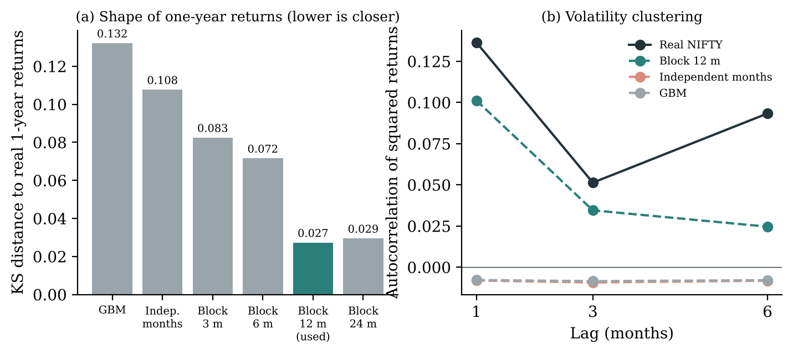
Figure 9.2: (a) Kolmogorov–Smirnov distance between each generator’s one-year returns and the real NIFTY 50; (b) autocorrelation of squared monthly returns, a measure of volatility clustering (plotted from paper_evaluation.json)
Table 9.2: Six market-path generators against the real index (10,000 ten-year paths each, same historical mean)
Generator | 1-yr p10 | 1-yr median | 1-yr p90 | Years < −20% | ACF of squared returns, lag 1 / 3 / 6 | KS distance
Real NIFTY (217 windows) | −7.5% | 11.3% | 33.3% | 4.6% | 0.136 / 0.051 / 0.093 | —
Lognormal (GBM) | −16.2% | 9.5% | 42.1% | 6.4% | −0.01 / −0.01 / −0.01 | 0.132
Independent months | −15.9% | 10.6% | 41.2% | 6.7% | −0.01 / −0.01 / −0.01 | 0.108
Block 3 months | −14.3% | 10.6% | 37.8% | 6.3% | 0.077 / −0.01 / −0.01 | 0.083
Block 6 months | −13.7% | 10.5% | 35.9% | 6.3% | 0.100 / 0.029 / −0.01 | 0.072
Block 12 months (used) | −8.1% | 10.3% | 33.1% | 4.7% | 0.101 / 0.035 / 0.025 | 0.027
Block 24 months | −8.1% | 10.3% | 33.0% | 4.9% | 0.105 / 0.023 / 0.033 | 0.030
Table 9.2 and Figure 9.2 justify the generator choice experimentally. All six generators share the same average growth, so only the shape and the dependence differ. The 12-month block bootstrap is the only one that reproduces both the spread of real one-year returns and volatility clustering: its KS distance (0.027) is a quarter of the independent-months bootstrap’s (0.108) and a fifth of GBM’s (0.132). GBM and independent months have no volatility clustering at all and make bad years about twice as bad as reality. Moving to 24-month blocks changes almost nothing, so 12 months is a reasonable choice. Because the 19-year record contains only one independent decade, ten-year KS distances (about 0.34 for every generator) carry no information and are not used to rank generators; the real windows also overlap, so KS distances are descriptive rather than formal tests.

9.3 The Horizon Matters, and How Stable the Numbers Are
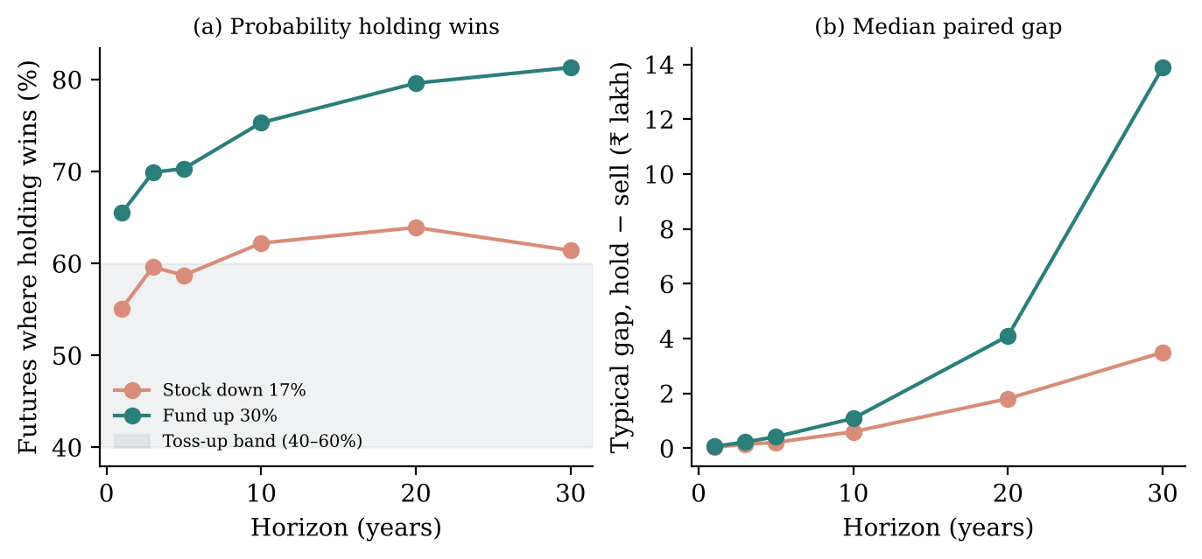
Figure 9.3: (a) Share of futures in which holding beats selling and (b) median paired gap, by horizon, for the base case (plotted from simulator_v2_evaluation.json)
Table 9.3: Effect of horizon (₹1 lakh position; investor on ₹18 lakh a year with ₹11 lakh liquid)
Horizon | Stock down 17%: holding wins | Typical gap | Fund up 30%: holding wins | Typical gap
1 year | 55% | ₹3,592 | 66% | ₹6,377
3 years | 60% | ₹13,950 | 70% | ₹22,244
5 years | 59% | ₹21,124 | 70% | ₹41,640
10 years | 62% | ₹59,925 | 75% | ₹1.09 L
20 years | 64% | ₹1.81 L | 80% | ₹4.09 L
30 years | 61% | ₹3.49 L | 81% | ₹13.9 L
Figure 9.3(a) shows the central practical result of the simulator. For a single stock down 17%, the probability that holding beats selling stays between 55% and 64% at every horizon—mostly inside or near the 40–60% band that the recommendation rules treat as a toss-up. A diversified fund, which carries little company-specific risk, favours holding much more clearly, reaching 80% at 20 years. The previous simulator always used a 20-year horizon and therefore tilted every recommendation towards holding, even for someone who needs the money in three years. The typical gap grows with horizon even when the probability does not, because the size of outcomes grows with time.
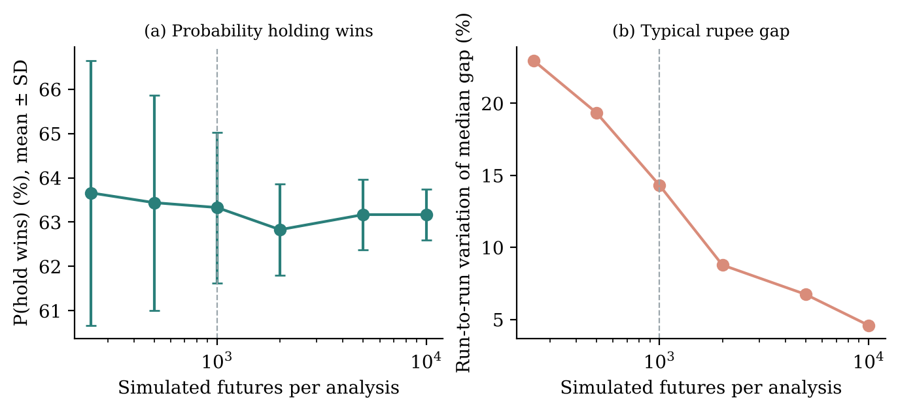
Figure 9.4: Monte Carlo convergence for the base case, 20 repeats per size: (a) probability that holding wins, mean ± SD; (b) run-to-run variation of the median rupee gap (plotted from paper_evaluation.json)
Table 9.4: Monte Carlo convergence (base case: stock down 17%, 20 years)
Futures | P(hold wins), mean ± SD | Median gap, mean ± SD
250 | 0.637 ± 0.030 | ₹1,60,784 ± 36,940
500 | 0.634 ± 0.024 | ₹1,70,247 ± 32,938
1,000 (app) | 0.633 ± 0.017 | ₹1,68,549 ± 24,140
2,000 | 0.628 ± 0.010 | ₹1,63,326 ± 14,347
5,000 | 0.632 ± 0.008 | ₹1,67,786 ± 11,317
10,000 | 0.632 ± 0.006 | ₹1,67,712 ± 7,700
Figure 9.4 and Table 9.4 show how much of each number is simulation noise. At the app’s 1,000 futures, the probability that holding wins—the input to the recommendation rules—is stable to about ±1.7 points, close to the theoretical binomial standard error of ±1.5 points. The median rupee gap is noisier, varying by about ±14% between runs. This is why the verdict is driven by the probability rather than the rupee figure, and why the rupee gap is presented as “about” a value. Raising the count to 5,000 futures would roughly halve this variation if the rupee figure became more prominent.

9.4 Results Across 1,000 Investors and Sensitivity to Assumptions
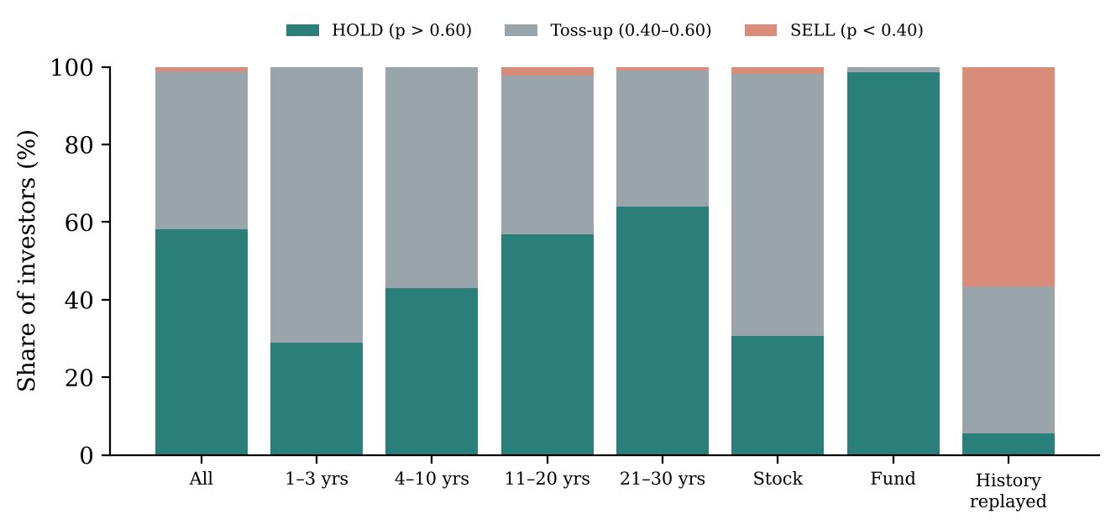
Figure 9.5: Share of 1,000 simulated investors whose analysis lands in each verdict band, overall, by horizon, by asset type, and with history replayed exactly (plotted from paper_evaluation.json)
Table 9.5: Paired simulation over 1,000 investors drawn from dataset v4.1
Group (long-run assumptions) | Investors | Mean P(hold wins) | HOLD / toss-up / SELL
All | 1,000 | 0.635 | 58.1% / 40.8% / 1.1%
Horizon 1–3 years | 52 | 0.571 | 29% / 71% / 0%
Horizon 4–10 years | 100 | 0.598 | 43% / 57% / 0%
Horizon 11–20 years | 275 | 0.624 | 57% / 41% / 2%
Horizon 21–30 years | 573 | 0.652 | 64% / 35% / 1%
Single stock | 596 | 0.562 | 31% / 67% / 2%
Equity fund | 404 | 0.742 | 99% / 1% / 0%
Position at a gain / at a loss | 543 / 457 | 0.635 / 0.635 | 59% / 57% HOLD
History replayed exactly | 1,000 | 0.380 | 5.6% / 37.8% / 56.6%
Figure 9.5 and Table 9.5 move from single examples to a population. Under the long-run assumptions, holding is clearly favoured for 58% of investors, the comparison is a toss-up for 41%, and selling is favoured for only 1%. The answer depends strongly on what is held and for how long: almost every equity fund (99%) clearly favours holding, while only 31% of single stocks do, because company-specific risk drags down the typical outcome. Short horizons are mostly toss-ups. Whether the position is currently at a gain or a loss makes no difference to the projection, which is exactly the point of the disposition-effect literature: the purchase price should not matter for a forward-looking decision.
The last row is the most important caution in this report. If history from 2007 to 2026 is replayed exactly, gold compounds at about 15% a year instead of the assumed 9%, and 86% of verdicts change: 52.5% of HOLD verdicts become a toss-up or SELL, and the sign of the median gap reverses for 67% of investors.
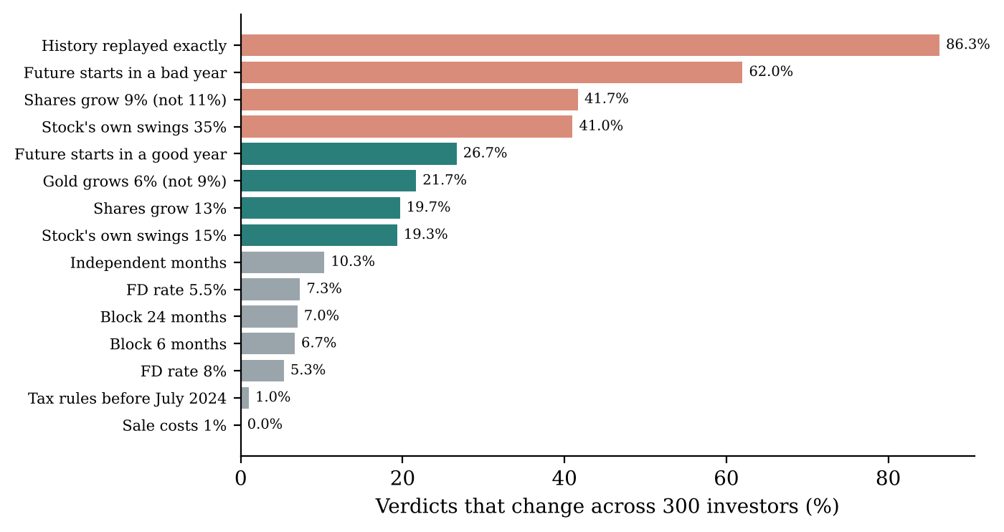
Figure 9.6: Share of verdicts that change across 300 investors when one assumption is changed at a time (plotted from paper_evaluation.json)
Table 9.6: Sensitivity analysis, one assumption at a time
Change | Base case: P(hold), median gap | Verdicts that change (300 investors)
None (base) | 0.642, ₹1,88,632 | —
Shares grow 9% (not 11%) | 0.536, ₹42,336 | 41.7%
Shares grow 13% | 0.740, ₹4,13,079 | 19.7%
Gold grows 6% (not 9%) | 0.698, ₹2,63,194 | 21.7%
FD rate 5.5% / 8% (not 6.75%) | 0.664 / 0.620 | 7.3% / 5.3%
Stock’s own swings 15% / 35% (not 21%) | 0.722 / 0.438 | 19.3% / 41.0%
Sale costs 0.5% or 1% (not 0.15%) | 0.642 | 0%
Independent months / 6- / 24-month blocks | 0.636 / 0.626 / 0.648 | 10.3% / 6.7% / 7.0%
Tax rules before 23 July 2024 | 0.644 | 1.0%
Future starts in a bad year (worst 10%) | 0.518, ₹9,626 | 62.0%
Future starts in a good year (best 10%) | 0.756, ₹4,66,968 | 26.7%
History replayed exactly | 0.430, −₹1,32,747 | 86.3%
Figure 9.6 ranks the assumptions by how many verdicts they change. The answer depends most on the growth assumptions (shares and gold), on how volatile the particular stock is, and on the kind of year the future starts in. It barely depends on the block length, the July 2024 tax change, or sale costs; the cost is charged on cashing out in both futures, so it largely cancels. This is why Folium measures each stock’s risk at submission instead of assuming it, and why the growth assumptions are stated on every result page.

9.5 Each Stock Is Different
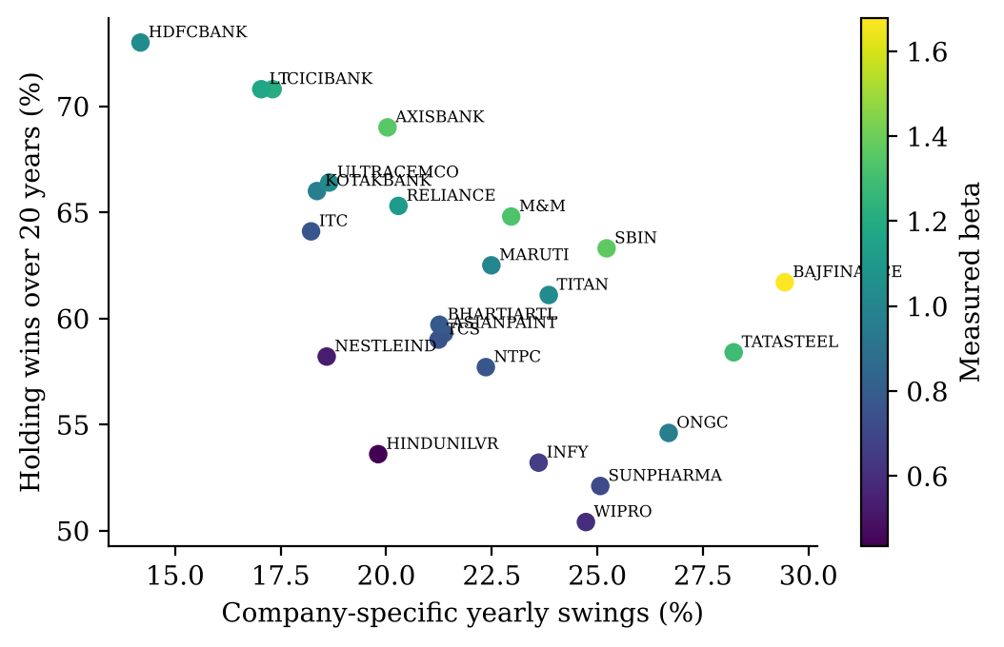
Figure 9.7: Measured company-specific volatility against the share of 20-year futures in which holding wins, for 24 NIFTY 50 stocks; colour shows measured beta (plotted from simulator_v2_evaluation.json)
Figure 9.7 shows a clear negative relationship between a stock’s own volatility and the advantage of holding it. HDFC Bank, with beta 1.03 and own swings of 14%, wins in 73% of 20-year futures; Wipro, with beta 0.60 and own swings of 25%, wins in 50%. The median of the 24 stocks—beta 1.00 and own swings 21%—is the default used when a stock cannot be measured. Two effects combine here: idiosyncratic volatility drags down the median compound outcome (the $−{σ^{2}}/2$ term), and a low beta lowers expected growth under the CAPM relation. The second effect is a modelling choice: historically, steady low-beta stocks such as HUL, Infosys and Nestlé have often done better than CAPM predicts.

9.6 Paired Gap Against Real History
Table 9.7: Walk-forward replay of a fund up 30% through every real window
 | Real windows (independent) | Hold won, real | Hold won, simulated | Real median gap | Simulated median gap | Real outcome inside simulated 10–90% band
5 years | 169 (3) | 88.8% | 61.0% | ₹56,378 | ₹23,133 | 99.4%
10 years | 109 (1) | 100% | 60.7% | ₹1,25,114 | ₹44,327 | 100%
Table 9.7 places what actually happened in each real 5-year and 10-year window inside the simulated distribution for the same case. Every real outcome but one falls inside the simulated 10th–90th percentile band, and the real outcomes sit in the upper middle of the band (median percentile 0.66–0.67): 2007–2026 was a good period for holding equity against this mix of safer assets. With only one to three independent windows, this is a consistency check, not a validation of forecasting ability.
Table 9.8: Base-case investor, stock down 17%, 14 years: difference of medians against the median paired gap
Year | HOLD median | SELL median | Difference of medians | Median paired gap [p10, p90] | Hold wins
5 | ₹1,51,619 | ₹1,29,647 | ₹21,972 | ₹21,787 [−75,796, 2,13,706] | 57.6%
10 | ₹2,33,490 | ₹1,69,700 | ₹63,790 | ₹51,717 [−1,19,371, 5,12,349] | 61.2%
14 | ₹3,10,324 | ₹2,16,030 | ₹94,294 | ₹85,272 [−1,65,144, 9,17,770] | 61.6%
Table 9.8 illustrates a methodological point. The difference of the two medians and the median of the paired differences are not the same quantity; they differ here by up to 19% at year 10. Folium reports the paired gap (Section 7.7), with its 10th–90th percentile range, because that range also shows that holding loses in a substantial share of futures even when it wins in the typical one.

9.7 Monthly Investing and Portfolio Context
The SIP and freed-up education fees flow into the investor’s current mix in both futures, so they leave the gap between holding and selling unchanged (verified by a unit test) but change the size of the whole portfolio. For the base case with ₹15,000 a month, the typical gap at 20 years is 0.7% of the projected portfolio; with no SIP it is 1.7%. Showing this helps an investor put a single decision in proportion.

9.8 Cause and Effect
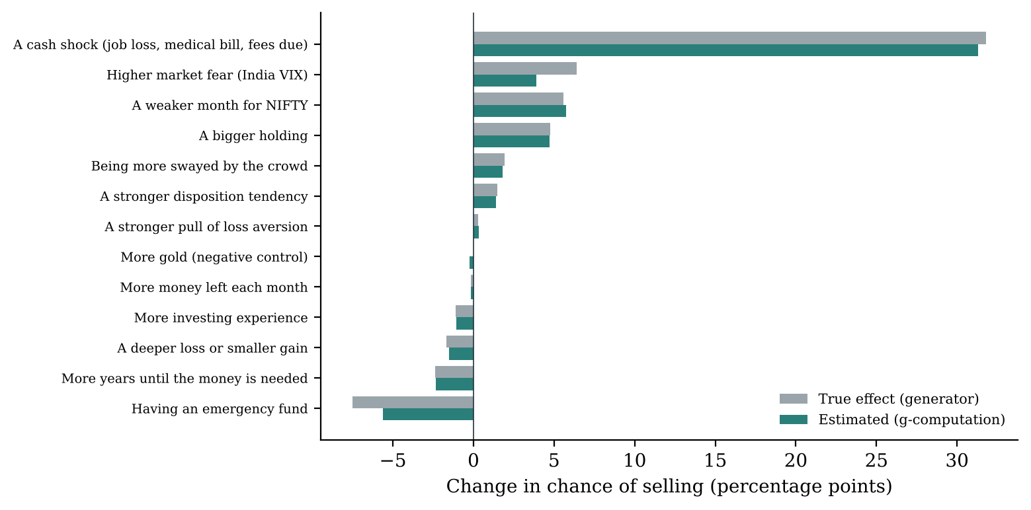
Figure 9.8: Effect of each factor on the chance of selling: true effect from the generator against the g-computation estimate (plotted from results/causal_v4.json)
Table 9.9: Average effects in percentage points, true value with the g-computation estimate in brackets (selected rows of CAUSAL_V4.md)
Factor | Change | Sell | Hold | Buy more
A cash shock | having one vs not | +31.8 (+31.3) | −23.6 (−23.3) | −8.2 (−8.0)
Having an emergency fund | having one vs not | −7.5 (−5.6) | +1.4 (−0.1) | +6.1 (+5.7)
Higher market fear | VIX +10 points | +6.4 (+3.9) | −4.7 (−2.9) | −1.7 (−1.0)
A weaker month for NIFTY | 5 points worse | +5.6 (+5.8) | −3.9 (−3.7) | −1.7 (−2.1)
A bigger holding | +10 points of liquid assets | +4.8 (+4.7) | +2.7 (+2.8) | −7.5 (−7.5)
More years until money is needed | +5 years | −2.4 (−2.3) | +1.4 (+1.4) | +1.0 (+1.0)
More swayed by the crowd | +0.1 tendency | +1.9 (+1.8) | −2.8 (−2.5) | +0.9 (+0.7)
More gold (negative control) | +10 points | 0.0 (−0.2) | 0.0 (+0.4) | 0.0 (−0.2)

Table 9.10: Accuracy of the causal estimates against the known truth
Accuracy measure | g-computation | DoWhy (linear)
Effects on selling, mean absolute error | 0.45 points | 1.07 points
All 45 effects, mean absolute error | 0.48 points | —
Correct direction (effects ≥ 0.5 points) | 97% | —
Tendency effect within its situation, mean error | 1.4 points | 0.3 points
Negative control, estimated effect on selling | −0.2 points | −0.0 points
Refutation tests passed | — | 12 of 13
Figure 9.8 and Table 9.9 show that money pressure dominates: a cash shock raises the chance of selling by about 32 points, and an emergency fund lowers it by 7.5 points, mostly by absorbing shocks. Market fear and a weak month push towards selling; a bigger holding pushes towards selling (largely through rebalancing) and strongly away from adding. Loss aversion’s population-wide effect is small (+0.3 points) because it acts only in specific situations; within them it is substantial.
Table 9.10 shows that the two estimators are good at different things. The flexible g-computation model is far better across the whole population—the linear model, for example, overstates the effect of investing experience about fivefold (−5.8 points against a true −1.1). The linear DoWhy model is better at the effect of a tendency within its situation, where the flexible model smooths and understates it. The one direction g-computation gets wrong is the emergency fund’s effect on holding (+1.4 true, −0.1 estimated), which the app does not display. The single failed refutation is the gold negative control, whose true effect is zero, so a test against chance cannot confirm anything—an expected outcome rather than a defect.
Table 9.11: Effect of the most helpful habit in each situation (habit modelled as halving the tendency)
Situation | Habit | True: before → after | Estimated: before → after
Loss aversion, sell | Reframing the loss as one step in a plan | 61% → 55% | 59% → 54%
Herd, sell | Not watching the crowd while deciding | 48% → 37% | 48% → 41%
Herd, buy more | Pausing for an independent analysis | 33% → 23% | 33% → 24%
Disposition, sell | Setting selling rules in advance | 56% → 39% | 54% → 40%
Disposition, hold | Setting selling rules in advance | 76% → 68% | 71% → 68%
The estimates move in the right direction every time and, where they are off, they understate the benefit; they never overclaim. An unexpected finding is that habits can offset each other: for someone holding a deep loser, all three habits together barely help (43% → 42% in truth), while reframing alone helps a lot (43% → 36%), because calming crowd-following also removes some panic-selling and leaves more people holding the loser. This finding is the reason the app offers the single most helpful habit rather than a bundle.

9.9 Explanation Quality
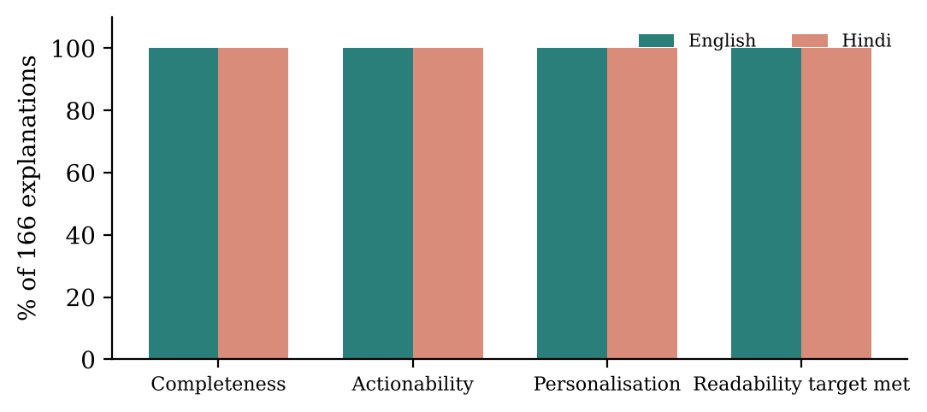
Figure 9.9: Explanation quality across 166 English and 166 Hindi explanations on the current pipeline (plotted from paper_evaluation.json)
Table 9.12: Explanation quality on bias model v4.1, simulator v2 and the template explainer (332 explanations, AI wording off)
Measure | English | Hindi | Target
Completeness (all six sections) | 100% | 100% | 100%
Actionability | 100% | 100% | 100%
Personalisation | 100% | 100% | 100%
Jargon leaks | 0 | 0 | 0
Flesch reading ease (mean / minimum) | 76.4 / 73.5 | — | ≥ 60
Words per sentence | 11.3 | 12.8 | Hindi ≤ 20
Mean length (words) | 939 | 1,058 | —
All targets are met for every one of the 332 explanations (Figure 9.9). A Flesch score of 76.4 corresponds to “fairly easy” text, and even the hardest explanation (73.5) is well above the target of 60. Flesch is not used for Hindi because its syllable model is undefined for Devanagari, so sentence length is used instead. These are measures of structure and readability; they do not show that the explanations change investor behaviour, which would require a user study.

9.10 Application Outputs
The repository does not contain screenshots of the running application, and the application was not run while preparing this report. The figures below are placeholders that must be replaced with real screenshots before submission; Appendix G gives the exact steps to capture them using the demo accounts created by scripts/seed_demo.py.
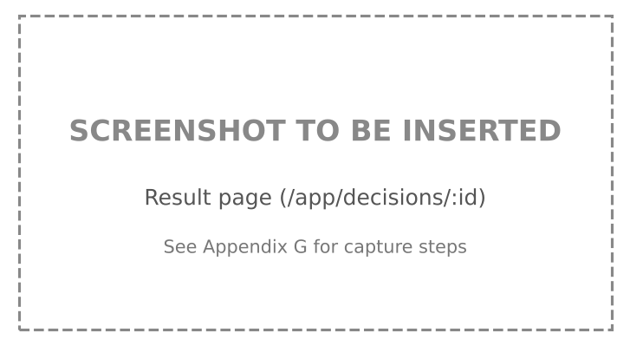
Figure 9.10: [PLACEHOLDER — screenshot to be inserted] Result page: recommendation with reasons, both futures chart and pattern found

Figure 9.11: [PLACEHOLDER — screenshot to be inserted] Live five-step progress during an analysis

Figure 9.12: [PLACEHOLDER — screenshot to be inserted] Six-part explanation in Hindi with the language switch

Figure 9.13: [PLACEHOLDER — screenshot to be inserted] Portfolio page with net worth, allocation and holdings

Figure 9.14: [PLACEHOLDER — screenshot to be inserted] “Verify this record” result and “How this was worked out”

Figure 9.15: [PLACEHOLDER — screenshot to be inserted] Google sign-in return and the Welcome profile step for a new Google account

9.11 Discussion
What the results demonstrate. On the development task, the four analytical components each do what they were designed to do. The classifier is accurate, calibrated and consistent with the label definitions. It is significantly better than the rules and a linear model and on par with a random forest; it changes its reading when the action changes, recognises forced sales when the need is stated, and generalises across time periods within the data. The simulator’s generator was chosen experimentally against five alternatives; it reproduces the real index’s one-year distribution and volatility clustering, its probability output is stable at the app’s path count, and every real historical window falls inside its band. The causal estimates recover a known mechanism closely and never overclaim the benefit of habits. The explanations are complete, readable and free of jargon on the current models.
What the results do not demonstrate. The behavioural labels are synthetic, so 87.9% accuracy means that the model recovers the generator’s labels, not that it diagnoses real investors. A rules-only baseline reaches 85.2%, so most of the accuracy follows from the definitions themselves. The simulator’s agreement with history is a distributional and consistency check, not a forecast, and its verdicts depend heavily on the stated growth assumptions (Table 9.6). The causal results describe the generator, not people. No study has measured whether investors who use Folium make better decisions or earn better returns.
Practical significance. The combination is more useful than any part alone. For a typical “sell a falling stock” request, the simulator often lands in the toss-up band (two-thirds of single-stock positions do), and the behavioural reading then decides whether waiting is the cautious choice. A stated cash need moves the reading to rational and lets the sale stand. The investor sees why, in their own language, with every figure traceable, and can later verify that the record has not been changed.
Limitations of the evaluation. The remaining gaps are those that only real data can close: there are no real investor labels, no user study, and only one independent decade of market history, which is why ten-year generator comparisons and the walk-forward replay are reported as consistency checks only. The optional Gemini paths have been tested with a stand-in rather than the live service. These gaps define the research phase of the roadmap in Chapter 12.

Chapter 10: Testing and Validation

10.1 Testing Objectives
Testing in Folium has four goals: (1) to show that each model and engine behaves as its specification says, including behavioural “sense” properties rather than only code paths; (2) to show that the security controls actually block what they are meant to block; (3) to show that the pipeline, database and live-progress stream work together end to end; and (4) to prevent regressions when models are retrained or replaced.

10.2 Test Suites and Execution Status
Table 10.1: Test suites in the repository
Suite | Location | Tests (documented) | Needs | Framework
Models and engines | tests/ (11 files) | 343 collected; 338 run, 5 skipped without an AI key | Python venv | pytest
Back end, unit (no database) | backend/tests/unit/ (6 files) | 149 (subset of the 267 below) | Python venv | pytest
Back end, full | backend/tests/ (17 files + unit) | 267 | PostgreSQL + Redis | pytest, httpx, pytest-asyncio
Front end | frontend/src/test/ (4 files) | 25 | Node | Vitest, Testing Library
In total the project has 635 automated tests. The counts in Table 10.1 are those recorded in FOLIUM_MASTER.md (updated 2026-10-27), which states that the suites passed at that time. Counting def test_ functions in the source gives 281 in tests/ and 203 in backend/tests/; the higher collected counts come from parametrised tests, where one function runs over many cases. The suites were not re-executed while preparing this report, so the pass status is as documented by the team, not independently verified here. Appendix D gives the commands to re-run them; the run log should be attached to the final report.

10.3 Unit Testing
Unit tests exercise pure functions and engines without a database. Representative examples, with the property each one asserts:
Table 10.2: Representative unit tests
ID | Test (file :: function) | Property checked
UT-1 | tests/test_bias_model_v4.py::test_one_row_and_batch_build_identical_features | Training and live feature paths agree
UT-2 | ::test_missing_input_and_unknown_action_are_rejected | Invalid input raises instead of silently filling
UT-3 | ::test_the_true_label_is_allowed_for_the_whole_dataset | Label rules and dataset agree for all 20,000 rows
UT-4 | ::test_guard_removes_ruled_out_patterns | Guard zeroes disallowed classes
UT-5 | ::test_calibration_never_changes_the_answer | Calibration changes confidence, not the chosen class
UT-6 | ::test_drivers_explain_the_chosen_pattern_exactly | SHAP drivers sum to the chosen class’s margin
UT-7 | ::test_the_action_changes_the_reading | Same situation, different action → different reading
UT-8 | tests/test_simulator_v2.py::test_short_term_equity_gain_pays_20_percent_plus_cess | Tax rule
UT-9 | ::test_long_term_equity_gain_is_exempt_up_to_125000 | Exemption rule
UT-10 | ::test_horizon_is_the_investors_within_1_to_30_years | Horizon clamping
UT-11 | ::test_same_inputs_same_answer | Determinism with a fixed seed
UT-12 | ::test_a_fund_is_less_spread_out_than_a_single_stock | Fund vs stock risk
UT-13 | ::test_monthly_investing_sizes_the_portfolio_not_the_decision | SIP leaves the gap unchanged
UT-14 | ::test_simulated_years_resemble_real_nifty | Realism within tolerance
UT-15 | ::test_beta_sets_typical_growth_the_standard_way | CAPM growth rule
UT-16 | backend/tests/unit/test_pipeline_logic.py::test_decide (parametrised) | Recommendation rules over intents, biases and $p$
UT-17 | ::test_missing_simulation_is_disclosed_and_treated_as_even | Missing $p$ handled and stated
UT-18 | ::test_inr_uses_lakh_and_crore | Indian money formatting
UT-19 | backend/tests/unit/test_audit_chain.py::test_an_edited_entry_is_caught | Tamper detection
UT-20 | ::test_a_removed_entry_is_caught, ::test_a_forged_insertion_is_caught, ::test_a_fork_is_caught | Deletion, forgery and fork detection
UT-21 | ::test_fingerprints_survive_database_round_trips | Canonical hashing stable across Decimal/UUID/JSON
UT-22 | ::test_a_chain_started_by_the_placeholder_still_verifies | Backward compatibility with legacy entries
UT-23 | backend/tests/unit/test_comment_and_debate.py (18 tests) | Comment rules in three languages; quotes verbatim; cases never alter the verdict
UT-24 | tests/test_explainer.py (88 functions, 128 collected) | Six sections, EN/HI structural parity, jargon blocklist, number guard

10.4 Integration Testing
Integration tests in backend/tests/ run the FastAPI app against real PostgreSQL and Redis instances through an HTTP client.
Table 10.3: Integration test scenarios
ID | Test file | Scenario | Expected result
IT-1 | test_auth_flow.py | Register → verify e-mail → log in → refresh → log out | Cookies set and rotated; old tokens blacklisted
IT-2 | test_mfa.py, test_mfa_recovery.py | Enable TOTP, log in with code, use a backup code, request recovery | Second factor enforced; backup code single-use; one recovery request per 24 h
IT-3 | test_csrf.py | Mutating request with missing / mismatched / matching CSRF header | 403 / 403 / passes; login exempt
IT-4 | test_rls.py | User A’s rows queried by user B; query with no user set | Zero rows in both cases
IT-5 | test_rate_limit.py | Repeated logins beyond the limit | HTTP 429
IT-6 | test_portfolio_api.py | Add, edit, delete holdings; price outage | Values computed; outage falls back to average cost
IT-7 | test_decisions.py, test_pipeline.py | Submit an analysis and run the pipeline | 202; status moves pending → processing → complete; columns filled
IT-8 | test_decisions_stream.py | Open the stream mid-run and after completion | Backlog replayed; no duplicate events; terminal event received
IT-9 | test_audit_chain_db.py | Two analyses; tamper with a row; verify | Chain linear; tampering detected and named
IT-10 | test_comment_reading_db.py | Analysis with “college fees are due” in the reason | comment_facts.cash_need = true; sale can read rational
IT-11 | test_account_deletion.py | Delete, log in during grace, purge after grace | “Keep my account” offered; data anonymised; audit kept
IT-12 | test_oauth.py | Google sign-in end to end with a stand-in for Google: new and existing accounts, unverified e-mail, two-step, “keep me signed in”, grace-period account, cancelled or expired state | Redirect to /auth/google#… with the right outcome; unverified addresses refused; state single-use
IT-13 | frontend/src/test/google-return.test.tsx (8 tests) | Google return page for each outcome in the URL fragment | Signs in, asks for the code, offers “Keep my account” or explains the failure; fragment wiped from the address bar

10.5 Functional and System Testing
Functional behaviour of the product as a whole was exercised through the demonstration walkthrough in DEMO.md, which uses accounts and analyses seeded by scripts/seed_demo.py. The walkthrough covers sign-in, the dashboard, the portfolio, a new analysis with live progress, the result page in both languages, report downloads, record verification and the data tools. We have not found a written record of the outcome of each walkthrough step in the repository; Table 10.4 therefore lists the system test cases with their expected results, and the “Observed” column must be completed when the walkthrough is repeated for the final submission.
Table 10.4: System test cases (expected results from the specification; observed results to be recorded)
ID | Test case | Steps | Expected | Observed
ST-1 | Analysis with stated cash need | Sell a losing holding; reason “need money for college fees in March” | Pattern reads rational; quote shown; verdict SELL or HOLD with reasons | [to be filled]
ST-2 | Calm-market sale of a winner | Sell a holding up 30% with no reason | Disposition effect with High or Medium confidence | [to be filled]
ST-3 | Buy more in a rally | Buy more after NIFTY +5% month | Herd reading; verdict HOLD | [to be filled]
ST-4 | Hindi explanation | Switch language on the result page | All six sections in Hindi; same numbers | [to be filled]
ST-5 | Hindi PDF | Request PDF with lang=hi | Refused with explanation; HTML offered | [to be filled]
ST-6 | Reload during analysis | Refresh the page at step 2 | Steps 1–2 shown from backlog; progress continues | [to be filled]
ST-7 | Verify record | Click “Verify this record” | “Verified”; chain intact | [to be filled]
ST-8 | Tampered record | Edit the stored recommendation in the database, verify again | “Changed”; names the analysis part | [to be filled]
ST-9 | Market data off | Set MARKET_DATA_ENABLED=false, run analysis | Calm market assumed and disclosed | [to be filled]
ST-10 | Data export | Settings → Download my data | JSON without password hash, TOTP secret or tokens | [to be filled]
ST-11 | First Google sign-in | “Continue with Google” with a new Google account | Returns to the app; Welcome page asks for the profile; other pages redirect there until it is filled | [to be filled]
ST-12 | Google account sets a password | Settings → Security → “Set a password” | Reset-link e-mail sent; afterwards e-mail login works | [to be filled]

10.6 Input Validation and Edge-Case Testing
Input validation is enforced at three layers. Pydantic schemas in backend/schemas/ reject malformed requests with HTTP 422 before any logic runs. Database CHECK constraints enforce domain rules regardless of the code path—for example age BETWEEN 18 AND 100, holding_quantity > 0, bias_confidence BETWEEN 0.0 AND 1.0, and recommendation IN ('HOLD','SELL','BUY_MORE') (migrations 0001 and 0003). The model and simulator raise on missing inputs or invalid values (build_features, SimInputs.__post_init__), which the tests UT-2 and test_bad_inputs_are_rejected check. Edge cases from Table 6.4 are covered by tests such as UT-10 (horizon), UT-17 (missing simulation) and IT-6 (price outage).

10.7 Performance Testing
No load or stress test has been performed. Two timing measurements are recorded in the evaluation files: one simulation of 1,000 paths over 30 years takes 103.4 ms, and each bias prediction reports its own inference time in milliseconds. Because analyses run in the background and the analyze endpoint is rate-limited to 10 per minute per client, request latency is dominated by the initial context capture (market data and stock risk, bounded by a timeout). A proper load test (for example with Locust against a deployed instance) is part of the scaling milestone in the roadmap (Table 12.2). Numerical stability, which matters more for the correctness of a verdict, was measured instead: at 1,000 paths the probability that holding wins varies by only ±1.7 points between runs (Section 9.3).

10.8 Defects, Inconsistencies and Open Issues
The following issues were found while auditing the repository for this report or are documented by the team. None of them changes a reported result, but each should be known before the viva.
Table 10.5: Defects and inconsistencies
# | Issue | Evidence | Status / suggested action
D-1 | Superuser connection bypassed RLS | Commit fix(M1): enforce RLS by connecting the app as non-superuser app_user | Fixed
D-2 | v3 explanations described a different class than shown (98.6% of cases) | bias_v4_evaluation.json | Fixed in v4 by explaining only the chosen class
D-3 | Google sign-in callback returned JSON instead of redirecting into the app | Commit feat(auth): Google sign-in return flow, welcome page and demo updates | Fixed: callback redirects to /auth/google#…; Welcome page added
D-4 | Stale comment in recommendation.py said nothing reads the investor’s free-text reason | backend/core/recommendation.py | Fixed: comment now explains that the verdict never reads the investor’s words, which are quoted separately
D-5 | guard_ok rejects added numbers but not removed ones; removal is only bounded by the 0.6× length limit, while the master document says a number may not be removed | src/llm_polish.py | Open; add a check that every number in the original appears in the rewording
D-6 | Explanation-quality evaluation (2026-08-22) predated bias model v4.1 and simulator v2 | explanation_quality.json | Fixed: re-measured on the current pipeline (166 cases, 332 explanations) in paper_evaluation.json
D-10 | Driver label read “Your choice to holding on” because two dictionaries shared one name | backend/core/explainer.py | Fixed: separate _ACTION_VERBS mapping
D-11 | Fallback story always said “Over 20 years” regardless of the investor’s horizon | backend/core/explainer.py::_fallback_story | Fixed: uses the simulated horizon
D-12 | Slab rate on interest was computed from take-home pay, understating it for higher earners | backend/core/simulator.py | Fixed: income grossed up with gross_from_take_home
D-7 | Column names such as hold_median_20y remain although the horizon is now variable | migration 0003, backend/core/simulator.py | Cosmetic; rename in a future migration
D-8 | Root requirements.txt lists older ranges (and causalnex) unlike the pinned backend/requirements-ml.txt | both files | Use the pinned file; tidy the root file
D-9 | Figures in results/figures/ and results/simulations/ are from v1–v3 | file names and dates | Not used in this report; archive them

Chapter 11: Applications, Advantages and Limitations

11.1 Real-World Applications
- A pause button for retail investors. The most direct use is as a second opinion before acting on a sell, hold or buy decision, especially during sharp market moves when emotional decisions are most likely.
- Investor education. Brokerages, mutual-fund distributors and investor-awareness programmes could use the explanations—what pushes people towards this action and which habit helps—to teach behavioural concepts with the learner’s own numbers rather than abstract examples.
- Advisory support. A registered adviser could use the paired after-tax projection and the “both sides” view as a structured starting point for a conversation with a client, while keeping the decision with the human.
- Research platform. The dataset generator, the known-truth causal check and the evaluation scripts form a reusable test bed for methods in behavioural finance and causal machine learning.

11.2 Advantages
- Decision-centric. It evaluates the action the investor is about to take, not just the asset.
- Context-aware. Income, EMIs, education fees, emergency fund, the whole portfolio and the horizon all shape the reading and the projection, so a forced sale is not mislabelled as a bias.
- Honest confidence. Calibrated High/Medium/Low bands that mean what they say (High is right 98.7% of the time on the test set).
- Paired, after-tax comparison. HOLD and SELL are compared on identical market paths, in cash in hand after Indian tax and charges.
- Traceable explanations. Every figure comes from computation; optional AI wording is guarded and off by default.
- Bilingual and offline. English and Hindi templates work without any external service.
- Verifiable record. A hash chain lets the investor confirm that an analysis has not been changed.
- Privacy by design. Row-level isolation, consent-gated AI, data export and deletion.
- Maintainable. One bridge between product and research code; versioned models with rollback switches.

11.3 Limitations

11.3.1 Data limitations
- Synthetic investors, real markets. The behavioural labels follow written behavioural-finance definitions, not observed Indian investors. The motive weights are set, not learned. All accuracy figures therefore measure recovery of the generator’s labels.
- Definitions do most of the work. A rules-only baseline reaches 85.2%; the model’s added value is in judgement on the remaining cases and in calibration.
- Hidden tendencies. About one case in ten cannot be resolved from observable inputs (ceiling 90.0%), and loss aversion versus herd behaviour in a fearful sell-off is close to a coin toss (about 58%).
- Unstated needs are often missed. Only 39% of forced sales read as rational when the investor does not mention the need.

11.3.2 Technical limitations
- Long-run growth rates are assumptions (shares 11%, gold 9%, FD 6.75%), and verdicts are sensitive to them: a 2-point change in share growth changes 42% of verdicts, and replaying 2007–2026 exactly changes 86% (Table 9.6).
- Rupees are nominal; inflation is not removed.
- Mutual funds are treated as equity funds; debt or hybrid funds would be projected as too risky.
- Tax rules are fixed to FY 2025-26; loss set-off is not modelled.
- Gold uses the international price before import duty and GST.
- One position per analysis; whole-portfolio rebalancing is not analysed.
- The comment reader uses phrase lists and misses paraphrase; feelings it misses or misreads never change the analysis, but a missed cash need does.

11.3.3 Release scope
The current release is a complete, locally hosted product. Three engineering items are deliberately outside it and are scheduled as the next milestones (Section 12.5): the administrator console, continuous integration, and public deployment with HTTPS and a production e-mail service. Optional Gemini assistance is implemented and guarded but has been verified only with a stand-in, pending a production API key. Google sign-in works at the registered local address; a deployment must register its own callback address with Google. The full back-end test suite needs PostgreSQL and Redis and takes about 15 minutes, and two runs cannot share the test database; this is a property of integration testing against a real database rather than a limitation of the product.

11.4 Security and Privacy Considerations
The system’s security rests on standard, well-understood controls (Table 6.2): bcrypt-hashed passwords with a strength check, short-lived RS256 tokens in httpOnly cookies with rotation and blacklisting, double-submit CSRF protection, TOTP two-step verification with encrypted secrets, rate limiting, security headers and restricted CORS. Google sign-in accepts only addresses Google has verified, guards the round trip with a single-use state value, and returns its result in a URL fragment that never reaches a server. Data isolation does not rely on application code alone: PostgreSQL row-level security binds every query on user-owned tables to the transaction’s user. Remaining risks are those of any unaudited system: no external penetration test has been done, HTTPS is not yet configured because the system is not deployed, and the development app_user password defaults to a known value that must be replaced in production. Secrets such as JWT keys and the Fernet key are generated by scripts/generate_dev_keys.py and loaded from .env, which is excluded from version control; only .env.example is committed.

11.5 Scalability
The API is asynchronous and stateless apart from cookies, so it can be scaled horizontally behind a load balancer; Redis already carries the shared state (blacklist, rate limits, events). The current design runs analyses as in-process background tasks, which ties an analysis to the worker that accepted it; under heavy load this should move to a job queue with separate workers. The ML libraries take about 400 MB per process, which limits how many workers fit on one machine. The database scales with standard PostgreSQL techniques; the audit chain is per investor, so verification cost grows with one person’s history, not with the total user base.

11.6 Maintenance Requirements
- Market data. market_history.csv and monthly_history.csv should be refreshed periodically; after refreshing, the dataset, model and evaluations should be regenerated and compared with the previous version.
- Tax rules. The TAX table must be updated when the Finance Act changes.
- Library versions. ML libraries are pinned; any upgrade must be followed by scripts/verify_ml_env.py and a full re-evaluation.
- Causal results. The back end caches results/causal_v4.json, so it must be restarted after regeneration.
- Comment rules. Phrase lists should be widened as real comments (with consent) reveal common wording.

11.7 Risks and Responsible Use
The largest risk is over-trust: an investor might treat a calibrated, well-presented reading as a diagnosis or the simulated gap as a promise. Folium mitigates this by describing the pattern as “a tendency to watch for”, showing confidence in words with both leading probabilities when they are close, stating every assumption, keeping the verdict in transparent rules, and labelling the whole product as information and education, not investment advice. A second risk is that synthetic labels encode the designers’ assumptions; this can only be resolved with consented real data. Finally, any future use of the AI features must preserve the guard and consent rules, because the system’s trustworthiness depends on the guarantee that wording can never change a number.

Chapter 12: Conclusion and Future Scope

12.1 Summary of the Problem
Retail investors often decide to sell, hold or buy more under the pull of recent losses, market fear or the crowd, and the tools available to them describe the asset rather than the decision. A useful decision-support system must tell a biased decision from a sensible one using the investor’s own finances, show the financial consequences of each choice honestly, explain itself without inventing numbers, and be trustworthy with sensitive data.

12.2 Summary of the Implemented Solution
We built Folium, a full-stack web application with a React front end, a FastAPI back end, PostgreSQL with row-level security and Redis. For each decision, a five-step background pipeline reads the investor’s comment, classifies the behavioural pattern with a calibrated, guarded XGBoost model explained by exact TreeSHAP, projects HOLD and SELL on the same block-bootstrapped market paths after Indian tax, attaches causal estimates validated against a known generator, renders a six-part explanation in English and Hindi, derives a verdict from explicit evidence rules, and seals the analysis into a per-investor hash chain. Investors sign in by e-mail or with Google; accounts are protected with two-step verification, CSRF protection and rate limits, and investors can export or delete their data.

12.3 Key Outcomes and Verified Findings
All figures below are taken from the evaluation files committed in the repository and are development-stage results on synthetic behavioural labels.
Table 12.1: Achievement of objectives
Objective | Outcome | Achieved?
O1 Behavioural reading | 87.9% accuracy, macro-F1 0.840, ECE 0.014; High band right 98.7%; 21/21 sense checks; out-of-time 86.5%; significantly above rules and logistic regression, tied with random forest | Achieved on synthetic labels; real-world validity is the next research step
O2 Consequence projection | One-year quantiles within 1.4 points of the real NIFTY; best of six generators (KS 0.027); stable to ±1.7 points at 1,000 paths; horizon-specific, after-tax, paired | Achieved
O3 Cause and effect | 45 effects, mean absolute error 0.48 points, 97% correct sign; 12/13 refutations | Achieved on a known generator
O4 Explanation | 332 explanations on the current models: 100% completeness, 0 jargon leaks, Flesch 76.4 (EN), 12.8 words/sentence (HI) | Achieved
O5 Recommendation | Pure rule function with stored reasons and inputs; never an LLM | Achieved
O6 Trust and security | RLS, hash chain with verification, MFA, CSRF, rate limits, Google sign-in (OpenID Connect), export and deletion | Achieved; public deployment with HTTPS is the next milestone

12.4 Boundaries of the Present Work
Two boundaries define what the results can claim. The first is scientific: the behavioural labels are synthetic by design, because no public dataset links Indian investors’ decisions to their finances and true motives. The readings are therefore validated against a known generator, not against real people, and no claim is made that the system improves investment outcomes. The second is about modelling: the simulator’s verdicts depend on stated long-run growth rates (Table 9.6), projections are in nominal rupees, tax handling is simplified, and each analysis concerns one position. Both boundaries are stated to the investor on every result page, and both are addressed directly in the roadmap below.

12.5 Roadmap and Future Scope
The project already follows a milestone plan (FOLIUM_MASTER.md §14). Phase C, the productisation phase, began with Google sign-in (C1), which is complete. The remaining work is organised in three phases, each building on foundations that already exist in the repository.
Table 12.2: Roadmap by phase
Phase | Milestone | What it delivers | Foundation already in place
C — Productisation | C2 Administrator console | Usage statistics, user management, MFA-recovery queue | admin_stats_view (aggregates, no personal data); audited MFA-status and MFA-reset endpoints; role column and admin guard
 | C3 Continuous integration | Every push runs the back-end, model and front-end suites and the production build | 635 tests runnable with one command each; pinned dependencies; verify_ml_env.py
 | C4 Public deployment | HTTPS, production e-mail, registered Google callback | Dockerfile.backend, docker-compose.yml; Secure cookies and CORS switch on outside development; Resend e-mail integration
 | Live AI assistance | Gemini comment reading and wording for consenting users | Implementation, consent switch, verbatim-quote and number guards, circuit breaker—all tested with a stand-in
D — Validation with real users | Consented decision data | Anonymised real decisions and investors’ own later reflections, so motive weights can be learned rather than set | Data export, consent model and audit chain; outcome_tracked, actual_outcome_pct and recommendation_followed columns already in decisions
 | Prospective user study | Whether investors who use Folium decide differently | Explanation engine with measured readability; seeded demo flow
 | Two-way number guard | AI wording must keep every original number, not only avoid new ones (D-5) | guard_ok and its test suite
E — Richer analysis | Simulation extensions | Inflation-adjusted outputs, debt and hybrid funds, loss set-off and tax-harvesting, other destinations for sale proceeds, regime-aware scenarios | Evaluation hooks paths= and return_gaps=; sensitivity framework
 | Whole-portfolio decisions | Rebalancing across several holdings | Portfolio snapshot and asset-mix computation
 | Wider language support | Learned comment patterns and more Indian languages | Bilingual template banks with structural-parity tests
 | Scale | Background analyses on a job queue with dedicated workers; load testing | Stateless API; Redis already holds shared state
Phase C turns a complete local product into a publicly available service, Phase D turns development-stage evidence into evidence about people, and Phase E widens what the system can analyse. Longer-term ideas from the original plan—broker integration, WhatsApp alerts and monthly retraining from tracked outcomes—follow naturally once Phase D produces real outcome data.

12.6 Potential for Further Research and Deployment
The project shows that established methods—calibrated gradient boosting, TreeSHAP, block bootstrapping, backdoor adjustment and hash chaining—can be combined into a single decision-time process with explicit numerical safeguards. The known-truth evaluation approach used for the causal module is itself reusable for testing causal methods. With consented real data and a user study, Folium could become an evidence-based tool for investor education. Until then, it should be presented exactly as it presents itself: information and education, not investment advice.

References
[1] D. Kahneman and A. Tversky, “Prospect theory: An analysis of decision under risk,” Econometrica, vol. 47, no. 2, pp. 263–291, 1979, doi: 10.2307/1914185.
[2] T. Odean, “Are investors reluctant to realize their losses?” The Journal of Finance, vol. 53, no. 5, pp. 1775–1798, 1998, doi: 10.1111/0022-1082.00072.
[3] S. Bikhchandani, D. Hirshleifer, and I. Welch, “A theory of fads, fashion, custom, and cultural change as informational cascades,” Journal of Political Economy, vol. 100, no. 5, pp. 992–1026, 1992, doi: 10.1086/261849.
[4] H. Shefrin and M. Statman, “The disposition to sell winners too early and ride losers too long: Theory and evidence,” The Journal of Finance, vol. 40, no. 3, pp. 777–790, 1985, doi: 10.1111/j.1540-6261.1985.tb05002.x.
[5] T. Chen and C. Guestrin, “XGBoost: A scalable tree boosting system,” in Proc. 22nd ACM SIGKDD Int. Conf. Knowledge Discovery and Data Mining, 2016, pp. 785–794, doi: 10.1145/2939672.2939785.
[6] B. Zadrozny and C. Elkan, “Transforming classifier scores into accurate multiclass probability estimates,” in Proc. 8th ACM SIGKDD Int. Conf. Knowledge Discovery and Data Mining, 2002, pp. 694–699, doi: 10.1145/775047.775151.
[7] S. M. Lundberg and S.-I. Lee, “A unified approach to interpreting model predictions,” in Advances in Neural Information Processing Systems, vol. 30, 2017, pp. 4765–4774.
[8] M. T. Ribeiro, S. Singh, and C. Guestrin, “‘Why should I trust you?’: Explaining the predictions of any classifier,” in Proc. 22nd ACM SIGKDD, 2016, pp. 1135–1144, doi: 10.1145/2939672.2939778.
[9] S. Wachter, B. Mittelstadt, and C. Russell, “Counterfactual explanations without opening the black box: Automated decisions and the GDPR,” Harvard Journal of Law & Technology, vol. 31, no. 2, pp. 841–887, 2018.
[10] J. Pearl, Causality: Models, Reasoning, and Inference, 2nd ed. Cambridge, U.K.: Cambridge University Press, 2009.
[11] A. Sharma and E. Kiciman, “DoWhy: An end-to-end library for causal inference,” arXiv:2011.04216, 2020.
[12] H. R. Künsch, “The jackknife and the bootstrap for general stationary observations,” The Annals of Statistics, vol. 17, no. 3, pp. 1217–1241, 1989, doi: 10.1214/aos/1176347265.
[13] B. Efron and R. J. Tibshirani, An Introduction to the Bootstrap. New York, NY, USA: Chapman & Hall, 1993.
[14] B. M. Barber and T. Odean, “Trading is hazardous to your wealth: The common stock investment performance of individual investors,” The Journal of Finance, vol. 55, no. 2, pp. 773–806, 2000, doi: 10.1111/0022-1082.00226.
[15] B. M. Barber and T. Odean, “Boys will be boys: Gender, overconfidence, and common stock investment,” The Quarterly Journal of Economics, vol. 116, no. 1, pp. 261–292, 2001, doi: 10.1162/003355301556400.
[16] M. Grinblatt and M. Keloharju, “What makes investors trade?” The Journal of Finance, vol. 56, no. 2, pp. 589–616, 2001, doi: 10.1111/0022-1082.00338.
[17] A. Tversky and D. Kahneman, “Advances in prospect theory: Cumulative representation of uncertainty,” Journal of Risk and Uncertainty, vol. 5, pp. 297–323, 1992, doi: 10.1007/BF00122574.
[18] R. Thaler, “Mental accounting and consumer choice,” Marketing Science, vol. 4, no. 3, pp. 199–214, 1985, doi: 10.1287/mksc.4.3.199.
[19] J. B. De Long, A. Shleifer, L. H. Summers, and R. J. Waldmann, “Noise trader risk in financial markets,” Journal of Political Economy, vol. 98, no. 4, pp. 703–738, 1990, doi: 10.1086/261703.
[20] E. F. Fama, “Efficient capital markets: A review of theory and empirical work,” The Journal of Finance, vol. 25, no. 2, pp. 383–417, 1970, doi: 10.2307/2325486.
[21] H. Markowitz, “Portfolio selection,” The Journal of Finance, vol. 7, no. 1, pp. 77–91, 1952, doi: 10.2307/2975974.
[22] R. C. Merton, “Lifetime portfolio selection under uncertainty: The continuous-time case,” The Review of Economics and Statistics, vol. 51, no. 3, pp. 247–257, 1969, doi: 10.2307/1926560.
[23] J. D. Hamilton, “A new approach to the economic analysis of nonstationary time series and the business cycle,” Econometrica, vol. 57, no. 2, pp. 357–384, 1989, doi: 10.2307/1912559.
[24] M. López de Prado, Advances in Financial Machine Learning. Hoboken, NJ, USA: Wiley, 2018.
[25] L. Breiman, “Random forests,” Machine Learning, vol. 45, pp. 5–32, 2001, doi: 10.1023/A:1010933404324.
[26] J. H. Friedman, “Greedy function approximation: A gradient boosting machine,” The Annals of Statistics, vol. 29, no. 5, pp. 1189–1232, 2001, doi: 10.1214/aos/1013203451.
[27] A. Niculescu-Mizil and R. Caruana, “Predicting good probabilities with supervised learning,” in Proc. 22nd Int. Conf. Machine Learning (ICML), 2005, pp. 625–632, doi: 10.1145/1102351.1102430.
[28] C. Guo, G. Pleiss, Y. Sun, and K. Q. Weinberger, “On calibration of modern neural networks,” in Proc. 34th Int. Conf. Machine Learning (ICML), PMLR 70, 2017, pp. 1321–1330.
[29] T. Saito and M. Rehmsmeier, “The precision-recall plot is more informative than the ROC plot when evaluating binary classifiers on imbalanced datasets,” PLOS ONE, vol. 10, no. 3, e0118432, 2015, doi: 10.1371/journal.pone.0118432.
[30] R. K. Mothilal, A. Sharma, and C. Tan, “Explaining machine learning classifiers through diverse counterfactual explanations,” in Proc. Conf. Fairness, Accountability, and Transparency (FAT*), 2020, pp. 607–617, doi: 10.1145/3351095.3372850.
[31] D. Janzing, L. Minorics, and P. Blöbaum, “Feature relevance quantification in explainable AI: A causal problem,” in Proc. 23rd Int. Conf. Artificial Intelligence and Statistics (AISTATS), PMLR 108, 2020, pp. 2907–2916.
[32] V. Chernozhukov, D. Chetverikov, M. Demirer, E. Duflo, C. Hansen, W. Newey, and J. Robins, “Double/debiased machine learning for treatment and structural parameters,” The Econometrics Journal, vol. 21, no. 1, pp. C1–C68, 2018, doi: 10.1111/ectj.12097.
[33] D. N. Politis and J. P. Romano, “The stationary bootstrap,” Journal of the American Statistical Association, vol. 89, no. 428, pp. 1303–1313, 1994, doi: 10.1080/01621459.1994.10476870.
[34] P. Weber, K. V. Carl, and O. Hinz, “Applications of explainable artificial intelligence in finance—a systematic review of finance, information systems, and computer science literature,” Management Review Quarterly, vol. 74, pp. 867–907, 2024, doi: 10.1007/s11301-023-00320-0.
[35] S. M. Lundberg, G. Erion, H. Chen, A. DeGrave, J. M. Prutkin, B. Nair, R. Katz, J. Himmelfarb, N. Bansal, and S.-I. Lee, “From local explanations to global understanding with explainable AI for trees,” Nature Machine Intelligence, vol. 2, pp. 56–67, 2020, doi: 10.1038/s42256-019-0138-9.
[36] J. Robins, “A new approach to causal inference in mortality studies with a sustained exposure period—application to control of the healthy worker survivor effect,” Mathematical Modelling, vol. 7, no. 9–12, pp. 1393–1512, 1986, doi: 10.1016/0270-0255(86)90088-6.
[37] M. A. Hernán and J. M. Robins, Causal Inference: What If. Boca Raton, FL, USA: Chapman & Hall/CRC, 2020.
[38] M. Jones, J. Bradley, and N. Sakimura, “JSON Web Token (JWT),” IETF RFC 7519, May 2015, doi: 10.17487/RFC7519.
[39] D. M’Raihi, S. Machani, M. Pei, and J. Rydell, “TOTP: Time-Based One-Time Password Algorithm,” IETF RFC 6238, May 2011, doi: 10.17487/RFC6238.
[40] N. Provos and D. Mazières, “A future-adaptable password scheme,” in Proc. USENIX Annual Technical Conference (FREENIX Track), 1999, pp. 81–91.
[41] D. L. Wheeler, “zxcvbn: Low-budget password strength estimation,” in Proc. 25th USENIX Security Symposium, 2016, pp. 157–173.
[42] OWASP Foundation, “Cross-Site Request Forgery Prevention Cheat Sheet,” OWASP Cheat Sheet Series. [Online]. Available: https://cheatsheetseries.owasp.org/cheatsheets/Cross-Site_Request_Forgery_Prevention_Cheat_Sheet.html
[43] The PostgreSQL Global Development Group, “Row Security Policies,” PostgreSQL Documentation. [Online]. Available: https://www.postgresql.org/docs/current/ddl-rowsecurity.html
[44] S. Haber and W. S. Stornetta, “How to time-stamp a digital document,” Journal of Cryptology, vol. 3, no. 2, pp. 99–111, 1991, doi: 10.1007/BF00196791.
[45] National Institute of Standards and Technology, “Secure Hash Standard (SHS),” FIPS PUB 180-4, Aug. 2015, doi: 10.6028/NIST.FIPS.180-4.
[46] WHATWG, “Server-sent events,” HTML Living Standard, ch. 9.2. [Online]. Available: https://html.spec.whatwg.org/multipage/server-sent-events.html
[47] A. P. Oron and N. Flournoy, “Centered isotonic regression: Point and interval estimation for dose–response studies,” Statistics in Biopharmaceutical Research, vol. 9, no. 3, pp. 258–267, 2017, doi: 10.1080/19466315.2017.1286256.
[48] F. Pedregosa et al., “Scikit-learn: Machine learning in Python,” Journal of Machine Learning Research, vol. 12, pp. 2825–2830, 2011.
[49] R. Flesch, “A new readability yardstick,” Journal of Applied Psychology, vol. 32, no. 3, pp. 221–233, 1948, doi: 10.1037/h0057532.
[50] S. Ramírez, “FastAPI,” official documentation. [Online]. Available: https://fastapi.tiangolo.com
[51] Meta Open Source, “React,” official documentation. [Online]. Available: https://react.dev
[52] R. Aroussi, “yfinance: Download market data from Yahoo! Finance’s API,” open-source library. [Online]. Available: https://github.com/ranaroussi/yfinance
[53] MFAPI.in, “Mutual Fund API for India.” [Online]. Available: https://www.mfapi.in
[54] NSE Indices Ltd., “NIFTY 50 Index” and National Stock Exchange of India, “India VIX.” [Online]. Available: https://www.niftyindices.com and https://www.nseindia.com
[55] Government of India, The Finance (No. 2) Act, 2024 (Act No. 15 of 2024), provisions on capital-gains tax rates and the long-term capital-gains exemption.
[56] Government of India, The Finance Act, 2025, provisions on new-regime income-tax slabs and the Section 87A rebate.
[57] Pallets Projects, “Jinja,” official documentation. [Online]. Available: https://jinja.palletsprojects.com

Appendix A: Installation and Execution Guide
The steps below follow SETUP.md and DEMO.md in the repository. They assume a Windows laptop with native PostgreSQL and Memurai, as used in development; on Linux or macOS, Redis replaces Memurai and paths use forward slashes.
A.1 Prerequisites. Python 3.13, Node.js with npm, PostgreSQL 18, Memurai (or Redis), Git.
A.2 Clone and create the environment.
git clone https://github.com/ParamShah77/Folium.git
cd Folium
python -m venv venv313
venv313\Scripts\activate
pip install -r backend/requirements.txt -r backend/requirements-ml.txt
python scripts/verify_ml_env.py
npm --prefix frontend install
A.3 Configure. Copy .env.example to .env. Generate development keys with python scripts/generate_dev_keys.py and paste the JWT key pair and Fernet key into .env. Set DATABASE_URL to the app_user role and ALEMBIC_DATABASE_URL to the owner role. Never commit .env.
A.4 Create the database schema.
python scripts/with_env.py -m alembic -c backend/db/migrations/alembic.ini upgrade head
A.5 Run.
python scripts/with_env.py -m uvicorn backend.main:app --port 8000 --reload
npm --prefix frontend run dev
Open http://localhost:3000. Without an e-mail service, verification and reset e-mails appear in the development inbox at /dev/mailbox.
A.6 Demo data. python scripts/with_env.py scripts/seed_demo.py creates demo accounts with portfolios and completed analyses (--refresh re-runs them after models change).

Appendix B: API Reference
All routes are under /v1 and use cookie authentication unless noted. Mutating requests (other than pre-session authentication) require the X-CSRF-Token header. Errors share one shape: {"error": "MACHINE_CODE", "message": "…", "request_id": "…"}.
Table B.1: API endpoints (backend/api/v1/, backend/auth/routes.py)
Area | Method and path | Purpose
Auth | POST /auth/register | Create account (3/hour)
 | GET /auth/verify-email | Verify e-mail from link
 | POST /auth/login, POST /auth/login/mfa | Log in (remember_me); second step
 | POST /auth/refresh, POST /auth/logout | Rotate or end session
 | POST /auth/forgot-password, POST /auth/reset-password, POST /auth/change-password | Password management
 | GET /auth/me | Current user
 | POST /auth/cancel-deletion | Keep an account during its grace period
 | GET /auth/google/login?remember=&next= | Start Google sign-in (single-use state, return page)
 | GET /auth/google/callback | Always redirects to /auth/google#… in the app with the outcome in the fragment
 | POST /auth/google/keep-account | Keep an account in its grace period after Google sign-in (pre-session, single-use token)
Two-step | POST /auth/mfa/setup, /mfa/verify-setup, /mfa/disable, /mfa-recovery-request | TOTP management and recovery
Profile and data | GET/PUT /users/me/profile | Profile
 | PUT /users/me/profile/sensitive | Sensitive fields with re-verification
 | PUT /users/me/ai-consent | Optional AI help consent
 | GET /users/me/export | Download all data as JSON
 | POST /users/me/delete | Schedule deletion (password and TOTP)
Portfolio | GET /portfolio | Holdings, assets and derived figures
 | POST /portfolio/holdings, PUT/DELETE /portfolio/holdings/{id} | Manage holdings
 | PUT /portfolio/assets | Gold, deposits, savings, property, loans, rent, SIP
 | GET /portfolio/mf-search, GET /portfolio/quote | Fund search; live quote
Decisions | POST /decisions/analyze | Start an analysis (returns 202; 10/minute)
 | GET /decisions/my, GET /decisions/stats | History and summary
 | GET /decisions/{id}/result | Full result
 | GET /decisions/{id}/stream | Live progress (server-sent events)
 | GET /decisions/{id}/verify | Verify the audit record
 | GET /decisions/{id}/report?format=html\|pdf&lang=en\|hi | Download report
Market | GET /market/ribbon, GET /market/context | Market summary and context
Meta | GET /meta/config (public), GET /dev/mailbox (development only) | Configuration; dev inbox
Admin | GET /admin/users/{id}/mfa-status, POST /admin/users/{id}/reset-mfa | Two-step administration
Health | GET /health | Liveness

Appendix C: Dataset and Database Schema
Table C.1: Columns of dataset v4.1 (grouped)
Column group | Columns in data/v4/decisions_v4.csv
Identity and day | case_id, date, regime
Market | nifty_1m_return, nifty_3m_return, nifty_volatility_30d, vix, drawdown_52w, crowd_ratio
Position | holding_period_months, unrealized_gl, action
Household | age, monthly_income, years_investing, risk_tolerance, investment_horizon, rent_paid, monthly_emi, education_monthly, education end year, has_emergency_fund, monthly_outflow
Portfolio | liquid_assets, position_share, equity_share, gold_share, real_estate_value, home_loan_outstanding, other_loans_outstanding, rent_received and component values
Observable need | cash_need_stated
Hidden truth (never a feature) | latent_loss_aversion, latent_herd, latent_disposition, latent_cash_shock, latent_shock_kind, latent_shock_u, latent_stated_u, latent_needs_cash
Label | motive, motive_share, bias_type

Table C.2: Database tables (migrations 0001–0012)
Table | Key columns | RLS
users | user_id PK, email unique, password_hash, mfa_enabled, mfa_secret_enc, profile fields, ai_consent, purge_after, anonymised_at | No (read by auth path)
refresh_tokens | token_id PK, user_id FK, token_hash, jti, expires_at, revoked | No
mfa_backup_codes / mfa_recovery_requests | user_id FK, code_hash, used / email, status, resolved_by | No
profile_change_log | user_id FK, field_changed, old_value_hash, verified_via | Yes
financial_profiles | user_id PK/FK, gold, deposits, savings, property, loans, rent, monthly_sip | Yes
portfolios | holding_id PK, user_id FK, symbol, exchange, quantity, avg_buy_price, asset_type | Yes
decisions | decision_id PK, user_id FK, inputs, market snapshot, portfolio_context, comment_facts, model outputs, status, pipeline_step | Yes
audit_logs | log_id PK, user_id, decision_id, payload_hash, previous_hash, chain_hash, payload | Yes; append-only rules

Appendix D: Reproducibility and Test Commands
Table D.1: Commands to reproduce results and run tests
Purpose | Command | Output
Check ML environment | python scripts/verify_ml_env.py | Version and artefact report
Rebuild dataset | python -m src.dataset_v4 | data/v4/decisions_v4.csv
Train and evaluate bias model | python scripts/train_bias_v4.py | models/bias_detector_v4.*, results/reports/bias_v4_evaluation.json
Evaluate simulator | python scripts/evaluate_simulator_v2.py | results/reports/simulator_v2_evaluation.json
Run causal study | python -m src.causal_v4 | results/causal_v4.json
Regenerate report figures | python blackbook/make_figures.py | blackbook/figures/*.png
Journal-paper evaluations | python scripts/evaluate_for_paper.py | results/reports/paper_evaluation.json (~4 min)
Model and engine tests | python -m pytest tests | 343 tests (5 skipped without AI key)
Back-end unit tests | python -m pytest backend/tests/unit | 149 tests
Full back-end tests | python scripts/with_env.py -m pytest backend/tests | 267 tests; needs PostgreSQL and Redis (~15 min)
Front-end tests and build | npm --prefix frontend test, npm --prefix frontend run build | 25 tests; production bundle

Appendix E: Configuration Reference
Table E.1: Environment variables (.env.example; values are secrets and are not reproduced here)
Variable | Purpose
ENV | development (dev mailbox, non-secure cookies) or production
DATABASE_URL | Application connection as app_user (never a superuser)
ALEMBIC_DATABASE_URL, APP_DB_PASSWORD | Owner connection for migrations; app_user password
REDIS_URL | Redis / Memurai
JWT_PRIVATE_KEY, JWT_PUBLIC_KEY, FERNET_KEY | Generated by scripts/generate_dev_keys.py
FRONTEND_URL, CORS_ALLOWED_ORIGINS | E-mail links and CORS
RESEND_API_KEY, EMAIL_FROM, ADMIN_EMAIL | E-mail (empty in development → dev mailbox)
GOOGLE_OAUTH_CLIENT_ID/SECRET/REDIRECT_URI | Google sign-in (empty id or secret hides the button); the redirect URI defaults to {FRONTEND_URL}/v1/auth/google/callback and must be listed in the OAuth client’s authorised redirect URIs
BIAS_MODEL_VERSION (v4), SIMULATOR_VERSION (v2) | Roll back to v3 / v1
MARKET_DATA_ENABLED, MARKET_DATA_TIMEOUT_SECONDS, SIMULATION_PATHS | Market capture and simulation size
EXPLAINER_LLM, GEMINI_API_KEY, AI_HELP | Optional AI wording and comment reading (off by default)
ACCOUNT_PURGE_INTERVAL_SECONDS | Anonymisation interval (default 6 hours; 0 disables)
PIPELINE_STUB_STEPS, SSE_*, RATE_LIMIT_ENABLED, SENTRY_DSN | Operations

Appendix F: User Manual
- Create an account. On the landing page choose “Create your free account”, enter your name, e-mail and a strong password, and open the verification link—or choose “Continue with Google”. With Google, the app asks for your profile on a Welcome page the first time.
- Complete your profile. Enter age, monthly income after tax, EMIs, rent, education fees and the year they end, whether you have an emergency fund, your horizon, and answer the five-question risk quiz.
- Secure your account (recommended). In Settings → Security, turn on two-step verification, scan the QR code with an authenticator app and store the eight backup codes safely.
- Add your portfolio. On the Portfolio page add shares (symbol, exchange, quantity, average price) and mutual funds (search by name), then gold, deposits, savings, property, loans, rent received and monthly SIP. Net worth, liquid assets and surplus are computed for you.
- Ask about a decision. Choose “New analysis”, pick a holding and what you are thinking of doing (sell, hold or buy more), optionally enter how many months you have held it and, in “Why? In your own words”, your reason—for example, “I need money for college fees in March”.
- Watch the analysis. Five steps appear as they complete. You can leave and come back; the progress is kept.
- Read the result. Start with the recommendation and its reasons, then the two futures, the pattern found and its confidence, and the explanation (switch to हिंदी if you prefer). “How this was worked out” lists every assumption and any value that was filled in for you.
- Keep or check the record. Download the report (HTML or PDF) and use “Verify this record” at any time to confirm the analysis has not been changed.
- Your data. Settings → Your data lets you download everything held about you, switch optional AI help on or off, or delete your account (you can change your mind for 30 days).

Appendix G: Screenshots and Evidence to Be Supplied
The following evidence is not in the repository and must be captured by the team before submission.
Table G.1: Evidence required from the team
# | Evidence | How to capture | Replaces
1 | Result page (top: recommendation, futures chart, pattern) | Seed demo data (Appendix A.6), log in as a demo user, open a completed analysis at /app/decisions/<id>, browser window ~1366 px wide, full-page screenshot | Figure 9.10
2 | Live progress | Start a new analysis and capture while steps 2–3 are running | Figure 9.11
3 | Hindi explanation | On a result page switch to हिंदी, capture the explanation section | Figure 9.12
4 | Portfolio page | /app/portfolio for a demo user with shares, a fund and gold | Figure 9.13
5 | Verify this record | Click “Verify this record” and capture the verified message with “How this was worked out” expanded | Figure 9.14
6 | Google sign-in and Welcome page | Click “Continue with Google” with a Google account not yet registered; capture the Welcome profile page | Figure 9.15
7 | Test run logs | Run the commands in Table D.1 and save terminal output (pytest summary lines) | Section 10.2 status
8 | System test observations | Complete the “Observed” column of Table 10.4 | Table 10.4
9 | Institutional details | Roll/UID numbers, names of HOD and Principal, submission month and year | Front matter
To insert a screenshot in the Word document, right-click the placeholder image, choose Change Picture, and select the new file; the caption and numbering remain unchanged.

Appendix H: Glossary
Table H.1: Glossary
Term | Meaning in this report
Calibration | Agreement between a model’s stated confidence and how often it is right
Common random numbers | Using the same random scenarios for two alternatives so that their difference is not polluted by noise
Disposition effect | Tendency to sell winners too early and hold losers too long
Do-operator | Notation for setting a variable by intervention rather than observing it
Genesis hash | The fixed starting value of an investor’s audit chain
Guard | Step that removes classes the label definitions rule out
Herd behaviour | Following what others are doing, especially selling into fear or buying into a rally
Isotonic regression | Fitting a non-decreasing function; used here to map raw confidence to calibrated confidence
Loss aversion | Feeling losses more strongly than equal gains; here panic-selling or refusing to sell a deep loser
Negative control | A variable known to have no effect, used to check that a method does not find spurious effects
Paired difference | HOLD minus SELL wealth on the same simulated path
Row-level security | Database policies that restrict which rows a session may see or change
SHAP value | A feature’s additive contribution to a model’s output for one prediction
Toss-up band | $0.40<p<0.60$, where the simulation does not clearly favour either choice

Appendix I: Repository Reference
The source code, data, models, evaluation scripts and this report’s figure script are in the Git repository https://github.com/ParamShah77/Folium. The repository’s FOLIUM_MASTER.md is the single current technical reference, and INTERVIEW_GUIDE.md summarises how to present the project; data/v4/DATASET_CARD.md, results/reports/BIAS_MODEL_V4.md, results/reports/SIMULATOR_V2.md and results/reports/CAUSAL_V4.md together with results/reports/PAPER_EVALUATION.md contain the full model reports from which Chapters 8 and 9 are drawn. The companion research paper by the same authors, “Folium: Behavioral Decision Intelligence Through Calibrated Bias Detection, Causal Analysis, and Paired Long-Horizon Portfolio Simulation”, reports the same development-stage results.

