**Development Diary for the Portfolio Website**

**Week 01 – Oct 2-9**

* Decided on the project’s file structure as per the specification, 3 HTML files, for Home, About, Projects and a single CSS file. In addition, a JS file is to be used sitewide.
* Decided the basic navigation as well: Home, About and Projects pages would be accessible via the navigation bar and some featured projects would be shown on the Home page.
* Decided that the newsletter subscription form would be on the bottom of the homepage, before the footer that would be constant sitewide.
* Initial low fidelity diagrams for the desktop and mobile layouts were decided and drawn:

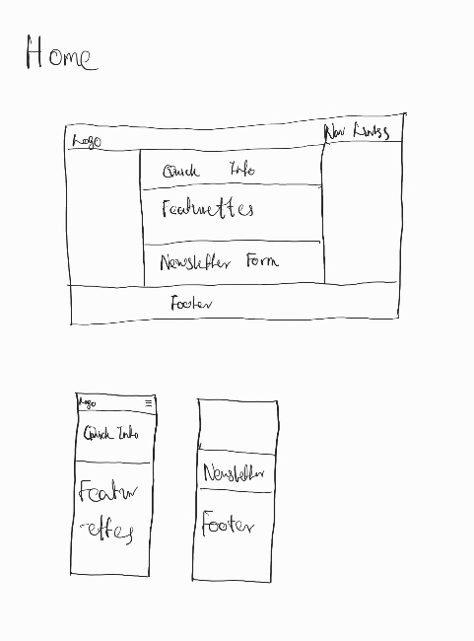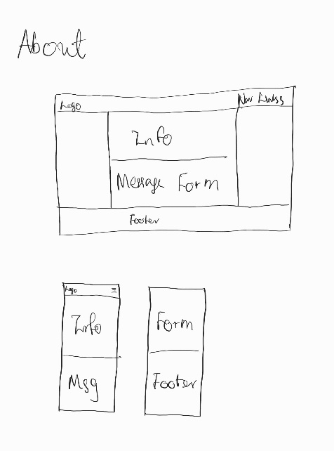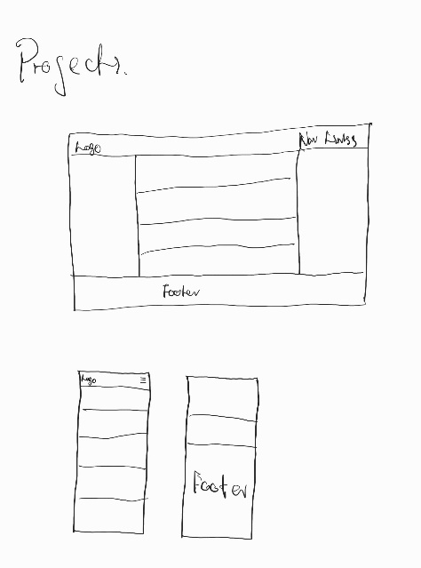

**Week 02 – Oct 9-16**

* Learned that including at least 2 blog posts were mandatory, regardless of choosing to showcase projects over a “more general blogs page”.
* Drew a low fidelity diagram for desktop and mobile layouts for this blogs page:

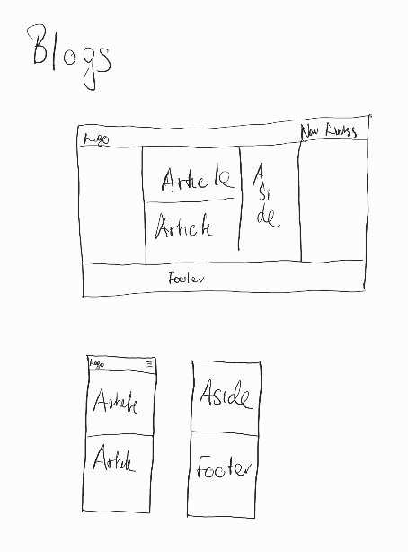

* Started working on the Home page, navigation bar and footer, the latter are to be reused for the other HTML files.
* Added background images, padding and a general first section of the body tag, which would be used to host a greeting and a quick message.
* As I’m developing on a desktop-first basis, made the navigation bar and footer responsive to fit for a mobile device. (ONLY mobile as of now) This is demonstrated by the screenshots below:

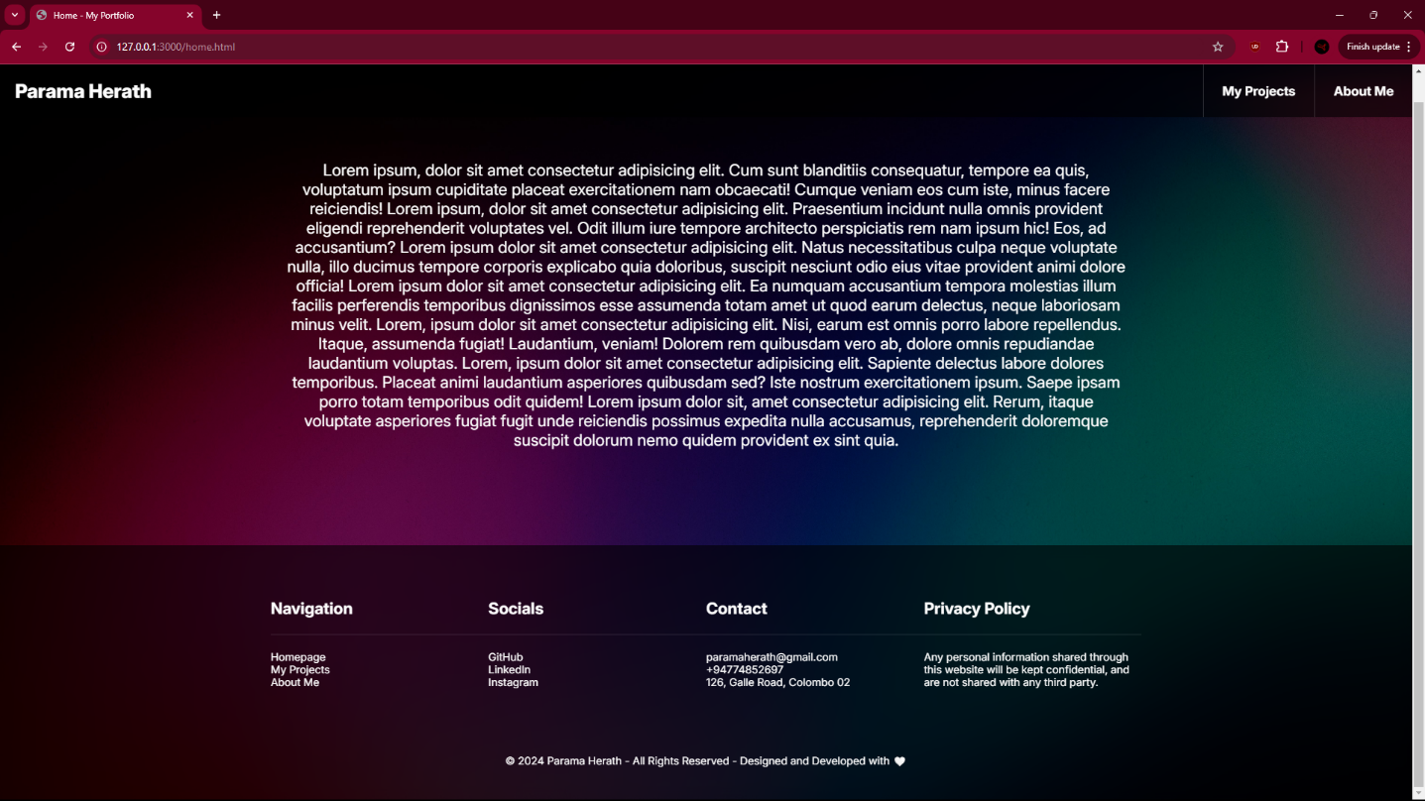

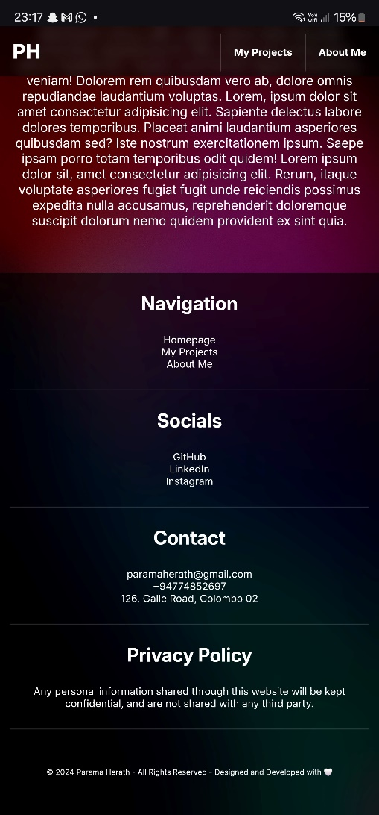

**Week 03 – Oct 16-23**

* Upon realizing that the specification asks for 3 HTML files, a CSS file at MINIMUM, had a change of plans for ease of coding and better management.
* Accordingly, the project structure that 4 HTML files, for Home, About, Projects and Blogs pages and 5 CSS files, for 4 HTML files each and a general sitewide CSS file was decided.
* However, most of the files other than the main HTML and CSS are just placeholders as of now with no at all.
* Finalized the basic navigation structure: Home, About and Projects pages would be accessible via the navigation bar, while the Blogs page would be one of the projects, and be accessible via both Projects, and the featured projects section in the Home page.
* Homepage is almost fully developed at this stage, while other pages are yet to be developed. A screenshot is attached below:

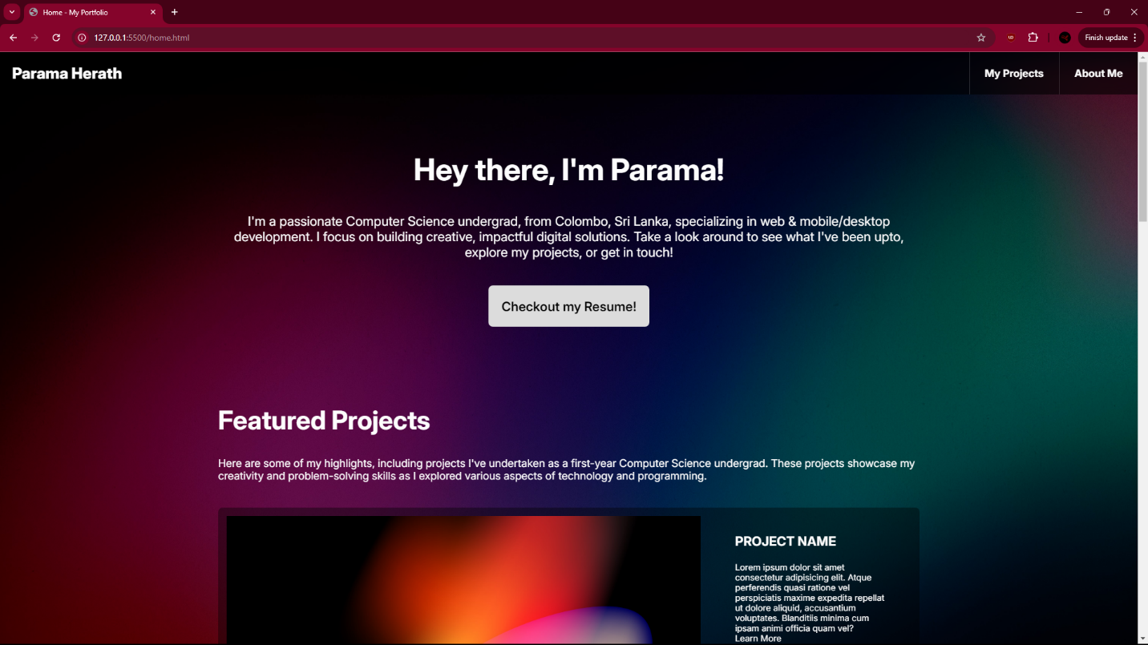

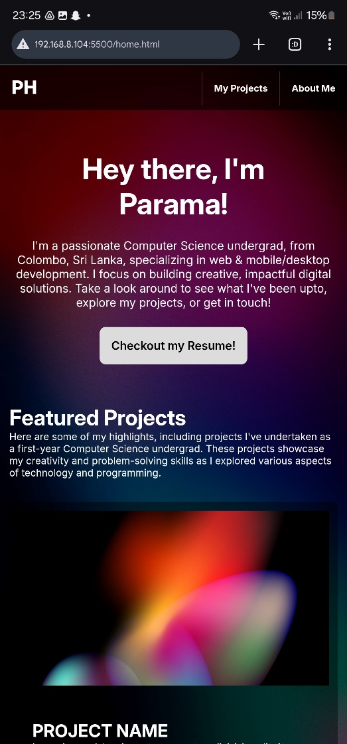

**Week 04 – Oct 23-30**

* Created a repository on GitHub, and the initial commit is the project as it stands of now. The repository is available at: <https://github.com/ParamaHerath/Portfolio-Website-for-ACS-Module>.
* Renamed the home.html file to index.html for GitHub hosting, and the second commit includes these changes. The portfolio is hosted at: <https://paramaherath.github.io/Portfolio-Website-for-ACS-Module/>.
* Built the basic structure of other HTML files and organized the styles into their corresponding CSS files. Created a new branch and committed, which is then to be merged with main branch.
* Developed the basic structure of all other pages, except the Blogs page and added the form to allow a viewer to send me a message in the About page.
* Organized CSS Styles into their corresponding files and optimized them to reduce redundancies.
* Made most of the other pages responsive, and accordingly more commits were made once I had achieved some sort of intended progress, that is named and described in the commit name and description section.

**Week 04 – Oct 30-Nov 5**

* Created a pull request that includes the latest commit, and verified if everything was correct and stable. Later, it was merged with the main branch.
* Upon re-reading the specification, it was evident that I had done a mistake by creating multiple, page specific CSS files, when there should be a SINGLE CSS file for the whole website.
* Adjusted the CSS files and merged all styles into one CSS file named style.css.
* Began work on the Blogs page and developed the other pages further using all required methods of targeting and styles in the specification.
* Made a commit once the above mentioned tasks were done.