Deployment Model:
- Deploy-Portal
- Deploying Azure resources by using the Azure portal usually involves two steps:
- Create a resource group.
- Deploy resources to the resource group.Also, you can create a customized ARM template to deploy Azure resources.
- Deploy-CLI
- Deploy-PowerShell
- Deploy-REST API
- Deploy resources with ARM templates and Azure Resource Manager REST API.
  - can either include your template in the request body or link to a file. When using a file, it can be a local file or an external file that is available through a URI. When your template is in a storage account, you can restrict access to the template and provide a shared access signature (SAS) token during deployment
- Deploy-Github
- Use a deployment button to deploy templates from GitHub repository
- Deploy-Cloudshell
- Deploy ARM templates from Azure Cloud Shell

Azure CLI 2.0: Create and Manage Resource Groups

Azure Command-Line Interface (CLI)

The Azure CLI is available to install in Windows, macOS and Linux environments. It can also be run in a Docker container and Azure Cloud Shell.
The Azure command-line interface (Azure CLI) is a set of commands used to create and manage Azure resources
Azure CLI is a cross-platform command-line experience for managing various Azure resources.

Azure CLI installed on your PC. To check that, open Command Prompt and type az. If you see the below screen, it means it’s not installed. Please go ahead and download and install from here.
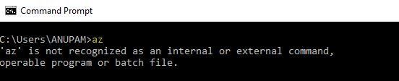

Open Command Prompt and check if Azure CLI is properly installed or not by using the az command.

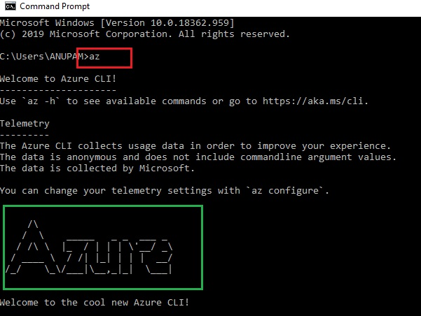

Now login to your Azure account using the az login command.

- The Azure CLI is available to install in Windows, macOS and Linux environments. It can also be run in a Docker container and Azure Cloud Shell.
- The Azure command-line interface (Azure CLI) is a set of commands used to create and manage Azure resources
- All cloud resources created / provisioned in Microsoft Azure need to be associated with Resource Groups\
- This is one of the basic features of the Azure Resource Management model to cloud resource management, and it makes it far easier to manage groupings of resources that comprise full applications and workloads

If you have multiple subscriptions, you have to set one of them for the current session.

az account set –subscription “NameOfYourSubscription”

Resource Group:

Managing Azure Resource Groups form the cross-platform command-line using the Azure CLI 2.0.

Create an Azure Resource Group
cloud resources (Web App, SQL Database, Virtual Machine, IP Address, Virtual Network, etc.) in Microsoft Azure needs to be associated with a Resource Group, this places the Resource Group at the forefront to Azure Resource provisioning

Azure CLI 2.0 command is used to create resource groups in your Azure Subscription

# command format
az group create --name {group name} --location {azure region}
# example
az group create --name LapRG --location westus

Tag Paramter:
Using tags to signify the Department or Cost Center for a Resource Group can help with rolling up into Azure Billing

- Using tags to signify the Environment for a Resource Group can help with defining specifically which Azure resources are for Production, Development, or Test environments.
# command format
az group create --name {group name} \
--location {azure region} \
--tags {tag keys/values}
# usage example
az group create --name BestAppEver \
--location westus \
--tags Dept=HR
# usage setting multiple Tags
az group create --name BestAppEver \
--location westus \
--tags Dept=HR Env=Prod

--
Delete an Azure Resource Group

# command format
az group delete --name {group name}
# usage example
az group delete --name labrg
# alternate usage with quotes
az group delete --name "labrg"

Be default, when you delete a Resource Group the Azure CLI 2.0 will prompt you to ensure you really mean to delete the Resource Group. You can optionally pass in the “–yes” parameter to indicate a hard yes

az group delete --name lblrg --yes

List All Resource Groups

az group list

Show a Resource Group

# command format
az group show --name {group name}
# usage example
az group show --name lblrg

List All Resources within the Resource Group

# command format
az resource list --resource-group {group name}
# usage example
az resource list --resource-group lblrg

Export Resource Group to ARM Template
The Azure Portal has some nice user interface components for being able to work with Azure ARM Templates

Here’s the command you can use to export a Resource Group to an ARM Template:
# command format
az group export --name {group name}
# usage example
az group export --name lblrgARM

From <https://build5nines.com/azure-cli-2-0-manage-resource-groups/>

Add Tags to Existing Resource Group

# command format
az group update --name {group name} \
--set {tag properties to set}
# usage example
az group update --name SuperCloudGroup \
--set tags.Env=Stage tags.Dept=IT

Blob:
Step 1 - Create a Resource Group
az group create --location westus --name demoresgrp1
Step 2 - Create Storage Account
az storage account create --name mystorage200 --resource-group demoresgrp1 --location westus --sku Standard_LRS

if you want to check all storage account for a resource group in command prompt, execute the below command:

az storage account list --resource-group demoresgrp1 --query [*].{Name:name,Location:primaryLocation,Kind:kind} --output table

Adding Tags in Storage Account:
az storage account update --name mystorage200 --resource-group demoresgrp1 --tags “env=dev”
Step 3 - Create a Container on Storage account
az storage container create --account-name mystorage200 --name democontainer
Step 4 - Upload a blob in Container
az storage blob upload --account-name mystorage200 --container-name democontainer --name clidemo.txt --file demo.txt
You will see Resource Not Found. That’s because the container that gets created by default has access permission set to private.

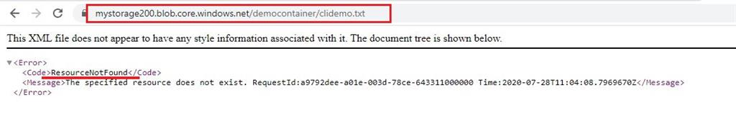
Now in order to change the public access level, we have one more command and that is to go ahead and set the permissions on the container.
az storage container set-permission --account-name mystorage200 --name democontainer --public-access blob
Now access the same URL from the browser again and you will able to view the contents of the file.

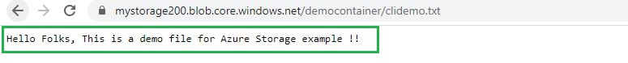

Now identify a list of blobs in our container using below command and you can see the name of the file and what the type of blob it is.

az storage blob list --account-name mystorage200 --container-name democontainer --output table
Step 5 - Download a blob from Container

az storage blob download --account-name mystorage200 --container-name democontainer --name clidemo.txt --file blobdownload.txt
Step 6 - Delete a blob from container

Let’s delete the blob that we created for demo purpose by using below command,

az storage blob delete -c democontainer -n clidemo.txt --account-name mystorage200

