Status Report *MCA*

|  |  |
| --- | --- |
| **Project** | Library Application |
| **Author** | Jessica Goertz |
| **Date** | 17. December 2014 |
| **Members** | Jessica Goertz, Bledar Baxhaku, Panagiotis Grivas |

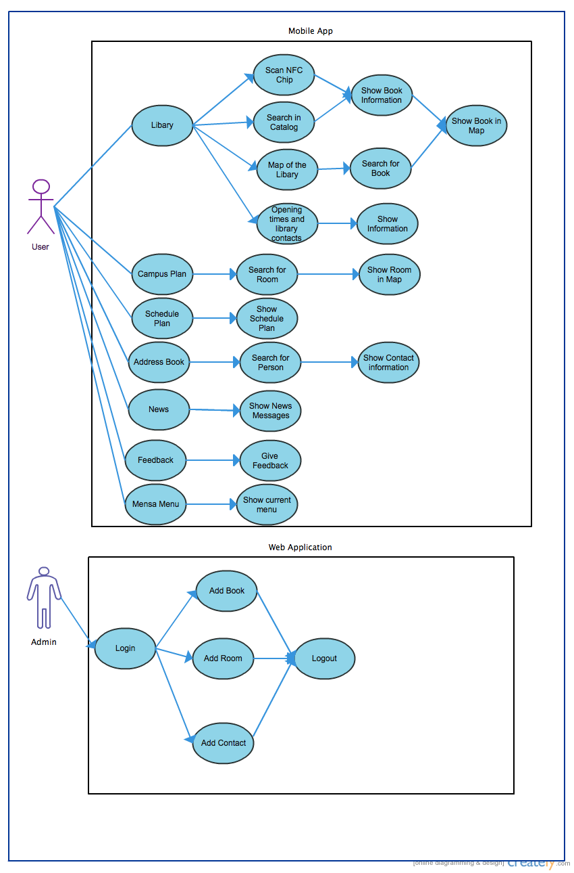Use Case Model

|  |
| --- |
|  |

Completed Tasks

Running Tasks