Data Flow Diagram - DormNest

Parameshwaran K – 2022503509

Inbavanan K – 2022503507

Pavithran S – 2022503705

Level 0:

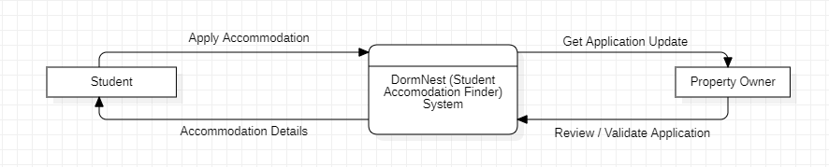

Level 1:

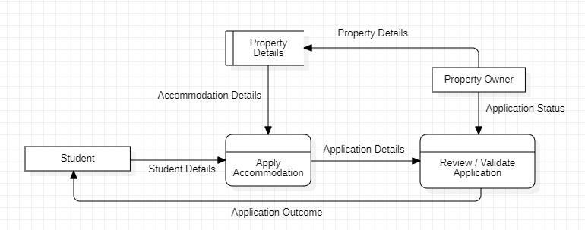

Level 2:

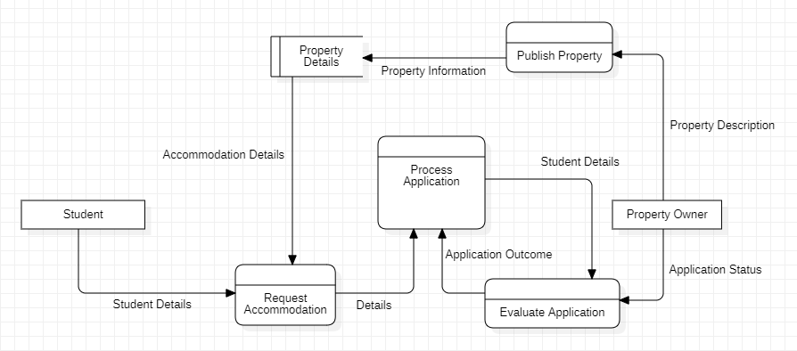

Level 3:

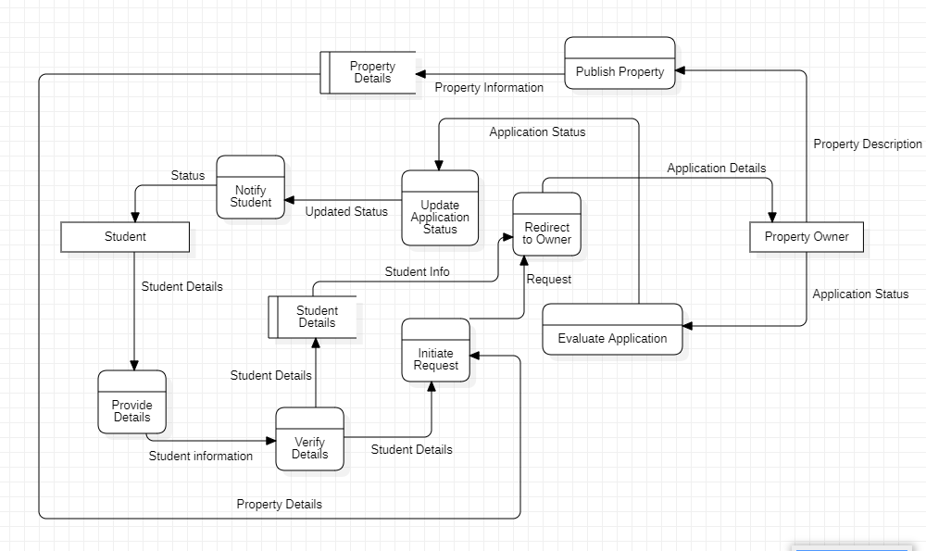

Level 4:

