**Software Requirements Specification (SRS) for Student Accommodation Finder**

**Purpose**

This document serves as a detailed guide for the development of the "Student  Accommodation Finder" application. It outlines the key requirements and features necessary to build a platform that helps college students find suitable housing and connect with potential roommates.

**Primary Objective**

The main objective of the "Student Accommodation Finder" is to simplify the process of finding accommodation for students. The platform will allow students to explore housing options, find compatible roommates. Additionally, it will provide property owners with a user-friendly platform to list and manage their properties.

**Scope:**

**Overview:**The "Student Accommodation Finder" is a web application designed to meet the needs of college students searching for accommodation and property owners who want to list rental properties. Key features will include property listings, roommate matching and map integration.

**Users:**This application will serve two main user groups:

* **Students**: Looking for accommodation near their college.
* **Property Owners**: Listing and managing rental properties.

**Major Features:**

* **User Registration and Authentication:** Account creation and login.
* **Property Listings Management:** Tools for property owners to manage listings.
* **Search and Filtering:** Advanced search capabilities for students.
* **Roommate Matching:** Matching system to find compatible roommates.
* **Maps Integration:** Finding Directions from current location to Property.
* **User Reviews and Ratings:** Students can leave feedback on properties.

**Problem Description:**

**Background:**Finding suitable and affordable accommodation near college campuses can be a challenging and time-consuming process for students. Existing solutions often lack search options and roommate matching services.

**Problem Statement:**The challenge is to create a web-based application that addresses these issues, providing students with a reliable platform to find housing and compatible roommates. The platform will also facilitate communication between students and property owners.

**Current System:**Currently, students rely on various disconnected resources such as social media, university boards, and other resources to find housing. These methods often complicate the process.

**Proposed System:**The "Student Accommodation Finder" will consolidate all essential features into a single platform, making the search for accommodation easier and more efficient. The application will provide tools for students to find housing and connect with roommates. Property owners, in turn, will have a dedicated platform to manage their listings.

**Unique Challenges:**A standout feature will be the dynamic roommate matching system, which suggests potential roommates based on their preferences. This feature will help students avoid common issues by offering compatible suggestions.

**Functional Requirements:**

**User Registration and Authentication:**

* Users should be able to create accounts and log in using their credentials.
* Different roles (students, property owners) should have role-specific access.

**Property Listings Management:**

* Property owners should have the ability to create, update, view, and delete property listings.
* Listings should include essential details like location, price and photos.

**Search and Filtering:**

* Students should be able to search for properties using various filters like price, location, and other facilities.
* The search should be efficient, providing results quickly even with multiple criteria.

**Roommate Matching:**

* The system should provide a roommate matching feature based on user preferences.

**Maps Integration:**

* Users should be able to view property locations on a map and see how close they are to campus or other points of interest.

**User Reviews and Ratings:**

* Students should be able to leave reviews and ratings for properties they have stayed in.
* Property owners should be able to respond to reviews.

**Notifications:**

* The system should send notifications for important events, like updates to listings.

**Non-Functional Requirements:**

**Performance:**

* The application should handle multiple user requests efficiently, with quick response times for search queries.

**Scalability:**

* The platform should be able to scale to accommodate an increasing number of users and property listings.

**Availability:**

* The system should be highly available, with minimal downtime and regular backups to prevent data loss.

**Usability:**

* The user interface should be intuitive and easy to navigate, ensuring a positive user experience.

**Reliability:**

* The system should be robust and able to recover from unexpected failures.

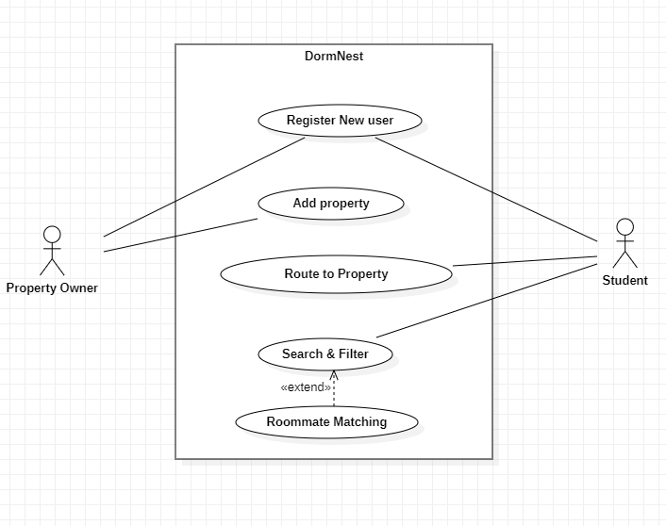**Use Case Diagram:**