Reading from Excel:

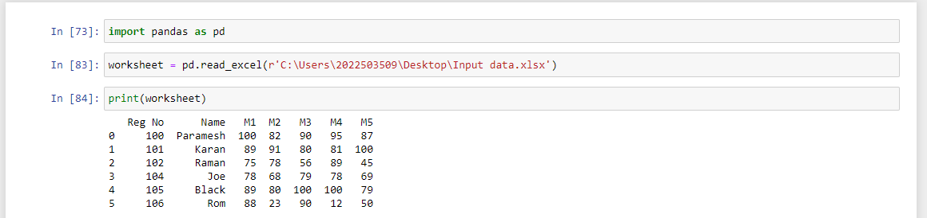

Finding Average:

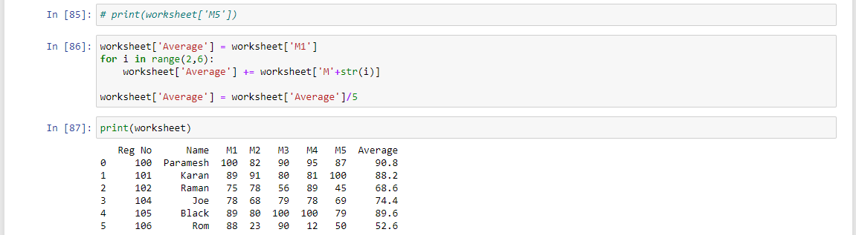

Finding Grade:

