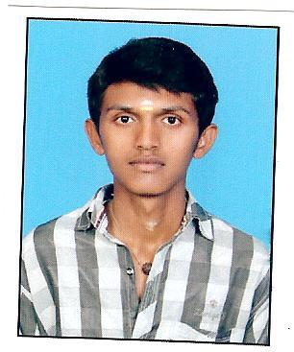

phone: +(91) 8778090994

email: [parameshkrishna98@gmail.com](mailto:parameshkrishna98@gmail.com)

github: https://github.com/paramesh98/

Pursuing Bachelor of engineering in United Institute of Technology with 71%.

Completed HSC from CSI CMM Hr Sec School with 81%.

Completed SSC from CSI CMM Hr Sec School .with 86%.

EXPERIENCE

TECHINICAL SKILL

* HTML
* CSS
* Javascript
* Reactjs
* Redux
* Nodejs
* Firebase
* MongoDB
* React Native

Date:

Place:

Hereby I declare you that the above details are true to the best of my knowledge.

DECLARATION

Worked on a static website

Freelancer

Full Stack Developer (march-2020 to present)

Working as a Mern Stack Develper for managing the admin panel of real estate company using Nodejs, mongoDb as backend and Reactjs as frontend technology

Worked as a Junior developer with front end technologies like HTML, CSS, Javascript for making e-commerce website in Design Shore Technlogies

Front End Developer (oct-2019 to march 2020)

K Parameshwar

QUALIFICATION

To grow with the company where I can effectively contribute my personal skill as professional.

Mern Stack Developer

K Parameshwar

OBJECTIVES