|  |  |
| --- | --- |
| Layered  Kernel  Architecture | Flower accent icon on third page Layered kernel architecture  * Two main layers -Software Layer   -Hardware Layer Why layered  * Functions and operations are defined by lower layers. * Simplified debugging and system verification. * Easy construction and none of the layers are connected for debugging. * No knowledge of how the operations are implemented is needed but only what these operations do. * Can rectify the errors easily.    Disavantages  * Defining of layers is difficult. * Careful planning Is needed as the higher layers use the lower layer operations. * It is less efficient. |
|  | |

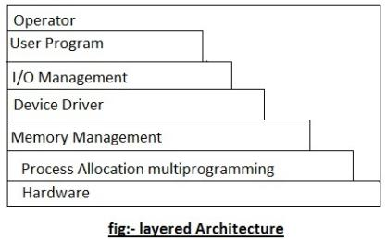**Software Layer**

1. Operator

2.User program

3.I/O Management

4.Device Management

5.Memory Management

6.PAM

**Hardware Layer**

1.CPU

2.RAM