Hands-on
Clean Up and Push Back to Remote Git

Verify Master Branch is in Clean State :
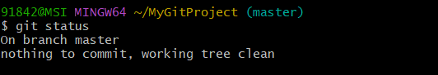
List All Available Branches :
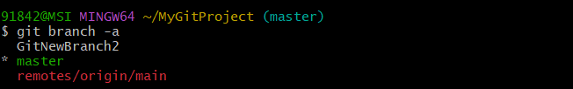
Pull Remote Repository to Master :
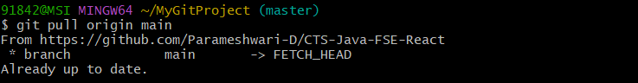
Push Changes to Remote Repository :
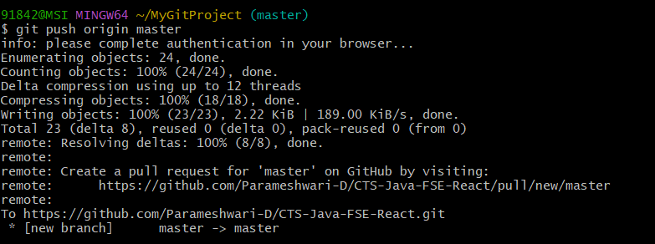

Verify Changes in GitHub :
