Hands-on
Microservices with Spring Boot 3 and Spring Cloud

Creating Microservices for account and loan
Project 1 – Account Microservice:

Spring Initializr Configuration :

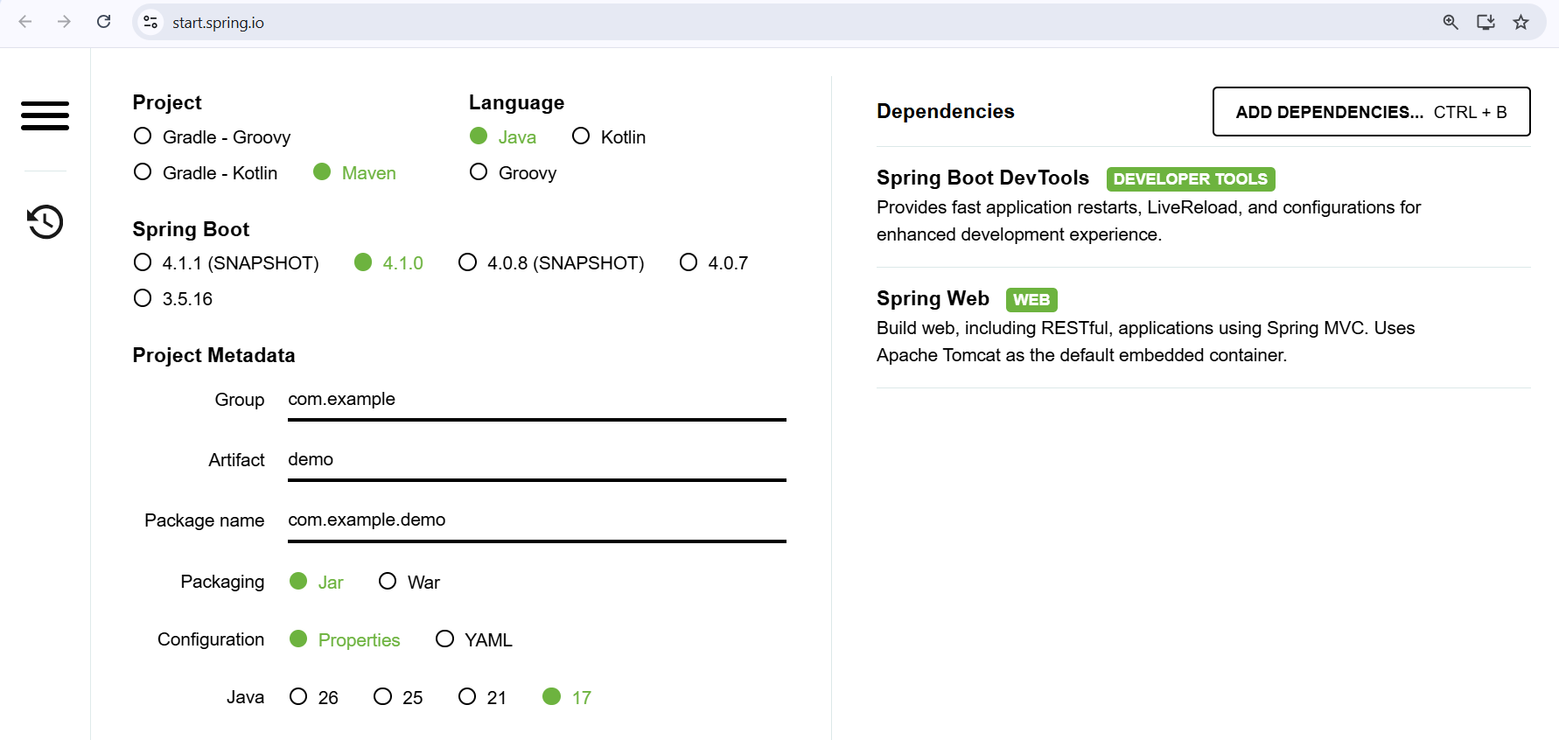

Project Structure :
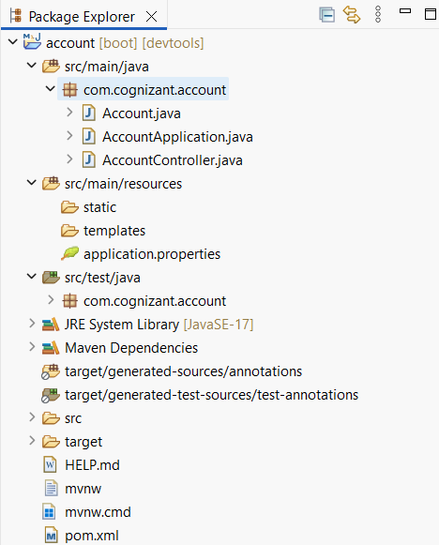

File name : Account.java
package com.cognizant.account;

public class Account {

private String number;
private String type;
private double balance;

public Account() {
}

public Account(String number, String type, double balance) {
this.number = number;
this.type = type;
this.balance = balance;
}

public String getNumber() {
return number;
}

public void setNumber(String number) {
this.number = number;
}

public String getType() {
return type;
}

public void setType(String type) {
this.type = type;
}

public double getBalance() {
return balance;
}

public void setBalance(double balance) {
this.balance = balance;
}
}

File name : AccountController.java
package com.cognizant.account;

import org.springframework.web.bind.annotation.GetMapping;
import org.springframework.web.bind.annotation.PathVariable;
import org.springframework.web.bind.annotation.RestController;

@RestController
public class AccountController {

@GetMapping("/accounts/{number}")
public Account getAccount(@PathVariable String number) {
return new Account(number, "savings", 234343);
}
}

File name : application.properties
spring.application.name=account

Console Output :
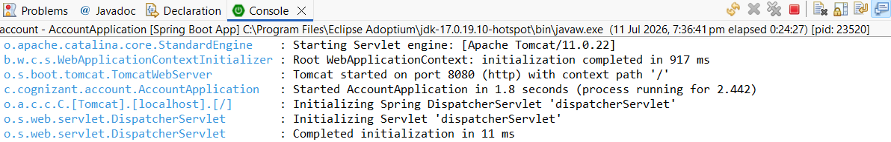

Browser Output :
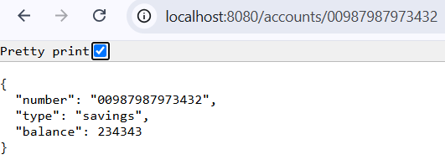

Project 2 – LoanMicroservice:
Project Structure :
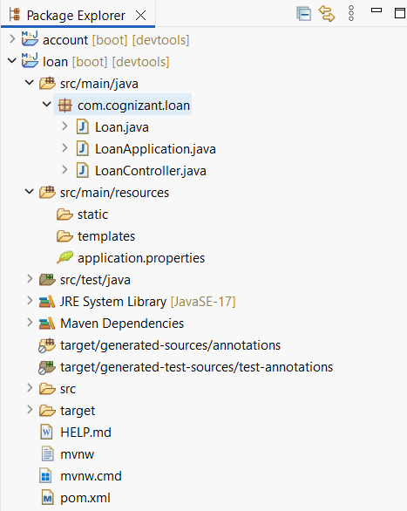

File name : Loan.java
package com.cognizant.loan;

public class Loan {

private String number;
private String type;
private double loan;
private double emi;
private int tenure;

public Loan() {
}

public Loan(String number, String type, double loan, double emi, int tenure) {
this.number = number;
this.type = type;
this.loan = loan;
this.emi = emi;
this.tenure = tenure;
}

public String getNumber() {
return number;
}

public void setNumber(String number) {
this.number = number;
}

public String getType() {
return type;
}

public void setType(String type) {
this.type = type;
}

public double getLoan() {
return loan;
}

public void setLoan(double loan) {
this.loan = loan;
}

public double getEmi() {
return emi;
}

public void setEmi(double emi) {
this.emi = emi;
}

public int getTenure() {
return tenure;
}

public void setTenure(int tenure) {
this.tenure = tenure;
}
}

File name : LoanController.java
package com.cognizant.loan;

import org.springframework.web.bind.annotation.GetMapping;
import org.springframework.web.bind.annotation.PathVariable;
import org.springframework.web.bind.annotation.RestController;

@RestController
public class LoanController {

@GetMapping("/loans/{number}")
public Loan getLoan(@PathVariable String number) {
return new Loan(number, "car", 400000, 3258, 18);
}
}

File name : application.properties
spring.application.name=loan
server.port=8081
Console Output :
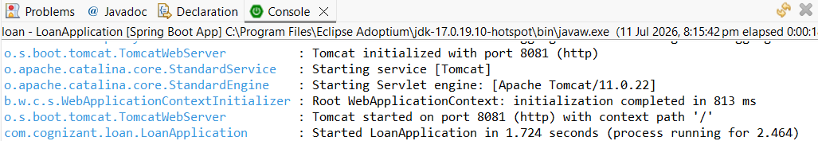

Browser Output :
