HANDS-ON
REACT
Creating Office Space Rental Application Using React JSX

Project explorer :
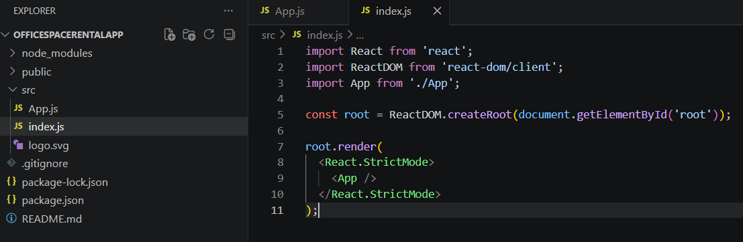

Filename : App.js
import React from 'react';

function App() {

const office = {
name: "DBS Office",
rent: 50000,
address: "Chennai"
};

return (
<div>
<h1>Office Space Rental App</h1>

<img
src="https://via.placeholder.com/300"
alt="Office Space"
/>

<h2>Name: {office.name}</h2>
<h2>Rent: {office.rent}</h2>
<h2>Address: {office.address}</h2>

</div>
);
}

export default App;

Filename : index.js
import React from 'react';
import ReactDOM from 'react-dom/client';
import App from './App';

const root = ReactDOM.createRoot(document.getElementById('root'));

root.render(
<React.StrictMode>
<App />
</React.StrictMode>
);

Output :
