HANDS-ON
REACT
Event Handling in React Applications

Project explorer :
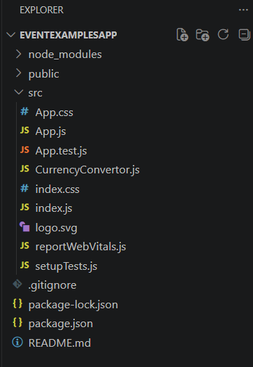

Filename : App.js Code
import React, { Component } from "react";
import CurrencyConvertor from "./CurrencyConvertor";

class App extends Component {

constructor(props) {
super(props);

this.state = {
count: 0
};

this.increment = this.increment.bind(this);
this.sayHello = this.sayHello.bind(this);
this.sayWelcome = this.sayWelcome.bind(this);
this.onPress = this.onPress.bind(this);
}

increment() {
this.setState({
count: this.state.count + 1
});
}

decrement() {
this.setState({
count: this.state.count - 1
});
}

sayHello() {
alert("Hello Welcome to React Events");
}

increaseButtonClick() {
this.increment();
this.sayHello();
}

sayWelcome(message) {
alert(message);
}

onPress() {
alert("I was clicked");
}

render() {

return (
<div>

<h1>Event Examples App</h1>

<h2>Counter Value: {this.state.count}</h2>

<button onClick={() => this.increaseButtonClick()}>
Increase
</button>

<button onClick={() => this.decrement()}>
Decrement
</button>

<br />
<br />

<button onClick={() => this.sayWelcome("Welcome")}>
Say Welcome
</button>

<br />
<br />

<button onClick={() => this.onPress()}>
OnPress
</button>

<br />
<br />

<CurrencyConvertor />

</div>
);
}
}

export default App;

Filename : CurrencyConvertor.js
import React, { Component } from "react";

class CurrencyConvertor extends Component {

constructor(props) {
super(props);

this.state = {
rupees: "",
euro: 0
};
}

handleSubmit = () => {

let euroValue = this.state.rupees / 90;

this.setState({
euro: euroValue
});

}

render() {

return (

<div>

<h2>Currency Convertor</h2>

<input
type="number"
placeholder="Enter Rupees"
onChange={(e) =>
this.setState({
rupees: e.target.value
})
}
/>

<br />
<br />

<button onClick={this.handleSubmit}>
Convert
</button>

<h3>
Euro Value: {this.state.euro}
</h3>

</div>

);

}
}
export default CurrencyConvertor;

Output 1 : Counter Application
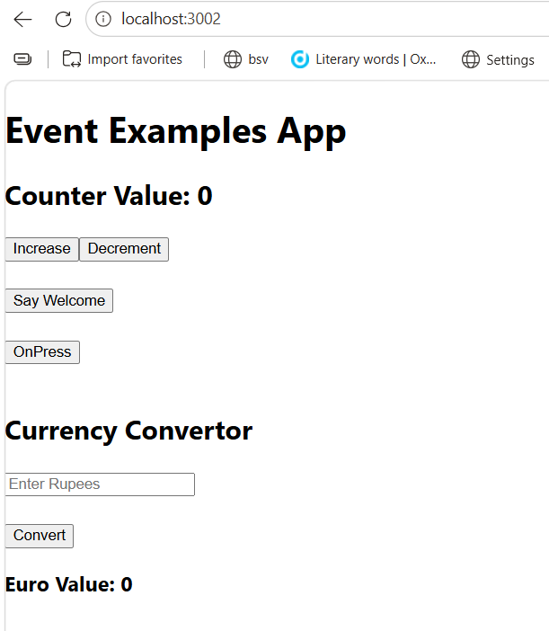
Output 2 : Increase Button Event
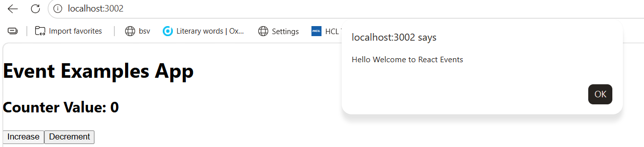

Output 3 : Say Welcome Event
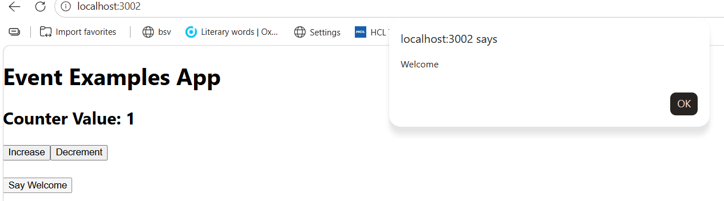

Output 4 : Synthetic Event
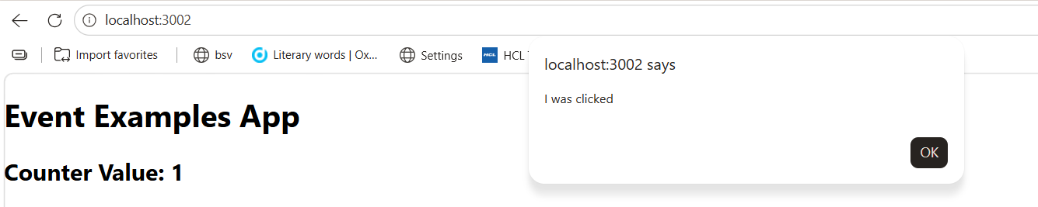

Output 5 : Currency Converter
