HANDS-ON
REACT
Conditional Rendering in React - Ticket Booking Application

Project structure :
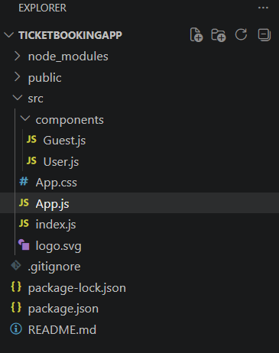

Filename : App.js
import React, { useState } from "react";
import "./App.css";
import Guest from "./components/Guest";
import User from "./components/User";

function App() {

const [isLoggedIn, setIsLoggedIn] = useState(false);

const handleLogin = () => {
setIsLoggedIn(true);
};

const handleLogout = () => {
setIsLoggedIn(false);
};

return (
<div>
<h1>Ticket Booking Application</h1>

{isLoggedIn ? (
<>
<User />

<button onClick={handleLogout}>
Logout
</button>
</>
) : (
<>
<Guest />

<button onClick={handleLogin}>
Login
</button>
</>
)}

</div>
);
}

export default App;

Filename : Guest.js
import React from "react";

function Guest() {
return (
<div>
<h2>Guest Page</h2>

<h3>Available Flights</h3>

<ul>
<li>Chennai to Bangalore - ₹3000</li>
<li>Chennai to Delhi - ₹5000</li>
<li>Chennai to Mumbai - ₹4500</li>
</ul>

<p>Please login to book tickets.</p>
</div>
);
}

export default Guest;

Filename : User.js
import React from "react";

function User() {
return (
<div>
<h2>User Page</h2>

<h3>Book Your Flight Ticket</h3>

<p>You can book your flight tickets now.</p>

<button>
Book Ticket
</button>
</div>
);
}

export default User;

Filename : App.css
body {
margin: 0;
padding: 0;
font-family: Arial, sans-serif;
background-color: #eaf2f8;
color: black;
}

h1 {
color: blue;
text-align: center;
}

h2 {
color: green;
text-align: center;
}

h3 {
color: purple;
}

p {
color: black;
font-size: 18px;
}

ul {
text-align: center;
list-style: none;
padding: 0;
}

li {
background-color: white;
margin: 10px auto;
padding: 10px;
width: 300px;
border-radius: 5px;
}

button {
display: block;
margin: 20px auto;
padding: 10px 25px;
background-color: blue;
color: white;
border: none;
border-radius: 5px;
font-size: 16px;
}

button:hover {
background-color: darkblue;
}

Output1 : Guest Page screenshot
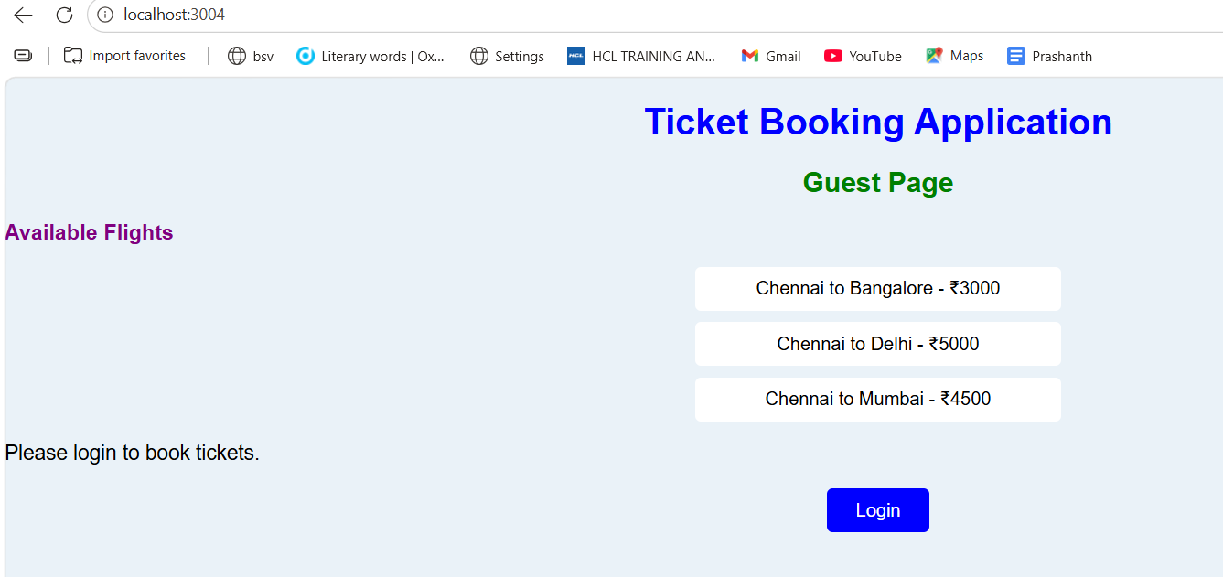

Output2 : User Page screenshot
