HANDS-ON
REACT
Implement Conditional Rendering in React Applications

Project explorer :
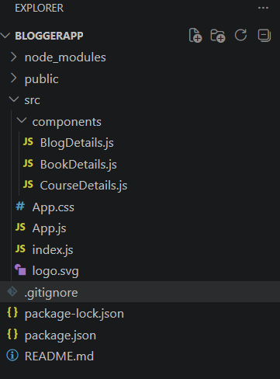

Filename : App.js
import React from "react";
import "./App.css";

import BookDetails from "./components/BookDetails";
import BlogDetails from "./components/BlogDetails";
import CourseDetails from "./components/CourseDetails";

function App() {

return (
<div className="App">

<h1>React Conditional Rendering Example</h1>

<BookDetails />

<BlogDetails />

<CourseDetails />

</div>
);
}

export default App;

Filename : BookDetails.js
import React from "react";

function BookDetails() {

const showBook = true;

return (
<div>
<h2>Book Details</h2>

{showBook ? (
<div>
<p>Book Name: React Basics</p>
<p>Author: John Smith</p>
<p>Price: ₹500</p>
</div>
) : (
<p>No Book Available</p>
)}

</div>
);
}

export default BookDetails;

Filename : BlogDetails.js
import React from "react";

function BlogDetails() {

const isLoggedIn = true;

return (
<div>
<h2>Blog Details</h2>

{isLoggedIn && (
<div>
<p>Title: React Conditional Rendering</p>
<p>Author: Somiya</p>
<p>Status: Published</p>
</div>
)}

</div>
);
}

export default BlogDetails;

Filename : CourseDetails.js
import React from "react";

function CourseDetails() {

const course = "React";

let message;

if (course === "React") {
message = "React Course Available";
}
else {
message = "Course Not Available";
}

const courses = [
{
id: 1,
name: "React",
duration: "8 Weeks"
},
{
id: 2,
name: "Java",
duration: "6 Weeks"
},
{
id: 3,
name: "Python",
duration: "5 Weeks"
}
];

return (
<div>
<h2>Course Details</h2>

<p>{message}</p>

<h3>Course List</h3>

<ul>
{courses.map((item) => (
<li key={item.id}>
{item.name} - {item.duration}
</li>
))}
</ul>

</div>
);
}

export default CourseDetails;

Output :
