HANDS-ON
REACT
Setting Up React Environment and Creating a Simple React Application :
Filename : Node.js Installation
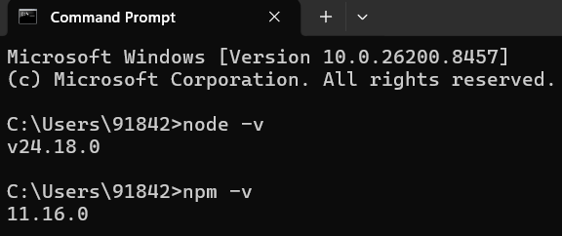

Filename : Project Opened in Visual Studio Code
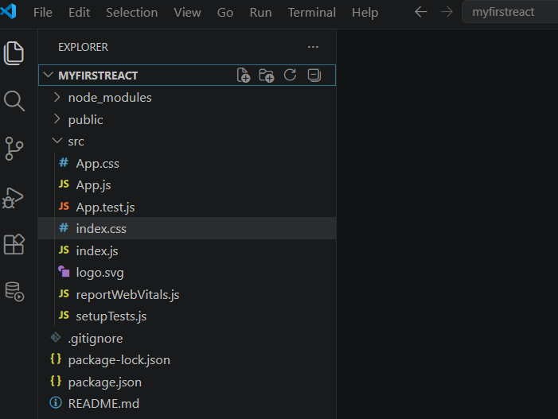

Filename : App.js
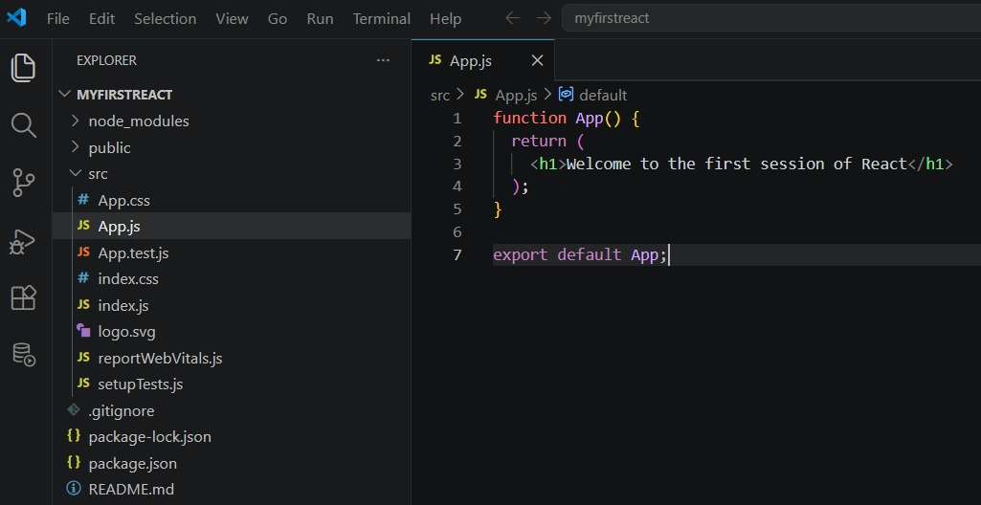

React Application Execution :
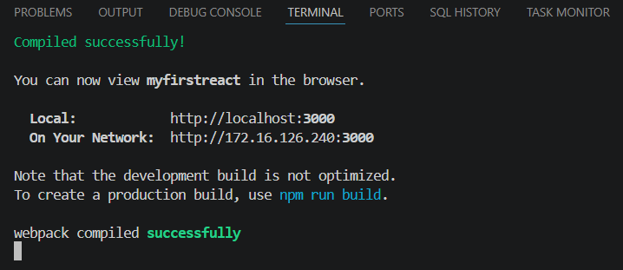

Output :
