HANDS-ON
REACT
Student Management Portal using React Function Component

Project folder structure :
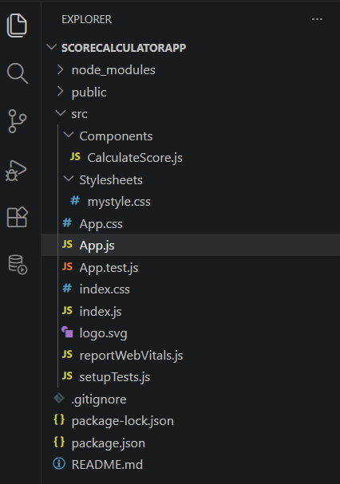

Filename : CalculatorScore.js
import React from 'react';
import '../Stylesheets/mystyle.css';

function CalculateScore(props) {

const average = props.Total / props.goal;
return (
<div className="container">
<h2>Student Score Calculator</h2>

<p><b>Name:</b> {props.Name}</p>

<p><b>School:</b> {props.School}</p>

<p><b>Total Score:</b> {props.Total}</p>

<p><b>Goal:</b> {props.goal}</p>

<p><b>Average Score:</b> {average}</p>
</div>
);
}
export default CalculateScore;

Filename : mystyle.css
.container {
width: 400px;
margin: 50px auto;
padding: 20px;
border: 2px solid black;
border-radius: 10px;
text-align: center;
font-family: Arial, sans-serif;
}

h2 {
color: blue;
}

p {
font-size: 18px;
}

Filename : App.js
import './App.css';
import CalculateScore from './Components/CalculateScore';

function App() {
return (
<div className="App">
<CalculateScore
Name="Somiya"
School="ABC Higher Secondary School"
Total={450}
goal={5}
/>
</div>
);
}

export default App;

Output :
