HANDS-ON
REACT
React Component Lifecycle – componentDidMount() and componentDidCatch()

Project explorer :
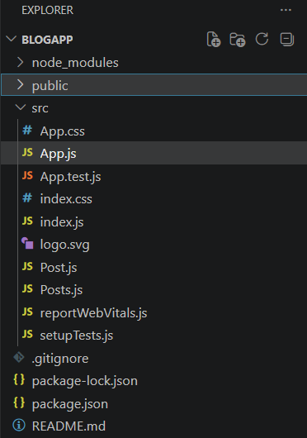
Filename : Post.js
class Post {
constructor(id, title, body) {
this.id = id;
this.title = title;
this.body = body;
}
}

export default Post;

Filename : Posts.js
import React, { Component } from 'react';
import Post from './Post';

class Posts extends Component {

constructor(props) {
super(props);

this.state = {
posts: [
new Post(1, "Loading...", "Please wait while posts are fetched.")
]
};
}

loadPosts() {
fetch("https://jsonplaceholder.typicode.com/posts")
.then(response => response.json())
.then(data => {
const posts = data.map(item =>
new Post(item.id, item.title, item.body)
);

this.setState({
posts: posts
});
});
}

componentDidMount() {
this.loadPosts();
}

componentDidCatch(error, info) {
alert("Error: " + error);
console.error(info);
}

render() {
return (
<div>
<h1>Posts</h1>

{this.state.posts.map(post => (
<div key={post.id}>
<h2>{post.title}</h2>
<p>{post.body}</p>
<hr />
</div>
))}
</div>
);
}
}

export default Posts;

Filename : App.js
import './App.css';
import Posts from './Posts';

function App() {
return (
<div className="App">
<Posts />
</div>
);
}

export default App;

Output :
