HANDS-ON
REACT

Implementing ES6 Features in React – Cricket App

Project explorer :
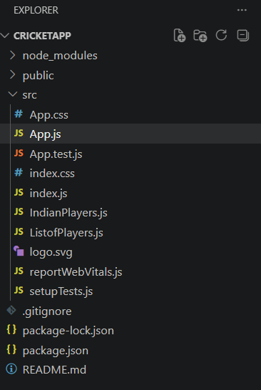

Filename : ListofPlayers.js
import React from "react";

function ListofPlayers() {

const players = [
{ name: "Virat Kohli", score: 85 },
{ name: "Rohit Sharma", score: 90 },
{ name: "MS Dhoni", score: 75 },
{ name: "KL Rahul", score: 65 },
{ name: "Hardik Pandya", score: 60 },
{ name: "Ravindra Jadeja", score: 72 },
{ name: "Jasprit Bumrah", score: 80 },
{ name: "Shubman Gill", score: 68 },
{ name: "Rishabh Pant", score: 55 },
{ name: "Suryakumar Yadav", score: 88 },
{ name: "Yuzvendra Chahal", score: 50 }
];

// Using map() feature of ES6
const playerList = players.map((player) =>
<li key={player.name}>
{player.name} - Score: {player.score}
</li>
);

// Using arrow function and filter()
const lowScorePlayers = players.filter((player) =>
player.score < 70
);

return (
<div>
<h2>List of Players</h2>

<h3>All Players</h3>
<ul>
{playerList}
</ul>

<h3>Players with Score below 70</h3>
<ul>
{
lowScorePlayers.map((player) =>
<li key={player.name}>
{player.name} - Score: {player.score}
</li>
)
}
</ul>

</div>
);
}
export default ListofPlayers;

Output :
When Flag=true
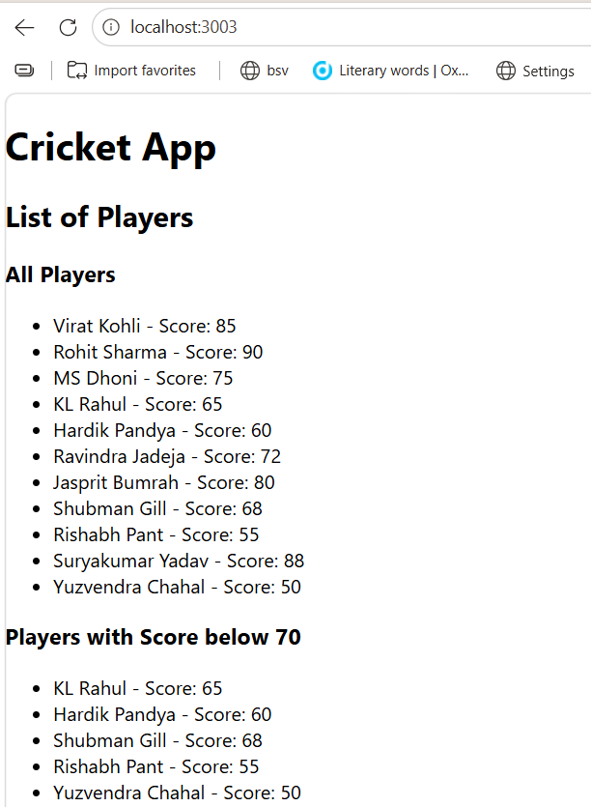

Filename : IndianPlayers.js
import React from "react";

function IndianPlayers() {

const players = [
"Rohit",
"Virat",
"Dhoni",
"Rahul",
"Hardik",
"Jadeja"
];

// Destructuring feature
const [player1, player2, player3, player4, player5, player6] = players;

const oddTeamPlayers = [player1, player3, player5];
const evenTeamPlayers = [player2, player4, player6];

// Merge feature using spread operator
const T20players = [
"Rohit",
"Virat",
"Hardik"
];

const RanjiTrophyPlayers = [
"Rahul",
"Jadeja",
"Pant"
];

const allPlayers = [
...T20players,
...RanjiTrophyPlayers
];

return (
<div>

<h2>Indian Players</h2>

<h3>Odd Team Players</h3>
<ul>
{
oddTeamPlayers.map((player) =>
<li key={player}>{player}</li>
)
}
</ul>

<h3>Even Team Players</h3>
<ul>
{
evenTeamPlayers.map((player) =>
<li key={player}>{player}</li>
)
}
</ul>

<h3>Merged T20 and Ranji Trophy Players</h3>
<ul>
{
allPlayers.map((player) =>
<li key={player}>{player}</li>
)
}
</ul>

</div>
);
}
export default IndianPlayers;

Output :
When Flag=false
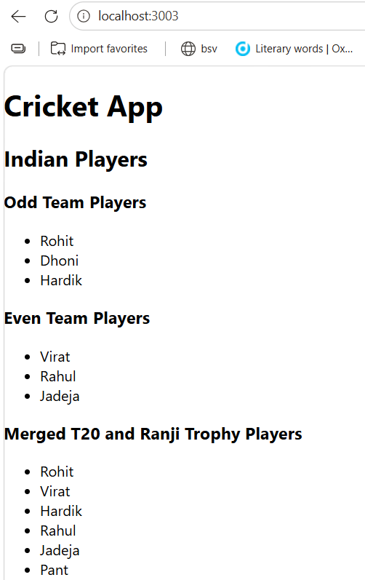

Filename : App.js
import React from "react";
import ListofPlayers from "./ListofPlayers";
import IndianPlayers from "./IndianPlayers";
function App() {
let flag = false;
return (
<div>
<h1>Cricket App</h1>
{

flag ?
<ListofPlayers />
:
<IndianPlayers />
}

</div>
);
}

export default App;

