Git Hands-on
Git Configuration and Repository Setup

Steps Performed
1. Git Installation Verification
- Installed Git and opened Git Bash successfully.
2. Setup Required
- Operating System: Windows 10/11
- Git
- Git Bash
- Notepad++
3. Git Configuration
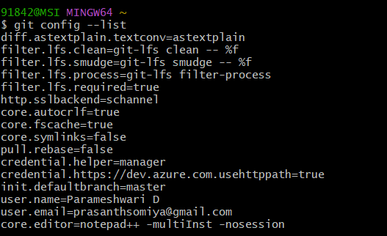

4. Git Repository Initialization
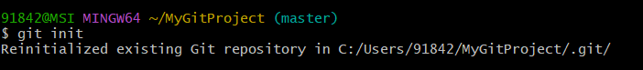
5. Repository Status
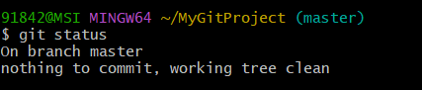
6. Commit History
