Git Hands-on
Implementing the .gitignore File in Git

Initial git status
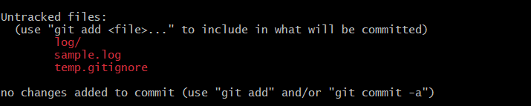

Creating the .gitignore file
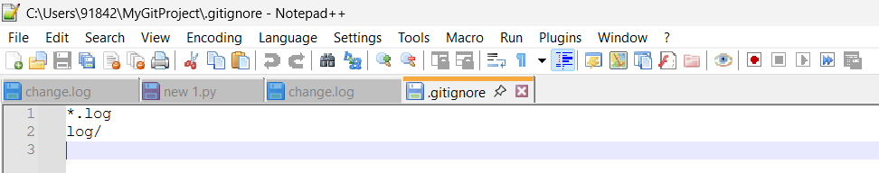

git status after .gitignore
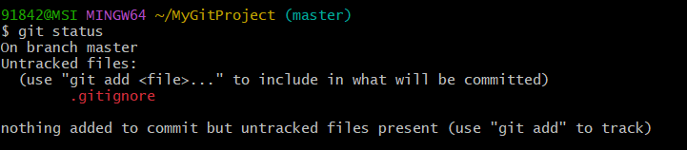

Adding .gitignore

Commit
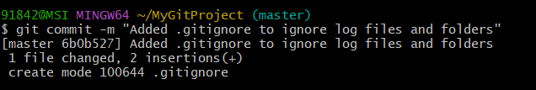

Final verification
