Git Hands-on
Git Branching and Merging

Git Repository Initialization :
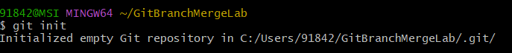

Initial Commit :
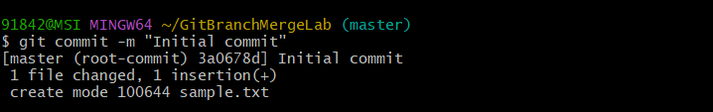

Creating a New Branch :


Switching to the New Branch :


Modifying the File in GitNewBranch :


Committing Changes in GitNewBranch :
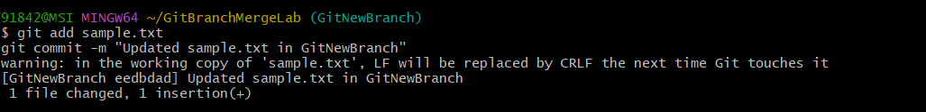

Checking Branch Status :
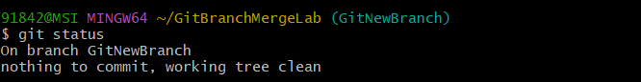

Switching Back to Master :


Viewing Differences Between Master and GitNewBranch :


Merging GitNewBranch into Master :
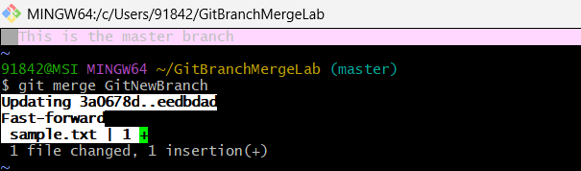

Final Repository Status :


