Hands-on
Merge Conflict Resolution

Verify Master is in Clean State :

Create GitWork Branch and hello.xml :
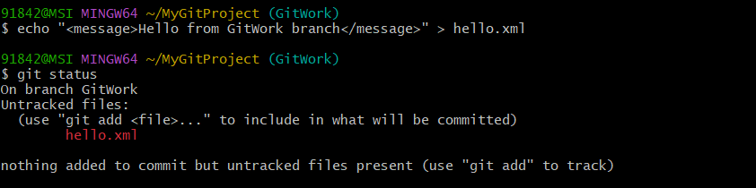
Update hello.xml :

Commit Changes in GitWork Branch :


Create and Commit hello.xml in Master :

Merge Conflict :

Conflict Markers in hello.xml :

Commit Resolved Merge Conflict :

Git Status After Merge :


Add Backup File to .gitignore :
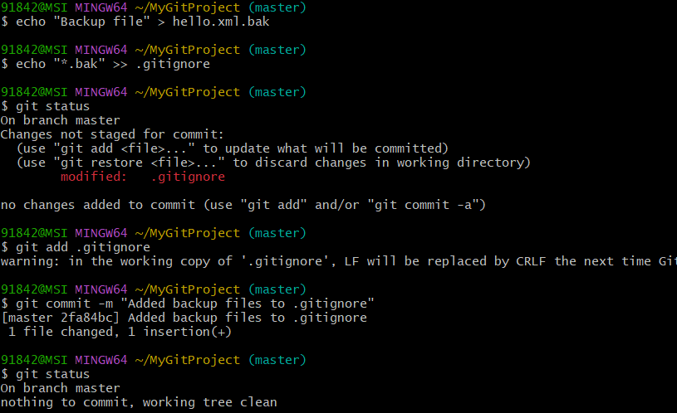
List Available Branches :

Final Git Log :


