**KPI’s Requirement**

**Total Revenue**

1.SELECT SUM(total_price) AS total_revenue FROM pizza_sales

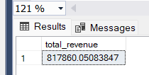

**AVG ORDER VALUE**

2. SELECT SUM(total_price)/COUNT(DISTINCT order_id) AS Avg_order_value FROM pizza_sales

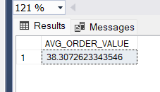

**TOTAL PIZZA SOLD**

3. SELECT SUM(quantity) AS Total_pizza_sold FROM pizza_sales

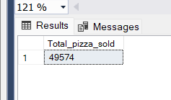

**TOTAL ORDERS**

4. SELECT COUNT(DISTINCT order_id) AS Total_order FROM pizza_sales

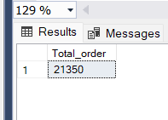

**AVG PIZZAS PER ORDER**

5. SELECT CAST (CAST (SUM(quantity) AS DECIMAL(10,2)) /

CAST (COUNT(DISTINCT order_id) AS DECIMAL (10,2)) AS DECIMAL(10,2)) AS Avg_pizzas_per_order FROM pizza_sales

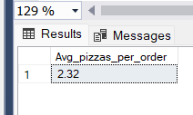

**DAILY TRENDS FOR TOTAL ORDER**

6. SELECT DATENAME(DW,order_date) AS order_day, COUNT(DISTINCT order_id) AS total_order

FROM pizza_sales

GROUP BY DATENAME(DW,order_date)

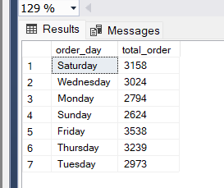

**MONTHLY TRENDS FOR TOTAL ORDER**

7. SELECT DATENAME(MONTH,order_date) AS month_name, COUNT(DISTINCT order_id) AS total_order

FROM pizza_sales

GROUP BY DATENAME(MONTH,order_date)

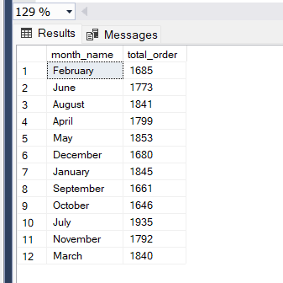

**PERCENTAGE OF SALES BY PIZZA CATAGORY**

8. SELECT pizza_category, CAST(SUM(total_price) AS DECIMAL (10,2)) AS total_sales, CAST(SUM(total_price)*100/(SELECT SUM(total_price) FROM pizza_sales) AS DECIMAL (10,2)) AS PCT

FROM pizza_sales

GROUP BY pizza_category

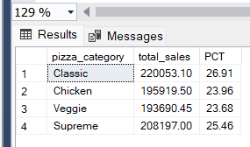

**PERCENTAGE OF SALES BY PIZZA SIZE**

9. SELECT pizza_size, CAST(SUM(total_price) AS DECIMAL(10,0)) AS total_sales, CAST(SUM(total_price)*100/(SELECT SUM(total_price) FROM pizza_sales WHERE DATEPART(quarter,order_date) = 1) AS DECIMAL (10,0)) AS PCT

FROM pizza_sales

WHERE DATEPART(quarter,order_date) = 1

GROUP BY pizza_size

ORDER BY PCT DESC

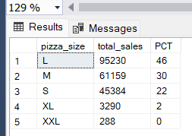

**TOP 5 BEST SELLERS BY REVENUE**

10. SELECT TOP 5 pizza_name, SUM(total_price) AS total_revenue FROM pizza_sales

GROUP BY pizza_name

ORDER BY total_revenue DESC

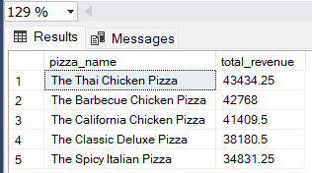

**TOTAL QUANTITY**

SELECT TOP 5 pizza_name, SUM(quantity) AS total_quantity FROM pizza_sales

GROUP BY pizza_name

ORDER BY total_quantity DESC

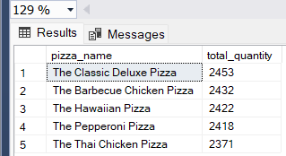

**TOTAL ORDERS**

SELECT TOP 5 pizza_name, SUM(order_id) AS total_order FROM pizza_sales

GROUP BY pizza_name

ORDER BY total_order DESC

