Data Profiling Document
1. title_episode
Overview:
Total number of records: 9,324,110
Total number of Columns:4
Duplicate records :0

Column Names | Source Data Type | Target Data Type
tconst | V_String | V_String
parentTconst | V_String | V_String
seasonNumber | V_String | Integer
episodeNumber | V_String | Integer

Data Quality Assessment:

1. Duplicated Records
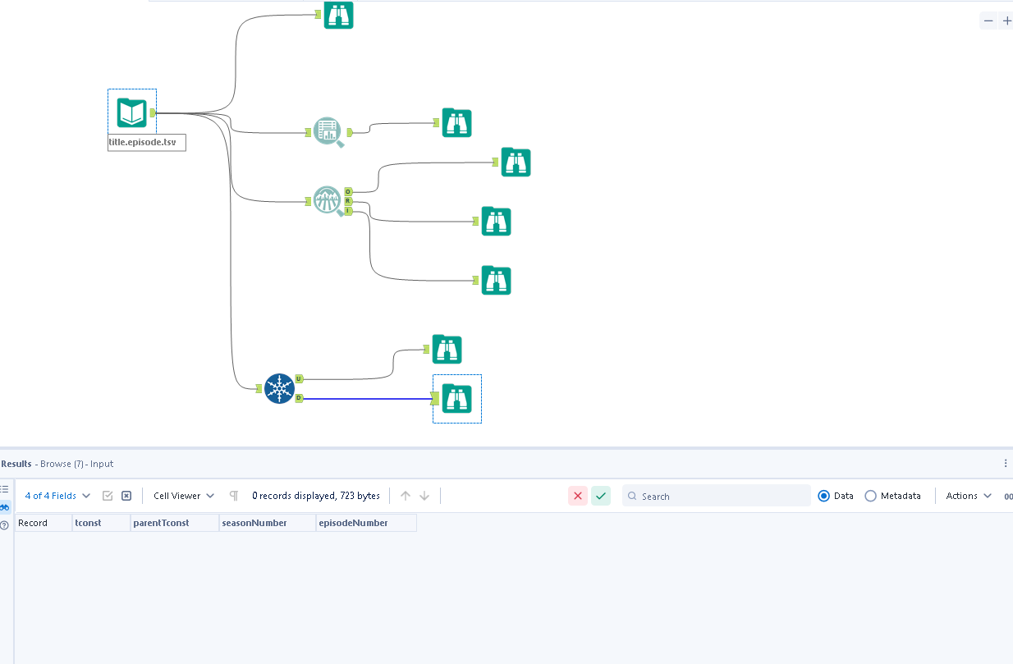
Detail : There are no duplicate record while selecting all the columns from the dataset.

2. Missing/Null values
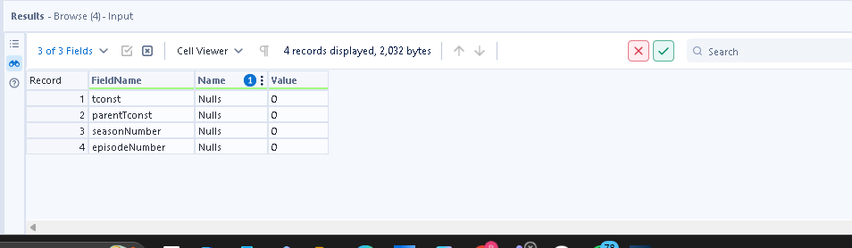
None of the fields have null /missing values

3. Leading and trailing whitespaces
There are no leading and trailing whitspaces in any of the columns in the entire dataset. Checked via basic profile toll

4. Contains ‘\N’ values :

Columns affected : seasonNumber, episodeNumber

Column Names | Replace ‘\N’ with | Reason
seasonNumber | -1 | To maintain numeric format
episodeNumber | -1 | To maintain numeric format

Summary Statistics:
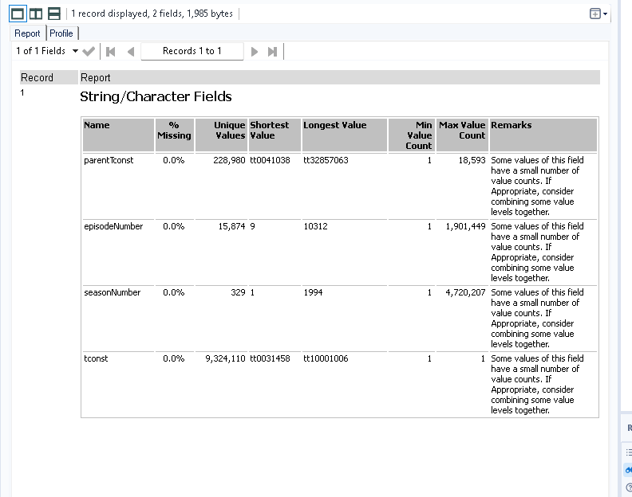

2. Title_ ratings
Overview:
Total number of records: 1605649
Total number of Columns:3
Duplicate records :0
Column Names | Source Data Type | Target Data Type
tconst | V_String | V_String
averageRating | V_String | double
numVotes | V_String | Integer

Data Quality Asssesment:
1. Duplicate records
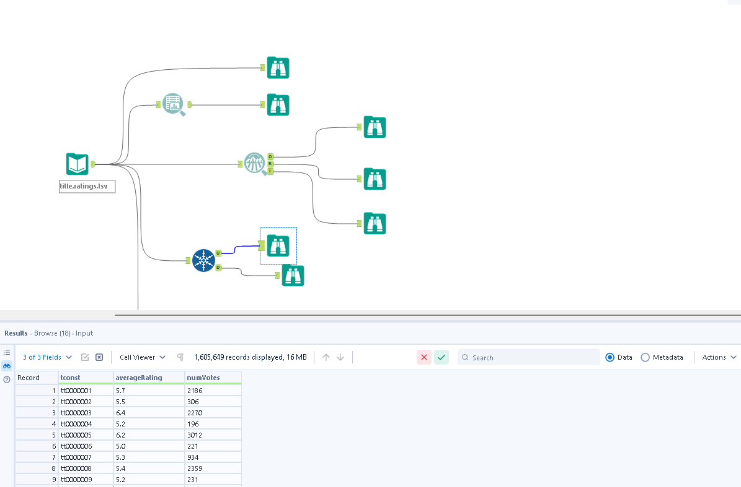
There are no duplicates in the entire dataset

2. Missing/Null values:
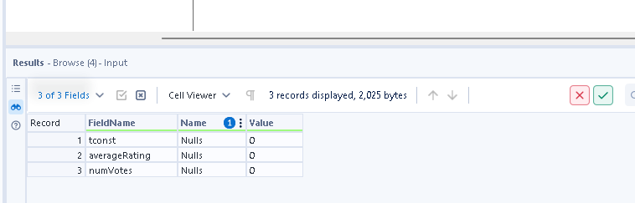
There are no nulls in the entire dataset

3. Leading and trailing whitespaces
There are no leading /trailing whitespaces in the entire dataset .Checked all the columns via basic data profile

Summary Statistics:
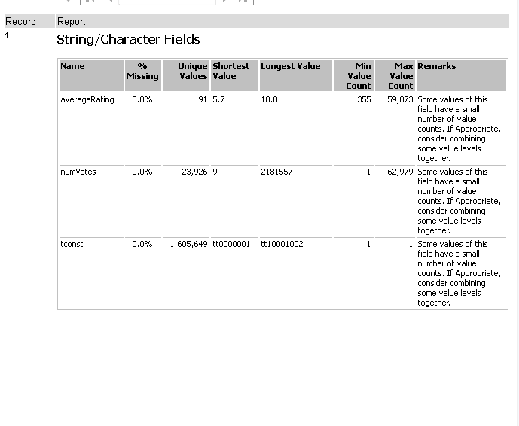

3. Title-Principles
Overview:
Total number of records: 96,132,477
Total number of Columns:4
Duplicate records :
Source to Target Datatype:
Column Names | Source Data Type | Target Data Type
tconst | V_String | V_String
ordering | V_String | Integer
nconst | V_String | V_String
job | V_String | V_String
characters | V_String | V_String
category | V_String | V_String

Data Quality Assessment

1. Missing/Null values:
Verified using basic data profiling tool
Affected Columns: tconst, ordering, nconst ,category, job, characters
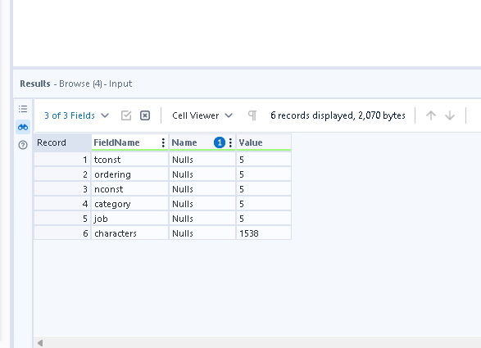
Plan of action:
Column Names | Replace with | Reason
tconst | ‘unknown’ | To maintain string format
ordering | ‘-1 ‘ | To main Integer format
nconst | ‘unknown’ | To maintain string format
job | ‘unknown’ | To maintain string format
characters | ‘unknown’ | To maintain string format
category | ‘unknown’ | To maintain string format

3.Leading and Trailing whitespaces:
Trailing and Both whitespaces:
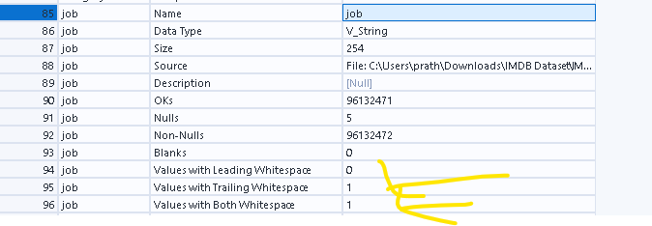
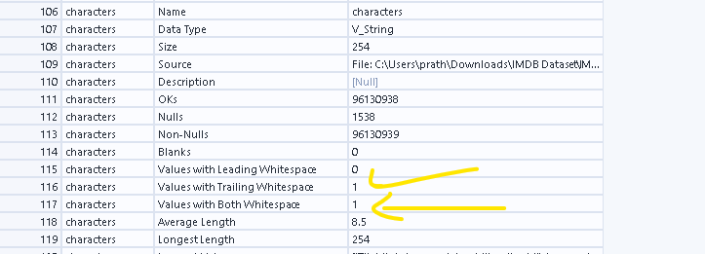
Affected columns: job and characters:
Plan of action :Remove the whitespaces in cleaning

4. Contains ‘N’ Values
Affected Columns
Column Names | Replace ‘\N’ with | Reason
job | ‘unknown’ | To maintain string format
characters | ‘unknown’ | To maintain string format

Summary Statistics:
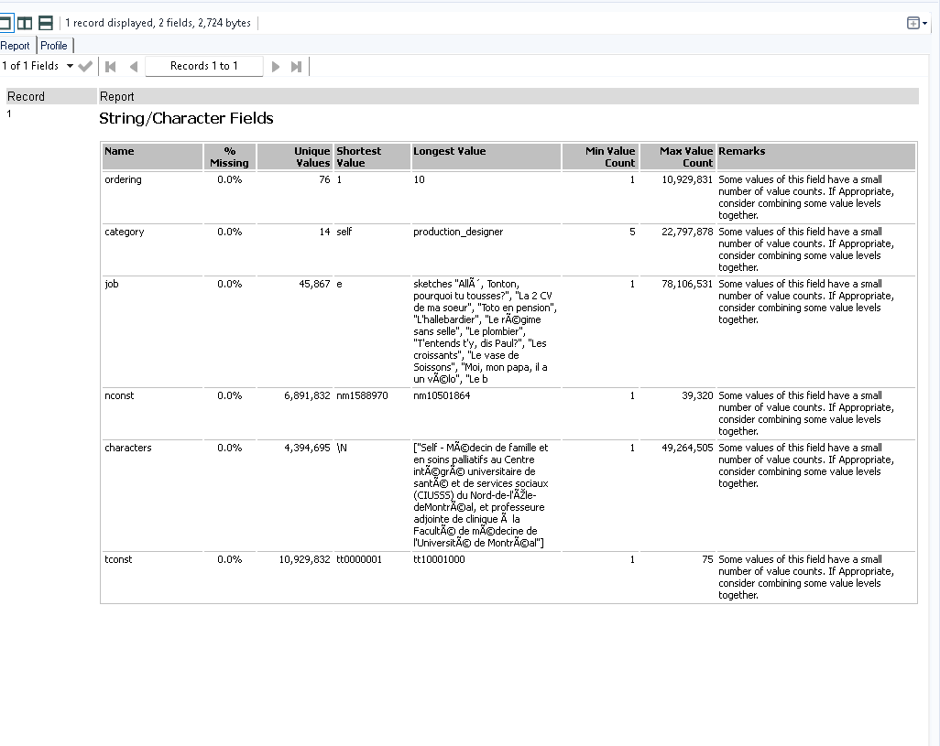

Title_crew
Overview:
Total number of records: 12,095,664
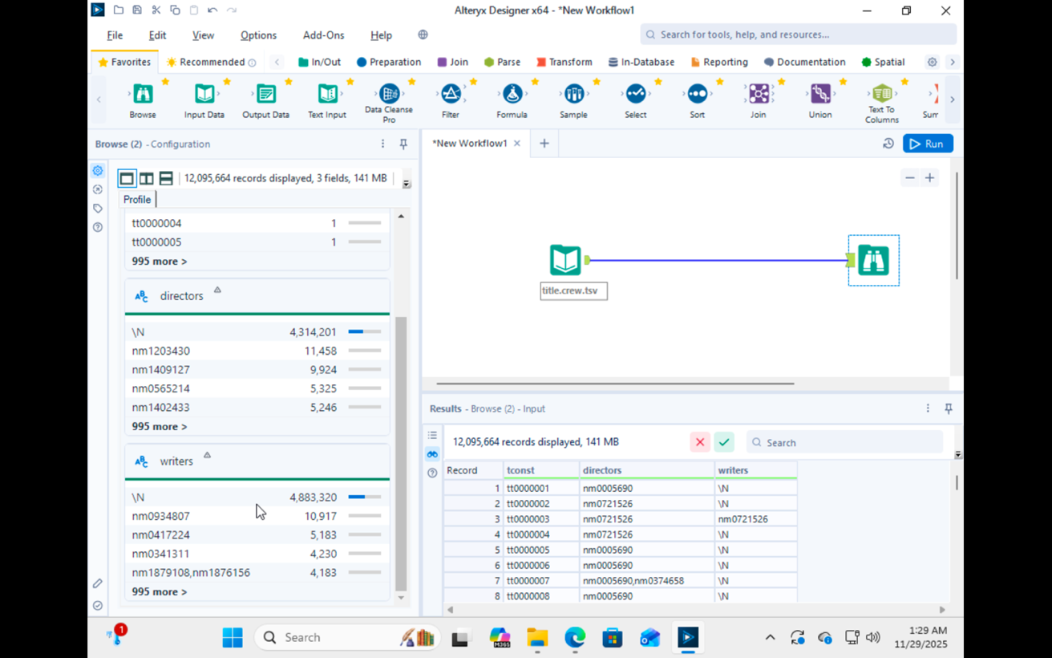
Total number of Columns:3
Duplicate records :0
Column Names | Source Data Type | Target Data Type
tconst | V_String | V_String
directors | V_String | V_String
writers | V_String | V_String

Data Quality Asssesment:
1. Missing /Null values:
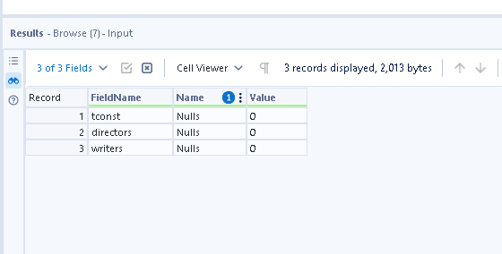
There are no nulls in the entire dataset

2. Leading/trailing whitespaces
There are no leading /trailing whitespaces in the dataset

3. Contains ’/N’ values:
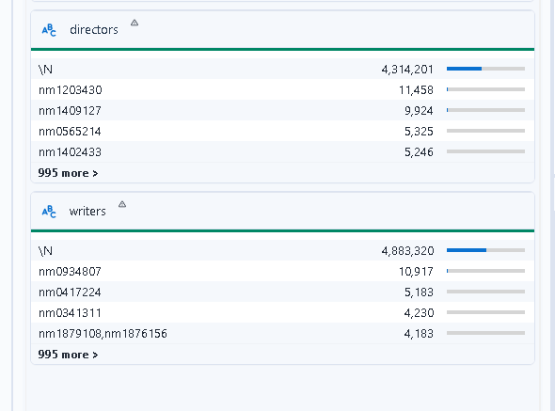
Action – need to replace ‘\N’ values in directors and writers with ‘unknown’ in cleaning

4. Comma-Separated Values
Need to flaten the table since multiple directors and writers are in same field in arrays which should be in different rows, so they would have to be exploded and a new field would have to be created called crew_role which would have the directors and writers
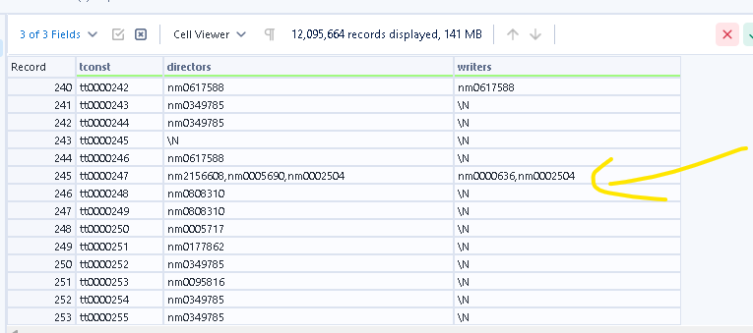

Title basics:

Overview:
Total number of records: 12,095,664
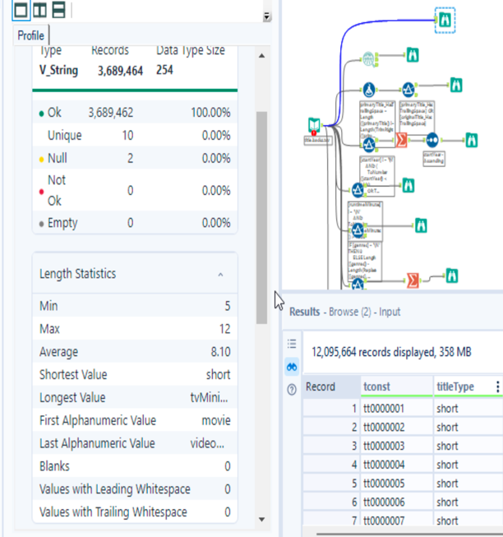
Total number of Columns:9
Duplicate records :0
Column Names | Source Data Type | Target Data Type
tconst | V_String | V_String
titleType | V_String | V_String
primaryTitle | V_String | V_String
originalTitle | V_String | V_String
isAdult | V_String | boolean
startYear | V_String | Integer
endYear | V_String | Integer
runtimeMinutes | V_String | integer
genres | V_String | V_String

Data Inconsitency:
1. Contains Nulls:

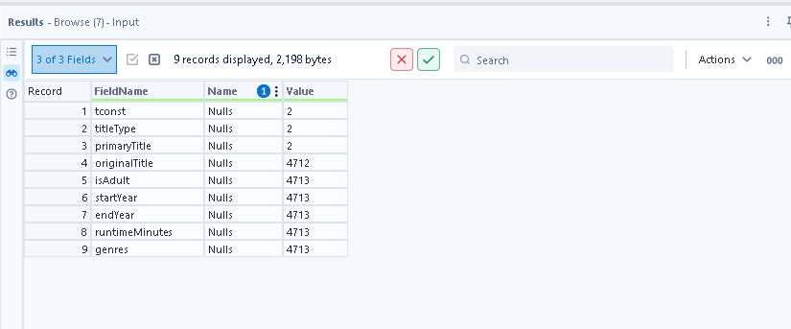
Action
Column Name | Replace with | Reason
tconst | Unknown | To maintain datatype format
titletype | Unknown | To maintain datatype format
primaryTitle | Unknown | To maintain datatype format
originalTitle | Unknown | To maintain datatype format
isAdult | -1 | To maintain datatype format
startYear | 0000 | To maintain YYYY format
endYear | 9999 | To maintain YYYY format
runtimeMinutes | -1 | To maintain datatype format
genres | Unknown | To maintain datatype format

2.. Contains ‘/N’ values:
Affected Columns: startYear ,endYear ,runtimeMinutes,genres

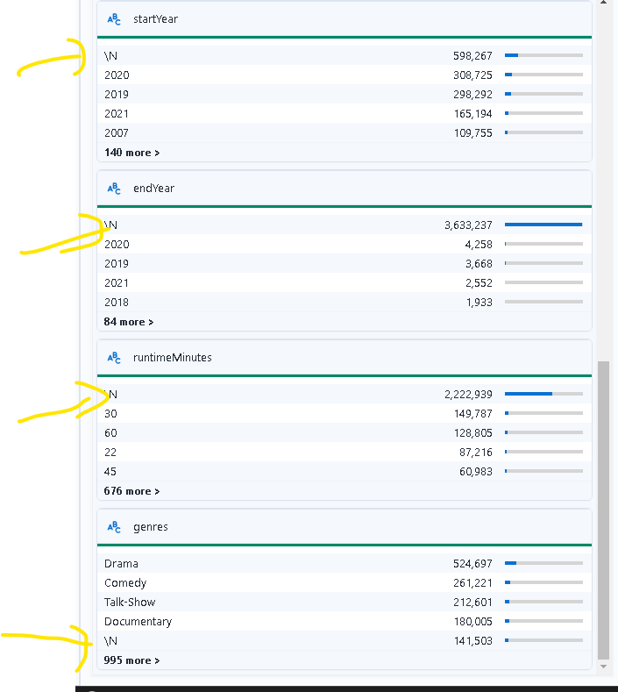

Action- Replace ‘\N’ with following:
Column Name | Replace with | Reason
startYear | 0000 | To maintain YYYY format
endYear | 9999 | To maintain YYYY format
runtimeMinutes | -1 | To maintain datatype format
genres | unknown | To maintain datatype format

2. Trailing whitespace:
Affected columns: primaryTitle , originalTitle
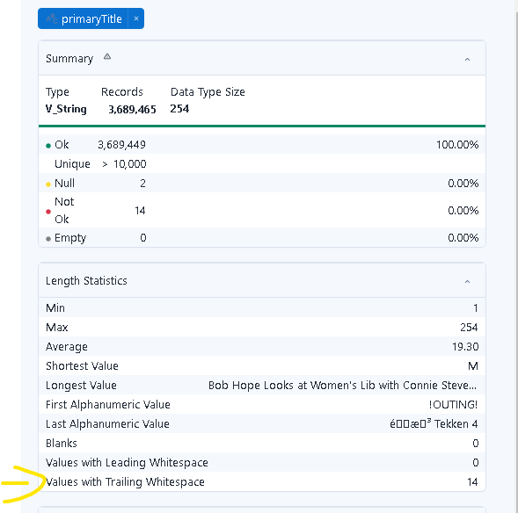
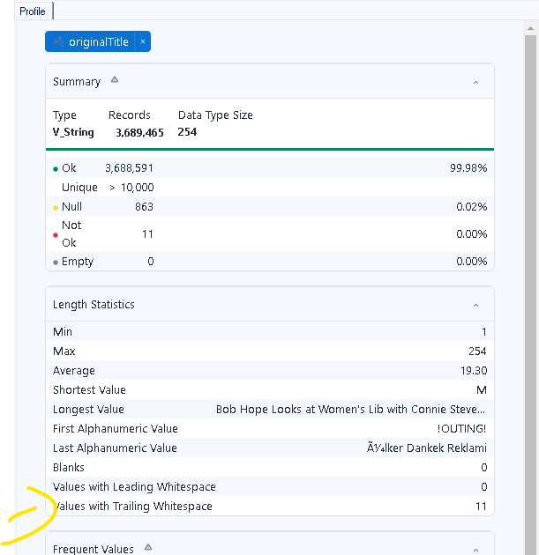

Action: Remove the trailing whitespaces using trim function in cleaning

3. Comma Seperated values
Genre field would have to be flattened since its having multiple values in a single field ie explore

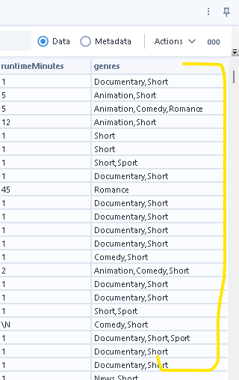

Additional verification
Checked if there are any records where end year is earlier than startYear
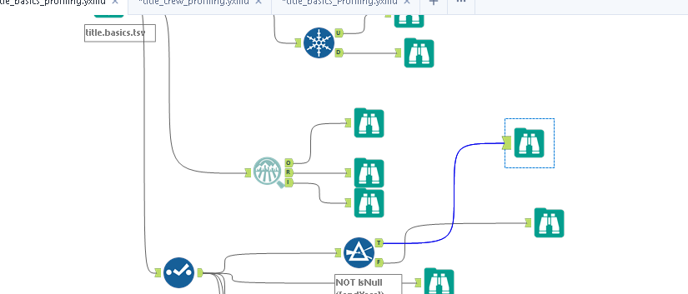
There are none in the dataset

Title_Region
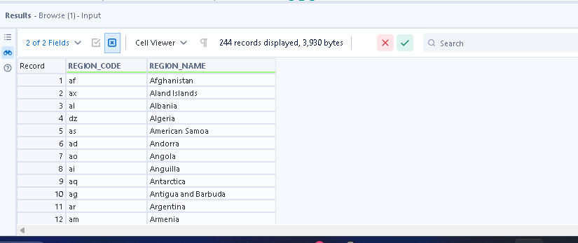
Overall Records: 244
Total Number of columns: 2
Missing values overall :0
Duplicates :0

Column Name | Source Target Data type
REGION_NAME | String
REGION_CODE | String
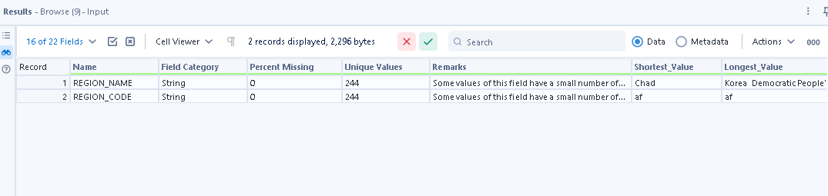

Conclusion- No issues identified in the dataset as its directly extracted from source

Title_Language_Codes
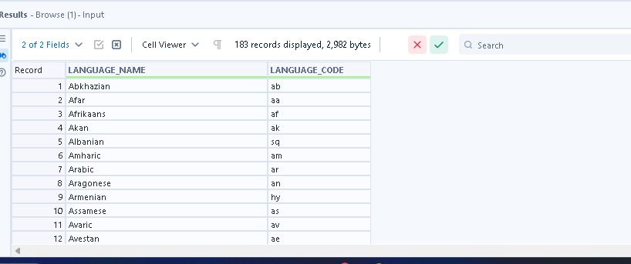
Overall Records: 183
Total Number of columns: 2
Missing values overall :0
Duplicates :0

Column Name | Source Target Data type
LANGUAGE_NAME | String
LANGUAGE_CODE | String

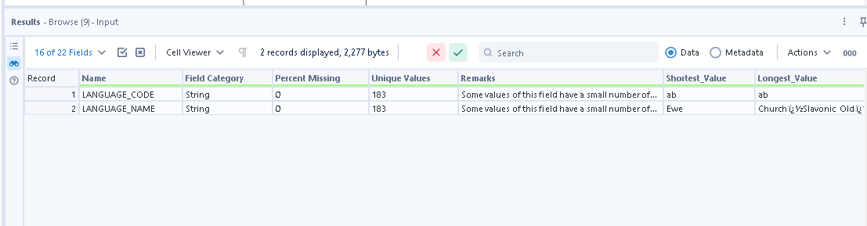

No issues identified in the dataset as its directly extracted from source

Dataset – name.basics

Total Records – 14,903,875
Total attributes – 6
Attributes | Data type | Required Data Type | Nulls
Nconst | V_String | V_String | 5
primaryName | V_String | V_String | 5
BirthYear | V_String | Integer | 7
DeathYear | V_String | Integer | 7
primaryProfession | V_String | V_String | 7
knownForTitles | V_String | V_String | 7

Observations –
We will drop all the records which have Nconst nulls.
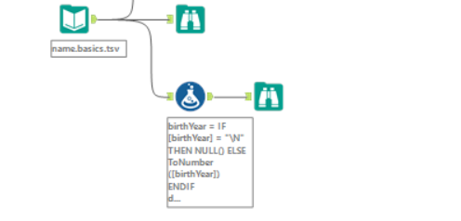

There are some records that have birthyear, death year, primary profession and the knownfortitles are nulls. They do not give any information. Therefore planning to drop them.

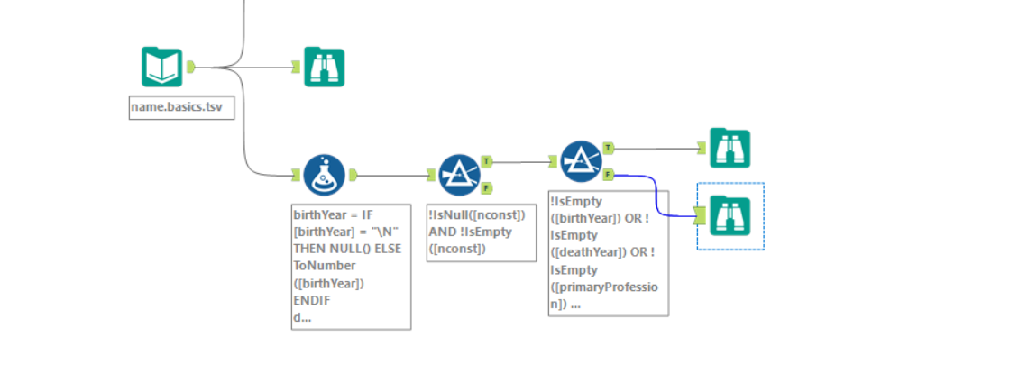
There are nulls in the birth Year which are represented by “\N” indicating that these details were not captured. We will replace all the “\N” by nulls first and then replace all these nulls with 0000 to indicate incorrect year format.
There are nulls in the death Year which are represented by “\N” indicating that these people are alive yet. We will replace all the “\N” by nulls first and then replace all these nulls with 9999 to indicate incorrect year format.
The nulls in the primary profession and the knownForTitles will be replaced with “Unknown”.

Cannot drop the rows that have no primary name as they are associated with a nconst

Title.Akas

Total records – 54,124,127
Total Attributes – 8
Basic view of data–
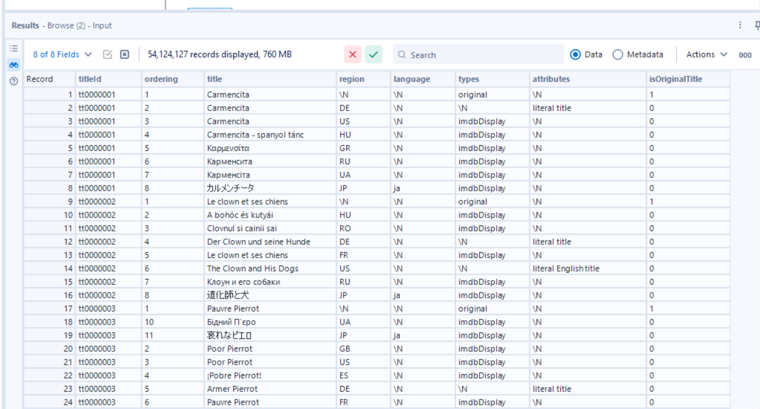
There are 5 nulls in the data. 4 are shown here as duplicates of the first null row.
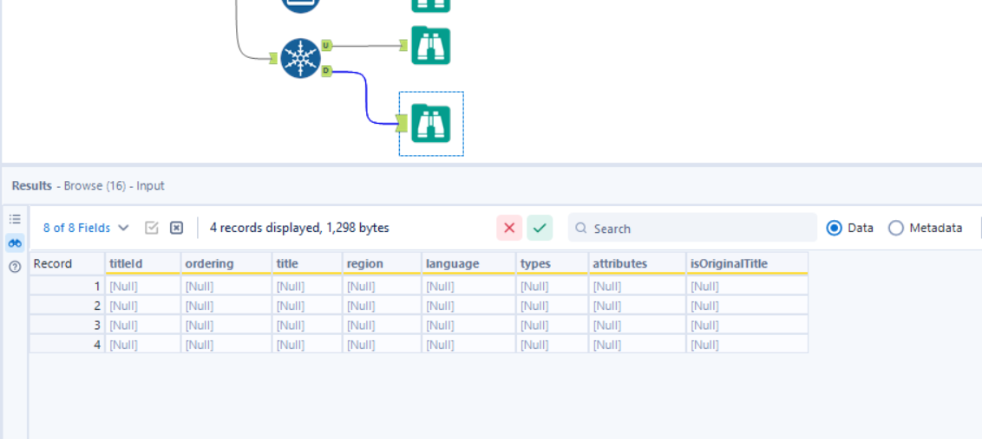

Attributes | Data type | Required Data Type | Nulls
titleID | V_WString | V_String | 5
Ordering | V_String | Integer | 5
Title | V_String | V_String | 5
region | V_String | V_String | 5091
language | V_String | V_String | 5091
types | V_String | Array | 5091
attributes | V_WString | Array | 5091
isOriginalTitle | V_WString | Boolean | 5091

All the values in the data are distinct.
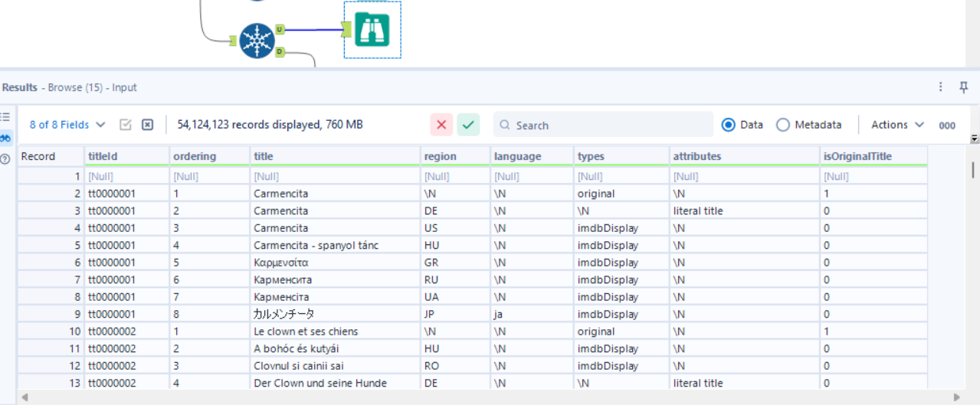

The corrected data types
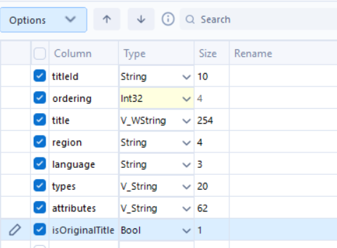
All the nulls and the \N values will be replaced with appropriate default values.
Expectations that will be applied here are that the titleId must not be null. Or the record will be rejected.
Default values for ordering -1
Default values for title Unknown
Default values for region Unknown
Default values for language Unknown
Default values for types Unknown
Default values for attributes Unknown
Default values for isOriginalTitle -1
The data type for isOriginalTitle will be changed to integer to account for the default value.

