HR Onboarding Automation System
Assessment Submission
Full Name | Muaaz Tasawar
Email | muaaztasawar1@gmail.com
Submission Date | 13 March 2026

Task 1 — Intermediate Airtable Skills:
All formulas were applied to the New Hires table in Airtable. Screenshots of each formula configuration and resulting column output are included below.

1. Full Name Formula:
Concatenates First Name and Last Name with space, trimming any accidental padding.
TRIM({First Name}) & " " & TRIM({Last Name})
Formula Configuration
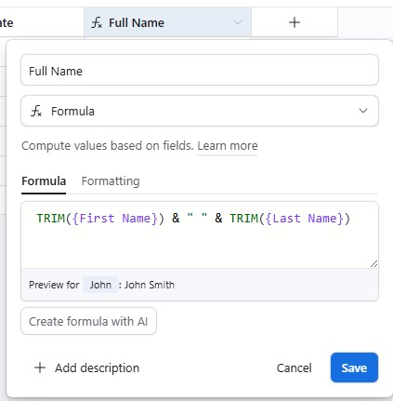
Fig 1.1 — Full Name formula editor showing formula and live preview

Result in Table
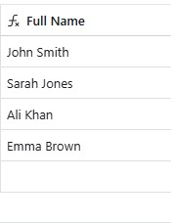
Fig 1.2 — Full Name column showing combined names for all records

2. Cleaned Email Formula:
Removes spaces and normalises to lowercase for consistent email formatting.
LOWER(TRIM(SUBSTITUTE({Email Input}, " ", "")))
Formula Configuration:
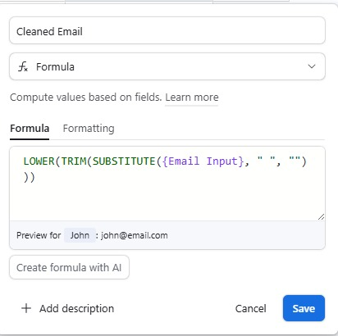
Fig 2.1 — Cleaned Email formula editor with live preview

Result in Table:
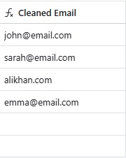
Fig 2.2 — Cleaned Email column showing normalised email addresses

3. Status Categorization Formula:
Categorises each hire as High Value (>$1000), Medium Value ($500–$1000), or Low Value (<$500).

IF({Amount Spent on Equipment} > 1000, "High Value",
IF({Amount Spent on Equipment} >= 500, "Medium Value",
"Low Value"))
Formula Configuration:
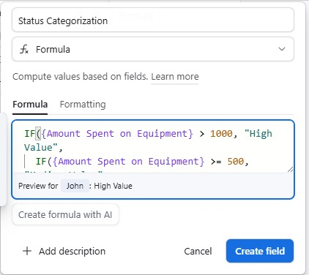
Fig 3.1 — Status Categorization formula editor showing nested IF logic

Result in Table:
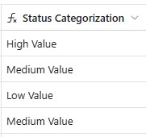
Fig 3.2 — Status Categorization column showing correct values per record

4. Days Since Created Formula:
Calculates how many days have passed since the record was created. Updates dynamically each day.
DATETIME_DIFF(TODAY(), {Created Date}, 'days')
Formula Configuration:
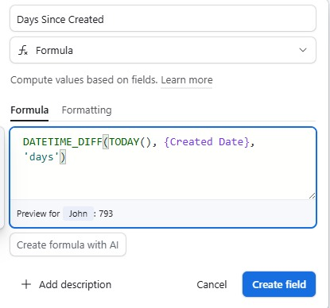
Fig 4.1 — Days Since Created formula editor with live preview (793 days for John)

Result in Table:
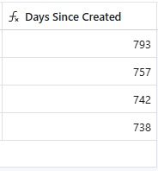
Fig 4.2 — Days Since Created column showing calculated values

5. Complete New Hires Table:
The table below shows all fields — original data columns and all 4 formula columns — populated correctly across all records.
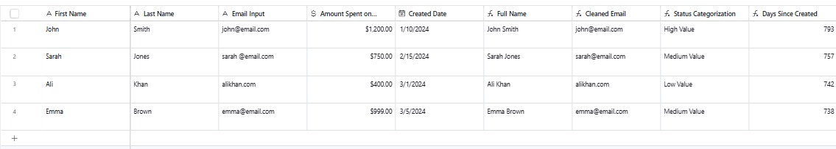
Fig 5 — Full New Hires table with all formula columns: Full Name, Cleaned Email, Status Categorization, Days Since Created

Task 2 — Advanced Airtable Automation:

1. Automation Steps:
The automation 'High Value Hire Alert' was built in Airtable Automations. It triggers when a new hire's Status Categorization becomes High Value, checks whether their email is valid, sends the appropriate notification, and is fully active.
Step 1 — Trigger: When a Record Matches Conditions:
Table: New Hires | Condition: Status Categorization is High Value

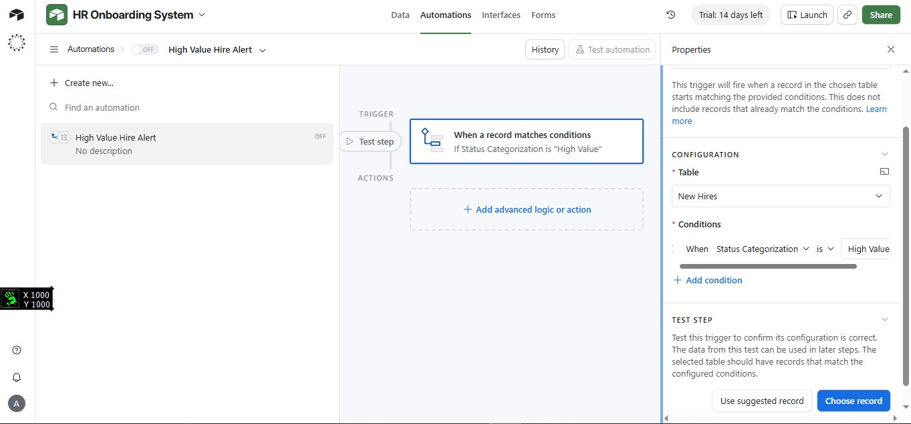
Fig 6 — Trigger configured: fires when Status Categorization is 'High Value'
Step 2 —Conditional Branch: Email Validation:
Checks if Cleaned Email is not empty before deciding which notification to send.

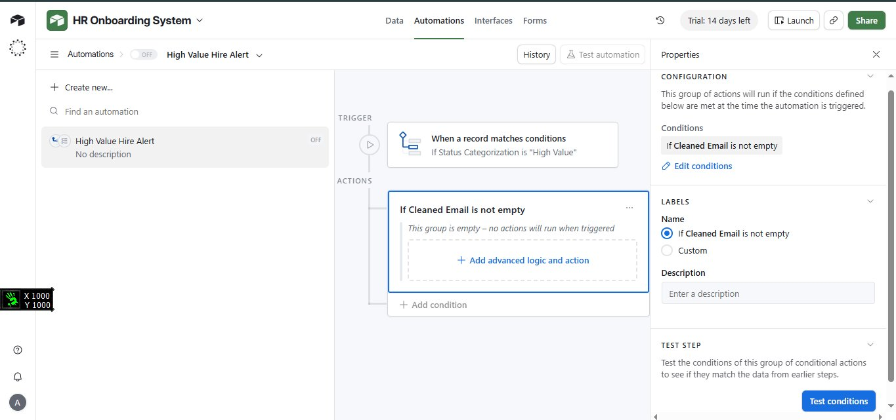
Fig 7 — Conditional logic block: 'If Cleaned Email is not empty'
Step 3 — Branch A: Valid Email Notification:
Send a dynamic HR notification email when the email address is present and valid.

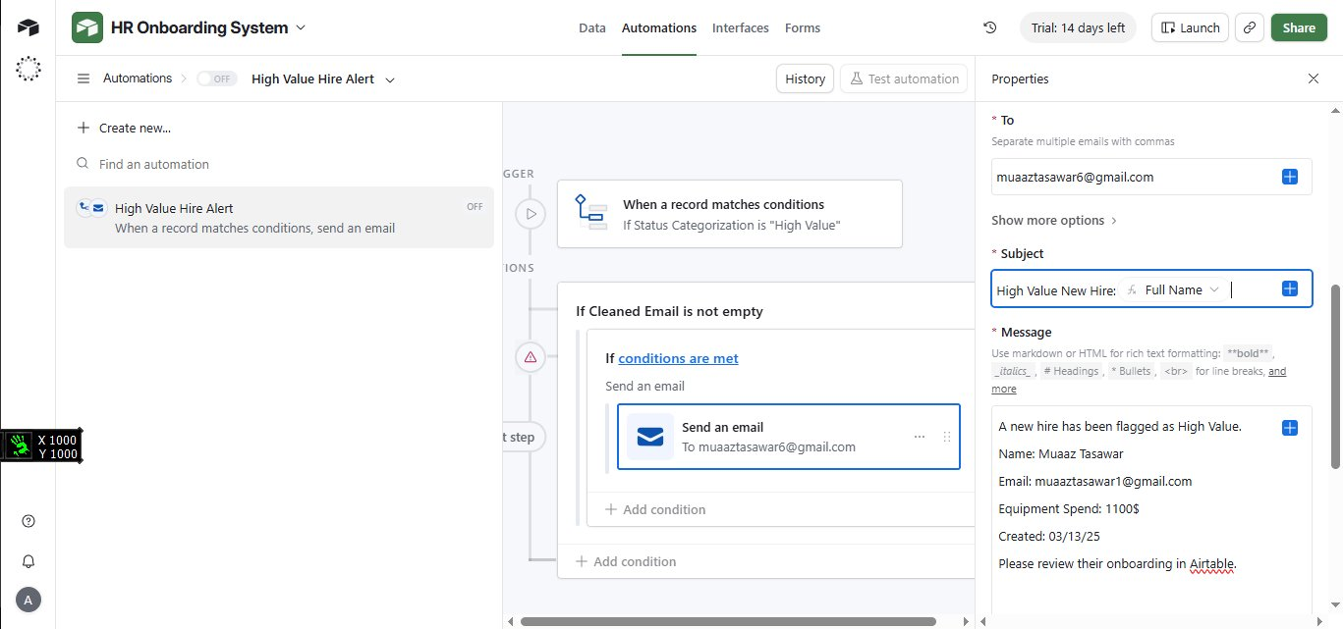
Fig 8 — Branch A email action: To, Subject with dynamic Full Name, and message body with all fields
Step 4 — Branch B: Missing Email Warning:
Send a warning email to HR when the email address is missing or invalid.

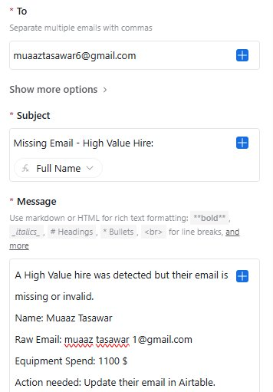
Fig 9 — Branch B email action: missing email warning with dynamic fields
Step 5 — Both Branches Active:
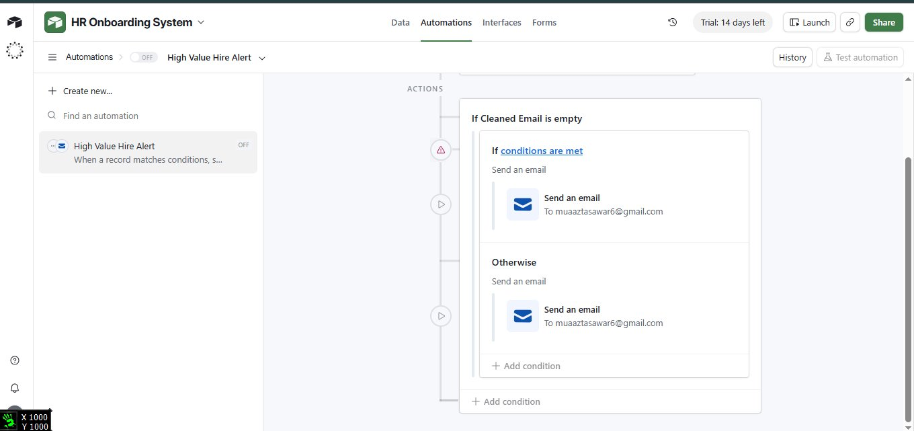
Fig 10 — Full conditional block showing both branches: 'If Cleaned Email is not empty' and 'Otherwise'
Step 6 — Automation Turned ON:
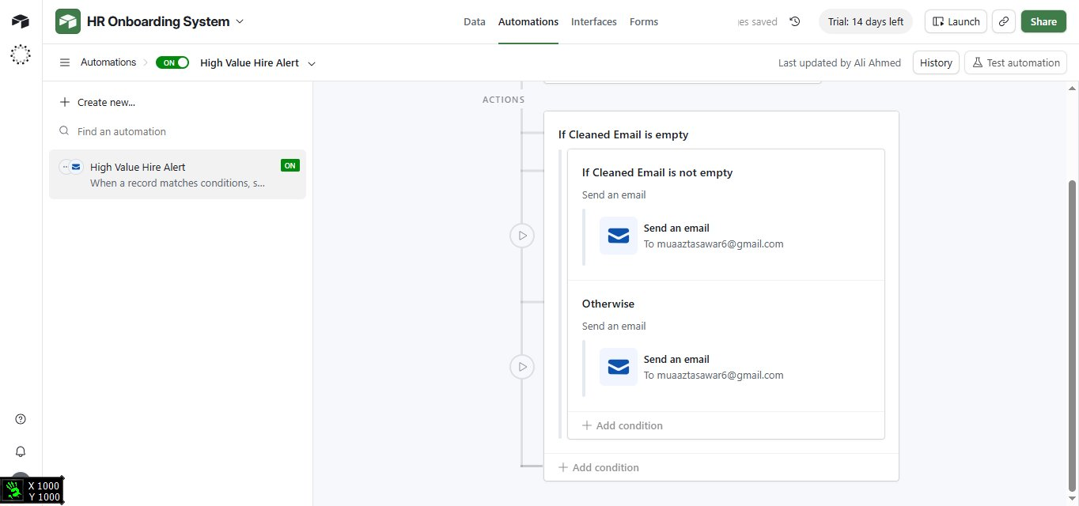
Fig 11 — Automation 'High Value Hire Alert' switched ON and live

2. Interface Design
The HR Onboarding Dashboard was built in Airtable Interface Designer with three sections: summary count tiles, a filtered High Value grid, and a record detail view.
Summary Tiles — High / Medium / Low Value Counts:
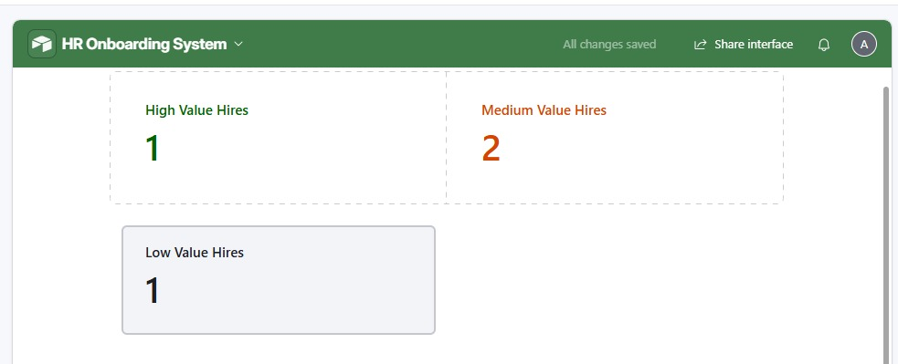
Fig 12 — Interface summary tiles showing High Value (1), Medium Value (2), Low Value (1) hire counts
Filtered Grid — High Value Hires Only:
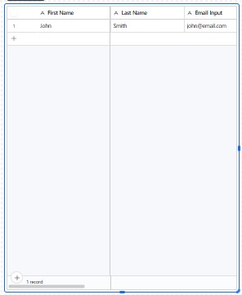
Fig 13 — Filtered grid view displaying only High Value hires
Full Interface — Edit Mode:
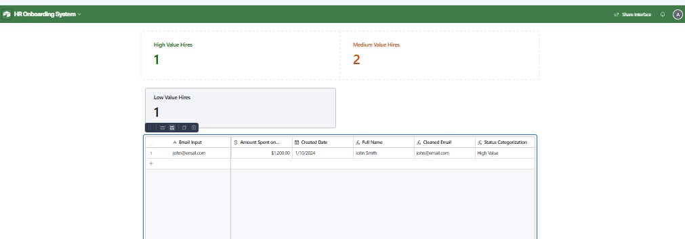
Fig 14 — Full interface layout in edit mode showing tiles and High Value grid
Full Interface — Preview Mode
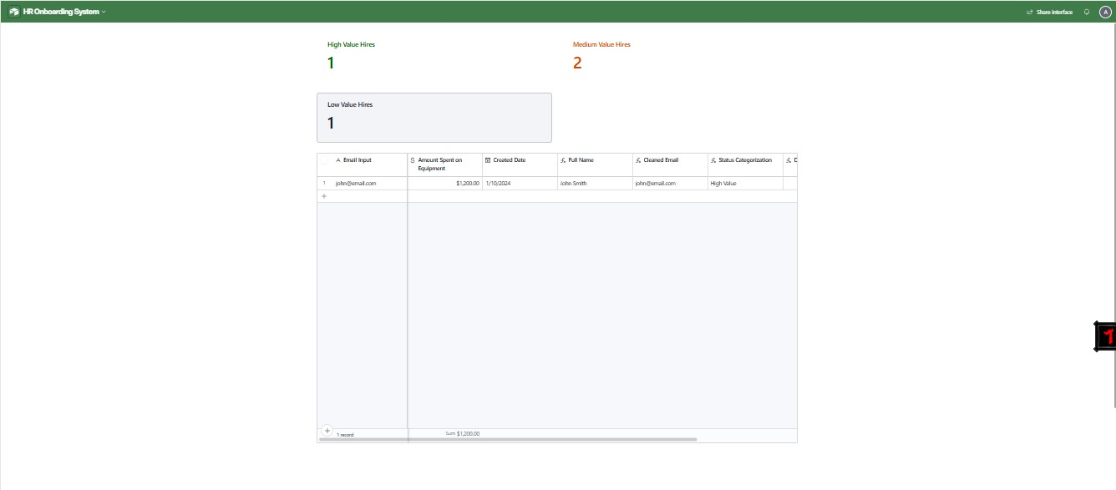
Fig 15 — Complete HR Onboarding Dashboard in preview mode

3. Formula Logic Used in Automation
Email Validation (Conditional Branch):
AND(
{Cleaned Email} != "",
FIND("@", {Cleaned Email}) > 0,
FIND(".", {Cleaned Email}) > FIND("@", {Cleaned Email})
)
Email Status Label (Tracking Table)
IF(AND({Cleaned Email} != "", FIND("@", {Cleaned Email}) > 0), "Valid", "Missing/Invalid")

4. Assumptions:
- Trigger fires on both record creation and updates, catching new and edited records that cross the $1,000 threshold.
- Email validation checks if the Cleaned Email field is not empty. Full SMTP verification would require an external service.
- The notification step was built for email but can be swapped for Slack using the same dynamic fields.
- Amount Spent on Equipment is stored as a currency field in USD.

The interface is intended for HR staff and is shared via Interface Designer permission settings.

