Attendance Management System

Contents

Introduction 3

Task 1 - Design and Architecture 3

Task 2 - Front-End Development 4

Task 3 - Back-End Development 5

Task 4 - Ubiquitous Design and Functionality 7

Task 5 - Usability Evaluation 8

Task 6 - Performance Evaluation 9

Conclusion 9

References 11

# Introduction

The Attendance Management System operates as an internet-based software application which makes student attendance registration more convenient and automatic. Admin users can perform routine tasks such as creating student accounts and marking attendance by using a simple interface that displays all attendance records. The system implements Django framework as the backend system to perform data handling securely while using structured databases for seamless integration. Through its use of HTML and CSS and JavaScript the system has a frontend which provides an interface that adapts to various devices while maintaining a modern aesthetic design. The system bases its structure on modules which allows expansion while maintaining simplicity in the maintenance process (Mohan 2025, p. 3).

A unique roll numbers and emails provision enables students to be added accurately without duplicate entries. Users can easily mark attendance through quick click operations while all stored information becomes immediately available for review to the system administrator. Users can access the system without difficulty because its interface presents organized sections and well-structured layout blended with properly styled elements. The application includes usability and performance testing standards as a way to enhance user experience together with ensuring fast and reliable system functionality. The project creates a practical method to handle student attendance through an organized system that provides accessibility to its management features.

# Task 1 - Design and Architecture

The Attendance Management System implements a designed architecture which provides data efficiency and seamless component integration. The system functions under the Model-View-Controller (MVC) architecture that includes database models which describe data structure and separate views for display purposes together with controllers to control forefront and backend communication. Django operates as a backend framework to maintain databases and process requests and generate API endpoints but the frontend interface is produced through HTML, CSS and JavaScript. Each section of the project exists in individual directories that support both maintenance and long-term development (Ma 2024, p. 7).

Student information along with their present and absent records are stored through a logical database structure which upholds precise data storage while maintaining consistency. The system supports API endpoints for automatic data acquisition and modification that eliminates needs for human operators. The design structure guarantees effective collaboration among the student management system and attendance marking and data retrieval functions. Both usability and performance matters have been integrated into the design to create an efficient user experience.

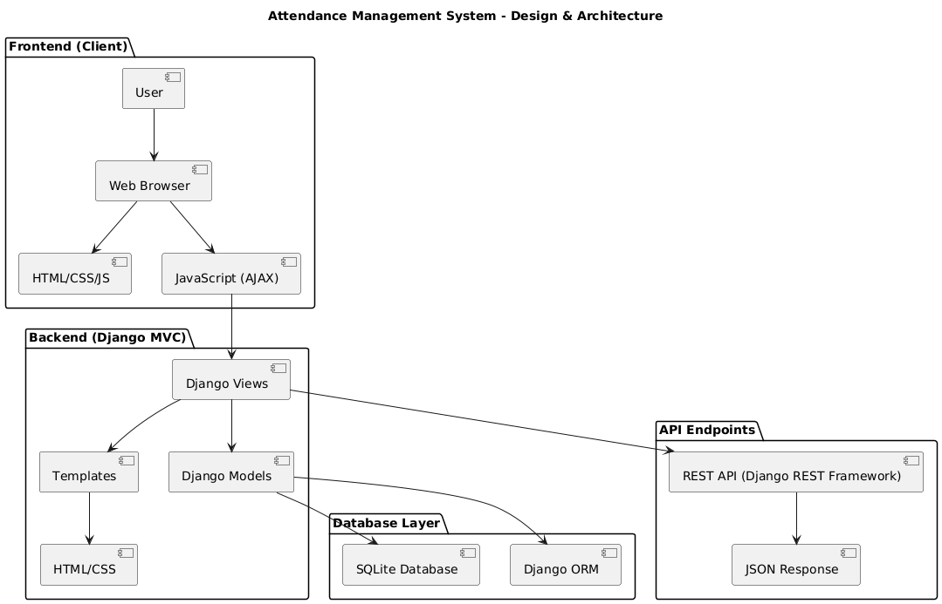

# Task 2 - Front-End Development

Students can effortlessly handle their attendance through the Attendance Management System's front-end interface which provides a good user experience. The HTML-embedded application utilizes CSS and JavaScript framework to develop an adaptive design structure that functions on various screen dimensions. The system divides its functionality into three distinct sections which enable adding students and viewing attendance records while also affording the ability to mark attendance entries through a properly designed interface. The application's presentation improves through CSS because it features balanced section dimensions and appropriate spacing measures and it utilizes attractive color schemes alongside visual borders.

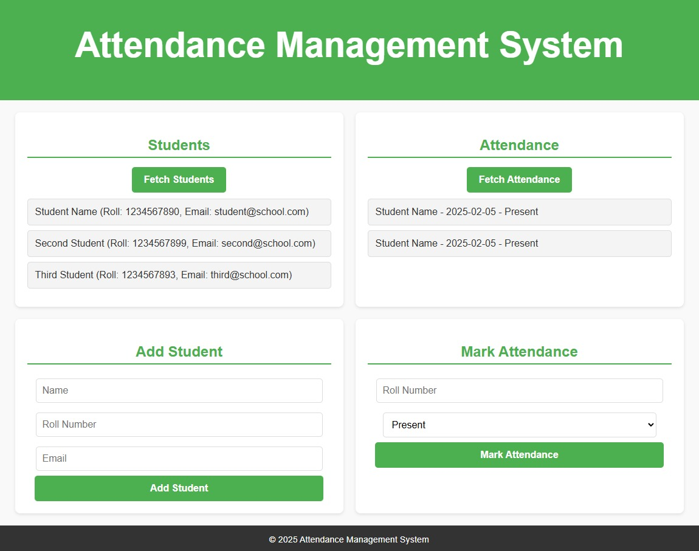

The front-end capabilities of JavaScript derive from its ability to interact with users by fetching data from students and updating attendance logs before submitting forms without page refreshes. JavaScript makes API requests that connect to the backend system while supporting instantaneous data retrieval to provide a well-integrated user experience. The system uses error handling together with form validation to stop incorrect input while improving user experience. Standard interface procedures adopted by this system maintain an easy path for users of all abilities to navigate between elements. Future maintenance and extension of the system will be easy because of its structured design approach which also provides administrators an intuitive experience when they manage student attendance (Bavaskar 2024, p. 5).

# Task 3 - Back-End Development

The Attendance Management System operates with Django as its back-end framework since this Python-based web framework applies Model-View-Controller (MVC) design architecture. Through Django developers receive a structured method to process requests for data retrieval and database operation with security protocols built in for efficiency. Django regulates the entire business logic and database communication for student record and attendance data management. The models establish a system of database organization which maintains data consistency throughout the database and prevents contradictions. Both the Student model and the Attendance model exist in this system to store information. The Student model stores name and roll number and email, while the Attendance model maintains daily presence status of students along with the recorded date. The ORM provided by Django enables user-friendly database management through Python code instead of traditional SQL statements thus providing better system maintenance and extension capabilities.

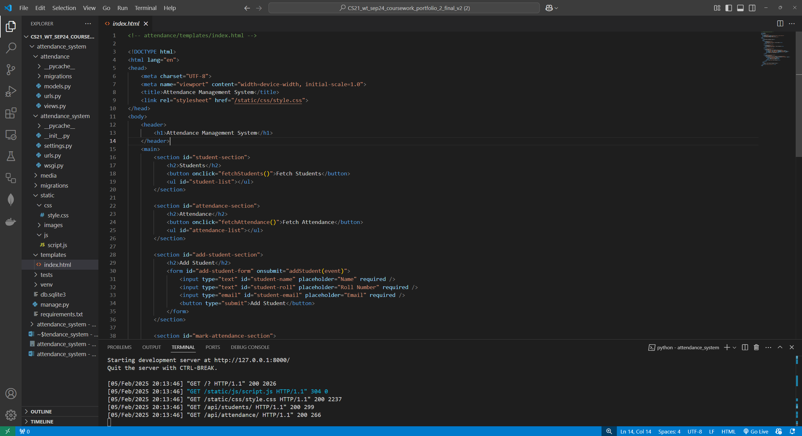

The system process user requests through its views which also handle the data operations. The system obtains data from Django views through which users receive output either as template page display or JSON-formatted API responses. Through its home view the system presents the main user interface but administrators can easily retrieve student information and record attendance data through API points that also display dynamic attendance records. The Django system implements its API endpoints through its built-in features along with Django REST Framework (DRF) to facilitate smooth data communication between front-end and back-end elements. Different requests are handled by the views who respond to GET request for data retrieval and POST requests to perform database updates. The system conducts validation checks to prevent duplicate student records from being made and to guarantee accurate attendance marking without any errors (Rahmatya & Wicaksono 2023, p. 9).

A system of security protection for user data exists within the back-end framework structure. Django includes built-in security features which both prevent CSRF attacks and defend against SQL injection attempts and unauthorized user actions. Form submissions and AJAX requests that use API endpoints defend themselves from unauthorized attempts through the implementation of CSRF tokens. The authentication system along with permissions within Django can be tailored to safeguard administrative areas and preserve only authorized personnel handle student entries at the same time attendance records.

The system needs database management as a core competency and Django does automatic database table creation through migrations that eliminates the need for human interaction. By default the system uses SQLite yet maintains an easy configuration to switch between PostgreSQL or MySQL database systems whenever needed. The database server delivers maximum operation speed through query optimization and caching implementations for data storage and retrieval processing. The API follows a specific structure for treating many client demands while maintaining quick response times for obtaining data. The system architecture enables a simple way to incorporate future functionality which includes both sophisticated reporting modules as well as analytics features and user access permissions based on roles.

The developers created the Attendance Management System's back-end section with priority placed on reliability alongside scalability and user-friendly design. The system functions with smooth efficiency because it utilizes Django's ORM combined with RESTful APIs and structured views. The architecture stays easy to maintain because the architectural separation maintains distinct boundaries between models, views and templates. The API-driven system operates as a communication bridge between the front-end and back-end to deliver immediate program updates which results in instant user responsiveness. The existence of security features in Django combined with its optimized database management and structured coding system enables a robust system adapted for educational attendance management (Addae 2023, p. 4).

# Task 4 - Ubiquitous Design and Functionality

The Attendance Management System provides universal accessibility together with functionality which enables users to access the system from desktops as well as tablets and mobile phones without interruption. The front-end application relies on responsive principles for adjustments through screen size changes to display content in a neatly organized fashion. The layout includes well-divided sections which combine proper spacing with distinctive buttons that allow users to navigate easily through the system. Users can seamlessly conduct student addition along with attendance marking and record examination using any device without facing difficulties. Through JavaScript users experience smooth transactions as the system updates its interface automatically without page reloading to achieve higher efficiency.

The system uses Django back-end technology to deliver quick data computations and defend attendance records securely together with high request handling capability. The programmed database design enables error-free storage and retrieval of all data it contains. Clear field labels and sufficient color contrast as well as other accessibility features have been added to the system for users with visual impairments and all other users. Because of its API-driven structure the system enables data retrieval from multiple platforms thus enabling potential future integration with additional systems. Administrators and users in any environment can perform attendance management quickly while experiencing no errors because the system puts an emphasis on usability and accessibility (Bangad et al. 2023, p. 11).

# Task 5 - Usability Evaluation

An evaluation of the Attendance Management System exists to confirm straightforward operation alongside proper efficiency and suitable user requirements fulfillment. Different sections within the system separate functions for adding students from viewing attendance and marking attendance through an intuitive and well-organized interface. The system includes easy-to-understand input fields with structured design elements to help users prevent mistakes upon entering information. The JavaScript functionality enables users to receive instant response through field clears and real-time feedback notifications that explain system actions. The software system prevents students from entering data twice while also validating attendance records to maintain correctness of input. Users can access the system smoothly on all screen sizes because of its responsive design which allows the system functions to operate well on desktops along with mobile phones (Nallusamy, Gowri & Priya 2025, p. 6).

Data retrieval operations in the system backbone operate at optimal levels for fast result delivery with reduced waiting times and streamlined user interfaces. The efficient structure of API responses minimizes waiting time for retrieving or updating information in records. The system features readable fonts and suitable color combinations and its fields and buttons have large enough sizes to remain accessible for all screen sizes. Tests were performed to detect usability problems which led to implementing fixes that improved system usability. The system allows administrators to manage attendance promptly through a streamlined operation that provides worry-free performance to users.

# Task 6 - Performance Evaluation

Testing has been conducted to evaluate exactly how the Attendance Management System operates and processes information along with delivering an uninterrupted user experience. The system design takes optimization into consideration to reduce delays in getting and modifying attendance records. Users benefit from a lightweight and responsive front-end interface which enables them to work with the application while avoiding any delays in page loading. The system optimizes CSS as well as JavaScript for reduced rendering with limited loading of essential scripts and styles to boost performance and page responsivity. The page features an efficient layout with JavaScript handling dynamic updates that prevent unneeded page reloads and boost the performance (Pandey 2024, p. 8).

The Django-based back-end provides efficient database operations through ORM technology that optimizes SQL commands from high-level queries. The student and attendance record database storage system follows an organization that enables immediate data retrieval while reducing processing time. The system’s query optimization mechanism retrieves only essential data points thus it avoids unwanted server performance consequences while lowering response times. The development of API endpoints through Django REST Framework provides efficient communication channels for front-end and back-end data exchange. JSON responses have been designed to reduce duplicate data while remaining clear thus enabling the system to handle several simultaneous requests without delay. The system shows its ability to handle operations for student additions therefore marking attendance and record retrieval through response time testing (Wendakoon Mudiyanselage 2024, p. 2).

# Conclusion

The Attendance Management System operates as an effective system for student attendance tracking which provides administrators with a structured platform that automates their work processes. The system delivers secure student data management and effective attendance recordkeeping through a front-end interface which integrates with the powerful back-end implementation using Django framework. The system operates through a Model-View-Controller (MVC) design architecture that makes the system expandable via modifications and works to keep the core functionality uninterrupted. Django's ORM makes database operations more efficient by simplifying data retrieval along with storage functionalities which produces precise and stable information about attendance records.

System users benefit from a user-friendly front-end which makes it possible to use their devices without limitation while providing access to the system across multiple systems. The interface design uses HTML CSS JavaScript to create a neat structured layout which properly separates system sections so administrators can find their way easily through the interfac The system implements JavaScript to provide live page updates and avoids reloads which together create a smooth experience between user interface and server components. Proper validation of forms along with user feedback systems and accessibility standards work together to make the system user-friendly for all types of users (Parmar, Quadros & Gaonkar 2024, p. 12).

Back-end development implements established principles of software engineering so it provides secure data management alongside efficient system execution and dependable system operation. The built-in security functions of Django offer a secure data handling environment for student information through its CSRF protection and SQL injection defense and authentication processes. Implementation of API-driven methods makes it possible for front-end and back-end to exchange data efficiently which eliminates prolonged delays when accessing and modifying attendance records. The structured database management implements methods which keep data well-organized for easy retrieval and avoid duplication while maintaining data consistency.

The deployed design features enable the system to adjust across multiple educational environments with a standardized user experience that functions on any device. The adaptable frontend front design enables users to monitor attendance both at school and from any type of device including personal computers and smartphones and tablets. Accessibility features such as clear labels with intuitive navigation along with appropriate color contrast standards make the system usable to all users including individuals with disabilities.

# References

1. Addae, PK 2023, ‘Improving attendance tracking in tertiary institutions using automated face recognition and QR code technology’, *Ashesi University Research Archive*, viewed 5 February 2025, <air.ashesi.edu.gh>.
2. Bangad, D, Shekhawat, AS, Jain, A, Tongya, P & Jha, P 2023, ‘Django React Integration’, *The International Journal of Innovative Research in Engineering*, viewed 5 February 2025, <theijire.com>.
3. Bavaskar, V 2024, ‘Face Recognition Attendance System’, *SSGMCE Journal*, viewed 5 February 2025, <ssgmce.ac.in>.
4. Ma, H 2024, ‘Research and Design of a B/S Platform Information Management System Based on Django and Vue Frameworks’, *IEEE Xplore*, viewed 5 February 2025, <ieeexplore.ieee.org>.
5. Mohan, N 2025, ‘Real-Time Attendance Management System Using AI and Django Full Stack Web Development’, *International Journal of Advanced Engineering and Management*, viewed 5 February 2025, <ijaem.net>.
6. Nallusamy, C, Gowri, RS & Priya, SH 2025, ‘GPS using attendance tracking system’, *Taylor & Francis*, viewed 5 February 2025, <taylorfrancis.com>.
7. Pandey, AK 2024, ‘College ERP System’, *ARKA Jain University Research Repository*, viewed 5 February 2025, <arkajainuniversity.ac.in>.
8. Parmar, H, Quadros, R & Gaonkar, P 2024, ‘Integrated Workspace Management System’, *IEEE Xplore*, viewed 5 February 2025, <ieeexplore.ieee.org>.
9. Rahmatya, MD & Wicaksono, MF 2023, ‘Online Attendance with Python Face Recognition and Django Framework’, *Sistemasi: Jurnal Sistemasi*, viewed 5 February 2025, <sistemasi.ftik.unisi.ac.id>.
10. Wendakoon Mudiyanselage, KB 2024, ‘An intelligent web-based system with an analytical dashboard to monitor employee mental workload for better decision-making’, *Oulu University Research Archive*, viewed 5 February 2025, <oulurepo.oulu.fi>.