Game Design Document

Fill up the following document

1. Write the title of your project.

Ninja Runner

1. What is the goal of the game?

We have to get of the roof to win a battle

1. Write a brief story of your game.

A ninja is never of duty! In this game a ninja would be runnig till his last breath to fight the great dragon

1. Which are the playing characters of this game?

* Playing characters are the ones who respond to the user based on the input from the user.
* Cars, monkeys, dinos, wizards, etc., are the playing characters in the game.

|  |  |  |
| --- | --- | --- |
| Number | Character Name | What can this character do? |
| 1 | Ninja |  |
| 2 |  |  |
| 3 |  |  |
| 4 |  |  |
| 5 |  |  |
| 6 |  |  |
| 7 |  |  |
| 8 |  |  |

1. Which are the Non-Playing Characters of this game?

* Non-Playing characters are the ones that don't have an action or behavior when the user interacts with the game.
* Hurdles, stones, bananas, coins, etc., are non-playing characters in the game.

|  |  |  |
| --- | --- | --- |
| Number | Character Name | What can this character do? |
| 1 | Dragon |  |
| 2 | Roof |  |
| 3 |  |  |
| 4 |  |  |
| 5 |  |  |
| 6 |  |  |
| 7 |  |  |
| 8 |  |  |

Draw your imagination of this game. What does this game look like?

* Draw the game either on your computer or on paper.
* Add images of the game scenes to show each of the playing and non-playing characters at least once.

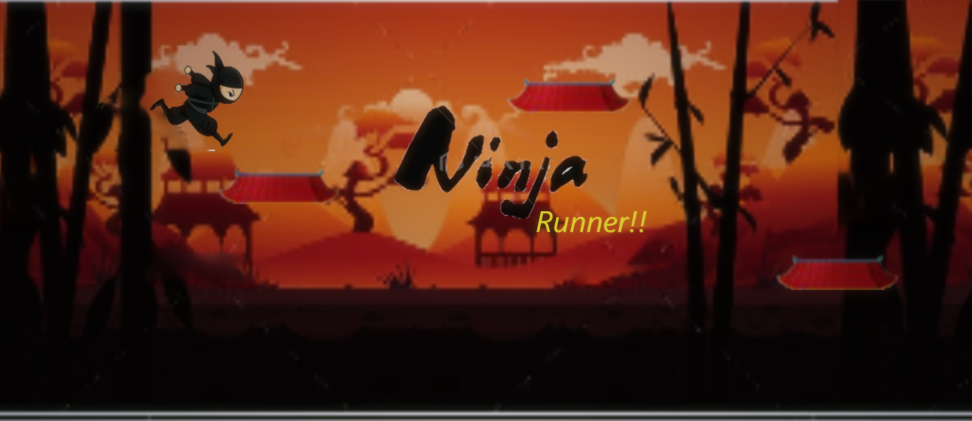

How do you plan to make your game engaging?

I am gonna put a dragon after 1000 roofs ,then a dragon will be spawned and it will throw fires after escaping 20 fires,the nija will kill the dragon!