Mr L. Paranthaman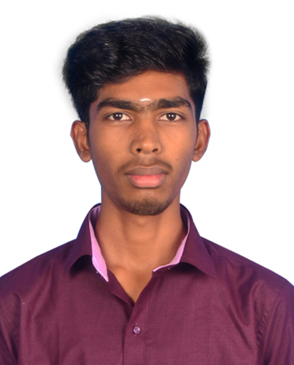 BE. CSE.,

9626474259

paranthamanl2004@gmail.com

PERSONAL INFO :

Father Name : Lakshmanan R

Dob : 02/06/2004

Address : 5.4.21, Parvathi Amman Kovil Street,

Sambavar vadakarai,

Tenkasi – 627856.

EDUCATION :

2021 – Present Sri Krishna College Technology, Kovaipudur,

B.E Computer Science Engineering

2014 – 2021 Government Higher Secondary School,

(VI - XII) Sambavar vadakarai, Tenkasi.

2009 – 2014 TDTA Middle School ,

(I – V) Surandai, Tenkasi.

SKILLS :

* HTML
* CSS
* C

CONTACT :

Mobile : 9626474259

Email : paranthamanl2004@gmail.com

insta : paranthaman_svk