Group No 2

Paras, Gursehbaj, Harpreet Kaur and Prabhjot Singh

Student management System

Customise this document - make this cover your own design

Table of Content

Executive Summary 2

Design Analysis Process 2

USER STORIES: 2

USES CASES: 3

USE CASE DIAGRAM: 4

FUNCTIONAL AND NON – FUNCTIONAL: 5

ACTORS 5

EVENTS 5

AGILE METHODOLOGY 6

Entity Relationship Diagram 7

Table Designs – Data Dictionary 7

Contributions 9

References 9

# Executive Summary

The **University Student Management System** (USMDS) is a **user-friendly** platform that will not assist academic staff to store and organize student’s information easily in **one place** but also help students to manage their profiles along with high level of security. We understand that how challenging it is, to store the information of the thousands of students and update it frequently when it is required. Therefore, we have made this database to to improve the overall experience for the students, staff members and administrators by utilization of just one centralized system.

By implementing University Student Management System, numerous fruitful benefits will arise that can enhance the overall academic experience: -

1. This system will help students to access their personal data and academic planning in which they will be able to check their personal information, academic records, enrolment status, course tenure and how much they are paying for it in just one place.
2. This system will also help academic staff to manage course information, grades and enrolment details just by one centralized system. It will also improve the accuracy and consistency across the institute regarding every aspect of students by better allocation of the data in system.
3. This system will play a predominant role for the admin to manage the student information effectively and efficiently. By the utilization of this system, administrators can keep thousands of students’ information in one database and can update it frequently whenever it is required.

To put it in a nutshell, USMS is such a great platform that will make the overall process easier and smoother for the universities to manage the students effectively. And will also become handy for the learners to access all the vital resources throughout their study duration.

# Design Analysis Process

## USER STORIES:

**User stories for the student**

* As a student, I want to update my contact information, including email, address, and phone number, so that I can receive correct information from the college and stay informed about new announcements and important updates without any difficulty. This will assist to stay connected with my studies if I am not able to attend lectures in any emergency.
* As a student, I want to view grades, including scores on individual assignments or exam so that I can easily monitor my academic progress and performance which will help me to stay on track with my educational goals. Additionally, knowing my grades will also help me to plan my studies accordingly if I am not able to match with passing criteria then I can change my strategies and can improve my performance.
* As a student, I want to know what classes I will be taking so I can organize my calendar and align with my academic and career goals as well as benefits include improved time management, greater planning goal alignment, and conflict avoidance. As a result, students are better prepared and engaged sin their next coursework.

**User stories for the teacher or academic staff member**

* As a teacher, I want to view the students grades so that I can help students to improve their performance by providing them extra support such as refer them for the extra classes during free time or by providing additional resources, giving feedback's and more. This will help me to understand the challenges faced by the students during their studies and later help them in improving the academic performance.
* As a teacher, I want to manage the lecture schedules according to my and students timetable so that I manage my lectures efficiently and can ensure that all the students can attend the classes without any scheduling conflicts. This will help me to improve the overall performance of the overall class just by organizing the lectures properly.
* As a teacher, I want to know how many students are enrolled in my course. So that I can manage classroom dynamics and plan resources effectively. This will help me to improved class management, better resource allocation and tailored instruction. As a result, it will be enhanced teaching effectiveness and improved student experience.

**User stories for the administrator:**

* As an administrator, I want to view the academic records of each student so that I can monitor their progress and identify any academic issues. This will help me to provide targeted support and interventions, such as academic support or additional tutoring, ensuring students have the resources they need to succeed.
* As an administrator, I want to update student contact information and personal details so that all communications and records are accurate and up to date. This will help in maintaining effective communication with students and their families, ensuring that important information reaches them without any issues.
* As an administrator, I want to manage student enrolment and course registrations so that I can ensure that students are enrolled in the right courses. This will help in balancing class loads and providing students with the courses they need to progress in their academic programs.

## USES CASES:

**Use cases for students:**

1. View personal information.
2. Update Personal information (name, phone number, email)
3. View courses.
4. View overall Grades
5. View aacademic progress summary
6. View lecture schedules

**Use cases for teachers or academic staff members:**

1. View courses.
2. Manage their courses. (If they want to add more content or delete some topics)
3. View student’s information. (they can communicate with them)
4. Manage student’s attendance.
5. Manage student’s grades.
6. Manage their class schedules. (according to their time management)

**Use cases for the administrator:**

1. Manage courses
2. Manage lectures schedules
3. Manage students’ enrolments
4. Manage student information
5. Manage tuition fee payments

## USE CASE DIAGRAM:

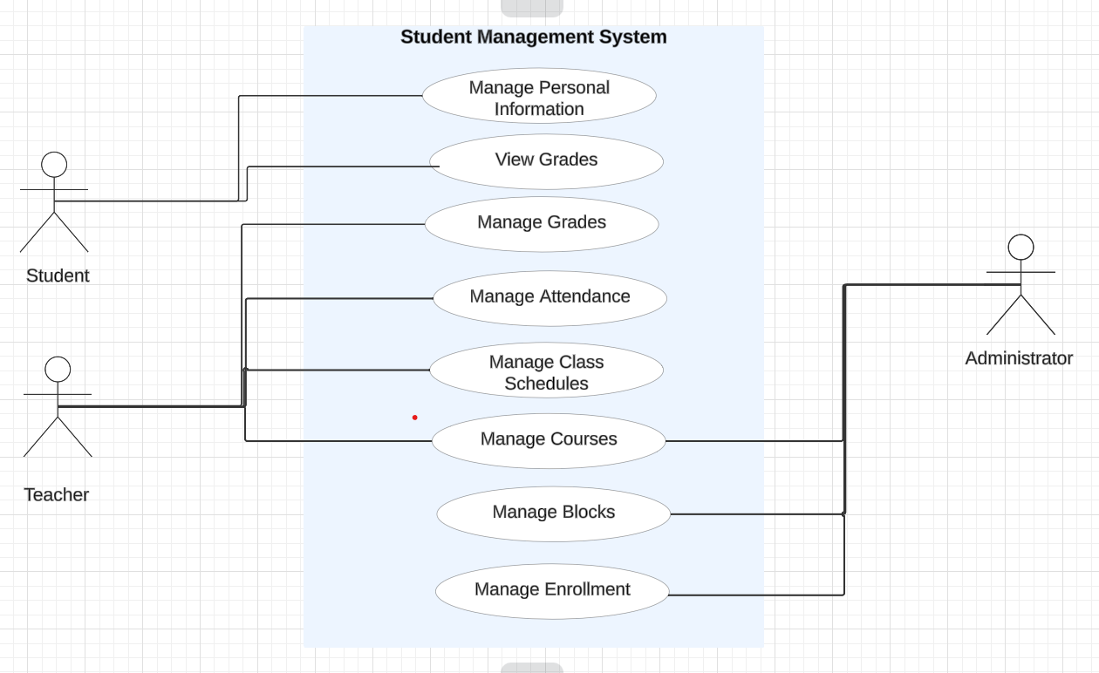

Retrieved from: [https://lucid.app/lucidchart/d4148ee5-d3fd-4378-a6e0-7220da95fc34/edit?page=.Q4MUjXso07N&invitationId=inv_ed4ac094-9a50-496a-9a8e-2b9b785d58ac#](https://lucid.app/lucidchart/d4148ee5-d3fd-4378-a6e0-7220da95fc34/edit?page=.Q4MUjXso07N&invitationId=inv_ed4ac094-9a50-496a-9a8e-2b9b785d58ac)

## FUNCTIONAL AND NON – FUNCTIONAL:

**Functional Requirements:**

* Ability to store and manage student information, including personal details academic courses and activities, and schedules. Use Cases ability to schedule classes and register students for lectures.
* Ability to create and manage student and parent profiles, including their contact information.
* Ability to manage university activities and its instructors.
* Ability to provide a user- friendly interface for all system users.

**Non – functional requirements:**

* The system should handle many users and transactions efficiently.
* The system should be easy to update and maintain.
* Ensure integration with other systems such as academic record systems financial system.
* Implement backup and recovery solutions to prevent data loss.

What you did. Why you did it. Why is your implementation better. Your final system is probably different from your proposal – why?

Spend some time thinking about why you made the design choices that you did - there is no wrong answer here

## ACTORS

1. **Students**: Students would be the primary users of the system they could check their class schedule, grades, sign them up for activities, see the upcoming events or changes in their curriculum, register for courses and they can update their information.
2. **Teachers**: Tutors or instructors would use the system to manage class roaster, input grades, create assignments and they have the access to communicate with students.
3. **Administrator**: The administrator can manage the overall system management, including user accounts, course offerings and reporting.d

## EVENTS

* **Update information:** Students can update their information.
* **Grade Submission**: Teachers could submit or update grades of the students.
* **Course Creation**: Administrators or faculty create or modify courses.
* **Schedule Update**s: Changes to class schedules are made.
* **Attendance**: Teachers record attendance.
* **Assignment Submission**: Students submit assignments.
* **Profile Update**: Users update their personal or professional information.

## AGILE METHODOLOGY

We have used **Agile Methodology** to build our **University Student Management System**. We have chosen this model because it is based on iterative methodology which basically means to start with basic skeleton and make regular changes until the final release. Moreover, it also allows user to understand the **requirements** of system and then later follow up with **planning** by evaluating the existing system**, design**, **developmen**t, **testing** and finally **deploymen**t which is quite easy and straightforward to utilize by the user in building the new system. Firstly, we started by collecting the requirements from the user then after making changes throughout the process we are able the deliver the result. Apart from that, this model allowed us to start by building basic structure with limited features and then follow up with continuous changes and delivery to the users.

Retrieved from: <https://asana.com/resources/agile-methodology>

# Entity Relationship Diagram

**You can add logical and physical ERD design (at least 5-6 entities) of your system here. Also briefly explain the relationships with cardinalities between entities in words.**

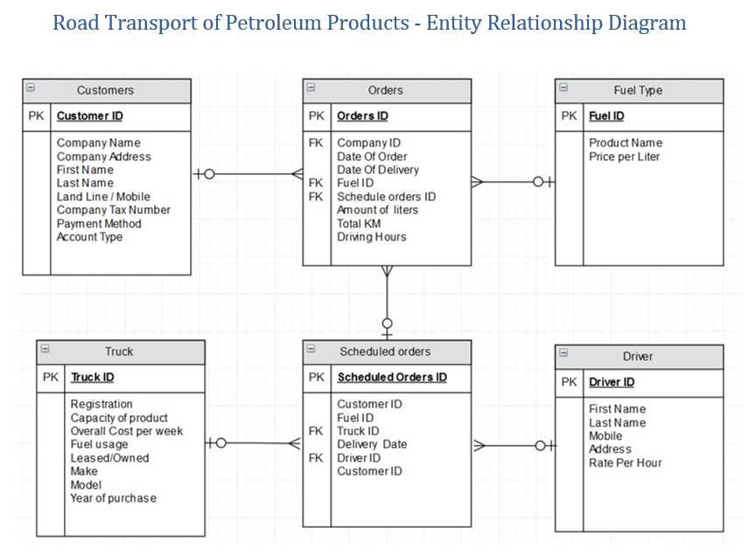

# Table Designs – Data Dictionary

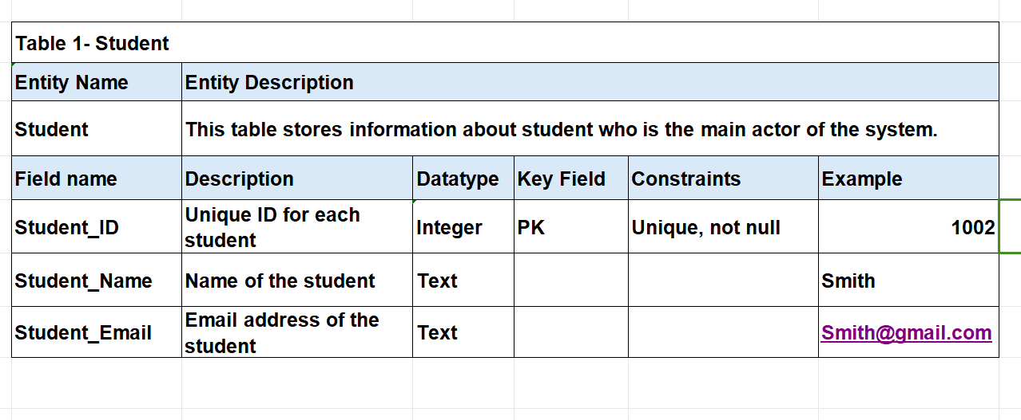

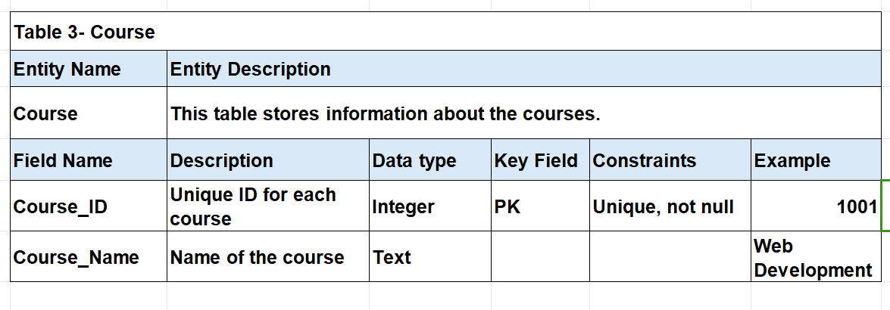

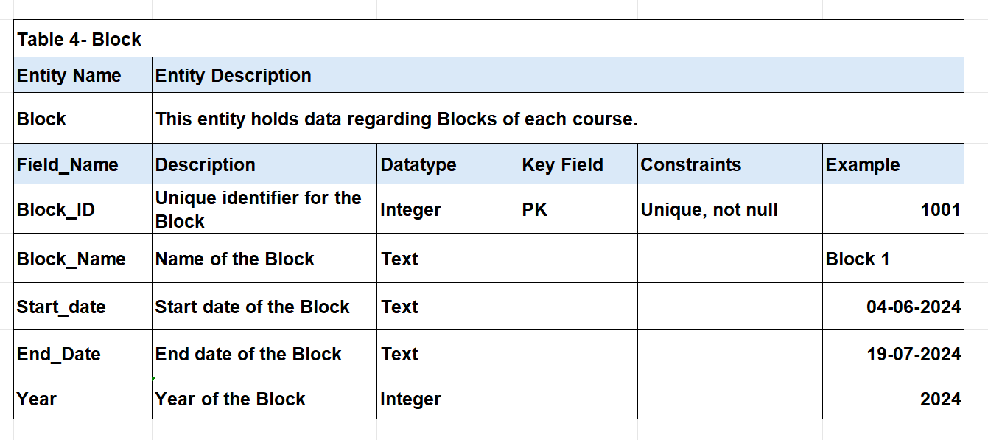

# Contributions

Add the list of members and their contributions to the project.

Also add the link to your GitHub Repository

# References

Laoyan, S. (2024). *What is Agile methodology?* Retrieved from Asana: https://asana.com/resources/agile-methodology

*Student Managent System*. (n.d.). Retrieved from LovelyCoding.Org: https://www.lovelycoding.org/student-management-system/#:~:text=Hardware%20Requirements%20of%20Student%20Management%20System&text=Processor%3A%20Intel%20P%2DIV%20System,Hard%20Disk%3A%2040%20Gb

*Use Case Diagram*. (n.d.). Retrieved from LucidChart: https://lucid.app/lucidchart/d4148ee5-d3fd-4378-a6e0-7220da95fc34/edit?invitationId=inv_ed4ac094-9a50-496a-9a8e-2b9b785d58ac&page=.Q4MUjXso07N#