**INDEX**

**Topics Page No**

1. **Introduction 1**
   1. **Introduction of the project (SRS) 1**
   2. **Problem definition 1**
   3. **Objective of Project 1**
   4. **Scope of Project 1**
2. **System Study 2**
   1. **Existing System 2**
   2. **Disadvantages of Existing system 2**
   3. **Proposed System 2**
   4. **Use Cases 2**
3. **Analysis & Design 3**
   1. **Software/Hardware Requirement Specification 3**
      1. **Software requirement 3**
      2. **Hardware requirement 3**
   2. **GANTT Chart 3**
   3. **Flowchart 4**
   4. **Module design and organization 5**
4. **Testing & Validation 6**
   1. **Test cases and Report 6**
5. **User Manual 7**
   1. **Explanation of key functions 7**
   2. **Method of implementation 8**
      1. **Forms 8**
      2. **Output screens 9**
6. **Conclusion 21**
   1. **Project conclusion & Future enhancement 21**
7. **References 21**
8. **Introduction** 
   1. **Introduction of the project (SRS)**

“*Space Shooter*” is a classic game that has been popular around the world for more then 3 decades. It has been developed for various gaming platforms like PC, Xbox, Play Station, Sega, Nintendo and for cell phones as well. The game revolves around a space ship which has embarked on a mission to eliminate as many asteroids and alien spaceships as possible and gather points for each successful elimination.

* 1. **Problem definition**

The project “*Space Shooter*” has been undertaken with the aim to get started and pursue further interests in the field of Game development. The project is fully developed using Java and uses Postgres as database.

* 1. **Objective of Project**
* Gain knowledge about java graphics libraries (example: javafx)
* Create a space shooter game using java.
* Randomly spawn asteroids and enemy ships towards the protagonist’s space ship.
* Entertainment.
  1. **Scope of Project**

The end product of this project will be a miniature version of the classic “*Space Shooter*” game developed using java. The project can further be improved by hosting it over a server to provide web-based gameplay. Also, improvement can be made by allowing user to customize their space ship, bullet and changing the background.

1. **System Study**
   1. **Existing System**

Existing Systems do not possess any inconvenience to the player but lack one aspect of further improvements and improvisations. In contrast, this project fully allows the user to modify every aspect of the game as per their desires (the user can also add cheat codes).

* 1. **Disadvantages of Existing system**
* Limited/Lack of customization
  1. **Proposed System**
* User is free to customize the game to their liking
* Open source
* Rich database connectivity
* Doesn’t require high end support specifications
  1. **Use Cases**

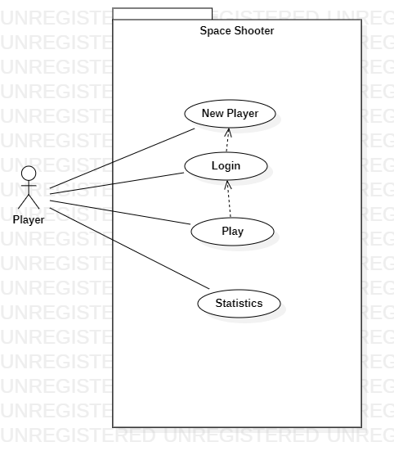

1. **Analysis & Design**
   1. **Software/Hardware Requirement Specification**
      1. **Software requirement**

* Any OS
* JavaSE (jdk 14.0.2 or jre 8u261) or above
* Javafx external library (11.0 or above)
* Postgres database (11.0 or above)
  + 1. **Hardware requirement**
* A computer/laptop
  1. **GANTT Chart**
  2. **Flowchart**

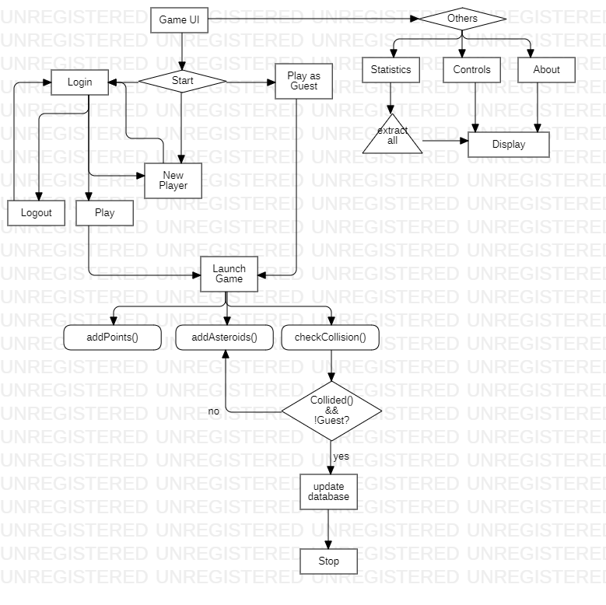

* 1. **Module design and organization**

Game UI

Start Others

Login Statistics

Logout Controls

Play About

Play As Guest

New Player

1. **Testing & Validation**
   1. **Test cases and Report**

|  |  |  |  |  |  |
| --- | --- | --- | --- | --- | --- |
| **Id** | **Pre-Condition** | **Input** | **Expected Output** | **Actual Output** | **Status** |
| 1 | Login | Invalid credentials | Display error message | Display error message | Pass |
| 2 | Login | Valid credentials | Update title with username | Update title with username | Pass |
| 3 | New User | No values | Display error message | Display error message | Pass |
| 4 | New User | Valid values | Add user to database | Add user to database | Pass |

1. **User Manual**
   1. **Explanation of key functions**

|  |  |  |
| --- | --- | --- |
| **Class** | **Method** | **Description** |
| SpaceShooterMain | display(String) | Takes file name as parameter in string format.  Displays contents of file based on selection from menu items.  Example: Controls, About |
| addPlayer() | Prompts user for username and password which can later be used to login and track progress. |
| viewStatistics() | Displays data of all users (except Guest) in descending order of their high scores. |
| getLoginInformation() | Prompts user for login credentials to play game.  Updates title bar of application with username if login is success. |
| initGame(String) | Launches main Space Shooter application.  Takes username as parameter. |
| DatabaseConnector | createConnection() | Creates connection with the postgres database |
| validateUsername(String)  validatePassword(String) | Both methods take username and password respectively and validate them.  Returns true if valid else false. |
| getPoints(String)  getAsteroids(String)  getDeathCount(String)  getStatistics() | All methods take username as parameter and return high score, asteroids destroyed & death count of user.  getStatistics() returns set containing progress of players. |
| updatePoints(String, int,int,int) | Takes 4 parameters with first one as username and other three as points, asteroid count and death count.  Updates the points, asteroids & death count of user. |
| GameLoader | start(Stage) | Method of Application class overridden to imply custom actions and gameplay.  Is automatically called by the launch(args) method provided by Application class. |
| addAsteroid(Pane) | Takes pane (similar to JPanel in SWING) as argument. Adds an asteroid(polygon) to the pane. |
| addPoints(int) | Keeps a count of points scored by the player while in-game. |

* 1. **Method of implementation**
     1. **Forms**

Adding new player

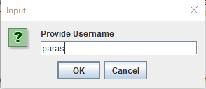

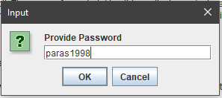

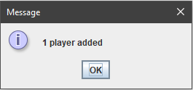

Login

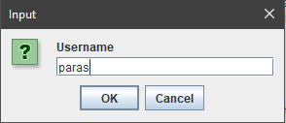

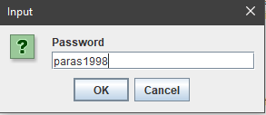



* + 1. **Output screens**

Start Up Screen

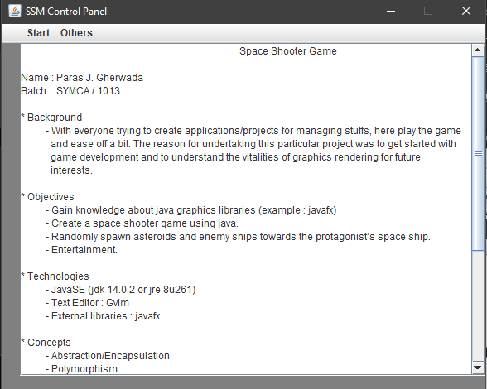

Start Menu

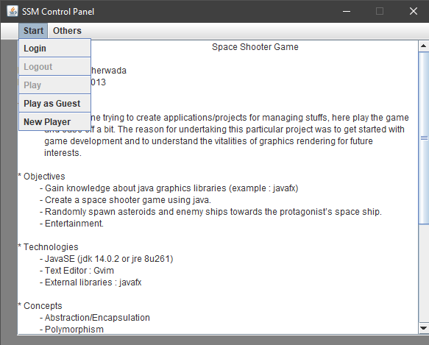

Others Menu

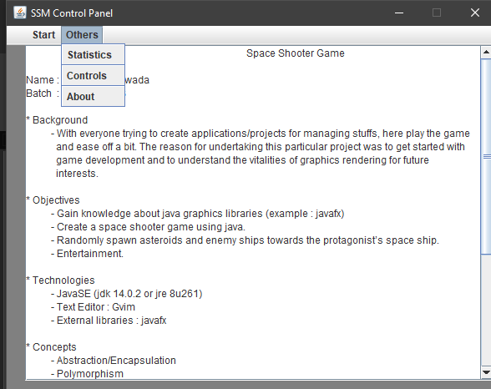

Others Menu Item – Statistics

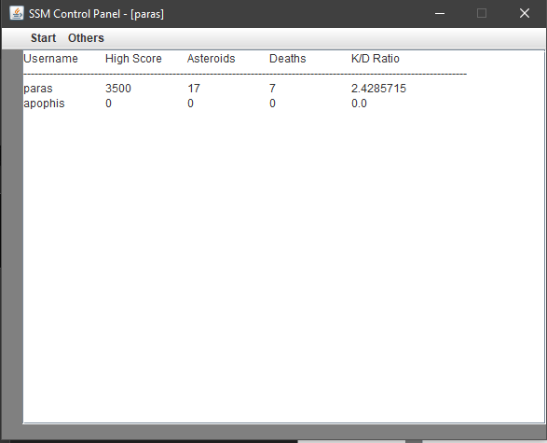

Others Menu Item – Controls

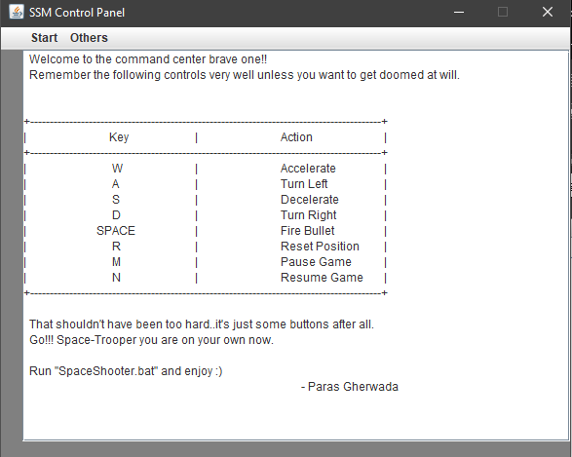

Others Menu Item – About

*\* Same as Start Up Screen \**

Start Menu Item – New Player

*\* Refer section 5.b.i \**

Start Menu Item – Play As Guest (in-game)

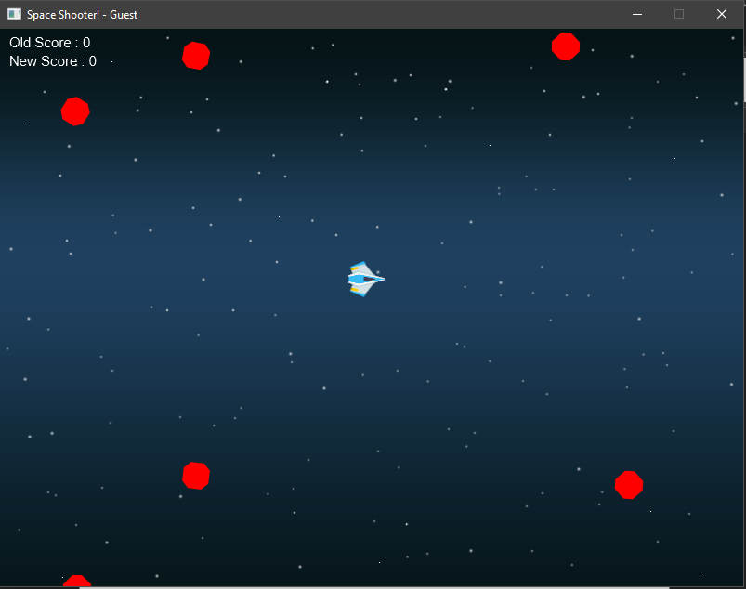

Note: The application does not store any kind of progress of Guest user.

Start Menu Item – Play As Guest (on collision with asteroid)

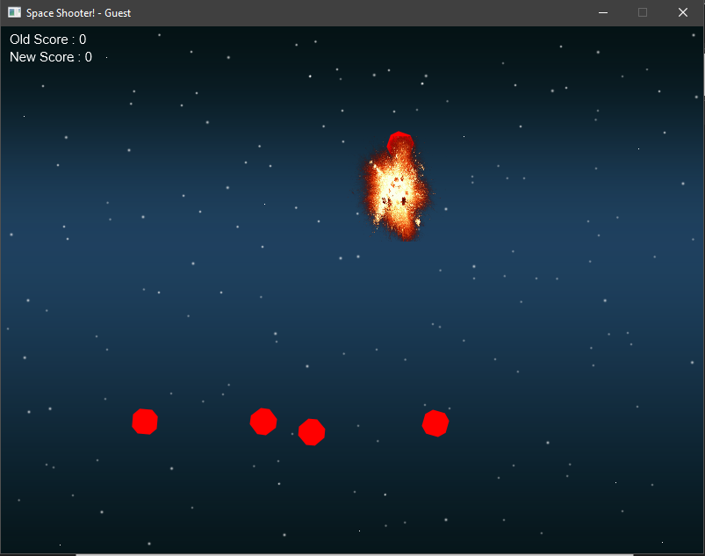

Start Menu Item – Login

*\* Refer section 5.b.i \**

Start Menu Item – After Login

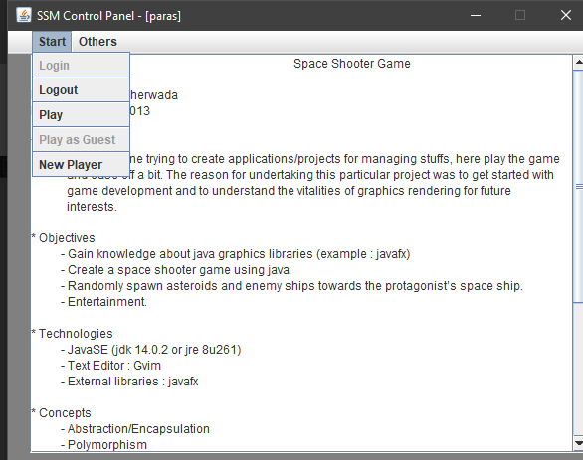

Note: The start options have now changed after login. Refer section 5.b.ii Start Menu screenshot for comparison. Also notice that the title bar now shows the logged-in user.

Start Menu Item – Play (in-game)

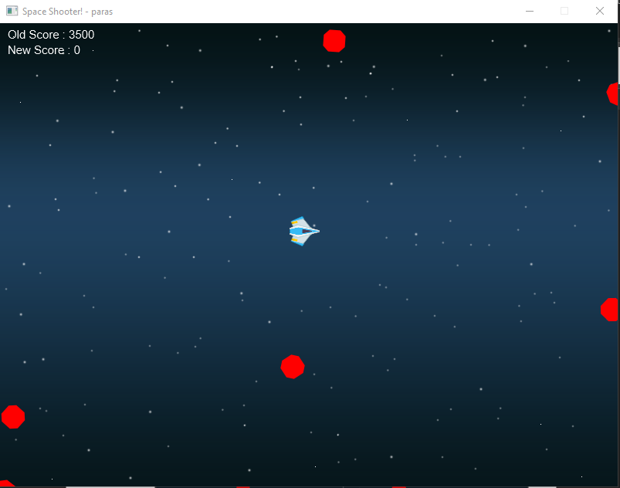

Start Menu Item – Play (After collision)

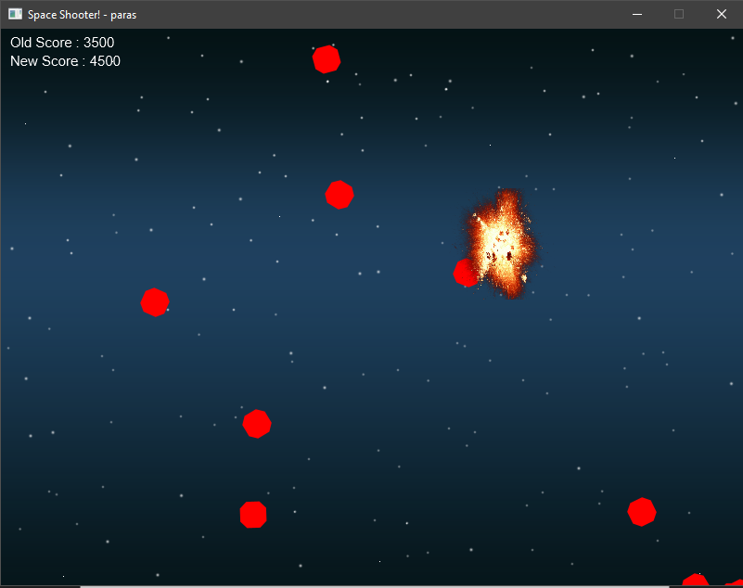

Others Menu Item – Statistics (After collision)

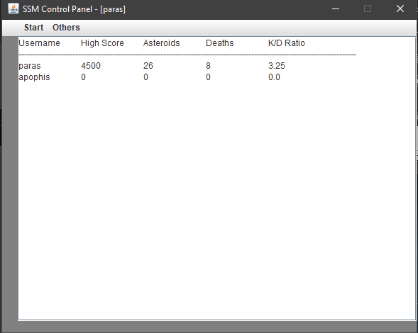

Start Menu Item - Logout

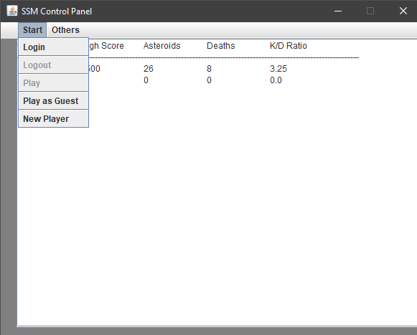

Note: After logout the Start Menu items have been set to their default i.e., the way they were before login. Also notice that the username has been removed from title.

1. **Conclusion**
   1. **Project conclusion & Future enhancement**

The end product of this project will be a miniature version of the classic “*Space Shooter*” game developed using java. Enhancements can be made by allowing user to customize their space ship, bullet and changing the background. In future, this project can be modified to be hosted over a server to provide web-based single/multi player gameplay.

1. **References**

* http://tutorials.jenkov.com/javafx/stage.html
* https://docs.oracle.com/javase/8/javafx/api/index.html
* https://www.geeksforgeeks.org/javafx-polygon-with-examples/
* https://www.programcreek.com/java-api-examples/
* https://ss64.com/nt/errorlevel.html