Week 1: Data Acquisition, Cleaning & Exploratory Data Analysis
Domain: Indian Financial Markets: NIFTY 50 Index
Author: Paras
Date: july 2026
Dataset: NIFTY 50 index daily prices, 1 June 2016 to 30 June 2026 (2,483 trading days)
Tools: Python (Pandas, NumPy, Matplotlib, Seaborn, yfinance), Jupyter

1. Task Objective
This report documents the data preparation stage of a five-week data science project on the NIFTY 50, India's benchmark equity index. It covers acquiring a public dataset, auditing its quality, cleaning and preprocessing it, and carrying out exploratory data analysis (EDA). The cleaned file produced here (data/nifty_cleaned.csv) is the single input for the visualisation, hypothesis-testing and modelling work in Weeks 2 to 4.

2. Data Acquisition

2.1 Source and Scope
- Provider: Yahoo Finance, accessed through the yfinance Python library, ticker ^NSEI (NIFTY 50 index)
- Period: 1 June 2016 to 30 June 2026 (about ten years); the end date is passed as 1 July 2026 because yfinance treats the end date as exclusive
- Fields: Date, Adj Close, Close, High, Low, Open, Volume (daily frequency)
- Size: 2,483 rows and 7 columns

2.2 Why This Source and Period
The official NSE historical-data page was tried first and has real turnover figures, but it refuses downloads longer than 365 days, so ten years would need about ten separate files to be merged. yfinance returns the whole range in one call, which makes the pipeline reproducible. A ten-year window was chosen because it is long enough to contain very different market regimes (the 2020 COVID crash, the 2021 rally, the 2022 correction and a 2026 sell-off) while keeping the dataset small enough to work with quickly.
import yfinance as yf
raw = yf.download("^NSEI", start="2016-06-01", end="2026-07-01",
auto_adjust=False, progress=False)
raw.columns = raw.columns.get_level_values(0)
raw = raw.reset_index()[["Date","Adj Close","Close","High","Low","Open","Volume"]]
raw.to_csv("data/NIFTY50_stock_history.csv", index=False)
The download is wrapped in an os.path.exists check, so re-running the notebook reads the saved file instead of calling Yahoo again.

3. Data Quality Audit and Cleaning

3.1 Audit Results
Before changing anything, the raw data was audited. The results are summarised below.
Check | Result | Action
Missing values (any column) | 0 | None needed
Exact duplicate rows | 0 | None needed
Duplicate dates | 0 | None needed
OHLC consistency failures | 0 | None needed
Date column data type | Text (string) | Convert to datetime
Rows with Volume = 0 | 28 (1.1%) | Recode as missing
The dataset arrived in good condition: there are no gaps, repeats or logically impossible prices. Two genuine issues were found and are handled below. In the interest of honest reporting, no further problems were invented to pad the cleaning section.

3.2 Correcting the Date Type and Ordering
Dates were stored as plain text, which prevents time-based operations such as sorting, rolling windows and grouping by year. The column was converted to datetime, the rows were sorted chronologically and the index was reset. The cleaned frame covers 2016-06-01 to 2026-06-30 with no duplicate dates.
df_clean = df.copy()
df_clean["Date"] = pd.to_datetime(df_clean["Date"])
df_clean = df_clean.sort_values("Date").reset_index(drop=True)

3.3 Recoding Zero Volume as Missing
The audit found 28 trading days (1.1%) with a Volume of exactly 0, even though the index level moved on those days. NIFTY 50 is an index rather than a traded instrument, and Yahoo's index volume is a derived figure that is sometimes recorded as zero when the feed fails. A genuine volume of zero on a normal trading day is not plausible, so these entries are missing data stored as a number. They were recoded to NaN so that they cannot distort averages or correlations. The rows themselves were kept, because their price data is valid.
df_clean["Volume"] = df_clean["Volume"].replace(0, np.nan)
# 28 rows set to NaN
This is the one case in the dataset where a plain isnull() check would have reported "no missing values" while a real data problem was present.

3.4 Why No Rows Were Dropped
All 2,483 rows were retained. Deleting a trading day from a time series breaks the continuity that rolling averages, daily returns and lag features depend on, and the 28 affected rows have perfectly good price data. Only the unreliable field (Volume) was neutralised, and Week 3's volume test excludes those rows explicitly.

3.5 Feature Engineering
- Daily_Return_% : percentage change in Close from the previous trading day
- MA_50 and MA_200 : 50-day and 200-day moving averages of Close
- Year : calendar year, used to group results in later weeks
df_clean["Daily_Return_%"] = df_clean["Close"].pct_change() * 100
df_clean["MA_50"] = df_clean["Close"].rolling(50).mean()
df_clean["MA_200"] = df_clean["Close"].rolling(200).mean()
df_clean["Year"] = df_clean["Date"].dt.year
These features introduce structural NaN values at the start of the series (1 for the return, 49 for MA_50, 199 for MA_200). They are rolling-window warm-up, not data errors, and models in Week 4 simply skip those rows.

4. Exploratory Data Analysis

4.1 Summary Statistics
Variable | Mean | Median | Std Dev | Min | Max
Close (index points) | 15,889.8 | 15,687.0 | 5,725.3 | 7,610.2 | 26,328.6
Volume (n = 2,455) | 350,494 | 290,900 | 187,374 | 100 | 1,811,000
Daily return (%) | 0.048 | 0.067 | 1.020 | -12.98 | 8.76
The index rose from 8,179.95 on 1 June 2016 to 23,865.75 on 30 June 2026, a gain of about 192% (roughly 11% a year, price return only and excluding dividends). The all-time high in the sample is 26,328.55 on 2 January 2026. The average day is slightly positive (+0.048%), but the standard deviation of 1.02% is about twenty times larger than the mean, so daily movement is dominated by noise.

4.2 Missing Data
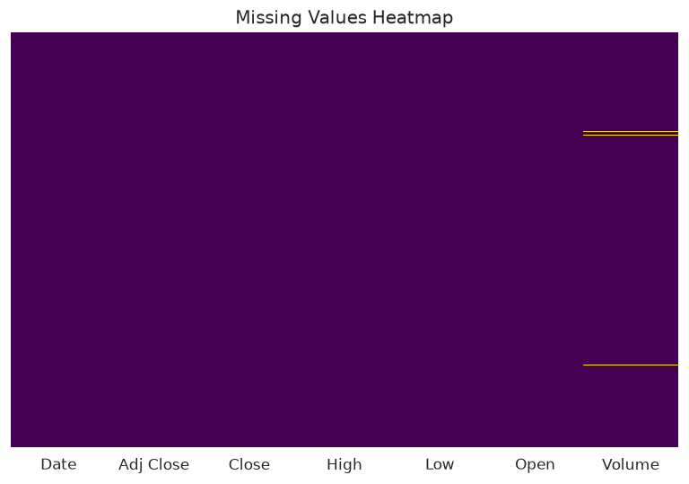
Figure 1: Missing-value heatmap after cleaning. The only gaps are the 28 zero-volume days recoded as NaN.
After cleaning, the only missing entries are in the Volume column, shown as thin horizontal lines. They are scattered across the period (13 of the 28 fall in 2018) rather than clustered, which suggests intermittent feed failures instead of a systematic gap.

4.3 Price Trend
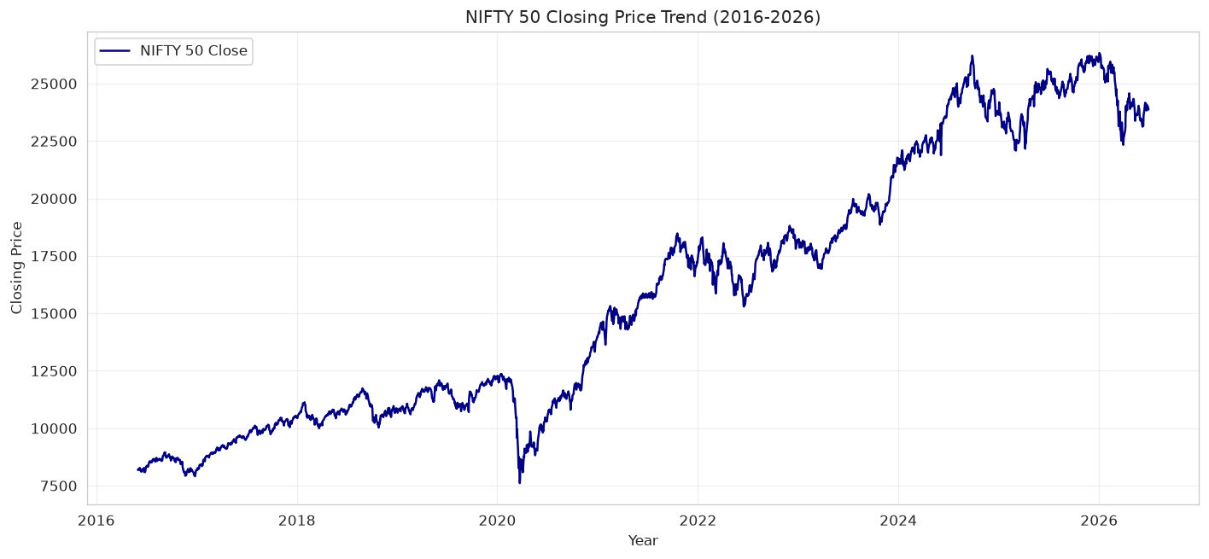
Figure 2: NIFTY 50 closing price, June 2016 to June 2026
Three features stand out: a steady climb through 2016 to 2019, a sharp collapse in March 2020 to a low of 7,610.25, and a strong rise afterwards that reached new highs in 2024 and 2026. The index lost value again in early 2026 and ended the sample about 9% below its peak.

4.4 Correlation Between Variables
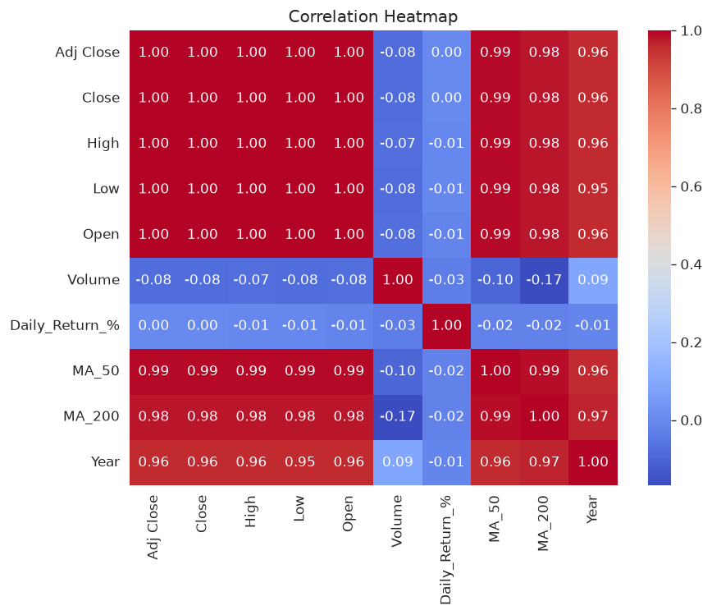
Figure 3: Correlation heatmap of all numeric columns
Open, High, Low, Close and Adj Close are almost perfectly correlated (about 1.00), which is expected because they are all measurements of the same price within one day; only one of them (Close) is needed for modelling. Volume has a weak negative correlation with price (-0.08), and Daily_Return_% is essentially uncorrelated with everything (between -0.03 and 0.00), a first hint that returns are hard to predict. The high correlation of Year with price (0.96) simply reflects the long-run upward trend. Because most of these price-based columns carry the same information, using them together would add redundancy rather than insight.

4.5 Distribution of Daily Returns
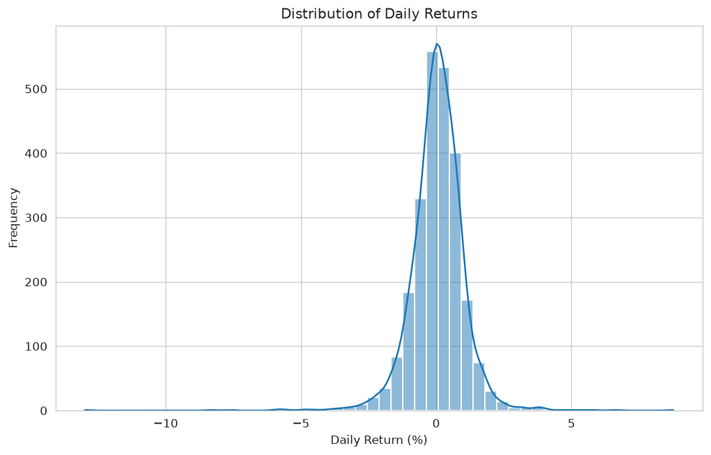
Figure 4: Histogram of daily returns with density curve
Returns are centred close to zero and look roughly bell-shaped, but the tails are much heavier than a normal distribution allows: the skewness is -1.07 and the excess kurtosis is 19.2. There are 37 days with a move larger than 3% in either direction, and 22 of them fall in 2020. The worst day was 23 March 2020 (-12.98%) and the best was 7 April 2020 (+8.76%).

5. Summary of Insights
- Data quality was high: no missing values, duplicates or inconsistent prices. The real issues were text-typed dates and 28 disguised-missing zero-volume days (1.1%).
- The index grew about 192% over the decade, but the path was uneven and was dominated by one event, the March 2020 crash.
- Price columns are redundant with each other; Close alone is enough for later analysis.
- Daily returns are fat-tailed and negatively skewed, so extreme days occur far more often than a normal-distribution assumption would suggest.
- Day-to-day returns are almost uncorrelated with every other variable, which sets cautious expectations for the prediction task in Week 4.

6. Limitations and Next Steps
- Yahoo's index volume is not the official NSE traded volume or turnover; the minimum of 100 shares in the data is a sign of its unreliability. Volume-based results should be treated as indicative.
- The data is for one index only and covers a single decade, so it contains one major crash (2020).
- Next steps: tell the story visually (Week 2), test the patterns statistically (Week 3), and test whether they can be used to predict next-day direction (Week 4).

