Week 3: Statistical Analysis & Hypothesis Testing
Domain: Indian Financial Markets: NIFTY 50 Index
Author: Paras
Date: October 2026
Dataset: NIFTY 50 index daily prices, 1 June 2016 to 30 June 2026 (2,483 trading days)
Tools: Python (SciPy, Statsmodels, Pandas, Seaborn), Jupyter

1. Introduction
Weeks 1 and 2 raised several questions by eye: does the index earn a positive return on an average day, was 2020 really more volatile than a normal period, do some weekdays behave differently, and does trading volume rise when prices swing? This report tests each of these with a formal hypothesis test. Every hypothesis is stated in advance with a null and an alternative, tested at a significance level of 0.05, and interpreted in plain terms, including what the result does not show.

2. Methodology Overview
Hypothesis | Question | Test used
H1 | Is the mean daily return different from zero? | One-sample t-test, plus 95% confidence interval
H2 | Was 2020 more volatile than 2017 to 2019? | Levene's test and Welch's t-test on absolute returns
H3 | Does the mean return differ across weekdays? | One-way ANOVA, Tukey post-hoc test
H4 | Do high-volume days have larger price moves? | Pearson correlation (volume vs absolute return)
Data: the cleaned file from Week 1. Daily returns are in percent. The 28 zero-volume days recoded as missing in Week 1 are excluded from H4. Sample sizes are given with each test.
import pandas as pd, numpy as np
from scipy import stats
df = pd.read_csv("data/nifty_cleaned.csv", parse_dates=["Date"])
df["Weekday"] = df["Date"].dt.day_name()
df["Abs_Return"] = df["Daily_Return_%"].abs()

3. Hypothesis 1: Is the Average Daily Return Different from Zero?

3.1 Hypotheses
H0: the true mean daily return is 0%. H1: the true mean daily return is not 0%.

3.2 Method and Result
returns = df["Daily_Return_%"].dropna() # n = 2,482
t_stat, p_value = stats.ttest_1samp(returns, popmean=0)
ci = stats.t.interval(0.95, len(returns)-1,
loc=returns.mean(), scale=stats.sem(returns))
Statistic | Value
Sample size | 2,482 daily returns
Mean daily return | 0.0484%
t statistic | 2.363
p-value | 0.0182
95% confidence interval for the mean | 0.0082% to 0.0886%
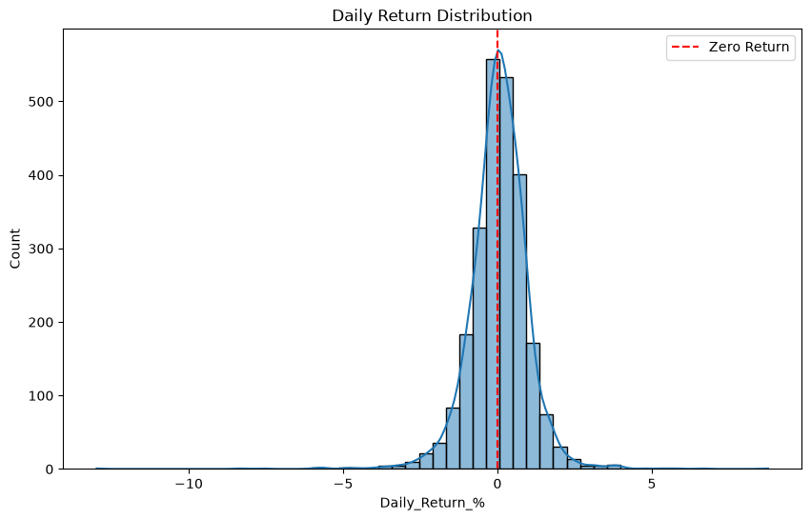
Figure 1: Distribution of daily returns, with the zero line

3.3 Interpretation
Because p = 0.0182 is below 0.05, H0 is rejected: the data support a mean daily return that is slightly above zero. The confidence interval says the same thing in another way. We are 95% confident that the true average is between about 0.008% and 0.089% a day, an interval that excludes zero, though only just at the lower end. The effect is small relative to the daily standard deviation of 1.02%, which is why it takes thousands of observations to detect. The positive drift is real in this sample but modest, and it is a statement about the average of the period, not a prediction for any single day.

4. Hypothesis 2: Was 2020 More Volatile Than Normal Years?

4.1 Hypotheses
H0: the volatility of daily returns in 2020 equals that of 2017 to 2019. H1: volatility in 2020 is different. 2017 to 2019 was used as the comparison group because it is the calm period before the COVID shock.

4.2 Method and Result
covid = df[df["Year"] == 2020]["Daily_Return_%"].dropna() # n = 250
normal = df[df["Year"].between(2017, 2019)]["Daily_Return_%"].dropna() # n = 734
stats.levene(covid, normal) # equality of variances
stats.ttest_ind(covid.abs(), normal.abs(), equal_var=False) # Welch t-test on |return|
Measure | 2020 | 2017-2019
Trading days | 250 | 734
Std dev of daily return | 1.97% | 0.76%
Mean absolute daily return | 1.23% | 0.57%
Test results:
Test | Statistic | p-value
Levene's test (equal variance) | 91.64 | 8.1e-21
Welch t-test on absolute returns | 6.557 | 2.8e-10
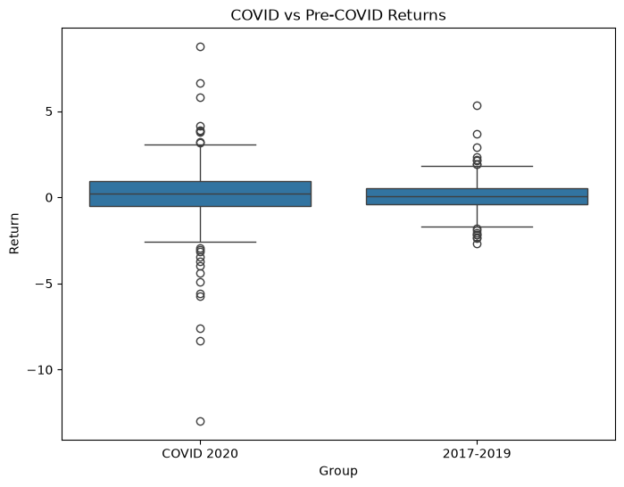
Figure 2: Daily returns in 2020 compared with 2017 to 2019

4.3 Interpretation
Both tests are strongly significant, so H0 is rejected. Returns in 2020 were spread about 2.6 times more widely than in 2017 to 2019 (standard deviation 1.97% against 0.76%), and the typical size of a daily move was more than double (1.23% against 0.57%). The boxplot shows the same thing: a taller box and far more extreme points. Levene's test checks whether the spread differs, and the Welch test on absolute returns checks whether the typical size of a move differs, and the two agree. This turns the volatility spike seen in Week 2 into a statistically confirmed fact.

5. Hypothesis 3: Does the Average Return Differ by Weekday?

5.1 Hypotheses
H0: mean daily return is the same on Monday, Tuesday, Wednesday, Thursday and Friday. H1: at least one weekday has a different mean.

5.2 Method and Result
weekday_groups = [df[df["Weekday"] == d]["Daily_Return_%"].dropna()
for d in ["Monday","Tuesday","Wednesday","Thursday","Friday"]]
f_stat, p_value3 = stats.f_oneway(*weekday_groups)
from statsmodels.stats.multicomp import pairwise_tukeyhsd
print(pairwise_tukeyhsd(tmp["Daily_Return_%"], tmp["Weekday"])) # post-hoc
Weekday | Trading days | Mean return %
Monday | 493 | -0.035
Tuesday | 498 | 0.145
Wednesday | 498 | 0.092
Thursday | 501 | 0.011
Friday | 491 | 0.029
ANOVA: F = 2.384, p = 0.0493. The Tukey post-hoc test, which compares each pair of days while controlling for multiple comparisons, found no pair with a significant difference. The closest was Monday against Tuesday (difference 0.18 percentage points, adjusted p = 0.062).
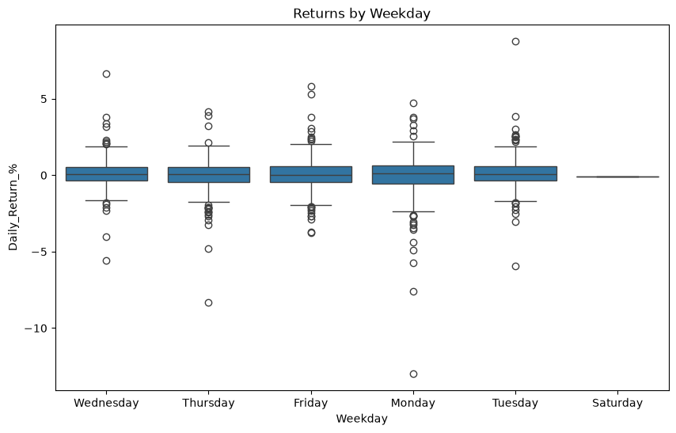
Figure 3: Daily returns by weekday
Note: the data contains one Saturday, 1 February 2025, when NSE held a special Union Budget trading session. It has a single observation, is not part of the ANOVA (Monday to Friday only) and appears as an empty box in Figure 3 and as extra rows in the Tukey table.

5.3 Robustness Checks
Because the ANOVA p-value is so close to the 0.05 line, two further checks were run to see whether the result is solid:
stats.kruskal(*weekday_groups) # rank-based, no normality needed
# repeat the ANOVA with 2020 removed
no2020 = df[df["Year"] != 2020]
Version of the test | p-value
One-way ANOVA, all years (above) | 0.049
Kruskal-Wallis (rank-based), all years | 0.391
One-way ANOVA, excluding 2020 | 0.355

5.4 Interpretation
Strictly at the 5% level, the ANOVA rejects H0. But this is weak evidence. The p-value barely clears the threshold, no individual pair of days is significantly different in the post-hoc test, the rank-based test is nowhere near significant (p = 0.39), and removing the extreme year 2020 raises the ANOVA p-value to 0.36. The pattern suggests that the borderline result is driven by a few extreme days (for example the 23 March 2020 crash, which fell on a Monday) rather than a consistent weekday pattern. The reasonable conclusion is that no reliable day-of-week effect has been established, and none that could be used for trading.

6. Hypothesis 4: Is Trading Volume Related to the Size of Price Moves?

6.1 Hypotheses
H0: there is no linear correlation between daily volume and the absolute daily return. H1: there is a correlation.

6.2 Method and Result
sub = df.dropna(subset=["Volume", "Abs_Return"]) # excludes the 28 recoded days
corr, p_value4 = stats.pearsonr(sub["Volume"], sub["Abs_Return"])
Statistic | Value
Sample size | 2,454 days
Pearson correlation r | 0.371
p-value | 7.6e-81
Shared variation (r squared) | about 14%
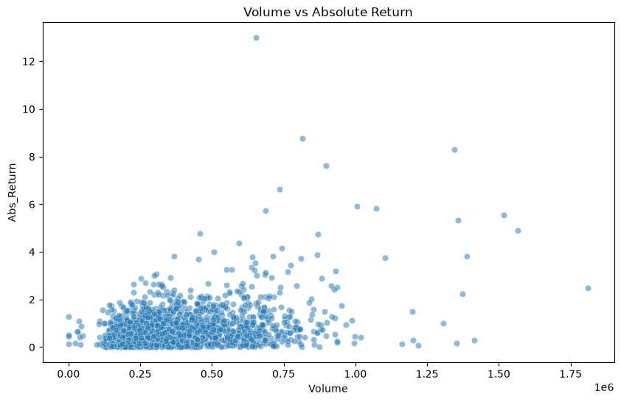
Figure 4: Daily volume against absolute daily return

6.3 Interpretation
H0 is rejected. There is a moderate positive relationship: days with heavier volume tend to be days with larger price moves, which fits the intuition that fear and excitement raise both trading activity and price swings. Volume explains only about 14% of the variation in the size of moves, so it is a useful clue and not a predictor. The scatter plot also shows that the relationship is driven by a minority of high-volume days. A rank-based check (Spearman) gives a weaker correlation of about 0.26, which is still clearly positive, so the conclusion holds. Because Yahoo's index volume is not official NSE volume, the figure should be read as indicative.

7. Summary of Findings
Hypothesis | Result | Conclusion
H1: mean return differs from 0 | p = 0.018 | Reject H0: small positive drift (0.048% a day)
H2: 2020 more volatile | p < 0.001 | Reject H0: spread about 2.6 times larger
H3: weekday effect | p = 0.049 (fragile) | Borderline; no robust effect established
H4: volume and price moves | p < 0.001 | Reject H0: moderate positive link (r = 0.37)

8. Validity and Limitations
- Independence: daily returns are not strictly independent, because volatility clusters (Week 2). Standard test p-values are therefore approximate, particularly for H1.
- Choice of groups in H2: 2020 and 2017 to 2019 were chosen from prior knowledge of the data, not by a formal change-point method, and 2021 onwards was not used as a comparison.
- Multiple testing: four hypotheses were tested at 0.05, so one borderline result (H3) should not be over-interpreted.
- Normality: returns are fat-tailed (Week 1), which is why a rank-based check was added for H3 and H4.
- Data: Yahoo index volume is an imperfect measure of trading activity.

