Week 4: Machine Learning Model Development & Evaluation
Domain: Indian Financial Markets: Predicting NIFTY 50 Next-Day Direction
Author: Paras
Date: October 2026
Dataset: NIFTY 50 index daily prices, 1 June 2016 to 30 June 2026 (2,483 trading days)
Tools: Python (Scikit-learn, Pandas, Seaborn), Jupyter

1. Task Objective
This report asks a single practical question: using only information available at the end of today's trading session, can we predict whether the NIFTY 50 will close higher or lower tomorrow? It builds two simple, interpretable classifiers and evaluates them honestly against a no-skill baseline. The value of the exercise lies as much in the careful evaluation as in the models themselves.

2. Data Preparation

2.1 Target
The target is 1 if tomorrow's return is positive (Up) and 0 otherwise (Down). The last day in the dataset has no "tomorrow", so it was removed instead of being silently labelled Down.
next_ret = df["Daily_Return_%"].shift(-1)
df["Target"] = (next_ret > 0).astype(int)
df = df[next_ret.notna()] # drop the final day: no next-day return exists

2.2 Features
Every feature uses only data known by the close of the current day (a lag of 1 means yesterday's return), so there is no look-ahead bias:
- Lag_Return_1, Lag_Return_2, Lag_Return_3 : returns of the previous three days
- Price_vs_MA50 and Price_vs_MA200 : percentage distance of Close from its 50-day and 200-day moving average
- Rolling_Volatility_20 : standard deviation of the last 20 daily returns
df["Price_vs_MA50"] = (df["Close"] / df["MA_50"] - 1) * 100
df["Price_vs_MA200"] = (df["Close"] / df["MA_200"] - 1) * 100
df["Rolling_Volatility_20"] = df["Daily_Return_%"].rolling(20).std()
The moving averages were expressed as a ratio to price, not as raw index levels. Raw levels trend upward over the decade, so a model trained on 2017 to 2024 levels would meet values it had never seen in the test period; ratios stay on a comparable scale throughout. After removing warm-up rows with incomplete history, 2,283 rows remained.

2.3 Train/Test Split and Scaling
The split is chronological, not random: the first 80% of days (1,826) train the models and the last 20% (457 days, 22 August 2024 to 29 June 2026) test them. A random split would let the model learn from days that sit between test days and would overstate performance, which is not possible for real forecasting. Features were standardised for the logistic regression, with the scaler fitted on training data only.
split_index = int(len(model_df) * 0.8)
X_train, X_test = X.iloc[:split_index], X.iloc[split_index:]
y_train, y_test = y.iloc[:split_index], y.iloc[split_index:]
scaler = StandardScaler()
X_train_s = scaler.fit_transform(X_train)
X_test_s = scaler.transform(X_test)
Class balance matters for judging accuracy. In the training period 55.1% of days were Up; in the test period only 49.7% were, so the test set is almost exactly balanced and the majority-class baseline is 50.3% (230 Down days out of 457).

3. Model Selection
- Logistic regression: a linear, transparent baseline whose coefficients show the direction of each feature's influence.
- Decision tree (maximum depth 3): a simple non-linear model; the shallow depth is deliberate to limit overfitting where genuine signal is expected to be weak.
log_model = LogisticRegression(max_iter=1000).fit(X_train_s, y_train)
tree_model = DecisionTreeClassifier(max_depth=3, random_state=42).fit(X_train, y_train)
Both were chosen for interpretability, which suits a first, honest test of a hard problem. More complex models would have more capacity to fit noise in 1,826 training days.

4. Evaluation

4.1 Performance
Model | Accuracy | Up-day precision | Up-day recall
Baseline: always predict the majority class | 50.3% | n/a | n/a
Logistic regression | 49.2% | 0.49 | 0.97
Decision tree (depth 3) | 48.4% | 0.48 | 0.45
Neither model beats the baseline. Both sit within about 2 percentage points of 50%, which is the accuracy of a coin toss on a balanced test set.

4.2 Confusion Matrices
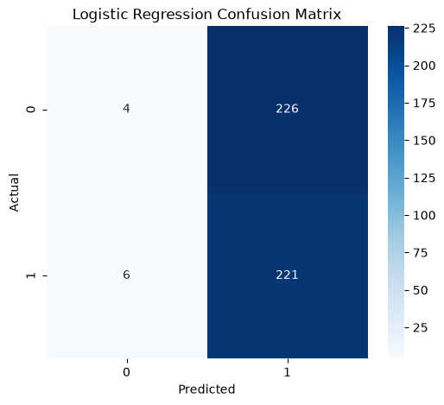
Figure 1: Confusion matrix, logistic regression (rows actual, columns predicted; 0 = Down, 1 = Up)
 | Predicted Down | Predicted Up
Logistic: actual Down | 4 | 226
Logistic: actual Up | 6 | 221
Tree: actual Down | 119 | 111
Tree: actual Up | 125 | 102
The logistic regression predicted "Up" on 447 of 457 test days. It identified Up days almost perfectly (recall 0.97), but only because it nearly always says Up, and it caught just 4 of 230 Down days. This is the typical signature of a model with no real signal that falls back on the most common class in its training data (55% Up). The decision tree spreads its predictions more evenly, but it is right slightly less than half the time, so it has no skill either.

4.3 ROC Curve
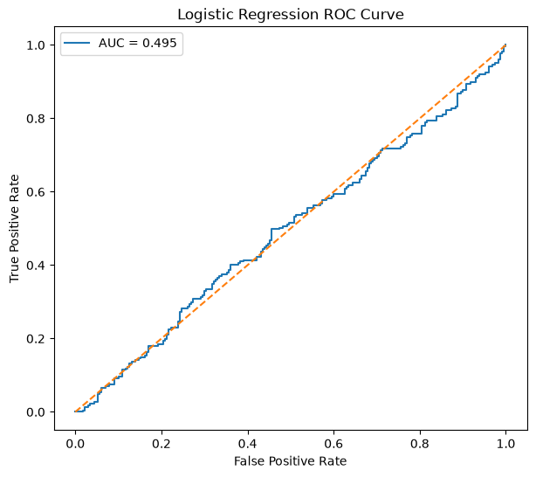
Figure 2: ROC curve for the logistic regression
The curve hugs the diagonal and its AUC is about 0.49, indistinguishable from the 0.50 of random guessing. The ROC view confirms the confusion matrix: the model's probabilities do not separate Up days from Down days.

4.4 Model Comparison
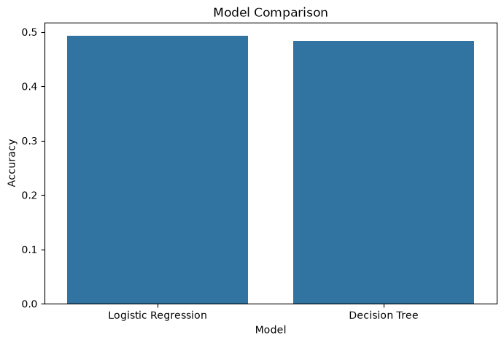
Figure 3: Test accuracy of the two models
The two bars are effectively equal and both are at roughly 50%, so choosing between these models would not matter in practice.

4.5 What Changed During Development
The first version used raw MA_50 and MA_200 levels without scaling, and the logistic regression predicted "Up" on every single test day. Switching to ratio features and standardising lowered that bias slightly (4 Down predictions instead of 0) but did not create real skill, which shows that the main cause of the poor result is the lack of predictive signal, not only the feature format.

5. Critical Discussion

5.1 Why the Result Is Weak, and Why That Is Plausible
A next-day direction forecast from past prices alone is one of the hardest problems in finance. In a liquid, heavily followed index such as the NIFTY 50, any simple pattern in past returns would be competed away by other participants, which is the idea behind the weak form of the efficient-market hypothesis. Week 1 already showed that daily returns are almost uncorrelated with every other column, and Week 3 found no robust weekday pattern. A near-chance result here is consistent with all of that. It should not be "fixed" with tricks that inflate accuracy.

5.2 Sources of Error
- Distribution shift: 55.1% of training days were Up but only 49.7% of test days, so a model leaning towards Up is penalised in the test period.
- Weak features: six price-derived features carry little information about tomorrow. No macro, global-market, news or sentiment data was used.
- Non-stationarity: relationships can change between regimes, for example before and after 2020, and one static model averages across them.
- Noise: the daily standard deviation (1.02%) is about twenty times the mean (0.048%), so the direction of one day is close to a coin toss.
- Evaluation size: 457 test days means an accuracy difference of one or two points is within random variation.

5.3 Suggestions for Improvement
- Predict a longer horizon, such as the 10-day or 20-day return, where trend and volatility signals have more room to matter.
- Add external information: overnight US market returns, India VIX, interest-rate and currency data, and news sentiment (the natural link to the market-news classifier project).
- Use walk-forward validation, retraining on a rolling window, instead of one fixed split.
- Plot a ROC curve and report AUC for the decision tree as well, and evaluate with a trading-relevant measure (return after costs) rather than accuracy alone.
- Handle class imbalance explicitly (class weights) so the model cannot default to the majority class.

