Week 2: Advanced Data Visualization & Storytelling
Domain: Indian Financial Markets: NIFTY 50 Index
Author: Paras
Date: October 2026
Dataset: NIFTY 50 index daily prices, 1 June 2016 to 30 June 2026 (2,483 trading days)
Tools: Python (Matplotlib, Seaborn, SciPy), Jupyter

1. Introduction
This report turns the cleaned NIFTY 50 dataset from Week 1 into a visual story for a non-technical reader, such as a first-time investor asking a simple question: "If I had invested in the Indian market over the last ten years, what would the ride have felt like?" Six charts answer that question in order. Each chart raises the question the next one answers.

2. Approach
Each visual was picked for the specific comparison it makes easiest to see: a line chart for the overall journey, a rolling-window line for risk that changes over time, a colour-coded bar chart for year-by-year results, a filled drawdown chart for the depth of losses, a heatmap for month-by-month patterns, and a histogram overlaid with a normal curve for the shape of daily returns. All charts use the cleaned data from Week 1 (data/nifty_cleaned.csv).
df = pd.read_csv("data/nifty_cleaned.csv")
df["Date"] = pd.to_datetime(df["Date"])

3. The Visual Story

3.1 Chapter One: The Journey
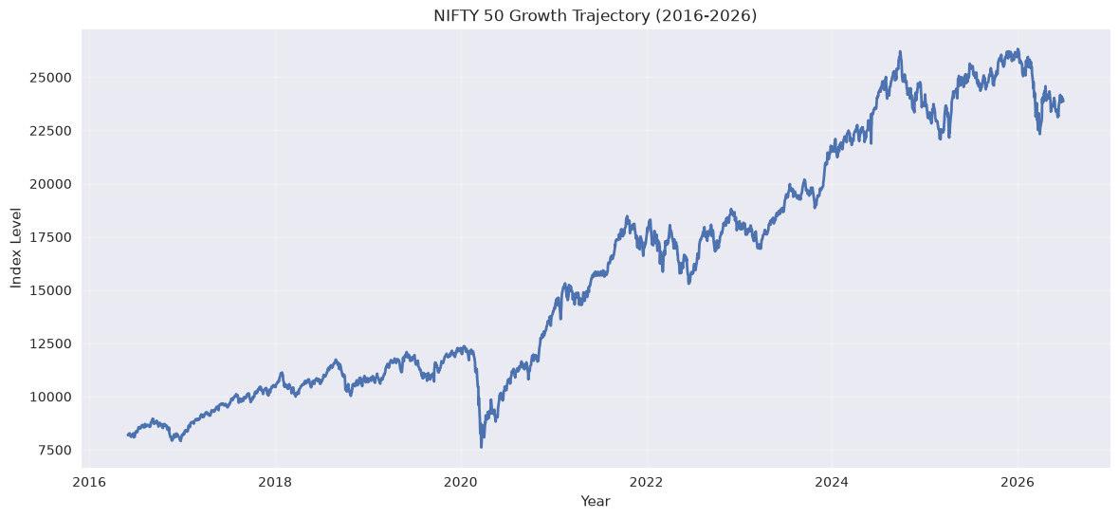
Figure 1: NIFTY 50 growth trajectory, 2016 to 2026
The index rose from about 8,180 to about 23,870, a gain of roughly 192%. A reader could stop here and conclude the market is a smooth upward climb, but one sharp break in early 2020 already hints that the path was not smooth. The next charts look at how rough it actually was.

3.2 Chapter Two: When Was Risk Highest?
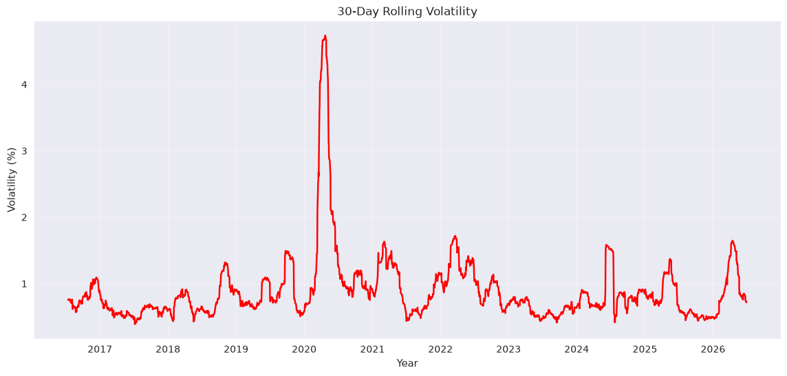
Figure 2: 30-day rolling volatility (standard deviation of daily returns, %)
For most of the decade, 30-day volatility stays between about 0.5% and 1.7% a day. In spring 2020 it spiked to 4.74% on 23 April 2020, nearly three times the size of the next-largest peaks. Smaller bumps appear in 2019, 2022, 2024 and 2026. The lesson is that risk comes in bursts: long calm stretches are interrupted by short, intense episodes.

3.3 Chapter Three: Good Years and Bad Years
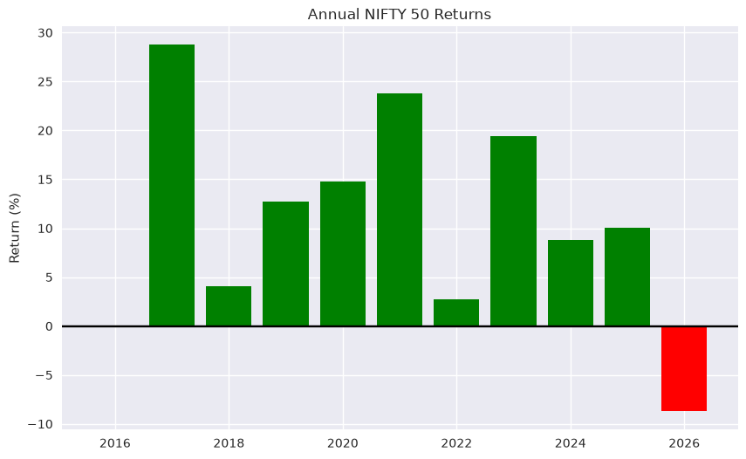
Figure 3: Annual return (first to last close within each calendar year)
Year | Return % | Year | Return %
2016* | 0.07 | 2022 | 2.72
2017 | 28.75 | 2023 | 19.42
2018 | 4.03 | 2024 | 8.75
2019 | 12.75 | 2025 | 10.05
2020 | 14.77 | 2026* | -8.72
2021 | 23.79
* 2016 covers June to December only and 2026 covers January to June only, so those two bars are not full-year figures. Each year's return is measured from its first to its last close, so it excludes the gap from the previous year's last close.
Ten of the eleven bars are positive. A surprise is 2020: despite the crash, the year finished up 14.77%, because the recovery that followed was almost as fast as the fall. The only negative bar is the part-year 2026 (-8.72%), which reflects the sell-off in the first half of that year. This is why a single annual number can hide a very turbulent year.

3.4 Chapter Four: How Deep Were the Falls?
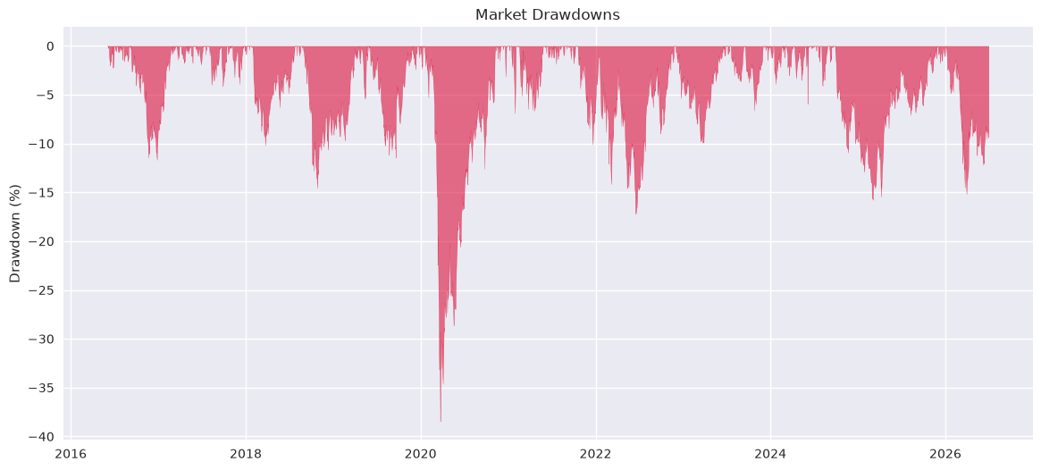
Figure 4: Drawdown from the previous all-time high
The drawdown chart shows how far the index sat below its prior peak at every point in time. The worst fall was -38.44% on 23 March 2020, measured from the 14 January 2020 peak. The index regained that peak on 9 November 2020, about seven and a half months after the trough. A second, shallower decline took place in 2026: the index fell as much as -15.18% (30 March 2026) from its 2 January 2026 high and was still 9.35% below it on 30 June 2026. Most other years also contain declines of about 10% to 17% from a prior high, so a double-digit decline is a normal feature of this market rather than an exception.

3.5 Chapter Five: Is There a Pattern in the Calendar?
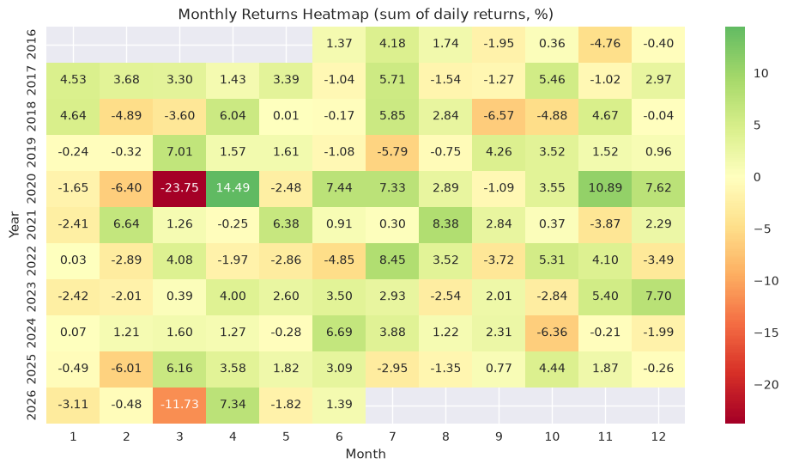
Figure 5: Monthly returns heatmap (sum of daily returns, %)
The heatmap shows each month of each year. The standout cells are March 2020 (-23.75) and the rebound in April 2020 (+14.49) and November 2020 (+10.89), followed by March 2026 (-11.73) and April 2026 (+7.34). Beyond those, the green and red cells are scattered with no obvious vertical stripe, meaning no month is reliably good or bad. Note that March was the worst month in both 2020 and 2026, but that is two observations and should not be treated as a seasonal rule (Week 3 tests weekday effects formally).

3.6 Chapter Six: What Does a Normal Day Look Like?
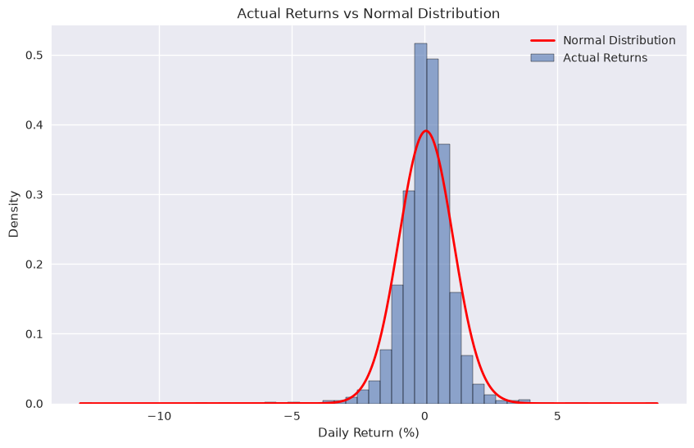
Figure 6: Actual daily returns versus a normal distribution
Most days are quiet: returns pile up in a tall, narrow peak around zero. But the actual distribution has a taller centre and heavier tails than the red normal curve, with an excess kurtosis of 19.2 and a skewness of -1.07. In plain terms, very calm days and very violent days are both more common than a textbook model predicts, and the violent ones lean towards falls.

4. How the Story Fits Together
Figure 1 shows that the market grew strongly. Figure 2 shows that its risk was concentrated in a few bursts. Figure 3 shows that most years were positive despite that. Figure 4 puts a number on the pain (-38% at worst) and shows recovery took months, not years. Figure 5 shows that these shocks do not follow a calendar. Figure 6 explains why: daily returns are fat-tailed, so rare large moves matter more than the average day suggests.

5. Business and Investment Implications
- Long-term investors: the decade's gain of about 192% came with a 38% peak-to-trough fall. Investors need a holding period and risk tolerance that allow them to sit through such a fall rather than sell at the bottom.
- Risk managers: volatility clusters in time (Figure 2), so a single fixed volatility estimate would understate risk in turbulent periods and overstate it in calm ones. Time-varying measures are more appropriate.
- Product and advisory teams: a chart of drawdowns (Figure 4) communicates risk to clients more honestly than annual returns alone, because a year can finish positive (2020) while containing a severe fall.
- Anyone considering calendar-based trading rules: the heatmap offers no support for "good" or "bad" months, so such rules would need strong evidence before use.
- Hedging and stress testing: because tails are heavier than normal, scenarios should be calibrated to actual extreme days rather than to a normal-distribution assumption.

6. Limitations
- The sample contains one major crash (2020); conclusions about crash behaviour rest on a single event.
- Yearly figures for 2016 and 2026 are part-years.
- The monthly heatmap sums daily percentage returns instead of compounding them, which is a close approximation for small moves but slightly overstates large ones such as March 2020.

