Week 4: Machine Learning Model Development & Evaluation
Domain: Financial Markets — Predicting NIFTY 50 Next-Day Direction
Author: Paras Nainwal
Date: August 2026
Tools: Python (Scikit-learn, Pandas)

1. Task Objective
This report builds and evaluates a basic machine learning model that attempts to predict whether the NIFTY 50 index will close higher or lower on the next trading day, using only information available at the end of the current day. The exercise is as much about honestly evaluating a hard, realistic problem as it is about the mechanics of model building.

2. Data Preparation

2.1 Target Variable
The target is binary: 1 if the next trading day's close is higher than the current day's close ("Up"), 0 otherwise ("Down"). This was built by shifting the Daily_Return_% column back by one day.
df['Next_Return'] = df['Daily_Return_%'].shift(-1)
df['Target'] = (df['Next_Return'] > 0).astype(int)
The resulting classes are close to balanced — 52.9% Up days vs. 47.1% Down days — which matters for interpreting accuracy later, since a naive always-predict-majority-class baseline already scores 54.1%.

2.2 Features
All features use only information known by the end of the current trading day, avoiding lookahead bias:
- Return_Lag1, Return_Lag2, Return_Lag3 — the last three days' returns
- MA5 — 5-day moving average of Close
- Price_vs_MA20 — percentage gap between Close and its 20-day moving average, a simple momentum/mean-reversion signal
- Rolling_Vol_10 — 10-day rolling standard deviation of returns, a recent-volatility signal
df['Price_vs_MA20'] = (df['Close'] - df['MA20']) / df['MA20'] * 100
df['Rolling_Vol_10'] = df['Daily_Return_%'].rolling(10).std()
After dropping rows with insufficient history for the rolling features, 4,535 rows remained for modeling.

2.3 Train/Test Split
A chronological (not random) 80/20 split was used — the first 3,628 days trained the model, and the most recent 907 days were held out for testing. This is essential for time-series problems: a random split would let the model "see the future" via nearby dates in the training set, producing artificially inflated performance.
split_idx = int(len(model_df) * 0.8)
X_train, X_test = X.iloc[:split_idx], X.iloc[split_idx:]
y_train, y_test = y.iloc[:split_idx], y.iloc[split_idx:]
Features were standardized (zero mean, unit variance) for the logistic regression model using a scaler fit only on the training set, to avoid leaking test-set statistics into training.

3. Model Selection & Training
Two models were trained for comparison, chosen for their interpretability rather than raw predictive power, which suits a first exploratory pass at a hard forecasting problem:
- Logistic Regression — a linear baseline; coefficients are directly interpretable as the direction and rough strength of each feature's association with the target
- Decision Tree (max depth 4) — a simple non-linear model, capped in depth specifically to reduce overfitting on a dataset where genuine signal is expected to be weak
logreg = LogisticRegression(max_iter=1000, random_state=42)
logreg.fit(X_train_scaled, y_train)
dt = DecisionTreeClassifier(max_depth=4, random_state=42)
dt.fit(X_train, y_train)

4. Evaluation

4.1 Performance Metrics
Model | Accuracy | Precision | Recall | F1 | AUC
Baseline (majority class) | 54.1% | — | — | — | 0.50
Logistic Regression | 53.9% | 54.0% | 99.4% | 70.0% | 0.51
Decision Tree (depth 4) | 49.3% | 55.7% | 31.0% | 39.8% | 0.52

4.2 Confusion Matrix
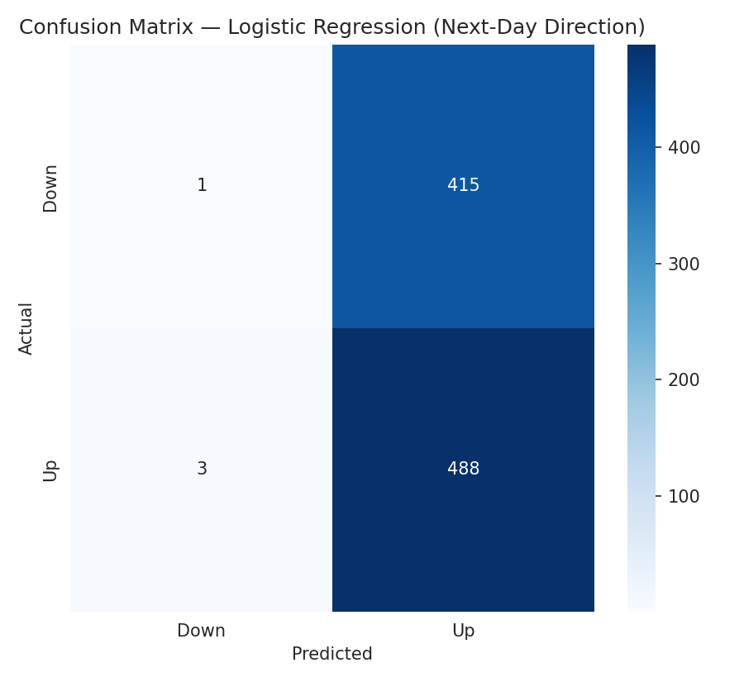
Figure 1: Confusion matrix, Logistic Regression on held-out test days
The confusion matrix reveals a critical detail hidden by the accuracy number alone: the logistic regression model predicts "Up" on almost every single test day (99.4% recall on the Up class), essentially defaulting to the majority class rather than learning a meaningful directional signal.

4.3 ROC Curve
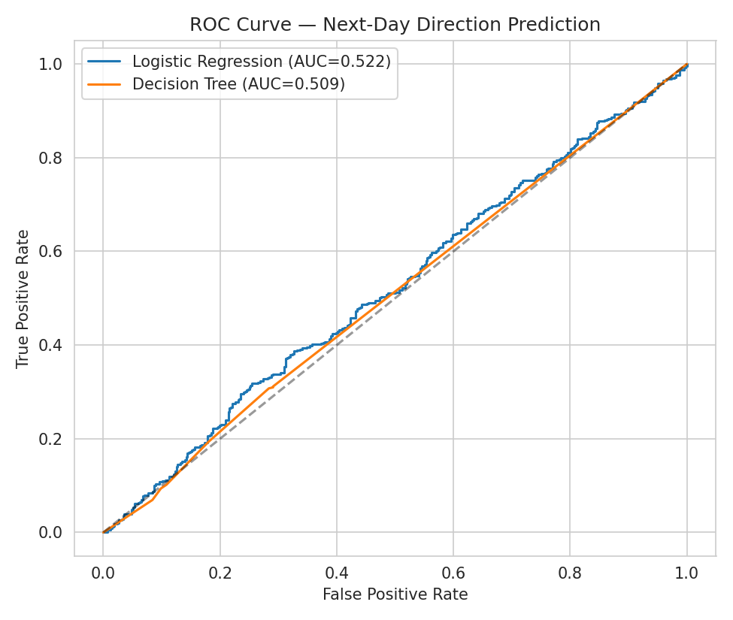
Figure 2: ROC curves for both models on the held-out test set
Both models sit only marginally above the diagonal no-skill line (AUC = 0.51 and 0.52), confirming the confusion matrix finding: neither model is meaningfully separating Up days from Down days better than chance.

4.4 Feature Coefficients
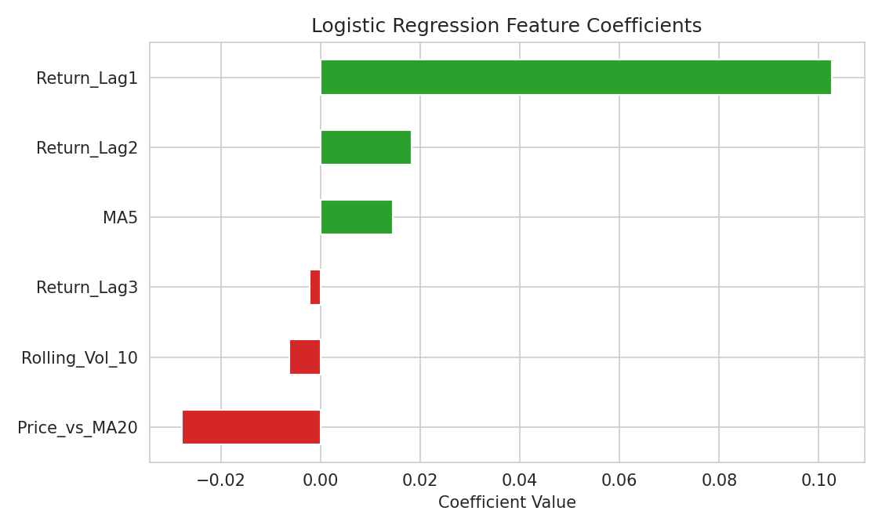
Figure 3: Logistic regression standardized coefficients
No single feature carries a strong, consistent signal — coefficients are small in magnitude, which is itself informative: it means the model isn't finding one dominant lever, it's finding weak, noisy associations across all of them.

5. Critical Discussion

5.1 Why Performance Is Weak — And Why That's the Correct Result
Both models perform at or just below the naive majority-class baseline (54.1% accuracy). This is not a modeling failure to be fixed with a better algorithm; it is broadly consistent with the weak-form Efficient Market Hypothesis, which holds that historical price and volume data should not, on their own, reliably predict next-day direction in a liquid, widely-traded index like NIFTY 50. If a simple model like this reliably beat the market, that edge would typically be arbitraged away quickly by other participants.

5.2 Sources of Error
- Class imbalance and majority-class collapse: logistic regression's 99.4% recall on "Up" shows it essentially learned to always predict the more frequent class rather than a genuine pattern — a textbook symptom of insufficient real signal in the features.
- Feature set limitations: only price/volume-derived technical features were used; no macroeconomic, news-sentiment, or cross-market (e.g., global index) data was included, any of which might carry more genuine next-day information.
- Non-stationarity: relationships between past returns and future direction can shift across regimes (pre/post-2020, for example), and a single static model trained across 18 years may average over meaningfully different market conditions.
- Short prediction horizon: next-day direction is an especially hard target; the same features might show more predictive power for a longer horizon (e.g., 20-day direction), which smooths out daily noise.

5.3 Suggestions for Improvement
- Reframe the target as a longer-horizon return (e.g., 10- or 20-day forward return) where technical signals have more plausible predictive value
- Incorporate external features: global index co-movement (e.g., S&P 500 overnight return), macro indicators, or news/sentiment scores
- Use walk-forward validation (retraining periodically on a rolling window) instead of one static train/test split, to account for regime changes
- If the goal is genuinely trading-oriented, evaluate using a trading-relevant metric (e.g., Sharpe ratio of a resulting strategy) rather than classification accuracy alone, since a 53% directional accuracy can still be economically meaningless after transaction costs

