Week 2: Advanced Data Visualization & Storytelling
Domain: Financial Markets — NIFTY 50 Index (2007-2026)
Author: Paras Nainwal
Date: August 2026
Tools: Python (Matplotlib, Seaborn, SciPy)

1. Introduction
This report builds a visual narrative around the NIFTY 50 index dataset introduced in Week 1 (4,554 trading days, 2007-2026). Rather than presenting isolated charts, the goal is to walk a non-technical reader — for example, a retail investor deciding how to think about market risk — through a coherent story: how the index has grown, how risky that growth has actually been along the way, and when that risk shows up.

2. Methods
Six visualizations were built, each chosen for a specific narrative purpose: an annotated line chart for the headline growth story, a rolling-window line chart for time-varying risk, a color-coded bar chart for year-by-year performance, a filled area ("underwater") chart for drawdown depth and duration, a heatmap for month-by-month seasonality, and a distribution overlay for tail-risk behavior. All charts were built in Matplotlib/Seaborn on the cleaned dataset from Week 1.

3. Visual Narrative

3.1 Chapter One: The Headline Story — Long-Term Growth
The story opens with the number every investor cares about first: did the index go up? The chart below plots the full 18.5-year closing price series, with the two defining crash events labeled directly on the chart.
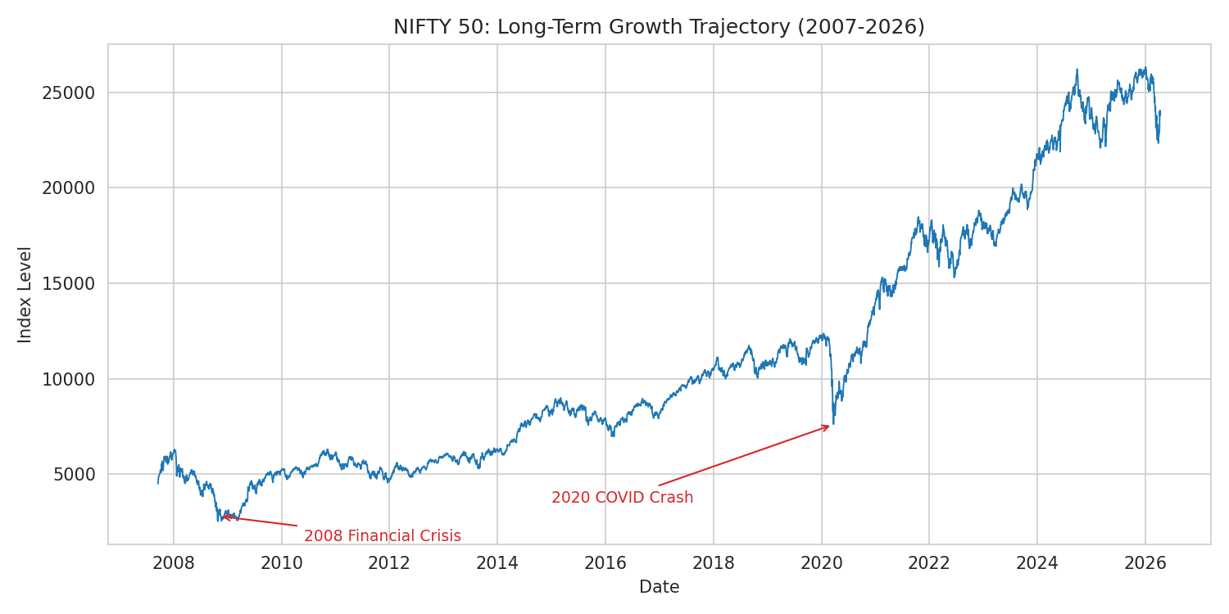
Figure 1: NIFTY 50 long-term growth trajectory, annotated with major crash events
The headline answer is yes — decisively — but the annotations immediately raise the next question the story needs to answer: growth doesn't mean smooth growth. What did the ride actually feel like along the way?

3.2 Chapter Two: How Risky Was That Ride, and When?
Total growth hides a huge amount of variation in day-to-day risk. The rolling 30-day annualized volatility chart makes that variation visible over time rather than collapsing it into a single average.
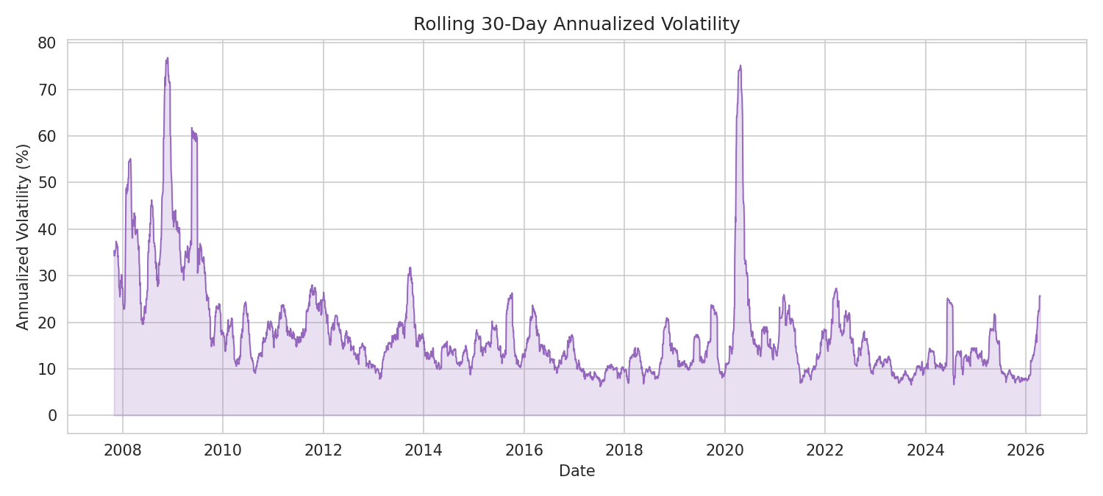
Figure 2: Rolling 30-day annualized volatility over the full period
Volatility is not constant — it spikes sharply around 2008 and again in March 2020, then decays back toward a low baseline. This is the core insight of the whole story: risk in equity markets comes in clusters, not as a steady background hum.

3.3 Chapter Three: Which Years Actually Delivered?
Zooming from daily detail out to yearly summaries makes the story easier to act on: was any given calendar year a good one to be invested?
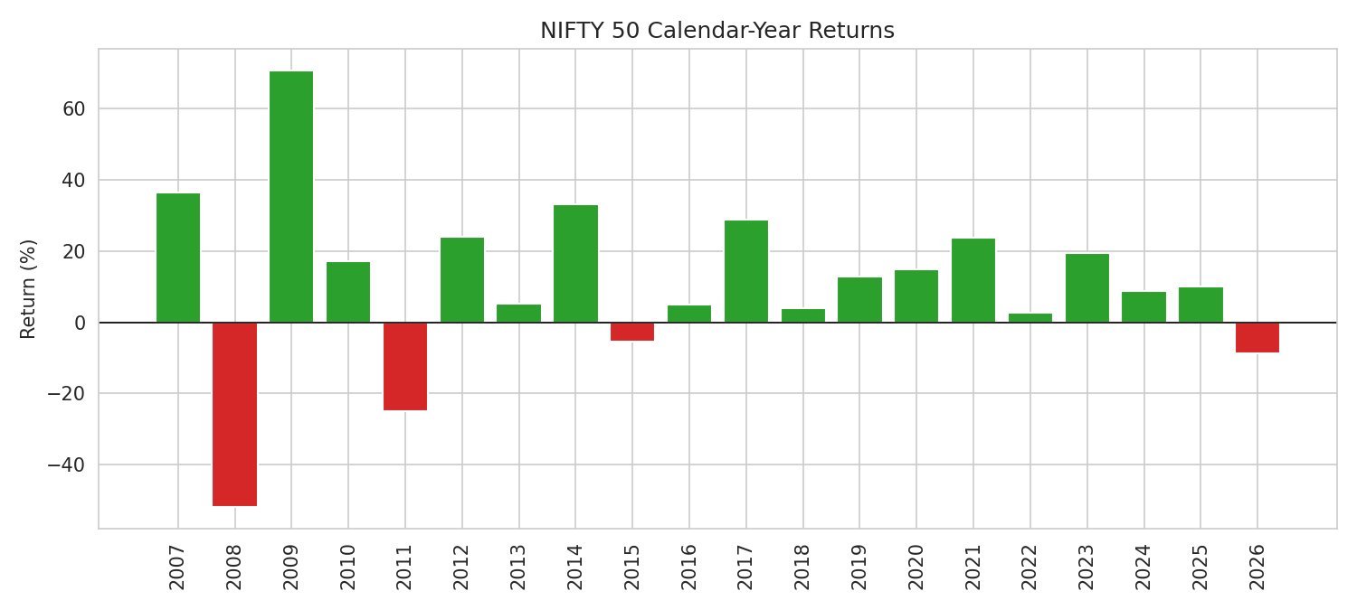
Figure 3: NIFTY 50 calendar-year returns, green for positive, red for negative
Losing years are rarer than winning years, but when they occur (2008, 2011, 2015, 2018, 2020) they tend to line up with the volatility spikes already seen in Figure 2 — reinforcing that the story of risk and the story of losses are really the same story told two ways.

3.4 Chapter Four: How Deep — and How Long — Were the Losses?
A drawdown chart answers a question yearly returns can't: not just whether a year was negative, but how far the index fell from its prior peak, and how long it took to recover.
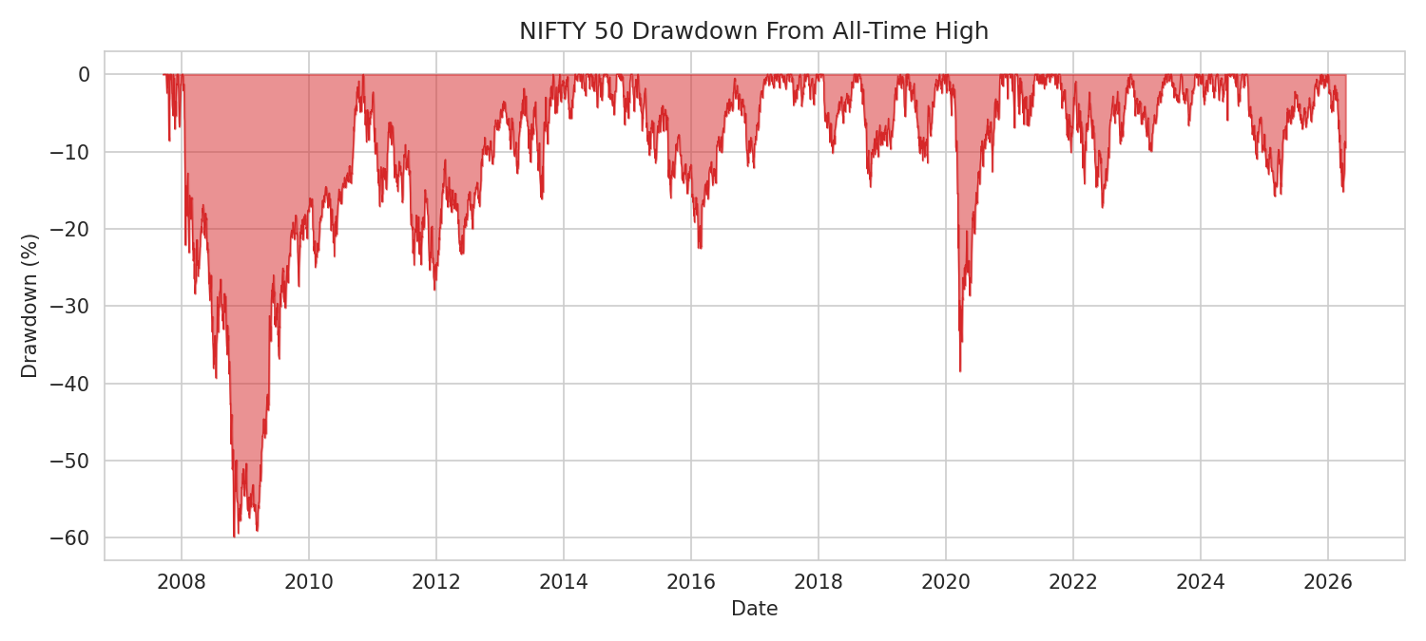
Figure 4: Drawdown from all-time high, full period
The 2008 crisis produced a drawdown of roughly -60% and took years to fully recover — by far the deepest and longest trough in the dataset. The 2020 COVID crash was nearly as deep (-38.7%) but resolved far faster, within months rather than years — a meaningfully different risk profile even though both events look similar in the yearly-returns view.

3.5 Chapter Five: Is There a Seasonal Pattern?
The heatmap below breaks returns down by year and month simultaneously, letting a reader scan for any recurring seasonal pattern (e.g., a historically weak or strong month) at a glance.
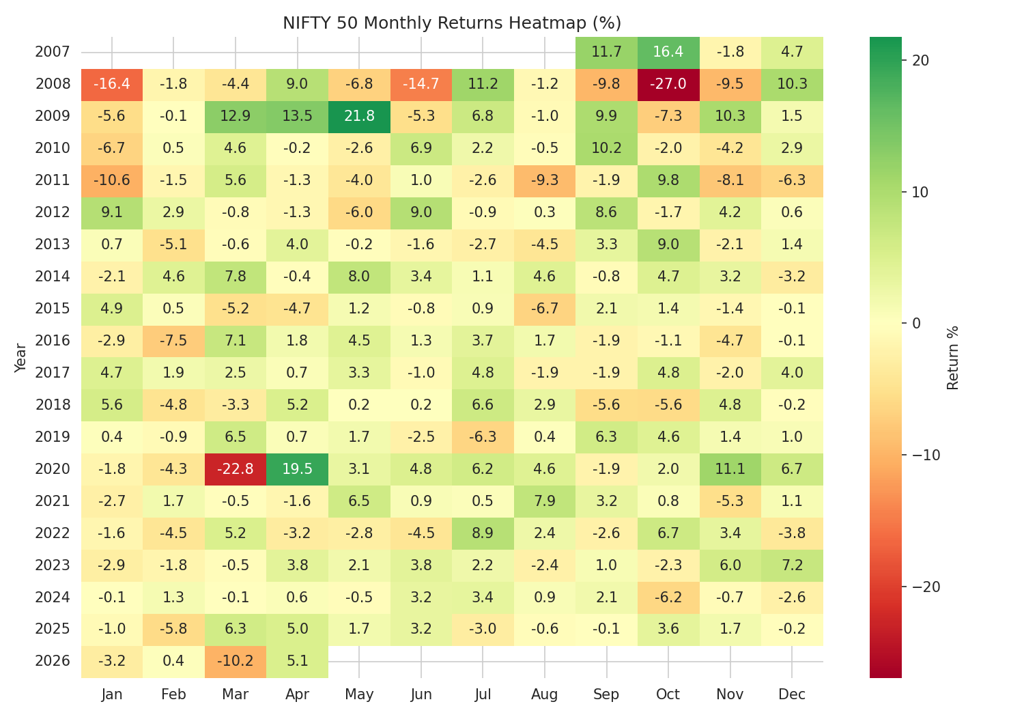
Figure 5: Monthly returns heatmap by year
No consistent month stands out as reliably positive or negative across most years — red and green cells are scattered rather than forming column-wise stripes. This visual absence of a pattern is itself the finding: it argues against relying on calendar-based seasonality as an investment strategy for this index (formally tested in Week 3).

3.6 Chapter Six: What Do 'Normal' Days Actually Look Like?
The final chapter zooms back into daily behavior, comparing the actual distribution of daily returns against a theoretical normal distribution with the same mean and standard deviation.
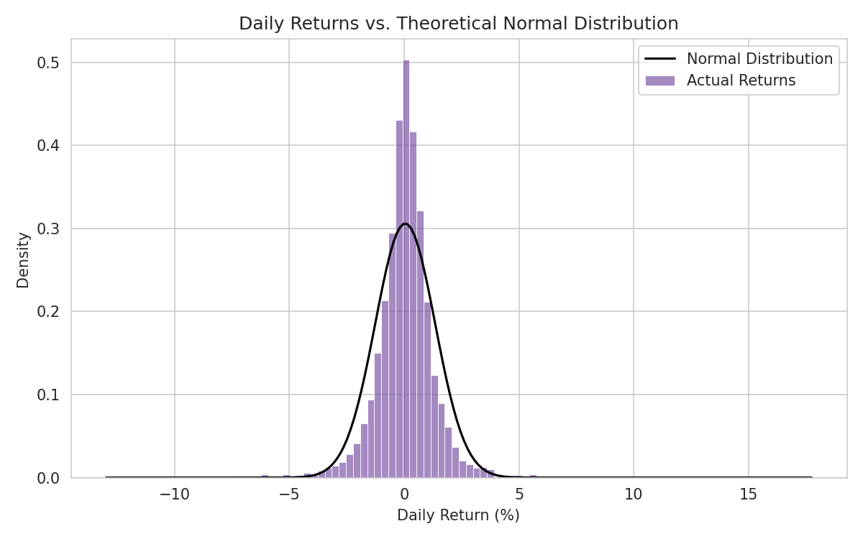
Figure 6: Daily return distribution vs. a fitted normal distribution
The actual distribution is taller and narrower in the middle, with visibly fatter tails, than the normal curve predicts — meaning extreme up and down days happen more often in reality than a normal-distribution assumption would suggest. This closes the loop back to Chapter Two: the volatility clustering seen in Figure 2 is, in part, a direct consequence of this fat-tailed daily behavior.

4. How the Narrative Fits Together
Read start to finish, the six charts move from a simple growth headline (Fig. 1), to when and how much risk was actually taken on to earn that growth (Figs. 2-4), to whether that risk follows any predictable calendar pattern (Fig. 5), down to the raw statistical shape of a single trading day (Fig. 6). Each chapter answers the question the previous one raises.

5. Business & Analytical Implications
- Buy-and-hold investors: the depth of the 2008 drawdown (-59.9%) versus its multi-year recovery underscores that headline long-term returns can mask periods requiring significant patience and risk tolerance.
- Risk managers: volatility clustering (Fig. 2) supports using time-varying risk models (e.g., GARCH-family models) rather than a single static volatility estimate for position sizing or margining.
- Retail investors considering calendar-based strategies: the absence of a clear seasonal pattern (Fig. 5) argues against strategies premised on specific months being reliably better or worse.
- Portfolio/derivatives desks: fat-tailed daily returns (Fig. 6) mean tail-risk hedging (e.g., options) should be priced and sized using return distributions calibrated to the data's actual kurtosis, not a normal-distribution assumption, which would understate the odds of extreme moves.

