Week 3: Statistical Analysis & Hypothesis Testing
Domain: Financial Markets — NIFTY 50 Index (2007-2026)
Author: Paras Nainwal
Date: August 2026
Tools: Python (SciPy, Pandas)

1. Introduction
This report applies formal statistical hypothesis testing to four questions about NIFTY 50 index behavior that were raised informally in Weeks 1-2: whether the index has a genuine positive drift, whether crisis periods are statistically more volatile, whether a day-of-week effect exists, and whether trading volume relates to volatility. Each hypothesis is stated up front, tested with an appropriate method, and interpreted at the standard alpha = 0.05 significance level.

2. Methodology Overview
Hypothesis | Test Used | Compares
H1: Mean daily return ≠ 0 | One-sample t-test | Sample mean vs. 0
H2: Crisis years more volatile | Levene's test + Welch's t-test | 2008 & 2020 vs. other years
H3: Day-of-week effect exists | One-way ANOVA | Mon-Fri mean returns
H4: Volume relates to volatility | Pearson correlation | Volume vs. |daily return|

3. Hypothesis 1: Does NIFTY 50 Have a Statistically Significant Positive Drift?

3.1 Formulation
H0 (null): the true mean daily return is 0% (no drift, consistent with a pure random walk). H1 (alternative): the true mean daily return is different from 0%.

3.2 Method
A one-sample t-test was run on all 4,553 daily returns against a hypothesized mean of 0.
from scipy import stats
t_stat, p_val = stats.ttest_1samp(returns, 0)
# t = 2.337, p = 0.0195
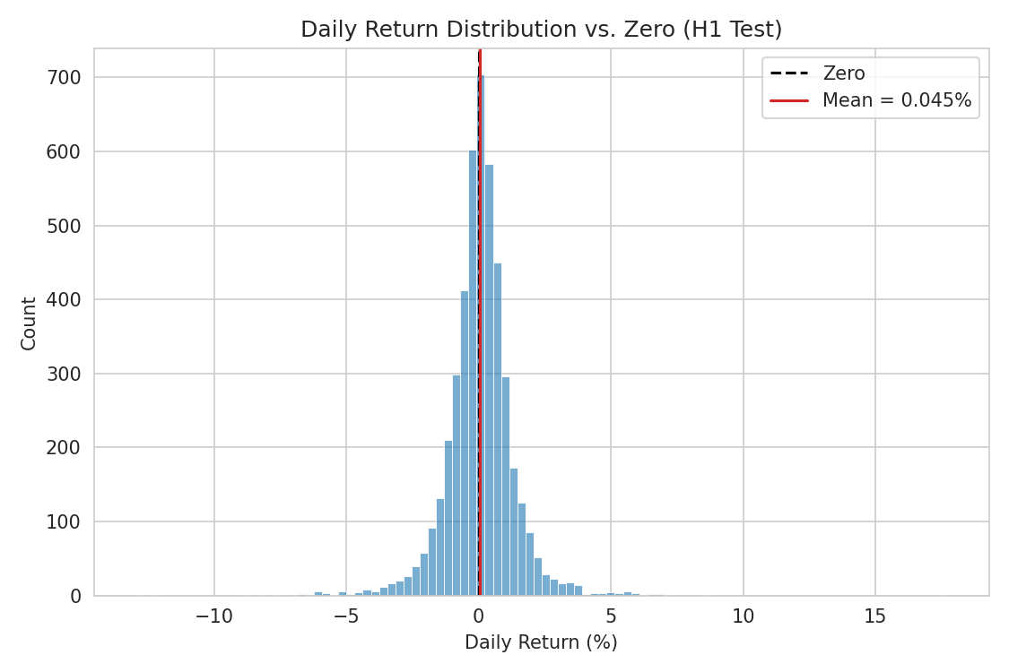
Figure 1: Daily return distribution centered near, but not exactly at, zero

3.3 Result & Interpretation
t = 2.34, p = 0.0195. Since p < 0.05, the null hypothesis is rejected: the mean daily return (+0.045%) is statistically significantly different from zero at the 5% level. Practically, this small but real positive daily drift compounds into the substantial long-run growth seen in Week 1-2 — though the effect size on any single day is small relative to daily volatility (~1.3%), meaning the drift is only detectable with a large sample, not from watching a handful of days.

4. Hypothesis 2: Are Crisis Years Significantly More Volatile?

4.1 Formulation
H0: daily volatility (measured as |daily return|) is the same in crisis years (2008, 2020) as in all other years. H1: crisis-year volatility is significantly different (higher).

4.2 Method
Levene's test was used first to formally confirm unequal variances between the two groups, followed by Welch's t-test (which does not assume equal variance) comparing absolute daily returns.
lev_stat, lev_p = stats.levene(crisis_returns, normal_returns)
# Levene: stat = 395.6, p < 0.001
t_stat, p_val = stats.ttest_ind(crisis_abs, normal_abs, equal_var=False)
# t = 11.11, p < 0.001
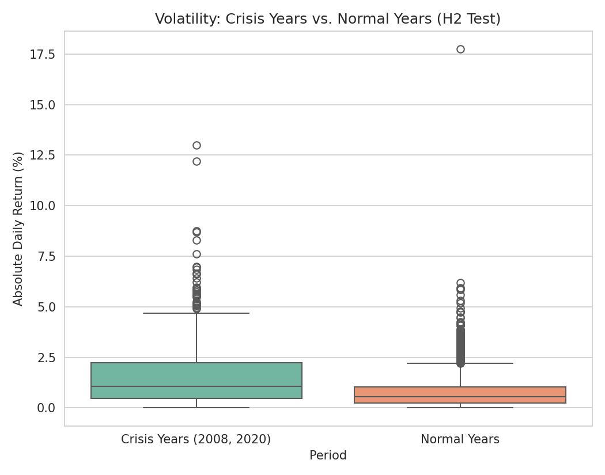
Figure 2: Absolute daily returns — crisis years vs. normal years

4.3 Result & Interpretation
Both tests are highly significant (p < 0.001). Average absolute daily movement was 1.66% in crisis years versus 0.77% in normal years — more than double. This confirms quantitatively what Week 2's rolling volatility chart showed visually: crisis periods are not just subjectively more turbulent, the difference is statistically overwhelming and more than twice the typical magnitude.

5. Hypothesis 3: Is There a Day-of-Week Effect?

5.1 Formulation
H0: mean daily return is the same across all five trading weekdays (Monday-Friday). H1: at least one weekday's mean return differs from the others.

5.2 Method
A one-way ANOVA was run across the five weekday groups of daily returns.
f_stat, p_val = stats.f_oneway(mon, tue, wed, thu, fri)
# F = 1.506, p = 0.198
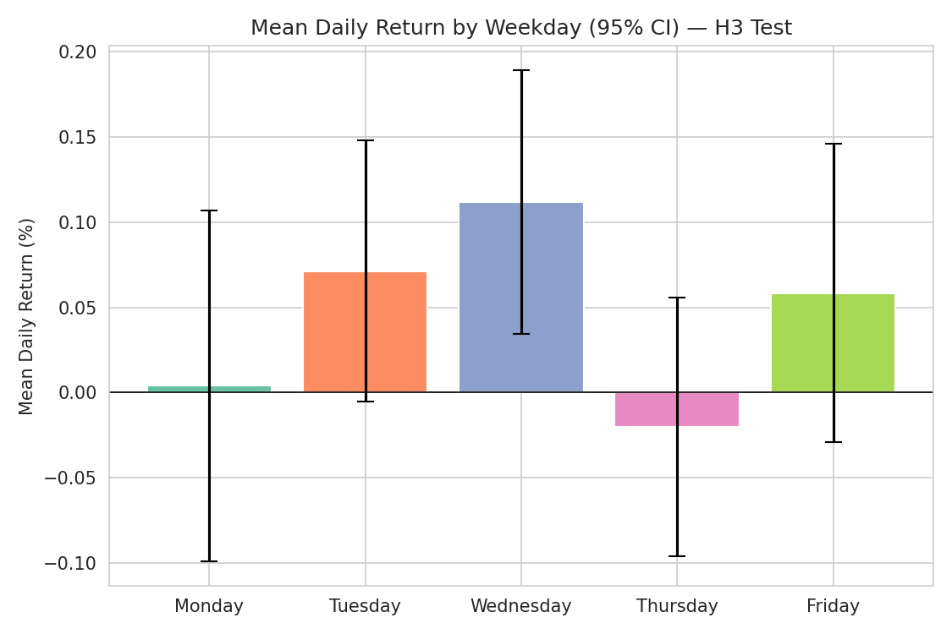
Figure 3: Mean daily return by weekday, with 95% confidence intervals

5.3 Result & Interpretation
F = 1.51, p = 0.198. Since p > 0.05, the null hypothesis cannot be rejected: there is no statistically significant difference in mean returns across weekdays. This matches the visual absence of a seasonal pattern from Week 2's monthly heatmap — NIFTY 50 shows no exploitable calendar effect at the weekday level in this dataset, consistent with market efficiency.

6. Hypothesis 4: Does Trading Volume Relate to Volatility?

6.1 Formulation
H0: there is no linear correlation between trading volume and absolute daily return. H1: volume and absolute daily return are correlated.

6.2 Method
A Pearson correlation test was run between Volume and the absolute value of Daily_Return_%, restricted to the post-2013 subset where volume data is reliable (per the missing-data finding in Week 1).
r, p_val = stats.pearsonr(volume, abs_returns)
# r = 0.297, p < 0.001, n = 3220
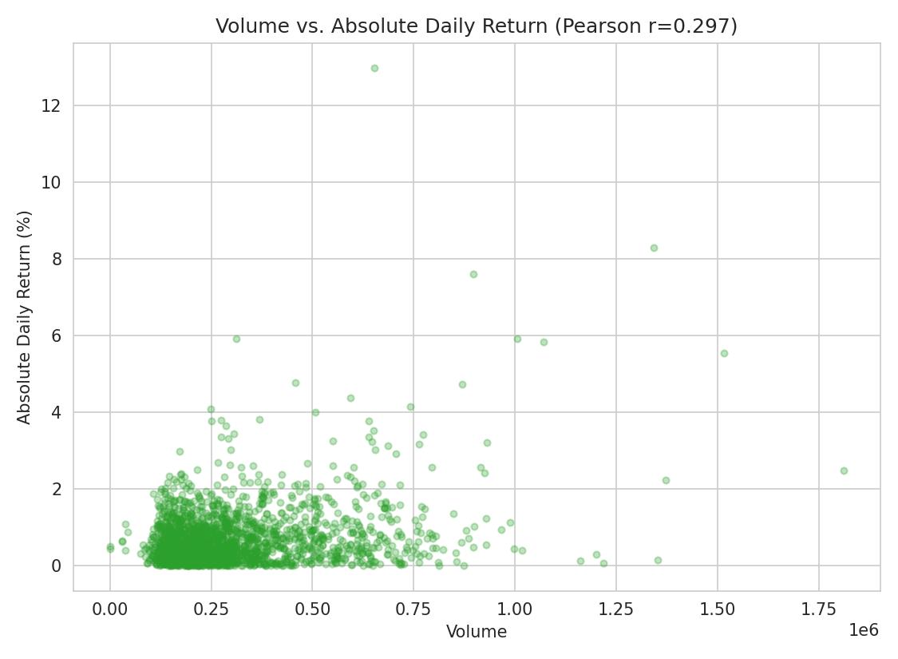
Figure 4: Trading volume vs. absolute daily return

6.3 Result & Interpretation
r = 0.30, p < 0.001. The correlation is statistically significant but only weak-to-moderate in strength — higher volume days are somewhat more likely to be volatile days, consistent with the intuition that panic or euphoria drives both higher trading activity and bigger price swings, but volume alone explains only a modest share of day-to-day volatility (r² ≈ 9%).

7. Summary of Findings
Hypothesis | Result | Conclusion
H1: Drift ≠ 0 | p = 0.0195 | Reject H0 — small but real positive drift
H2: Crisis volatility | p < 0.001 | Reject H0 — crisis years >2x more volatile
H3: Day-of-week effect | p = 0.198 | Fail to reject H0 — no weekday effect
H4: Volume-volatility link | p < 0.001 | Reject H0 — weak-moderate positive link
Three of the four hypotheses were statistically confirmed, and one (day-of-week effect) was not — an equally important and honest result, since a non-significant finding rules out a commonly assumed market anomaly rather than failing the analysis.

8. Validity Considerations
- Daily returns are not independent in the strict statistical sense (volatility clustering, confirmed in Week 2, violates the i.i.d. assumption underlying a standard t-test), so p-values here should be read as indicative rather than exact.
- H2's crisis-year definition (2008, 2020) was chosen based on prior domain knowledge from Weeks 1-2 rather than a data-driven changepoint detection method, which could introduce selection bias.
- H4 was restricted to the post-2013 period where Volume data was validated as reliable in Week 1 — using the full series would have mixed genuine volume signal with the disguised-missing-data issue already documented.

